**EXERCISE-4**

**COMPUTER VISION**

**DARK IMAGE HISTOGRAM:**

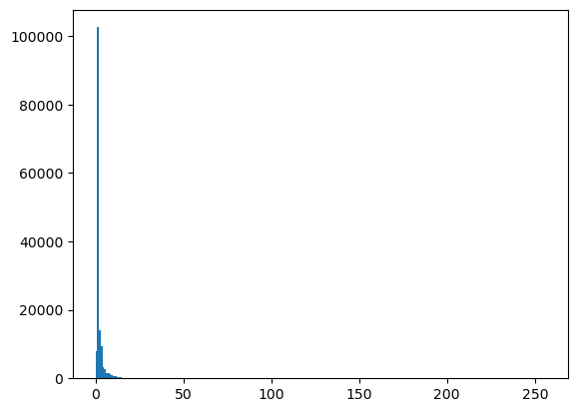

**LIGHT IMAGE HISTOGRAM:**

**HIGH CONTRAST IMAGE HISTOGRAM:**

**LOW CONTRAST IMAGE HISTOGRAM:**

**EQUALIZIED HISTOGRAM:**

**ORIGINAL IMAGE:**

**HISTOGRAM EQUALIZIED IMAGE:**

**HISTOGRAM MATCHING:**

