EXERCISE-2

FULL STACK LABORATORY

1)

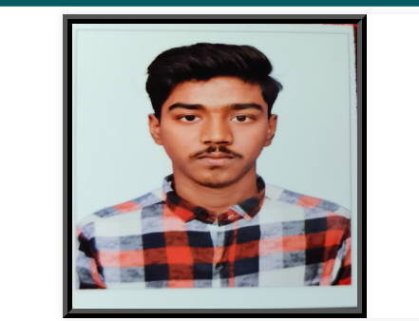

2)

3)

4)

5)

6)

7)

8)

a)

8)

b)

