EXERCISE-7

FULL STACK LABORATORY

1)

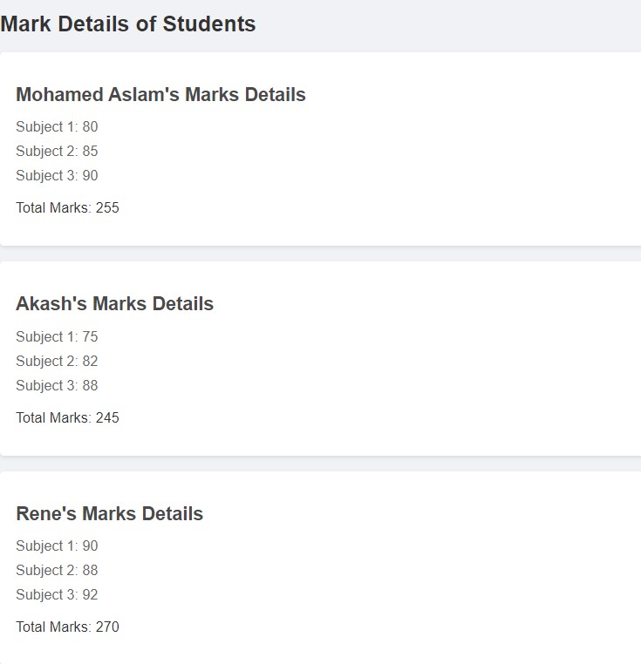

2)

Inserting

Completed

3)

