EXERCISE-8

FULL STACK LABORATORY

1)

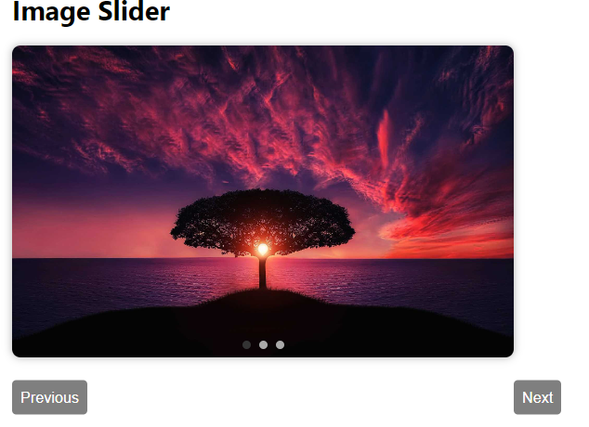

2)

