

**UNITED STATES INTERNATIONAL UNIVERSITY – AFRICA (USIU)**

**ASSIGNMENT I**

**SUMMER SEMESTER 2024**

**APT2050: TELECOMMUNICATIONS & COMPUTER NETWORKS**

**INSTRUCTOR: DR. ABRAHAM NYETE**

**…………………………………………………………………………………………….**

**DATE: 8/5/2024**

***INSTRUCTIONS:***  ANSWER **ALL** QUESTIONS

**Question One 20 MARKS**

(a) Draw the OSI and TCP/IP protocol architecture models and explain the function of each layer

**[12 Marks]**

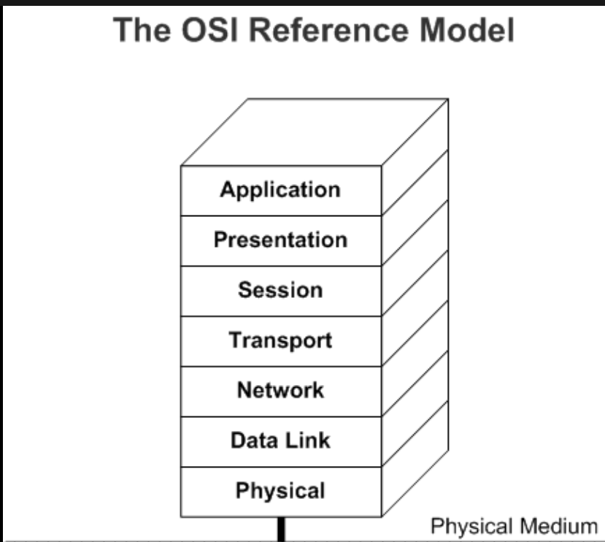 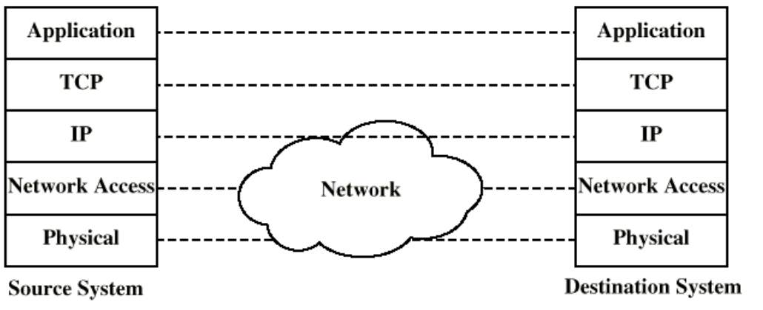

**OSI Model:**

1. **Physical Layer (Layer 1): Deals with the physical connection of devices and the transmission of raw data over a physical medium.**
2. **Data Link Layer (Layer 2): Manages the communication between devices on the same network, including error detection and correction. It's divided into two sublayers:**
   * **LLC (Logical Link Control): Deals with the framing, flow control, and error checking.**
   * **MAC (Media Access Control): Handles access to the physical medium.**
3. **Network Layer (Layer 3): Responsible for routing packets between different networks, using logical addressing and routing tables.**
4. **Transport Layer (Layer 4): Provides end-to-end communication between hosts, including error checking and data flow control. TCP (Transmission Control Protocol) and UDP (User Datagram Protocol) operate at this layer.**
5. **Session Layer (Layer 5): Establishes, manages, and terminates connections between applications.**
6. **Presentation Layer (Layer 6): Deals with data representation, encryption, and compression for the application layer.**
7. **Application Layer (Layer 7): Provides interface between the applications and the network. It includes protocols for file transfers, email, and other network services.**

**TCP/IP Model:**

1. **Application Layer: Corresponds to the top three layers of the OSI model (Application, Presentation, and Session). It includes protocols like HTTP, FTP, SMTP, etc.**
2. **Transport Layer: Equivalent to the Transport layer in the OSI model. It includes TCP and UDP.**
3. **Internet Layer: Equivalent to the OSI Network layer. It handles addressing, routing, and fragmentation of packets. IP (Internet Protocol) operates at this layer.**
4. **Link Layer: Combines the OSI Data Link and Physical layers. It includes protocols for Ethernet, Wi-Fi, etc.**

b) For computer networks, list at least eight computer components and explain their functions. Also, indicate the layer of the TCP/IP Stack where each device is found. **[8 Marks]**

1. **Network Interface Card (NIC):**
   * **Function:** It connects a device to the network medium (e.g., Ethernet cable or Wi-Fi).
   * **Layer:** Link Layer (Layer 2)
2. **Router:**
   * **Function:** Routes data packets between different networks based on their IP addresses.
   * **Layer:** Internet Layer (Layer 3)
3. **Switch:**
   * **Function:** Connects multiple devices within the same network and forwards data packets to the correct destination based on MAC addresses.
   * **Layer:** Link Layer (Layer 2)
4. **Hub:**
   * **Function:** Connects multiple devices within the same network, but it operates at a simpler level than a switch, broadcasting data to all devices.
   * **Layer:** Link Layer (Layer 2)
5. **Firewall:**
   * **Function:** Monitors and controls incoming and outgoing network traffic based on predetermined security rules.
   * **Layer:** Can operate at various layers, typically Network Layer (Layer 3) or Transport Layer (Layer 4)
6. **Modem:**
   * **Function:** Converts digital data from a computer into analog signals for transmission over telephone lines (for DSL) or vice versa.
   * **Layer:** Physical Layer (Layer 1)
7. **Gateway:**
   * **Function:** Acts as an entry and exit point for a network, translating between different network protocols or data formats.
   * **Layer:** Can operate at various layers, depending on its function, often Network Layer (Layer 3) or Application Layer (Layer 7)
8. **DNS Server:**
   * **Function:** Translates domain names into IP addresses, enabling users to access websites using easy-to-remember names.
   * **Layer:** Application Layer (Layer 7)

**Question Two 20 MARKS**

(a) Differentiate between analog and digital signals. **[2 Marks]**

• Analogue signals: Constantly changing and continuous signals that depict physical quantities like sound waves, voltage, and current.   
• Accepts any value falling inside a range.   
Discrete signals are represented by a series of binary digits (0s and 1s) in digital signals.   
• Possess unique, discrete values.

b) Define telecommunications**. [2 Marks]**

**Telecommunications refers to the transmission of information over significant distances to communicate. It involves the use of various technologies such as telephones, radios, television, and the internet to send and receive messages, data, and signals between devices or locations.**

c) List three wireless media transmission technologies and also three wired media types and explain their working briefly. **[12 Marks]**

1. Wireless Fidelity (Wi-Fi): This technology uses radio waves in the 2.4 GHz or 5 GHz frequency bands to send data.   
• Devices link to a Wi-Fi access point, which serves as a communication hub.   
• Gives users movement and flexibility inside the coverage region.   
2. Bluetooth: This technology connects devices across short distances by using short-range radio frequency transmission.   
• Frequently utilised for wireless keyboards, headphones, and other accessories.   
• Low power consumption, which makes it appropriate for tiny, battery-operated gadgets.   
3. Cellular networks (such as 4G and 5G): • By using a network of cell towers, they enable long-distance wireless data transmission.   
• Provides mobile devices, including tablets and smartphones, with high-speed internet access.   
• Offers coverage across wide geographic regions, enabling customers to maintain connectivity while on the go.

(d) Differentiate between periodic and aperiodic signals.

1. Twisted Pair Cable: Typically used for Ethernet and phone connections, this type of cable is made up of two pairs of insulated copper wires that have been twisted together.   
• Offers dependable and reasonably priced data transfer across short to medium distances.   
2. Coaxial cable: Used for high-speed internet and cable television (CATV), it consists of an exterior insulating layer, a metallic shield, and an insulation-enclosed central conductor.   
It Provides a larger bandwidth than twisted pair wires and is less prone to interference.   
3. Fibre Optic Cable: This type of cable has a high bandwidth and is resistant to electromagnetic interference. It transmits data by means of light pulses via glass or plastic fibre.   
• Applied to high-speed internet connections, internet backbone networks, and long-distance communication.

(e) For periodic signals, define the following terms:

1. Amplitude
2. Wavelength
3. Time period
4. Frequency **[4 Marks]**

i. Amplitude:

Amplitude refers to the maximum displacement or strength of a periodic signal from its mean or zero value.

In other words, it represents the height of the waveform from the zero line to the peak (or trough) of the signal.

For example, in a sine wave, the amplitude is the distance from the center line to the peak (or trough) of the wave.

ii. Wavelength:

Wavelength is the distance between two consecutive points in a periodic signal that are in the same phase, usually measured in meters.

It represents the physical length of one complete cycle of the signal.

In electromagnetic waves, such as light or radio waves, wavelength determines the color or frequency of the wave.

iii. Time period:

Time period (T) is the duration taken by a periodic signal to complete one full cycle.

It is measured in seconds.

Time period is the reciprocal of frequency (T = 1/f), where f is the frequency of the signal.

iv. Frequency:

Frequency (f) of a periodic signal is the number of complete cycles occurring per unit of time.

It is measured in Hertz (Hz), where 1 Hz equals one cycle per second.

Frequency is the reciprocal of the time period (f = 1/T).