**Results**

At this stage of the study we compared the differential expression between two aligners; kallisto and salmon based on six samples from 64, three control and three liver cancer patient and we will report the results here;

Salmon has a significant higher number of differentially expressed genes than kallisto as shown in figure (1) and figure (2), both aligners used human transcriptome as a reference. Analyzing the whole study will increase the significance of the analysis, however due the time limitation and the huge size of the data (1 tera uncompressed), we were capable of analyzing this section only, although we are committed to analyze the whole study with the other aligners followed by wet lab experiment validation using real time PCR for the top DEGs.

figure (1); volcano plot to visualize the abundance of the differentially expressed genes between kallisto and salmon the colored DEGs are higher than log2 fold change, red for adjusted p value lower than 0.05, and blue for p value lower than 0.05.

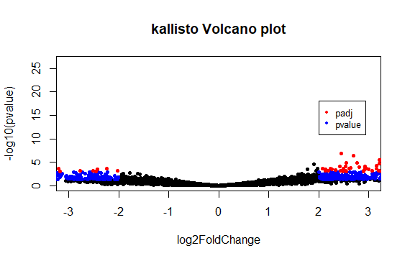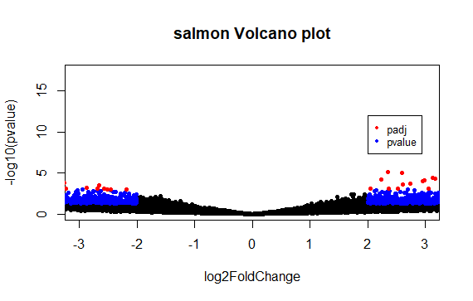

figure (2); kallisto identified 232 differentially expressed genes while salmon was able to identify 446 DEGs

