


Acknowledgements
First and foremost, we would like to express our deepest gratitude to Allah for granting us the strength, knowledge, and patience to complete this graduation project successfully.

We would like to extend our sincere appreciation to our project supervisor, Dr. Wael abbas, for their continuous guidance, valuable feedback, and support throughout the development of this project. Their experience and advice played an important role in improving our work and achieving our goals.

We would also like to thank the Faculty of [Faculty Name] at [University Name] for providing us with the necessary knowledge, learning environment, infrastructure, and resources that supported us throughout our academic journey.

Our sincere thanks go to our families and friends for their encouragement, motivation, and constant support during the challenging stages of this project.

Finally, we would like to thank everyone who contributed directly or indirectly to the completion of this project. Their help and support are truly appreciated.

Table of Contents
Acknowledgements 1
Table of Contents 1
List of Tables 1
List of Figures 1
Abstract 1
Chapter 1: Introduction 1
1.1 Overview 1
1.2 Objectives 1
1.3 Purpose 1
1.4 Scope 1
1.5 General Constraints 1
Chapter 2: Project Planning and Analysis 1
2.1 Project Planning 1
2.1.1 Feasibility Study 1
2.1.2 Estimated Cost 1
2.1.3 Gantt Chart 1
2.2 Analysis and Limitations of the Existing System 1
2.3 Need for the New System 1
2.4 Analysis of the New System 1
2.4.1 User Requirements 1
2.4.2 System Requirements 1
2.4.3 Domain Requirements 1
2.4.4 Functional Requirements 1
2.4.5 Non-Functional Requirements 1
2.5 Advantages of the New System 1
2.6 Risk and Risk Management 1
Chapter 3: Software Design 1
3.1 Database Design (ERD / Class Diagram) 1
3.2 Use Case Diagram 1
3.3 Sequence Diagram 1
3.4 Activity Diagram 1
Chapter 4: Implementation 1
4.1 Software Architecture 1
4.2 Pseudocode, Flowchart, or Workflow 1
Chapter 5: Testing 1
5.1 Unit Testing 1
5.2 Integration Testing 1
5.3 Additional Testing 1
Chapter 6: Results and Discussion 1
6.1 Results 1
6.1.1 Expected Results 1
6.1.2 Actual Results 1
6.2 Discussion 1
Chapter 7: Conclusion 1
Chapter 8: Future Work 1
Bibliography 1
Appendix 1
Appendix A — [Title] 1
Appendix B — [Title] 1

List of Tables
No. | Table Title | Page
Table 1 | [Table Title]
Table 2 | [Table Title]
Table 3 | [Table Title]

List of Figures
No. | Figure Title | Page
Figure 1 | [Figure Title]
Figure 2 | [Figure Title]
Figure 3 | [Figure Title]

Abstract
Write this section last. Provide a brief, clear summary of your project — its objectives, methods, and results. Plain text only, no images.

Chapter 1: Introduction

1.1 Overview
The Egyptian used-car market is one of the largest second-hand vehicle markets in the Arab region, valued at approximately USD 6.43 billion in 2024 (~335 billion EGP) and projected to grow to USD 8.91 billion (~463 billion EGP) by 2032. Despite this scale, price discovery in this market is entirely manual. Sellers set prices based on personal judgment, peer comparison, or dealer advice, with no data-driven tool to validate their estimates. The result is a well-documented and widely experienced problem: identical cars under equivalent conditions are regularly listed at prices differing by 20% or more on the same platform on the same day. Buyers have no independent reference, and sellers have no data-driven guidance, making the market fertile ground for misinformation and deception.
This project addresses that problem through an integrated web platform that combines machine learning-based dynamic pricing with an AI-powered advisory assistant, both designed specifically for the Egyptian used-car market.
The system is built on four core components working together.
First, a data acquisition pipeline scrapes real car listings from Hatla2ee and Dubizzle .. Egypt's two leading automotive classifieds platforms and stores them in a structured Supabase database.
Second, a machine learning pricing engine trains ensemble models (XGBoost and LightGBM) on cleaned Egyptian market data to predict fair price ranges for any queried car, together with prediction confidence intervals and the top factors that drove the price estimate. Third, a fully automated retraining pipeline ingests newly scraped data, processes it through a multi-stage cleaning and feature engineering pipeline, retrains the models, evaluates them against promotion gates, and updates the production models — all without any manual intervention beyond a single command. Fourth, an AI-powered chatbot assistant answers buyer and seller questions about cars in the Egyptian context, covering resale value, spare parts availability, known defects, model suitability for Egyptian roads and use cases, responding in both Egyptian Arabic dialect and formal English depending on the user's language.
The platform follows a modular monolith with satellite services architecture. The frontend communicates with a .NET backend monolith structured as a Clean Architecture layered system. The backend orchestrates a dedicated ML pricing service internally. A separate AI chatbot service is consumed directly by the frontend. All components are fully containerized by docker and are deployment-ready.

1.2 Objectives
- To collect a dataset of no fewer than 20,000 real used-car listings from Egyptian online marketplaces by the end of Semester 1, covering at least 40 distinct car brands and encompassing listings across 17 Egyptian location categories.
- To develop and validate a machine learning pricing model achieving a Mean Absolute Percentage Error (MAPE) below 15% on a held-out test set by the end of Semester 2, using gradient boosting ensemble methods trained exclusively on Egyptian market data.
- To build and expose a production-ready REST API for the ML pricing service by the end of Semester 2, capable of returning a fair price estimate, a negotiation price range, a confidence level, and the top contributing price factors for any supported car.
- To implement a bilingual AI chatbot assistant capable of answering car-related queries in both Egyptian Arabic and English, integrated into the platform frontend and backed by a multi-provider LLM fallback chain, by the end of Semester 2.
- To deliver a fully Dockerized, containerized prototype of all system components: frontend, backend, ML service, and AI service by the project submission deadline in June 2026..

1.3 Purpose
The purpose of this project is to protect Egyptian used-car buyers and sellers from price misinformation and information asymmetry by providing a data-driven pricing reference and an intelligent advisory assistant, accessible through a unified web platform.
Concretely, the system aspires to achieve three outcomes.
First, to eliminate the information gap between buyers and sellers by providing an objective, machine-learning-generated fair price and price range for any queried car, so that both parties in any transaction have access to the same data-derived reference point.
Second, to reduce the incidence of deceptive pricing practices: which are common in informal car trading in Egypt, by making the fair market range visible and explainable to anyone who queries the system.
Third, to improve buyer literacy about cars by providing access to an AI assistant with deep, Egypt-specific knowledge: which models hold resale value well, which gearbox variants are problematic on Egyptian roads, which models have spare parts readily available locally, and what typical ownership experiences look like for each car in the Egyptian context.

1.4 Scope
Data acquisition & Data Engineering:
Automated the extraction of used-car listings from Hatla2ee and Dubizzle, storing raw snapshots in Supabase with scraping version. Orchestrated dynamic scraping workflows to seamlessly parse, clean, and transform raw web data into structured information. Streamed data in real-time across containerized, decoupled services to ensure a reliable and reproducible execution environment. Maintained persistent structured storage in relational databases alongside secure environment configurations and legacy Arabic title normalization.
Data science & Machine learning:
A multi-stage data-cleaning pipeline covering make/model canonicalization, impossible-year detection and removal, EV/hybrid fuel and transmission correction, deduplication, mileage and price bounds filtering, and location normalization, producing versioned processed datasets registered in a data manifest. Feature engineering merges cleaned listing data with an external car specifications lookup. Training, cross-validation, hyperparamters tunning, and evaluation of XGBoost and LightGBM quantile models feed into an ensemble assembly (robust average and weighted average) trained exclusively on Egyptian market data. A model registry with a configurable promotion gate supports switching the active production model without downtime, backed by a Streamlit admin dashboard for registry management. The serving layer implements make-model coverage routing: an exact training combo triggers the active model directly, while a known make with an unsupported model is accepted but served with degraded confidence. A dedicated ML service exposes REST endpoints for single and batch price prediction, per-car MAPE-based confidence scoring, SHAP-derived price factor explainability, and service health. Conformal prediction interval calibration is used internally to address model uncertainty.
AI chatbot:
A python FastAPI service powering a bilingual conversational assistant embedded across the frontend. The service handles user queries in both Egyptian Arabic and English, routing them through a resilient multi-provider LLM fallback chain: DeepInfra-hosted Gemini pro (primary), Claude Sonnet and Opus, Qwen, and SambaNova Llama as final fallback. The system detects the input language automatically and switches prompts and system context accordingly, including Egyptian automotive terminology and market-specific phrasing.
In-session conversation history is maintained in-memory (development environment) with a configurable turn cap, enabling contextual follow-up questions and user intent detection for history recap queries. The chat API supports explicit model selection for testing and diagnostics, and exposes health and reset endpoints for operational management.

Backend:
A .NET REST API organized in Clean Architecture with layered projects (APIs, Controllers, Core Application, Core Domain, Infrastructure, and Infrastructure Persistence). Authentication uses ASP.NET Identity with custom ApplicationUser entities and JWT tokens delivered via HttpOnly cookies to keep tokens out of browser JavaScript. The API supports role-based authorization for buyers, sellers, and administrators. Persistence is handled through Entity Framework Core with dual SQL Server contexts, one for application data (listings, makes, models, condition catalogs) and one for identity. with migrations, seeding, and an auditable entity interceptor. A unit-of-work and repository pattern encapsulate data access. The backend exposes domain-driven controllers for authentication, user profiles, car catalog management (makes, models, lookups), condition checklists and defects, and a full listing lifecycle: creation, condition defect assignment, photo upload, ML price generation (via internal HTTP client to the ML service), submission, admin review with approve/reject workflows, and sale finalization. All listing endpoints support pagination, filtering by make/model/seller/status/date, and sorting. A localization middleware provides bilingual response support, and a custom ML API client (IMLApiClient) handles pricing requests to the ML service with structured error mapping and timeout resilience.

Frontend:
A React 19 single-page application built with Vite and TypeScript, using React Router for client-side navigation and Tailwind CSS v4 for styling. The app is bilingual (English/Arabic) via i18next with full RTL support, including dynamic layout direction and locale-aware formatting. Authentication is cookie-based; the frontend does not store tokens, relying on Axios interceptors for silent token refresh on 401 failures and an auth signal pattern to decouple the API layer from React context. Role-based route guards protect buyer, seller, and admin experiences. Pages are lazy-loaded to minimize initial bundle size, and a shared gp/design-system package provides consistent UI primitives across all user contexts. The frontend serves distinct role-based experiences: public visitors (home, about, contact), authenticated buyers (car feed, details, profile), sellers (analytics, listings management, and a multi-step add-listing wizard integrating checklist defects, photo uploads, and ML price generation), and administrators (analytics, pending user review, pending car moderation, and full CRUD for makes, models, and condition catalogs with bilingual data merge). An embedded AI chatbot widget is lazy-loaded on every public page and calls the AI service directly for conversational assistance.

1.5 General Constraints
Data quality at the source. The primary constraint on the machine learning pipeline was severe data inconsistency in the raw listings. Make and model names were inconsistent across spellings and dialects (for example, Honda CRV, Honda Cr V, and Honda / Cr-V representing the same model). Cross-brand mis-assignments were common (for example, Toyota Cruze, Volkswagen Tiggo). Impossible car-year combinations appeared frequently due to seller input errors. Fake mileage figures, price-on-call placeholders, and extreme outliers were present throughout. Resolving these problems required building a full deterministic canonicalization and cleaning pipeline as a dedicated engineering workstream before any model training could begin.
Repeated marketplace structural changes. The data engineering team encountered three separate HTML and DOM structure changes on the target marketplace sites during the project period. Each change invalidated the scraping selectors and required rewriting the parsing logic, which delayed the delivery of fresh data into the pipeline.
Hardware limitations. All model training, hyperparameter tuning, and evaluation ran on a local laptop (Intel Core i7-8U, no discrete GPU). Each Optuna hyperparameter search across both XGBoost and LightGBM frameworks ran for hours per experiment. The CPU-only environment forced sequential rather than parallel evaluation of ensemble combinations, compounding total experiment time. This also made local LLM deployment infeasible, requiring the AI chatbot service to depend on paid external API providers with associated latency and cost.
Cross-team coordination overhead. Because the ML and AI services are direct runtime dependencies for both the backend (prediction API calls) and the frontend (chatbot widget), the ML/AI component functioned as a technical dependency point for all other tracks simultaneously, creating a bottleneck that consumed time beyond what pure implementation would have required. Additionally, the ML prediction API response schema (fair_price, negotiation_range, confidence, price_factors) became a cross-team contract early; any internal refactor switching from single models to ensembles, adding conformal intervals, or introducing per-car MAPE had to preserve backward compatibility to avoid breaking the backend listing creation flow.
External LLM provider dependency. The chatbot relies on external inference providers (Gemini, DeepInfra, SambaNova). These introduce response latency, per-request costs, and availability uncertainty that a local GPU-hosted model would have eliminated.

Chapter 2: Project Planning and Analysis

2.1 Project Planning

Feasibility Study
Technical Feasibility: All technologies required for this project are mature, open-source, and well-supported. Python with XGBoost, LightGBM, Optuna, FastAPI, Pydantic, and SHAP covers the ML pipeline, hyperparameter tuning, and API layers. React 19 with TypeScript and Vite covers the frontend. .NET 10 with EF Core and ASP.NET Identity covers the backend. Docker and Docker Compose enable containerized packaging. LLM inference is handled through external API providers (Gemini, DeepInfra, SambaNova) which provides high reliability and scalability , eliminating the need for local GPU infrastructure.
Economic Feasibility: Direct monetary costs are low and predictable. All core software the ML stack, API frameworks, database, and frontend tooling is open-source and license-free.
Infrastructure. A single modest cloud VPS (USD 10-20 per month) hosts the full Docker Compose stack, serving the frontend, backend, ML service, AI service, and SQL Server from one environment. The domain is registered through Namecheap at approximately USD 20 per year (~USD 1.67 per month). SSL certificates are provisioned at no cost via Let's Encrypt.
Machine Learning. The ML pricing service runs locally on the VPS. At the expected volume of 200–300 prediction calls per month, inference incurs no marginal cost beyond the VPS itself. models are loaded in memory and predictions are served directly from the containerized service.
LLM API (Chatbot). The AI chatbot service delegates inference to external providers (Gemini, DeepInfra, SambaNova). At an estimated 500 messages per month with average token utilization (2,500 input tokens and 5,000 output tokens per message), monthly token consumption and cost break down as follows:
Component | Calculation | Monthly Cost (USD)
Input tokens | 500 × 2,500 = 1.25 million @ $2.00/M | $2.50
Output tokens | 500 × 5,000 = 2.50 million @ $12.00/M | $30.00
Total LLM API |  | $32.50
Storage. Model artifacts, metadata, and processed datasets total approximately 1 GB per month and retraining cycles. Backup storage for artifacts is estimated at USD 2–5 per month.
Estimated monthly operating costs:
Cost Item | Monthly Estimate (USD)
Cloud VPS | ~10.00 -- 20
Domain (amortized) | ~1.67
LLM API | 32.50 -- 40
Backup storage | 2.00 -- 5.00
Total monthly | ~46$ – ~66$
Annual estimate: Approximately USD 555 – 590 even if the usage dupled and reached 960-1000USD it’s still manageable.
Development-phase costs (local environment setup, development tooling, initial data acquisition) are estimated at USD 40 – 80. The project is economically feasible.
Operational Feasibility. The system is designed for non-technical users. Obtaining a price estimate requires only four inputs: make, model, year, and mileage. The chatbot responds in the user's own language. The admin interface requires no technical background. The automated retraining pipeline reduces the ongoing maintenance burden. The project is operationally feasible.

2.2 Analysis and Limitations of the Existing System
Hatla2ee (hatla2ee.com): Founded in 2016 by Samy Swellam, Hatla2ee grew to become Egypt's largest dedicated automotive marketplace, attracting over two million monthly visitors. In February 2025, it was acquired by UAE-based Dubizzle Group.
Dubizzle Egypt (dubizzle.com.eg): A general-purpose classifieds platform that includes automotive listings alongside real estate and other categories.
OLX Egypt (olx.com.eg): A global general classifieds platform widely used in Egypt for vehicle listings among other categories.
ContactCars (contactcars.com): A platform covering both new and used car listings in Egypt, with financing information.
YallaMotor Egypt (egypt.yallamotor.com): A regional automotive portal covering the Egyptian market.
Sylndr (sylndr.com): A C2B2C platform operating on a different model, Sylndr purchases used cars directly from sellers, inspects them, and resells them. It does not operate as an open classifieds platform.
Biddex (biddex.com): A newer platform offering price-tracking alerts and an offer-submission feature for specific listings.
Despite differences in focus and business model, all of these platforms share fundamental limitations that this project addresses:
1. No seller pricing guidance. None of the Egyptian platforms provide a tool that recommends or estimates a fair price for a car based on its specific attributes. Pricing is entirely the seller's responsibility, based on informal comparisons and personal judgment.
2. No buyer price reference. Buyers have no way to determine independently whether a listed price is appropriate for the given make, model, year, mileage, and location combination. No platform provides a market-derived reference price or price range.
3. Significant and measurable price disparity. Because pricing is entirely seller-controlled and unguided, identical cars under equivalent conditions routinely appear at prices differing by 20% or more on the same platform simultaneously. This disparity is not theoretical it is directly observable in the raw listing data collected for this project.
4. No AI-powered advisory tool. None of the Egyptian platforms provide a conversational assistant capable of answering natural-language questions about specific cars in the Egyptian context: which models have locally available spare parts, which gearbox variants are problematic on Egyptian roads, which years to avoid for a specific model, or how a car's resale value is likely to hold.
5. Structural vulnerability to deception. Without a validated price reference, buyers are exposed to deliberate overpricing. The information asymmetry between experienced dealers and private buyers is not addressed by any current platform feature.
Note: Dubizzle Group does operate a car valuation tool through its Drive Arabia platform. However, this tool is designed for the UAE market and is denominated in UAE Dirhams, with models and pricing patterns specific to the UAE. It does not serve the Egyptian market.

2.3 Need for the New System
Market scale justifies the investment: The Egyptian used-car market was valued at USD 6.43 billion in 2024, growing at a projected CAGR of 3.87% toward USD 8.91 billion by 2032. Cairo alone accounts for 38% of this market. With Egypt's population of 114 million and rising demand for affordable personal transportation, this market represents a substantial and growing base of users who would benefit from price transparency.
No Egyptian platform currently provides ML-based pricing: As established in Section 2.2, the gap is real and total. Platforms in the UAE (Dubizzle's Drive Arabia) demonstrate that data-driven car valuation tools are technically achievable and commercially adopted in the Arab world — but no equivalent exists for Egypt, which has different import histories, different model availability, a different currency (EGP), and different market dynamics.
Static and manual pricing is structurally weak: Manual price estimation fails because it cannot simultaneously account for the full combination of year, mileage, engine specification, location, fuel type, and transmission. It is vulnerable to anchoring bias. And it cannot adapt to market changes: the Egyptian Pound experienced significant devaluation between 2022 and 2025, which materially affected car prices in EGP terms, but a rule-of-thumb or peer-comparison estimate cannot track such shifts.
Information asymmetry is a documented market failure: Dealers and experienced traders have significantly more pricing knowledge than private buyers. This asymmetry is a well-understood market failure that suppresses fair outcomes. An ML model trained on real Egyptian transaction data gives both buyer and seller access to the same data-derived reference, leveling the asymmetry.
The AI advisory gap is real and unaddressed: Beyond price, Egyptian car buyers face a distinct knowledge gap about model-specific reliability, maintenance requirements, and suitability for Egyptian conditions. This knowledge is currently locked inside professional networks, unavailable at scale. An AI assistant grounded in Egypt-specific car data provides that knowledge to any user, in their own language, at any time.

2.4 Analysis of the New System

2.4.1 User Requirements

2.4.1.1 Visitor (Unauthenticated User)
Requirement | Description
UR-V01 | Browse approved, active car listings without requiring authentication
UR-V02 | View detailed information about any approved listing, including vehicle specifications, photos, seller contact, and condition checklist
UR-V03 | Filter listings by make, model, year range, mileage range, fuel type, transmission, location, and price range
UR-V04 | Sort listings by price, year, and mileage in ascending or descending order
UR-V05 | View paginated results with configurable page size
UR-V06 | Browse active car makes and models
UR-V07 | View active condition checklist categories and defect items
UR-V08 | Register a new account to become a Buyer/Seller
UR-V09 | Access lookup data (fuel types, transmission types, locations)

2.4.1.2 Buyer/Seller (Authenticated User — Role: "User")
Requirement | Description
UR-U01 | Log in using email and password with secure JWT-based authentication
UR-U02 | Log out from current device or all devices simultaneously
UR-U03 | Refresh authentication tokens via secure HTTP-only cookies
UR-U04 | View and update personal profile (name, username, phone, WhatsApp)
UR-U05 | Change account password with old password verification
UR-U06 | Create a new car listing with vehicle specifications and contact information
UR-U07 | Upload photos for a listing (minimum 3 required for submission)
UR-U08 | Add a condition checklist to a listing by selecting defect items
UR-U09 | Request ML-based price prediction for a listing
UR-U10 | Set a listing price (accept fair price or set custom price)
UR-U11 | Submit a completed listing for admin approval
UR-U12 | View all personal listings with status filtering and pagination
UR-U13 | View detailed information about own listings including ML pricing data
UR-U14 | Update listing details (auto-transitions status based on current state)
UR-U15 | Delete (soft-delete/archive) own listings
UR-U16 | Mark an active listing as sold
UR-U17 | View status history and pricing history of own listings
UR-U18 | See "Good Deal" indicator on marketplace listings
UR-U19 | Add an active listing to personal favorites
UR-U20 | Remove a listing from personal favorites
UR-U21 | View paginated list of favorited listings

2.4.1.3 Administrator (Authenticated User — Role: "Admin")
Requirement | Description
UR-A01 | View all pending listings awaiting approval with pagination
UR-A02 | Approve a pending listing, making it publicly visible
UR-A03 | Reject a pending listing with a mandatory rejection reason
UR-A04 | View all registered users with search and pagination
UR-A05 | Toggle user account active/deactivated status (with automatic token revocation)
UR-A06 | Manage car makes (create, update, activate, deactivate, delete)
UR-A07 | Manage car models (create, update, activate, deactivate, delete)
UR-A08 | Manage condition checklist categories (CRUD + activate/deactivate)
UR-A09 | Manage condition defect items (CRUD + activate/deactivate)
UR-A10 | View admin activity logs with filtering and pagination
UR-A11 | View status and pricing history of any listing

2.4.2 System Requirements

2.4.2.1 Hardware Requirements
Component | Minimum Specification
Server CPU | 2-core x86-64 processor (Intel/AMD)
Server RAM | 4 GB (8 GB recommended for SQL Server + Backend + ML Service)
Storage | 20 GB SSD for database, application binaries, and uploaded photos
Network | Stable internet connection for inter-service communication

2.4.2.2 Software Requirements
Software | Version | Purpose
.NET SDK | 9.0+ | Backend runtime and compilation
ASP.NET Core | 9.0 | Web API framework
Entity Framework Core | 9.0 | Object-Relational Mapping
SQL Server | 2022 | Relational database engine
Docker & Docker Compose | Latest | Container orchestration
Python | 3.11+ | ML Service runtime
FastAPI | Latest | ML Service HTTP framework
Node.js | 18+ | Frontend build toolchain

2.4.2.3 Server Requirements
The Karna system is deployed as a multi-container Docker application with the following services:
Service | Container | Port | Description
Backend API | karna_backend | 9090→8080 | ASP.NET Core Web API
SQL Server | karna_db | 1433 | Microsoft SQL Server 2022
ML Service | karna_ml_service | 8001 | FastAPI prediction service
AI Service | karna_ai_service | 8000 | FastAPI chatbot service
Frontend | frontend | 5173 | React/Vite development server

Environment Configuration:
- ASPNETCORE_ENVIRONMENT: Development/Production
- ConnectionStrings__DefaultConnection: SQL Server connection string
- MLApiSettings__BaseUrl: ML service endpoint (http://ml-service:8001)
- JwtSettings: JWT issuer, audience, secret key, expiration configuration

2.4.2.4 Security Requirements
Requirement | Implementation
Authentication | JWT Bearer tokens with HMAC-SHA256 signing
Token Storage | HTTP-only, Secure, SameSite=None cookies
Refresh Tokens | SHA-256 hashed storage, per-device tracking, revocation support
Password Security | ASP.NET Identity with lockout after failed attempts
Authorization | Role-based access control (RBAC) with "User" and "Admin" roles
Input Validation | FluentValidation on all DTOs with server-side enforcement
CORS | Configurable allowed origins policy
Soft Delete | Logical deletion with IsDeleted flag and global query filters
Account Lockout | Automatic lockout after configurable failed login attempts
Data Isolation | Users can only access/modify their own listings

2.4.4 Functional Requirements

FR-01: User Registration
Field | Description
Name | FR-01: User Registration
Description | Allows a new user to create an account. The system creates both an Identity user (ASP.NET Identity) and a domain User entity, assigns the "User" role, and returns JWT tokens.
Inputs | Name, Email, PhoneNumber, WhatsAppNumber (optional), Password, ConfirmPassword
Processing | 1. Validate input via RegisterDtoValidator (email format, password strength, phone format). 2. Check if email already exists. 3. Create Identity user with UserManager. 4. Assign "User" role. 5. Create domain User entity. 6. Generate JWT access token and refresh token. 7. Set HTTP-only cookies. If domain user creation fails, rollback Identity user.
Outputs | TokenResponseDto containing AccessToken, RefreshToken, Expiration
Related APIs | POST /api/auth/register
Related Entities | ApplicationUser, User, RefreshToken

FR-02: User Login
Field | Description
Name | FR-02: User Login
Description | Authenticates an existing user with email and password. Includes account lockout detection and failed attempt recording.
Inputs | Email, Password, DeviceInfo (extracted from User-Agent header)
Processing | 1. Validate via LoginDtoValidator. 2. Find user by email. 3. Check if account is active. 4. Check lockout status. 5. Verify password. 6. On success: reset failed count, generate tokens, set cookies. On failure: record access failure.
Outputs | TokenResponseDto with AccessToken, RefreshToken, Expiration
Related APIs | POST /api/auth/login
Related Entities | ApplicationUser, RefreshToken

FR-03: Token Refresh
Field | Description
Name | FR-03: Token Refresh via Cookie
Description | Silently refreshes expired access tokens using the refresh token stored in HTTP-only cookies. Implements token rotation (old token revoked, new token issued).
Inputs | AccessToken cookie, RefreshToken cookie (automatic from browser)
Processing | 1. Extract tokens from cookies. 2. Validate expired access token signature. 3. Lookup hashed refresh token. 4. Check expiration and revocation. 5. Revoke old token. 6. Issue new token pair.
Outputs | New TokenResponseDto with rotated tokens
Related APIs | POST /api/auth/refresh-cookie
Related Entities | RefreshToken

FR-04: Logout
Field | Description
Name | FR-04: Logout (Single/All Devices)
Description | Revokes refresh tokens and clears authentication cookies. Supports single-device logout (most recent token) and all-devices logout.
Inputs | Authenticated user context
Processing | Single: Revoke latest active token. All: Revoke all active tokens for user. Clear AccessToken and RefreshToken cookies.
Outputs | Success message
Related APIs | POST /api/auth/logout, POST /api/auth/logout-all
Related Entities | RefreshToken

FR-05: Change Password
Field | Description
Name | FR-05: Change Password
Description | Allows an authenticated user to change their password with old password verification.
Inputs | OldPassword, NewPassword, ConfirmNewPassword
Processing | 1. Validate via ChangePasswordValidator. 2. Verify old password. 3. Update password via Identity ChangePasswordAsync.
Outputs | Success/failure message
Related APIs | POST /api/auth/change-password
Related Entities | ApplicationUser

FR-06: Create Listing
Field | Description
Name | FR-06: Create Car Listing
Description | Allows an authenticated seller to create a new car listing in Draft status. Validates that the selected Model belongs to the selected Make.
Inputs | MakeId, ModelId, Year, Mileage, FuelType, Transmission, EngineSize, Color, Description, Location, ContactPhoneNumber, WhatsAppNumber, PreferredContactMethod
Processing | 1. Validate via CreateListingValidator. 2. Verify authentication. 3. Resolve domain user. 4. Validate Make and Model exist. 5. Validate Model belongs to Make. 6. Create Listing entity with Draft status. 7. Persist.
Outputs | ListingDto with created listing data
Related APIs | POST /api/listings
Related Entities | Listing, User, Make, Model

FR-07: Generate ML Price Prediction
Field | Description
Name | FR-07: Generate Suggested Price
Description | Calls the external ML service to generate a fair price prediction with negotiation range and confidence level. Records pricing history.
Inputs | ListingId (from URL path)
Processing | 1. Validate ownership and Draft/Pending status. 2. Verify required pricing data completeness (Make, Model, Year, Mileage, Fuel, Transmission, Location). 3. Load Make/Model names. 4. Build MLPredictionRequestDto with brand, model, year, mileage_km, fuel, transmission, location, include_factors. 5. POST to ML service /api/v1/predict. 6. Map response to listing fields. 7. Record pricing history if fair price changed.
Outputs | GeneratePriceResponseDto with FairPrice, NegotiationRangeLower, NegotiationRangeUpper, ConfidenceLevel, PriceFactors, ModelVersion, PredictedAt
Related APIs | POST /api/listings/{id}/generate-price
Related Entities | Listing, PricingHistory, Make, Model

FR-08: Set Listing Price
Field | Description
Name | FR-08: Set Listing Price
Description | Allows the seller to set a final asking price by either accepting the ML fair price or entering a custom price.
Inputs | AcceptFairPrice (boolean), Price (decimal, optional)
Processing | 1. Validate ownership and Draft/Pending status. 2. If AcceptFairPrice: set Price = FairPrice. 3. Else: validate custom price > 0, set Price. 4. Record pricing history with change reason.
Outputs | Updated ListingDto
Related APIs | POST /api/listings/{id}/set-price
Related Entities | Listing, PricingHistory

FR-09: Submit Listing for Approval
Field | Description
Name | FR-09: Submit Listing
Description | Transitions a Draft listing to Pending status after validating completeness requirements.
Inputs | ListingId (from URL path)
Processing | 1. Validate ownership and Draft status. 2. Validate data completeness (all required fields populated). 3. Validate minimum 3 photos uploaded. 4. Validate ML pricing generated (FairPrice, NegotiationRange, ConfidenceLevel). 5. Change status Draft → Pending. 6. Record status history.
Outputs | Updated ListingDto with Pending status
Related APIs | PATCH /api/listings/{id}/submit
Related Entities | Listing, ListingStatusHistory, ListingPhoto

FR-10: Admin Approve Listing
Field | Description
Name | FR-10: Approve Listing
Description | Admin approves a pending listing, making it publicly visible in the marketplace.
Inputs | ListingId (from URL path)
Processing | 1. Resolve admin identity. 2. Validate Pending status. 3. Set status to Active. 4. Record ApprovedByAdminId and ApprovedAt. 5. Clear any previous rejection reason. 6. Record status history. 7. Log admin activity.
Outputs | Updated ListingDto with Active status
Related APIs | PATCH /api/admin/listings/{id}/approve
Related Entities | Listing, ListingStatusHistory, AdminActivityLog

FR-11: Admin Reject Listing
Field | Description
Name | FR-11: Reject Listing
Description | Admin rejects a pending listing with a mandatory reason. Listing returns to seller for revision.
Inputs | ListingId, Reason (rejection reason text)
Processing | 1. Validate non-empty reason. 2. Resolve admin identity. 3. Validate Pending status. 4. Set status to Rejected. 5. Store rejection reason. 6. Record status history with reason. 7. Log admin activity with reason.
Outputs | Updated ListingDto with Rejected status
Related APIs | PATCH /api/admin/listings/{id}/reject
Related Entities | Listing, ListingStatusHistory, AdminActivityLog

FR-12: Browse Approved Listings (Marketplace)
Field | Description
Name | FR-12: Browse Marketplace
Description | Publicly accessible endpoint returning approved, active, non-deleted listings with filtering, sorting, and pagination. Includes a computed "Good Deal" indicator.
Inputs | PageIndex, PageSize, MakeId, ModelId, YearFrom, YearTo, MinPrice, MaxPrice, MinMileage, MaxMileage, FuelType, Transmission, Location, SortBy, SortDescending
Processing | 1. Build ActiveListingsSpecification (Status=Active, !IsDeleted, !SoldAt). 2. Apply filters. 3. Apply sorting. 4. Apply pagination. 5. Project to BuyerListingDto with IsGoodDeal (ListingPrice ≤ FairPrice or ListingPrice < NegotiationRangeLower).
Outputs | Pagination<BuyerListingDto> with count and paginated data
Related APIs | GET /api/listings/approved
Related Entities | Listing, Make, Model, ListingPhoto

FR-13: Admin User Management
Field | Description
Name | FR-13: Toggle User Status
Description | Admin activates or deactivates a user account. Deactivation revokes all refresh tokens and syncs status to Identity system.
Inputs | UserId
Processing | 1. Prevent self-deactivation. 2. Toggle IsActive. 3. If deactivating: revoke all active refresh tokens. 4. Sync to Identity SetUserActiveStatusAsync. 5. Log admin activity.
Outputs | ToggleUserStatusDto with new status
Related APIs | PATCH /api/admin/users/{id}/toggle-status
Related Entities | User, ApplicationUser, RefreshToken, AdminActivityLog

FR-14: Favorites Management
Field | Description
Name | FR-14: Favorites Management
Description | Allows authenticated users to add active listings to their favorites, remove them, and view a paginated list of their favorited listings. Favorites are automatically filtered to exclude Draft, Rejected, and soft-deleted listings.
Inputs | ListingId (for add/remove), PaginationSpecParams (for listing)
Processing | Add: 1. Validate authentication. 2. Validate listing exists, is not deleted, and has Active status. 3. Check for duplicate favorite (unique constraint on UserId+ListingId). 4. Create Favorite entity. 5. Persist. Remove: 1. Validate authentication. 2. Find favorite by UserId + ListingId. 3. Hard-delete the record. List: 1. Build UserFavoritesSpecification filtering by userId and excluding Draft/Rejected listings. 2. Include Listing, Make, Model, Photos. 3. Order by CreatedAt DESC. 4. Apply pagination. 5. Map to BuyerListingDto with IsGoodDeal indicator.
Outputs | Add/Remove: ApiResponseDto with success message. List: Pagination<BuyerListingDto>
Related APIs | POST /api/favorite/{listingId}, DELETE /api/favorite/{listingId}, GET /api/favorite
Related Entities | Favorite, Listing, User, Make, Model, ListingPhoto

2.4.5 Non-Functional Requirements

NFR-01: Security
Metric | Requirement
Authentication Mechanism | JWT Bearer tokens with HMAC-SHA256 signing, configurable expiration (default 60 min)
Token Storage | HTTP-only, Secure, SameSite=None cookies (prevents XSS token theft)
Refresh Token Security | SHA-256 hashed before database storage; token rotation on each refresh
Password Policy | Enforced via ASP.NET Identity (minimum length, uppercase, digit, special character)
Account Lockout | Automatic lockout after configurable failed attempts with AccessFailedCount tracking
Authorization | Role-based with [Authorize(Roles = "Admin")] and [Authorize(Roles = "User")] attributes
Data Isolation | Ownership validation on every listing operation (SellerId == currentUser.Id)
Input Validation | Server-side FluentValidation on all DTOs; no trust of client-side validation

NFR-02: Performance
Metric | Target
API Response Time | < 500ms for standard CRUD operations
ML Price Generation | < 30 seconds (configurable timeout via MLApiSettings.TimeoutSeconds)
Database Queries | Server-side filtering, sorting, and pagination via Specification Pattern
No N+1 Queries | Eager loading via Include expressions in specifications
No Tracking | AsNoTracking() for read-only queries

NFR-03: Scalability
Aspect | Implementation
Containerized Deployment | Docker Compose with independent service scaling
Stateless API | JWT-based auth eliminates server-side session state
Generic Repository | Type-agnostic data access with ConcurrentDictionary caching
Specification Pattern | Database-level query execution, no in-memory filtering

NFR-04: Reliability
Aspect | Implementation
Transaction Support | ExecuteInTransactionAsync with automatic rollback on failure
Registration Rollback | If domain user creation fails, Identity user is deleted
Soft Delete | Listings and photos use logical deletion (IsDeleted flag) with global query filters
ML Service Resilience | Structured error handling for timeouts, HTTP errors, and unexpected exceptions
Audit Trail | Complete status history and pricing history for every listing change

NFR-05: Availability
Aspect | Implementation
Container Restart | restart: unless-stopped policy for ML, AI services
Database Persistence | Docker volume karna_db_data for SQL Server data persistence
Health Monitoring | ML service health check endpoint

NFR-06: Maintainability
Aspect | Implementation
Clean Architecture | Four-layer separation (Domain, Application, Infrastructure, Presentation)
Dependency Injection | All services registered via DI extension methods
Interface Segregation | Every service has an abstraction interface (e.g., IListingService, IAuthService)
Localization | ILocalizationService for all user-facing messages
Specification Pattern | Reusable, composable query specifications

NFR-07: Extensibility
Aspect | Implementation
Generic Repository | New entities only need BaseEntity inheritance
Unit of Work | Automatic repository instantiation via GetRepository<T>()
Entity Base Classes | BaseEntity → BaseAuditableEntity → BaseAuditableWithSoftDeleteEntity hierarchy
Localization Ready | Bilingual support (English/Arabic) for makes, models, categories, defects

NFR-08: Data Integrity
Aspect | Implementation
Foreign Key Constraints | EF Core configuration with navigation properties
Enum Validation | Enum.IsDefined() checks before persistence
Referential Integrity | Model must belong to Make validation before listing creation/update
Audit Fields | Automatic CreatedAt and UpdatedAt timestamps
Status Machine | Enforced state transitions (Draft→Pending→Active/Rejected→Sold/Archived)

2.5 Advantages of the New System
1. ML-generated fair price with confidence interval: For the first time in the Egyptian market, a user can receive a data-driven price estimate for any listed car, together with an explicit negotiation range (lower and upper bounds) and a confidence level. This is not a manual estimate it is produced by a model trained on tens of thousands of real Egyptian listings.
2. Explainable predictions: The system explains which factors contributed to the price and by how much. A user can see, for example, that the 2024 model year adds significant value relative to 2021, or that 130,000 km of mileage reduces the estimate meaningfully. This transparency makes the estimate meaningful rather than opaque, and helps users understand how to evaluate or improve a car's value.
3. Automated data freshness and retraining: The system continuously collects new listings and can retrain its models on the accumulated data without manual involvement. This means the pricing model tracks real market conditions over time, including currency fluctuations, supply shocks, and seasonal demand patterns.
4. Bilingual AI assistant with Egyptian market context: The chatbot responds in the user's language (Egyptian Arabic or English) and is grounded in Egypt-specific car knowledge: model-specific known defects, spare parts availability in the Egyptian market, suitability for different road and climate conditions, and resale value expectations. This level of localized, specialized knowledge is unavailable on any current competing platform.
5. Protection against deceptive listings: By surfacing a data-derived price range, the system alerts buyers when a listed price significantly exceeds the market range for that car, providing leverage in negotiation and reducing the success rate of deliberate overpricing.
6. Structured platform with admin oversight: Unlike passive classifieds platforms, the system includes admin review and approval workflows for listings, structured pricing history per listing, and role-based access for buyers, sellers, and administrators creating a more trustworthy trading environment.

2.6 Risk and Risk Management
2.6 Risk and Risk Management
ID | Risk | Category | Likelihood | Impact | Mitigation | Status
R1 | Raw listing data contains structurally incorrect entries (impossible years, fake mileage, cross-brand errors, naming chaos) | Data | High | High | Built deterministic canonicalization and cleaning pipeline with year validation, mileage bounds, EV overrides, deduplication. | Materialized mitigated
R2 | Marketplace website structure changes break scraping selectors | Data | Medium | High | Versioned raw snapshots ensure no data is lost on breakage. Scraper rewritten many times during the project. | Materialized recovered
R3 | Model overfits to training data | ML | Medium | High | Price-stratified KFold cross-validation, regularization, early stopping, held-out test set never used during training or tuning. | Avoided
R4 | Scope creep causes timeline overrun | Management | High | Medium | Explicitly descoped: CatBoost comparison, mobile application, real-time notifications, payment integration, and full cloud production deployment. Focused on core deliverables for prototyping. | Avoided through descoping
R5 | Garbage predictions for unusual or invalid inputs | ML/API | Medium | High | Strict input validation on the prediction API. Unknown makes are rejected outright. Known make with unsupported model triggers the active model with degraded confidence and a widened negotiation range rather than a false precise output. | Avoided
R6 | Data leakage via metadata columns in training features | ML | Low | High | Pipeline audit detected and removed scraping round metadata from training features. Verified in processed dataset schema. | Caught and fixed
R7 | ML service internal refactor breaks backend integration | Integration | Medium | High | External API contract (request/response schema) held frozen during all internal refactors. Backend consumed the same endpoints throughout. | Avoided
R8 | AI chatbot provider outage causes service failure | AI/Operations | Medium | High | Multi-provider fallback chain: primary → secondary → tertiary provider. Automatic retry with exponential backoff on transient failures. | Mitigated by design
R9 | Database uniqueness constraint fails on same model name across brands (BMW X3 vs Hyundai X3) | Backend/Data | Low | Medium | Uniqueness rule scoped to per-brand model name after data audit caught the collision. | Caught early fixed
R10 | No GPU hardware slows model iteration cycle | Infrastructure | High | Medium | Long Optuna runs scheduled overnight. Experiment results cached to avoid re-running completed trials. | Materialized managed
R11 | Model registry filesystem write fails inside container on model activation | Operations | Medium | Medium | Admin activation endpoint and streamlit dashboard. | Mitigated by design

Chapter 3: Software Design

3.1 Database Design (ERD / Class Diagram)

3.1.1 Entity Descriptions
The Karna backend database consists of 12 domain entities organized around three core concerns: Identity & Users, Listings & Vehicles, and Audit & History.

Entity Inheritance Hierarchy
All domain entities inherit from a layered base class hierarchy that provides common infrastructure:
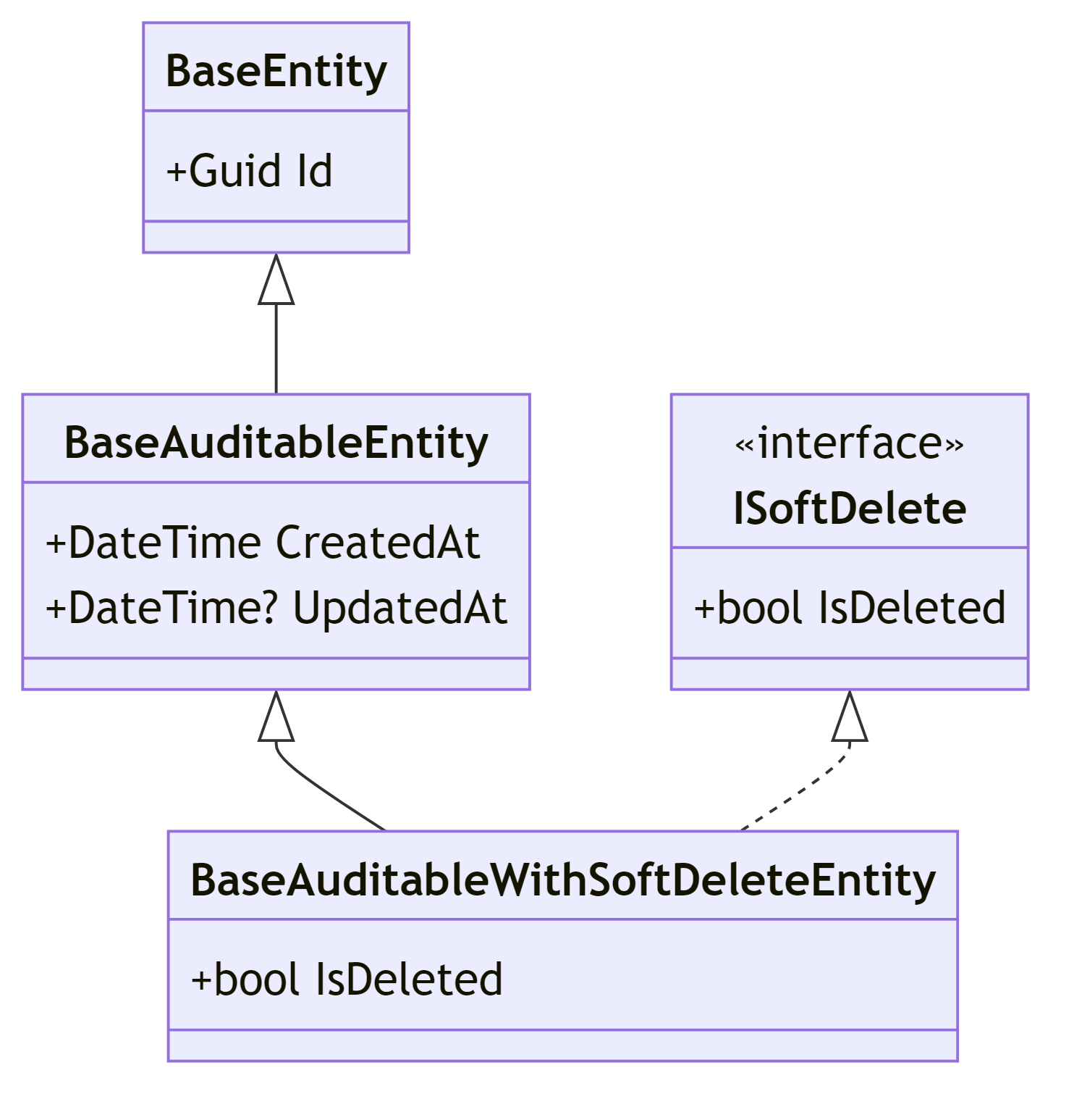

Design Decision: The three-tier inheritance hierarchy allows entities to opt into auditing and soft-delete behavior independently. Entities implementing ISoftDelete receive automatic global query filters in Entity Framework Core, ensuring soft-deleted records are transparently excluded from all queries without manual filtering.

Core Entities
Entity | Base Class | Purpose
User | BaseAuditableEntity | Domain user profile linked to ASP.NET Identity
Listing | BaseAuditableWithSoftDeleteEntity | Car listing with vehicle specs, pricing, and status
Make | BaseAuditableEntity | Car manufacturer (bilingual: English/Arabic)
Model | BaseAuditableEntity | Car model belonging to a Make (bilingual)
ListingPhoto | BaseAuditableWithSoftDeleteEntity | Photo attached to a listing
ConditionChecklistCategory | BaseAuditableEntity | Category grouping for condition defects
ConditionDefect | BaseAuditableEntity | Individual defect item within a category
ListingDefect | BaseEntity | Junction: links a listing to its reported defects
PricingHistory | BaseEntity | Audit trail of price changes (seller + ML)
ListingStatusHistory | BaseEntity | Audit trail of listing status transitions
AdminActivityLog | BaseEntity | Audit trail of administrative actions
RefreshToken | BaseAuditableEntity | Hashed refresh tokens per user/device
Favorite | BaseAuditableEntity | User's favorited listing (unique per user+listing)

3.1.2 Relationship Explanations
User → Listing (One-to-Many): A user (seller) can own multiple listings. Each listing has a SellerId foreign key referencing the User table. Additionally, listings track ApprovedByAdminId as a separate nullable FK to the admin who approved it.
Make → Model (One-to-Many): Each car make (e.g., "Toyota") contains multiple models (e.g., "Camry", "Corolla"). Models have a MakeId FK with a cascade relationship.
Listing → Make/Model (Many-to-One): Each listing references exactly one Make and one Model. The system validates that the selected Model belongs to the selected Make during creation and updates.
ConditionChecklistCategory → ConditionDefect (One-to-Many): Categories group related defects (e.g., "Engine" category contains "Oil Leak", "Overheating" defects). Both entities support bilingual names.
Listing ↔ ConditionDefect (Many-to-Many via ListingDefect): The ListingDefect junction table records which defects a seller has reported for their vehicle. Each record includes an AppliedAt timestamp.
Listing → ListingPhoto (One-to-Many): A listing can have multiple photos with IsPrimary and DisplayOrder fields for presentation control.
Listing → ListingStatusHistory (One-to-Many): Every status change (Draft→Pending→Active/Rejected→Sold/Archived) is recorded with old/new status, who changed it, reason, and timestamp.
Listing → PricingHistory (One-to-Many): Every price change (ML prediction updates or seller price sets) is recorded with old/new prices, old/new fair prices, who changed it, and reason.
User → RefreshToken (One-to-Many): Each user can have multiple refresh tokens (one per device). Tokens store hashed values, expiration, device info, and revocation status.
User → AdminActivityLog (One-to-Many): Admin actions (approve, reject, toggle user status) are logged with action type, target entity, and details.
User → Favorite (One-to-Many): A user can favorite multiple listings. Each Favorite has a UserId FK. A unique composite index on (UserId, ListingId) prevents duplicate favorites.
Listing → Favorite (One-to-Many): A listing can be favorited by multiple users. FavoriteConfiguration applies a query filter !Listing.IsDeleted to automatically exclude favorites pointing to soft-deleted listings.

3.1.3 Design Decisions
- Dual Database Context: The system uses two separate DbContext instances — AppDbContext for domain data and AppIdentityDbContext for ASP.NET Identity. This separation enforces the Clean Architecture boundary between domain logic and infrastructure.
- Separate User Entity: The domain User entity is distinct from ApplicationUser (Identity). They are linked by IdentityUserId, allowing the domain layer to remain independent of the Identity framework.
- Soft Delete with Global Query Filters: Entities implementing ISoftDelete automatically have HasQueryFilter(e => !e.IsDeleted) applied, ensuring deleted records are invisible to normal queries.
- Enum-based Fields: ListingStatus, FuelType, TransmissionType, ContactMethod, and EgyptLocation are stored as integer enums for type safety and database efficiency.
- Bilingual Support: Make, Model, ConditionChecklistCategory, and ConditionDefect all include both English and Arabic name fields (Name/NameAr), supporting the localization requirements.

3.1.4 Entity Relationship Diagram (ERD)
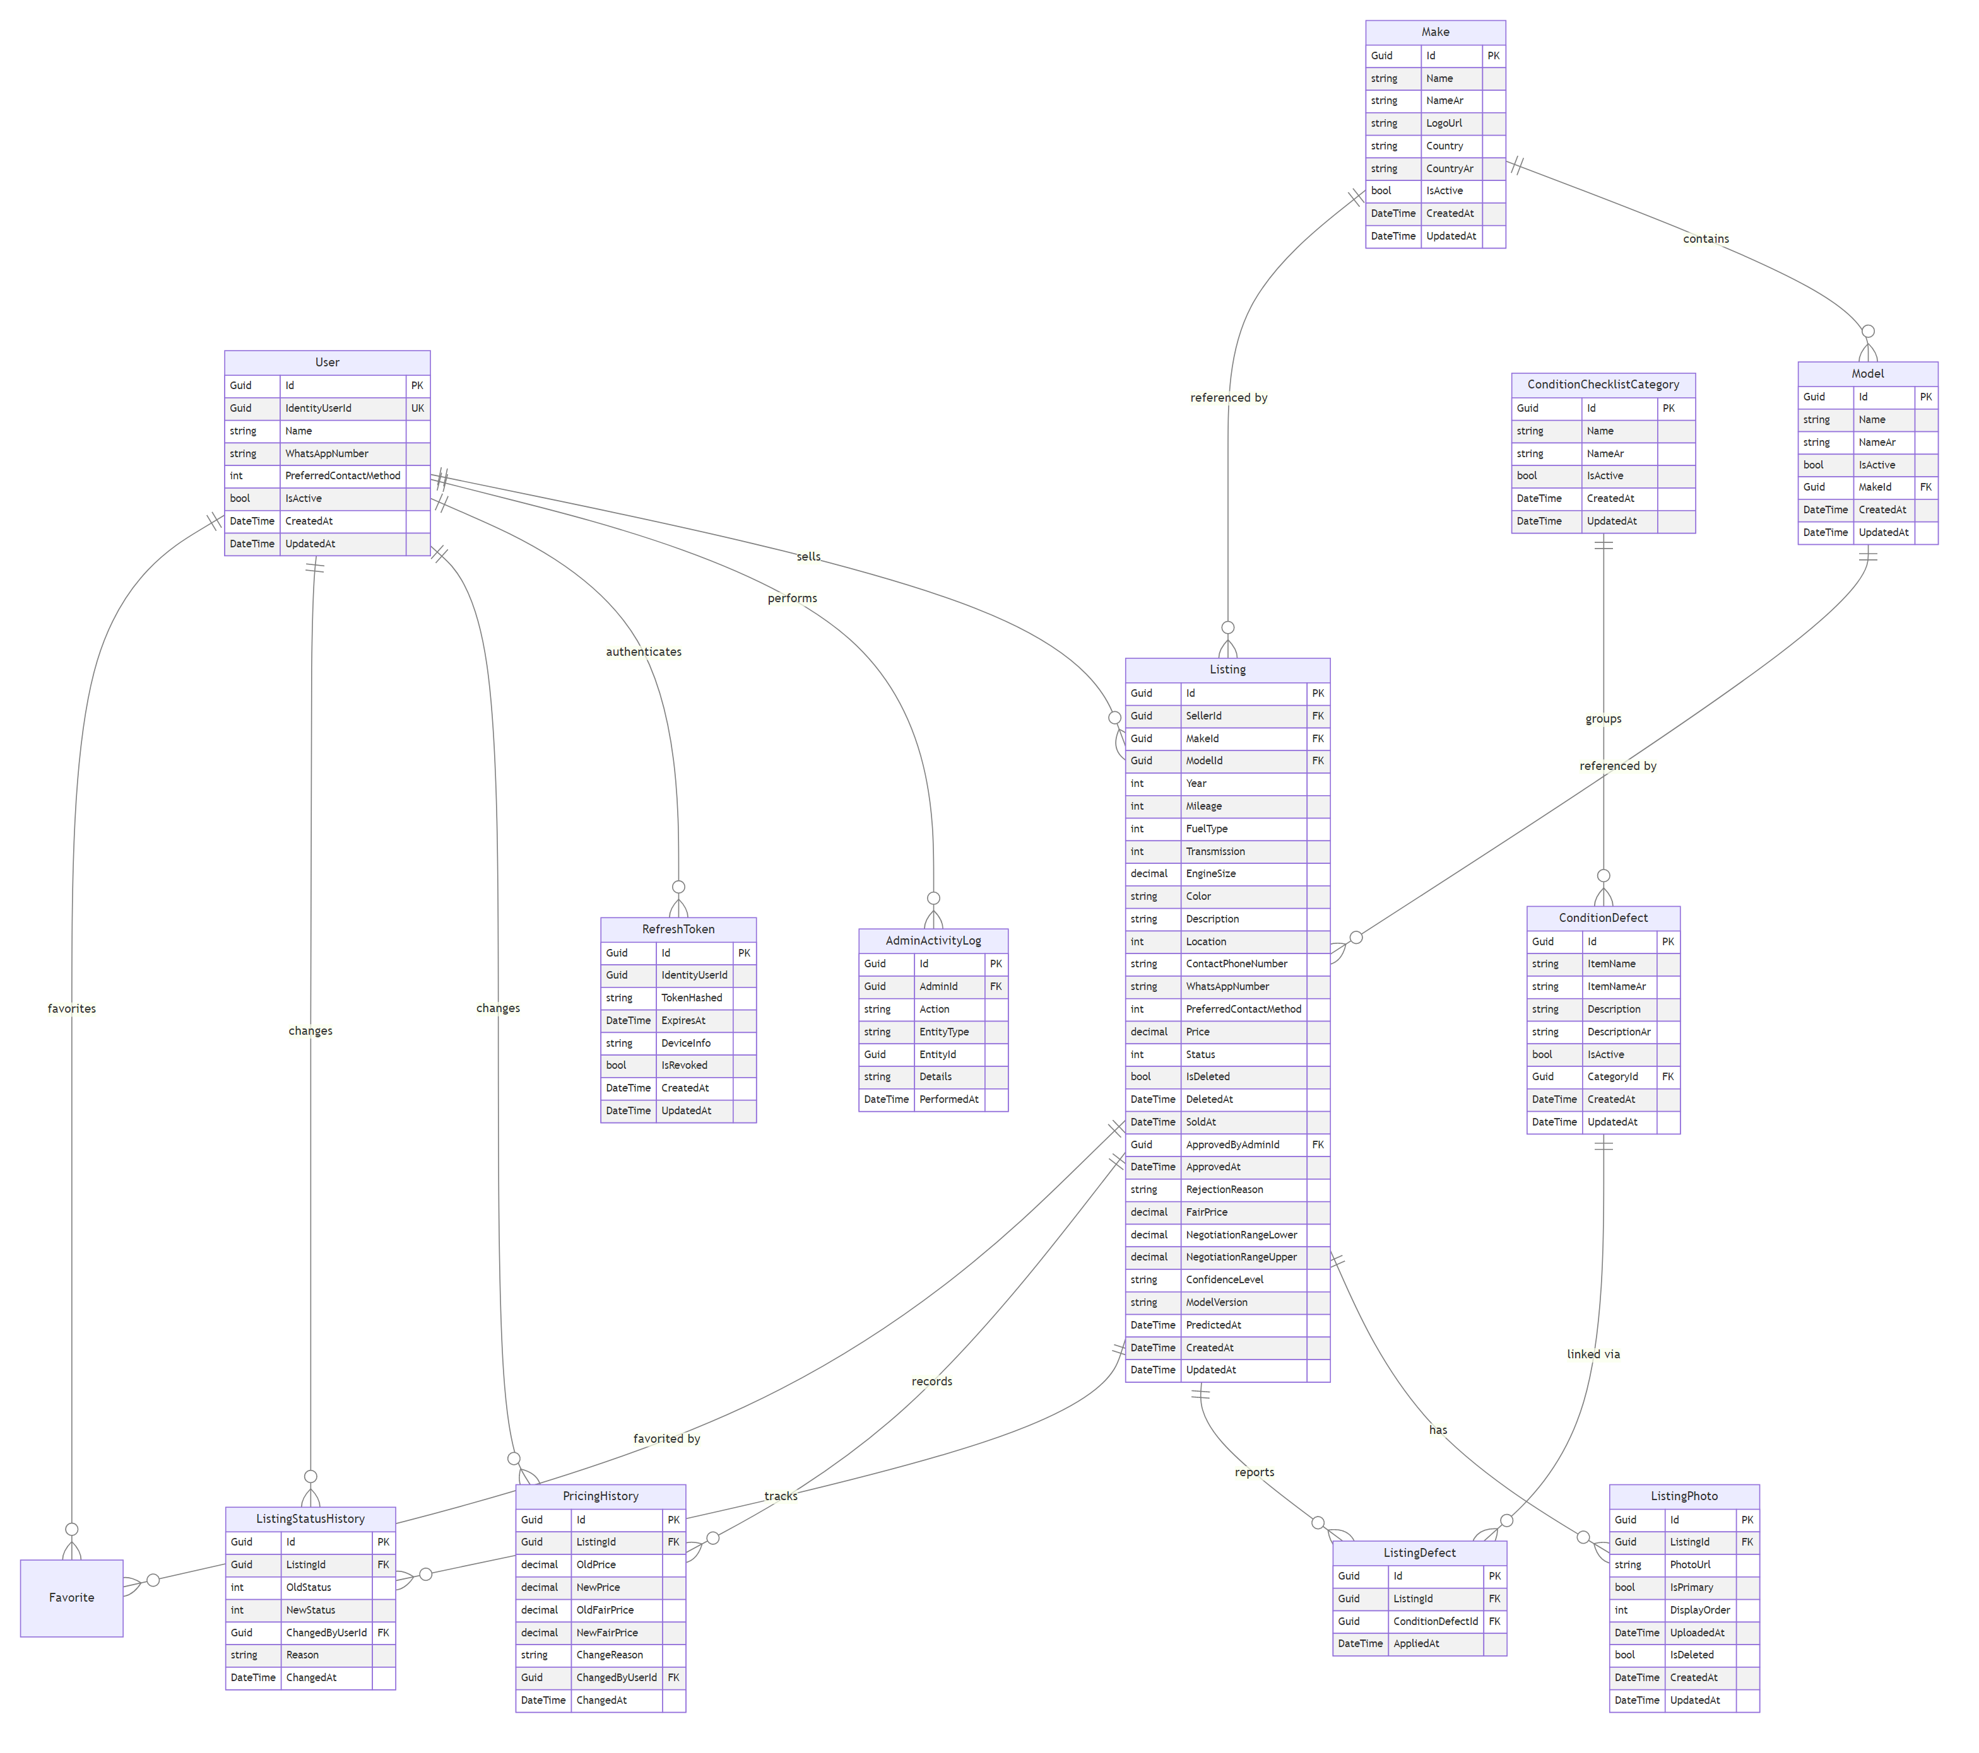

3.2 Use Case Diagram
3.2.1 Actor Descriptions
Actor | Description
Visitor | An unauthenticated user who can browse the marketplace, view listings, and register for an account
Buyer | An authenticated user (Role: "User") who browses listings, views details, and contacts sellers
Seller | An authenticated user (Role: "User") who creates, manages, and submits car listings for sale
Admin | An authenticated user (Role: "Admin") who manages the platform — approving/rejecting listings, managing users, and administering reference data
Note: In the implementation, Buyer and Seller share the same "User" role. Any authenticated user can both browse (buyer behavior) and create listings (seller behavior).

3.3 Sequence Diagram

3.3.1 User Registration
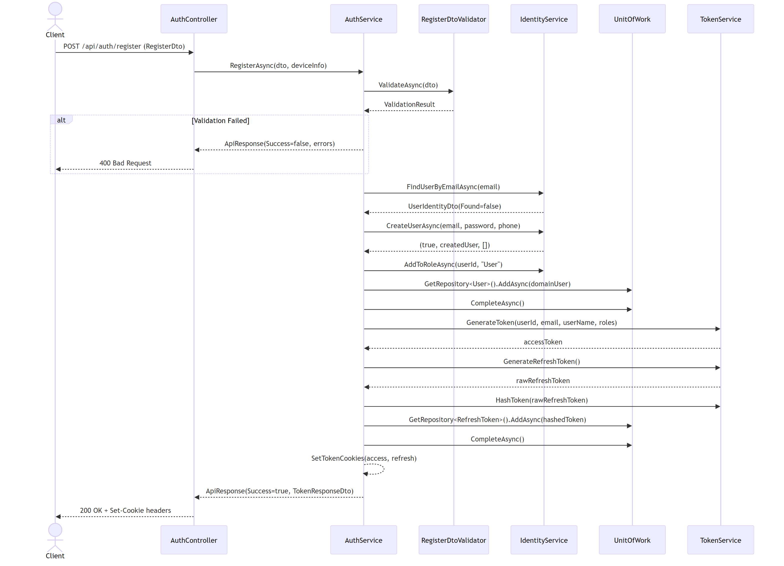

3.3.2 User Login
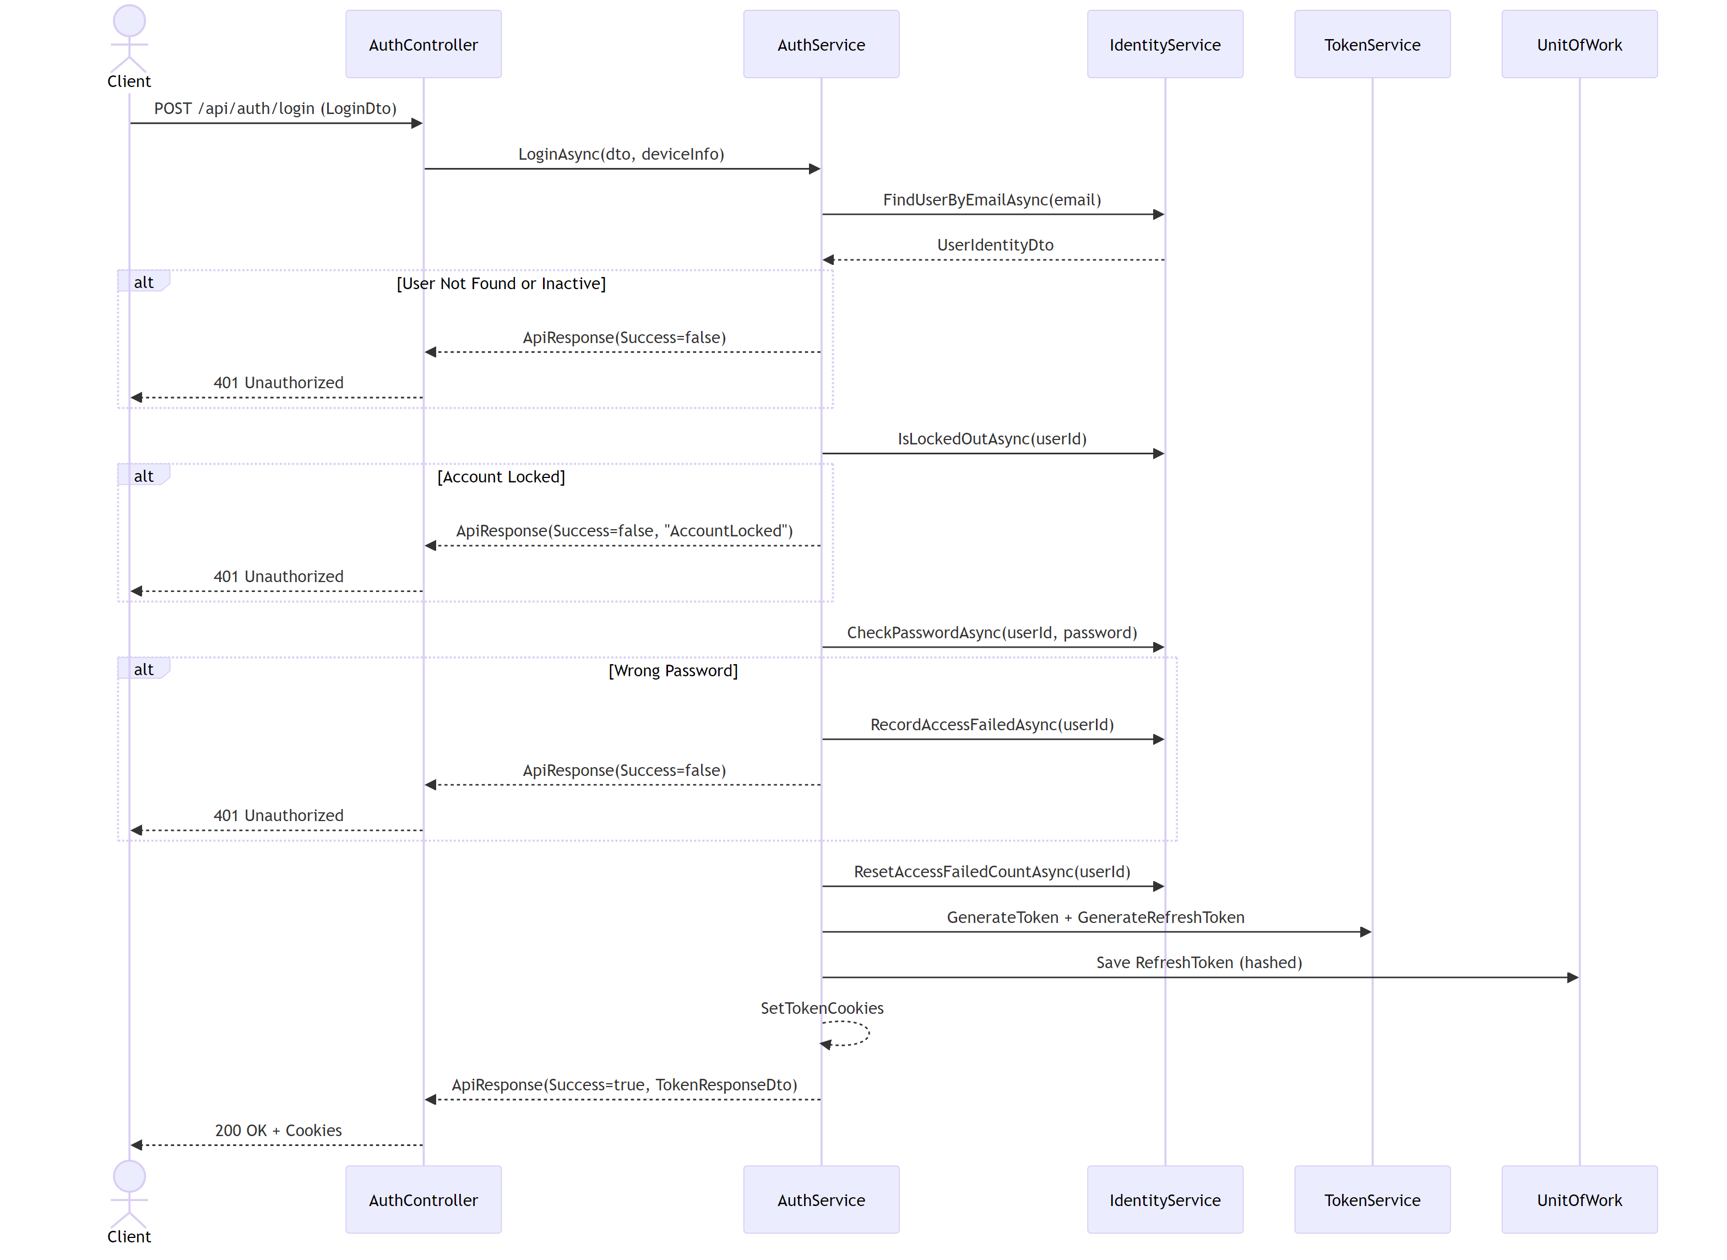

3.3.3 Create Listing
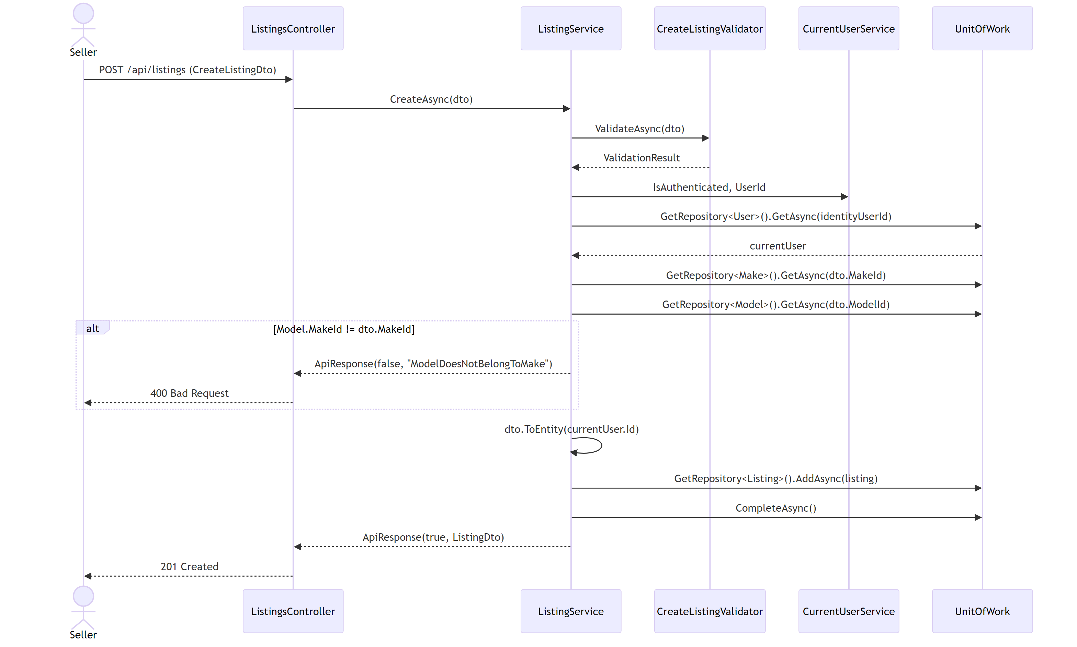

3.3.4 Generate Suggested Price
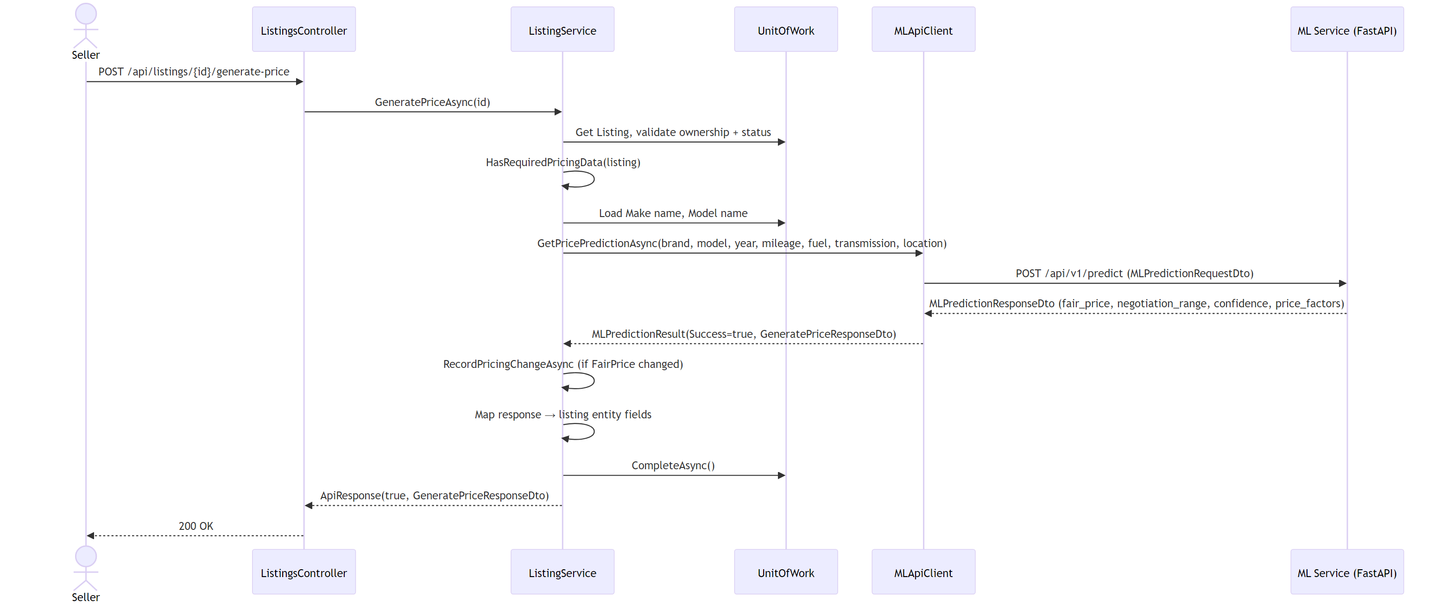

3.3.5 Submit Listing For Approval
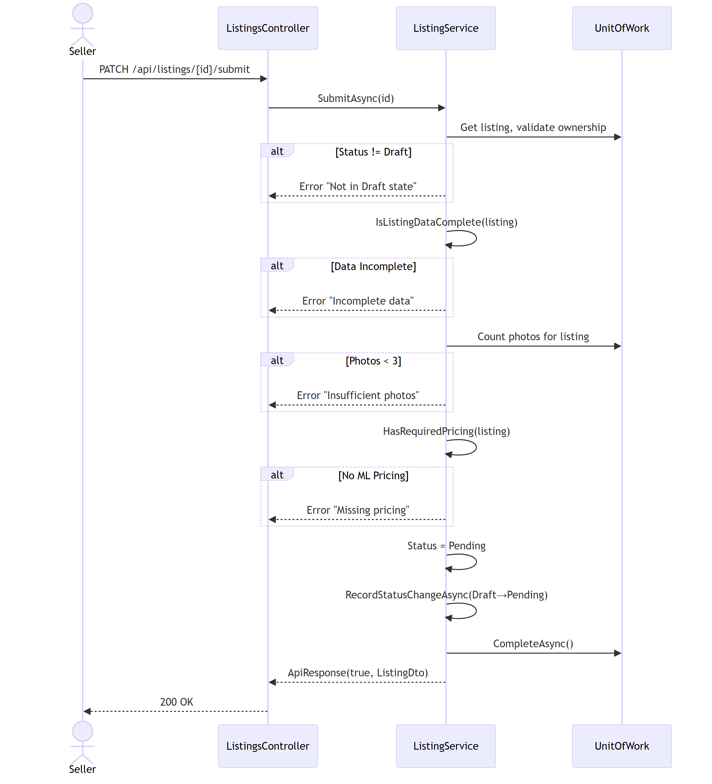

3.3.6 Approve Listing
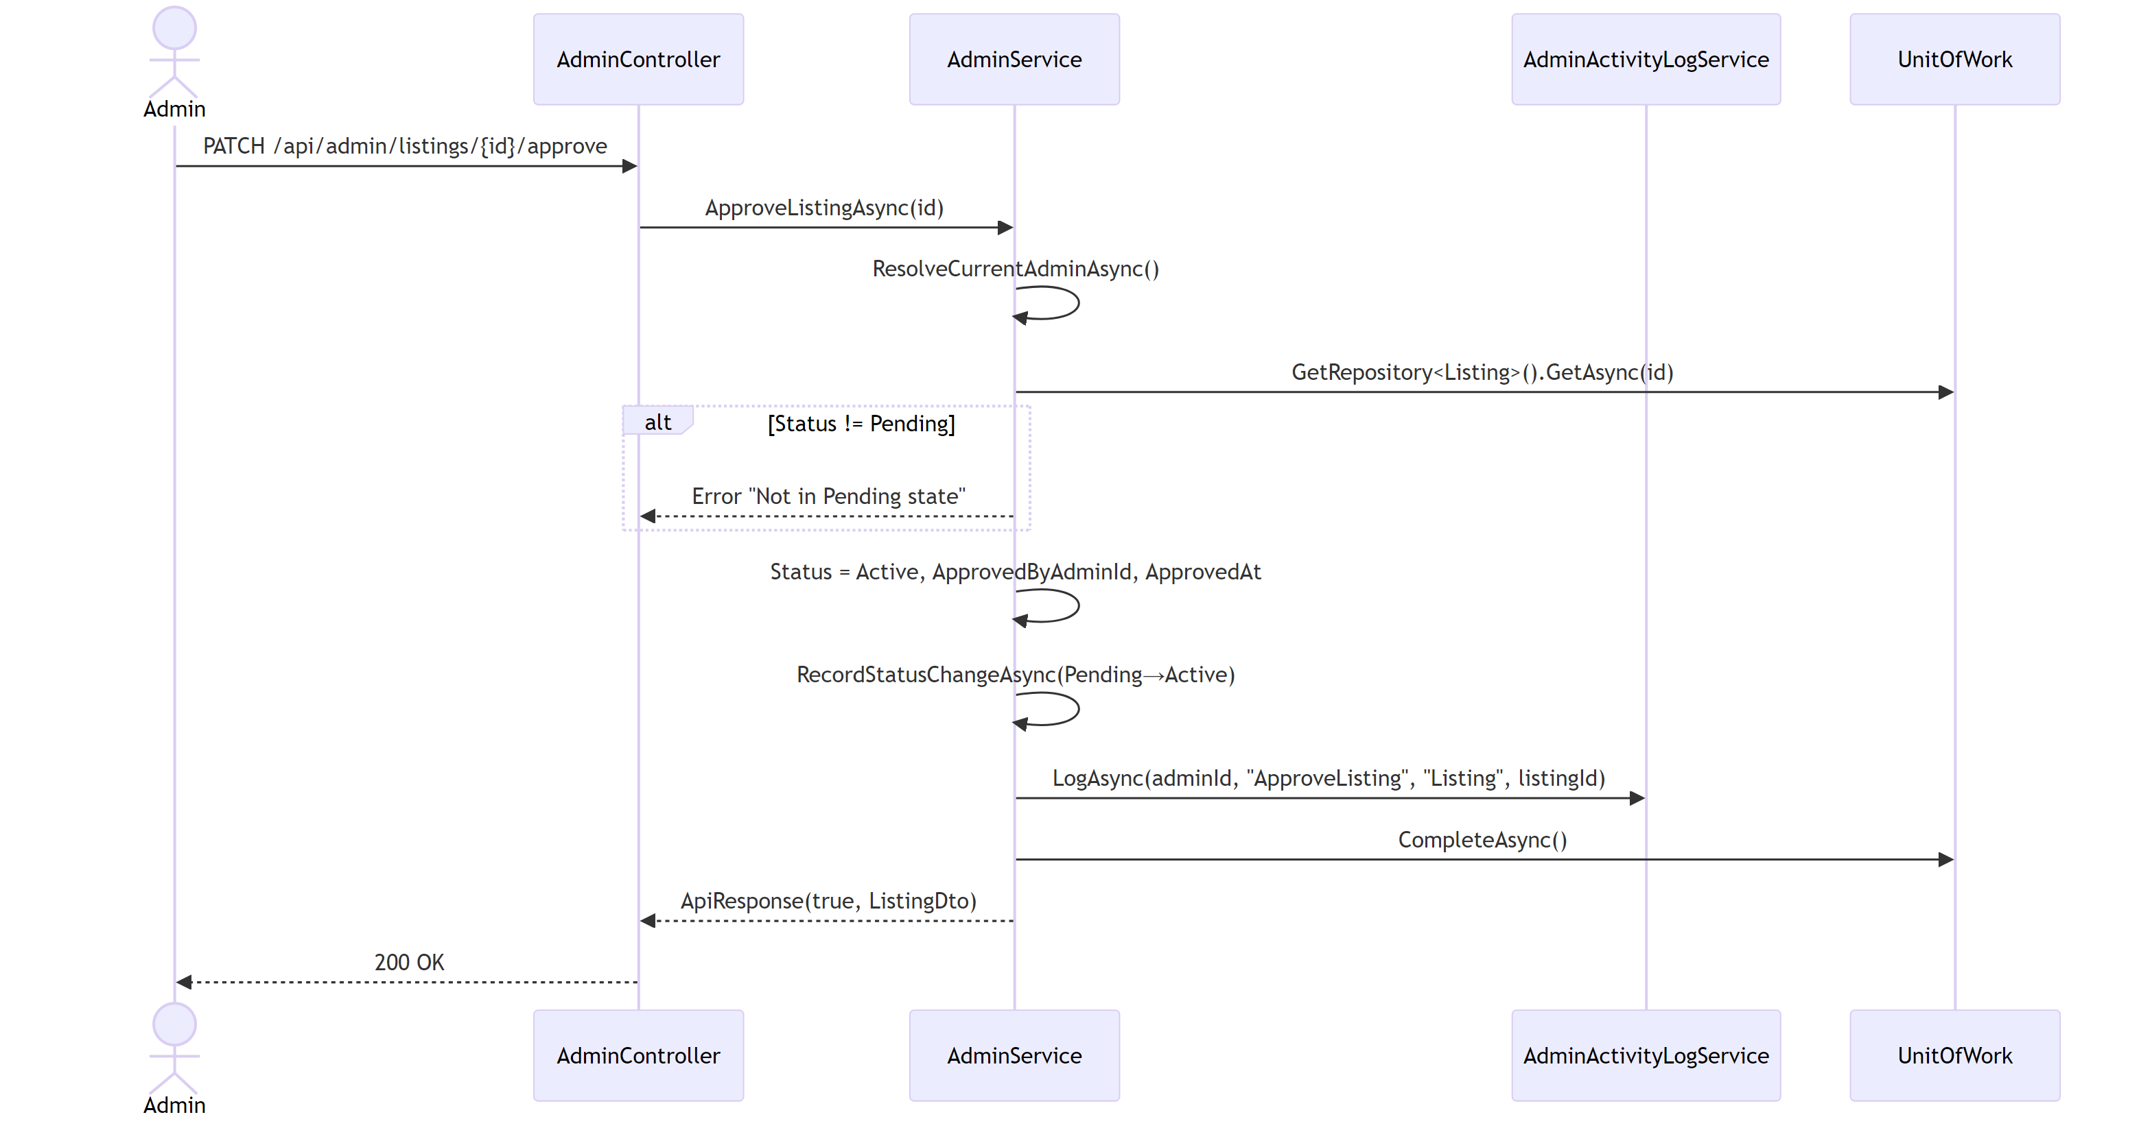

3.3.7 Reject Listing
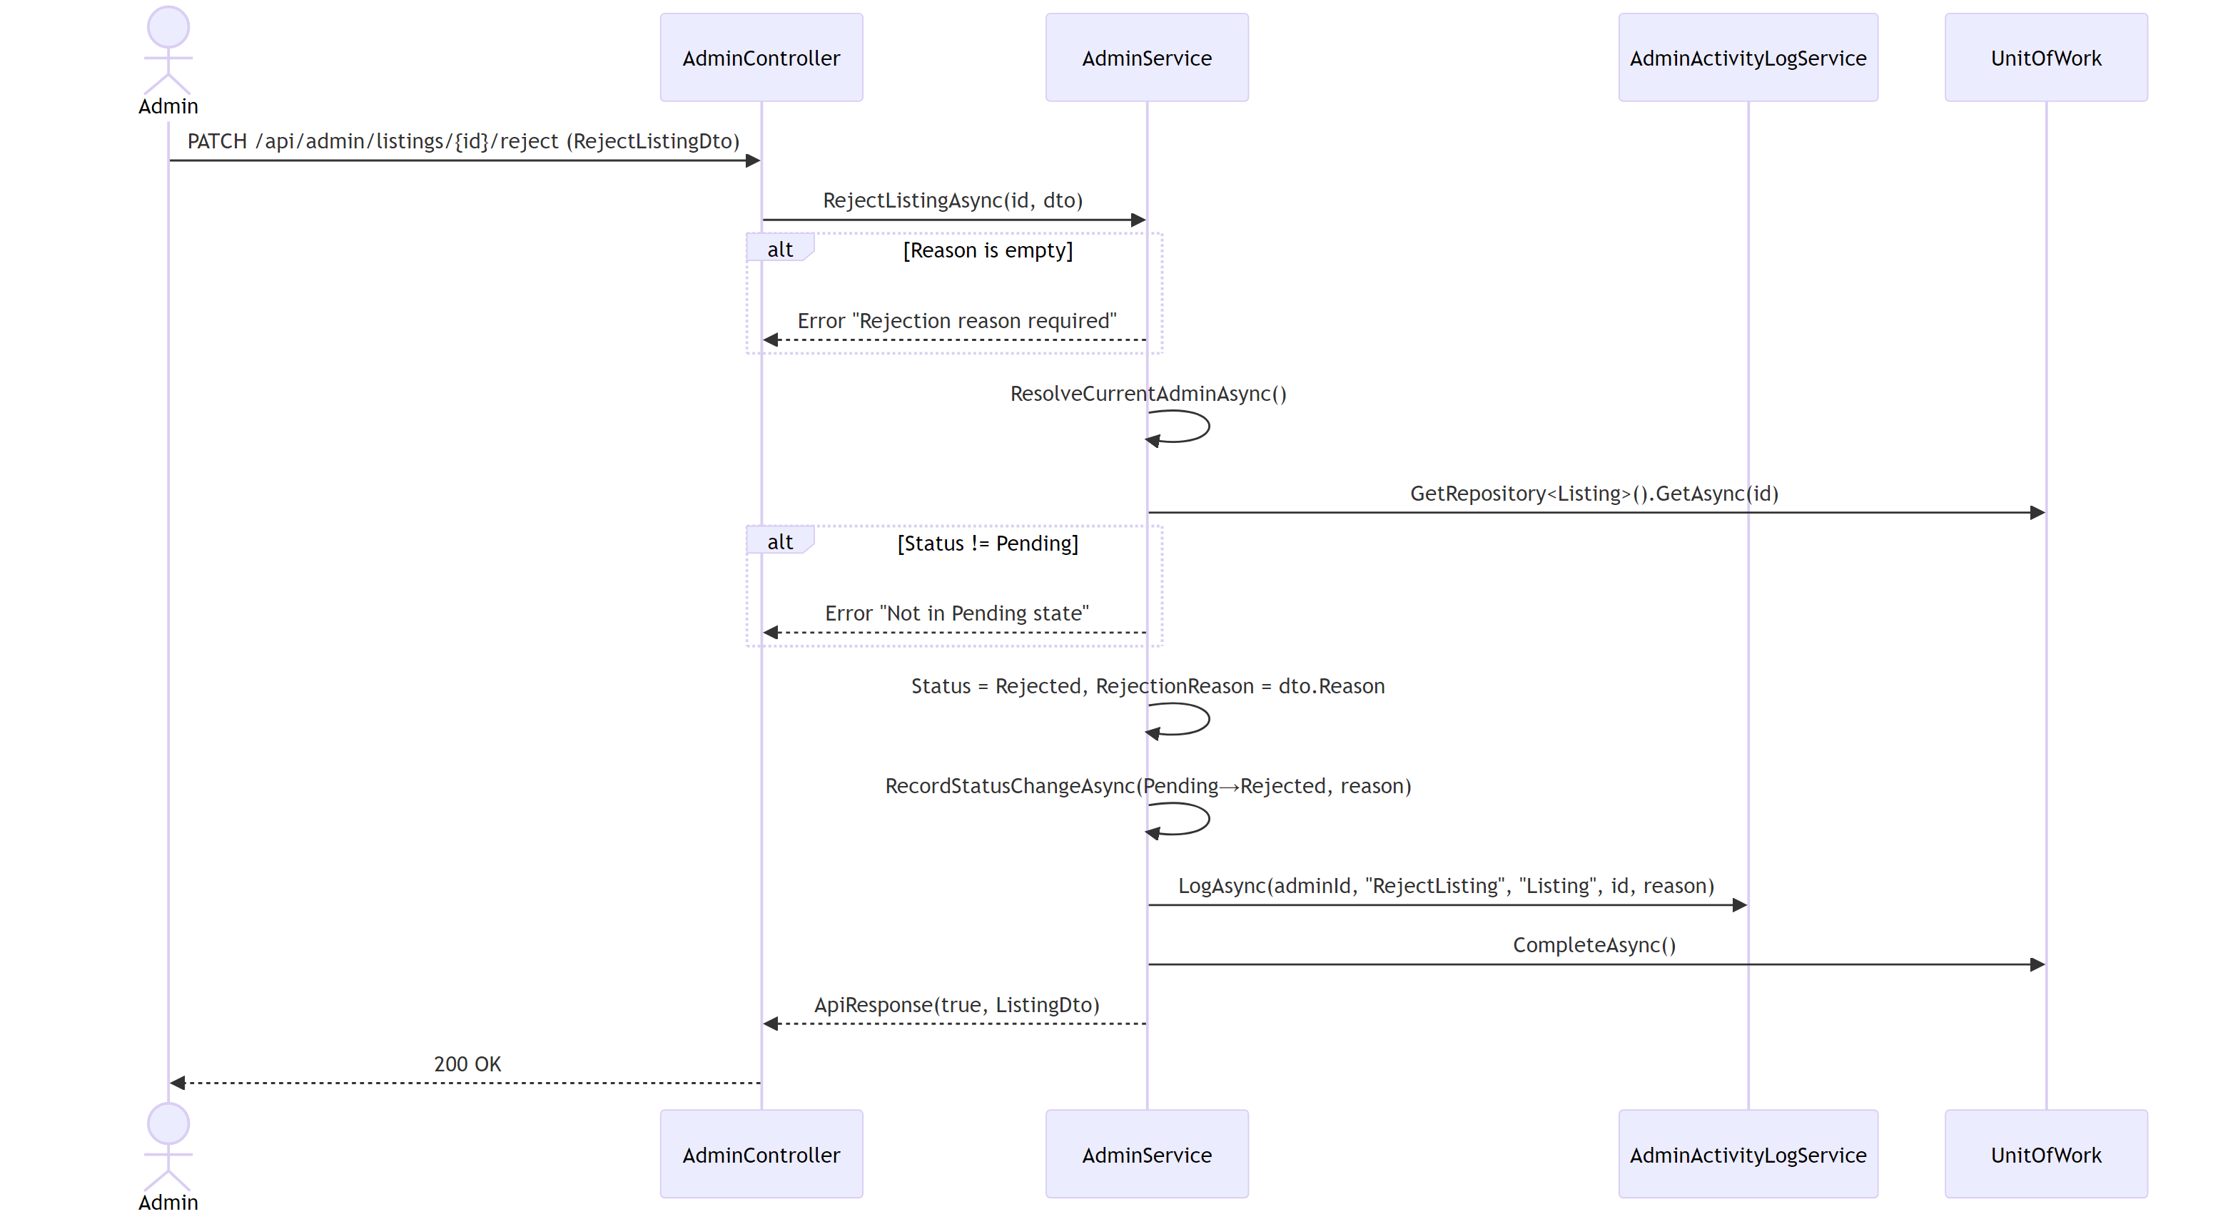

3.3.8 Browse Listings
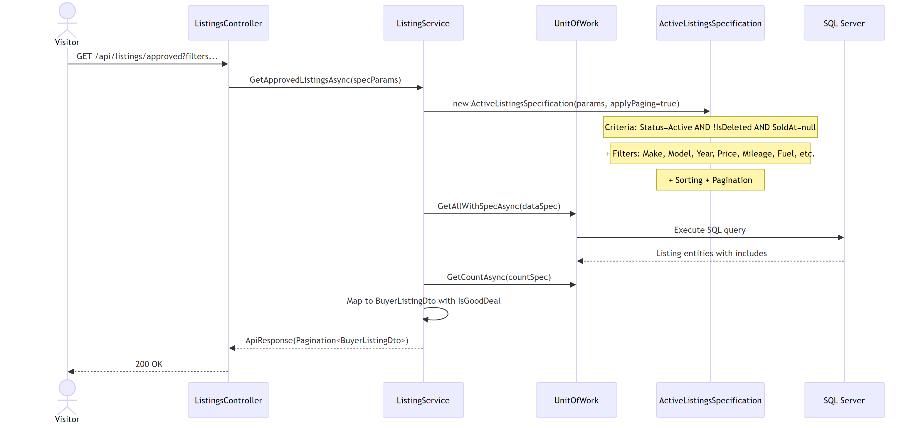

3.3.9 Add Favorite
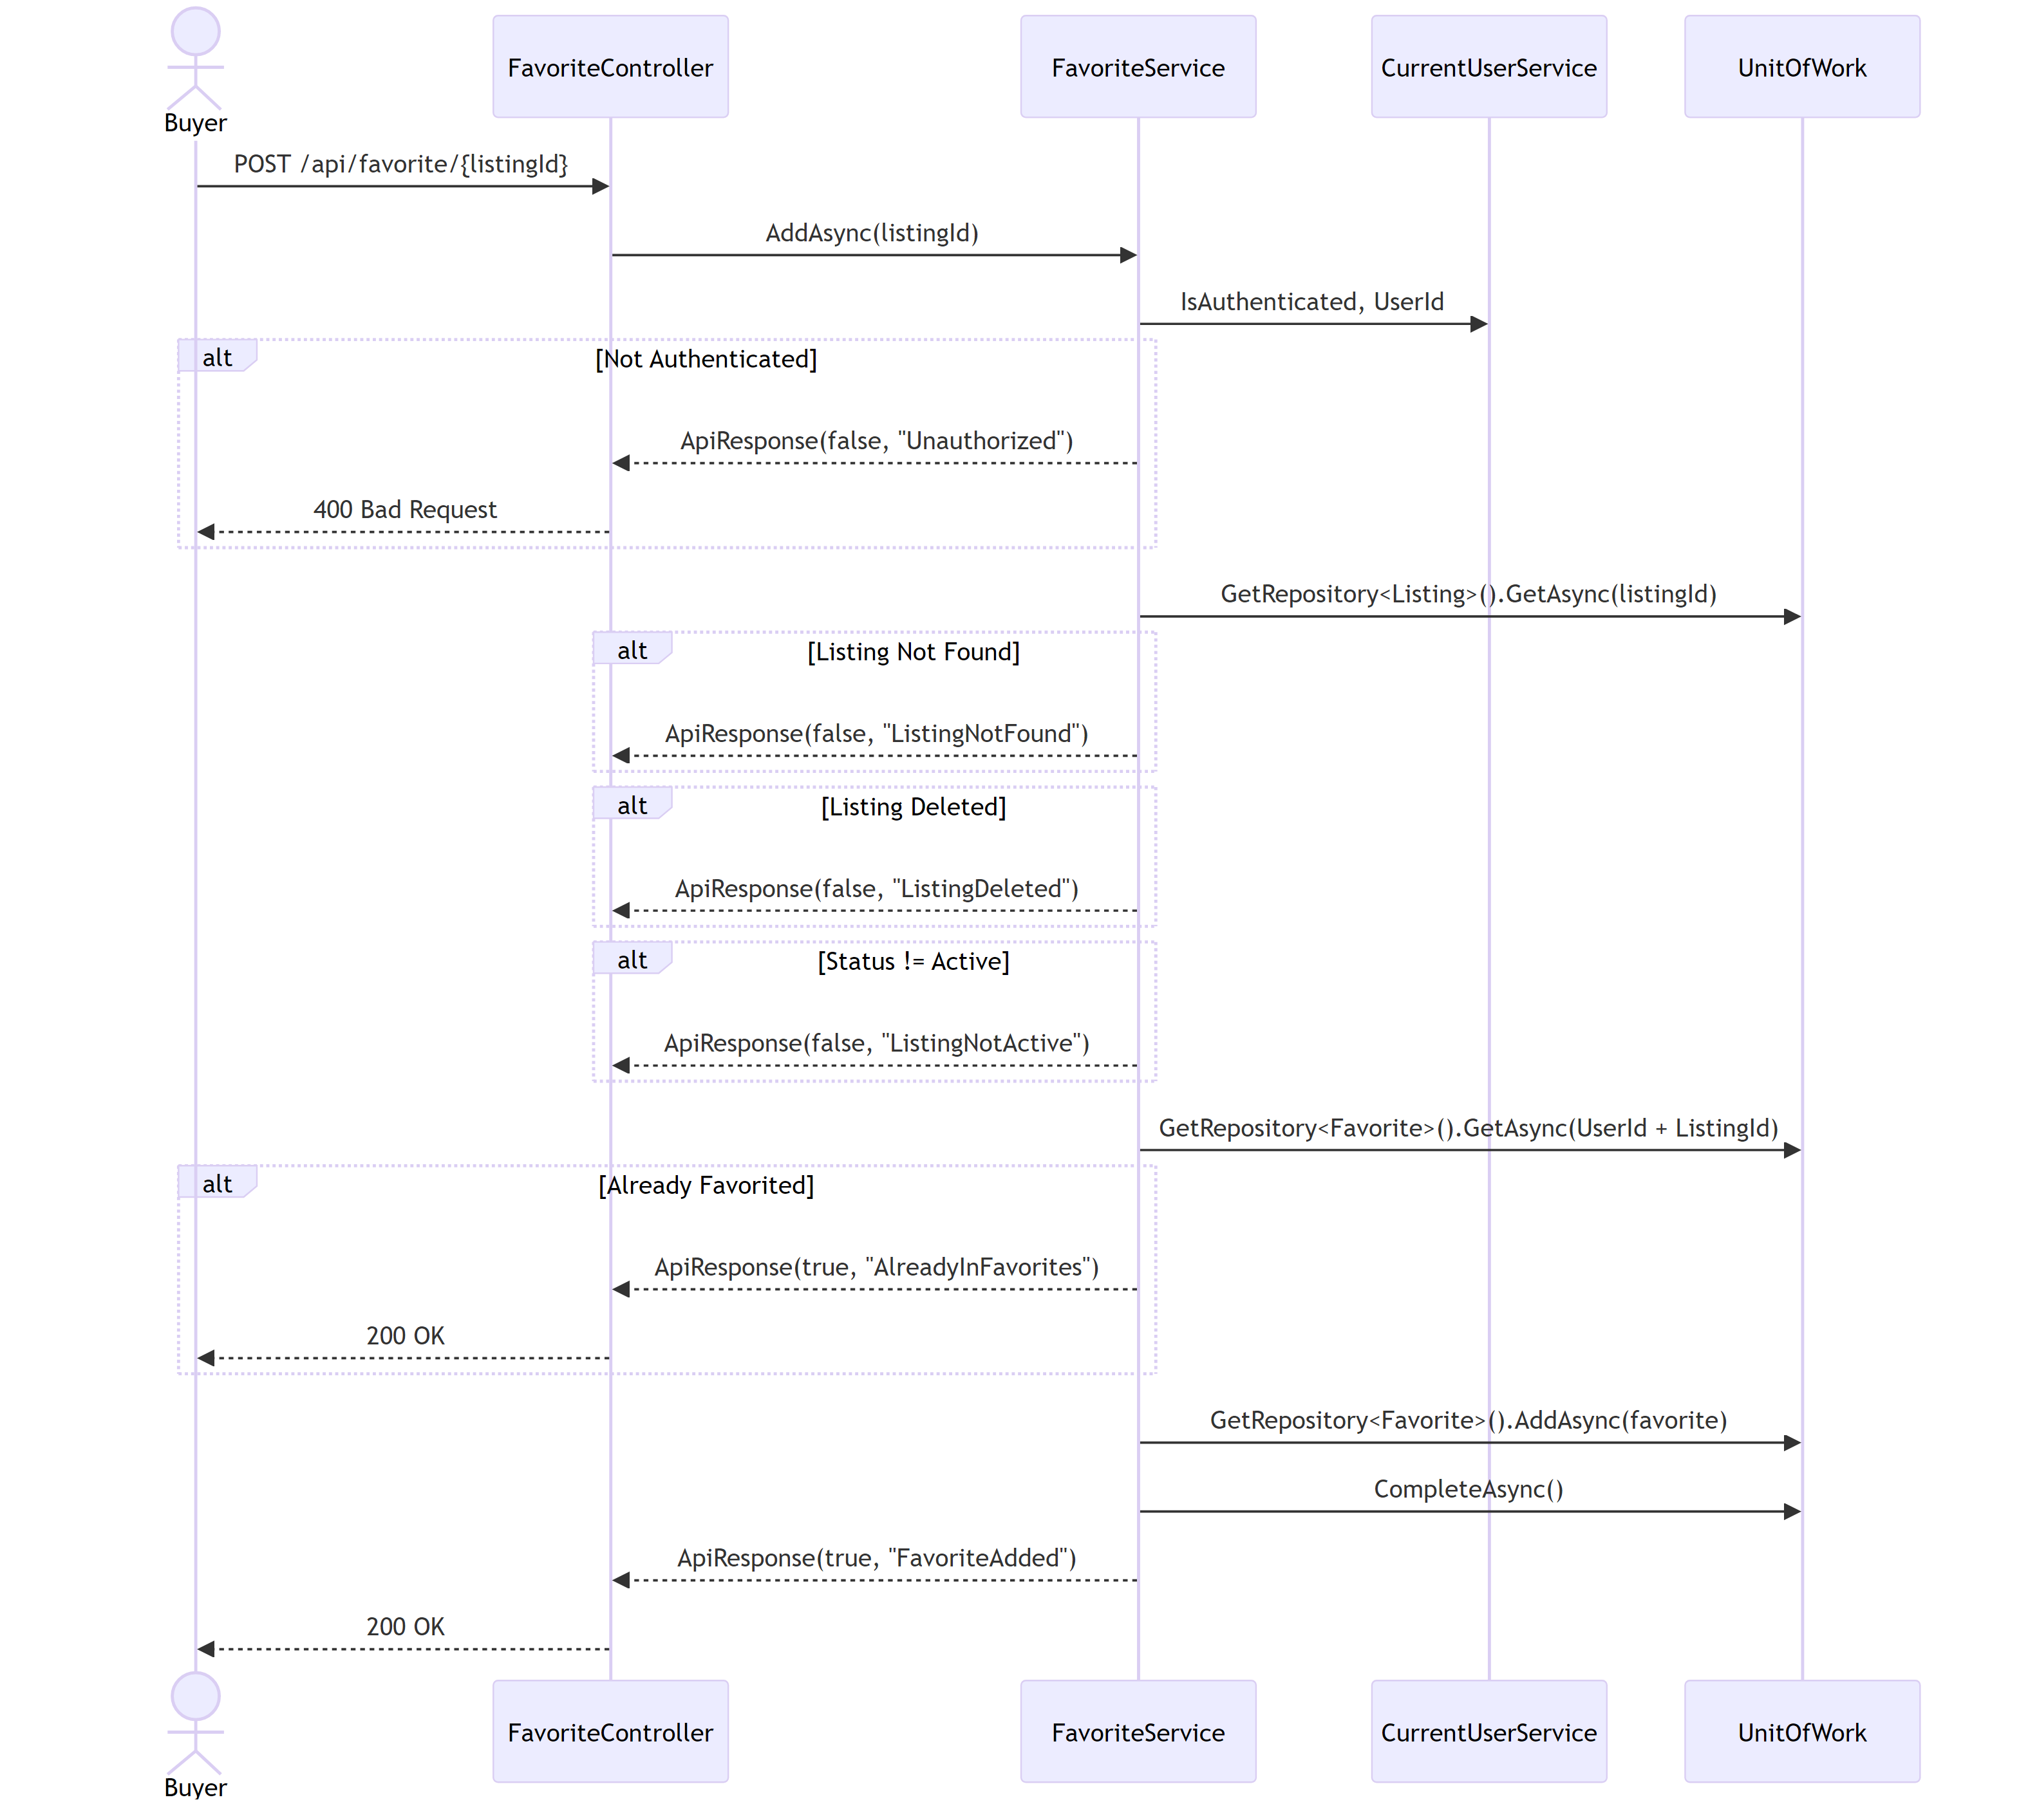

3.3.10 Remove Favorite
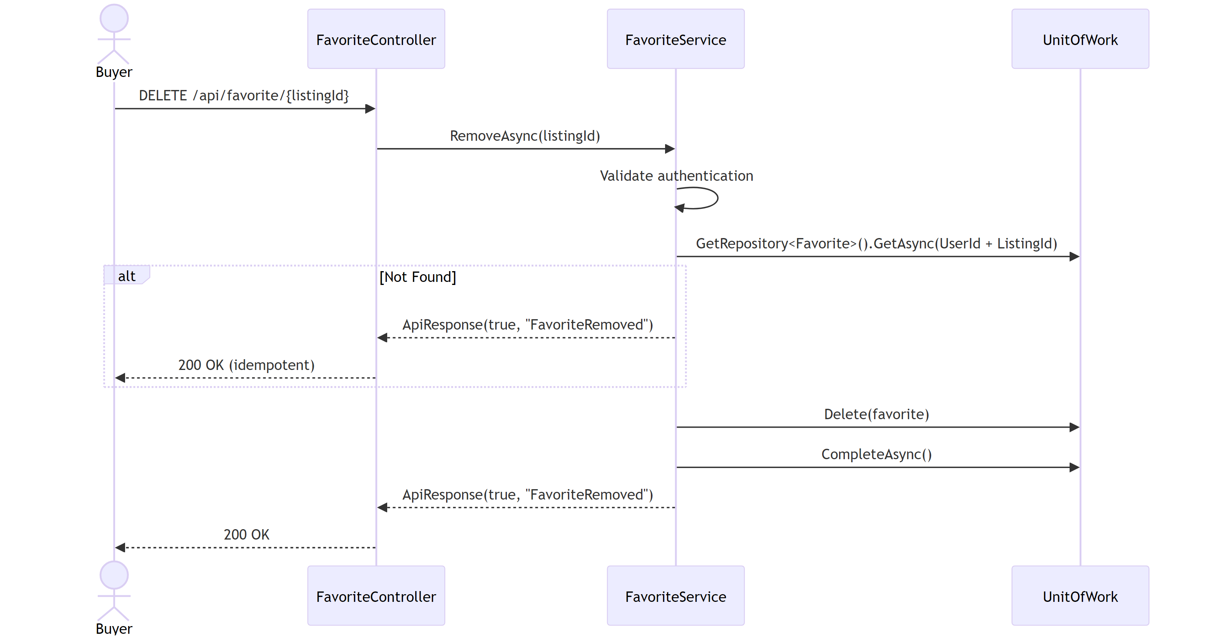

3.3.11 Get User Favorites
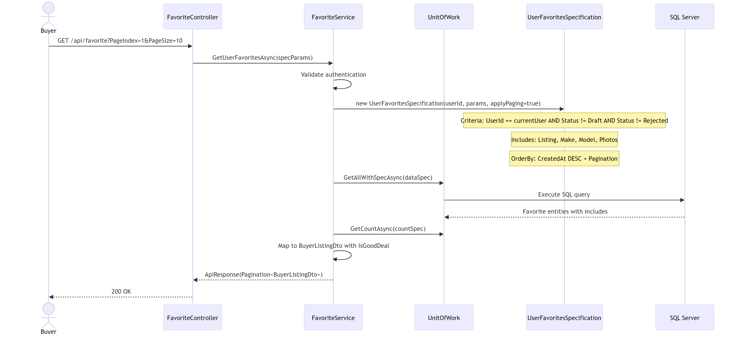

3.4 Activity Diagram
This section documents the five core user flows in the Karna frontend: Visitor, Buyer/User, Seller, Admin, and Chatbot UI. Each diagram models the sequence of UI actions and decisions a user makes within their role.

3.4.1 Visitor Flow
The visitor flow covers unauthenticated
users who arrive at the platform and either
browse public pages or proceed to
Registration.
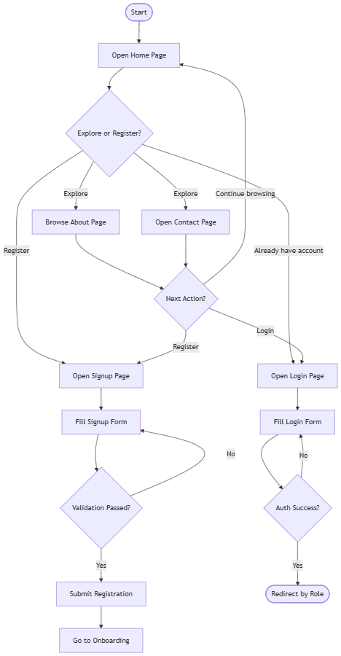

3.4.2 User (Buyer) Flow

The buyer flow covers logged-in users browsing the car feed and interacting with their profile.
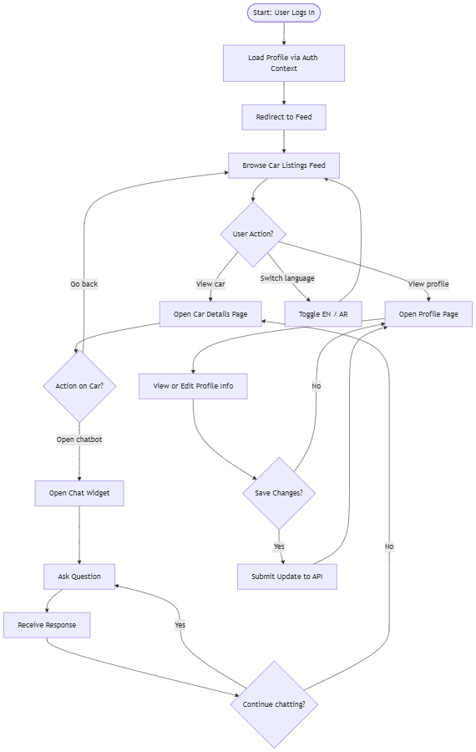

3.4.3 Admin Flow

The admin flow covers reviewing and managing pending listings, as well as managing makes, models, and condition data.
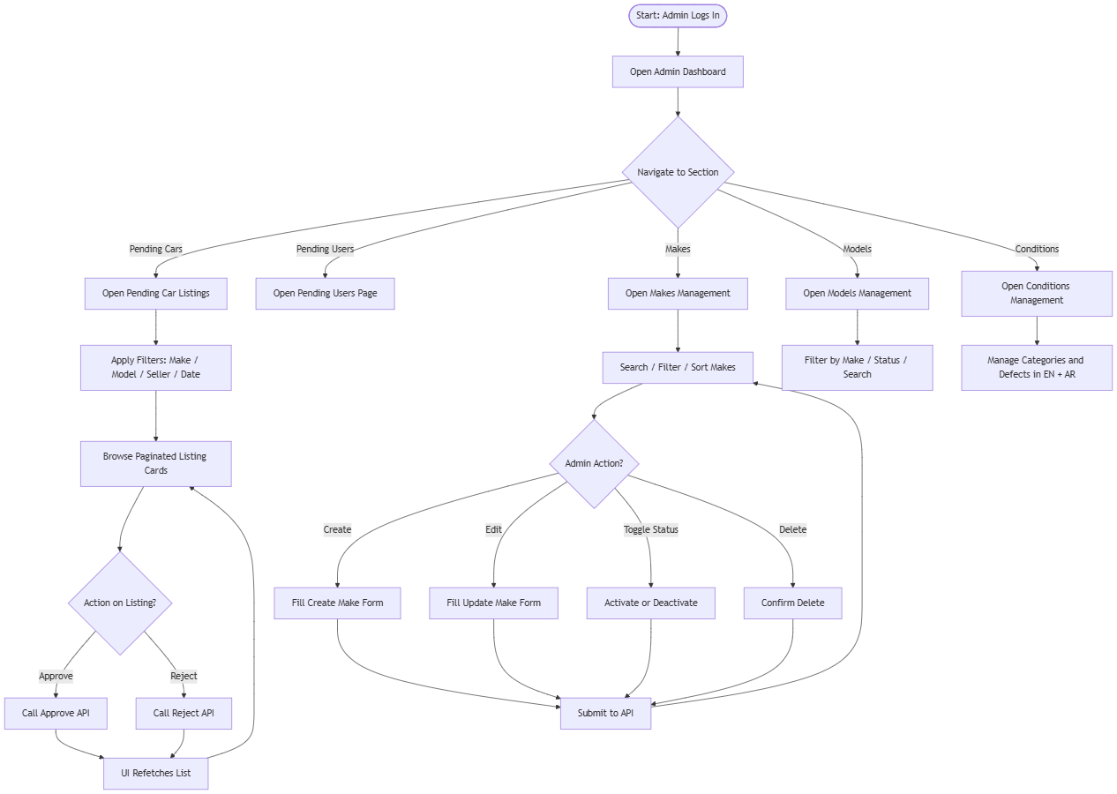

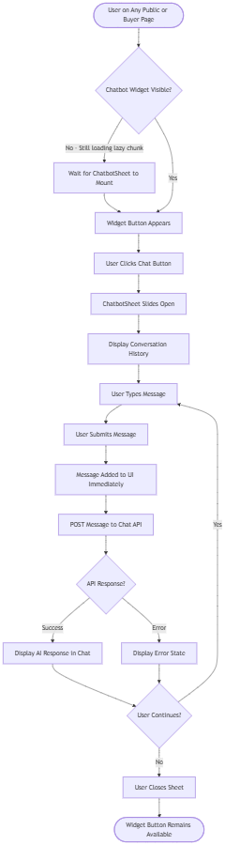
3.4.4 Chatbot UI Flow

The chatbot flow covers the UI-side

interaction from opening the chat widget to

sending and receiving messages.

Chapter 4: Implementation

4.1 Front-end Implementation

4.1.1 Client-Side Architecture

Overview
Karna's frontend is a role-based React Single-Page Application (SPA). It is designed to serve four distinct user experiences — public visitor, buyer, seller, and admin — within a single codebase, using route-level access control, shared UI primitives, and a unified API communication layer. The frontend is located at frontend/ in the project monorepo.

Technology Stack
Technology | Version / Notes | Purpose
React | 18+ | UI component model and rendering
TypeScript | Strict mode | Type safety across components, props, and API contracts
Vite | v5 | Dev server, hot reload, and production bundling
React Router | v6 | Client-side routing and nested route guards
Axios | Latest | HTTP client with interceptors and cookie support
i18next + react-i18next | Latest | English/Arabic translation and language switching
Tailwind CSS | v4 | Utility-first styling with design token integration
@gp/design-system | Local package | Shared component library, tokens, and Storybook
TanStack Query | v5 | Server state and caching (configured, partially adopted)

Why Each Technology Was Chosen
React was chosen because it enables the application to be built from reusable, composable UI components. It supports dynamic user interaction, such as form state, page transitions, and live data without requiring full page reloads.
TypeScript was chosen to make the codebase safer and easier to maintain at scale. API response types, form DTOs, component props, and route guards are all typed, which reduces runtime errors and makes backend/frontend contracts explicit in code.
Vite was chosen for its fast development server startup, near-instant hot module replacement, and modern bundling capabilities. It integrates cleanly with TypeScript and React and simplifies production build configuration.
React Router was chosen because the application requires multiple distinct pages grouped by user role. React Router's nested routes and route element wrapping make it straightforward to apply role-based access control at the layout level.
Axios was chosen because it supports request and response interceptors, works well with withCredentials for cookie-based authentication, and makes the refresh-token retry pattern easy to implement centrally.
i18next was chosen because it has strong React support, handles language detection from multiple sources, supports namespace-based translation files, and integrates cleanly with runtime language switching between English and Arabic.
Tailwind CSS v4 was chosen for fast utility-class-based styling that integrates with the design system's CSS variable tokens, avoiding the need for many separate component-level CSS files.
@gp/design-system is a local package (packages/design-system) built in the monorepo. It provides shared, brand-consistent components, design tokens, and dark-mode support across all pages. It is covered in detail in Section 4.3.

Project Structure
frontend/
docs/
public/
src/
actions/
components/
context/
data/
examples/
hooks/
lib/
locales/
pages/
types/
App.tsx
index.css
main.tsx
index.html
package.json
vite.config.ts
eslint.config.js
tsconfig.json
tsconfig.app.json
tsconfig.node.json

Entry Point — src/main.tsx
- main.tsx is the application entry point. It sets up the following providers around the entire app:
- QueryClientProvider : exposes TanStack Query to the component tree
- BrowserRouter: enables client-side routing
- The QueryClient: is configured with:
- 5-minute stale time data is not considered stale immediately after fetch
- 10-minute garbage collection unused cached data is held before disposal
- No refetch on window focus prevents unnecessary requests when switching tabs
- One retry failed requests retry once before surfacing an error
- No refetch on mount avoids redundant re-fetching when components remount
This configuration reduces unnecessary network activity and prepares the app for progressively adopting React Query for server state management.

Application Shell: src/App.tsx
- App.tsx defines the entire route tree and wraps it with global providers:
- ErrorBoundary: catches unhandled React rendering errors
- AuthProvider: provides authentication state to all routes
- Suspense: shows a PageLoader while lazy-loaded page chunks download

All major pages are lazy-loaded using React.lazy(). This means:
- The initial JavaScript bundle is smaller
- dmin, seller, buyer, and public pages are downloaded only when visited
- Route splitting happens automatically per user role

Global toast notifications are rendered here with position adapted to the current language direction (top-right for English, top-left for Arabic).

Routing Structure
Routes are grouped by product area using React Router's element-based nesting.
/ → Home (public, inside Layout)
/about → About (public, inside Layout)
/contact → Contact (public, inside Layout)
/login → Login (GuestRoute — redirects if authenticated)
/signup → Signup (GuestRoute — redirects if authenticated)
/onboarding → Onboarding (authenticated)
/profile → Profile (PrivateRoute — all authenticated users)
/feed → Feed (PrivateRoute — all authenticated users)
/cars/:id → Car Details (PrivateRoute — all authenticated users)
/seller → Seller Dashboard (PrivateRoute — role: user)
/seller/listings → My Listings (PrivateRoute — role: user)
/seller/add-listing → Add Listing Wizard (PrivateRoute — role: user)
/admin → Admin Dashboard (PrivateRoute — role: admin)
/admin/users-pending → Pending Users (PrivateRoute — role: admin)
/admin/cars-pending → Pending Cars (PrivateRoute — role: admin)
/admin/makes → Makes Management (PrivateRoute — role: admin)
/admin/models → Models Management (PrivateRoute — role: admin)
/admin/conditions → Conditions Management (PrivateRoute — role: admin)
Public routes use Layout.tsx, which wraps every page with a Navbar, Footer, and the lazily-loaded chatbot widget.
Guest routes use GuestRoute, which redirects already-authenticated users away from login and signup pages.
Protected routes use PrivateRoute, which accepts an optional allowedRoles prop. If the current user's role does not match, they are redirected to an appropriate fallback.
Page Organization by Role: Pages are physically grouped in src/pages/ by role using route-group folder naming:
src/pages/
(public)/ → home, about, contact
(auth)/ → login, signup
(buyer)/ → feed, car details, profile
(seller)/ → seller dashboard, listings, add-listing
(admin)/ → admin dashboard, pending cars, pending users,
makes, models, conditions
This grouping makes it immediately clear which pages belong to which user role and makes the codebase easier to navigate and reason about.
Shared Components: Shared UI components in src/components/ are used across multiple page groups
Component | Purpose
Layout.tsx | Public page shell — Navbar, outlet, Footer, lazy Chatbot
Navbar.tsx | Top navigation with language switcher and auth state
Footer.tsx | Site-wide footer
PrivateRoute.tsx | Protects routes by auth state and optional role
GuestRoute.tsx | Redirects authenticated users away from auth pages
LanguageSwitcher.tsx | Toggles between English and Arabic at runtime
ChatbotSheet.tsx | Sliding chat UI panel, lazily mounted
ErrorBoundary.tsx | Catches rendering failures globally
onboarding/FavoriteModelsSlide.tsx | Onboarding step for selecting preferred car makes
Language Switching and RTL Handling
The frontend supports English and Arabic using i18next and react-i18next. Translation files are organized in namespaces:
src/locales/
en/
translation.json
common.json
ar/
translation.json
common.json
Language detection order:
1. localStorage (cached from previous session)
2. Browser navigator.language
3. HTML lang attribute
When Arabic is active, the frontend:
- Sets document.dir = "rtl" and document.lang = "ar" on the HTML element
- The design system's html[lang="ar"] CSS rule switches to Tajawal font for correct Arabic typography
- Sidebar direction adapts to RTL layout
- Toast notifications move to top-left
- All layout uses Tailwind's logical properties (ms-, me-, ps-, pe-) instead of directional classes (ml-, mr-) so the layout mirrors correctly in both directions
- Admin data (condition categories, defects) includes both English and Arabic values. The frontend API clients fetch both language versions and merge them by record ID so admins can manage bilingual content in a single unified view.
Authentication State Handling
Authentication is handled through HttpOnly cookies set by the backend. The frontend never stores tokens manually in localStorage or JavaScript variables.
`src/context/AuthContext.tsx` stores:
- user: the authenticated user object including role
- isLoading: whether the initial profile check is in progress
- setUser / clearUser: controlled state setters
On app load, AuthContext calls getProfile(). If the backend session is still valid, the user is populated. If not, the user remains null and protected routes redirect to /login.
`src/lib/api.ts` owns the shared Axios instance. It configures
- withCredentials: true — instructs the browser to include HttpOnly cookies on every request
- Accept-Language header — set dynamically to the current language for localized API responses
- A 401 response interceptor that:
- 1. Checks whether the request has already retried once
- 2. Calls POST /api/auth/refresh-cookie to attempt token renewal
- 3. Queues any parallel failing requests while refresh is in progress
- 4. Retries the original request after a successful refresh
- 5. Clears auth state and redirects to /login if refresh fails
This means users are not logged out the moment an access cookie expires the refresh happens silently in the background.
Axios API Integration Pattern
All backend communication is handled through domain-specific API client files in src/lib/. React components never call api.get() or api.post() directly — they call typed functions from these files.Example:
export const getAllMakes = (params?: MakeSpecParams) =>
api
.get<ApiResponse<PaginatedResponse<MakeDto>>>("/api/Makes/All", { params })
.then((r) => r.data);
Benefits of this pattern
- DTO types are co-located with their endpoint functions
- Components remain focused on UI logic
- Backend payload casing and URL changes are handled in one place
- API contracts are documented in code
:API client files
File | Responsibility
api.ts | Shared Axios instance — base URL, cookies, interceptors, refresh logic
authApi.ts | Login, register, logout, profile, update profile, change password
listingsApi.ts | Create, update, checklist, photos, generate price, set price, submit, approve, reject, delete
adminApi.ts | Pending listings, pagination, filters
makesApi.ts | Active makes, admin CRUD, activate/deactivate, logo URL formatting
modelsApi.ts | Active models, admin CRUD, make-filter, activate/deactivate
conditionChecklistCategoriesApi.ts | Active categories, admin CRUD, bilingual EN/AR merge
conditionDefectsApi.ts | Active defects, admin CRUD, category filter, bilingual EN/AR merge
lookupsApi.ts | Fuel types, transmission types, listing statuses, locations

Chatbot UI
The chatbot is implemented as ChatbotSheet.tsx — a sliding panel (Sheet component) mounted inside Layout.tsx.
It is lazy-loaded, meaning it is not included in the initial JavaScript bundle. The component is downloaded only when the user first visits a page that uses the public layout.
The chatbot:
- Appears as a persistent chat button on public and buyer pages
- Opens as an overlay panel using the Sheet component from the design system
- Sends user messages to the chat API and displays AI-generated responses
- Maintains conversation history within the session
- Uses formatMarkdown.tsx from src/lib/ to render structured AI responses

Performance Choices
Route-Level Lazy Loading: All major pages are lazy-loaded in App.tsx, producing a smaller initial JavaScript bundle and ensuring role-specific pages are only downloaded when actually visited.
Lazy Chatbot: ChatbotSheet is lazy-loaded in Layout.tsx so it does not add weight to the public page's initial render.
Memoized Formatters: Admin table pages memoize Intl.NumberFormat and Intl.DateTimeFormat instances to avoid re-creating them on every table render.
Parallel Page Fetching:Some catalog loaders fetch the first page to get a total count, then load remaining pages in parallel, reducing overall waiting time when backend page sizes are capped.
Object URL Cleanup: Image preview URLs created with URL.createObjectURL are revoked after upload to prevent memory leaks.
Build Chunking: vite.config.ts defines manual chunks for react-vendor, ui-vendor, i18n-vendor, and query-vendor so that vendor code can be cached separately from application code and route lazy loading works more efficiently.

4.1.2 Front-end Workflows
Authentication Workflow
- User submits login or signup form
- Frontend calls the appropriate authApi function
- Backend validates credentials and sets an HttpOnly access cookie (and optionally a refresh cookie)
- Frontend calls getProfile() — the response populates AuthContext
- User is redirected based on their role: user → /feed, admin → /admin
- On subsequent requests, cookies are sent automatically and the Axios interceptor handles token refresh silently
Seller Listing Creation Workflow
The add-listing flow is a sequential multi-step wizard driven by a single page (add-listing.tsx) that manages local step state:
- Vehicle Details: Seller fills make, model, year, mileage, fuel type, transmission, location, price request, and description. Frontend validates required fields before calling POST /api/Listings.
- Condition Checklist: The backend returns the listing ID. Seller selects defects per category. Frontend submits the checklist to the API.
- Photo Upload: Seller selects images. Frontend calls the upload endpoint. Object URLs are revoked after upload to prevent memory leaks.
- Generate Price: Frontend calls the ML price generation endpoint. The suggested price is displayed and the seller can accept it or override it.
- Submit: Frontend calls the submit endpoint. The listing enters a "Pending" state awaiting admin review.
The multi-step approach is necessary because the backend requires a listing ID before checklist or photos can be attached.
Admin Car Review Workflow
- Admin navigates to /admin/cars-pending
- Frontend requests the first page of pending listings from adminApi
- Admin can filter by make, model, seller, or date using the filter bar
- Admin reviews each listing card with vehicle details and photos
- Admin clicks Approve or Reject, which calls the corresponding listingsApi function
- After action, the UI automatically refetches the pending list
4.1.3 Design System: @gp/design-system
Overview and Problem Statement
The Karna platform serves four distinct user areas: public pages, authentication, a buyer interface, a seller dashboard, and an admin dashboard. Without a shared component foundation, each of these areas risks developing its own visual patterns, spacing conventions, and interactive behaviors producing an inconsistent product that is difficult to maintain and extend.
The @gp/design-system is a centralized, reusable UI component library built as a local monorepo package (packages/design-system) to solve this problem. It acts as the single source of truth for all visual decisions: colors, typography, spacing, radius, motion, and component behavior. Every page in the frontend imports from this package, ensuring that the platform looks and behaves as a unified product.
The design system was built with four primary objectives:
- Consistency: A single token file governs all color, spacing, and typography decisions across the entire frontend.
- Reusability: Components are written once and consumed across public, buyer, seller, and admin pages without duplication.
- Customizability: Because the component source code is owned by the project (not locked inside an NPM dependency), any component can be adapted to specific business requirements.
- Accessibility: All interactive components meet WAI-ARIA standards through Radix UI primitives, covering keyboard navigation, screen reader support, and focus management.

Architecture The Ownership Model
The design system follows the shadcn/ui ownership model. Unlike component libraries such as MUI or Bootstrap, which are consumed as black-box NPM packages, this system generates component source code directly into packages/design-system/src/components/. The project fully owns and controls every line of component code.
This approach provides three key benefits:
- There is no risk of a dependency update breaking component styling or behavior
- Components can be adapted for project-specific needs without fighting override specificity
- The full source is visible and readable, which makes the project easier to understand and present
New components are added using the Shadcn CLI
npx shadcn@latest add [component-name]
After generation, each component is customized and exported for platform-wide use

Package Structure
packages/design-system/
src/
components/ ← all UI components (owned source code)
hooks/ ← shared hooks (e.g., use-mobile)
lib/ ← utility functions (cn)
styles/
tokens.css ← all design tokens as CSS variables
utils/
index.ts ← main export barrel
styles.css ← compiled styles entry point
package.json
README.md
components.json ← shadcn configuration
The package is consumed by the frontend as a local workspace dependency
"@gp/design-system": "file:../packages/design-system"
In src/index.css, the frontend scans and imports the design system

@source "../../packages/design-system/src";
@import "@gp/design-system/styles.css";
In components, shared primitives are imported directly
import { Button, Dialog, Table } from "@gp/design-system";

Theming Engine Design Tokens:
All visual decisions in the platform are governed by CSS custom properties (variables) defined in packages/design-system/src/styles/tokens.css. This makes global visual changes — such as updating the primary brand color or adjusting the base border radius a single-file operation that propagates instantly across every page

Color Tokens
Token | Purpose
--background | Page background
--foreground | Primary text color
--card / --card-foreground | Card surface and text
--popover / --popover-foreground | Popover surface and text
--primary / --primary-foreground | Brand action color and contrast text
--secondary / --secondary-foreground | Secondary surfaces
--muted / --muted-foreground | De-emphasized content areas
--accent / --accent-foreground | Highlighted interactive states
--destructive | Error and delete actions
--success | Positive feedback states
--warning | Caution states
--info | Informational states
--border | Element borders
--input | Input field borders
--ring | Focus ring color

Typography Tokens
Token | Value
--font-sans | Inter, system-ui (body text)
--font-heading | Inter, system-ui (headings)
--font-mono | Monospace (code blocks)

Spacing Tokens: --space-1 through --space-8, providing a consistent 8-point spacing scale
Shadow Tokens: --shadow-xs, --shadow-sm, --shadow-md, --shadow-lg for layered elevation
Motion Tokens — --duration-fast, --duration-normal, --duration-slow, --ease-standard, --ease-emphasized for consistent animation timing across components

Tailwind Integration
The design system maps its CSS variable tokens into Tailwind's theme using @theme
inline. This makes all token-based values available as standard Tailwind utility classes
bg-background text-foreground
bg-card text-muted-foreground
bg-primary text-primary-foreground
border-border ring-ring
This is important because it means developers never write hardcoded color values in components. All color references point back to the token syste
.so a theme update automatically updates every component that uses these classes
The cn() utility function handles dynamic class composition without Tailwind conflict
import { clsx, type ClassValue } from "clsx"
import { twMerge } from "tailwind-merge"
export function cn(...inputs: ClassValue[]) {
return twMerge(clsx(inputs))
}
When multiple Tailwind classes that control the same CSS property are applied (for example p-2 and px-4 together), twMerge resolves the conflict in a predictable way. This is essential for component variants, where a consumer might override a default style

Dark Mode Support
The token file includes a .dark section that redefines all color tokens for dark mode. This means that every component in the design system and by extension, every page in the frontend supports dark mode automatically, with no per-component dark mode logic required. The theme switch happens at the token level
Arabic Font Support
.The design system handles Arabic typography at the token level
html[lang="ar"] {
--font-sans: "Tajawal", "Inter", system-ui, ...;
--font-heading: "Tajawal", "Inter", system-ui, ...;
}
When i18next switches the language to Arabic, it sets lang="ar" on the HTML element. The design system responds by switching the font tokens to Tajawal, an Arabic-optimized typeface. Because the font tokens flow through the same @theme inline mapping, every component that uses font-sans or font-heading automatically uses the correct font — with no component-level changes required

Component Library: The design system exports components organized by functional category
Foundation and Layout
Component | Purpose
Card | Content container surface with border and shadow
ScrollArea | Custom-scrollbar scrollable region
Separator | Horizontal or vertical visual divider
Sidebar | Collapsible navigation panel for dashboard layouts

Form Controls and Inputs
Component | Purpose
Button | Primary interactive action element with variants
Input | Text input field with focus and validation styling
Textarea | Multi-line text input
Select | Dropdown selection using Radix Select primitive
Combobox | Searchable dropdown with keyboard navigation
Label | Accessible form field label

Data Display
Component | Purpose
Table | Structured data table with header, body, and pagination support
ChartContainer | Recharts wrapper for consistent chart styling
Avatar | User profile image with fallback initials
Badge | Status label with color variants
Carousel | Horizontal scroll carousel
ImageCarousel | Photo gallery carousel for car listing images
Pagination / PaginationBar | Page navigation controls

Feedback and Overlays
Component | Purpose
Dialog | Modal dialog with focus trap and keyboard dismissal
Sheet | Slide-in drawer panel (used for chatbot and mobile menus)
Popover | Anchored floating content panel
Tooltip | Hover-triggered label for icons and actions
Skeleton | Loading placeholder that mirrors content shape
PageLoader | Full-page loading spinner for route transitions
DropdownMenu | Contextual action menu with keyboard support
Accessibility: is treated as a core requirement rather than an afterthought. The design system achieves this through Radix UI headless primitives, which provide all necessary interactive behavior with zero styling
- Keyboard Navigation —> All interactive components (dropdowns, dialogs, sheets, comboboxes) support standard keyboard interactions: Tab for focus movement, Esc to close overlays, arrow keys for list navigation.
- ARIA Attributes —> aria-expanded, aria-selected, aria-disabled, aria-label, and role attributes are injected automatically by Radix primitives and kept in sync with component state.
- Focus Management —> When a Dialog or Sheet opens, focus is trapped inside the overlay, preventing the user from accidentally interacting with background content. Focus returns to the trigger element on close.
Component Variants with class-variance-authority
Component variants are defined using class-variance-authority (CVA). This provides a type-safe API for specifying all visual states of a component in one place:
This pattern ensures that every variant is explicitly typed, discoverable via TypeScript autocomplete, and composed without class conflicts

Storybook
The design system includes Storybook for component development and demonstration in isolation. It is available via
npm run storybook # launch interactive dev environment
npm run build-storybook # build static Storybook for hosting
docker compose up design-system-storybook # run via Docker
Component stories exist for: Button, Badge, Card, Table, Select, Dialog, Combobox, Pagination, Sidebar, Chart, and ImageCarousel. Each story demonstrates the component's variants, interactive states (default, disabled, loading), and edge cases
Storybook serves two purposes in the project. During development, it allows components to be built and tested before the pages that use them exist. For the

Design System Architecture Diagram
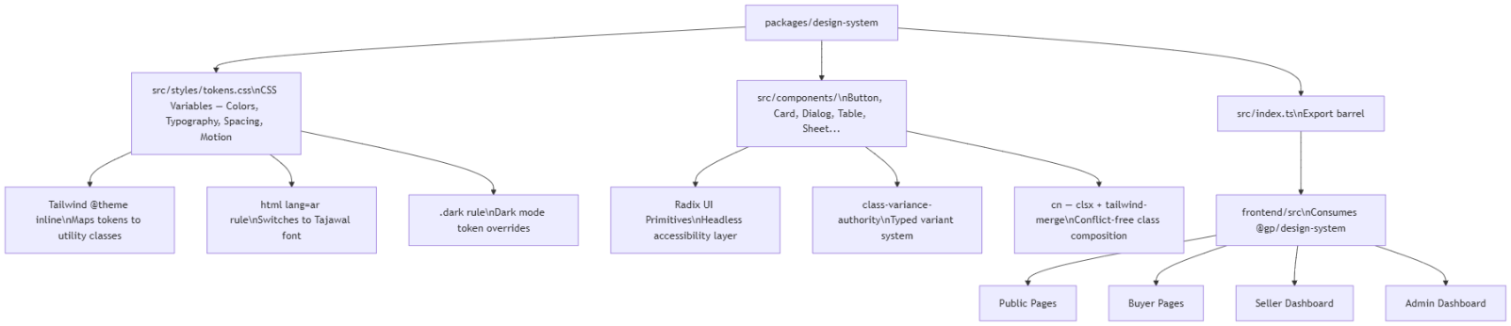

4.2 Data Engineering Implementation

4.2.1 Data Engineering Overview
The data engineering module is responsible for the full data ingestion and streaming pipeline for this graduation project. The core objective is to reliably scrape, stream, and process used-car listings from the Egyptian market specifically targeting Dubizzle and Hatla2ee, and deliver clean, structured data to the rest of the system.
To meet enterprise-grade reliability standards, the pipeline is built on a microservices-based architecture utilizing Docker for containerization and Apache Kafka for real-time data streaming. The ETL workflow is automated end-to-end using Apache Airflow.

4.2.2 Architecture and Workflow
The pipeline follows a linear Extract → Transform → Load (ETL) architecture, automated through Apache Airflow:
- Web Scraping (Extract): Two parallel scraping scripts — one for Dubizzle and one for Hatla2ee — collect raw listing data and write it to intermediate CSV files in a Docker-mounted shared volume.
- Data Extraction (Extract): Airflow tasks read the CSV files into Pandas DataFrames for in-memory processing.
- Cleaning and Transformation (Transform): Source-specific cleaning tasks normalize each dataset independently — price formatting, mileage parsing, type casting, and title standardization.
- Union (Transform): A merging task combines both cleaned datasets into a single unified DataFrame with a consistent schema.
- Final Cleaning (Transform): A final normalization pass standardizes fuel-type labels, removes duplicates, and drops rows with missing titles.
- Scraping Number Assignment (Transform): Each pipeline run is assigned an auto-incremented scraping_num, enabling historical versioning in the database.
- Database Load (Load): The cleaned DataFrame is appended to a PostgreSQL table using SQLAlchemy + psycopg2.
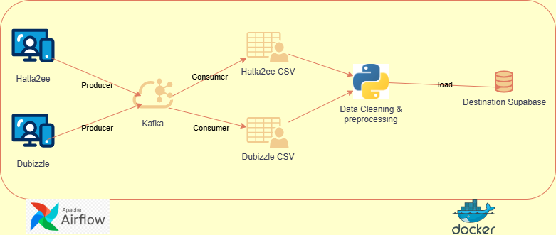

4.2.3 Technologies Used
Component | Technology | Purpose
Web Scraping | Python, Selenium, ChromeDriver | Dynamic page rendering and data extraction
HTML Parsing | BeautifulSoup4 | DOM traversal and content extraction
Data Processing | Pandas | Cleaning, transformation, and merging
Pipeline Orchestration | Apache Airflow 3.0 | DAG scheduling and task dependency management
Containerization | Docker / Docker Compose | Isolated, reproducible execution environment
Message Streaming | Apache Kafka | Decoupled real-time data streaming between services
Database | PostgreSQL | Persistent structured data storage
DB Connector | SQLAlchemy + psycopg2 | Python-to-PostgreSQL interface
Configuration | python-dotenv (.env) | Secure credential and environment management
Translation (legacy, retired) | Custom dictionary + rapidfuzz | Arabic title normalization — superseded by structured extraction

4.2.4 Containerization with Docker

What It Is
Docker is a platform that packages scripts, databases, and streaming services into standardized, isolated containers. Each container holds all required software — libraries, system tools, runtime, and code — removing dependency on the host operating system.

Why It Was Used
- Reproducibility: Scraping depends on headless browsers and specific driver versions. Docker ensures the pipeline runs identically on every developer machine and on any future cloud deployment.
- Environment isolation: The data ingestion environment is fully separated from the host OS, preventing dependency conflicts with other parts of the project.
- Automated setup: Instead of lengthy installation manuals, the entire data infrastructure is brought online with a single docker-compose up command. The Dockerfile installs Google Chrome, ChromeDriver, and all Python packages automatically.

How It Works
A custom Dockerfile based on a PySpark image was created. During the build process, Docker:
- Installs essential system libraries and Google Chrome for headless browsing.
- Installs Python dependencies: Selenium, Playwright, BeautifulSoup4, kafka-python.
- Mounts the local workspace into the container so scripts can be edited locally and executed inside the isolated environment.
The Docker Compose file defines the following services: PostgreSQL (Airflow metadata DB), Airflow API server, Airflow scheduler, DAG processor, triggerer, and Kafka + Zookeeper. Shared named volumes mount the dags/, scripts/, data/, and config/ directories into the containers.

4.2.5 Data Streaming with Apache Kafka

What It Is
Apache Kafka is a distributed event streaming platform. In this architecture it acts as a message broker between the web scrapers (Producers) and the data processing engine (Consumers), decoupling the two sides of the pipeline.

Why It Was Used
- Decoupling (Independence): Without Kafka, if the data processor (Spark) crashes or is being updated, the scraper must stop. Kafka acts as a buffer — the scraper pushes data into a Kafka topic and moves on, regardless of whether the consumer is currently online.
- Speed mismatch handling: Web scraping speeds fluctuate with site response times, while downstream processing can occur in rapid batches. Kafka absorbs this difference so neither system forces the other to wait.
- Multi-consumer broadcasting: Multiple teams — the ML team, the dashboard team — can independently consume the same car-listings stream simultaneously without interfering with each other.

Architectural Highlight: Dual-Network Setup
Kafka is configured to listen on two network ports simultaneously to maximize flexibility:
- Internal container network (ed-kafka:29092): Used by scripts and services running inside the Docker network. Provides high-speed, secure communication between the Dockerized scrapers, Spark consumers, and Kafka without routing traffic through the host machine.
- External host network (localhost:9092): Kafka is explicitly exposed outside the Docker container. This allows any team member to connect a local Python script on their physical laptop to localhost:9092 and consume data without needing to interact with Docker themselves.
Scrapers extract car details (Price, Mileage, Year, Location, etc.), serialize them as JSON, and push them to a Kafka topic named car-listings.

4.2.6 ETL Pipeline in Detail

4.2.6.1 Source-Level Cleaning
Each source has a dedicated cleaning task in the Airflow DAG due to differing raw formats:
- clean_dubizzle(): Strips the 'EGP' prefix and comma separators from the price field and casts it to nullable Int64. Mileage is cleaned with a regex removing all non-digit characters. Year is cast to Int64. Timestamps are parsed with pd.to_datetime(). The url and page columns are dropped as they are not needed downstream.
- clean_hatla2ee(): Lowercases titles, replaces hyphens with spaces for consistency, drops the page column, and parses the scraped_at timestamp.

4.2.6.2 Union and Schema Alignment
The union_datasets() task enforces a strict column order before concatenation to prevent schema misalignment. Both DataFrames are cast to the same Int64 types for numeric fields before pd.concat() is called with ignore_index=True. The final schema is: title, year, mileage_km, transmission, fuel, price_egp, location, scraped_at.

4.2.6.3 Final Cleaning Pass
The final_clean() task performs cross-source normalization:
- Fuel label standardization: A fuel_map dictionary maps all synonyms (gas, benzine, gasoline → petrol; natural gas, cng → cng) to canonical values.
- Duplicate removal: df.drop_duplicates() removes exact duplicate rows across all columns.
- Title validation: Rows where title is null or an empty string after stripping whitespace are dropped, as title is the primary feature used by downstream ML models.

4.2.6.4 Scraping Version Tracking
The add_scraping_num() task queries the database for the current maximum scraping_num before each run and assigns the next integer to all new records. This enables the team to track data provenance, compare model performance across data collection cycles, and roll back to a specific snapshot if needed.

4.2.7 Airflow Pipeline Design

4.2.7.1 DAG Structure
The DAG is named data_pipeline and uses the TaskFlow API throughout. Task dependencies are expressed through direct Python variable assignment, making the data flow explicit and readable. The two scraping branches run independently and in parallel, converging only at the union step — reducing total pipeline wall-clock time.
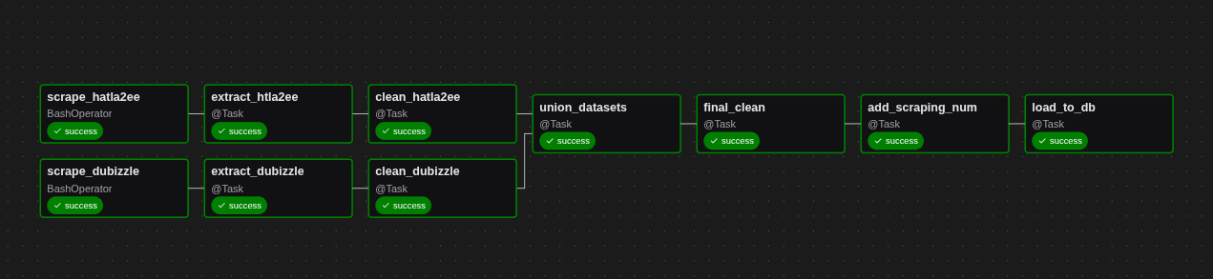

4.2.7.2 Scheduling and Automation
The pipeline is designed to be triggered on demand or scheduled via Airflow's cron-based scheduler. Each run represents one complete data collection cycle. A 6-hour execution timeout on scraping tasks accommodates scraping 200+ pages across both sources while still allowing Airflow to recover from hung processes. Retry configuration (retries=2, retry_delay=10 minutes) on scraping tasks ensures transient network failures do not abort the entire run.

4.2.7.3 Infrastructure — Docker Compose
The Airflow stack is containerized using Docker Compose with the following services: a PostgreSQL instance for the Airflow metadata database, an API server, a scheduler, a DAG processor, and a triggerer. The CeleryExecutor and Redis are commented out in the compose file, as LocalExecutor is sufficient for the current single-machine workload. Shared volumes mount the dags/, scripts/, data/, and config/ directories into containers.

4.3 Backend implmentation

4.3.1 Clean Architecture
The Karna backend follows Clean Architecture principles, organizing the codebase into four distinct layers with strict dependency rules. Inner layers have no knowledge of outer layers, and all dependencies point inward.

Layered Architecture Diagram
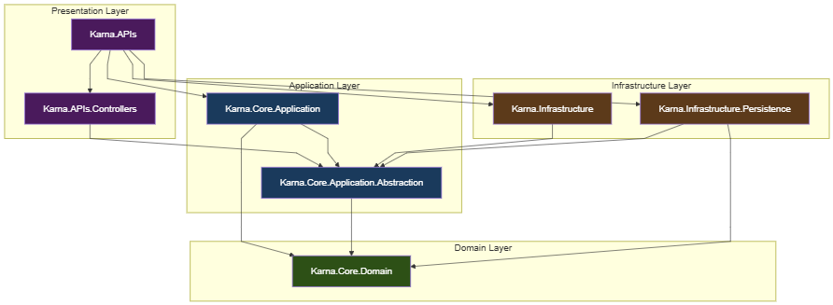

Domain Layer (Karna.Core.Domain)
The innermost layer containing enterprise business rules with zero external dependencies.
Component | Files | Purpose
Entities | User, Listing, Make, Model, ListingPhoto, ConditionChecklistCategory, ConditionDefect, ListingDefect, PricingHistory, ListingStatusHistory, AdminActivityLog, RefreshToken, Favorite | Core business objects with properties and relationships
Enums | ListingStatus, FuelType, TransmissionType, ContactMethod, EgyptLocation | Type-safe value objects for domain concepts
Common | BaseEntity, BaseAuditableEntity, BaseAuditableWithSoftDeleteEntity, ISoftDelete | Shared base classes providing Id, audit fields, and soft-delete

Application Layer (Karna.Core.Application + Karna.Core.Application.Abstraction)
Contains application business rules, orchestration logic, and interface definitions.
Abstraction Project (defines contracts):
Component | Examples | Purpose
Service Interfaces | IAuthService, IListingService, IAdminService, IUserService, IMakeService, IModelService, IFavoriteService | Service contracts consumed by controllers
External Interfaces | IIdentityService, ITokenService, IMLApiClient, ICurrentUserService, ILocalizationService, IFileService | Infrastructure contracts (Dependency Inversion)
Persistence Interfaces | IGenericRepository<T>, IUnitOfWork, ISpecification<T> | Data access contracts
DTOs | LoginDto, RegisterDto, CreateListingDto, BuyerListingDto, GeneratePriceResponseDto, etc. | Data transfer objects for API communication
Settings | JwtSettings, MLApiSettings | Configuration POCOs

Application Project (implements business logic):
Component | Examples | Purpose
Services | AuthService, ListingService, AdminService, UserService, MakeService, ModelService, FavoriteService | Business logic orchestration
Validators | LoginDtoValidator, RegisterDtoValidator, CreateListingValidator, ChangePasswordValidator | FluentValidation rules
Specifications | ActiveListingsSpecification, PendingListingsSpecification, SellerListingsSpecification, AllUsersSpecification, UserFavoritesSpecification | Query specifications for data access
Mapping | Extension methods (.ToDto(), .ToEntity(), .ToBuyerDto()) | Entity ↔ DTO mapping

Infrastructure Layer (Karna.Infrastructure + Karna.Infrastructure.Persistence)
Implements external concerns: database access, identity, JWT, and ML service communication.
Infrastructure Project:
Component | Class | Purpose
Identity | ApplicationUser, IdentityServiceAdapter | ASP.NET Identity integration with IIdentityService
ML | MLApiClient, MLPredictionRequestDto, MLPredictionResponseDto | HTTP client for ML service communication
Services | JwtTokenService, LocalizationService | JWT generation/validation and localization
Persistence Project:
Component | Class | Purpose
Contexts | AppDbContext, AppIdentityDbContext | EF Core database contexts
Repositories | GenericRepository<T>, UnitOfWork, SpecificationEvaluator<T> | Data access implementation
Configurations | EF Core entity configurations | Fluent API table/column mappings
Interceptors | Audit interceptors | Automatic CreatedAt/UpdatedAt population
Seeds | Database seed data | Initial data for roles, admin user, makes, models

Presentation Layer (Karna.APIs + Karna.APIs.Controllers)
The outermost layer handling HTTP concerns.
Component | Class | Purpose
Controllers | AuthController, ListingsController, AdminController, UserController, MakesController, ModelsController, ConditionChecklistCategoriesController, ConditionDefectsController, ListingPhotosController, LookupsController, FavoriteController | REST API endpoints
Middleware | LocalizationMiddleware | Accept-Language header processing
Services | CurrentUserService, FileService | HTTP-context-dependent services
Extensions | DI registration, DB initialization | Startup configuration
Program.cs | Application entry point | Middleware pipeline configuration

4.3.2 Authentication Architecture
The authentication system uses a dual-token strategy with JWT access tokens and rotating refresh tokens.

Authentication Flow Diagram
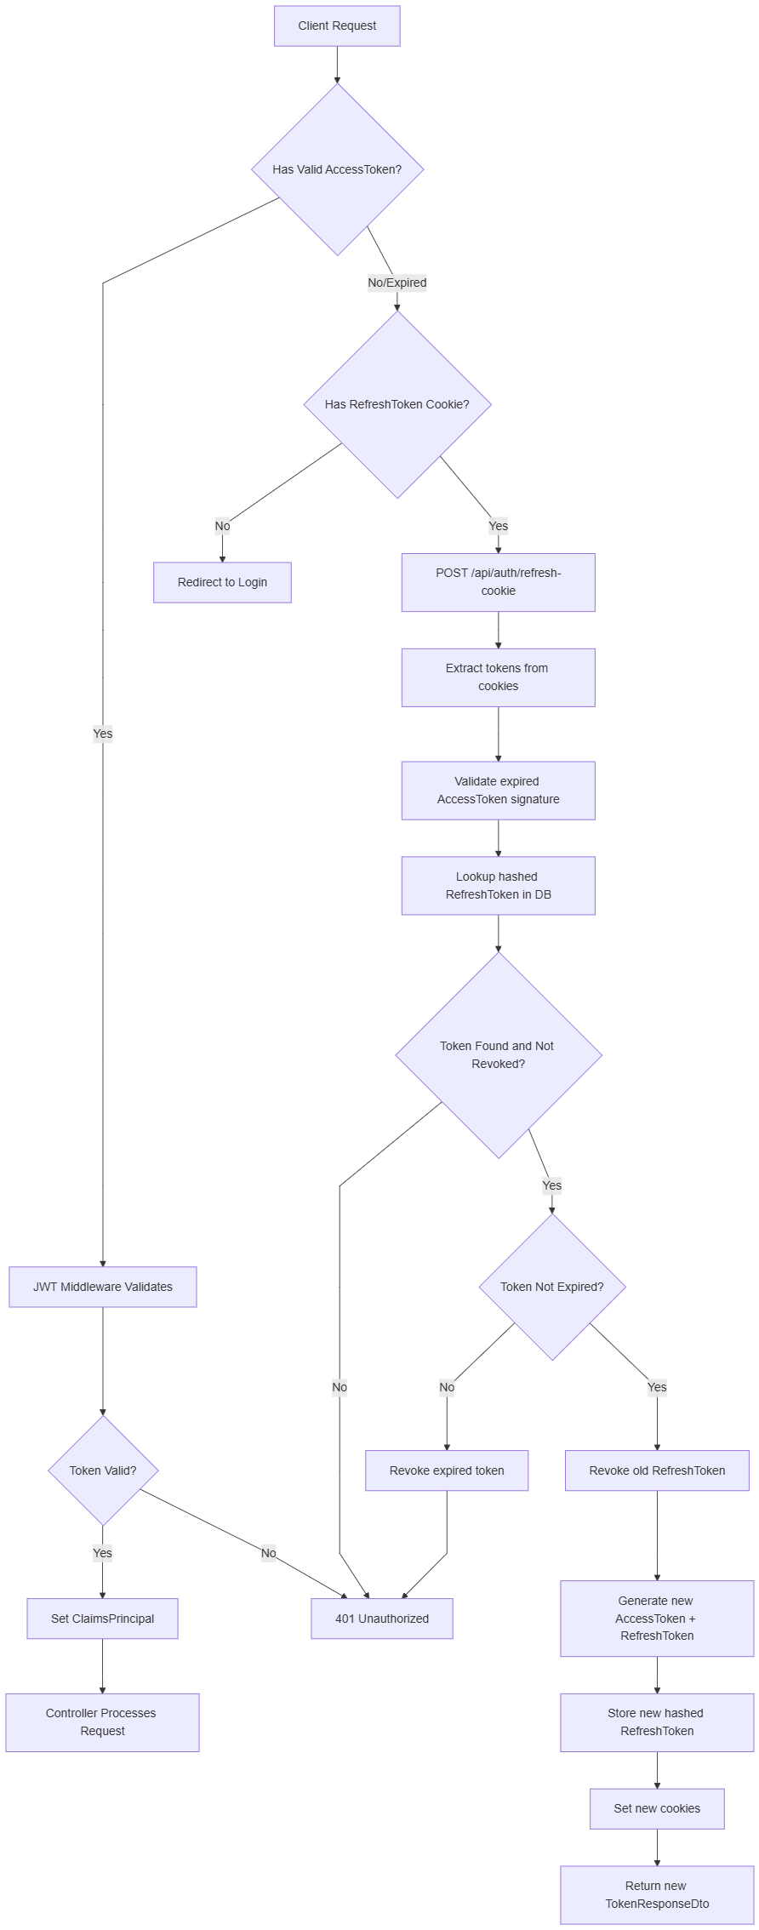

Token Security Implementation
Aspect | Implementation Detail
Access Token | JWT with HMAC-SHA256, contains NameIdentifier, Email, Name, Role claims
Token Expiration | Access: 60 minutes (configurable). Refresh: 7 days (configurable)
Refresh Token Storage | SHA-256 hashed before database persistence (TokenHashed field)
Token Rotation | On every refresh, old token is revoked and new pair is issued
Cookie Configuration | HttpOnly=true, Secure=true, SameSite=None
Device Tracking | DeviceInfo from User-Agent header stored per refresh token
Logout | Single-device: revokes most recent token. All-devices: revokes all active tokens

4..3 Authorization Architecture

Role and Permission Flow Diagram
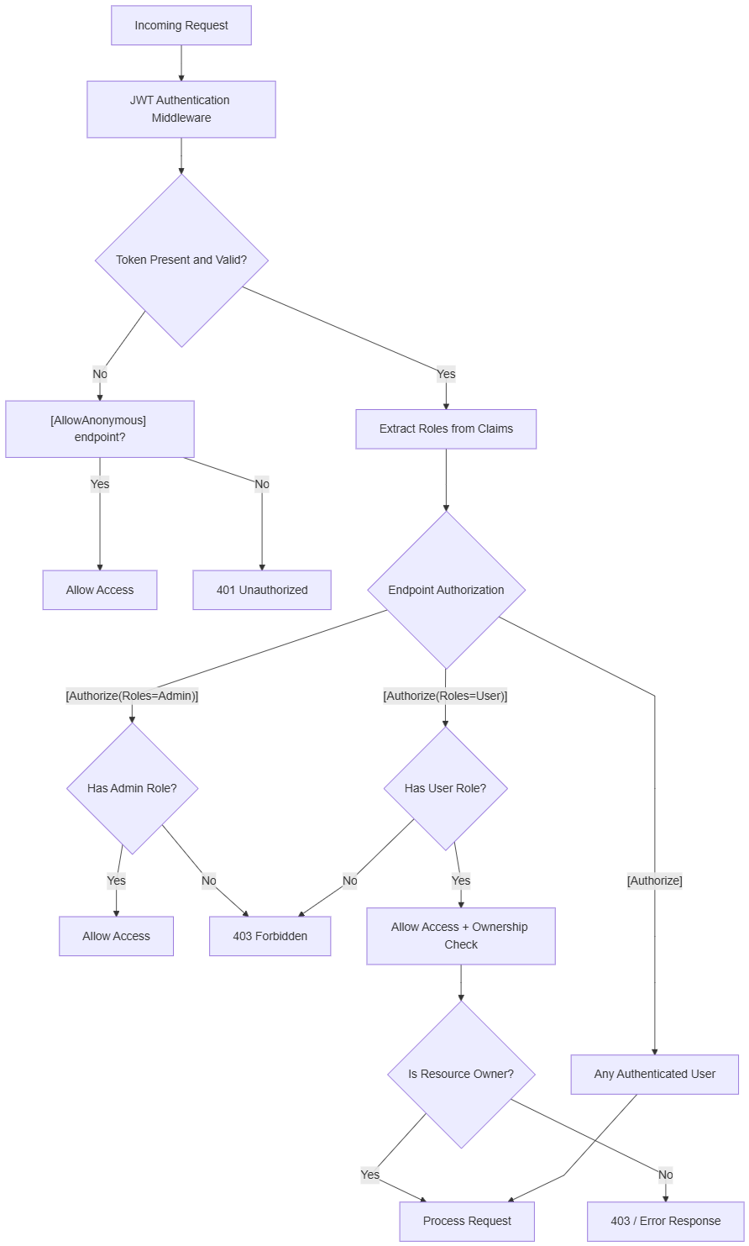

Role Definitions
Role | Controllers | Capabilities
Anonymous | Public endpoints with [AllowAnonymous] | Browse listings, view details, view makes/models, register
User | ListingsController, UserController | Full CRUD on own listings, profile management, price generation
Admin | AdminController, MakesController, ModelsController, ConditionChecklistCategoriesController, ConditionDefectsController | User management, listing approval/rejection, reference data management
User,Admin | Status/pricing history endpoints | View listing histories (owner or admin)

Ownership Enforcement
Every seller-specific operation in ListingService follows a consistent ownership validation pattern:
1. Resolve currentUser via ICurrentUserService.UserId → User.IdentityUserId
2. Load target listing
3. Verify listing.SellerId == currentUser.Id
4. If mismatch → return "ListingNotOwnedByUser" error

4.3.4 Persistence Architecture

Persistence Architecture Diagram
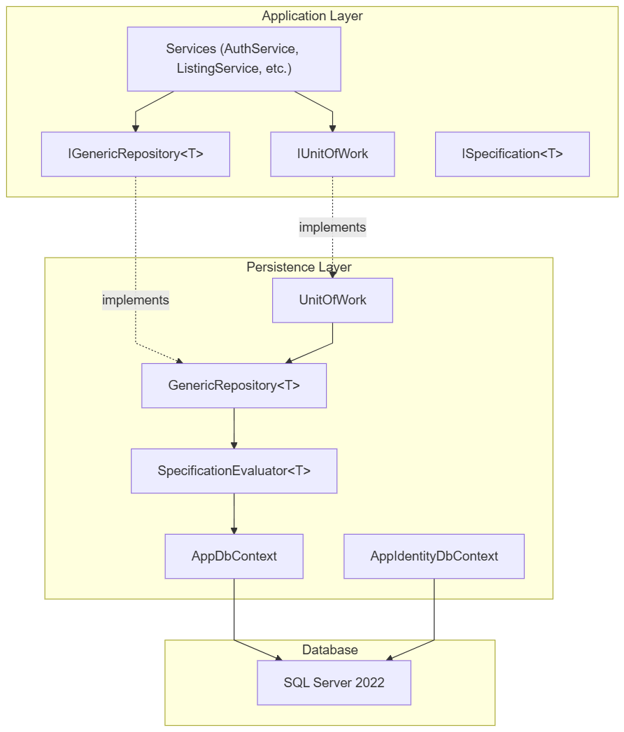

Entity Framework Core Implementation
Dual DbContext Strategy:
Context | Database | Purpose
AppDbContext | KarnaDb (domain tables) | 12 domain entity DbSets with fluent configurations
AppIdentityDbContext | KarnaDb (identity tables) | ASP.NET Identity tables (AspNetUsers, AspNetRoles, etc.)
Generic Repository Pattern:
The GenericRepository<T> provides type-safe data access for any entity inheriting from BaseEntity:
- GetAsync(Guid id) — Find by primary key
- GetAsync(Expression<Func<T, bool>>) — Find by predicate
- GetWithSpecAsync(ISpecification<T>) — Query with specification
- GetAllWithSpecAsync(ISpecification<T>) — List with specification
- FindAsync(predicate) — Filter with optional tracking
- GetCountAsync(ISpecification<T>) — Count with specification
- AddAsync, AddRangeAsync, Update, Delete, DeleteRange — Mutations
- Smart Delete: checks ISoftDelete → sets IsDeleted=true instead of physical deletion

Unit of Work Pattern:
UnitOfWork manages repository lifetime with a ConcurrentDictionary cache and provides:
- GetRepository<T>() — Lazy repository instantiation per entity type
- CompleteAsync() — Saves all changes in a single transaction
- ExecuteInTransactionAsync(Func<Task>) — Explicit transaction with rollback on failure

Specification Pattern:
Specifications encapsulate complex query logic (criteria, includes, ordering, pagination) into reusable objects:
Specification | Purpose
ActiveListingsSpecification | Approved + non-deleted + non-sold listings with buyer filters
SellerListingsSpecification | Owner's listings with status filter and pagination
SellerListingDetailsSpecification | Single owner listing with full includes
ListingDetailsSpecification | Single approved listing with includes for public view
PendingListingsSpecification | Pending listings for admin review
AllUsersSpecification | Admin user list with search and pagination
AdminActivityLogsSpecification | Admin logs with filtering
UserFavoritesSpecification | User favorites with listing includes and pagination

4.3.5 API Architecture

API Flow Diagram
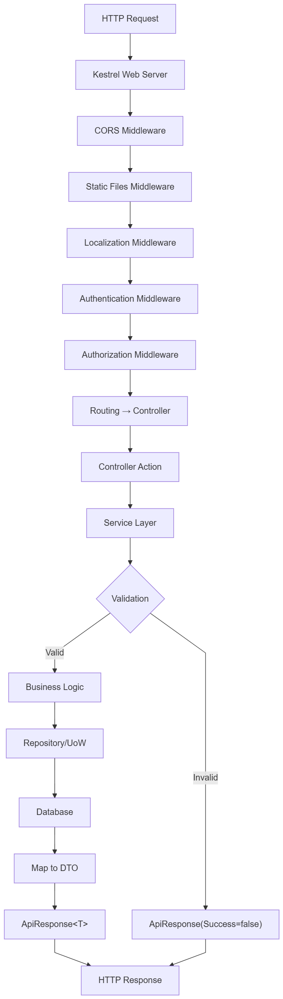

Controller Summary
Controller | Route Prefix | Auth | Actions
AuthController | /api/auth | Mixed | Login, Register, Refresh, Logout, LogoutAll, ChangePassword
ListingsController | /api/listings | Mixed | CRUD, Submit, GeneratePrice, SetPrice, MarkAsSold, StatusHistory, PricingHistory
AdminController | /api/admin | Admin | GetUsers, ToggleUserStatus, GetPendingListings, Approve, Reject, GetLogs
UserController | /api/users | Authorized | GetProfile, UpdateProfile
MakesController | /api/makes | Admin (public reads) | GetAllActive, GetAll, GetById, Create, Update, Activate, Deactivate, Delete
ModelsController | /api/models | Admin (public reads) | GetAllActive, GetAll, GetById, Create, Update, Activate, Deactivate, Delete
ConditionChecklistCategoriesController | /api/conditionchecklistcategories | Admin (public reads) | GetAll, GetById, GetActive, Create, Update, Activate, Deactivate, Delete
ConditionDefectsController | /api/conditiondefects | Admin (public reads) | GetAll, GetById, GetActive, Create, Update, Activate, Deactivate, Delete
ListingPhotosController | /api/listingphotos | User | Upload, Delete, SetPrimary
LookupsController | /api/lookups | Anonymous | FuelTypes, TransmissionTypes, Locations
FavoriteController | /api/favorite | User | AddFavorite, RemoveFavorite, GetFavorites

Standardized API Response
All API responses use a consistent envelope:
{
"success": true,
"message": "Operation completed successfully",
"data": { ... }
}
Paginated responses include:
{
"success": true,
"data": {
"pageIndex": 1,
"pageSize": 10,
"count": 42,
"data": [ ... ]
}
}

Validation Architecture
All input DTOs are validated using FluentValidation before business logic execution:
Validator | DTO | Key Rules
LoginDtoValidator | LoginDto | Email required + valid format, Password required
RegisterDtoValidator | RegisterDto | Name 2-100 chars, valid email, phone format, password strength, password confirmation match
ChangePasswordValidator | ChangePasswordDto | Old password required, new password strength, confirmation match
CreateListingValidator | CreateListingDto | Valid IDs, Year 1900-current+1, Mileage ≥ 0, EngineSize 0.1-20.0, valid enums
UpdateListingValidator | UpdateListingDto | Same as create
UpdateProfileDtoValidator | UpdateProfileDto | Name 2-100 chars, username 3-50 chars, phone format

4.3.6 ML Integration Architecture

Component Diagram
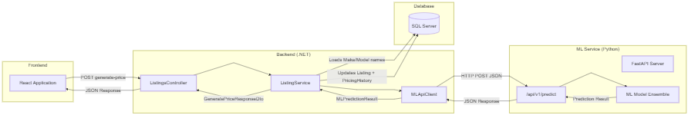

Communication Flow


ML Request/Response Mapping
Backend → ML Service (Request):
Backend Field | ML API Field | Source
Make.Name | brand | Loaded from Make entity
Model.Name | model | Loaded from Model entity
Listing.Year | year | Listing entity
Listing.Mileage | mileage_km | Listing entity
Listing.FuelType.ToString() | fuel | Enum to lowercase string
Listing.Transmission.ToString() | transmission | Enum to string
Listing.Location.ToDisplayString() | location | Enum to display string
true | include_factors | Always request explainability
ML Service → Backend (Response Mapping):
ML Response Field | Listing Entity Field | DTO Field
fair_price | FairPrice | FairPrice
negotiation_range.min_price | NegotiationRangeLower | NegotiationRangeLower
negotiation_range.max_price | NegotiationRangeUpper | NegotiationRangeUpper
confidence | ConfidenceLevel | ConfidenceLevel
model_version | ModelVersion | ModelVersion
predicted_at | PredictedAt | PredictedAt
price_factors[].factor/direction/description | (not persisted) | PriceFactors list

Error Handling Strategy
The MLApiClient implements structured error handling with specific user-friendly messages:
Error Condition | User Message
HTTP 400/422 | "Unable to generate a price for the provided vehicle data: {detail}"
HTTP 408/504 | "The pricing service timed out. Please try again."
Other HTTP errors | "The pricing service is temporarily unavailable. Please try again later."
TaskCanceledException (timeout) | "The pricing service timed out. Please try again."
HttpRequestException (network) | "Unable to reach the pricing service at the moment. Please try again."
Null/invalid response body | "The pricing service returned an invalid response. Please try again."
Unexpected exception | "An unexpected error occurred while generating price. Please try again."
All errors are logged with structured logging including Brand, Model, Year, and status code details.

Chapter 5: Backend Testing Documentation

5.1 Authentication Testing

5.1.1 Registration Testing
Test ID | Test Scenario | Method | Input | Expected Result | Status
AUTH-R01 | Register with valid data | POST /api/auth/register | Valid name, email, phone, password | 200 OK with TokenResponseDto + Set-Cookie headers | ✅ Pass
AUTH-R02 | Register with duplicate email | POST /api/auth/register | Already registered email | 400 with "EmailAlreadyInUse" | ✅ Pass
AUTH-R03 | Register with weak password | POST /api/auth/register | Password "123" | 400 with password policy errors | ✅ Pass
AUTH-R04 | Register with mismatched passwords | POST /api/auth/register | Password ≠ ConfirmPassword | 400 with validation error | ✅ Pass
AUTH-R05 | Register with invalid email format | POST /api/auth/register | "not-an-email" | 400 with validation error | ✅ Pass
AUTH-R06 | Register with empty required fields | POST /api/auth/register | Empty name, email, or password | 400 with validation errors | ✅ Pass
AUTH-R07 | Verify domain User created | Database inspection | After successful registration | User record with correct IdentityUserId exists | ✅ Pass
AUTH-R08 | Verify "User" role assigned | Database inspection | After registration | AspNetUserRoles contains User role mapping | ✅ Pass
AUTH-R09 | Verify cookies set correctly | Browser DevTools | After registration | HttpOnly, Secure, SameSite=None cookies present | ✅ Pass

5.1.2 Login Testing
Test ID | Test Scenario | Method | Input | Expected Result | Status
AUTH-L01 | Login with valid credentials | POST /api/auth/login | Valid email + password | 200 OK with tokens | ✅ Pass
AUTH-L02 | Login with wrong password | POST /api/auth/login | Valid email + wrong password | 401 with "InvalidCredentials" | ✅ Pass
AUTH-L03 | Login with non-existent email | POST /api/auth/login | Unknown email | 401 with "InvalidCredentials" | ✅ Pass
AUTH-L04 | Login with deactivated account | POST /api/auth/login | Deactivated user credentials | 401 with "InvalidCredentials" | ✅ Pass
AUTH-L05 | Login lockout after failures | POST /api/auth/login | 5+ wrong password attempts | 401 with "AccountLocked" | ✅ Pass
AUTH-L06 | Verify DeviceInfo stored | Database inspection | After login | RefreshToken.DeviceInfo contains User-Agent | ✅ Pass

5.1.3 Token Refresh Testing
Test ID | Test Scenario | Method | Expected Result | Status
AUTH-T01 | Refresh with valid cookies | POST /api/auth/refresh-cookie | 200 OK with new token pair | ✅ Pass
AUTH-T02 | Refresh with expired refresh token | POST /api/auth/refresh-cookie | 401 Unauthorized | ✅ Pass
AUTH-T03 | Refresh with revoked token | POST /api/auth/refresh-cookie | 401 Unauthorized | ✅ Pass
AUTH-T04 | Token rotation verified | Database inspection | Old token revoked, new token created | ✅ Pass
AUTH-T05 | Refresh without cookies | POST /api/auth/refresh-cookie | 401 Unauthorized | ✅ Pass

5.1.4 Logout Testing
Test ID | Test Scenario | Method | Expected Result | Status
AUTH-O01 | Logout single device | POST /api/auth/logout | 200 OK, latest token revoked, cookies cleared | ✅ Pass
AUTH-O02 | Logout all devices | POST /api/auth/logout-all | 200 OK, all tokens revoked, cookies cleared | ✅ Pass
AUTH-O03 | Access after logout | GET protected endpoint | 401 Unauthorized | ✅ Pass

5.1.5 Change Password Testing
Test ID | Test Scenario | Method | Expected Result | Status
AUTH-P01 | Change with correct old password | POST /api/auth/change-password | 200 OK "PasswordChanged" | ✅ Pass
AUTH-P02 | Change with wrong old password | POST /api/auth/change-password | 400 with identity errors | ✅ Pass
AUTH-P03 | Change with weak new password | POST /api/auth/change-password | 400 with validation errors | ✅ Pass
AUTH-P04 | Login with new password after change | POST /api/auth/login | 200 OK success | ✅ Pass

5.1.6 Authorization Testing
Test ID | Test Scenario | Method | Expected Result | Status
AUTHZ-01 | Anonymous access to public endpoint | GET /api/listings/approved | 200 OK | ✅ Pass
AUTHZ-02 | Anonymous access to protected endpoint | POST /api/listings without token | 401 Unauthorized | ✅ Pass
AUTHZ-03 | User access to admin endpoint | PATCH /api/admin/listings/{id}/approve with User role | 403 Forbidden | ✅ Pass
AUTHZ-04 | Admin access to admin endpoint | GET /api/admin/users with Admin role | 200 OK | ✅ Pass
AUTHZ-05 | User access to own listing | GET /api/listings/my-listings/{id} | 200 OK | ✅ Pass
AUTHZ-06 | User access to other's listing ops | PUT /api/listings/{otherId} | 400 "ListingNotOwnedByUser" | ✅ Pass
AUTHZ-07 | User/Admin access to history endpoints | GET /api/listings/{id}/status-history | 200 OK for owner/admin | ✅ Pass

5.1.7 User Profile Testing
Test ID | Test Scenario | Method | Expected Result | Status
USER-01 | Get profile | GET /api/users/profile | 200 OK with UserDto (name, email, phone, roles) | ✅ Pass
USER-02 | Update profile | PUT /api/users/update-profile | 200 OK with updated data | ✅ Pass
USER-03 | Update with taken username | PUT /api/users/update-profile | 400 "UsernameAlreadyTaken" | ✅ Pass
USER-04 | Update with invalid data | PUT /api/users/update-profile | 400 with validation errors | ✅ Pass
USER-05 | Verify transaction rollback | PUT /api/users/update-profile with Identity failure | Domain changes rolled back | ✅ Pass

5.1.8 Listing Testing

5.1.8.1 Listing CRUD Testing
Test ID | Test Scenario | Method | Expected Result | Status
LIST-C01 | Create listing with valid data | POST /api/listings | 201 Created with Status=Draft | ✅ Pass
LIST-C02 | Create with invalid MakeId | POST /api/listings | 400 "MakeNotFound" | ✅ Pass
LIST-C03 | Create with Model not belonging to Make | POST /api/listings | 400 "ModelDoesNotBelongToMake" | ✅ Pass
LIST-U01 | Update own Draft listing | PUT /api/listings/{id} | 200 OK, status unchanged | ✅ Pass
LIST-U02 | Update Active listing | PUT /api/listings/{id} | 200 OK, status → Pending (re-review) | ✅ Pass
LIST-U03 | Update Rejected listing | PUT /api/listings/{id} | 200 OK, status → Draft, RejectionReason cleared | ✅ Pass
LIST-U04 | Update Sold listing | PUT /api/listings/{id} | 400 "NotInValidStateForUpdate" | ✅ Pass
LIST-U05 | Update other user's listing | PUT /api/listings/{id} | 400 "ListingNotOwnedByUser" | ✅ Pass
LIST-D01 | Delete own listing | DELETE /api/listings/{id} | 200 OK, IsDeleted=true, Status=Archived | ✅ Pass
LIST-D02 | Delete sold listing | DELETE /api/listings/{id} | 400 "ListingCannotBeDeleted" | ✅ Pass
LIST-D03 | Delete already deleted listing | DELETE /api/listings/{id} | 400 "ListingAlreadyDeleted" | ✅ Pass

5.1.8.2 Listing Workflow Testing
Test ID | Test Scenario | Method | Expected Result | Status
LIST-W01 | Add condition checklist | POST /api/listings/{id}/conditions | 200 OK with ListingDefectDto list | ✅ Pass
LIST-W02 | Add checklist to non-Draft | POST /api/listings/{id}/conditions | 400 "NotInDraftState" | ✅ Pass
LIST-W03 | Add checklist with inactive defect | POST /api/listings/{id}/conditions | 400 "ConditionDefectInactive" | ✅ Pass
LIST-W04 | Generate ML price | POST /api/listings/{id}/generate-price | 200 OK with pricing data | ✅ Pass
LIST-W05 | Generate price with incomplete data | POST /api/listings/{id}/generate-price | 400 "DataIncompleteForPricing" | ✅ Pass
LIST-W06 | Set price (accept fair price) | POST /api/listings/{id}/set-price | 200 OK, Price = FairPrice | ✅ Pass
LIST-W07 | Set custom price | POST /api/listings/{id}/set-price | 200 OK, Price = custom value | ✅ Pass
LIST-W08 | Submit complete listing | PATCH /api/listings/{id}/submit | 200 OK, Status=Pending | ✅ Pass
LIST-W09 | Submit without photos | PATCH /api/listings/{id}/submit | 400 "InsufficientPhotos" | ✅ Pass
LIST-W10 | Submit without ML pricing | PATCH /api/listings/{id}/submit | 400 "MissingPricing" | ✅ Pass
LIST-W11 | Mark Active listing as sold | PATCH /api/listings/{id}/sold | 200 OK, Status=Sold, SoldAt set | ✅ Pass

5.1.8.3 Listing Browse Testing
Test ID | Test Scenario | Method | Expected Result | Status
LIST-B01 | Get approved listings (no filter) | GET /api/listings/approved | 200 OK with paginated results | ✅ Pass
LIST-B02 | Filter by MakeId | GET /api/listings/approved?MakeId=... | Only matching listings returned | ✅ Pass
LIST-B03 | Filter by price range | GET /api/listings/approved?MinPrice=X&MaxPrice=Y | Only listings in range | ✅ Pass
LIST-B04 | Sort by price descending | GET /api/listings/approved?SortBy=Price&SortDescending=true | Correctly ordered | ✅ Pass
LIST-B05 | Pagination | GET /api/listings/approved?PageIndex=2&PageSize=5 | Correct page with count | ✅ Pass
LIST-B06 | View listing details | GET /api/listings/{id} | Full details with photos, condition, seller contact | ✅ Pass
LIST-B07 | View non-active listing | GET /api/listings/{id} | 404 "ListingNotAvailable" | ✅ Pass
LIST-B08 | Good Deal indicator | GET /api/listings/approved | IsGoodDeal=true when Price ≤ FairPrice | ✅ Pass

5.1.9 Favorites Testing
Test ID | Test Scenario | Method | Expected Result | Status
FAV-01 | Add favorite | POST /api/favorite/{listingId} | Favorite created | ✅ Pass
FAV-02 | Remove favorite | DELETE /api/favorite/{listingId} | Favorite removed | ✅ Pass
FAV-03 | View favorites | GET /api/favorite | Paginated favorites returned | ✅ Pass
FAV-04 | Duplicate prevention | POST same favorite twice | AlreadyInFavorites returned | ✅ Pass

5.1.10 Admin Workflow Testing
Test ID | Test Scenario | Method | Expected Result | Status
ADMIN-01 | Get all users | GET /api/admin/users | Paginated user list with identity data | ✅ Pass
ADMIN-02 | Search users by name | GET /api/admin/users?Search=... | Filtered results | ✅ Pass
ADMIN-03 | Deactivate user | PATCH /api/admin/users/{id}/toggle-status | IsActive=false, tokens revoked | ✅ Pass
ADMIN-04 | Reactivate user | PATCH /api/admin/users/{id}/toggle-status | IsActive=true | ✅ Pass
ADMIN-05 | Self-deactivation blocked | PATCH /api/admin/users/{adminId}/toggle-status | 400 "CannotDeactivateSelf" | ✅ Pass
ADMIN-06 | Deactivated user login blocked | POST /api/auth/login after deactivation | 401 "InvalidCredentials" | ✅ Pass
ADMIN-07 | Approve pending listing | PATCH /api/admin/listings/{id}/approve | Status=Active, ApprovedAt set | ✅ Pass
ADMIN-08 | Approve non-pending listing | PATCH /api/admin/listings/{id}/approve | 400 "NotInPendingState" | ✅ Pass
ADMIN-09 | Reject with reason | PATCH /api/admin/listings/{id}/reject | Status=Rejected, reason stored | ✅ Pass
ADMIN-10 | Reject without reason | PATCH /api/admin/listings/{id}/reject | 400 "RejectionReasonRequired" | ✅ Pass
ADMIN-11 | View admin activity logs | GET /api/admin/logs | Paginated log entries | ✅ Pass
ADMIN-12 | Verify activity log recorded | Database inspection | AdminActivityLog has correct entries | ✅ Pass

5.1.11 ML Integration Testing
Test ID | Test Scenario | Method | Expected Result | Status
ML-01 | Successful price prediction | POST /api/listings/{id}/generate-price | FairPrice, NegotiationRange, Confidence returned | ✅ Pass
ML-02 | PriceFactors returned | POST with include_factors=true | PriceFactors array populated | ✅ Pass
ML-03 | ML service timeout handling | POST when ML service slow | "Pricing service timed out" error | ✅ Pass
ML-04 | ML service unavailable | POST when ML service down | "Unable to reach pricing service" error | ✅ Pass
ML-05 | Invalid vehicle data to ML | POST with unsupported brand/model | Descriptive error with ML detail | ✅ Pass
ML-06 | Pricing history recorded | Database inspection after generate | PricingHistory entry with "ML prediction" reason | ✅ Pass
ML-07 | Listing fields updated | Database inspection after generate | FairPrice, NegotiationRange*, ConfidenceLevel, ModelVersion, PredictedAt set | ✅ Pass

5.1.12 Database Verification Testing
Test ID | Test Scenario | Verification Method | Expected Result | Status
DB-01 | Soft delete global filter | Query Listings table | IsDeleted=true records excluded from queries | ✅ Pass
DB-02 | Audit fields populated | Create entity, inspect DB | CreatedAt auto-set, UpdatedAt on changes | ✅ Pass
DB-03 | Foreign key constraints | Insert listing with invalid MakeId | Constraint violation / handled by service | ✅ Pass
DB-04 | Status history audit trail | Transition listing through all states | Complete history chain recorded | ✅ Pass
DB-05 | Pricing history audit trail | Generate price + set price | Both ML and seller changes recorded | ✅ Pass
DB-06 | Refresh token hashing | Inspect RefreshTokens table | Only SHA-256 hashes stored, not raw tokens | ✅ Pass
DB-07 | Dual context isolation | Inspect databases | Identity and domain tables in same DB, separate contexts | ✅ Pass
DB-08 | Favorite uniqueness constraint | Attempt duplicate insert | Composite unique index (UserId, ListingId) prevents duplicates | ✅ Pass

5.1.13 Validation Testing
Test ID | Test Scenario | Validator | Expected Result | Status
VAL-01 | Email format validation | RegisterDtoValidator | Rejects invalid email formats | ✅ Pass
VAL-02 | Password strength validation | RegisterDtoValidator | Requires min length + complexity | ✅ Pass
VAL-03 | Password confirmation match | RegisterDtoValidator | Rejects mismatch | ✅ Pass
VAL-04 | Phone number format | RegisterDtoValidator | Validates Egyptian phone format | ✅ Pass
VAL-05 | Name length (2-100) | RegisterDtoValidator | Rejects too short/long | ✅ Pass
VAL-06 | Year range (1900-current+1) | CreateListingValidator | Rejects out of range | ✅ Pass
VAL-07 | Mileage ≥ 0 | CreateListingValidator | Rejects negative values | ✅ Pass
VAL-08 | Engine size (0.1-20.0) | CreateListingValidator | Rejects out of range | ✅ Pass
VAL-09 | Valid enum values | CreateListingValidator | Rejects invalid FuelType/Transmission | ✅ Pass
VAL-10 | Required string fields | CreateListingValidator | Rejects empty Color/Description | ✅ Pass

5.1.14 Error Handling Testing
Test ID | Test Scenario | Method | Expected Result | Status
ERR-01 | Non-existent listing ID | GET /api/listings/{randomGuid} | 404 with structured error | ✅ Pass
ERR-02 | Invalid GUID format | GET /api/listings/not-a-guid | 400 Bad Request | ✅ Pass
ERR-03 | Malformed JSON body | POST /api/listings with bad JSON | 400 Bad Request | ✅ Pass
ERR-04 | Missing required fields | POST /api/auth/register with partial data | 400 with validation details | ✅ Pass
ERR-05 | Consistent response envelope | All endpoints | {success, message, data} format | ✅ Pass
ERR-06 | Localized error messages | Various endpoints with Accept-Language header | Messages in correct language | ✅ Pass

5.2 Front end testing
Script | Description
npm run dev | Start development server
npm run build | Production build with TypeScript compilation
npm run lint | ESLint static analysis
npm run preview | Preview production build locally

Static Analysis & Type Safety

ESLint: is configured and provides static analysis for code quality. It catches common React mistakes, unused variables, and TypeScript errors that would otherwise only appear at runtime.

TypeScript: (tsconfig.json, tsconfig.app.json) is set to strict mode. This enforces typed component props, typed API responses, typed form state, and typed route parameters — catching a large class of bugs at compile time before any test could find them.

Storybook
Storybook is available for the design system package:
Script | Description
npm run storybook | Launch Storybook development server
npm run build-storybook | Build static Storybook site
Storybook allows design system components to be rendered in isolation with all their variants visible. Component stories exist for:
- Button
- Badge
- Card
- Table
- Select
- Dialog
- Combobox
- Pagination
- Sidebar
- Chart
- ImageCarousel
This provides a form of visual unit testing for shared UI components, ensuring that regressions in the component library are immediately visible before they affect any page.

Additional Testing — UI/UX
Since no automated frontend test suite exists, the following manual testing procedures were applied during development.

Manual Page Testing
Each page was verified manually in the browser by navigating to it and interacting with its core functionality. The pages tested include:
- Home, About, Contact (public)
- Login and Signup (auth)
- Feed, Car Details, Profile (buyer)
- Seller Dashboard, My Listings, Add Listing (seller)
- Admin Dashboard, Pending Cars, Makes, Models, Conditions (admin)

Form Validation Scenarios
Forms were tested with the following scenarios:
Scenario | Expected Result
Submit login form with empty fields | Validation errors shown per field
Submit signup with mismatched passwords | Error displayed, form not submitted
Submit listing with missing required fields | Step blocked, errors highlighted
Upload no photos and attempt to proceed | Warning shown, step not advanced
Enter invalid values in numeric fields | Field-level error returned

Route Protection Checks
Route guards were verified manually:
Scenario | Expected Result
Unauthenticated user visits /feed | Redirected to /login
Unauthenticated user visits /admin | Redirected to /login
Regular user (role: user) visits /admin | Redirected to fallback
Authenticated user visits /login | Redirected away from login page
Admin visits /seller | Redirected to fallback

Responsive Behavior Checks
Pages were tested at the following viewport widths:
- Desktop (1440px, 1280px)
- Tablet (768px)
- Mobile (375px, 390px)
Sidebar collapse behavior, card grid reflow, and table horizontal scroll were verified at each breakpoint.

Localization and RTL Checks
The following RTL behaviors were verified when switching to Arabic:
Element | Expected Arabic Behavior
Page layout direction | Flips to right-to-left
Navbar items | Order mirrors correctly
Sidebar | Renders on the right side
Form labels and inputs | Align to the right
Toast notifications | Appear at top-left instead of top-right
Typography | Switches to Tajawal font via design system token
Translation strings | All visible text shows Arabic content
Translation parity between en/translation.json and ar/translation.json was verified by switching language and checking that no untranslated (English fallback) strings appear in Arabic mode.

Design System Component Checks
The following design system behaviors were manually verified:
Scenario | Expected Result
Open Dialog component | Focus traps inside modal; background is not interactive
Press Esc on open Dialog | Modal closes and focus returns to trigger
Navigate Combobox with keyboard | Arrow keys move through options correctly
Open Sheet on mobile viewport | Drawer slides in from correct side
Switch to Arabic and inspect Sidebar | Sidebar renders on right side
Inspect Button component variants | Default, outline, destructive, ghost all render correctly
Verify Skeleton during data load | Skeleton placeholders appear before data arrives

Browser and Device Checks
The frontend was tested in:
- Google Chrome (primary)
- Firefox
- Safari (macOS)
- Chrome on Android (mobile)
No significant rendering differences were observed across these environments.

5.3 Data Engineering Testing

5.3.1 Pipeline Integration Testing
The data pipeline was verified through end-to-end integration runs rather than automated unit test suites, given the I/O-heavy, network-dependent nature of scraping tasks. The following scenarios were tested and verified:
- Full DAG run: A complete data_pipeline DAG run was triggered and monitored through the Airflow UI. All tasks completed successfully, and the final record count in PostgreSQL matched the expected number of listings scraped.
- Parallel scraping branches: Both the Dubizzle and Hatla2ee scraping tasks were confirmed to run concurrently without resource conflicts.
- Schema alignment: The union step was verified to produce a DataFrame with the correct column order and types (title: str, year: Int64, mileage_km: Int64, transmission: str, fuel: str, price_egp: Int64, location: str, scraped_at: datetime).
- Scraping version increment: After two consecutive DAG runs, scraping_num values in the database were confirmed to be distinct (e.g., all records from run 1 having scraping_num=1, run 2 having scraping_num=2).

5.3.2 Data Quality Verification
- Null title removal: A dataset containing deliberate null-title rows was injected into the final_clean() function. Post-clean output confirmed zero null-title records.
- Duplicate removal: A dataset with exact duplicate rows was processed. Output confirmed all duplicates were eliminated.
- Fuel label normalization: Input records with 'benzine', 'gasoline', 'gas', 'natural gas' values were processed. All were mapped correctly to 'petrol' or 'cng' canonical labels.
- Price and mileage type casting: Records with 'EGP 150,000' price strings and '45,000 km' mileage strings were processed. Both fields were confirmed to be cast to Int64 (150000 and 45000 respectively).

5.3.3 Browser Crash Recovery Testing
The crash recovery mechanism was verified under controlled conditions:
- Simulated tab crash: The _is_tab_crashed() method was tested by intentionally killing the Chrome renderer process mid-run. The scraper was confirmed to detect the crash, reinitialize the WebDriver, and continue from the next page without losing previously collected data.
- 50-page recycle boundary: A run of 100 pages was executed and logs confirmed that the WebDriver was proactively recycled exactly at page 50, regardless of crash state.
- Retry behavior: A transient network failure was simulated by temporarily blocking the scraping target. Airflow's retry configuration (2 retries, 10-minute delay) was confirmed to trigger correctly.

5.4.4 Kafka Connectivity Testing
- Producer verification: A test producer script was run inside the Docker network, publishing 10 sample JSON messages to the car-listings topic. A Kafka console consumer confirmed all 10 messages were received on the internal port (ed-kafka:29092).
- External consumer verification: A local Python consumer script was run on the host machine (outside Docker), connecting to localhost:9092. All 10 test messages were successfully consumed.

Chapter 6: Results and Discussion

6.1 Results

6.1.1 Expected Results
Describe what your project was theoretically supposed to achieve (assuming 100% success).

6.1.2 Actual Results
Present the real, obtained results. Include screenshots, data, or outputs as appropriate.

6.2 Discussion
Analyze and compare the expected vs. actual results. Explain any differences, failures, or unexpected outcomes, and suggest reasons

Chapter 7: Conclusion
Paragraph 1 — Summary: Summarize your report and highlight your key achievements.

Paragraph 2 — Recommendations: Suggest how the project could be enhanced or extended if more resources or time were available.

Chapter 8: Future Work
Describe the improvements, extensions, or new features that could be developed in future work on this project.
- [Future enhancement 1]
- [Future enhancement 2]
- [Future enhancement 3]

Bibliography
List all sources you consulted while writing this report (books, websites, papers, magazines). These do not need to be cited directly in the text.
- [Author, Title, Publisher, Year, URL]
- [Author, Title, Publisher, Year, URL]

Appendix
1. Front-end Appendix

A.1 Page Screenshots
Note: Screenshots of each major page and workflow should be inserted here during final report preparation. Suggested screenshots per section:

Public Pages

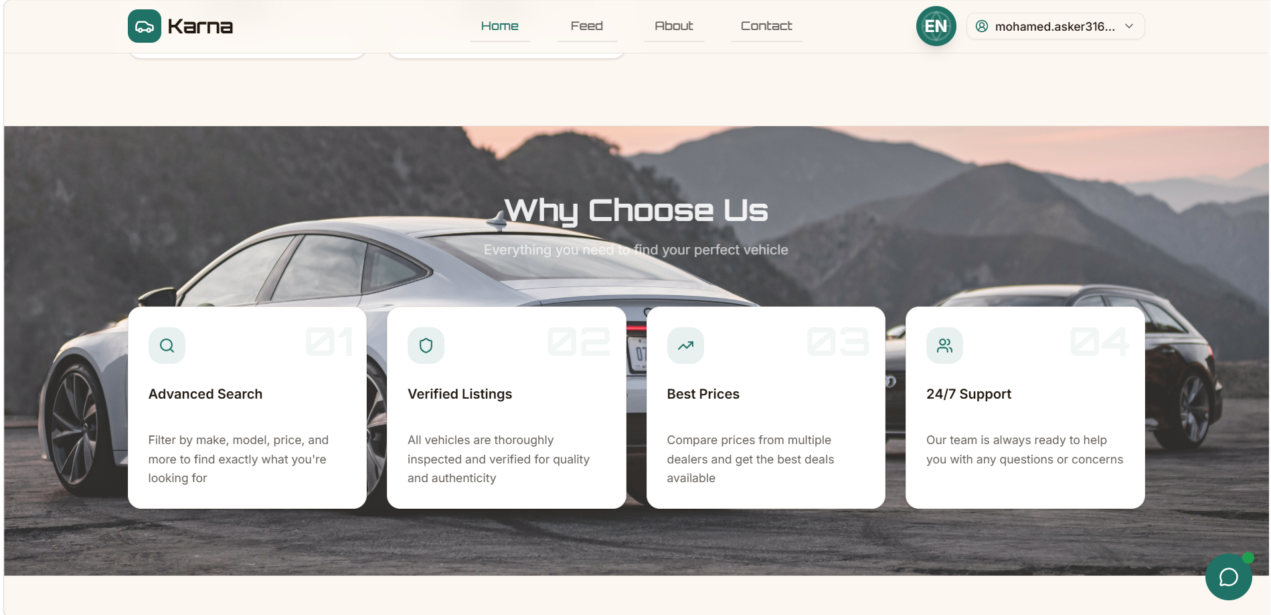
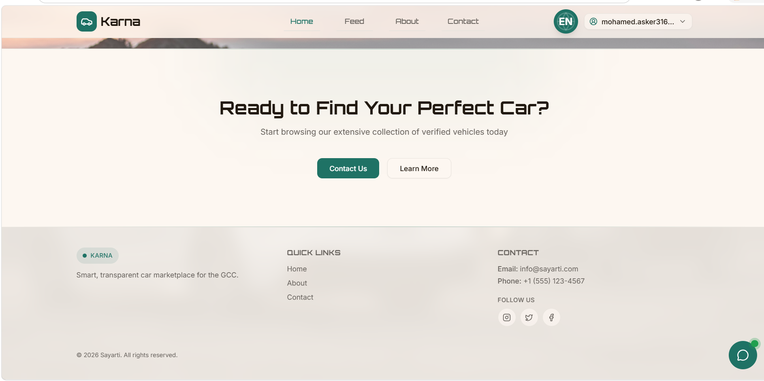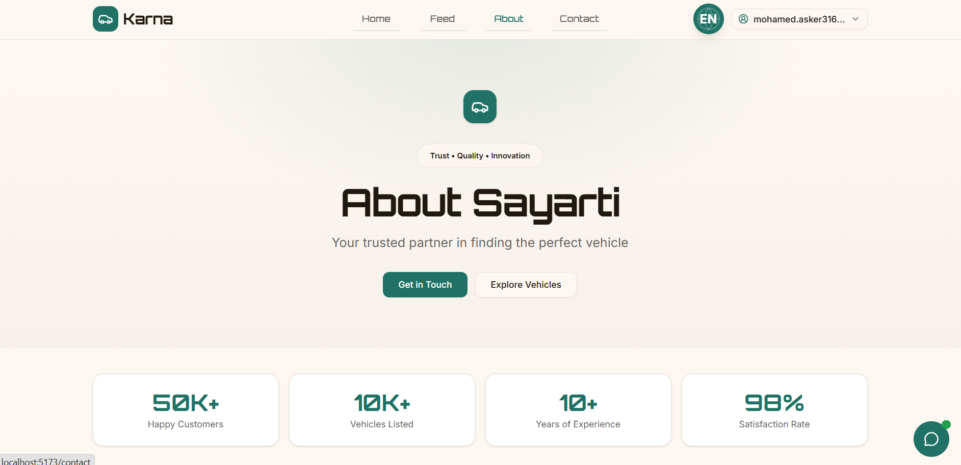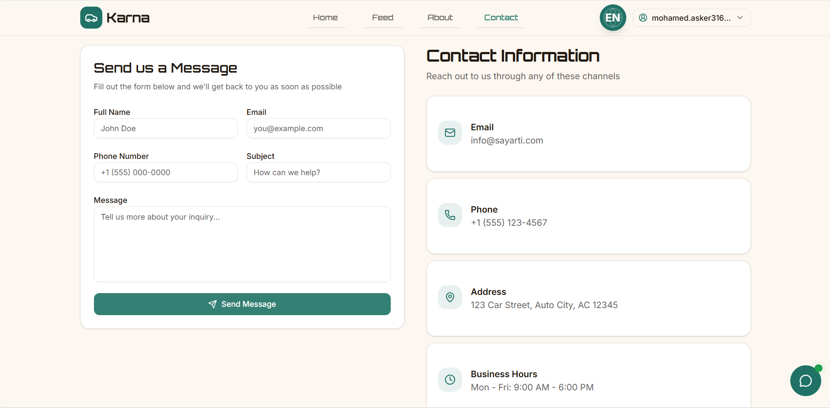
Authentication Pages

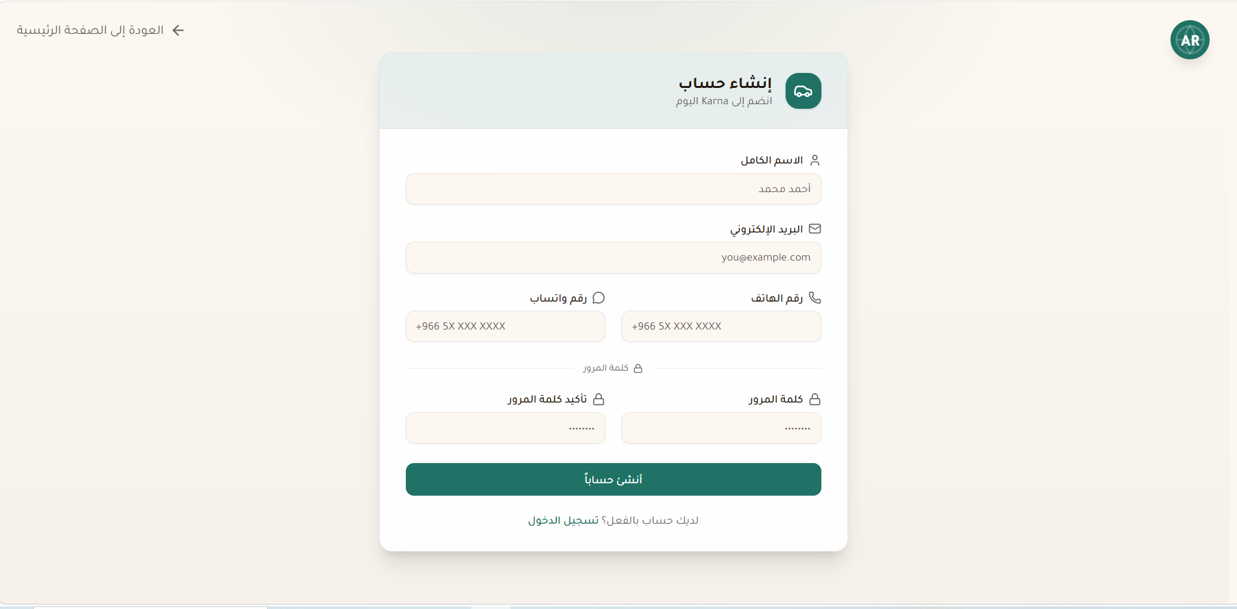

Buyer Pages

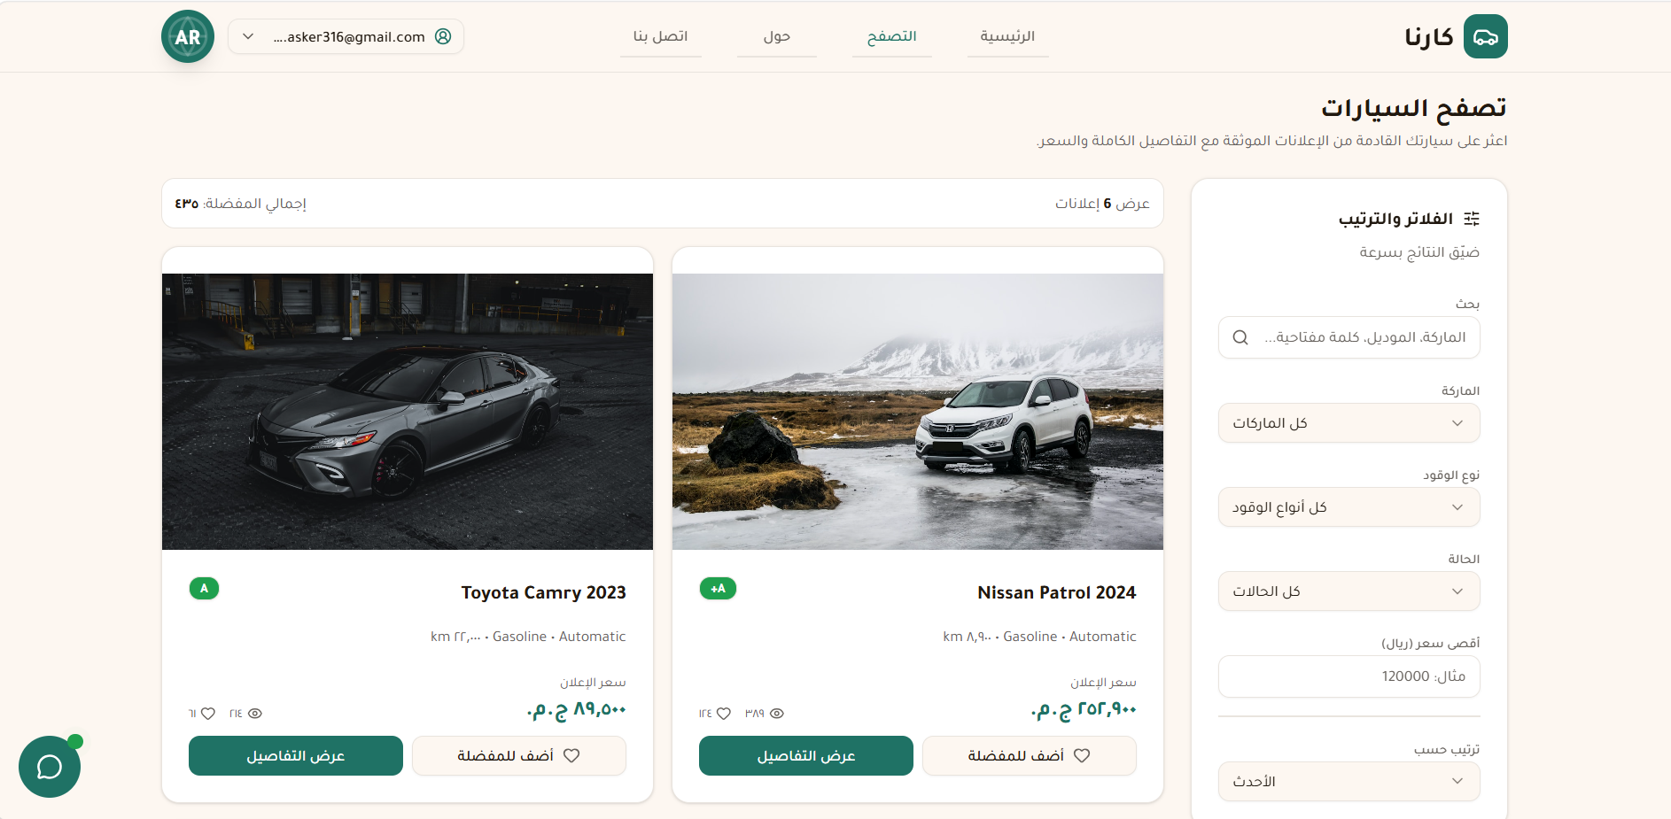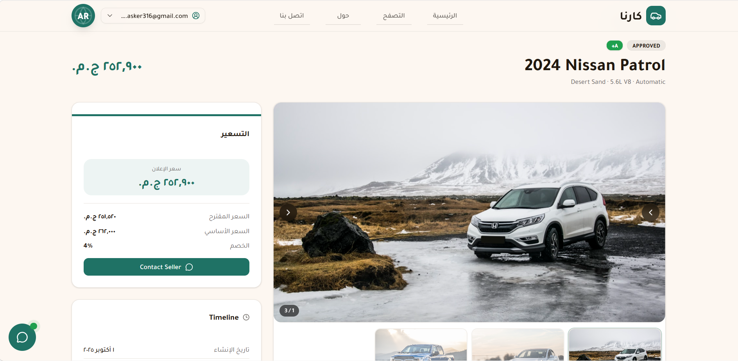
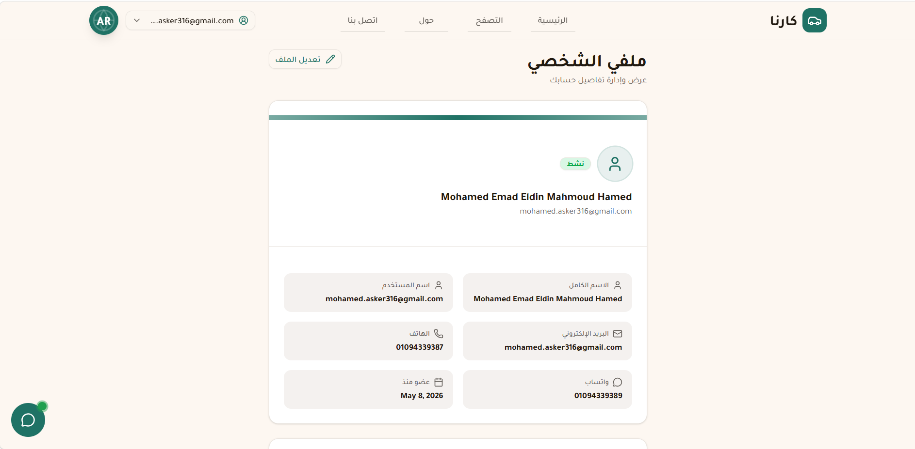

Seller Pages
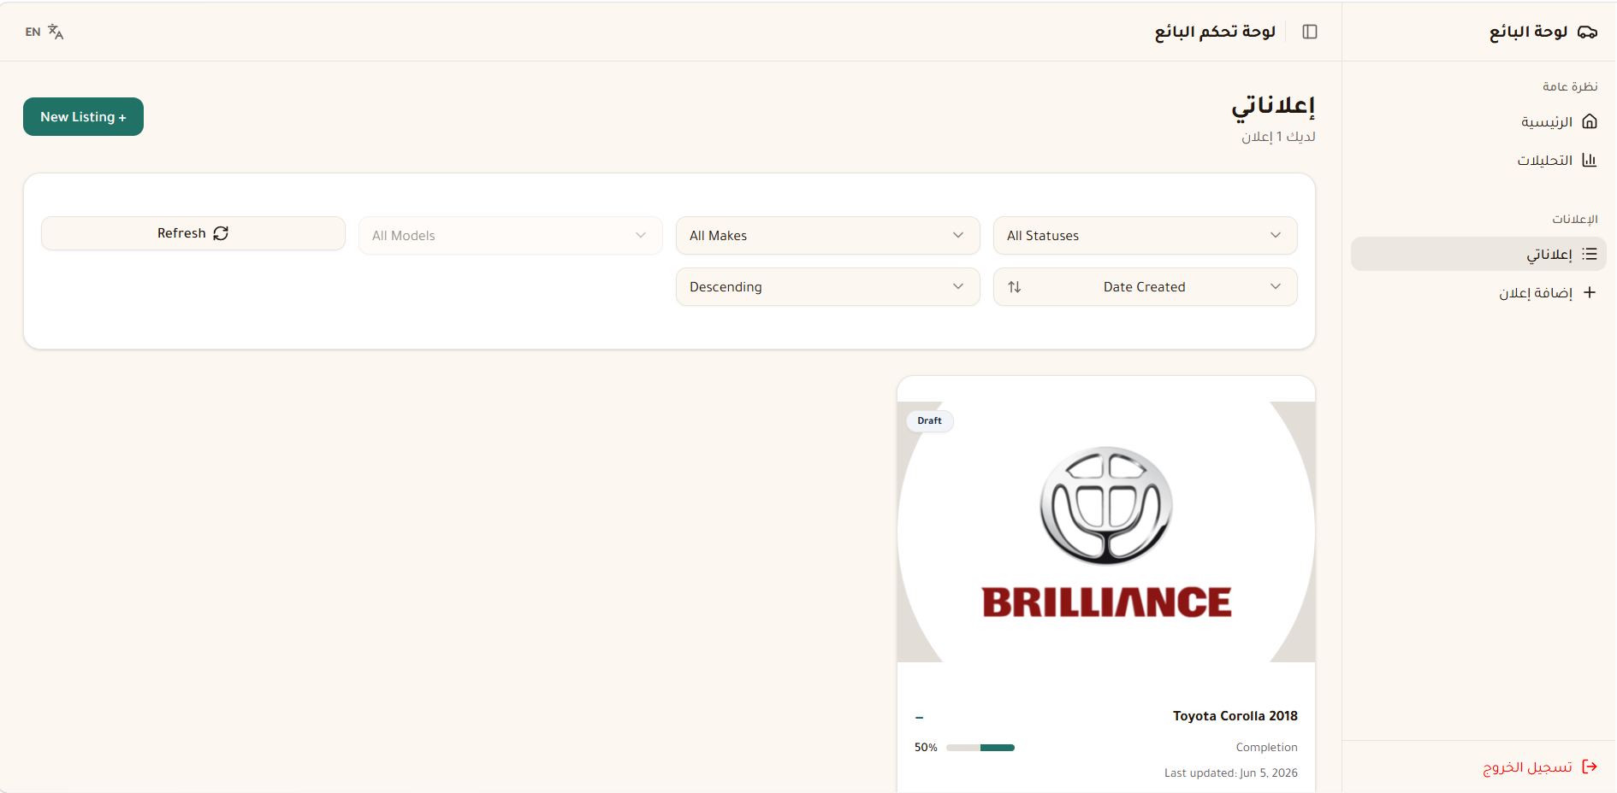

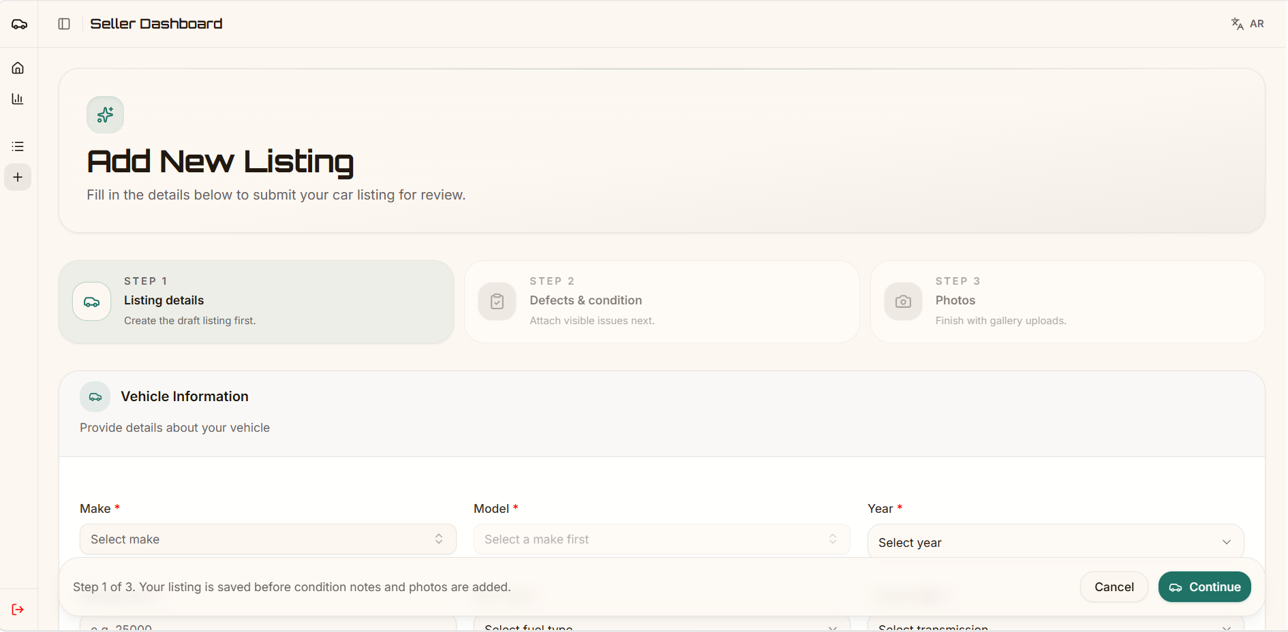
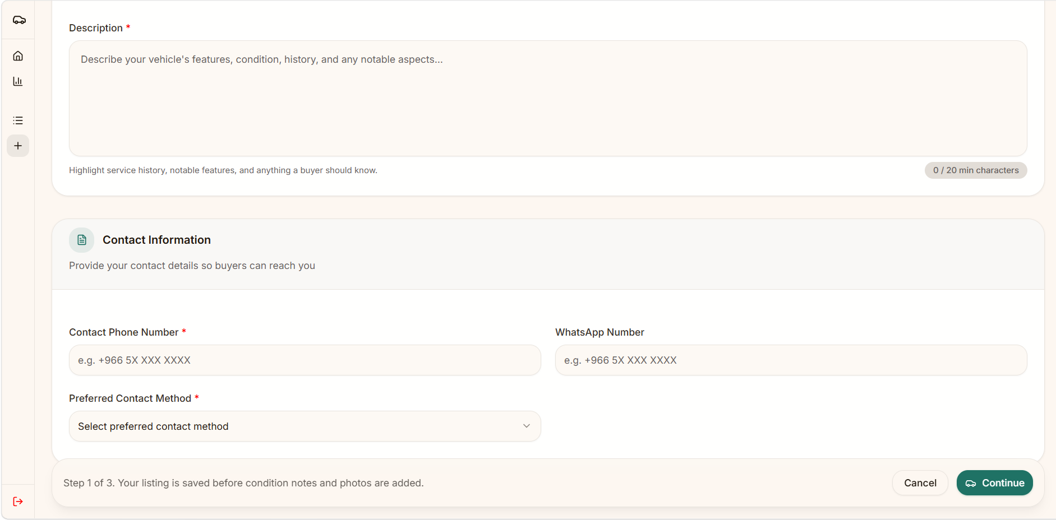

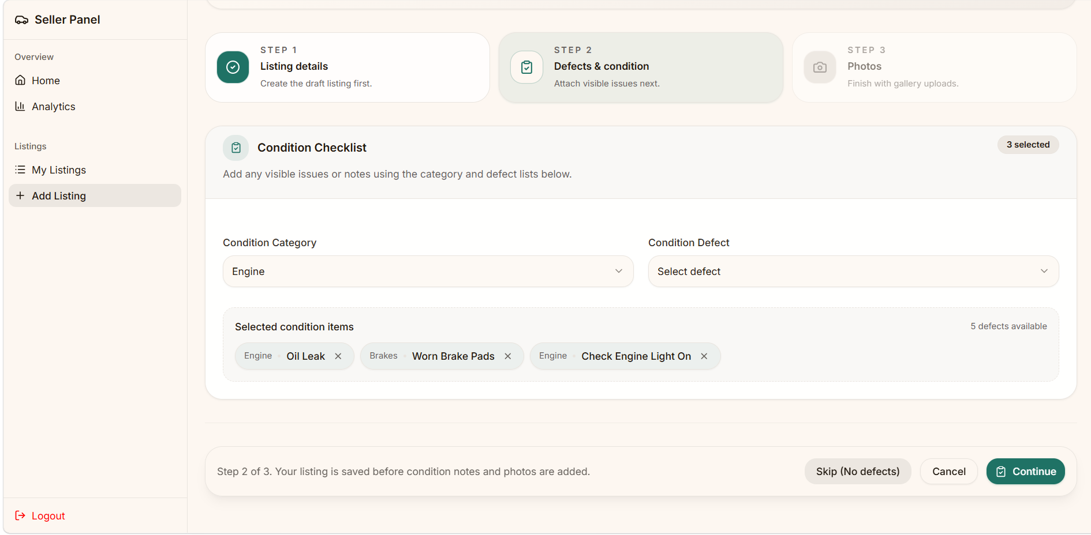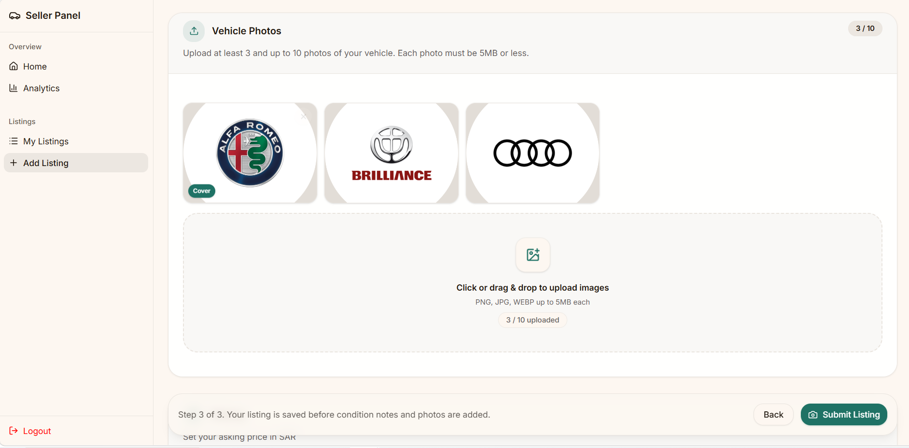
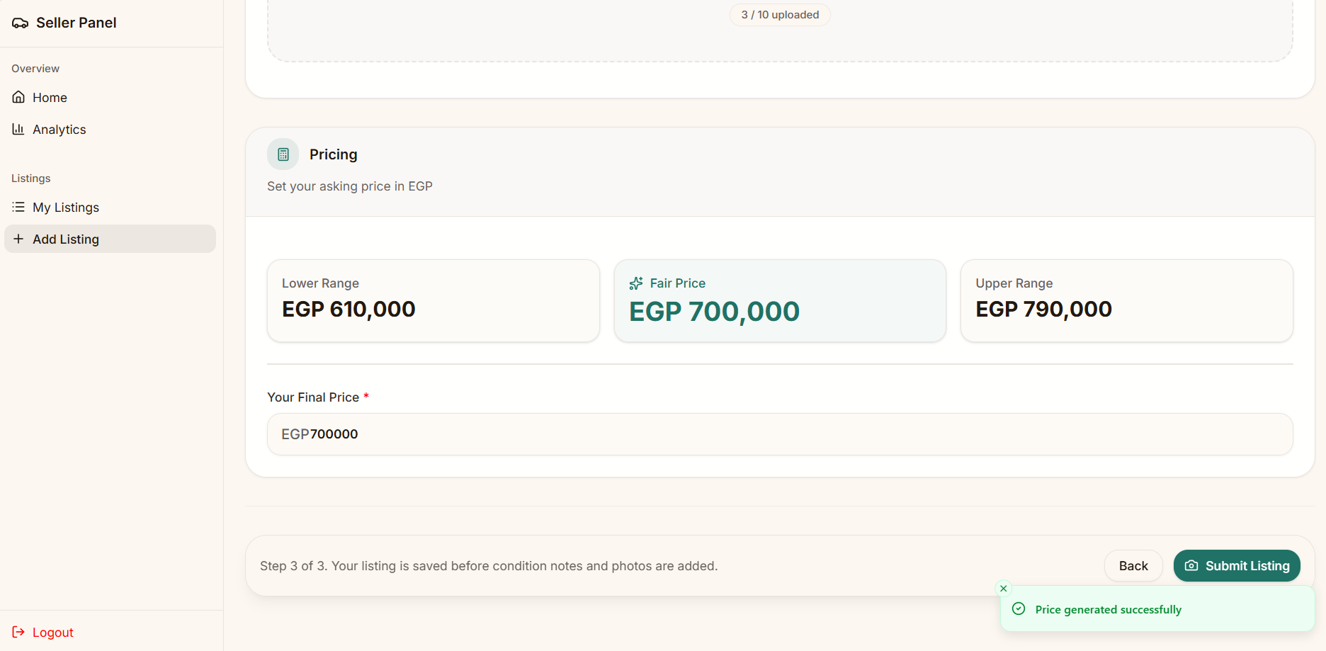
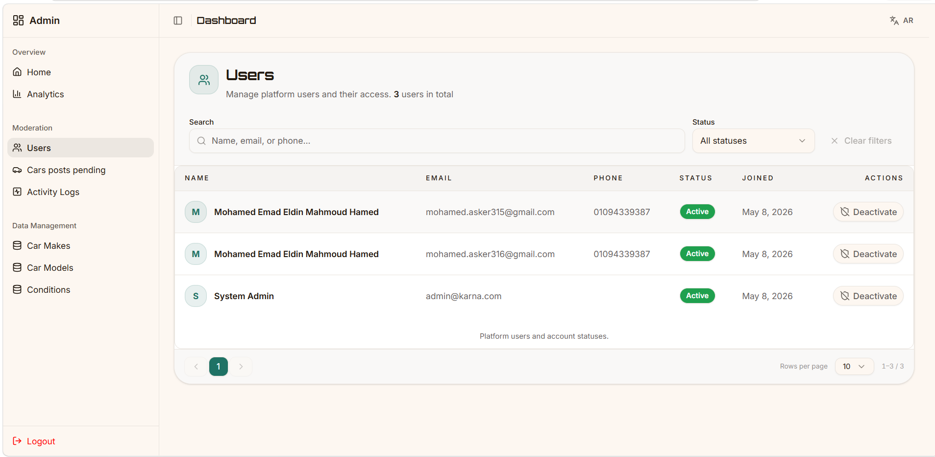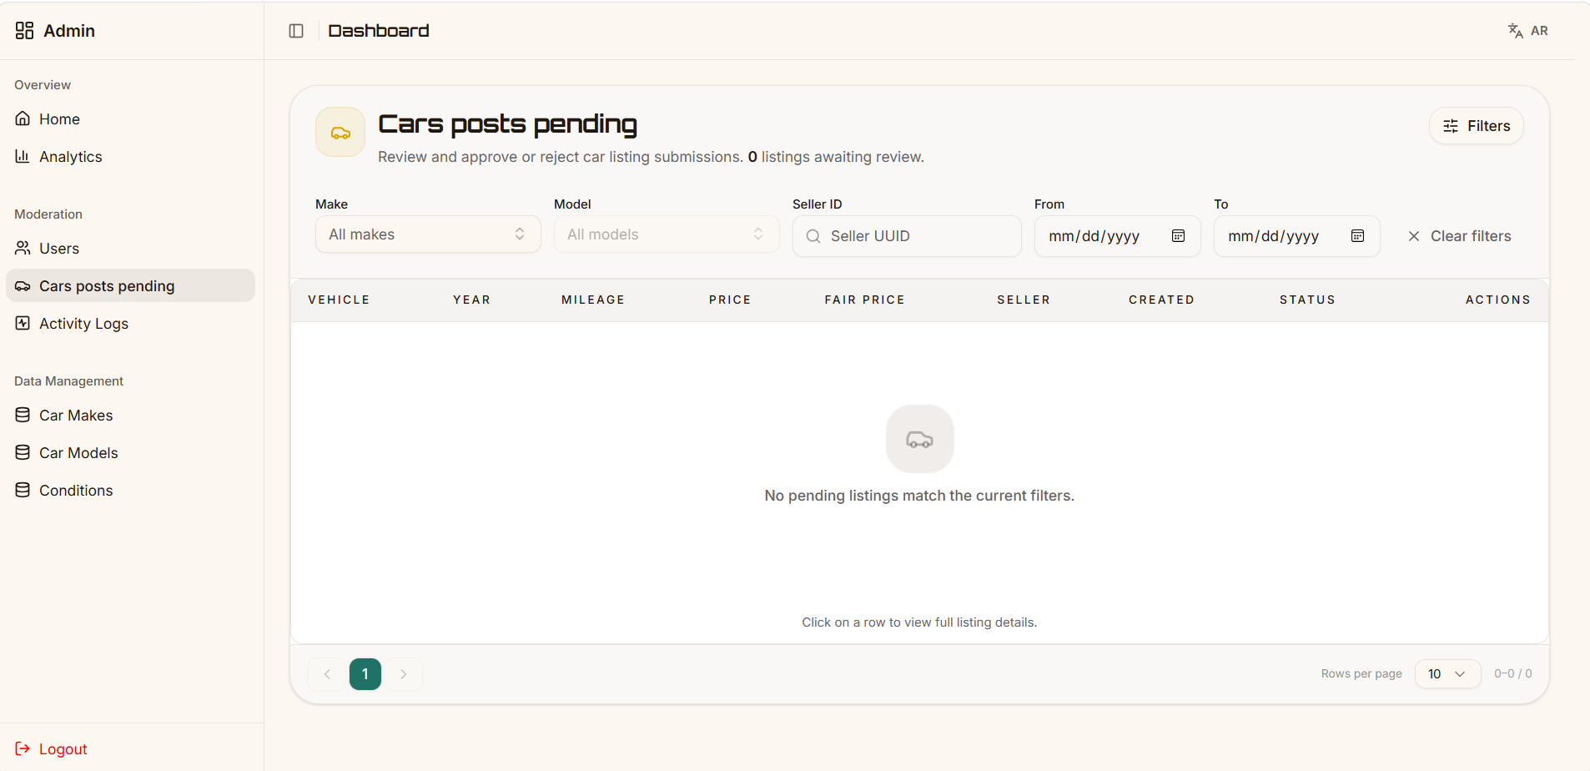

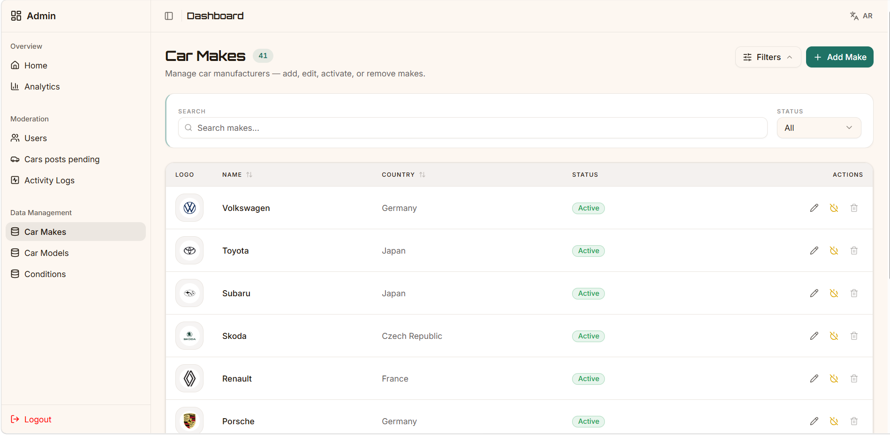
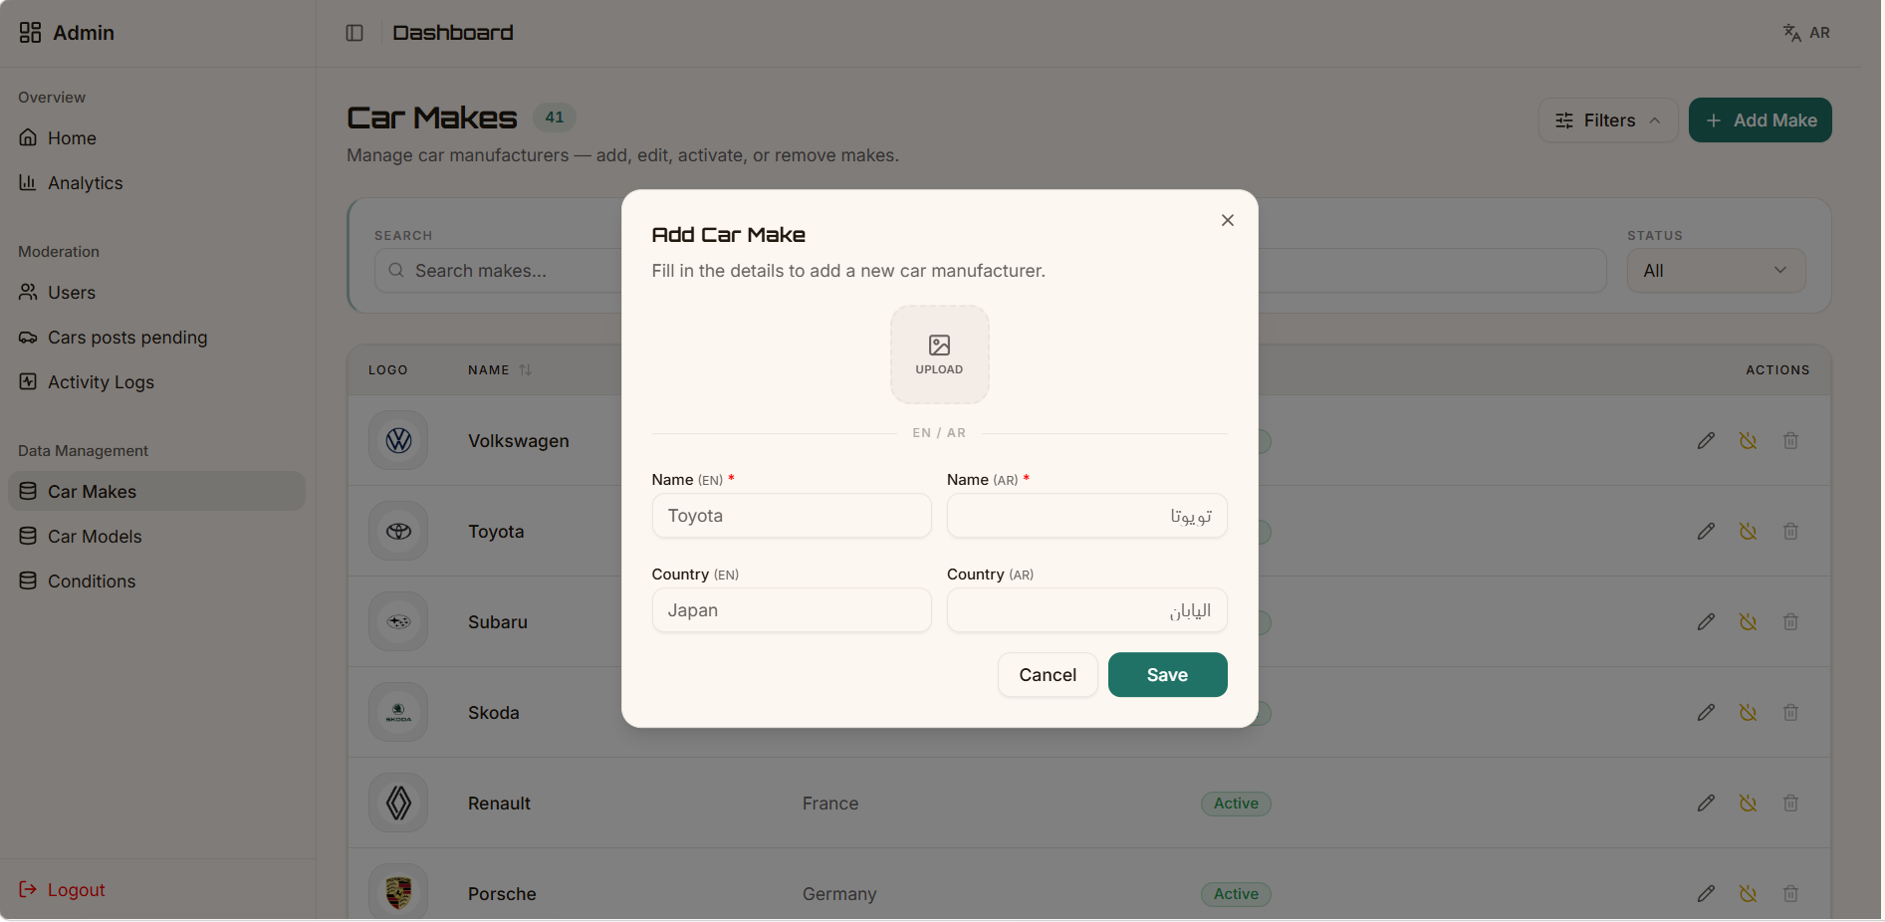
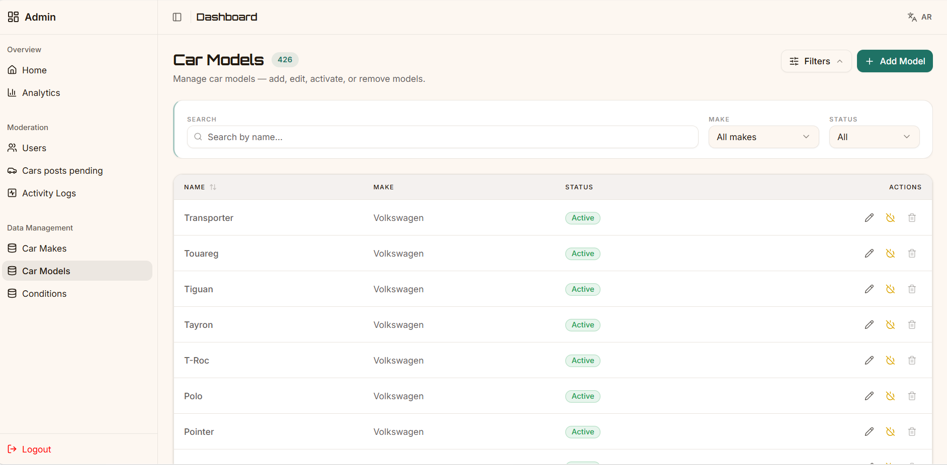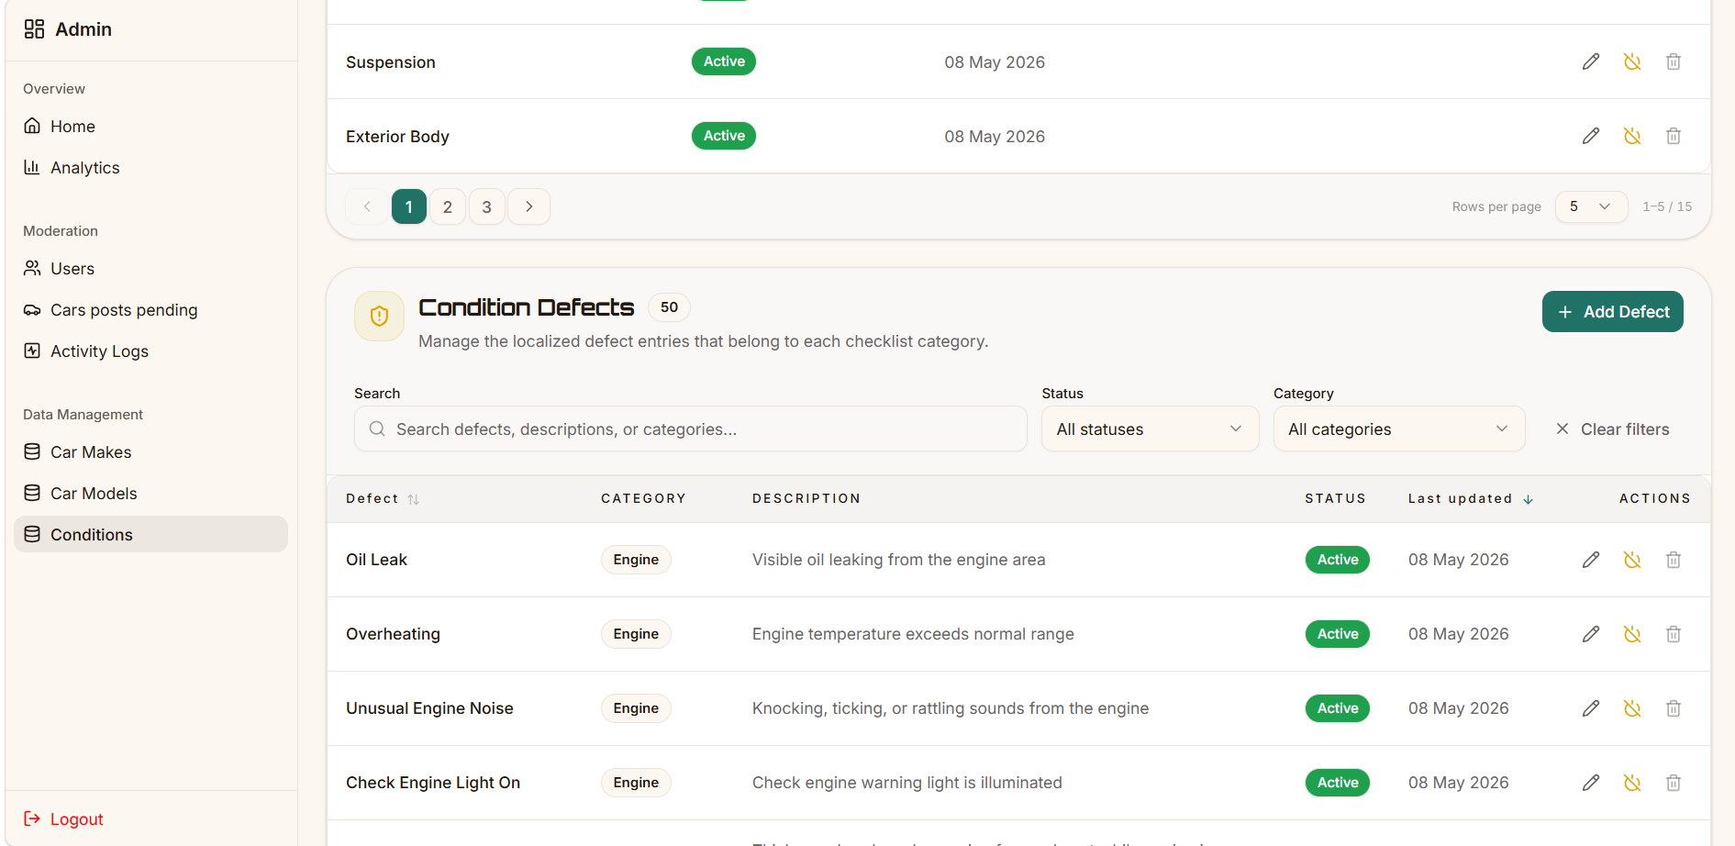

Chat UI
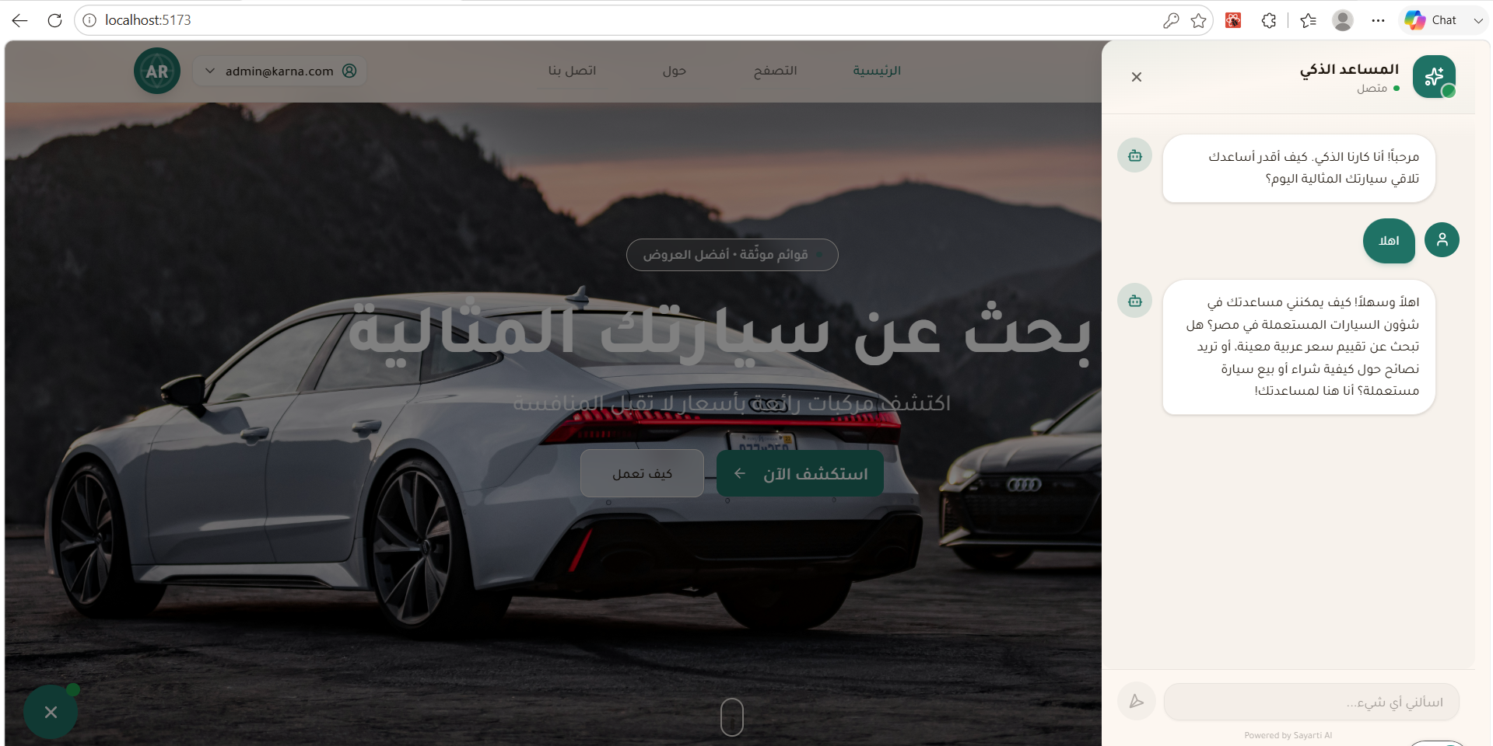

Design System (Storybook)

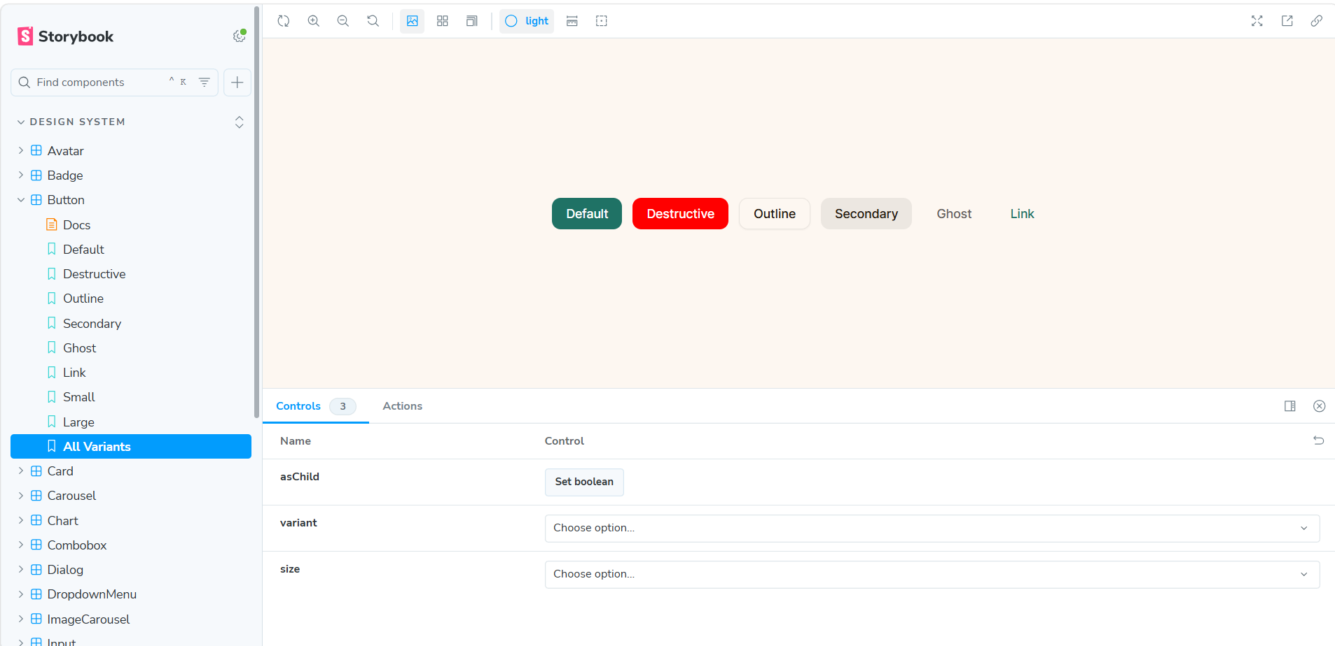

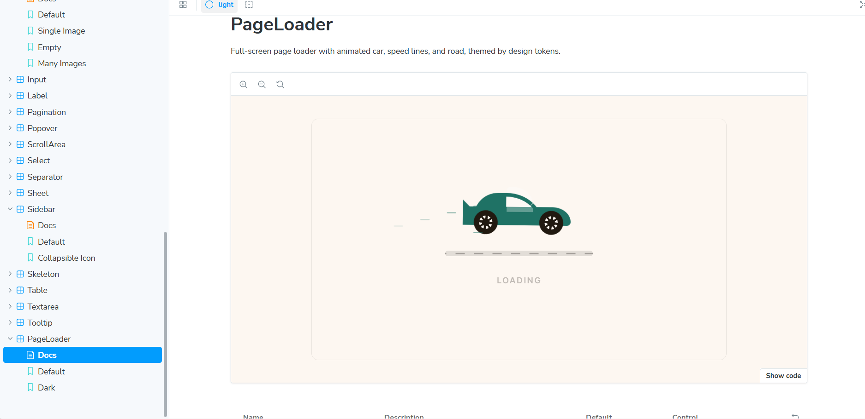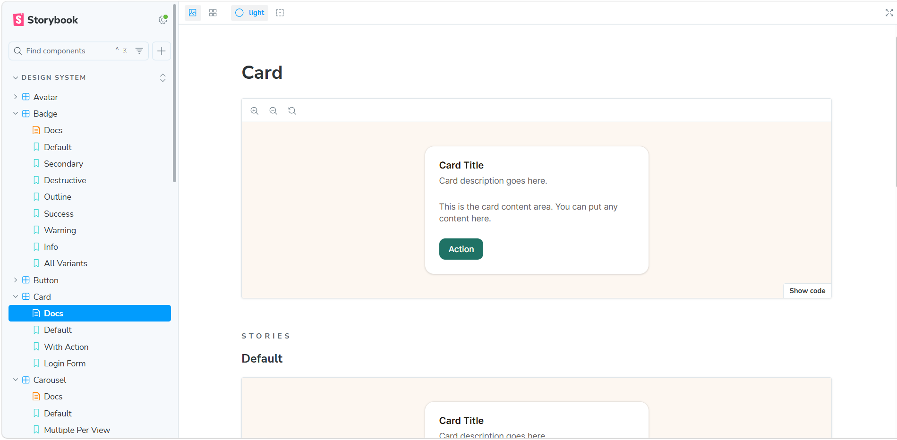
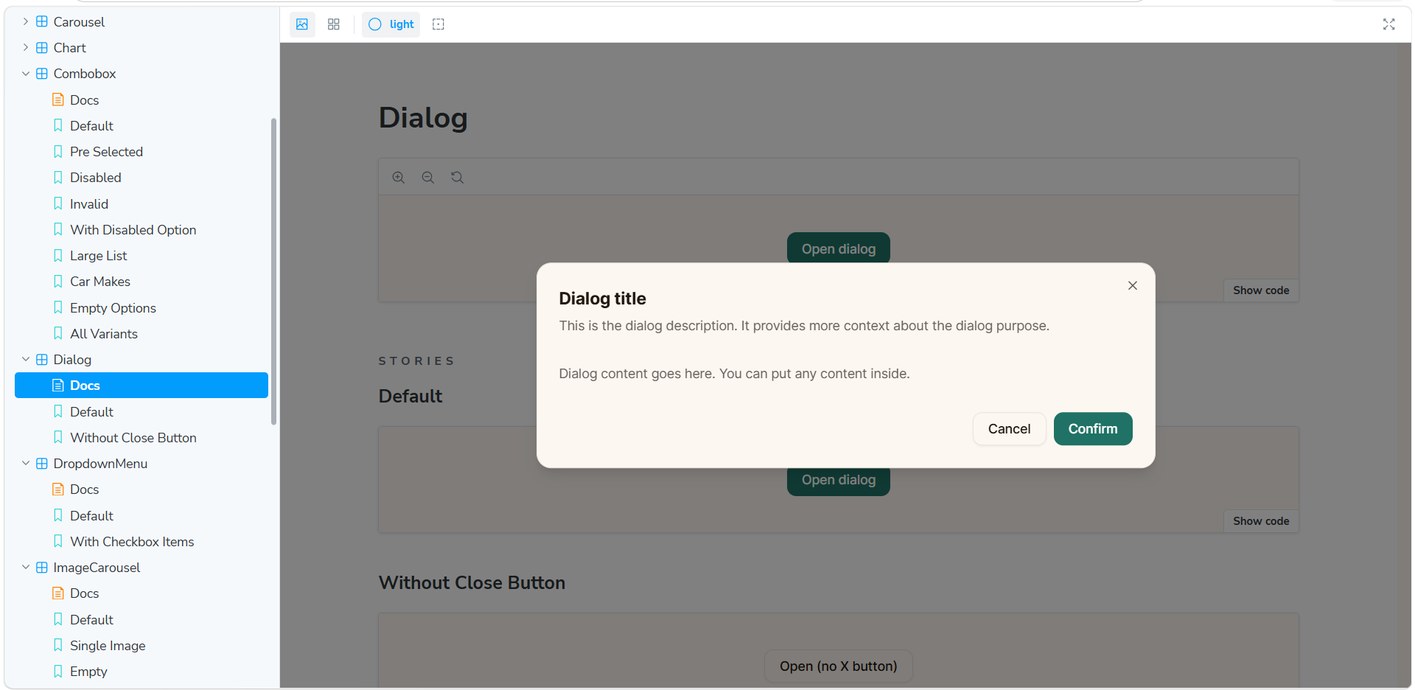

A.3 Frontend References
Reference | Purpose
React Documentation | Component model, hooks, lazy loading
React Router v6 Documentation | Routing, nested routes, route guards
Vite Documentation | Build configuration, manual chunks
Axios Documentation | Interceptors, withCredentials, retry logic
i18next Documentation | Language detection, namespaces, RTL integration
Tailwind CSS v4 Documentation | Utility classes, @theme inline, logical properties
TanStack Query Documentation | QueryClient configuration, stale time, GC
Radix UI Primitives | Accessible headless component primitives used in design system
shadcn/ui | Ownership model, component scaffolding via CLI
class-variance-authority | Typed component variant definitions in design system
clsx | Conditional class name composition
tailwind-merge | Tailwind class conflict resolution in cn() utility
Storybook Documentation | Component isolation, visual testing, and catalog

2. Data Engineering Appendix

Appendix A — Airflow DAG Source Structure
The data_pipeline DAG file is located at dags/data_pipeline.py in the project repository. The TaskFlow API is used throughout. Key task functions:
- scrape_dubizzle() — BashOperator triggering the Dubizzle scraping script
- scrape_hatla2ee() — BashOperator triggering the Hatla2ee scraping script
- extract_dubizzle() / extract_hatla2ee() — read CSV into DataFrame
- clean_dubizzle() / clean_hatla2ee() — source-specific cleaning
- union_datasets() — merge with schema enforcement
- final_clean() — cross-source normalization and deduplication
- add_scraping_num() — version assignment
- load_to_db() — PostgreSQL load via SQLAlchemy
Insert Airflow DAG screenshot and/or annotated code snippet here.

Appendix B — Docker Compose Service Inventory
Service | Image | Role
postgres | postgres:15 | Airflow metadata database
airflow-api | apache/airflow:3.0.0 | REST API server for Airflow UI and CLI
airflow-scheduler | apache/airflow:3.0.0 | Parses and schedules DAG runs
airflow-dag-processor | apache/airflow:3.0.0 | Processes and validates DAG files
airflow-triggerer | apache/airflow:3.0.0 | Manages deferred task triggers
kafka | confluentinc/cp-kafka | Message broker (topics, partitions)
zookeeper | confluentinc/cp-zookeeper | Kafka coordination service

