Project: Naive Bayes, Feature Selection, and PCA
Naive Bayes Classifier, Feature Selection, and Dimensionality Reduction

1. Dataset Description

1.1 Dataset 1: Mushroom (Categorical)
Property | Details
Source | UCI Machine Learning Repository (ID: 73)
Instances | 8,124
Features | 22 categorical features (veil-type dropped as constant)
Class Distribution | Edible: 4,208 (~52%) | Poisonous: 3,916 (~48%)
Missing Values | stalk-root: 2,480 missing (30.5%) — imputed with mode

Justification: All 22 features are categorical (object dtype), making this dataset ideal for CategoricalNB. It also allows exploration of PCA challenges on categorical data when label-encoded to integers.

1.2 Dataset 2: Iris (Numerical)
Property | Details
Source | sklearn built-in dataset (load_iris)
Instances | 150
Features | 4 numerical features (sepal length/width, petal length/width in cm)
Class Distribution | Setosa: 50 | Versicolor: 50 | Virginica: 50 (balanced)
Missing Values | None

Justification: All features are continuous numerical values, making this dataset ideal for GaussianNB. Its small size and perfectly balanced classes make it a reliable benchmark for PCA effectiveness on numerical data.

2. Algorithm Implementation

2.1 Naive Bayes Classifier
Two variants of Naive Bayes were used, matched to each dataset type:
- CategoricalNB — Applied to the Mushroom dataset. Assumes features follow a categorical distribution and models the conditional probability of each category given the class label.
- GaussianNB — Applied to the Iris dataset. Assumes each feature follows a Gaussian (normal) distribution and estimates class-conditional mean and variance.

Preprocessing steps for both datasets:
- Train/test split with stratify=True to preserve class proportions (80/20 split).
- Mushroom: LabelEncoder applied to all categorical columns; missing stalk-root values imputed with mode; veil-type dropped (zero variance).
- Iris: No preprocessing required (no missing values, all numerical).

2.2 PCA — From Scratch Implementation
PCA was implemented entirely from scratch using only NumPy, without using sklearn.decomposition.PCA. The implementation follows these mathematical steps:

Step 1: Mean Centering
X_centered = X - mean(X, axis=0)
Each feature is shifted by its mean so that the data is centered around the origin. This removes bias in variance calculations.
Step 2: Covariance Matrix
Cov(X) = (1 / (n-1)) * X_centered^T * X_centered
The covariance matrix captures how features vary together. Using numpy.cov() with rowvar=False ensures each column is treated as a variable.
Step 3: Eigen Decomposition
Cov(X) * v = lambda * v
numpy.linalg.eig() decomposes the covariance matrix into eigenvalues (lambda) and eigenvectors (v). Eigenvalues represent the amount of variance explained by each component; eigenvectors define the direction of each principal component.
Step 4: Sort and Select Top-k Components
Eigenvalues are sorted in descending order. The top-k eigenvectors (principal components) that capture the most variance are selected to form the projection matrix.
Step 5: Transform Data
X_PCA = X_centered * Components
The centered data is projected onto the selected principal components to produce the reduced-dimensionality representation.

3. Experimental Pipeline

3.1 Dataset 1 — Mushroom (Categorical)
Experiment 0: Baseline — All Features + CategoricalNB
Metric | Value
Accuracy | 0.9471 (94.71%)
Macro Avg Precision | 0.95
Macro Avg Recall | 0.95
Macro Avg F1-Score | 0.95
Test Samples | 1,625

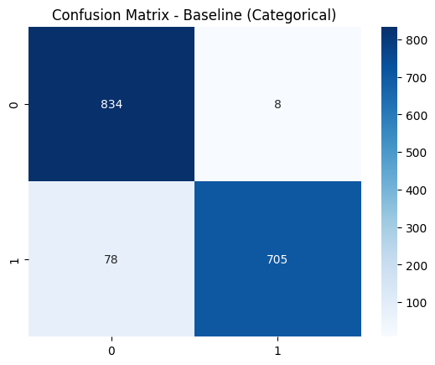
Figure 1: Confusion Matrix — Mushroom Baseline
Experiment A: Feature Selection + CategoricalNB
Method: SelectKBest with chi2 statistic (top 10 features selected).
Metric | Value
Accuracy | 0.9009 (90.09%)
Macro Avg Precision | 0.91
Macro Avg Recall | 0.90
Macro Avg F1-Score | 0.90
Features Used | 10 out of 21

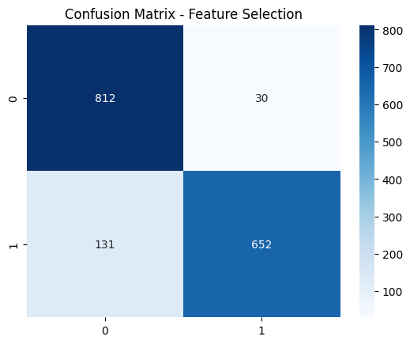
Figure 2: Confusion Matrix — Mushroom Feature Selection
Experiment B: PCA (From Scratch) + CategoricalNB
Best k found by iterating k = 1 to 21 and selecting the value yielding maximum accuracy.
Metric | Value
Best k (components) | 17
Accuracy | 0.9009 (90.09%)
Macro Avg Precision | 0.91
Macro Avg Recall | 0.90
Macro Avg F1-Score | 0.90

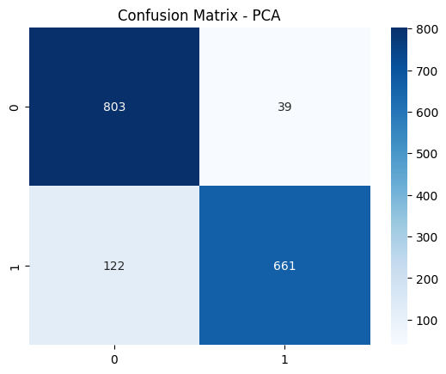
Figure 3: Confusion Matrix — Mushroom PCA (k=17)
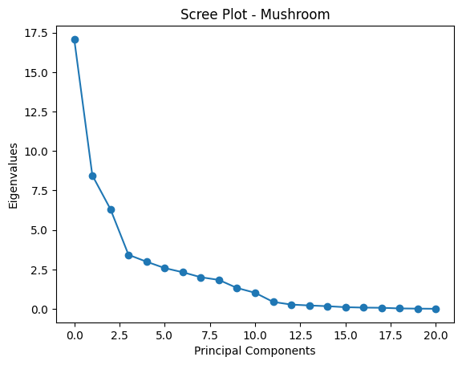
Figure 4: Scree Plot — Mushroom
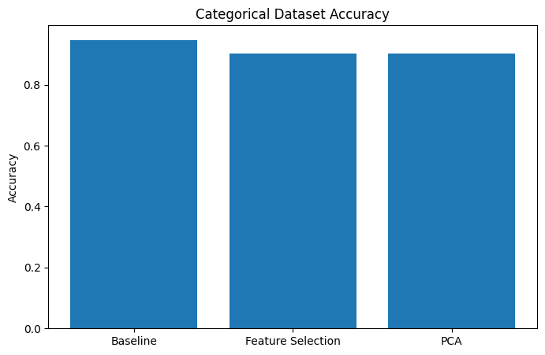
Figure 5: Accuracy Comparison Bar Chart — Mushroom

3.2 Dataset 2 — Iris (Numerical)
Experiment 0: Baseline — All Features + GaussianNB
Metric | Value
Accuracy | 0.9667 (96.67%)
Macro Avg Precision | 0.97
Macro Avg Recall | 0.97
Macro Avg F1-Score | 0.97
Test Samples | 30

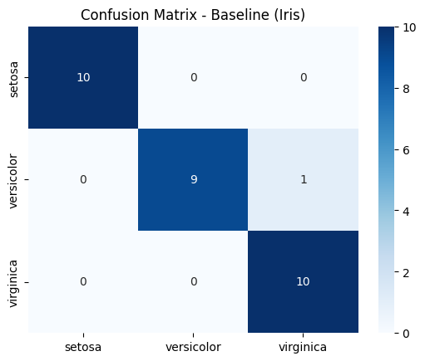
Figure 6: Confusion Matrix — Iris Baseline
Experiment A: Feature Selection + GaussianNB
Method: SelectKBest with f_classif (ANOVA F-value), top 2 features selected.
Metric | Value
Accuracy | 0.9667 (96.67%)
Macro Avg Precision | 0.97
Macro Avg Recall | 0.97
Macro Avg F1-Score | 0.97
Features Used | 2 out of 4

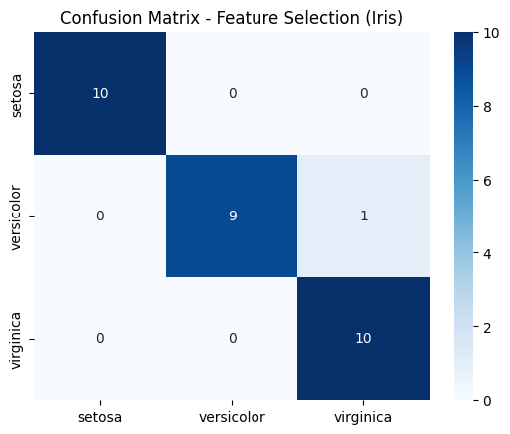
Figure 7: Confusion Matrix — Iris Feature Selection
Experiment B: PCA (From Scratch) + GaussianNB
Best k found by iterating k = 1 to 4.
Metric | Value
Best k (components) | 1
Accuracy | 0.9333 (93.33%)
Macro Avg Precision | 0.93
Macro Avg Recall | 0.93
Macro Avg F1-Score | 0.93

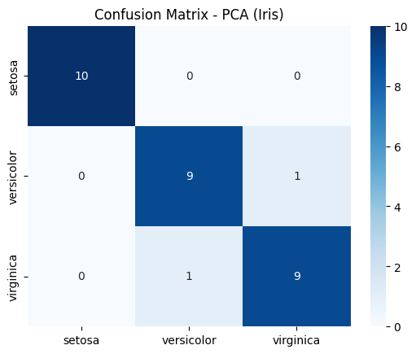
Figure 8: Confusion Matrix — Iris PCA (k=1)

Figure 9: Scree Plot — Iris
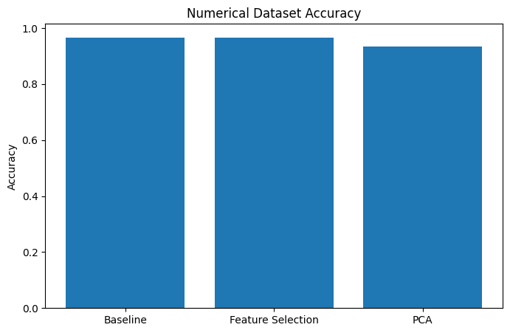
Figure 10: Accuracy Comparison Bar Chart — Iris

4. Comparative Analysis

4.1 Accuracy Comparison Table
Method | Mushroom (Categorical) | Iris (Numerical)
Baseline (All Features) | 94.71% | 96.67%
Feature Selection | 90.09% | 96.67%
PCA (From Scratch) | 90.09% | 93.33%

4.2 Analysis and Discussion
How did Naive Bayes perform on categorical versus numerical data?
GaussianNB (Iris, numerical) achieved 96.67% accuracy on the baseline, slightly outperforming CategoricalNB (Mushroom, categorical) at 94.71%. GaussianNB is theoretically well-suited to continuous features where the Gaussian distribution assumption is a reasonable approximation. CategoricalNB performed well but is more sensitive to feature encoding and the presence of many categories per feature.

Which approach achieved better results for each dataset? Why?
- Mushroom (Categorical): The Baseline using all features achieved the best accuracy (94.71%). Feature Selection and PCA both yielded 90.09%. The baseline benefits from having all 21 features without information loss. Feature selection still performed well by retaining the 10 most chi2-significant features, while PCA required 17 components to match that accuracy because it needed most of the variance to compensate for treating encoded categorical data as continuous.
- Iris (Numerical): Baseline and Feature Selection tied at 96.67%. PCA with k=1 achieved 93.33%, slightly lower because compressing 4 features to a single component loses some discriminative information between Versicolor and Virginica, which overlap more in the principal component space.

How did both methods compare to the baseline model?
For the Mushroom dataset, both Feature Selection and PCA reduced accuracy compared to the baseline by approximately 4.6 percentage points. This suggests that the full feature set contains complementary information that neither method fully preserves. For the Iris dataset, Feature Selection matched baseline performance exactly, demonstrating that the 2 selected features were sufficient to discriminate all 3 classes. PCA degraded accuracy slightly because a single principal component, while capturing maximum variance, is not optimal for classification when class boundaries exist in multiple directions.

What are the trade-offs between feature selection and feature reduction?
Aspect | Feature Selection | PCA (Feature Reduction)
Interpretability | High — original features retained | Low — components are linear combinations
Categorical Data | Highly suitable (chi2 test) | Less suitable (assumes numerical continuity)
Information Loss | Removes irrelevant features | Compresses all variance into k dimensions
Dimensionality | Subset of original features | Dense projection of all features
Best for | High-dimensional categorical data | Continuous data with correlated features

Is PCA appropriate for categorical data? Discussion.
PCA is fundamentally designed for continuous numerical data. It operates by computing a covariance matrix from feature values and extracting directions of maximum variance. When applied to label-encoded categorical features, several problems arise:
- Ordinal bias: LabelEncoder assigns arbitrary integer codes (e.g., 0, 1, 2) to categories with no natural ordering. PCA treats these as numerical distances, introducing misleading relationships.
- Variance distortion: Categories with more integer values assigned to them appear to have higher variance, skewing the principal components.
- Accuracy loss: In our experiment, PCA on the Mushroom dataset required k=17 (out of 21) components to achieve only 90.09% accuracy, compared to 94.71% for the baseline. This confirms that PCA is an inefficient dimensionality reduction tool for categorical data.
- Better alternatives for categorical data include Multiple Correspondence Analysis (MCA), which is the categorical equivalent of PCA, or using chi2-based feature selection as demonstrated in Experiment A.

5. Conclusion
This assignment demonstrated the application of Naive Bayes classification combined with two dimensionality reduction strategies — feature selection and PCA — across categorical and numerical datasets.

- Naive Bayes is effective on both dataset types, with GaussianNB performing slightly better on the numerical Iris dataset due to its distributional assumptions aligning well with the data.
- Feature Selection (chi2 for categorical, f_classif for numerical) is the more appropriate dimensionality reduction technique for categorical data. For the Iris dataset it preserved full accuracy with only 2 of 4 features.
- PCA from scratch correctly implements the standard algorithm (centering, covariance, eigen-decomposition, projection). It performs well on numerical data but is theoretically mismatched with categorical features.
- The Baseline model using all features remained the best or tied-best performer in both datasets, suggesting that neither feature selection nor PCA improved over the original representation when the feature set is already clean and informative.
- The trade-off between interpretability (feature selection) and maximum variance preservation (PCA) should guide the choice of method based on data type and downstream requirements.

