EJADA EGYPT
Summer Internship Program 2026
Cloud Build Track
OCI & TERRAFORM
Hands-on Labs & Deployment Documentation

Prepared by: | Mohamed Essam
Track: | Cloud Build — OCI & Terraform
Cloud Provider: | Oracle Cloud Infrastructure (OCI)
Region: | Saudi Arabia West (Jeddah) — me-jeddah-1
Date: | August 2026

2. Project Overview
This document reports the hands-on deployment work completed as part of the Ejada Egypt Summer Internship Program 2026, Cloud Build Track. The engagement covers two complementary labs on Oracle Cloud Infrastructure (OCI): a manual, console-driven deployment of a Linux compute environment (Lab 1), and an Infrastructure-as-Code approach to the same class of deployment using Terraform (Lab 2).
The report documents the actual sequence of actions performed in the OCI Console and via SSH on the deployed instance, using the evidence captured throughout the labs. All resource names, CIDR blocks, compartments, and configuration values referenced in this report are taken directly from the console screenshots and terminal sessions produced during the labs.
The deployment establishes a self-contained Virtual Cloud Network (VCN) with public internet connectivity, a compute instance running Oracle Linux, and an attached iSCSI block volume formatted and mounted for persistent data storage.

3. Objectives
The objectives of the hands-on labs were to:
- Design and provision a Virtual Cloud Network (VCN) with a public subnet, Internet Gateway, and routing suitable for internet-facing workloads.
- Deploy a Linux-based Compute instance into the provisioned network using the OCI Console.
- Attach, configure, and mount an additional Block Volume as persistent storage on the compute instance via the iSCSI protocol.
- Establish secure remote administration of the instance using SSH key-based authentication.
- Understand and apply the Infrastructure-as-Code (IaC) approach to OCI provisioning using Terraform, including provider configuration, resource definitions, variables, and outputs.
- Produce professional technical documentation suitable for internship evaluation, reflecting real-world Cloud/DevOps engineering practice.

4. Environment & Prerequisites
The following environment and prerequisites were used throughout the labs:
Item | Value
Cloud Provider | Oracle Cloud Infrastructure (OCI)
Region | Saudi Arabia West (Jeddah) — me-jeddah-1
Compartment | intern-20-mohamed-essam-cmp
Operating System | Oracle Linux 9 (Oracle-Linux-9.8-2026.07.20-0)
Compute Shape | VM.Standard.E5.Flex (Flexible AMD shape)
Console Access | OCI Web Console
Remote Access Tool | Windows PowerShell with OpenSSH client
IaC Tool | Terraform (OCI Provider)

Access to the OCI Console required a provisioned internship (intern-20) compartment, and remote administration of the deployed instance required an SSH key pair generated prior to instance creation. Private key material is not reproduced in this report for security reasons; only the public outcome of key-based authentication is documented.

5. Lab 1 — OCI Compute Deployment
Lab 1 covers the manual, console-driven provisioning of the networking and compute infrastructure required to run a Linux workload on OCI. The steps below are presented in the actual deployment sequence: network foundation first, followed by compute instance creation, storage attachment, and verification.

5.1 Virtual Cloud Network (VCN) Creation
The deployment begins with the creation of a dedicated Virtual Cloud Network named lab1-vcn inside the intern-20-mohamed-essam-cmp compartment. The VCN was assigned the IPv4 CIDR block 10.0.0.0/16, providing address space for all subnets used in the lab. DNS hostnames were enabled for the VCN with the DNS label vcn1, allowing instances to be resolved by name within the network.
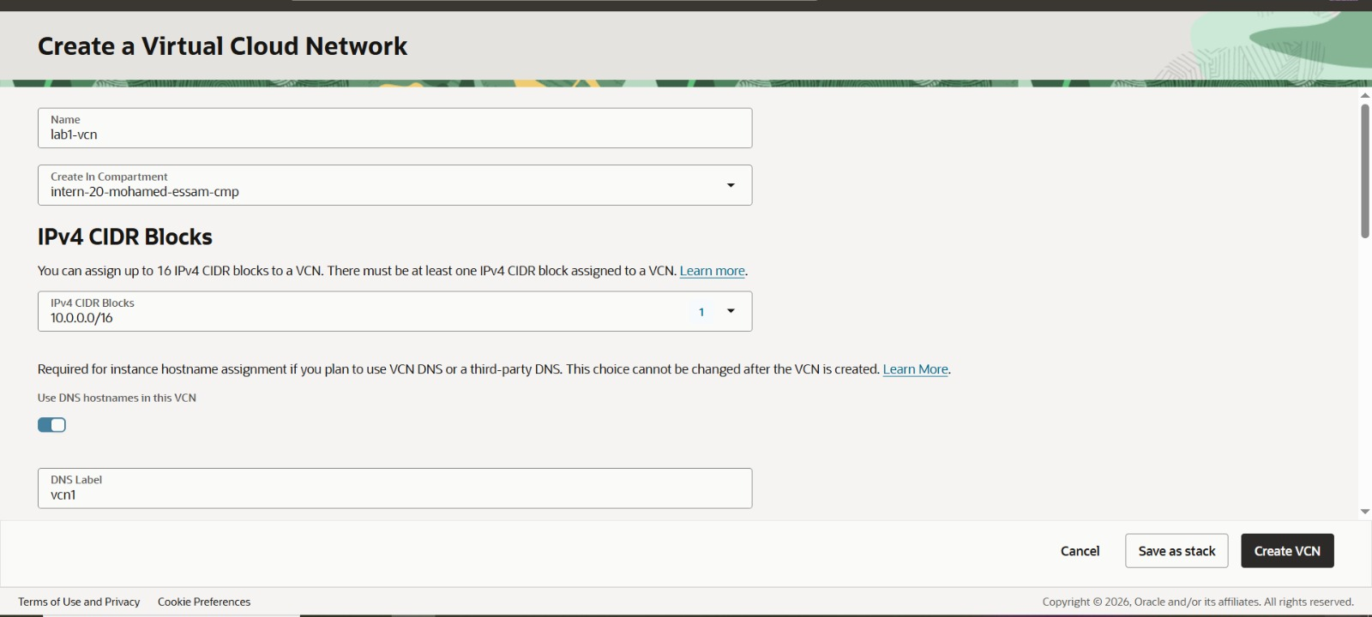
Figure 1 — VCN creation form showing name (lab1-vcn), compartment, and IPv4 CIDR block (10.0.0.0/16).
Once created, the VCN details confirm the assigned configuration: compartment intern-20-mohamed-essam-cmp, CIDR block 10.0.0.0/16, an automatically generated DNS resolver, a default route table ("Default Route Table for lab1-vcn"), and the DNS domain name vcn1.oraclevcn.com.
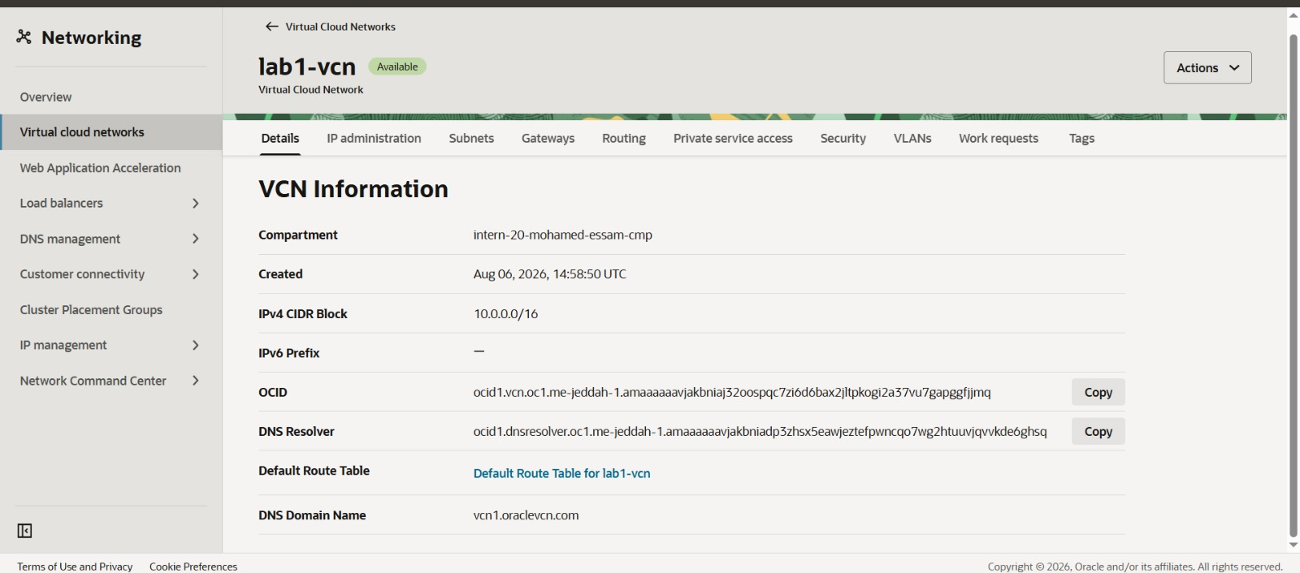
Figure 2 — VCN Information page confirming CIDR block, DNS resolver, default route table, and DNS domain name.

5.2 Public Subnet Creation
A regional public subnet, public-subnet-lab1, was created within lab1-vcn using the IPv4 CIDR block 10.0.0.0/24 (256 usable addresses). The Regional subnet type was selected, allowing instances placed in the subnet to be created in any availability domain within the region, which supports higher availability than an availability-domain-specific subnet.
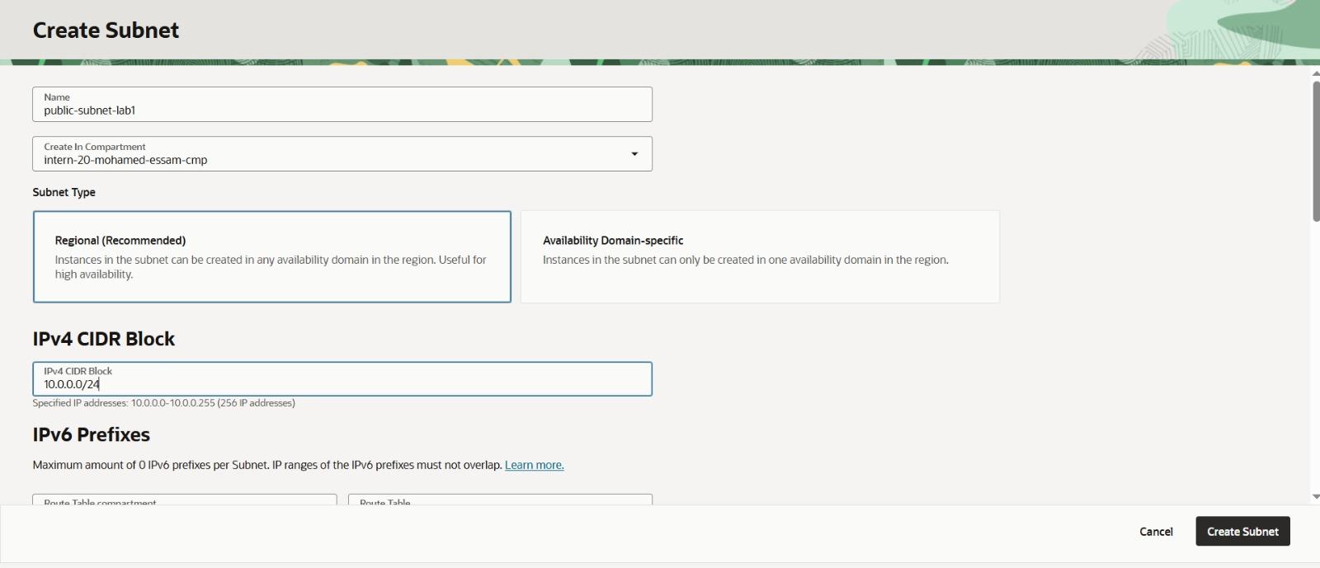
Figure 3 — Create Subnet form for public-subnet-lab1 with Regional subnet type and CIDR block 10.0.0.0/24.

5.3 Internet Gateway
To provide outbound and inbound internet connectivity for resources in the public subnet, an Internet Gateway named lab1-igw was created within the compartment and attached to lab1-vcn. The gateway's state is shown as Available.
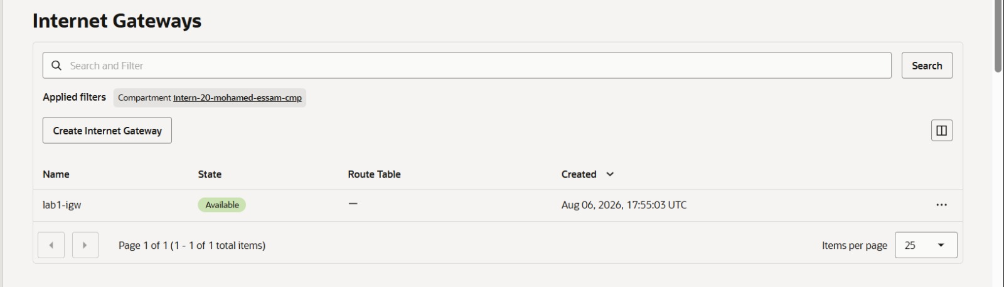
Figure 4 — Internet Gateways list showing lab1-igw in an Available state.

5.4 Route Table Configuration
Internet-bound traffic from the public subnet is routed through the Internet Gateway using the VCN's default route table ("Default Route Table for lab1-vcn"). A static route rule was added with destination 0.0.0.0/0 targeting the Internet Gateway lab1-igw, which routes all outbound traffic to the internet.
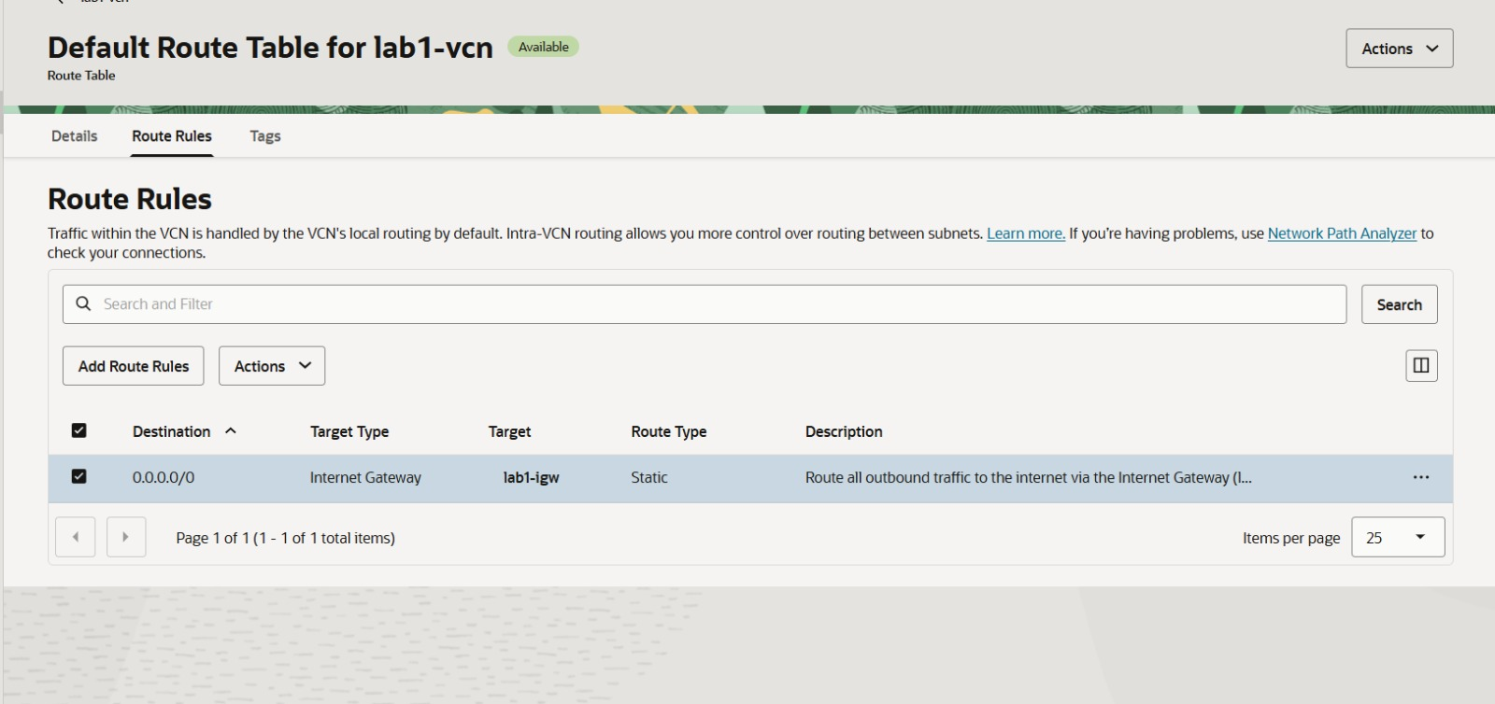
Figure 5 — Route Rules for the default route table: destination 0.0.0.0/0 routed via Internet Gateway lab1-igw (Static).

5.5 Security List
Instance-level traffic in the VCN is additionally controlled by the Default Security List for lab1-vcn, which works alongside any firewall rules configured on the instance itself. This security list governs ingress and egress traffic permitted at the subnet level for resources such as the lab1-instance compute instance.
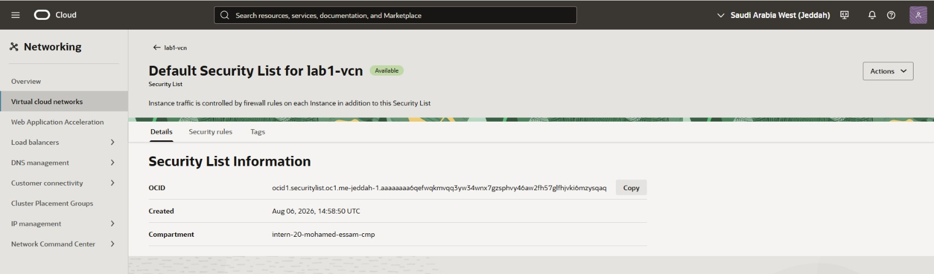
Figure 6 — Default Security List for lab1-vcn, associated with the VCN's network security configuration.

5.6 Compute Instance — Basic Information
The compute instance was provisioned through the OCI Console "Create compute instance" wizard. The instance was named lab1-instance and created inside the intern-20-mohamed-essam-cmp compartment, with placement in availability domain AD-1 (oXVt:ME-JEDDAH-1-AD-1).
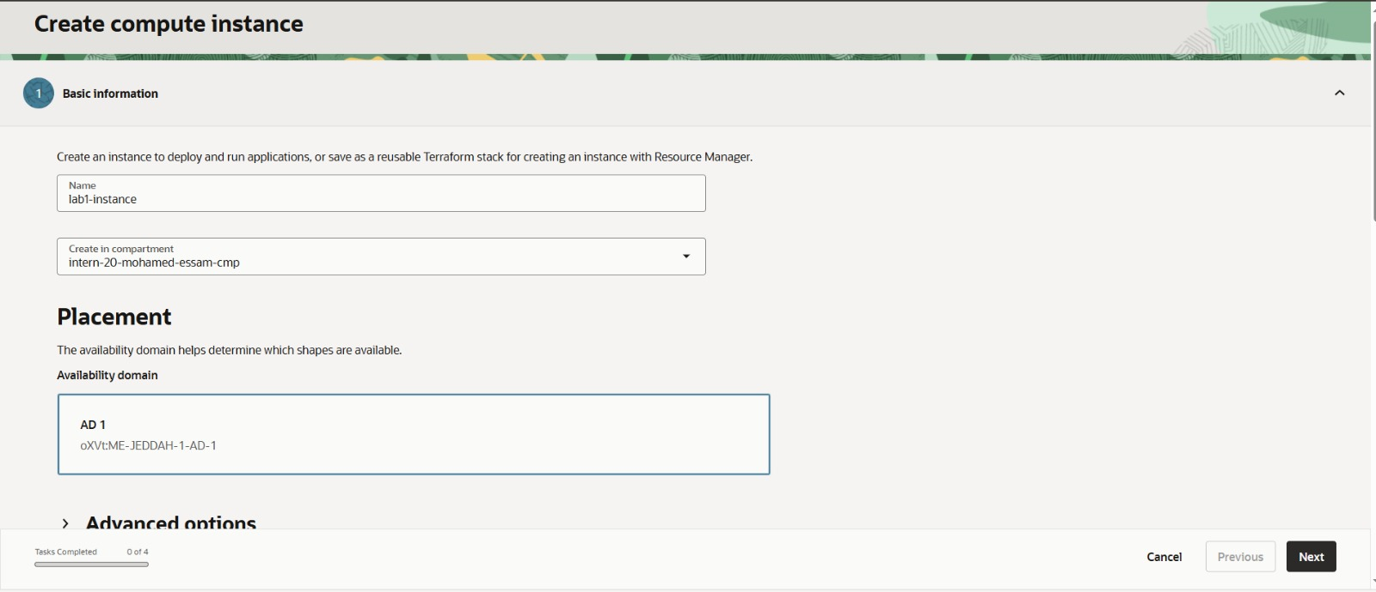
Figure 7 — Create Compute Instance wizard — Basic Information step, showing instance name lab1-instance and availability domain AD-1.

5.7 Boot Volume Configuration
During instance creation, the Storage step confirmed the boot volume configuration. The default boot volume size was used, and in-transit encryption was enabled to encrypt data moving between the instance, the boot volume, and any attached block volumes.
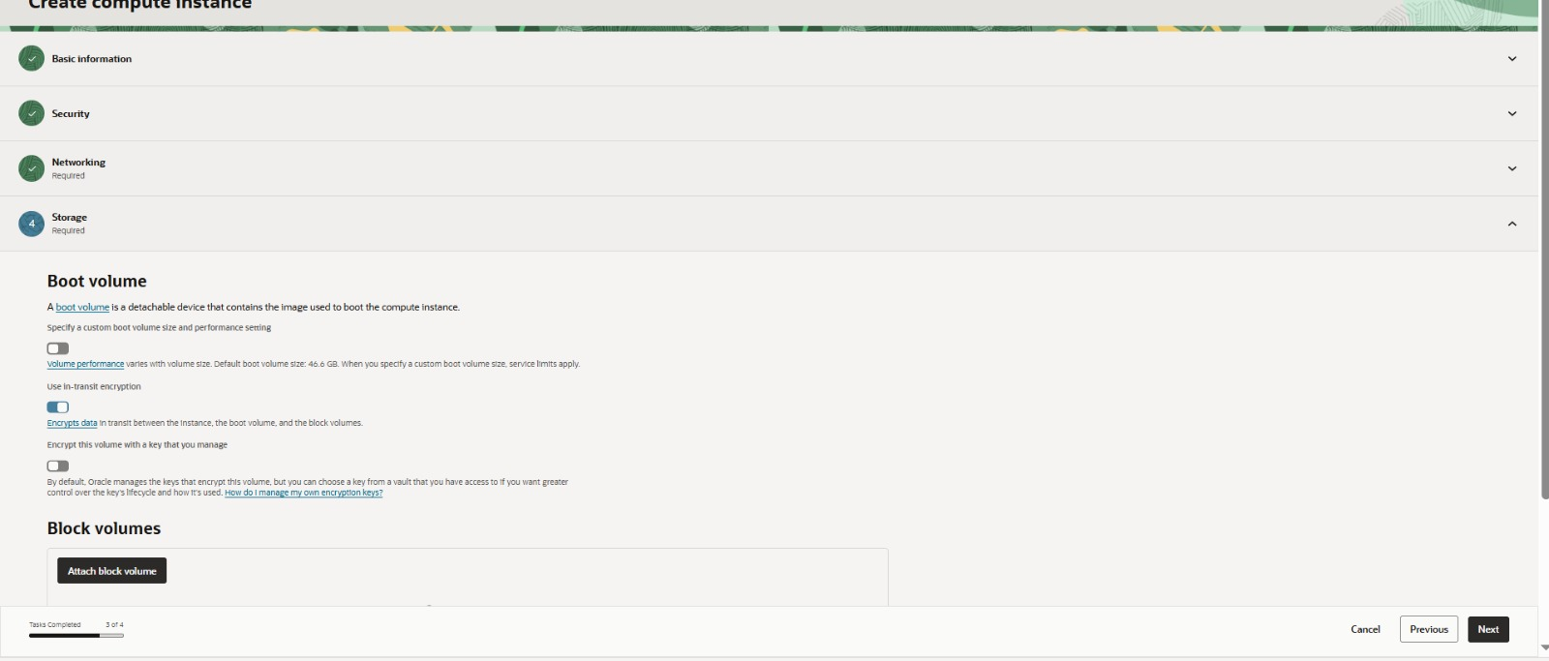
Figure 8 — Create Compute Instance wizard — Storage step, showing boot volume settings with in-transit encryption enabled.

5.8 Review and Instance Creation
With Basic Information, Security, Networking, and Storage steps completed (4 of 4 tasks), the wizard's Review step summarized the configuration prior to creation, confirming the instance name lab1-instance and compartment intern-20-mohamed-essam-cmp before the Create action was submitted.
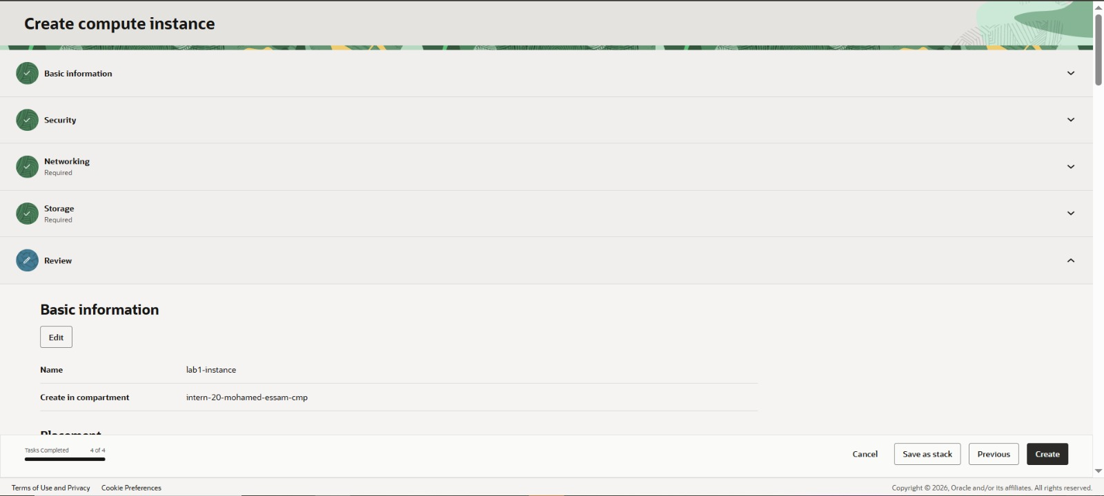
Figure 9 — Create Compute Instance wizard — Review step with all four configuration tasks completed.

5.9 Instance Verification
Following creation, lab1-instance reached the Running state. The instance details confirm the deployed configuration: Oracle Linux 9 (image Oracle-Linux-9.8-2026.07.20-0), shape VM.Standard.E5.Flex with 1 OCPU and 12 GB of memory, availability domain AD-1 / fault domain FD-2, and network placement in the lab1-vcn network.
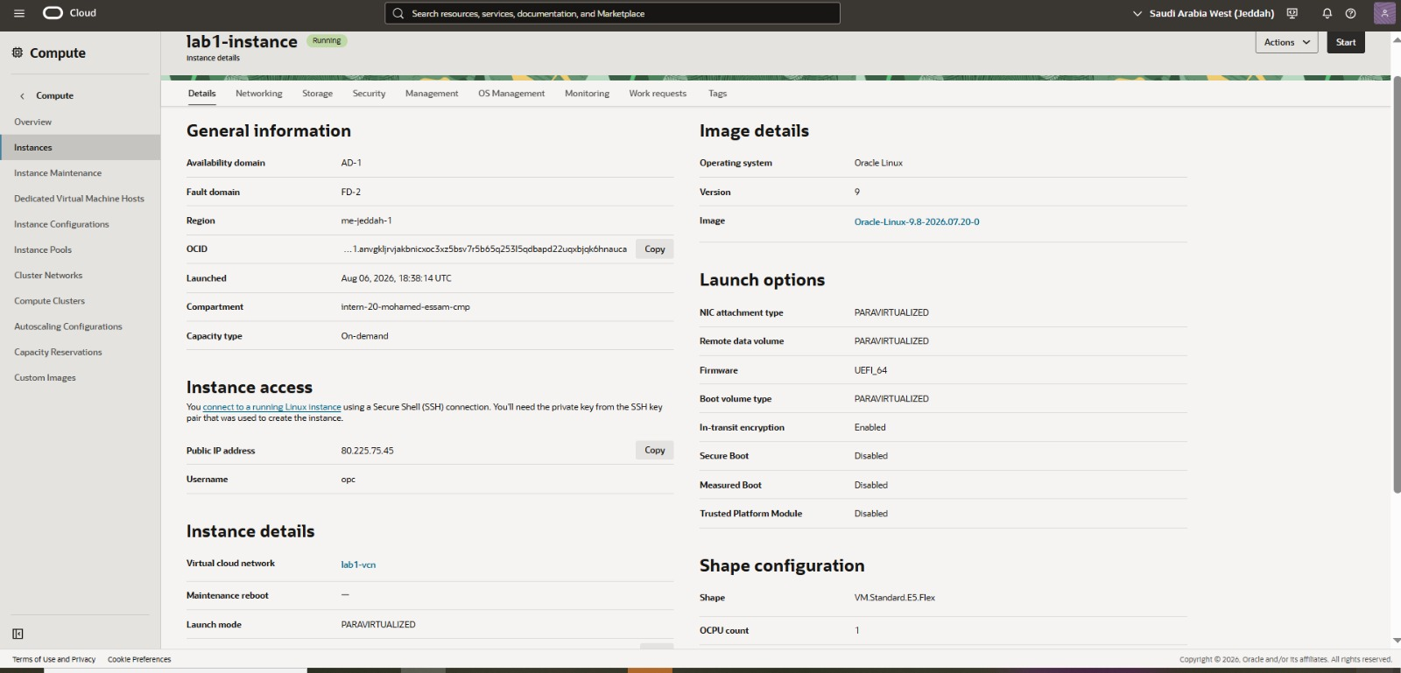
Figure 10 — lab1-instance Details page showing general information, image details, launch options, and shape configuration.

5.10 Block Volume Attachment
A dedicated Block Volume, lab1-block-volume, was attached to the running instance to provide persistent, high-performance storage independent of the boot volume's lifecycle. The volume was created with the default size and performance settings: 1024 GB capacity, Balanced performance tier, and 25,000 IOPS (60 IOPS/GB), in the same availability domain as the instance (oXVt:ME-JEDDAH-1-AD-1).
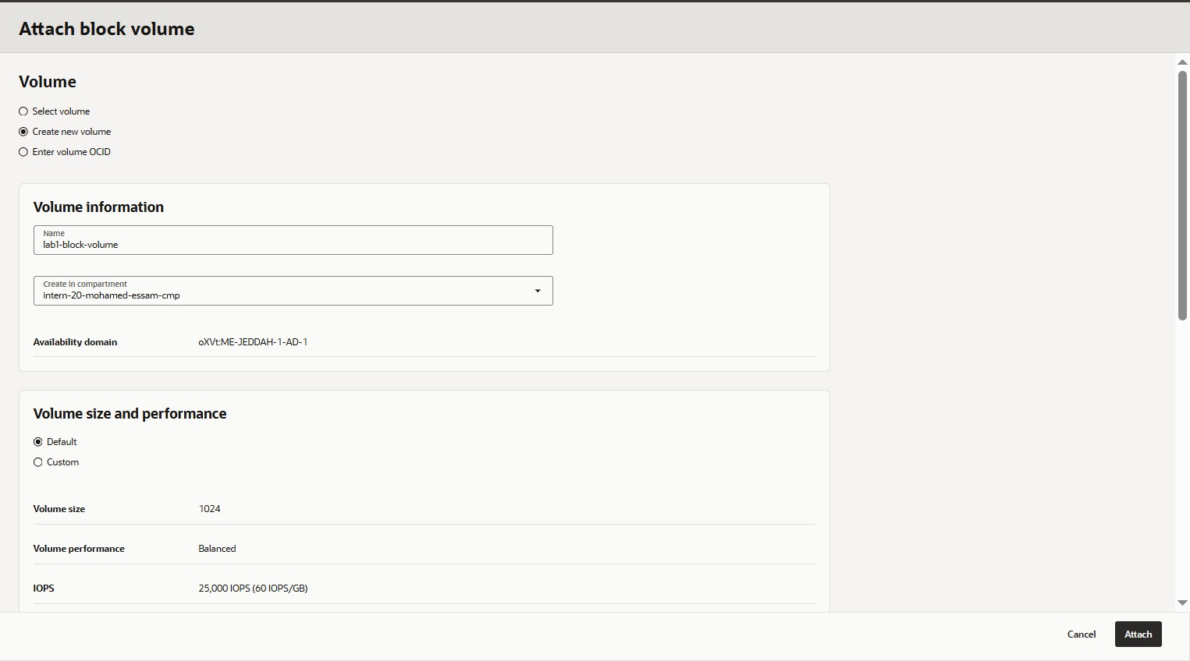
Figure 11 — Attach Block Volume dialog — creating and attaching lab1-block-volume (1024 GB, Balanced performance, 25,000 IOPS).
After the attachment completed, the instance's Storage tab confirmed both the 47 GB boot volume and the 1 TB lab1-block-volume in an Attached state, connected over the ISCSI protocol with Read/Write access.
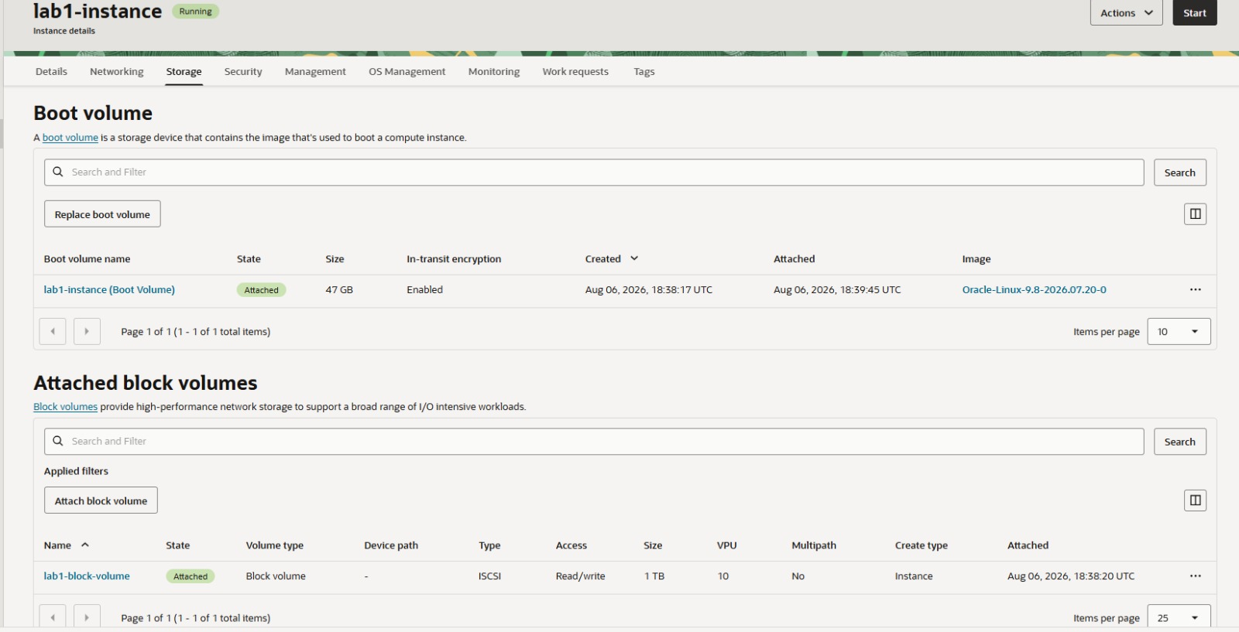
Figure 12 — Instance Storage tab showing the attached boot volume and the 1 TB lab1-block-volume (iSCSI, Read/Write).

6. Lab 2 — Terraform Deployment
Lab 2 applies an Infrastructure-as-Code (IaC) approach to provisioning the same class of OCI environment built manually in Lab 1, using Terraform and the OCI provider. This section documents the intended configuration structure and the standard Terraform workflow followed for the lab. No Terraform console/CLI screenshots were included in the evidence set provided for this report; this section is therefore presented as a description of the IaC methodology and configuration approach rather than as a screenshot-verified deployment record. Resource-level values (such as CIDR blocks and instance names) mirror the equivalent Lab 1 console deployment where applicable.

6.1 Terraform Configuration Files
A typical Terraform project for this deployment is organized into the following files, each with a distinct responsibility:
File | Purpose
provider.tf | Declares the OCI provider and authentication configuration (tenancy, user, region, API key) required for Terraform to communicate with the OCI API.
variables.tf | Declares input variables (e.g., compartment OCID, VCN CIDR, instance shape, SSH public key) so the configuration can be reused across environments without hard-coded values.
network.tf | Defines networking resources: the VCN, public subnet, Internet Gateway, route table, and security list.
compute.tf | Defines the compute instance resource, referencing the network resources, chosen image, shape, and SSH key for instance access.
outputs.tf | Exposes useful values after deployment, such as the instance's public IP address, for use by the operator or downstream tooling.
terraform.tfvars.example | Provides an example set of variable values (without secrets) that operators copy to terraform.tfvars and populate with environment-specific values.

6.2 Terraform Workflow
The standard Terraform workflow used to plan, apply, and manage the infrastructure lifecycle consists of the following commands:
Command | Purpose / Result
terraform init | Initializes the working directory, downloads the OCI provider plugin, and configures the Terraform backend.
terraform fmt | Rewrites configuration files to a canonical formatting style for readability and consistency.
terraform validate | Checks the configuration for internal consistency and syntax correctness without contacting OCI.
terraform plan | Produces an execution plan showing which resources will be created, changed, or destroyed, without making any changes.
terraform apply | Applies the execution plan, provisioning or updating the actual OCI resources to match the configuration.
terraform output | Displays the values defined in outputs.tf after a successful apply, such as the instance public IP.
terraform destroy | Tears down all resources managed by the Terraform state, returning the environment to its pre-deployment state.

6.3 Core Terraform Concepts
- Provider — the plugin (oci) that translates Terraform resource definitions into calls against the OCI API.
- Variables — named, typed inputs that parameterize a configuration so it can be reused across compartments, regions, or environments.
- Resources — the declarative building blocks (e.g., oci_core_vcn, oci_core_instance) that describe the desired state of infrastructure.
- Data Sources — read-only lookups (e.g., the latest Oracle Linux image) that pull existing information from OCI into the configuration without managing it.
- Outputs — values exported from a configuration after apply, used to surface information such as IP addresses or resource OCIDs.
- Terraform State — the record Terraform maintains of the real-world resources it manages, used to compute the difference between desired and actual infrastructure on each plan or apply.
- Infrastructure as Code (IaC) — managing and provisioning infrastructure through versioned, declarative configuration files rather than manual console operations, enabling repeatability, peer review, and consistent environments.

Note: Because no Terraform execution evidence (init/plan/apply/destroy output) was supplied for this report, Lab 2 is documented at the methodology level only. It should not be represented in the final deliverables checklist as a screenshot-verified deployment.

7. Compute Instance Configuration
The lab1-instance compute instance serves as the workload endpoint for the deployment: an internet-reachable Linux virtual machine on which the attached block storage is formatted, mounted, and verified. Its confirmed configuration, drawn from the instance Details page, is summarized below.
Attribute | Value
Instance Name | lab1-instance
State | Running
Compartment | intern-20-mohamed-essam-cmp
Availability Domain | AD-1
Fault Domain | FD-2
Region | me-jeddah-1 (Saudi Arabia West / Jeddah)
Operating System | Oracle Linux 9
Image | Oracle-Linux-9.8-2026.07.20-0
Shape | VM.Standard.E5.Flex
OCPU Count | 1
Memory | 12 GB
Network Bandwidth | 1 Gbps
Local Disk | Block storage only
Boot Volume Type | PARAVIRTUALIZED
In-Transit Encryption | Enabled
Secure Boot | Disabled
Virtual Cloud Network | lab1-vcn
Public IP Address | 80.225.75.45
Default Username | opc

The instance uses the VM.Standard.E5.Flex flexible shape, which allows the OCPU and memory allocation to be tuned independently of a fixed shape family — in this deployment configured at 1 OCPU / 12 GB memory, sized appropriately for a lab workload. Boot volume and remote (block volume) traffic both use the PARAVIRTUALIZED attachment type, and in-transit encryption is enabled to protect data moving between the instance and its attached volumes.

8. Networking Configuration
The network architecture follows a standard single-tier public design: one VCN, one public regional subnet, an Internet Gateway for connectivity, a route table directing default traffic to that gateway, and a security list governing traffic at the subnet boundary.
Component | Configured Value
VCN Name | lab1-vcn
VCN CIDR Block | 10.0.0.0/16
DNS Label | vcn1
DNS Domain Name | vcn1.oraclevcn.com
Subnet Name | public-subnet-lab1
Subnet Type | Regional
Subnet CIDR Block | 10.0.0.0/24 (256 IP addresses)
Internet Gateway | lab1-igw (Available)
Route Table | Default Route Table for lab1-vcn
Default Route Rule | 0.0.0.0/0 → Internet Gateway lab1-igw (Static)
Security List | Default Security List for lab1-vcn
Instance Public IP | 80.225.75.45

This configuration allows the compute instance placed in public-subnet-lab1 to be reached directly over the internet via its public IP address, while all outbound traffic from the subnet is routed through lab1-igw. The VCN's DNS resolver and DNS label (vcn1) allow internal name resolution using the domain vcn1.oraclevcn.com.

9. Storage Configuration
Block Storage was used in this lab to provide persistent, resizable data storage that is decoupled from the compute instance's lifecycle — the volume can be detached, backed up, resized, or reattached independently of the instance itself, which is not possible with boot-volume-only storage. lab1-block-volume (1 TB, Balanced performance) was attached to lab1-instance over the iSCSI protocol and then configured at the operating-system level.
Attribute | Value
Volume Name | lab1-block-volume
Size | 1024 GB (1 TB)
Performance Tier | Balanced
IOPS | 25,000 (60 IOPS/GB)
Attachment Type | iSCSI
Access Mode | Read/Write
Availability Domain | oXVt:ME-JEDDAH-1-AD-1
Attached Instance | lab1-instance

9.1 iSCSI Attachment and Filesystem Creation
On the instance, the iSCSI target was registered and logged in using iscsiadm, exposing the volume to the operating system as block device /dev/sdb (1 TB) alongside the existing boot disk /dev/sda. The device was then formatted with the ext4 filesystem, a mount point was created at /mnt/data, and the volume was mounted.
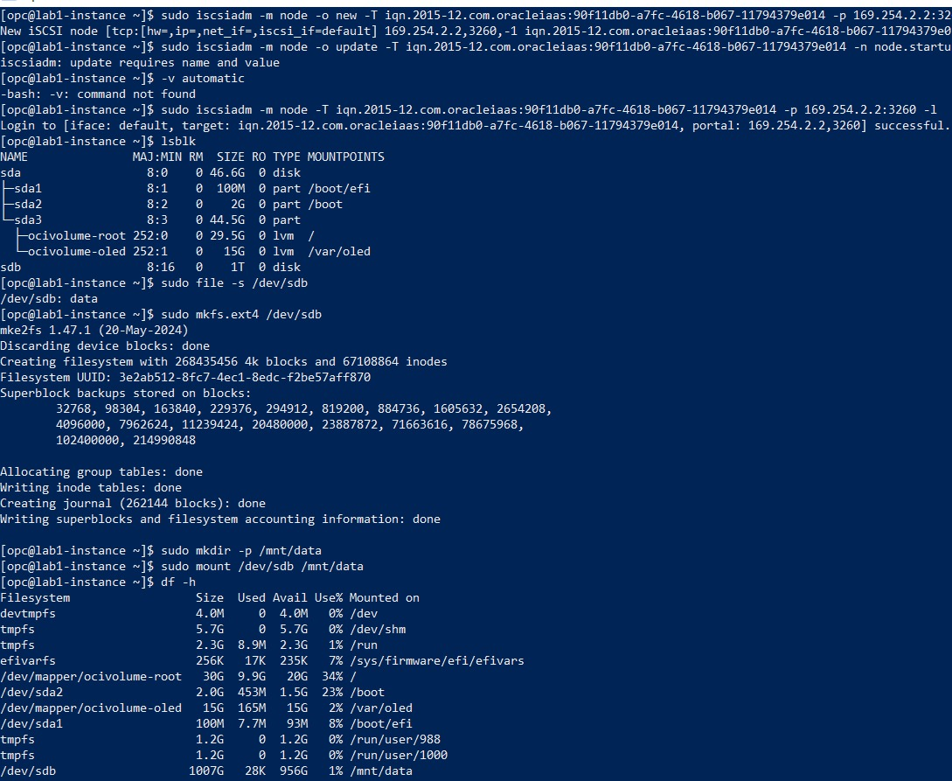
Figure 13 — iSCSI node discovery/login (iscsiadm), block device confirmation (lsblk), ext4 filesystem creation (mkfs.ext4), and mounting /dev/sdb at /mnt/data.
The resulting df -h output confirmed the new 1 TB filesystem mounted at /mnt/data with 956 GB available, alongside the existing boot and OS-managed logical volumes (/, /boot, /boot/efi, /var/oled).

9.2 Persistent Mount Configuration
To ensure the volume mounts automatically and safely on subsequent boots, its UUID was identified with blkid and an entry was added to /etc/fstab using the ext4 filesystem type with the defaults,nofail options. The entry was then updated to include the _netdev option, which is required by OCI for iSCSI-attached remote block volumes so that the system waits for networking to be available before attempting the mount, preventing boot failures if the volume is temporarily unreachable.
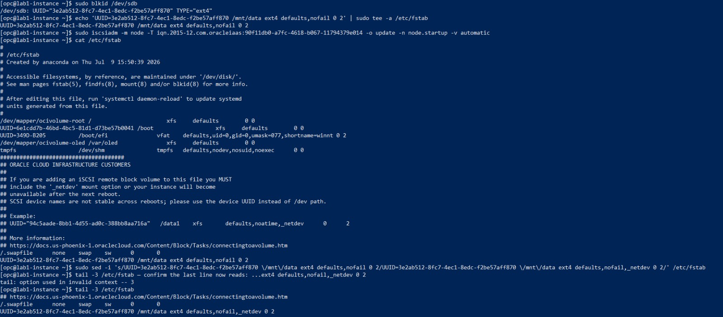
Figure 14 — Identifying the volume UUID with blkid, adding the /etc/fstab entry, and updating it with the _netdev mount option.

9.3 Mount Verification
The updated configuration was validated by unmounting and remounting via mount -a, followed by a systemctl daemon-reload to ensure systemd picked up the modified fstab. The final df -h output confirms /mnt/data is correctly re-mounted from /dev/sdb, verifying that the persistent mount configuration is correct and will survive a reboot.
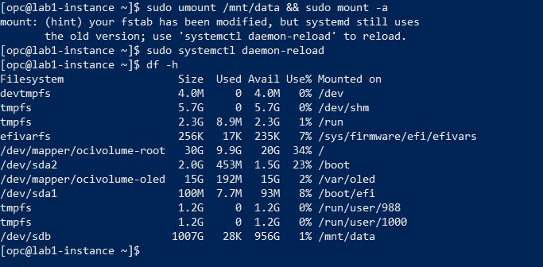
Figure 15 — Verification of the persistent mount: umount/mount -a, systemctl daemon-reload, and final df -h output.

10. SSH Access
SSH (Secure Shell) was used to remotely administer lab1-instance in order to attach and format the block volume, edit system configuration files, and verify the running state of the operating system. SSH provides an encrypted channel and, in this lab, key-based authentication rather than a password, which is the recommended practice for securing cloud compute instances.

10.1 Initial Connection Attempt
The first connection attempt from a Windows PowerShell client using the private key file ssh-key-2026-08-06.key was rejected by the SSH client itself before authentication, because the key file's Windows file permissions were too permissive (readable by the built-in Users group). OpenSSH refuses to use private key files that are not adequately restricted, to prevent unauthorized users on the same machine from reading the key.
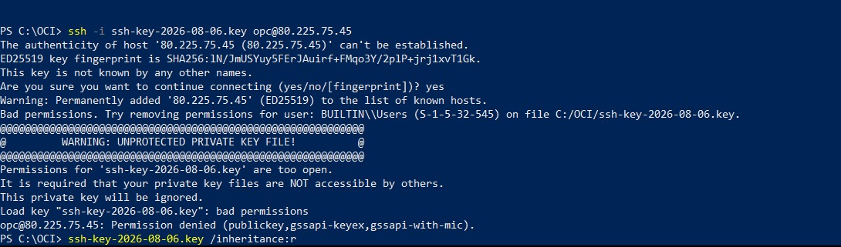
Figure 16 — Initial SSH attempt rejected due to unprotected private key file permissions on the Windows client.

10.2 Permission Remediation and Successful Connection
The key file's access control list was corrected using icacls to remove inherited permissions and grant read access only to the current user. With the permissions restricted, the SSH connection to opc@80.225.75.45 succeeded, and an initial lsblk command confirmed the instance's boot disk layout (/dev/sda with EFI, boot, and LVM-managed root/var partitions) prior to the block volume being attached at the OS level.
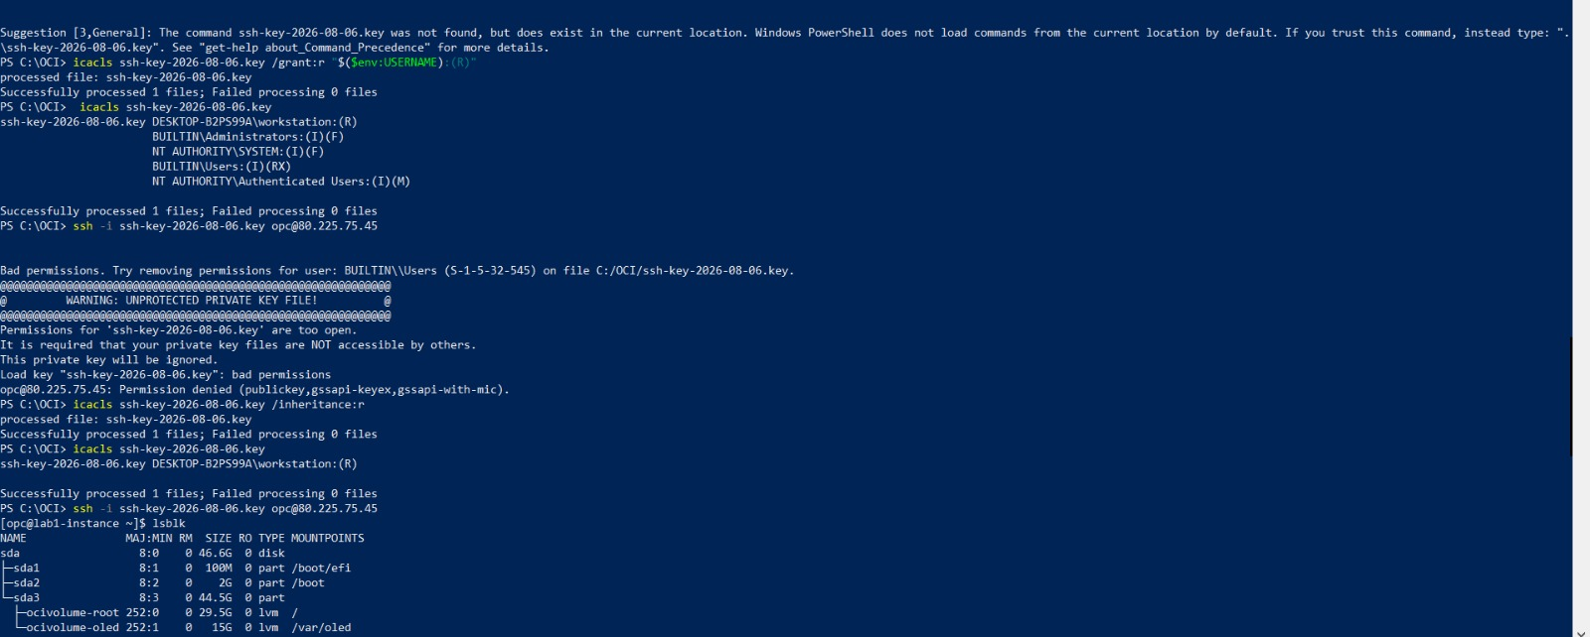
Figure 17 — Private key permissions corrected with icacls; successful SSH login to opc@80.225.75.45 and initial disk layout via lsblk.
A successful, non-interactive SSH login using only the key pair — with no password prompt — demonstrates that key-based authentication was correctly configured on the instance at launch and that network connectivity through the public subnet, Internet Gateway, and route table is functioning as designed.

11. Verification
The deployment was verified across three layers: infrastructure state in the OCI Console, network reachability via SSH, and filesystem state on the operating system.
- Console verification — lab1-instance shows a Running state with the expected shape, image, and network attachment; lab1-vcn shows an Available state with the configured CIDR, DNS resolver, and default route table; the block volume shows an Attached state over iSCSI with Read/Write access.
- Network verification — successful SSH authentication to the instance's public IP address (80.225.75.45) using the configured key pair confirms that the Internet Gateway, route table, and security list are correctly permitting inbound SSH traffic.
- Storage verification — the df -h output following the fstab update confirms /mnt/data is mounted from /dev/sdb with 956 GB available, and the remount test (mount -a) confirms the configuration will persist correctly across reboots.

12. Cleanup
Cleanup of temporary cloud resources is a standard and important step in any cloud engineering exercise. Leaving compute instances, block volumes, and networking components running after a lab is complete leads to unnecessary resource consumption, avoidable cost, and a cluttered training environment that makes subsequent labs harder to manage. In a production context, the same discipline prevents orphaned resources from becoming a security or cost liability.
The recommended cleanup order for this deployment is to remove resources in the reverse of their creation order, so that dependent resources are detached before the resources they depend on are deleted:
- Terminate the compute instance (lab1-instance), which also removes the associated boot volume unless it is explicitly preserved.
- Detach and terminate the block volume (lab1-block-volume).
- Delete the Internet Gateway (lab1-igw).
- Remove the custom route rule from the default route table (or leave the default table intact for deletion with the VCN).
- Delete the public subnet (public-subnet-lab1).
- Delete the Virtual Cloud Network (lab1-vcn).
No cleanup/termination screenshots were included in the evidence set provided for this report. This section documents the recommended cleanup procedure for completeness; actual resource termination should be confirmed against the OCI Console before the compartment is considered fully clean.

13. Final Deliverables Checklist
The table below summarizes the lab deliverables and their verification status, based strictly on the evidence captured during the labs.
Deliverable | Status | Evidence
Virtual Cloud Network (lab1-vcn) | Completed | Figures 1–2
Public Subnet (public-subnet-lab1) | Completed | Figure 3
Internet Gateway (lab1-igw) | Completed | Figure 4
Route Table configuration | Completed | Figure 5
Security List | Completed | Figure 6
Linux Compute Instance (lab1-instance) | Completed | Figures 7–10
Block Volume attachment (lab1-block-volume) | Completed | Figures 11–12
Block volume formatting & mount (/mnt/data) | Completed | Figure 13
Persistent mount (/etc/fstab, _netdev) | Completed | Figures 14–15
SSH key-based access | Completed | Figures 16–17
Terraform IaC configuration | Documented (methodology only) | Section 6 — no CLI evidence provided
Architecture Diagram | Completed | Section 14
Deployment Documentation | Completed | This document
Resource Cleanup | Not evidenced / Recommended procedure documented | Section 12

Items marked "Completed" are directly supported by console screenshots or terminal output captured during the labs. The Terraform configuration and resource cleanup are documented at the procedural level, as no corresponding execution evidence was included in the screenshot set provided for this report.

14. Architecture Diagram
The diagram below summarizes the deployed architecture as evidenced across the labs: internet traffic flows through the Internet Gateway and route table into the public subnet, reaching the compute instance, which in turn accesses its attached block volume over iSCSI.
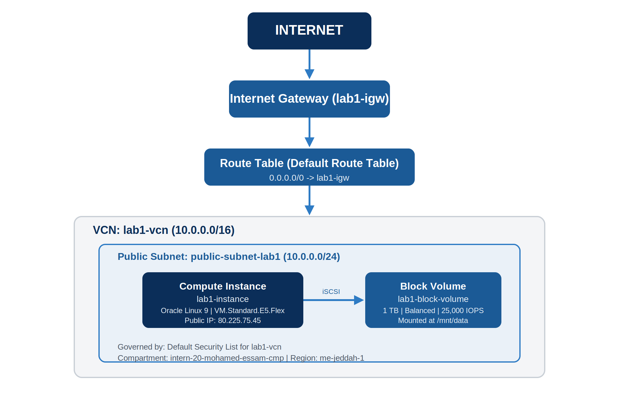
Figure 18 — Deployment architecture: Internet → Internet Gateway → Route Table → Public Subnet → Compute Instance → Block Volume.

15. Technical Summary
This engagement provisioned a self-contained OCI environment consisting of a /16 VCN (lab1-vcn), a /24 public regional subnet (public-subnet-lab1), an Internet Gateway (lab1-igw) with a default 0.0.0.0/0 route, and a default security list governing subnet-level traffic. A single Oracle Linux 9 compute instance (lab1-instance, VM.Standard.E5.Flex, 1 OCPU / 12 GB memory) was deployed into the public subnet with a public IP address (80.225.75.45) and key-based SSH access.
A 1 TB Balanced-tier block volume (lab1-block-volume) was attached to the instance over iSCSI, formatted with ext4, mounted at /mnt/data, and made persistent across reboots via an /etc/fstab entry using the _netdev option required for OCI remote block storage. All configuration was verified through OCI Console state checks and operating-system-level commands (lsblk, df -h, blkid) executed over an authenticated SSH session.
In parallel, the Terraform methodology for reproducing this class of environment as code was documented, covering the provider, variable, network, compute, and output configuration files and the standard init/plan/apply/destroy workflow, to support repeatable, version-controlled infrastructure provisioning beyond manual console operations.

16. Conclusion
The hands-on labs completed under the Ejada Egypt Summer Internship Program 2026 Cloud Build Track demonstrate a working, end-to-end OCI deployment: from network design and Internet Gateway configuration, through compute provisioning, to persistent block storage attached and mounted at the operating-system level, all accessed securely over SSH. The exercise reinforced core Cloud/DevOps engineering practices — network segmentation, least-privilege security list configuration, encrypted data in transit, key-based remote access, and durable storage configuration — while also introducing the Infrastructure-as-Code discipline through Terraform as a path toward repeatable, auditable infrastructure management.
This documentation, together with the underlying screenshots and terminal evidence, is submitted as the official record of Lab 1 and Lab 2 deliverables for evaluation.

