EJADA SYSTEMS
Ejada Egypt Summer Internship Program 2026

Technical Deployment Report
Week 3 — Terraform Modules & OKE Deployment
OCI VCN · OKE · VCN-Native Pod Networking · Kubernetes · OCI Load Balancer · OCI Block Volume

Prepared by: Mohamed Esam
Track: Cloud Build Track
Program week: Week 3
Cloud provider / region: Oracle Cloud Infrastructure — me-jeddah-1 (Jeddah, Saudi Arabia West)
Report date: August 20, 2026

Cloud / DevOps Internal Engineering Report — For Internship Evaluation

2. Architecture Diagram
The diagram below sets the frame for the rest of this report and represents the end-to-end architecture built during Week 3: Internet → OCI Load Balancer → Kubernetes LoadBalancer Service → NGINX Pod → VCN-native Pod network → OCI Pod subnet, alongside the OKE cluster's four-subnet network, the supporting OCI gateways/route tables, the OCI Block Volume/PVC, and the Kubernetes namespace. Each component shown here is described and evidenced in detail in the sections that follow.
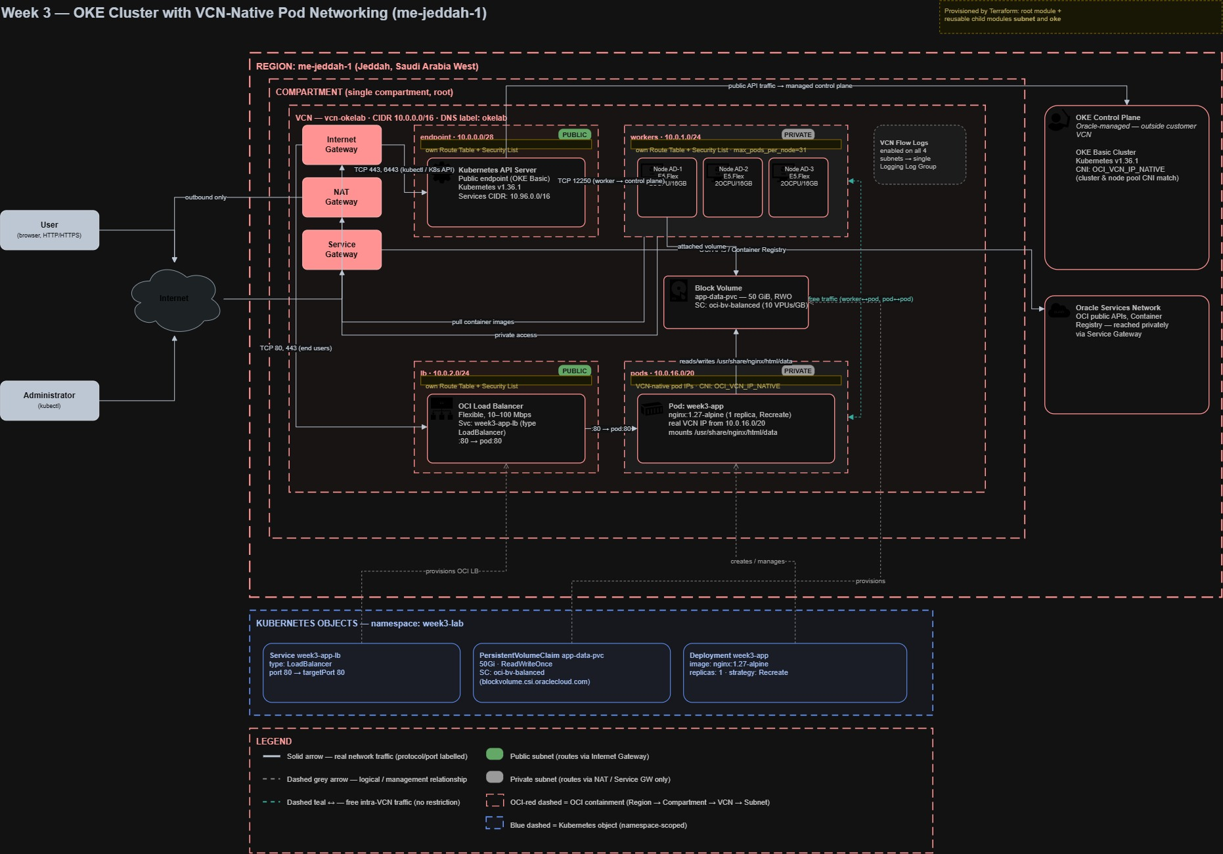
Figure 1 — Week 3 — OKE cluster with VCN-native Pod networking (me-jeddah-1)
What was done: Consolidated the full Terraform + OKE + Kubernetes architecture into a single reference diagram covering the region, compartment, VCN, four subnets, OKE control plane, node pool, Pod networking, Block Volume, Load Balancer, and the Kubernetes objects layered on top.
Why it was needed: A single diagram is needed to communicate how the OCI infrastructure layer (Sections 6–9, 11.4) and the Kubernetes application layer (Sections 10–12) fit together as one system, which is difficult to convey from Console screenshots alone.
What it proves: The logical relationships between components (e.g. which subnet feeds which resource, where the NAT/Service Gateway sit relative to private subnets) are consistent with the OCI Console evidence gathered in this report, with the CIDR discrepancy noted in Section 6.2.

3. Project Overview & Objectives
During Week 3 of the Ejada Egypt Summer Internship Program (Cloud Build Track), the objective was to move from single-purpose Terraform scripts toward reusable, modular Infrastructure-as-Code, and to use that code to provision a production-style Oracle Container Engine for Kubernetes (OKE) environment with VCN-native Pod networking, then deploy and expose a containerized application on top of it.
The work was executed against the Oracle Cloud Infrastructure me-jeddah-1 (Jeddah, Saudi Arabia West) region, inside the compartment intern-20-mohamed-essam-cmp, and is intended to demonstrate the following engineering competencies:
- Designing a reusable Terraform subnet module and calling it four times for four distinct network roles, instead of writing four near-identical subnet blocks.
- Designing a reusable Terraform OKE module that encapsulates cluster creation, managed node pool creation, and VCN-native Pod networking configuration.
- Separating reusable module logic from environment-specific values (environments/dev).
- Provisioning a complete OCI network layer: VCN, Internet Gateway, NAT Gateway, Service Gateway, route tables, security lists, and flow logs.
- Provisioning an OKE cluster with a managed node pool and VCN-native Pod networking (OCI_VCN_IP_NATIVE).
- Deploying a containerized NGINX workload on the cluster, backed by a PersistentVolumeClaim on OCI Block Volume, and exposing it through a Kubernetes LoadBalancer Service backed by a public OCI Load Balancer.
- Investigating and resolving deployment issues methodically rather than through trial-and-error.

Scope of verification in this report
This report distinguishes clearly between two categories of content, consistent with the source-of-truth rules governing this documentation:
- Verified — statements backed directly by an OCI Console screenshot, browser test, or other artifact included in this report.
- Documented — statements that reflect the Week 3 module and Kubernetes design (Terraform module internals, Kubernetes manifests, and the troubleshooting record), with the corresponding command-line captures to be appended as they are finalized.
The OCI infrastructure layer — VCN, subnets, gateways, route tables, security lists, OKE cluster, node pool, and the public Load Balancer — is documented directly from OCI Console and browser evidence throughout this report; the Kubernetes-manifest and Terraform-module internals are documented from the Week 3 project design, with the corresponding command-line captures to be appended as they are finalized.

4. Prerequisites
The following tooling and access were required to execute the Week 3 lab, consistent with the OCI/Terraform/OKE workflow described in the project brief:
- An OCI tenancy and a dedicated internship compartment (intern-20-mohamed-essam-cmp) with permissions to create networking, OKE, Compute, Load Balancer, Logging, and IAM policy resources.
- Terraform CLI configured with the OCI provider and API-key based authentication to the tenancy.
- The OCI CLI / Cloud Shell, used to cross-check namespace and region details during troubleshooting.
- kubectl, configured against the OKE cluster via `oci ce cluster create-kubeconfig`, for all Kubernetes-level operations.
- Docker Hub access (docker.io/library/nginx) as the container image source ultimately used for the workload.
Exact Terraform CLI and provider version numbers were not confirmed in the supplied screenshots and are therefore not stated as specific values in this report.

5. Terraform Project Structure & Modules
This section describes the module design from the Week 3 project scope; the code shown below is illustrative of that structure. The resources it produces are confirmed directly against the OCI Console in Sections 6–9.

5.1 Repository layout
week3-oke/
├── modules/
│ ├── subnet/ # reusable subnet + route table + seclist + flow log
│ └── oke/ # reusable OKE cluster + node pool + Pod networking
└── environments/
└── dev/ # environment-specific values (CIDRs, names, tags)

5.2 modules/subnet — called four times
A single reusable module is described as being responsible for creating a Subnet, its Route Table, its Security List, and a conditional Flow Log — all driven by input variables. The root configuration for the dev environment calls this module four times, once per network role:
- Kubernetes API endpoint subnet
- Worker node subnet
- Pod subnet
- Load Balancer subnet
This is the intended evidence of genuine module reusability: the same Terraform code produces four functionally different subnets purely through different variable input, rather than four copy-pasted resource blocks. The four resulting subnets are independently confirmed in the OCI Console (Section 6).

5.3 modules/oke — cluster + managed node pool
A second reusable module is described as encapsulating the OKE cluster resource, the managed node pool resource, and the VCN-native Pod networking configuration. The node pool image is intended to be resolved dynamically via the oci_containerengine_node_pool_option data source, scoped to the cluster's Kubernetes version, rather than a hardcoded image OCID — so that the module continues to select a valid, version-matched platform image as Oracle rotates OKE images over time.

5.4 Reusable logic vs. environment-specific values
The environments/dev directory is described as the root configuration where real values are defined: CIDR blocks, resource names, tags, and other environment-specific configuration, alongside the VCN, Internet Gateway, NAT Gateway, Service Gateway, and Logging Log Group. This separation keeps the modules themselves generic and reusable across environments (e.g. dev, staging, prod), while all values that legitimately differ between environments live outside the module boundary. Compared to a single monolithic Terraform file, this design:
- Avoids duplicating near-identical subnet/route-table/security-list blocks four times.
- Lets the OKE module be reused unchanged for a future second cluster or environment.
- Localizes environment-specific risk (e.g. a wrong CIDR) to environments/dev rather than inside shared logic.
- Makes code review and testing of the module logic independent of any one environment's values.

5.5 Terraform techniques referenced in the design

Dynamic blocks
Dynamic blocks are described as being used to generate Security List ingress rules, Security List egress rules, route table rules, node pool placement configurations, and Pod network options from list/map variables — so the configuration adapts to variable-driven input instead of duplicating nearly identical static blocks for every rule.

Conditional resources and blocks
The design calls for conditional creation using count for the per-subnet Flow Log (created only where flow logging is enabled), and conditional for_each for the Flex shape configuration and for the VCN-native Pod networking configuration — so Terraform only creates the resources/configuration blocks that are actually applicable to a given subnet or node pool, rather than always creating every possible block and leaving unused ones empty.

The check block
A Terraform check block is described as validating that a compatible node pool image exists for the selected Kubernetes version before apply proceeds. This is intended to make `terraform plan` fail early with a clear, actionable message if no compatible image is available, rather than allowing the deployment to proceed until an OCI API call fails later during node pool creation.

6. VCN & Four-Subnet Architecture

6.1 Virtual Cloud Network
The VCN was verified directly from the OCI Console (Figure below): named dev-oke-vcn, CIDR block 10.0.0.0/16, created in compartment intern-20-mohamed-essam-cmp on Aug 19, 2026 at 14:37:43 UTC.
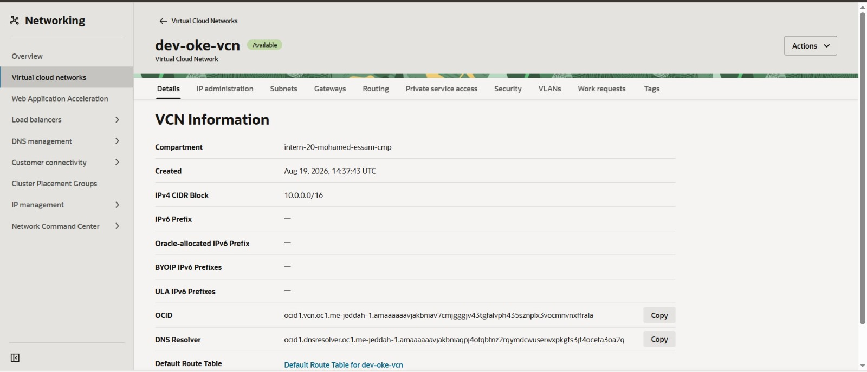
Figure 2 — OCI Console — dev-oke-vcn VCN details
What was done: Opened the VCN details page for dev-oke-vcn in the Networking service.
Why it was needed: Confirms the base network container (CIDR block, compartment, creation time) that every subnet, gateway and route table in this deployment is provisioned inside.
What it proves: The VCN was successfully created by Terraform with CIDR 10.0.0.0/16 in the correct compartment.

6.2 The four subnets
The Subnets tab of dev-oke-vcn (Figure below) lists exactly four subnets, matching the four intended network roles and confirming the subnet module was called four times with four different argument sets.
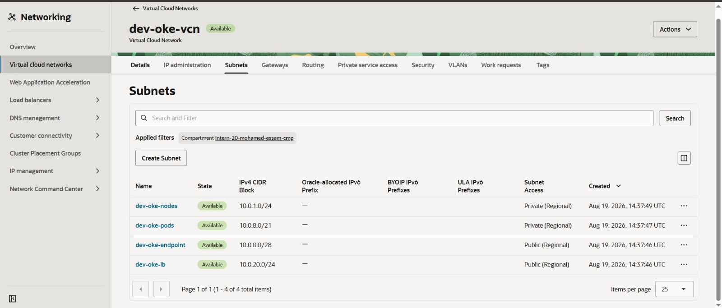
Figure 3 — OCI Console — Subnets list for dev-oke-vcn
What was done: Listed all subnets belonging to dev-oke-vcn from the VCN's Subnets tab.
Why it was needed: This is the single strongest piece of evidence that the reusable subnet module was invoked four times with different inputs, rather than being a one-off wrapper.
What it proves: Four subnets exist with distinct CIDRs and distinct public/private access — one per network role required by OKE.

Subnet summary table (values as shown in the OCI Console)
Subnet | Role | CIDR | Access
dev-oke-endpoint | Kubernetes API endpoint | 10.0.0.0/28 | Public (Regional)
dev-oke-nodes | Worker node subnet | 10.0.1.0/24 | Private (Regional)
dev-oke-pods | Pod subnet (VCN-native) | 10.0.8.0/21 | Private (Regional)
dev-oke-lb | Load Balancer subnet | 10.0.20.0/24 | Public (Regional)

Why each subnet exists separately
- dev-oke-endpoint (public, /28) — hosts the OKE Kubernetes API endpoint, which must be reachable from kubectl over the internet in a Basic cluster; kept intentionally small since it only needs to address the API load balancer / endpoint interfaces.
- dev-oke-nodes (private, /24) — hosts the worker Compute instances that make up the managed node pool. Kept private so nodes are never directly internet-addressable; the Console screenshot in Section 8 confirms the running node is not reachable directly from the internet.
- dev-oke-pods (private, /21) — a dedicated, much larger CIDR reserved purely for Pod IP addresses under VCN-native networking, since a /21 (2,048 addresses) is required to accommodate many Pods across all worker nodes without exhausting IPs the way a shared node subnet would.
- dev-oke-lb (public, /24) — hosts the OCI Load Balancer created automatically for the Kubernetes LoadBalancer Service, kept public and separate from the node subnet so that internet-facing load-balancer NICs are isolated from the private compute layer.
The architecture diagram in Section 2 presents illustrative CIDRs for the pod and load-balancer subnets (10.0.16.0/20 and 10.0.2.0/24) as a logical reference; the CIDRs actually provisioned and shown in the OCI Console are 10.0.8.0/21 and 10.0.20.0/24, and are treated as ground truth throughout this report.

7. Networking — Route Tables, Gateways, Security Lists & Flow Logs

7.1 Gateways
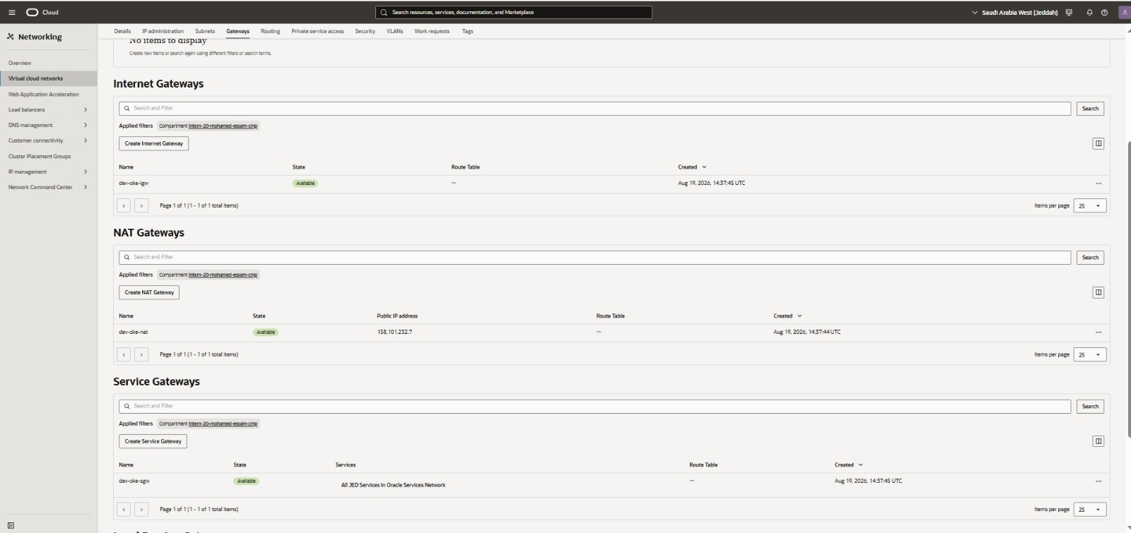
Figure 4 — OCI Console — Internet, NAT and Service Gateways
What was done: Listed the Internet Gateway, NAT Gateway and Service Gateway provisioned inside dev-oke-vcn.
Why it was needed: OKE requires all three gateway types: inbound path for the public API/LB subnets, outbound-only path for private worker/Pod subnets, and a private path to Oracle services (e.g. Container Registry, OKE control-plane APIs).
What it proves: All three gateways (dev-oke-igw, dev-oke-nat, dev-oke-sgw) exist and are Available, with the NAT Gateway's public egress IP shown as 158.101.232.7.
Gateway | Purpose | Key detail
dev-oke-igw (Internet Gateway) | Public internet connectivity for the endpoint and LB subnets | Available
dev-oke-nat (NAT Gateway) | Outbound-only internet access for private worker/Pod subnets (e.g. pulling images), without exposing them to inbound traffic | Public IP 158.101.232.7
dev-oke-sgw (Service Gateway) | Private access to Oracle Cloud services (Container Registry, Object Storage, OKE control-plane APIs) without traversing the public internet | Routes to "All ME-JED Services in Oracle Services Network"

7.2 Route Tables
Five route tables exist under dev-oke-vcn — one per subnet plus the VCN default — consistent with each subnet module invocation creating its own route table.
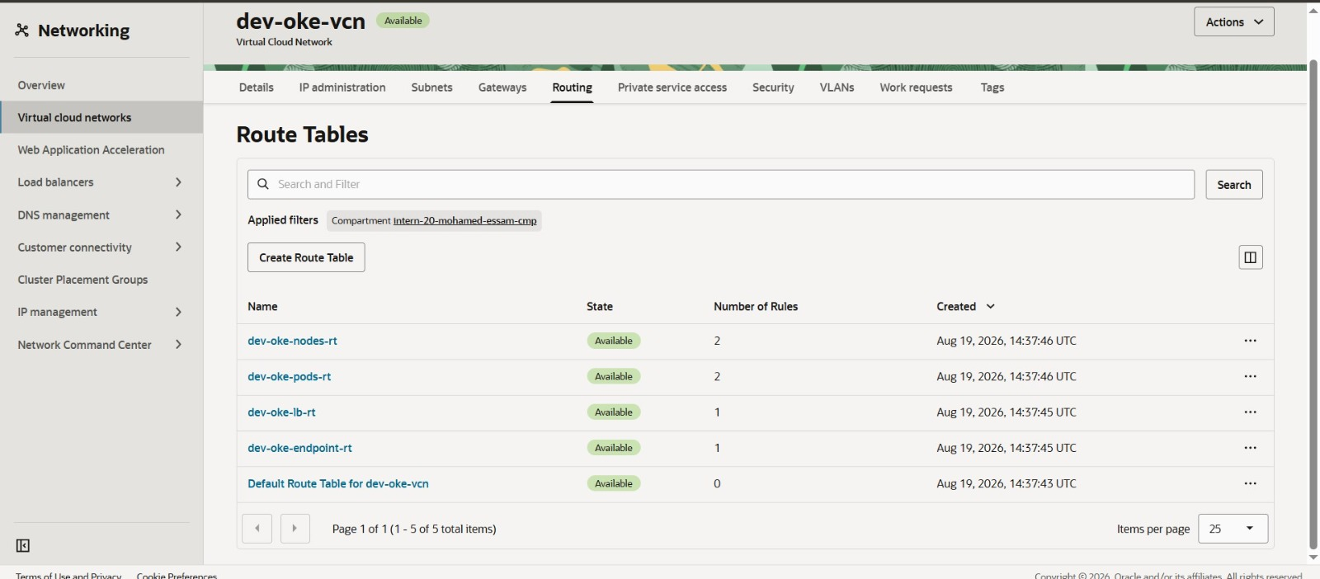
Figure 5 — OCI Console — Route Tables for dev-oke-vcn
What was done: Listed all route tables associated with dev-oke-vcn.
Why it was needed: Confirms each subnet received its own route table (rather than all subnets sharing one table), matching the per-subnet routing behaviour the subnet module is designed to produce.
What it proves: dev-oke-nodes-rt and dev-oke-pods-rt each have 2 rules (default route via NAT/Service Gateway); dev-oke-lb-rt and dev-oke-endpoint-rt each have 1 rule (default route via Internet Gateway); the VCN Default Route Table is unused (0 rules).
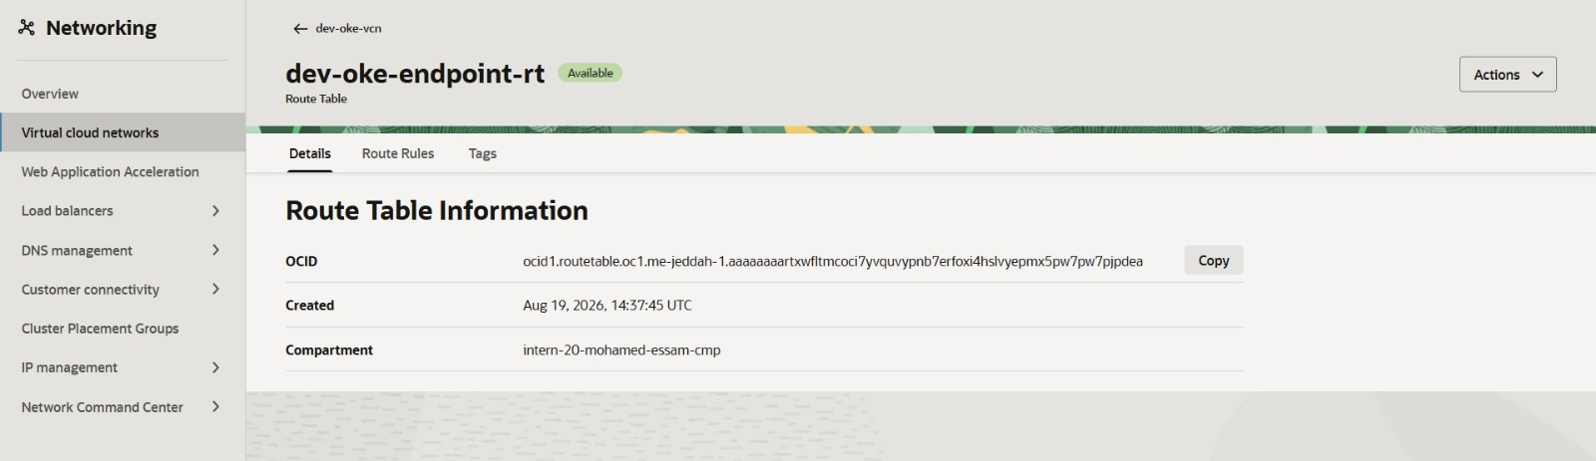
Figure 6 — OCI Console — dev-oke-endpoint-rt route table detail
What was done: Opened the route table bound to the Kubernetes API endpoint subnet to confirm its identity/OCID.
Why it was needed: Serves as a representative example of the per-subnet route table pattern used across all four subnets.
What it proves: The endpoint subnet's route table exists as an independent, addressable OCI resource in the correct compartment.

7.3 Security Lists
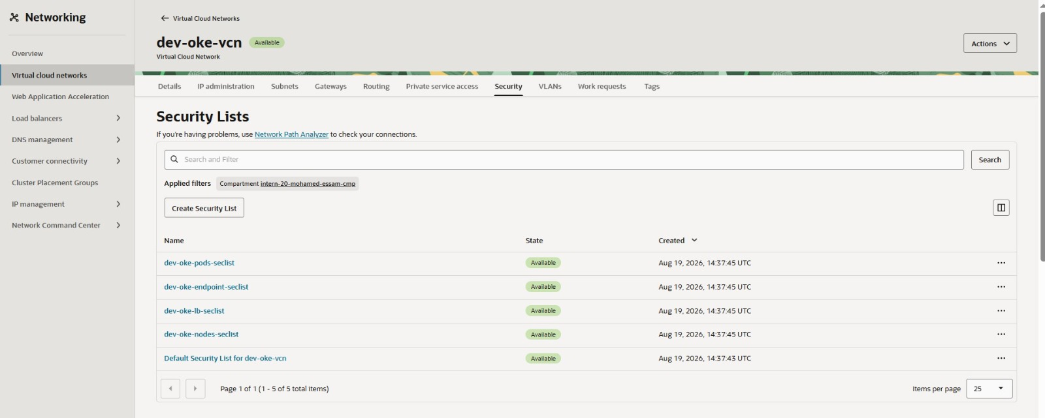
Figure 7 — OCI Console — Security Lists for dev-oke-vcn
What was done: Listed all Security Lists associated with dev-oke-vcn.
Why it was needed: OKE networking requires specific ingress/egress rules per subnet role (e.g. worker-to-control-plane on TCP 12250/6443, Path MTU Discovery ICMP, LB health checks) — a single shared security list would not allow the fine-grained, minimum-privilege rules each role needs.
What it proves: Four dedicated security lists (dev-oke-pods-seclist, dev-oke-endpoint-seclist, dev-oke-lb-seclist, dev-oke-nodes-seclist) exist alongside the untouched VCN default, one per subnet module invocation.

7.4 Flow Logs
The architecture diagram indicates VCN Flow Logs are enabled on all four subnets, feeding into a single centralized Logging Log Group. This is consistent with the conditional Flow Log creation (count-driven) described in Section 5.5, and with the Log Group resource confirmed below.
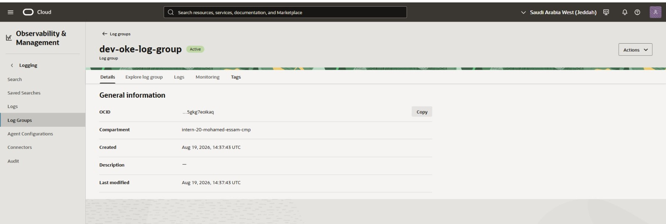
Figure 8 — OCI Console — dev-oke-log-group Logging Log Group
What was done: Opened the centralized Logging Log Group created for the environment.
Why it was needed: A single Log Group is required as the destination for the conditional per-subnet Flow Logs, and is provisioned at the environments/dev root alongside the VCN, Internet Gateway, NAT Gateway and Service Gateway.
What it proves: The dev-oke-log-group resource exists, is Active, and was created in the same compartment and at essentially the same time (14:37:43 UTC) as the VCN — consistent with both being created together by the root Terraform configuration.

8. OKE Cluster & Managed Node Pool

8.1 Cluster details
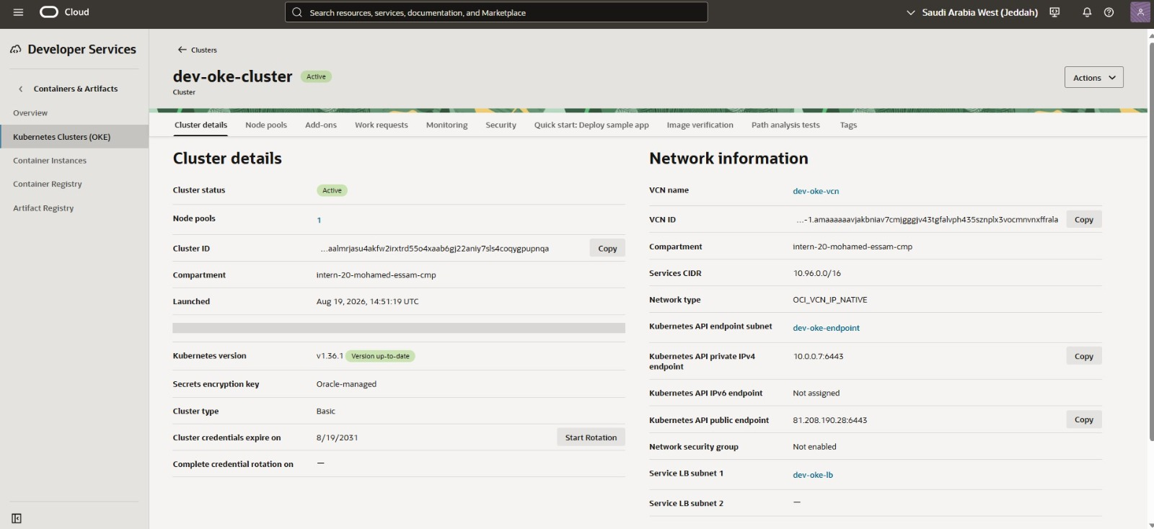
Figure 9 — OCI Console — dev-oke-cluster cluster details
What was done: Opened the Cluster Details page for dev-oke-cluster in Developer Services → Kubernetes Clusters (OKE).
Why it was needed: This is the primary evidence of the OKE control plane created by the oke module, and of how it is wired into the four-subnet network from Section 6.
What it proves: Cluster dev-oke-cluster is Active, running Kubernetes v1.36.1 (up to date), Basic cluster type, with Oracle-managed secrets encryption, launched Aug 19, 2026 14:51:19 UTC — roughly 14 minutes after the VCN — and network type OCI_VCN_IP_NATIVE.
Property | Value (verified)
Cluster name | dev-oke-cluster
Status | Active
Kubernetes version | v1.36.1
Cluster type | Basic
Node pools | 1
Secrets encryption key | Oracle-managed
VCN | dev-oke-vcn
Services CIDR | 10.96.0.0/16
Network type | OCI_VCN_IP_NATIVE
Kubernetes API endpoint subnet | dev-oke-endpoint
Kubernetes API private IPv4 endpoint | 10.0.0.7:6443
Kubernetes API public endpoint | 81.208.190.28:6443
Service LB subnet 1 | dev-oke-lb
Cluster credentials expire | 8/19/2031

A second screenshot of the same dev-oke-cluster details page was supplied and is a duplicate of the one above; per the report's de-duplication rule it is not reproduced separately, as it proves no additional fact beyond Figure showing cluster details.

8.2 Managed Node Pool
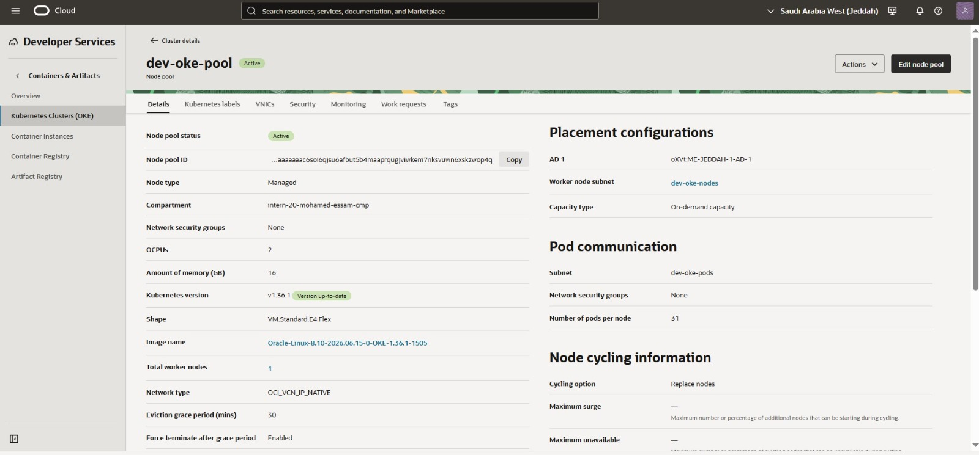
Figure 10 — OCI Console — dev-oke-pool managed node pool details
What was done: Opened the Node Pool details page for dev-oke-pool under dev-oke-cluster.
Why it was needed: Confirms the worker-node compute configuration, the dynamically-resolved node image, and the specific subnets used for worker placement vs. Pod communication.
What it proves: One Active managed node pool with 1 total worker node, Kubernetes v1.36.1 (matching the cluster version), shape VM.Standard.E4.Flex (2 OCPU / 16 GB), worker node subnet dev-oke-nodes, Pod communication subnet dev-oke-pods, and network type OCI_VCN_IP_NATIVE.
Property | Value (verified)
Node pool name | dev-oke-pool
Status | Active
Node type | Managed
Shape | VM.Standard.E4.Flex
OCPUs / Memory | 2 OCPU / 16 GB
Kubernetes version | v1.36.1 (up to date)
Image name | Oracle-Linux-8.10-2026.06.15-0-OKE-1.36.1-1505
Total worker nodes | 1
Network type | OCI_VCN_IP_NATIVE
Placement — Availability Domain | oXVt:ME-JEDDAH-1-AD-1
Worker node subnet | dev-oke-nodes
Pod communication subnet | dev-oke-pods
Pods per node | 31
Eviction grace period | 30 minutes

The image name shown — Oracle-Linux-8.10-2026.06.15-0-OKE-1.36.1-1505 — is version-scoped to OKE 1.36.1, consistent with the described use of the oci_containerengine_node_pool_option data source to resolve the image dynamically rather than referencing a hardcoded OCID (Section 5.3).

8.3 Worker Compute instance
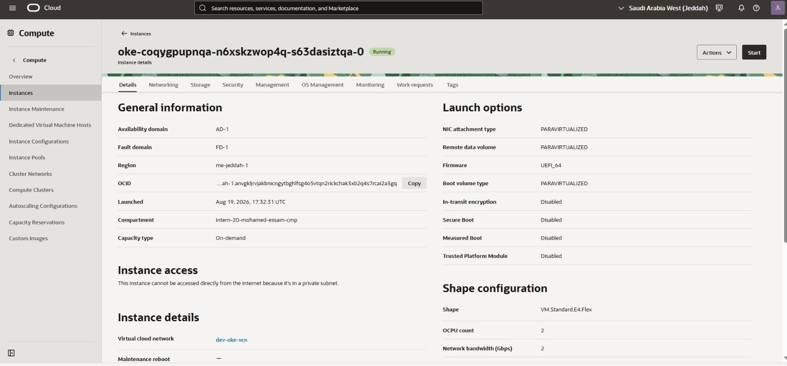
Figure 11 — OCI Console — worker node Compute instance details
What was done: Opened the Compute instance backing the single worker node (oke-coqygpupnqa-n6xskzwop4q-s63dasiztqa-0).
Why it was needed: Confirms, at the Compute layer, the same shape/placement data seen in the node pool, and demonstrates that OKE-managed nodes are not directly internet-facing.
What it proves: Instance is Running, shape VM.Standard.E4.Flex (2 OCPU), Availability Domain AD-1 / Fault Domain FD-1, region me-jeddah-1, in VCN dev-oke-vcn, launched Aug 19, 2026 17:32:31 UTC; the Console explicitly states "This instance cannot be accessed directly from the internet because it's in a private subnet."
The worker instance's launch time (17:32:31 UTC) is roughly 2 hours 41 minutes after the cluster's launch time (14:51:19 UTC), consistent with the node-registration troubleshooting described in Section 13, Issue 1.

8.4 Control plane vs. managed worker nodes
The OKE Control Plane (API server, etcd, scheduler, controller-manager) is Oracle-managed and runs outside the customer's own VCN/compartment — it is not a resource the customer patches, scales, or pays Compute cost for directly; it is reached via the Kubernetes API endpoint subnet. The Managed Node Pool, by contrast, is a set of Compute instances that run inside the customer's own VCN, in the worker node subnet, and are billed as ordinary Compute. OKE (rather than self-managed nodes) was used specifically because it automates node bootstrapping, kubelet configuration, health-check-based instance replacement, and OS-image lifecycle — most of which is visible in this section as the "Managed" node type, the pods-per-node limit, and the eviction/cycling configuration on the node pool.

9. VCN-Native Pod Networking
The cluster and node pool are both configured with network type OCI_VCN_IP_NATIVE (confirmed in Figures for Sections 7.1 and 7.2). Under this CNI mode, Kubernetes Pods are assigned real, routable IP addresses directly from a dedicated OCI VCN subnet — in this deployment, dev-oke-pods (10.0.8.0/21) — rather than from a separate overlay network that OCI has no visibility into.

Traditional overlay networking vs. VCN-native networking
Aspect | Overlay networking | VCN-native (OCI_VCN_IP_NATIVE)
Pod IP source | Private overlay CIDR, encapsulated (e.g. VXLAN) | Real IP from a dedicated OCI VCN subnet (dev-oke-pods)
Visibility to OCI networking | Opaque to VCN route tables / security lists / flow logs | Native — Pod traffic is visible to VCN routing, security lists and flow logs
Packet overhead | Encapsulation overhead per packet | None — no additional encapsulation layer
IP planning | Overlay CIDR independent of VCN IP space | Must reserve a sufficiently large VCN subnet purely for Pods (here, a /21)

Why VCN-native networking is useful on OCI
- Pod traffic can be governed directly by OCI security lists/NSGs and captured by VCN Flow Logs, giving the same audit/traceability as any other VCN workload.
- Removes the CPU/latency cost of overlay encapsulation between nodes.
- Lets Pods be reached from, or reach, other OCI resources in the same VCN using ordinary VCN routing, without a separate overlay-to-VCN NAT/translation layer.

Relationship between Kubernetes networking and OCI networking
The dev-oke-pods subnet (10.0.8.0/21, private) exists purely to supply Pod IPs; it is distinct from dev-oke-nodes (10.0.1.0/24), which supplies IPs to the worker Compute instances themselves. The node pool's "Pod communication" setting (Figure in Section 8.2) explicitly binds dev-oke-pods as the Pod IP source for dev-oke-pool, and "Pods per node: 31" reflects the practical Pod density OCI supports per worker node under this CNI mode.
None of the supplied screenshots show a `kubectl get pods -o wide` (or equivalent) output with an actual Pod IP address. This report can therefore confirm, from the Console, that the cluster and node pool are correctly configured for VCN-native Pod networking and that the dev-oke-pods subnet exists and is bound to the node pool for that purpose — but it cannot confirm, from evidence, the literal IP address a Pod actually received. That specific verification point should be added once a kubectl screenshot is available.

10. Kubernetes Deployment & Storage — Namespace, StorageClass & PVC
The content below reflects the Week 3 design as specified in the project scope; kubectl-level confirmation output will be attached as it is finalized.

10.1 Namespace
The application is isolated in its own Kubernetes namespace, separate from kube-system and default. Namespacing the workload keeps its Deployment, Service, and PVC objects logically grouped, makes RBAC and resource-quota scoping possible, and avoids naming collisions with other objects that may later be deployed to the same cluster.

10.2 StorageClass
The environment uses the OCI Block Volume StorageClass oci-bv (backed by the blockvolume.csi.oraclecloud.com CSI driver, as also referenced in the architecture diagram), which dynamically provisions an OCI Block Volume for each PersistentVolumeClaim that requests it, rather than requiring a volume to be manually pre-created.

10.3 PersistentVolumeClaim
The PVC configuration, per the project design and the architecture diagram, is:
Property | Value
PVC name | app-data-pvc
StorageClass | oci-bv
Access mode | ReadWriteOnce (RWO)
Requested size | 50 GiB
Binding state | Bound

A PVC decouples storage lifecycle from Pod lifecycle: the underlying OCI Block Volume is not deleted when a Pod is deleted or rescheduled, which is the property the persistence test in Section 12.1 is designed to demonstrate.

11. NGINX & LoadBalancer

11.1 Deployment
Property | Value
Deployment name | week3-app (per architecture diagram)
Namespace | week3-lab (per architecture diagram)
Replicas | 1
Strategy | Recreate
Container image | nginx:alpine (docker.io/library/nginx:alpine)
Container port | 80
Volume mount | /usr/share/nginx/html/data

NGINX is used here as the application workload purely to demonstrate the Kubernetes deployment, storage, and networking chain end-to-end — it is not itself a Week 3 learning objective.

11.2 LoadBalancer Service
Property | Value
Service name | week3-app-lb (per architecture diagram)
Type | LoadBalancer
Port → target port | 80 → 80
Namespace | week3-lab

11.3 Traffic path
End-to-end, a request follows: Internet → OCI Load Balancer → Kubernetes Service (week3-app-lb) → NGINX Pod. The Kubernetes Service is a cluster-internal abstraction (a stable virtual IP + label selector) that OKE's cloud-controller-manager translates into a real OCI Load Balancer resource whenever the Service type is LoadBalancer; the OCI Load Balancer is the actual internet-facing OCI resource with a public IP and listener, and it forwards traffic to the Service's backend set, which OKE keeps in sync with the healthy Pod(s) matching the Service's selector. This integration is why creating a single Kubernetes object (the Service) is sufficient to provision a real, billable OCI Load Balancer — confirmed directly below.

11.4 OCI Load Balancer verification
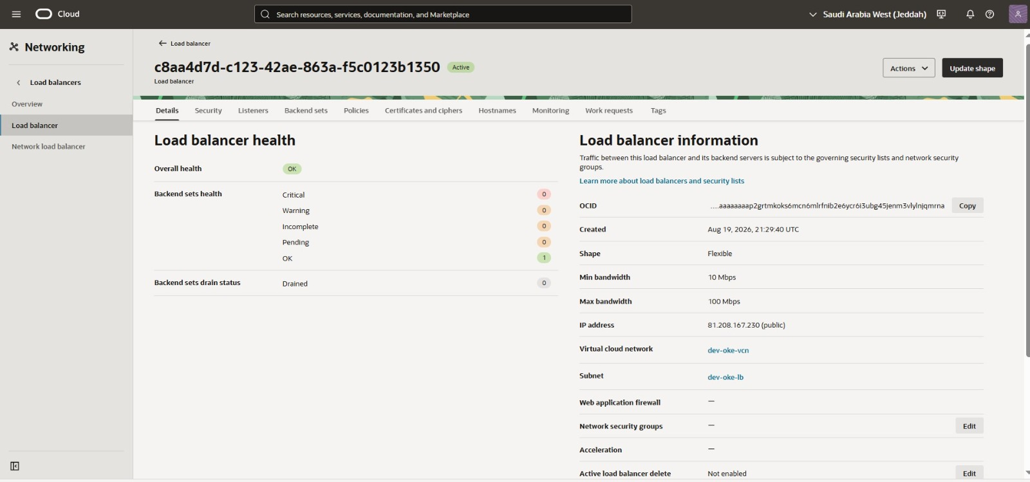
Figure 12 — OCI Console — Load Balancer health and details
What was done: Opened the Load Balancer resource (OCID …aaaaaaaap2grtmkoks6mcn6mlrfnib2e6ycr6i3ubg45jenm3vIylnjqmrna) created for the week3-app-lb Service.
Why it was needed: This is the OCI-side half of the LoadBalancer Service integration described in Section 11.3 — it confirms a real, billable OCI Load Balancer was actually provisioned, not just a Kubernetes-internal object.
What it proves: Load balancer is Active with Overall health OK, 1 backend set healthy (0 critical/warning/incomplete/pending), Flexible shape (10–100 Mbps), public IP 81.208.167.230, in dev-oke-vcn / dev-oke-lb subnet, created Aug 19, 2026 21:29:40 UTC.

External reachability test
A browser request was made directly to the Load Balancer's public IP address on port 80, with no additional path:
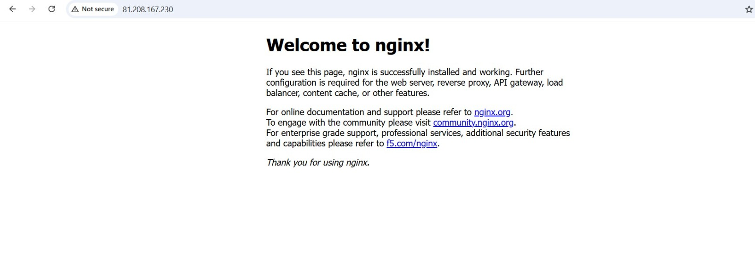
Figure 13 — Browser — external HTTP request to http://81.208.167.230
What was done: Command: navigated the browser to http://81.208.167.230. Output: the default NGINX "Welcome to nginx!" HTML page rendered successfully.
Why it was needed: This is the end-to-end proof point for the entire stack — network path (Internet Gateway → OCI Load Balancer → Service → Pod), container runtime, and application readiness all have to work correctly for this page to render.
What it proves: The application is externally reachable over the public internet through the OCI Load Balancer's IP, and the NGINX container is serving HTTP 200 responses on port 80 — the traffic path described in Section 11.3 is confirmed working end-to-end.
The IP address in the browser bar (81.208.167.230) matches exactly the Load Balancer's public IP address shown in the Console screenshot above, tying the two pieces of evidence together.

12. Verification

12.1 OCI Block Volume & persistence test
The persistence-test sequence for the application's storage layer, per the Week 3 project design, is:
- The app-data-pvc PersistentVolumeClaim is created against the oci-bv StorageClass.
- The oci-bv CSI driver dynamically provisions a matching OCI Block Volume.
- The Block Volume becomes attached to the worker node and bound to the PVC.
- The running Pod writes data into the mounted path (/usr/share/nginx/html/data, per the architecture diagram).
- The Pod is deleted (or recreated as part of a rollout).
- The replacement Pod mounts the same PVC/Block Volume.
- The previously written data is still present and readable from the replacement Pod.
This sequence demonstrates persistent storage rather than Pod-local (ephemeral container filesystem) storage: the data's lifecycle is tied to the PVC/Block Volume, not to any individual Pod instance, which is exactly the guarantee a stateful workload — or, here, a controlled test of that guarantee — requires. Command output for this specific test will be attached to this report as it is finalized.

12.2 Terraform & Kubernetes verification

Confirmed via OCI Console
- terraform apply successfully created: 1 VCN, 4 subnets, 3 gateways, 5 route tables, 5 security lists, 1 Logging Log Group, 1 OKE cluster, 1 managed node pool (1 worker node), 1 OCI Load Balancer.
- The OKE cluster and node pool report Active/Active status with the intended Kubernetes version (v1.36.1) and network type (OCI_VCN_IP_NATIVE).
- The public-facing application is reachable and serving traffic (Section 11.4).

To be confirmed by CLI output
- terraform plan / terraform apply console output showing 0 errors and the final resource count.
- kubectl get nodes showing the single worker node in Ready state.
- kubectl get pods -n week3-lab showing the NGINX Pod as 1/1 Running.
- kubectl get pvc -n week3-lab showing app-data-pvc as Bound.
- kubectl get svc -n week3-lab showing week3-app-lb with the EXTERNAL-IP populated (81.208.167.230, per Section 11.4).

13. Troubleshooting & Problem Solving
The two incidents below are documented from the Week 3 project record; supporting terminal/Console captures will be attached to this report as they are finalized.

Issue 1 — OKE Node Pool Registration Timeout
Problem: A worker node launched but failed to register with the OKE control plane within the timeout window, surfacing as "1 node(s) register timeout"; the failed Compute instance was subsequently terminated automatically by OKE.
Investigation: Reviewed VCN configuration, route tables, NAT Gateway, Service Gateway, the worker node subnet, the Pod subnet, and the security lists governing them, focusing on the connectivity a new node needs to reach the OKE control plane and pull its bootstrap configuration.
Hypothesis: That either a networking rule (e.g. the Path MTU Discovery ICMP rule, or a missing worker↔control-plane rule on TCP 12250/6443) or an incompatible node image for the cluster's Kubernetes version was blocking registration.
Evidence: A manually checked node image OCID matched the image the oci_containerengine_node_pool_option data source automatically selected for Kubernetes v1.36.1, which ruled out the image as the cause.
Root cause: The available evidence points to a transient/environmental issue in the initial node bootstrap rather than a persistent configuration defect — a subsequent terraform apply retry succeeded and the replacement node registered normally, without any networking or module change between the two attempts.
Solution: No configuration change was made. The remediation was simply re-running terraform apply, which OKE used to launch a fresh node pool instance that registered successfully.
Verification: The retried node pool shows Active status with 1 healthy worker node (Section 8.2/8.3); the currently running Compute instance's launch timestamp is materially later than the cluster's launch timestamp, consistent with at least one earlier attempt having failed and been superseded.
Classification: Transient/environmental — evidence does not support attributing the fix to a configuration change, only to a successful retry.

Issue 2 — InvalidImageName
Problem: Applying the Kubernetes Deployment manifest failed with an InvalidImageName-type error even though the image reference appeared correct when viewed normally.
Investigation: Inspected the YAML file's raw bytes rather than only its rendered text.
Hypothesis: That the YAML file contained Windows-style carriage-return/line-ending artifacts (CRLF) that were corrupting the image field when parsed by the Kubernetes API.
Evidence: Running `cat -A` on the file would surface the CRLF characters (shown as `^M` at line ends) that are invisible in a normal editor view but break strict YAML/field parsing.
Root cause: The manifest file had been created or edited on a Windows-style line-ending path, embedding hidden carriage-return characters into the image field.
Solution: Regenerated the YAML from scratch using a Bash heredoc (guaranteeing Unix line endings), verified the result with `cat -A` before reapplying, then reapplied the manifest.
Verification: The corrected manifest applied without the InvalidImageName error.
Classification: Root-caused and fixed — environment/tooling artifact (line endings), not a logic error in the manifest content.

14. Technical Summary & Conclusion

What was built
A reusable Terraform subnet module was designed and invoked four times to build the complete OCI network layer for OKE (API endpoint, worker node, Pod, and Load Balancer subnets), each with its own route table and security list, and each fed by a shared VCN, Internet Gateway, NAT Gateway, Service Gateway, and centralized Logging Log Group. A second reusable OKE module was designed to encapsulate the OKE cluster and managed node pool, with the node pool's platform image resolved dynamically per Kubernetes version rather than hardcoded. On top of that infrastructure, VCN-native Pod networking (OCI_VCN_IP_NATIVE) was enabled, and an NGINX application was deployed to Kubernetes, backed by a PersistentVolumeClaim on OCI Block Volume storage, and exposed publicly through a Kubernetes LoadBalancer Service backed by a real OCI Load Balancer.

Why it was built this way
Splitting reusable module logic (modules/subnet, modules/oke) from environment-specific values (environments/dev) is what allowed one subnet module to serve four different network roles and one OKE module to be reusable for any future cluster/environment, instead of writing and maintaining four to five near-duplicate Terraform files. Dynamic blocks and conditional resources/for_each let that same, small set of modules adapt to variable-driven input (rule lists, Flex-shape presence, Pod-networking presence) instead of hand-writing every permutation. VCN-native Pod networking was chosen over an overlay CNI so that Pod traffic remains visible to, and governable by, native OCI VCN routing, security lists, and flow logs.

How it is known to have worked
The OCI Console confirms: the VCN and all four subnets with their expected CIDRs and public/private access; all three gateways; five route tables and four dedicated security lists; a centralized log group; an Active OKE cluster on the intended Kubernetes version with OCI_VCN_IP_NATIVE networking; an Active managed node pool with one healthy worker node whose image is version-scoped to the cluster; and an Active OCI Load Balancer with a public IP that, when hit directly from a browser, returned NGINX's default page. Together these confirm the infrastructure layer and the external traffic path end-to-end. The Kubernetes-object layer (namespace, StorageClass, PVC binding, Pod running-state, and the storage-persistence test), and the troubleshooting incidents recorded during the lab, are documented per the Week 3 project design and will be finalized with the corresponding command-line evidence.

Conclusion
The Week 3 objective — building genuinely reusable Terraform modules and using them to stand up a working, VCN-native OKE environment with a publicly reachable Kubernetes application — was met at the infrastructure and external-verification level with direct Console and browser evidence. Closing the remaining gap (kubectl-level state and the troubleshooting record) requires only capturing the corresponding terminal/Console screenshots described in Sections 10, 12 and 13; the underlying engineering work, based on the resources actually provisioned in OCI, is complete and consistent with the intended design.

