**Name**: **محمد عبدالعزيز عبدالقادر حسنين هدهود**

**B.N:** **750**

**Topic**: **Artificial intelligence**

# **Topic Brief**:

Artificial intelligence (AI) is wide-ranging branch of computer science concerned with building smart machines capable of performing tasks that typically require human intelligence. AI is an interdisciplinary science with multiple approaches, but advancements in machine learning and deep learning are creating a paradigm shift in virtually every sector of the tech industry.

And we choose this topic in particularly to talk about because artificial intelligence is the field of the future and basically all the efforts of the mankind right now is concentrated on it as they expect to make robots to think on its own now and maybe replace us in the future and do all of our jobs.

# **Github link:** <https://github.com/Mohamedhadhoud1/index.html>

# **Screen shots:**

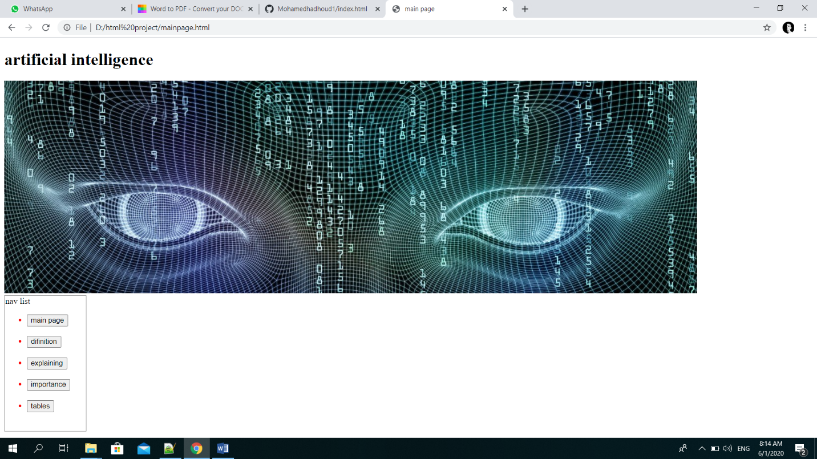

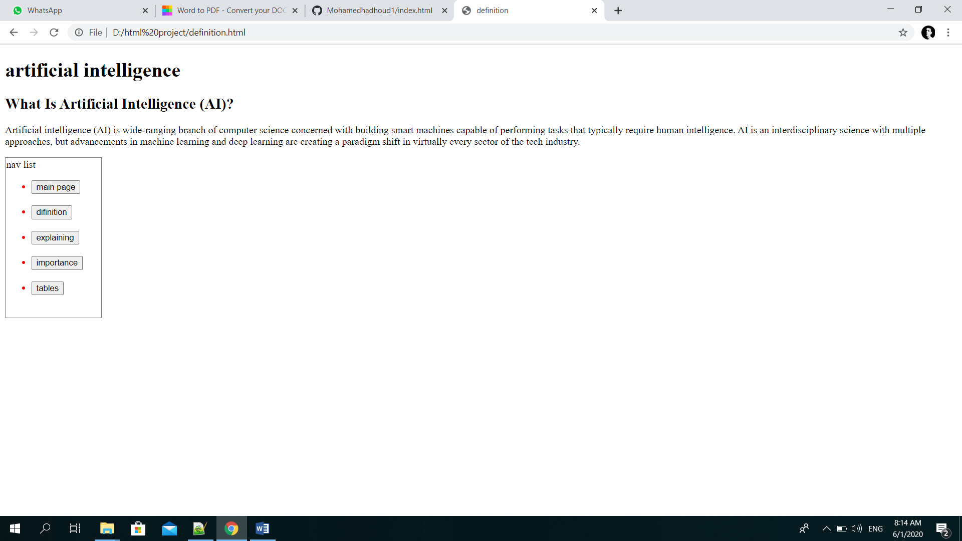

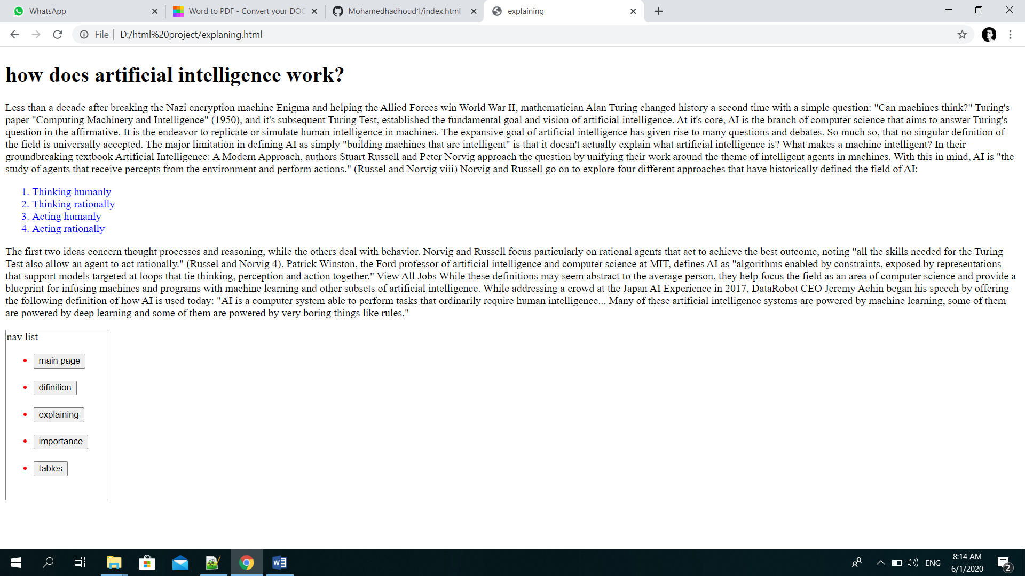

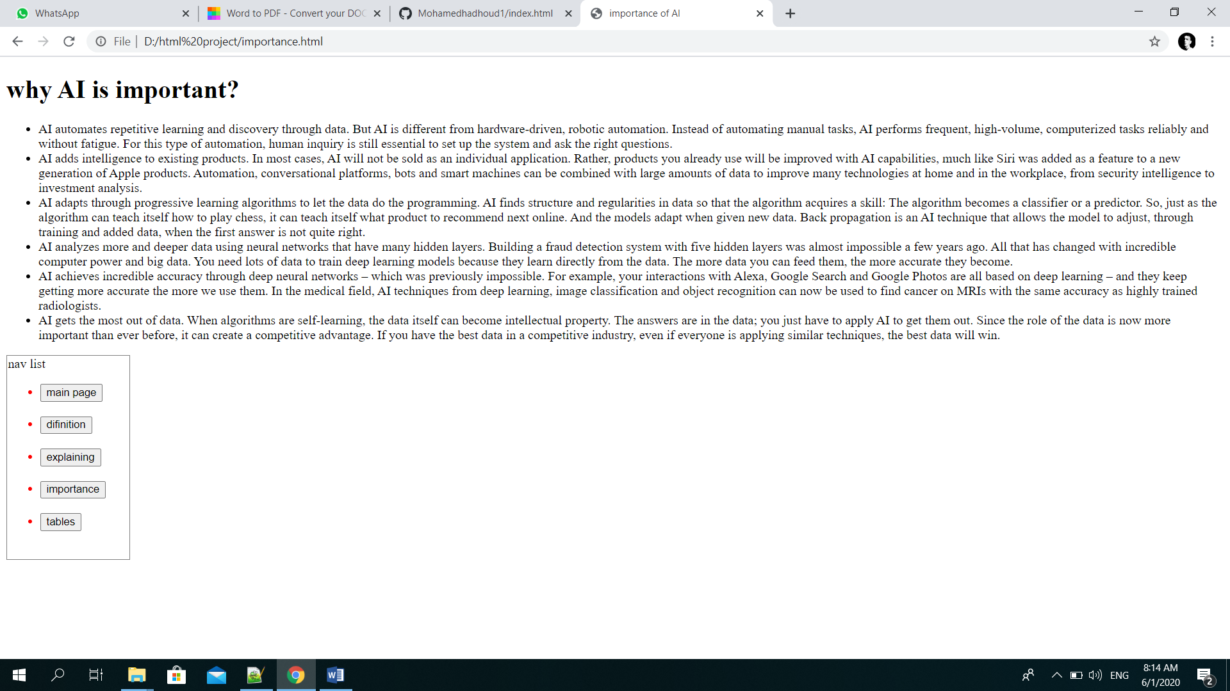

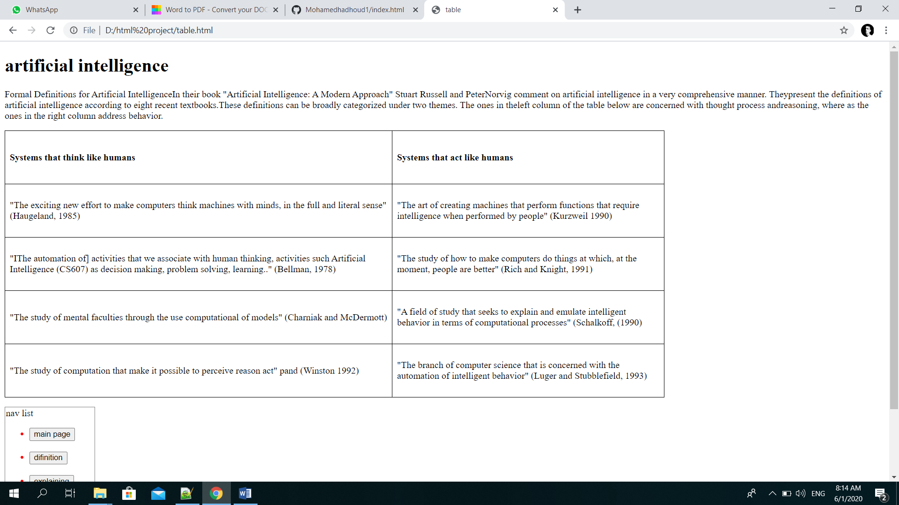

**Source codes:**

