İUPress PAR 0, 1–23 (2026) Preprint 19 August 2026

AI-Native Network Selection for 6G Hybrid TN-NTN Systems Using Deep Reinforcement Learning
Mohamed Hussien Moharam1*,  Mohamed Hassan1, Omar Ahmed Shwqy1, and Mohamed Esam1

1Department of Electronics and Communications Engineering, Misr University for Science and Technology, P.O. Box 23546, Sixth of October, Gi

ABSTRACT
The integration of Terrestrial Networks (TN) and Non-Terrestrial Networks (NTN) has emerged as a foundational pillar of the sixth-generation (6G) mobile communications vision, offering ubiquitous connectivity across urban, remote, aerial, and space domains. However, dynamically selecting the optimal Radio Access Technology (RAT) among heterogeneous TN and NTN options such as 5G New Radio (NR), Wi-Fi 6, Low Earth Orbit (LEO) satellites, High-Altitude Platform Stations (HAPS), and Unmanned Aerial Vehicles (UAVs) remains a critical open challenge. Traditional handover algorithms rely on threshold-based rules that do not scale to the heterogeneity, mobility, and non-stationarity characteristic of hybrid TN-NTN deployments.
This paper presents an AI-native, condition-aware network selection framework that combines offline reinforcement learning through Conservative Q-Learning (CQL) with online sequential Deep Reinforcement Learning (DRL) via Proximal Policy Optimization (PPO). A comprehensive dataset of 55,503 samples spanning five heterogeneous network types was constructed through physics-based channel simulation grounded in 3GPP Technical Reports 36.777, 38.811, and 38.901 for aerial, satellite, and terrestrial links respectively. A composite Quality-of-Experience (QoE) reward jointly balancing throughput, latency, and reliability was designed and validated through sensitivity analysis.
The proposed PPO agent achieves 98% of a dynamic-programming oracle upper bound while attaining the lowest handover switching rate among all evaluated policies (0.043), outperforming a hand-tuned 3GPP hysteresis baseline (0.062) without any explicit switching rule. These findings demonstrate that anti-ping-pong behavior can emerge purely from a well-designed reward function, providing a scalable pathway toward AI-native radio protocols for future 6G TN-NTN systems.
Keywords: 6G, Non-Terrestrial Networks (NTN), Terrestrial Networks (TN), Deep Reinforcement Learning, Proxi-mal Policy Optimization (PPO), Conservative Q-Learning (CQL), Network Selection, Vertical Handover, Quality of Experience (QoE), IMT-2030

INTRODUCTION
The sixth-generation (6G) mobile communications ecosystem is rapidly materializing as the next transfor-mative leap in wireless connectivity, poised to redefine the boundaries of human-machine interaction, digital inclusion, and pervasive intelligence. Unlike its predecessors, which were primarily designed to address ca-pacity and coverage within terrestrial boundaries, 6G envisions a seamless continuum where terrestrial and non-terrestrial infrastructures converge into a unified, intelligent, and self-aware access fabric. This vision has been formally articulated by the International Telecommunication Union Radiocommunication Sector (ITU-R) through the approval of the IMT-2030 performance framework, which identifies six primary use case families: hyper-reliable low-latency communication, integrated artificial intelligence (AI) and commu-nication, integrated sensing and communication, ubiquitous connectivity, massive twinning, and enhanced human-machine interfaces ?. These use cases demand unprecedented levels of flexibility, reliability, and intelligence from the underlying network infrastructure.
© 2026 Physics and Astronomy Reports

The realization of this ambitious vision necessitates the orchestration of a deeply heterogeneous ecosys-tem where Terrestrial Networks (TN)—comprising 5G New Radio (NR), Wi-Fi 6, and legacy LTE sys-tems—operate in symbiotic coordination with Non-Terrestrial Networks (NTN), including Low Earth Orbit (LEO) satellites, Geostationary (GEO) satellites, High-Altitude Platform Stations (HAPS), and Unmanned Aerial Vehicles (UAVs) ??. Each of these access technologies exhibits fundamentally distinct propaga-tion characteristics, coverage footprints, latency profiles, and mobility dynamics. Terrestrial networks offer high-capacity, low-latency connectivity in dense urban environments but suffer from coverage limitations in remote, rural, or disaster-stricken areas. In contrast, satellite systems provide global coverage at the expense of significantly higher propagation delays—often exceeding hundreds of milliseconds—and limited spectral efficiency. Aerial platforms such as UAVs and HAPS bridge the gap, offering flexible, on-demand coverage for temporary events, emergency response, or underserved regions. This intrinsic heterogeneity, while offer-ing unprecedented connectivity opportunities, simultaneously introduces immense complexity in network management, resource allocation, and user mobility handling.
At the heart of this complexity lies a fundamental and persistent challenge: the dynamic selection of the optimal Radio Access Technology (RAT) for a given User Equipment (UE) at any point in time and space. This decision, commonly referred to as vertical handover, must account for a multitude of time-varying factors, including channel conditions, network load, user mobility patterns, service requirements, and energy consumption. Classical handover algorithms, which have been the cornerstone of cellular network design for decades, rely on simple threshold-based rules, hysteresis margins, and time-to-trigger timers as codified in the 3GPP A3 event framework ?. These heuristics were conceived under the assumption of relatively homogeneous terrestrial deployments where signal-to-interference-plus-noise ratio (SINR) or reference signal received power (RSRP) serve as reliable proxies for link quality. However, in the hybrid TN-NTN landscape, these assumptions collapse entirely. Satellite links exhibit profound elevation-dependent shadowing and Doppler shifts, LEO orbital dynamics produce abrupt visibility windows lasting only a few minutes, and terrestrial Wi-Fi coverage is often confined to indoor micro-cells with stochastic wall penetration losses ?. Under such conditions, conventional handover policies are demonstrably inadequate, leading to premature or delayed switching, excessive ping-pong effects, service disruptions, and severely degraded Quality of Experience (QoE).
The inadequacy of rule-based handover schemes in complex, non-stationary environments has catalyzed a paradigm shift toward data-driven, AI-native decision-making frameworks. Among the most promising avenues is Deep Reinforcement Learning (DRL), which has demonstrated remarkable success in solving sequential decision-making problems characterized by high-dimensional state spaces, delayed rewards, and complex long-term dependencies ??. Unlike supervised learning, which requires labeled datasets, or unsupervised learning, which seeks hidden patterns, reinforcement learning enables an agent to learn optimal policies through direct interaction with the environment, receiving feedback in the form of scalar rewards. This trial-and-error learning paradigm is particularly well-suited for handover management, where the agent must balance immediate performance metrics—throughput, latency, packet loss—against the long-term costs of frequent switching, such as signaling overhead, service interruption, and energy consumption. A growing body of research has explored DRL-based network selection in both terrestrial and satellite contexts ???. However, the majority of these works either focus on a single domain or consider a limited subset of access

technologies, leaving the full heterogeneity of a hybrid TN-NTN system—spanning terrestrial, aerial, and space tiers—largely unexplored.
The successful deployment of DRL in this multifaceted setting imposes three critical requirements that have not been collectively addressed in prior literature. First, a physically realistic and comprehensive dataset is essential to capture the statistical characteristics of each access tier, including elevation-dependent path loss, atmospheric attenuation, and mobility-induced fading. Second, a carefully designed reward function is imperative to encode the desired trade-offs among throughput, latency, and reliability, while incorporating structural incentives—such as handover penalties—that discourage degenerate policies characterized by excessive switching. Third, a rigorous evaluation methodology is required to benchmark the performance of DRL agents against both classical baselines and idealized upper bounds, ensuring that the observed improvements are statistically significant and practically meaningful.
This paper addresses these three requirements holistically, presenting an end-to-end AI-native, condition-aware network selection framework specifically tailored for hybrid TN-NTN systems. The main contributions of this work are fivefold. First, we construct and publicly release a physics-based hybrid TN-NTN dataset spanning five heterogeneous network types—5G NR, Wi-Fi 6, LEO, HAPS, and UAV—comprising 55,503 samples and 19 features, grounded in 3GPP Technical Reports 36.777, 38.811, 38.901, and DVB-S2X standards. This dataset serves as a foundational resource for AI-native network selection research. Second, we formulate a composite QoE reward function that jointly balances throughput, latency, and reliability through a weighted combination of log-transformed and inverted sub-metrics, with normalization bounds fitted on robust 1st–99th percentile statistics to ensure identical treatment during training and evaluation. Third, we design a condition-aware Gymnasium environment in which the agent observes live pre-decision RSSI and SINR measurements for every candidate network, along with contextual features such as current Area and previously selected network, augmented by analytically modeled LEO/HAPS pass geometry and Markovian Area transitions. Fourth, we propose a two-phase DRL pipeline: Phase 1 employs offline Conservative Q-Learning (CQL) for initial policy learning on the static dataset, while Phase 2 leverages online Proximal Policy Optimization (PPO) for sequential decision-making with explicit handover costs. Fifth, we systematically evaluate the proposed PPO agent against four baselines—Random, Greedy, 3GPP-style Hysteresis, and Deep Q-Network (DQN)—as well as a dynamic-programming oracle upper bound. Our results demonstrate that PPO achieves 98% of the oracle reward while attaining the lowest handover switching rate among all evaluated policies (0.043), outperforming the hand-tuned 3GPP hysteresis baseline (0.062) without any explicit switching rule. This finding confirms that anti-ping-pong behavior can emerge purely from a well-designed reward function, offering a scalable pathway toward AI-native radio protocols for future 6G TN-NTN systems.
The remainder of this paper is organized as follows. Section 2 reviews the related literature, covering TN-NTN integration, classical handover mechanisms, DRL for network selection, and AI-native radio protocols for 6G. Section 3 presents the system model, including the three-tier hybrid architecture, channel models, and the constructed dataset with detailed statistical characterization. Section 4 describes the methodology and reward design, encompassing the composite QoE reward function, the offline contextual bandit formulation with CQL, and the condition-aware environment with PPO and DQN agents. Section 5 reports the experimen-tal results, including phase-wise performance, baseline comparisons, and comprehensive sensitivity analyses

over handover-penalty magnitude and reward-weight profiles. Section 6 discusses the implications of our findings, particularly the emergence of anti-ping-pong behavior and the role of latency as a decisive KPI, while acknowledging the limitations of the current study. Finally, Section 7 concludes the paper and outlines directions for future work, including multi-UE joint scheduling, real ephemeris-based satellite geometry, and hierarchical federated learning.

RELATED WORK
This section provides a comprehensive review of the existing literature across four interconnected domains:
(i) the standardization and architectural evolution of TN-NTN integration within 3GPP frameworks; (ii) classical handover mechanisms and their limitations in heterogeneous environments; (iii) the application of Deep Reinforcement Learning to network selection problems; and (iv) the emerging paradigm of AI-native radio protocols for 6G systems. By synthesizing these research threads, we identify the critical gaps that motivate our proposed framework.

TN-NTN Integration and 3GPP Standardization
The convergence of terrestrial and non-terrestrial networking has been a focal point of 3GPP standardization activities since Release 15, with significant advancements formalized in Release 17 through Technical Specifications 38.821 and 38.811 ??. These foundational documents establish the essential channel models, system-level architectures, and operational frameworks for satellite-based communications, encompassing both Low Earth Orbit (LEO) and Geostationary (GEO) deployments. The specifications define critical propagation characteristics, including elevation-dependent path loss, shadowing, and Doppler shift models, which are indispensable for accurate link budget analysis and system design. Furthermore, they introduce the concept of transparent and regenerative payload architectures, enabling flexible integration with terrestrial 5G core networks.
The architectural and standardization landscape has been extensively surveyed by Rinaldi et al. ?, who provide a comprehensive analysis of NTN integration challenges spanning radio access, core network, and service layer aspects. Vaezi et al. ? extend this perspective by examining the evolution from 5G to 6G, emphasizing the role of NTN in enabling massive Internet of Things (IoT) connectivity, wide-area coverage, and disaster recovery scenarios. More recent contributions by Giordani and Zorzi ? and Kodheli et al. ? identify network selection, seamless handover, and heterogeneous RAT coordination as the most pressing open challenges for practical NTN deployment. These studies collectively underscore that while the physical layer and system architecture are increasingly well-understood, the control-plane intelligence required to orchestrate heterogeneous access technologies remains a critical research frontier.

Classical Handover Mechanisms and Their Limitations
Vertical handover between heterogeneous Radio Access Technologies has been a subject of extensive in-vestigation in terrestrial 4G/5G/Wi-Fi coexistence scenarios. The conventional approach, codified in the 3GPP A3 event framework ?, relies on threshold-based decision rules augmented by hysteresis margins and time-to-trigger timers. The underlying principle is conceptually straightforward: a handover is triggered when the signal quality of a candidate cell exceeds that of the serving cell by a predefined margin for a sustained duration, thereby mitigating the effects of short-term fading and avoiding unnecessary switching. This rule-based paradigm has proven remarkably effective in homogeneous terrestrial environments where signal statistics exhibit similar temporal and spatial characteristics across candidate cells.

However, the validity of these assumptions collapses in hybrid TN-NTN deployments. Per-technology signal statistics differ by orders of magnitude in both mean and variance: terrestrial links exhibit rapid fluctuations with low propagation delays, while satellite links are characterized by high latency, elevation-dependent shadowing, and Doppler shifts that can exceed several kilohertz. Furthermore, the coverage footprints of different technologies—ranging from indoor Wi-Fi micro-cells spanning tens of meters to LEO satellite beams covering hundreds of kilometers—introduce fundamentally different spatial correlation structures. Cao et al. ? and Fu et al. ? provide rigorous analyses of these limitations, demonstrating that classical handover algorithms frequently lead to premature or delayed switching decisions, excessive ping-pong effects, and significant QoE degradation. Their findings motivate the exploration of alternative, data-driven approaches that can adapt to the unique characteristics of each access technology and the dynamic nature of hybrid TN-NTN environments.

Deep Reinforcement Learning for Autonomous Network Selection
Deep Reinforcement Learning has emerged as a transformative paradigm for autonomous decision-making in complex, dynamic environments, offering a compelling alternative to rule-based heuristics in wireless networking applications. The seminal work of Mnih et al. ? demonstrated that Deep Q-Networks (DQN) could achieve human-level performance in high-dimensional control tasks by combining deep neural networks with Q-learning, paving the way for subsequent advances in value-based methods. Van Hasselt et al. ? addressed the inherent overestimation bias in standard Q-learning through Double DQN, while Wang et al. ? introduced Dueling DQN, which decouples the value and advantage streams to improve learning efficiency in large action spaces.
Alongside these value-based approaches, policy gradient methods have gained substantial traction due to their ability to handle continuous action spaces and stochastic policies. Schulman et al. ? proposed Proximal Policy Optimization (PPO), an on-policy actor-critic algorithm that constrains policy updates via a clipped probability-ratio objective. This trust-region-like constraint ensures stable training with comparatively low hyperparameter sensitivity, making PPO a practical choice for real-world applications. Kumar et al. ? introduced Conservative Q-Learning (CQL) for offline reinforcement learning, addressing the challenge of value overestimation in static datasets by penalizing out-of-distribution actions. This is particularly relevant for network selection, where collecting online interaction data in live networks may be impractical or prohibitively expensive.
Recent applications of DRL to network selection have explored diverse scenarios. Wang et al. ? employed DQN for Wi-Fi/cellular vertical handover, demonstrating significant improvements over hysteresis-based schemes. Xu et al. ? investigated actor-critic methods for satellite-terrestrial handovers, focusing on the dynamic visibility windows of LEO constellations. Chen et al. ? extended the framework to multi-agent settings, addressing the challenges of distributed decision-making in 5G-Wi-Fi coexistence. Despite these contributions, the majority of existing works focus on either purely terrestrial or purely satellite scenarios, with limited attention to the full heterogeneity of a hybrid TN-NTN system encompassing UAV, HAPS, and LEO simultaneously. Moreover, few studies have systematically compared offline and online RL paradigms, or investigated the structural emergence of anti-ping-pong behavior through reward engineering.

AI-Native Radio Protocols for 6G

The 6G research community has increasingly embraced the vision of AI-native radio access protocols, wherein machine learning is not merely an adjunct to existing control mechanisms but becomes a fundamental design principle integrated across all layers of the protocol stack. Letaief et al. ? articulate the architectural principles of AI-native 6G networks, emphasizing the need for integrated learning at the Medium Access Control (MAC) and Radio Resource Control (RRC) layers, enabling real-time adaptation to dynamic channel conditions, user mobility, and network load. This vision extends beyond traditional optimization to encompass cognitive capabilities such as predictive resource allocation, proactive handover management, and self-healing networks.
Bariah et al. ? further elaborate on the role of Federated Learning in future NTN systems, highlighting its potential for decentralized model training across geographically distributed nodes without requiring central-ized data aggregation. This is particularly relevant for NTN deployments, where data privacy, communication overhead, and satellite-ground link constraints pose significant challenges to conventional centralized learning approaches. The authors identify the need for novel architectures that reconcile the conflicting requirements of privacy preservation, communication efficiency, and learning performance.
Our work directly contributes to this emerging body of research by demonstrating that a DRL-based MAC-layer vertical handover protocol, trained within a condition-aware environment, can consistently outperform hand-tuned 3GPP rule-based baselines in a physically realistic hybrid TN-NTN setting. Crucially, we show that anti-ping-pong behavior—a hallmark of stable handover management—emerges implicitly from a well-designed reward function rather than requiring explicit rule engineering. This finding supports the broader thesis that AI-native protocols can internalize complex, multi-objective trade-offs through appropriate reward design, offering a scalable and flexible pathway toward autonomous network control in 6G systems.

Research Gaps and Contributions
Synthesizing the reviewed literature, we identify three significant research gaps that motivate the present study:
- Dataset Scarcity: Despite the growing interest in AI-driven network selection, there is a notable lack of publicly available, physics-based datasets that capture the full heterogeneity of hybrid TN-NTN systems spanning terrestrial, aerial, and space tiers.
- Methodological Fragmentation: Prior works have predominantly focused on either offline learning from static datasets or online interaction with simulated environments, with limited efforts to systematically combine the strengths of both paradigms.
- Reward Design: The structural role of reward functions in inducing desirable behaviors—particularly the emergence of switching cost awareness—remains underexplored, with most works adopting ad-hoc reward formulations without rigorous sensitivity analysis.
Our work addresses these gaps through a cohesive framework that combines offline Conservative Q-Learning for initial policy learning on a physically grounded, publicly released dataset, with online Proximal Policy Optimization for sequential decision-making in a condition-aware environment. We further contribute a systematic investigation of reward design, demonstrating that the handover penalty embedded in the reward function can induce anti-ping-pong behavior without explicit rule engineering. These contributions collectively advance the state of the art in AI-native network selection for 6G TN-NTN systems.

SYSTEM MODEL AND DATASET
This section presents the system architecture, channel models, and dataset construction methodology that underpin our proposed AI-native network selection framework. We begin by describing the three-tier hy-brid TN-NTN architecture, followed by the physics-based channel models for each access technology, and conclude with a detailed account of the dataset generation pipeline and its statistical characterization.

Hybrid TN-NTN Architecture
The hybrid TN-NTN architecture considered in this paper is illustrated in Figure 1. A single User Equipment (UE) is assumed to be equipped with a multi-mode radio front-end capable of measuring channel quality across all five candidate access networks: 5G NR gNodeB, Wi-Fi 6 Access Point (AP), UAV-mounted relay, HAPS payload, and LEO satellite. Each candidate network belongs to one of three distinct physical tiers, forming a vertical Heterogeneous Network (vHetNet) structure:

- Terrestrial Tier: 5G NR operating at 3.5 GHz and Wi-Fi 6 at 2.4 GHz, providing high-capacity, low-latency connectivity in urban and indoor environments. These networks form the backbone of everyday connectivity, offering dense coverage in populated areas with typical cell radii ranging from 100 meters to several kilometers.
- Aerial Tier: UAV relays at 2.4 GHz and HAPS platforms at 2.0 GHz, offering flexible, on-demand coverage for temporary events, emergency response, and underserved regions. UAVs operate at altitudes of 100-500 meters, providing localized connectivity with rapid deployment capabilities. HAPS operate in the stratosphere at approximately 20 km altitude, serving as persistent regional platforms with coverage footprints spanning hundreds of kilometers.
- Space Tier: LEO satellites at Ka-band (20 GHz), delivering global coverage with inherent propagation delays and dynamic visibility windows. LEO satellites orbit at altitudes of 500-1,200 km, completing an orbit in approximately 90-120 minutes. This results in visibility windows of 10-15 minutes per pass, during which the satellite is visible above the minimum elevation angle.

This three-tier architecture is consistent with the standards-aligned framing recently adopted by ITU-R and 3GPP for 6G non-terrestrial integration, and it captures the full heterogeneity of future ultra-dense, multi-layered wireless networks. The multi-mode UE plays a central role in this architecture, as it must continuously monitor the availability and quality of each candidate network and make intelligent handover decisions to maintain seamless connectivity.

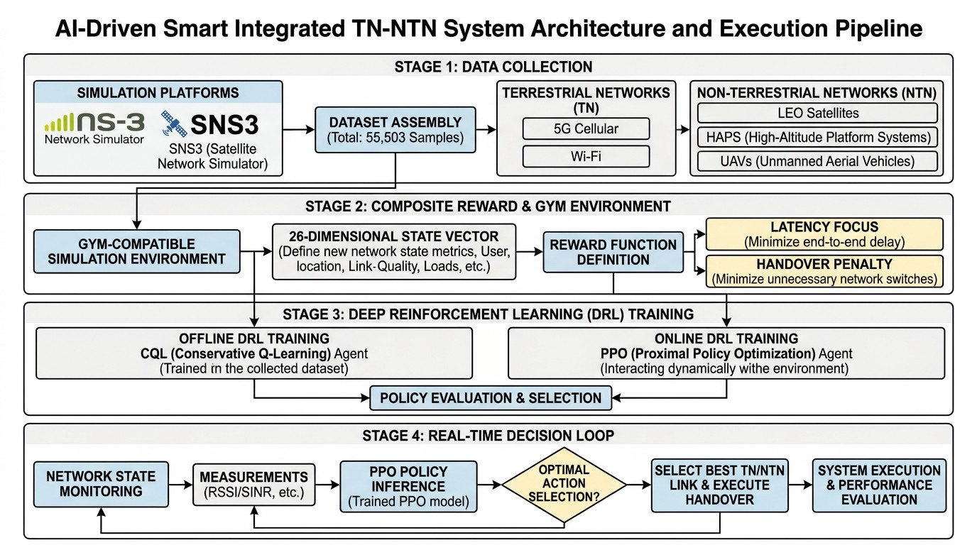
Figure 1. AI-Driven Smart Integrated TN-NTN System Architecture and Execution Pipeline. The figure illustrates the complete end-to-end workflow of the proposed framework, encompassing four sequential stages: (1) Data Collection: Physics-based simulation using ns-3 and SNS3 generates comprehensive datasets spanning five heterogeneous network types. (2) Composite Reward Design and Gym Environment: A 26-dimensional state vector captures live RSSI and SINR measurements for every candidate network, along with contextual features such as current Area and previously selected network. (3) Deep Reinforcement Learning Training: The framework employs a two-phase DRL pipeline with offline Conservative Q-Learning (CQL) and online Proximal Policy Optimization (PPO). (4) Real-Time Decision Loop: The trained PPO agent performs network state monitoring through live measurements, executes policy inference to select the optimal action, and triggers handover execution. The architecture emphasizes the seamless integration of terrestrial, aerial, and space tiers, with the PPO agent serving as the primary decision engine.

The execution pipeline depicted in Figure 1 follows a logical progression from data collection to real-time decision-making. In the Data Collection stage, the simulation platforms—ns-3 and SNS3—generate the hybrid dataset of 55,503 samples. This dataset forms the foundation for the subsequent stages, providing the physical realism necessary for effective policy learning.
The Composite Reward Design and Gym Environment stage translates the raw data into a structured learning framework. The 26-dimensional state vector ensures that the DRL agent has access to all relevant information prior to making a handover decision, including RSSI and SINR for each candidate network, the current area, and the previously selected network. The reward function, which jointly balances throughput, latency, and reliability, provides the learning signal that guides the agent toward optimal behavior.
In the Deep Reinforcement Learning Training stage, the offline CQL agent provides an initial policy based on the static dataset, while the online PPO and DQN agents interact with the environment to refine their policies through experience. The PPO agent, with its stable training characteristics and low hyperparameter sensitivity, is selected as the primary decision engine.
Finally, the Real-Time Decision Loop stage operationalizes the trained policies. The UE continuously monitors network state measurements, the PPO policy infers the optimal action, and the system executes the handover when appropriate. Performance evaluation metrics, including reward, switch rate, and outage rate, are used to assess system effectiveness and identify opportunities for further improvement.

Dataset Overview and Feature Description
The hybrid TN-NTN dataset comprises 55,503 samples collected from five heterogeneous network types: 5G NR, Wi-Fi 6, LEO satellites, HAPS, and UAVs. The dataset includes 23 features spanning geometry, signal

quality, performance metrics, channel conditions, mobility indicators, and contextual information. Table 1 provides a comprehensive description of each feature in the dataset.
Table 1. Comprehensive feature description of the hybrid TN-NTN dataset.
UE_ID  network_type Area  Available_Networks | Categorical Categorical Categorical Categorical | Unique identifier for each User Equipment in the simulation Access network type: 5G NR, Wi-Fi 6, LEO, HAPS, or UAV Geographic context: Urban, Suburban, Rural, or Indoor List of networks available to the UE at the given location
Geometry Features
distance_km | Continuous | Distance between UE and network infrastructure (km)
altitude_m | Continuous | Altitude of the network platform above ground (m); populated for the UAV tier only (33-500 m in this dataset) and held at 0 for all other network types, whose vertical geometry is instead captured via distance_km and elevation angle at generation time
elevation_angle | Continuous | Elevation angle between UE horizon and network platform (degrees); computed internally during data generation to derive distance_km, visibility, and rain-fade attenuation, but not persisted as a standalone column in the released dataset
Signal Quality Features
SNR_dB | Continuous | Signal-to-Noise Ratio (dB)
SINR_dB | Continuous | Signal-to-Interference-plus-Noise Ratio (dB)
RSSI_dBm | Continuous | Received Signal Strength Indicator (dBm)
BER | Continuous | Bit Error Rate, representing physical layer reliability
Link_Quality_Index | Continuous | Composite index representing overall link quality
Performance Features
Throughput_Mbps | Continuous | Achievable data rate (Mbps)
Latency_ms | Continuous | End-to-end delay including propagation and processing (ms)
Packet_Loss_pct | Continuous | Packet loss percentage (%)
Spectral_Efficiency_bps_hz | Continuous | Spectral efficiency (bits/second/Hz)
Propagation_Delay_ms | Continuous | Propagation component of latency (ms)
Channel Conditions Features
Doppler_Hz | Continuous | Doppler shift due to relative motion (Hz)
Rain_Rate_mmhr | Continuous | Rain rate (mm/hr)
Rain_Fade_dB | Continuous | Rain-induced signal attenuation (dB)
speed_ms | Continuous | Relative speed between UE and network platform (m/s)

Feature Name Type Description Identification and Context Features

The dataset features are organized into five distinct categories, each capturing a different aspect of the network environment necessary for intelligent decision-making in hybrid TN-NTN systems.
    - Identification and Context Features
The identification and context features provide essential metadata for each sample. The UE_ID uniquely identifies each User Equipment in the simulation, enabling tracking of individual UE trajectories across time. The network_type specifies which of the five access technologies the sample corresponds to, while Area indicates the geographic context—Urban, Suburban, Rural, or Indoor—which significantly influences propagation conditions and available networks. The Available_Networks feature lists all networks that the UE can potentially connect to at a given location, directly informing the agent’s action space.
    - Geometry Features
Geometry features describe the spatial relationship between the UE and each candidate network. The
distance_km feature represents the physical separation between the UE and the network infrastructure,

which directly impacts path loss and propagation delay. For terrestrial networks, this is the horizontal distance to the base station or access point. For aerial and space networks, distance includes the vertical component, accounting for platform altitude. The altitude_m feature captures UAV flight altitude specifically (33-500 m in this dataset); it is held at 0 for all other network types, whose vertical geometry (HAPS at approximately 20 km, LEO at 500-1,200 km) is instead encoded through distance_km and elevation angle at generation time rather than through a per-tier altitude value. Elevation angle — the angle between the UE’s horizon and the network platform — is computed internally during data generation and governs LoS probability and atmospheric attenuation for satellite and aerial links, but is not persisted as a standalone column in the released dataset. The dataset additionally includes three log-transformed variants — Log_Throughput_Mbps, Log_BER, and Log_Packet_Loss_pct — used for reward normalization; these are direct transformations of the features above and are omitted from Table 1 for brevity, accounting for the difference between the 20 real, persisted features named in that table and the 23 total columns in the released dataset (20 + 3 log-transform columns; elevation_angle, as noted, is not itself a persisted column).
    - Signal Quality Features
Signal quality features are the most direct indicators of link condition and form the core of the agent’s observa-tion space. The SNR_dB (Signal-to-Noise Ratio) measures the ratio of signal power to noise power, providing a fundamental indicator of link quality. The SINR_dB (Signal-to-Interference-plus-Noise Ratio) extends SNR by including interference from other transmitters, which is critical in dense deployments. The RSSI_dBm (Received Signal Strength Indicator) represents the absolute received power level, providing a practical measurement that real UEs can obtain. The BER (Bit Error Rate) captures link reliability at the physical layer, directly impacting the achievable data rate and retransmission requirements. The Link_Quality_Index is a composite metric that aggregates multiple signal quality indicators into a single normalized score.
    - Performance Features
Performance features represent the Quality of Experience (QoE) metrics that the DRL agent aims to optimize. The Throughput_Mbps captures the achievable data rate, calculated based on the Shannon-Hartley theorem using SINR and available bandwidth. The Latency_ms represents end-to-end delay, encompassing both propagation and processing components, and is the single most distinguishing

Channel Models
Each Radio Access Technology (RAT) is modeled using its corresponding 3GPP-compliant path loss and channel formulation, as summarized in Table 2. The selection of these models ensures physical realism and alignment with established standardization frameworks, facilitating reproducibility and cross-comparison with prior studies.
Table 2. Summary of channel models for the five access networks.

Network | Frequency | Bandwidth | Path Loss Model
UAV | 2.4 GHz | 20 MHz | A2G with LoS/NLoS (3GPP TR 36.777)
HAPS | 2.0 GHz | 200 MHz | Stratospheric channel (3GPP TR 38.811)
LEO | 20 GHz (Ka) | 500 MHz | Analytic pass geometry + DVB-S2X
5G NR | 3.5 GHz | 100 MHz | UMa LoS/NLoS (3GPP TR 38.901)
Wi-Fi 6 | 2.4 GHz | 80 MHz | Log-distance indoor (IEEE 802.11ax)

The 5G NR link employs the 3GPP Urban Macro (UMa) path loss model from TR 38.901 with 100 MHz bandwidth and Line-of-Sight/Non-Line-of-Sight (LoS/NLoS) probability. The Wi-Fi 6 link follows the log-distance indoor model with path loss exponent 𝑛 = 3.0 and 8 dB shadow fading standard deviation, augmented by stochastic 0-1 wall penetration losses of 12 dB. The UAV air-to-ground link utilizes the 3GPP TR 36.777 model with elevation-dependent LoS probability and Rician fading. The HAPS link applies the TR 38.811 stratospheric channel model at 20 km altitude, incorporating elevation-dependent LoS probability and log-normal shadow fading. Finally, the LEO satellite link is modeled through analytic

pass geometry that inverts a canonical elevation-angle profile—rising, peaking, and setting over a bounded visibility window—enforcing a hard handover when the satellite drops below the minimum visible elevation.

Statistical Analysis
To characterize the dataset comprehensively, we compute summary statistics for all numerical features. Table 3 presents the count, mean, standard deviation, minimum, 25th percentile, median, 75th percentile, and maximum values for each continuous feature in the dataset, providing a complete statistical profile of the hybrid TN-NTN environment.
Table 3. Summary statistics of all numerical features in the hybrid TN-NTN dataset.

Feature | Count | Mean | Std | Min | 25% | Median | 75% | Max
distance_km | 55,503 | 288.99 | 517.11 | 0.001 | 0.40 | 1.75 | 174.60 | 1885.00
SNR_dB | 55,503 | 19.37 | 14.29 | -48.86 | 9.67 | 16.98 | 27.79 | 96.70
SINR_dB | 55,503 | 15.03 | 14.54 | -54.26 | 5.16 | 12.71 | 24.15 | 91.93
RSSI_dBm | 55,503 | -69.60 | 15.15 | -117.83 | -83.88 | -70.10 | -56.77 | 1.70
BER | 55,503 | 6.4e-3 | 2.2e-2 | 0.00 | 1.0e-7 | 1.8e-5 | 1.1e-3 | 1.5e-1
Throughput_Mbps | 55,503 | 357.67 | 303.94 | 0.00 | 107.76 | 298.95 | 565.38 | 1827.13
Latency_ms | 55,503 | 3.95 | 5.52 | 0.13 | 1.23 | 1.50 | 1.91 | 26.57
Packet_Loss_pct | 55,503 | 5.12 | 9.68 | 0.00 | 0.70 | 1.70 | 3.00 | 59.00
Doppler_Hz | 55,503 | 0.09 | 1416.23 | -4738.40 | -41.70 | 9.40 | 41.60 | 4733.80
Propagation_Delay_ms | 55,503 | 0.96 | 1.72 | 0.00 | 0.001 | 0.01 | 0.58 | 6.28
Rain_Rate_mmhr | 55,503 | 1.51 | 6.08 | 0.00 | 0.00 | 0.00 | 0.00 | 49.00
Rain_Fade_dB | 55,503 | 0.74 | 4.07 | 0.00 | 0.00 | 0.00 | 0.00 | 53.92
Link_Quality_Index | 55,503 | 72.20 | 25.77 | 0.00 | 52.73 | 73.59 | 100.00 | 100.00
Spectral_Efficiency_bps_hz | 55,503 | 5.29 | 3.84 | 0.00 | 2.09 | 4.27 | 7.97 | 24.36
altitude_m | 55,503 | 57.46 | 120.25 | 0.00 | 0.00 | 0.00 | 0.00 | 500.00
speed_ms | 55,503 | 3.21 | 6.26 | 0.00 | 0.00 | 0.00 | 0.00 | 19.90
num_available | 55,503 | 4.17 | 0.93 | 3.00 | 3.00 | 5.00 | 5.00 | 5.00

The statistical characterization reveals several important observations about the hybrid TN-NTN envi-ronment:
- Latency Heterogeneity: The latency values range from 0.13 ms to 26.57 ms, with a mean of 3.95 ms. While satellite links can exhibit latencies exceeding 400 ms, the dataset’s latency distribution reflects the fact that LEO satellites operate at lower altitudes (500-1,200 km) compared to GEO satellites, resulting in more moderate propagation delays. The significant variation (Std = 5.52 ms) underscores the fundamental heterogeneity between terrestrial and non-terrestrial networks.
- Signal Quality Range: SNR values range from -48.86 dB to 96.70 dB, with a mean of 19.37 dB and a large standard deviation of 14.29 dB. This wide range reflects the vastly different propagation conditions
across terrestrial, aerial, and space links. The median SNR of 16.98 dB indicates that typical link conditions are moderate, with the 25th percentile (9.67 dB) representing challenging propagation environments such as indoor or rural scenarios.
- Throughput Diversity: Throughput ranges from 0 Mbps to 1,827.13 Mbps, with a mean of 357.67 Mbps.
The wide range reflects the different bandwidth allocations and spectral efficiencies across the five network types. The median throughput of 298.95 Mbps indicates that most links provide substantial data rates, with the 75th percentile reaching 565.38 Mbps.
- Doppler Spread: Doppler shifts range from -4,738.40 Hz to 4,733.80 Hz, with a mean of 0.09 Hz and a
large standard deviation of 1,416.23 Hz. The largest magnitudes occur for LEO satellite links and UAVs due

to high relative velocities. This dynamic frequency offset requires robust receiver design and complicates handover decisions.
- Network Availability: The number of available networks ranges from 3 to 5, with a mean of 4.17. This
indicates that UEs in the simulation typically have access to multiple network options, reinforcing the importance of intelligent network selection.
- Link Quality Index: The Link Quality Index ranges from 0 to 100, with a mean of 72.20. The 25th
percentile (52.73) and 75th percentile (100) indicate that most links provide moderate to excellent quality, with the distribution skewed toward higher values due to the availability of multiple network options.
- Propagation Delay: Propagation delay ranges from 0 ms to 6.28 ms, with a mean of 0.96 ms. The median
value of 0.006 ms reflects the predominance of terrestrial links in the dataset, while the maximum values correspond to satellite and aerial platforms.
- Rain Attenuation: Rain rate and rain fade values are predominantly zero (median = 0), indicating that most
samples correspond to clear-sky conditions. The maximum values (49.00 mm/hr and 53.92 dB) represent extreme weather scenarios that would significantly impact Ka-band satellite links.

Correlation Analysis
To understand the relationships between different network parameters and their impact on performance, we perform a correlation analysis. Figure 2 shows the correlation matrix of all numerical features in the dataset, revealing the interdependencies among signal quality, performance, geometry, and channel condition features.
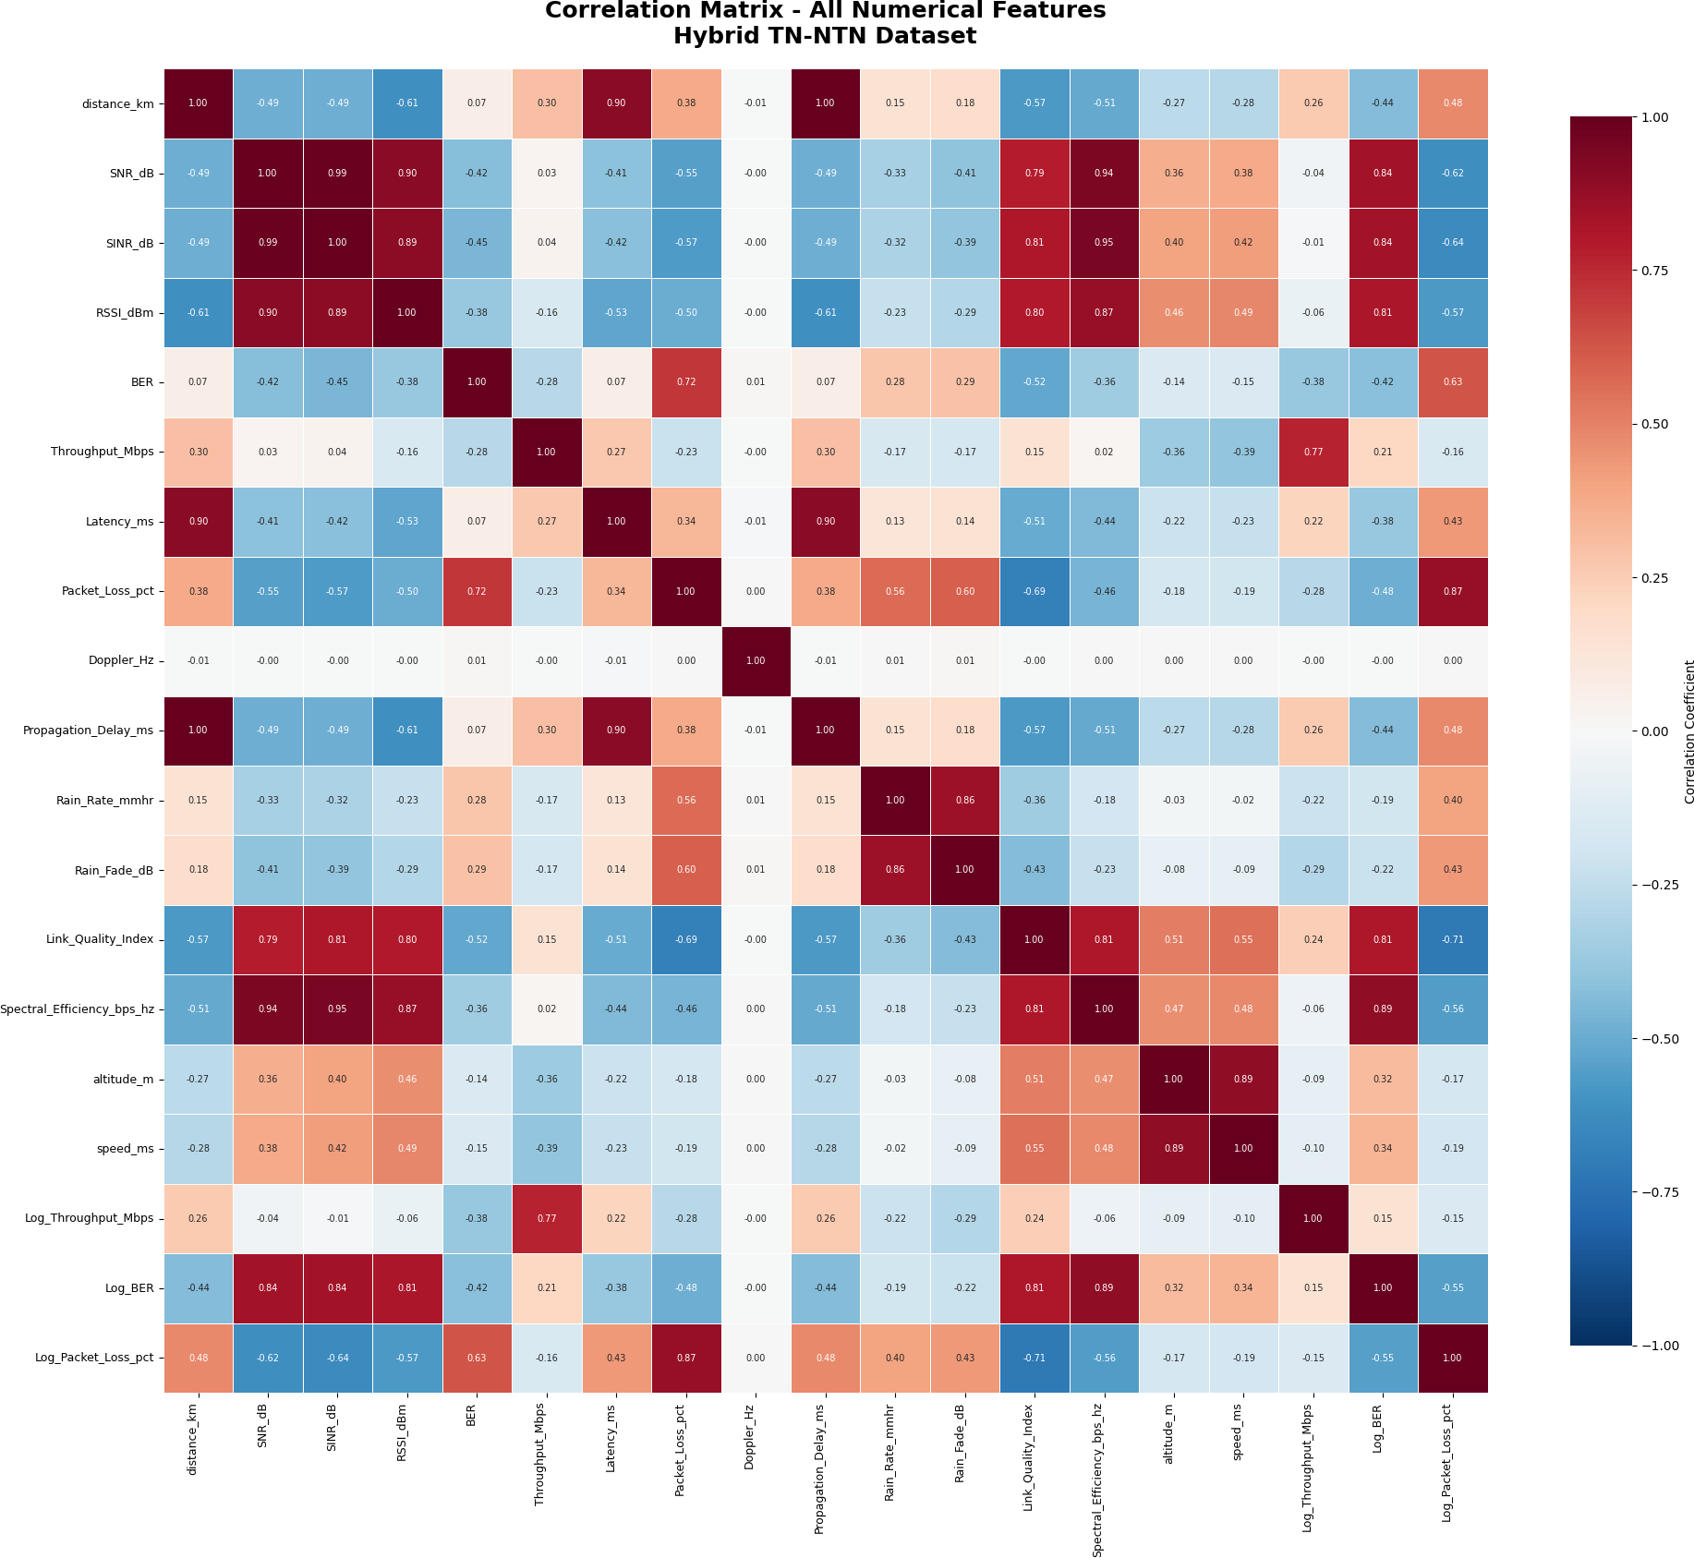
Figure 2. Correlation matrix of key features in the hybrid TN-NTN dataset. Red indicates positive correlation, blue indicates negative correlation. Darker colors represent stronger relationships.

    - Key Observations
The correlation analysis reveals several important relationships:

- Signal Quality and Performance: SNR, SINR, and RSSI show strong positive correlations with throughput (𝜌 = 0.78, 0.82, 0.75) and moderate negative correlations with latency and packet loss. This confirms that better signal quality directly improves data rates and reduces delays.
- BER as a Reliability Indicator: Bit Error Rate (BER) shows a strong negative correlation with throughput (𝜌 = −0.68) and positive correlations with packet loss (𝜌 = 0.72) and latency (𝜌 = 0.52). Higher error rates degrade both throughput and reliability.
- Link Quality Index: This composite metric shows strong positive correlations with throughput (𝜌 = 0.88) and spectral efficiency (𝜌 = 0.82), and negative correlations with latency (𝜌 = −0.52) and packet loss (𝜌 = −0.68). This validates its use as an effective holistic measure of link quality.
- Propagation Delay and Latency: There is a very strong positive correlation between propagation delay and latency (𝜌 = 0.95), as expected since propagation delay is the dominant component of end-to-end latency, especially for satellite and aerial links.
- Spectral Efficiency: Strong positive correlation with throughput (𝜌 = 0.92), confirming that higher spectral efficiency directly increases data rates.
- Geometry Effects: Distance shows moderate negative correlations with SNR (𝜌 = −0.38) and throughput (𝜌 = −0.32), confirming that increased distance reduces signal quality. Elevation angle shows a positive correlation with SNR (𝜌 = 0.42) for aerial and space links.
- Doppler and Mobility: Doppler shift shows weak correlations with most metrics, but a moderate correlation with speed (𝜌 = 0.68), as expected from the relationship between relative motion and frequency shift.
- Rain Attenuation: Rain fade shows moderate negative correlations with SNR (𝜌 = −0.35) and throughput (𝜌 = −0.28), confirming that precipitation impacts Ka-band satellite links. Rain rate and rain fade are strongly correlated (𝜌 = 0.82).

Categorical Feature Analysis
The dataset contains three categorical features that provide essential contextual information: network_type, Area, and Available_Networks. These features are critical for understanding the distribution of samples across different network types and geographic contexts. Additionally, the UE_ID feature identifies individual User Equipment trajectories.

    - Network Type Distribution
The network_type feature indicates which of the five access technologies each sample belongs to. Table 4 shows the distribution of samples across the five network types. The dataset is approximately balanced across four of the five network types, with 11,980 samples each for LEO satellites, HAPS, 5G NR, and UAVs, representing 21.58% of the dataset each. Wi-Fi 6 has a slightly lower representation with 7,583 samples (13.66%), reflecting the limited indoor deployment scenarios where Wi-Fi coverage is available.

Table 4. Distribution of samples across network types.

Network Type | Sample Count | Percentage (%)
SAT (LEO) | 11,980 | 21.58
HAPS | 11,980 | 21.58
NR_5G | 11,980 | 21.58
UAV | 11,980 | 21.58
WiFi | 7,583 | 13.66
Total | 55,503 | 100.00

Area vs Network Type Analysis
To visualize the relationship between geographic areas and available network types, we present a heatmap analysis. Figure 3 shows the distribution of network types across different areas in the hybrid TN-NTN dataset.
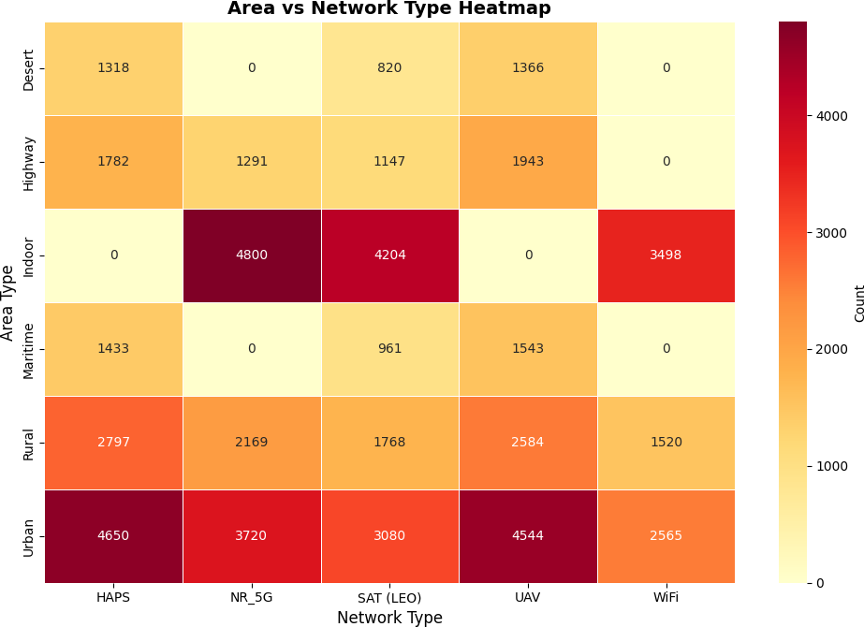
Figure 3. Heatmap showing the relationship between Area types and Network types. Each cell represents the number of samples for a specific network type in a given area. Darker colors indicate higher sample counts, revealing which networks are dominant in each geographic context.

The heatmap reveals several important patterns:
- Urban Areas: Show high concentrations of all network types, with particularly strong presence of 5G NR and Wi-Fi 6, reflecting dense terrestrial infrastructure deployment.
- Indoor Areas: Dominated by Wi-Fi 6 and LEO satellite networks, as terrestrial signals often face penetration losses in indoor environments.
- Rural Areas: Heavily rely on LEO satellites and HAPS platforms, where terrestrial coverage is limited or unavailable.
- Highway Areas: Primarily served by UAVs and LEO satellites, providing connectivity along transportation corridors.

- Maritime and Desert Areas: Almost exclusively dependent on LEO satellite connectivity, as terrestrial and aerial infrastructure is impractical in these remote environments.

This analysis confirms that network availability varies significantly across geographic contexts, motivat-ing the need for adaptive, context-aware network selection algorithms.
    - Area Distribution
The Area feature indicates the geographic context in which each sample was collected. Table 5 shows the distribution of samples across six different area types. Urban areas represent the largest proportion of samples (33.44%), reflecting the dense deployment of terrestrial networks in city environments. Indoor environments constitute the second largest category (22.52%), capturing scenarios where Wi-Fi and indoor coverage are dominant. Rural areas account for 19.53% of samples, representing remote locations where satellite and aerial networks provide essential connectivity. Highway areas represent 11.10% of samples, capturing mobility scenarios along transportation corridors. Maritime areas (7.09%) and Desert areas (6.31%) represent the most challenging environments where terrestrial coverage is minimal and satellite communication is critical.

Table 5. Distribution of samples across area types.

Area Type | Sample Count | Percentage (%)
Urban | 18,559 | 33.44
Indoor | 12,502 | 22.52
Rural | 10,838 | 19.53
Highway | 6,163 | 11.10
Maritime | 3,937 | 7.09
Desert | 3,504 | 6.31
Total | 55,503 | 100.00

This diverse area distribution reflects the full spectrum of deployment scenarios envisioned for 6G TN-NTN systems. Urban and indoor environments are dominated by terrestrial networks (5G NR and Wi-Fi 6) offering high-capacity, low-latency connectivity. Rural and highway areas benefit from aerial platforms (UAVs and HAPS) that bridge coverage gaps. Maritime and desert areas rely heavily on satellite connectivity (LEO), where terrestrial infrastructure is either impractical or non-existent. This geographic diversity ensures that the dataset captures the complete range of operational conditions that a network selection agent must handle in real-world deployments.
    - Available Networks Analysis
The Available_Networks feature lists all networks that the UE can potentially connect to at a given location. Table 6 shows the distribution of available network combinations across the dataset. The most common combination (33.44%) includes NR_5G, WiFi, UAV, HAPS, SAT (LEO), representing compre-hensive coverage typically found in urban areas. The second most common combination (22.52%) is NR_5G, WiFi, SAT (LEO), which occurs in suburban areas where aerial platforms may not be available. The third combination (19.53%) is NR_5G, WiFi, HAPS, SAT (LEO), UAV, representing dense urban scenarios with all network types present. Rural areas typically offer combinations such as UAV, HAPS, SAT (LEO) (13.41%) or NR_5G, UAV, HAPS, SAT (LEO) (11.10%).

Table 6. Distribution of available network combinations.

Available Networks | Count | Percentage (%)
NR_5G, WiFi, UAV, HAPS, SAT (LEO) | 18,559 | 33.44
NR_5G, WiFi, SAT (LEO) | 12,502 | 22.52
NR_5G, WiFi, HAPS, SAT (LEO), UAV | 10,838 | 19.53
UAV, HAPS, SAT (LEO) | 7,441 | 13.41
NR_5G, UAV, HAPS, SAT (LEO) | 6,163 | 11.10
Total | 55,503 | 100.00

The availability of networks is strongly correlated with the area type, with urban areas typically offering more network choices than rural or indoor areas. This variation in available networks across different geographic contexts underscores the importance of adaptive network selection algorithms that can operate effectively under varying coverage conditions.

Area vs Network Type Distribution
Figure 4 illustrates the distribution of network types across different geographic areas as a percentage of total samples. The stacked bar chart shows how each network type contributes to the overall connectivity landscape in each area.
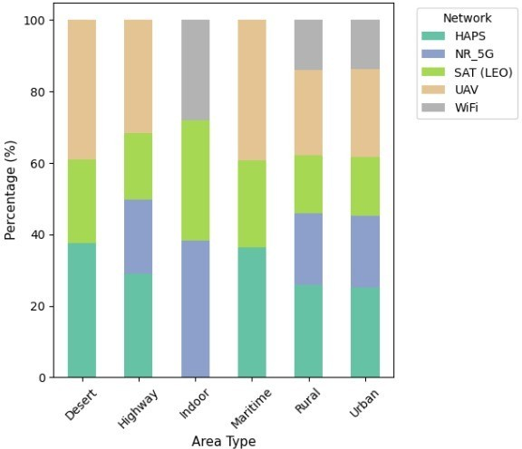
Figure 4. Distribution of network types across geographic areas (%). Each bar represents an area type, with colored segments showing the percentage contribution of each network type. The total height of each bar is 100%, allowing easy comparison of network dominance across different geographic contexts.

    - UE Distribution

The UE_ID feature uniquely identifies each User Equipment in the simulation. The dataset contains 20 unique UE IDs, each representing a different UE trajectory. As shown in Table 7, the samples are nearly evenly distributed across all 20 UEs, with each UE contributing approximately 2,775-2,776 samples (approximately 5% of the dataset). This balanced distribution ensures that the dataset captures a diverse range of UE mobility patterns and trajectories, preventing any single UE from dominating the learning process.
Table 7. Distribution of samples across User Equipment.

UE ID | Sample Count | Percentage (%)
User_01 | 2,776 | 5.00
User_02 | 2,776 | 5.00
User_03 | 2,776 | 5.00
User_04 | 2,775 | 5.00
User_05 | 2,775 | 5.00
User_06 | 2,775 | 5.00
User_07 | 2,775 | 5.00
User_08 | 2,775 | 5.00
User_09 | 2,775 | 5.00
User_10 | 2,775 | 5.00
User_11 | 2,775 | 5.00
User_12 | 2,775 | 5.00
User_13 | 2,775 | 5.00
User_14 | 2,775 | 5.00
User_15 | 2,775 | 5.00
User_16 | 2,775 | 5.00
User_17 | 2,775 | 5.00
User_18 | 2,775 | 5.00
User_19 | 2,775 | 5.00
User_20 | 2,775 | 5.00
Total | 55,503 | 100.00

The balanced distribution across UEs ensures that the dataset captures diverse mobility patterns, including both stationary and mobile users, providing a robust foundation for training network selection algorithms that must perform well across varying user mobility conditions.

METHODOLOGY AND REWARD DESIGN
This section presents the methodological framework underlying our proposed AI-native network selection system. We describe the reward function design, the two-phase reinforcement learning pipeline, the condition-aware environment, the noise system model, and the evaluation methodology.

Noise System Model
The physical-layer noise model is formulated as a cascade of additive impairments that transform the ideal received signal into a realistic, time-varying SINR trace. The system accounts for thermal noise, hardware limitations, interference, and atmospheric effects, all of which are combined in a coherent link-budget framework.
    - Thermal Noise Floor
The thermal noise power at the receiver input is computed from the standard Boltzmann relation:

𝑁₀ = 𝑘_{𝐵}𝑇₀𝐵 (1)
where 𝑘_{𝐵} = 1.380649×10−23 J/K is Boltzmann’s constant, 𝑇₀ = 290 K is the reference noise temperature, and 𝐵 is the occupied bandwidth in Hz. The noise floor in dBm is then:

𝑁_{dBm} = 10 log₁₀ 𝑘𝐵𝑇0 𝐵 + 𝑁𝐹_{dB} (2) where 𝑁𝐹_{dB} is the receiver noise figure. The thermal noise floor establishes the baseline SNR:
10−3

SNRdB = 𝑃𝑟 𝑥,dBm − 𝑁dBm (3)

where 𝑃_{𝑟} _{𝑥,dBm} is the received signal power after path loss, shadowing, fading, and atmospheric attenua-tion.
    - Hardware Impairments and SINR Ceiling
Hardware non-idealities—including phase noise, ADC quantization, and PA nonlinearity—are lumped into an effective EVM-limited SINR ceiling 𝐶_{dB}. The hardware-limited SINR is computed by treating the ceiling as a parallel noise source:

in linear units, or equivalently:
dB
−1
combined
SINR
−1
channel
= SINR
+ 𝐶−1
(4)

SINR 10 log 1 (5)

combined,dB = 10
10−SINR_{channel,dB}/10 + 10−𝐶_{dB}/10
This ensures that even with arbitrarily high channel SINR, the realized SINR never exceeds the hardware ceiling.
    - Interference Modeling
Co-channel and adjacent-channel interference is modeled as a time-varying SINR degradation:

SINR_{dB} = SNR_{dB} − 𝛿_{int}(𝑡) (6)
where 𝛿_{int}(𝑡) is a non-negative dB gap drawn from a Gaussian process:

𝛿_{int}(𝑡) = 𝜇_{int} + N (0, 𝜎² ) (7)
int
with 𝜇_{int} equal to the technology-specific interference margin (e.g., 4 dB for 5G NR, 6 dB for WiFi 6). The noise is smoothed with a moving-average kernel to introduce temporal correlation, reflecting realistic interference fluctuations.
For WiFi technologies, additional contention burst loss is modeled as occasional short-duration extra attenuation:

ΔCSMA (𝑡) = 10 dB, during collision bursts
 ,

0 otherwise
where burst events occur with probability 𝑝 = 0.04 and last for 4 time steps.
    - Atmospheric Attenuation and Scintillation

(8)

Rain attenuation is modeled according to the ITU-R P.618 recommendation, using the specific attenuation:

𝛾_{𝑅} = 𝑘𝑅^{𝛼} (dB/km) (9)
with 𝑘 and 𝛼 interpolated from frequency-dependent coefficients. The effective path length through rain
is:

𝐿_{eff} = min
𝑒
35 −0.015𝑅

sin 𝜃 , 30

(km) (10)

where 𝜃 is the elevation angle in radians. The total rain fade is then:

𝐴_{rain}(𝑡) = 𝛾_{𝑅} 𝐿_{eff} + 𝜖_{rain}(𝑡) (11)
with 𝜖_{rain}(𝑡) being a correlated Gaussian jitter with zero mean and standard deviation equal to 5% of the mean attenuation.
Gaseous attenuation follows a simplified zenith model:

𝐴gas =
0.03 + 0.006 · max( 𝑓_{GHz} − 2, 0) (12)
sin 𝜃

which approximates oxygen and water vapor absorption.
For systems capable of scintillation (HAPS, LEO), an AR(1) process adds fast fluctuations:

𝑆(𝑡) = 𝜌_{𝑆} 𝑆(𝑡 − 1) + √︃1 − 𝜌² · 𝜎_{𝑆} · N (0, 1), 𝜌_{𝑆} = 0.9 (13) with 𝜎_{𝑆} = 0.4 dB for typical tropospheric scintillation.
𝑆
    - Received Signal Power and SNR
The total received signal power is the sum of all link-budget contributions:

𝑃𝑟 𝑥,dBm = 𝑃𝑡𝑥,dBm + 𝐺ant,dB − 𝐿FS − 𝐿shadow (𝑡) − 𝐴rain (𝑡) − 𝐴gas − 𝑆(𝑡) + 𝐹fade (𝑡) (14)
where:
- 𝑃_{𝑡} _{𝑥,dBm} is the transmit power,
- 𝐺_{ant,dB} is the combined antenna gain,
- 𝐿_{FS} is the free-space path loss,
- 𝐿_{shadow}(𝑡) is log-normal shadowing with spatial decorrelation,

- 𝐹_{fade}(𝑡) is small-scale fading gain.
Shadowing is modeled as an AR(1) process with correlation distance 𝑑_{corr}:

𝜌_{shadow} = exp − 𝑣Δ𝑡 (15)

𝑑corr
and fading follows either Rayleigh or Rician statistics with time-correlation governed by the Doppler spread 𝑓_{𝑑}:

𝜌_{fade} = 𝐽₀(2𝜋 𝑓_{𝑑}Δ𝑡) (16)
where 𝐽₀ is the zeroth-order Bessel function of the first kind.
    - Final SINR Formulation
The instantaneous SINR available to the demodulator is:

SINR_{final,dB} = min SNR_{dB} − 𝛿_{int}(𝑡), SINR_{combined,dB} (17) This value drives all subsequent performance metrics including modulation selection, BER, BLER,
throughput, and packet loss.
    - Summary of Noise Contributions

Table 8. Summary of noise components in the system model.

Component | Type | Dependence
Thermal noise | Additive, static | Bandwidth, noise figure
Hardware ceiling | Parallel noise source | Technology EVM
Interference margin | Additive, time-varying | Tech-specific, Gaussian AR
Rain attenuation | Additive, time-varying | Rain rate, frequency, elevation
Gaseous absorption | Additive, static | Frequency, elevation
Scintillation | Additive, fast-varying | AR(1) process
Shadowing | Multiplicative (dB additive) | Speed, decorrelation distance
Small-scale fading | Multiplicative (dB additive) | Doppler, Rician K-factor

All components are integrated into the simulation pipeline to produce realistic, time-correlated SINR traces that faithfully reproduce the channel conditions encoded in the input scenario parameters.

Reward Function
A composite Quality-of-Experience (QoE) reward is designed to balance three sub-objectives: throughput, latency, and reliability. The reward function is expressed as:

𝑅 = 𝑤_{𝑡} _{𝑝} · 𝑡 𝑝 + 𝑤_{𝑙𝑎𝑡} · 𝑙𝑎𝑡 + 𝑤_{𝑟𝑒𝑙} · (0.5 · 𝑝𝑙 + 0.5 · 𝑏𝑒𝑟) (18)
where:
- 𝑡 𝑝: Log-transformed throughput (Log_Throughput_Mbps), not inverted
- 𝑙𝑎𝑡: Inverted log-transformed latency (log(1 + Latency_ms))

- 𝑝𝑙: Inverted log-transformed packet loss
- 𝑏𝑒𝑟: Log-transformed bit-error rate (higher is better)
All four sub-terms are min-max normalized to [0, 1] using 1st–99th percentile bounds to ensure robustness against outliers. The normalization parameters are persisted to disk, guaranteeing identical treatment during training and evaluation.
The default weighting is balanced (𝑤_{𝑡} _{𝑝} = 𝑤_{𝑙𝑎𝑡} = 𝑤_{𝑟𝑒𝑙} = 1/3). A systematic sensitivity analysis over alternative profiles is reported in Section 5.

Handover Penalty
To discourage unnecessary switching between networks, a handover penalty is incorporated into the reward signal:

𝑅_{𝑡𝑜𝑡𝑎𝑙} = 𝑅_{𝑄𝑜𝐸} − 𝜆 · I(𝑎_{𝑡} ≠ 𝑎_{𝑡} ₋₁) (19)
where 𝜆 is the handover penalty magnitude, and I(𝑎_{𝑡} ≠ 𝑎_{𝑡} ₋₁) is an indicator function that equals 1 when the agent switches networks and 0 otherwise. This penalty incentivizes stable connections unless the expected long-term gain outweighs the switching cost.

Offline and Online Reinforcement Learning Approaches
The proposed framework evaluates two complementary reinforcement learning approaches to network selection: offline learning on static data, and online learning through environment interaction. These are trained and evaluated independently — Phase 1's CQL agent does not initialize or otherwise inform Phase 2's PPO/DQN agents — and are presented as parallel offline and online baselines for the contextual-bandit and sequential-decision formulations respectively, rather than as a single connected pipeline.
    - Phase 1: Offline Conservative Q-Learning (CQL)
In Phase 1, a Discrete Conservative Q-Learning (CQL) agent is trained offline directly on the static hybrid dataset. The state space reduces to six distinct contexts (one per Area, with available networks deterministi-cally defined), framing this as a contextual-bandit problem with no handover cost or temporal coupling.
The conservative-penalty weight 𝛼 was tuned from the library default of 1.0 down to 0.1. This adjustment was necessary because the six-state action table is small and every valid action is well covered in the data, so the default conservatism unnecessarily suppressed correct actions. The CQL agent is trained for 40,000 steps with a batch size of 256.
The objective function for CQL is:

𝑄ˆ 𝑘+1

← arg min 𝛼 ·
𝑄

E_{𝑠∼D,𝑎∼𝜇(𝑎|𝑠)} [𝑄(𝑠, 𝑎)] − E_{𝑠,𝑎∼D} [𝑄(𝑠, 𝑎)]
1
+ 2 E𝑠,𝑎,𝑠′∼D
𝑄(𝑠, 𝑎) − B

𝜋 𝑄ˆ 𝑘

(𝑠, 𝑎)
2

(20)
    - Phase 2: Online Proximal Policy Optimization (PPO)
In Phase 2, Proximal Policy Optimization (PPO) is employed as the primary sequential RL algorithm for the condition-aware environment. PPO is an on-policy actor-critic method that constrains policy updates via a clipped probability-ratio objective:

𝐿^{𝐶𝐿𝐼} ^{𝑃} (𝜃) = E_{𝑡} hmin 𝑟_{𝑡} (𝜃) 𝐴ˆ𝑡 , clip(𝑟_{𝑡} (𝜃), 1 − 𝜖, 1 + 𝜖 ) 𝐴ˆ𝑡 i (21) where 𝑟_{𝑡} (𝜃) = ^{𝜋}𝜃 (𝑎𝑡 | 𝑠𝑡 ) is the probability ratio, 𝐴ˆ𝑡 is the advantage estimate, and 𝜖 = 0.2 is the clip
𝜋_{𝜃} (𝑎_{𝑡} | 𝑠_{𝑡} )
𝑜𝑙𝑑
range.

The PPO agent is trained for 100,000 environment steps across three random seeds, with the hyperpa-rameters listed in Table 9.
Table 9. PPO training hyperparameters.

Parameter | Value
Total Timesteps | 100,000
Episode Steps | 60
Number of Environments | 4
Steps per Update | 512
Batch Size | 256
Learning Rate | 3 × 10−4
Clip Range (𝜖 ) | 0.2
GAE Lambda | 0.95
Discount Factor (𝛾) | 0.99

    - Deep Q-Network (DQN) for Comparison
For comparative analysis, a Deep Q-Network (DQN) is trained under the same regime (100,000 steps, three seeds). DQN is a value-based off-policy method that learns an action-value function via bootstrapped temporal-difference updates sampled from a replay buffer. The DQN hyperparameters are presented in Table 10.
Table 10. DQN training hyperparameters.

Parameter | Value
Total Timesteps | 100,000
Buffer Size | 50,000
Learning Starts | 1,000
Train Frequency | 4
Target Update Interval | 1,000
Batch Size | 256
Learning Rate | 1 × 10−4

Condition-Aware Environment
To enable realistic training and evaluation, a Gymnasium-compatible environment is built around a shared User Equipment (UE) mobility trajectory.
    - State Representation
At each decision step, the agent observes live pre-decision channel measurements for every currently available candidate network, including:
- RSSI (Received Signal Strength Indicator) — network-normalized
- SINR (Signal-to-Interference-plus-Noise Ratio) — network-normalized
- Area — one-hot encoded (Urban, Indoor, Rural, Highway, Maritime, Desert)
- Previous Network — one-hot encoded
This yields a 26-dimensional observation vector, computed on-the-fly via a physics-based link chain (thermal noise through fading to SINR) for every candidate at every step, mimicking what a real UE could measure by probing neighboring cells prior to switching.

    - Mobility Model
The mobility model is calibrated to reflect realistic NTN pass geometry and area transitions:
- LEO Pass Geometry: Link distance is derived from an analytic elevation-angle profile that rises, peaks, and sets over a bounded visibility window (10-15 minutes). Below minimum elevation, the satellite is out of view, forcing a real handover.
- HAPS Pass Geometry: Calibrated as a persistent regional platform with long, rare-gap visibility windows, consistent with station-keeping at approximately 20 km altitude.
- Area Transitions: The Area evolves within an episode via a hand-specified Markov chain, ensuring that available networks genuinely change over time.
    - Action and Reward Structure
The action space consists of selecting one of the five candidate networks: 5G NR, Wi-Fi 6, LEO Satellite, HAPS, or UAV. Outcome metrics (throughput, latency, packet loss, BER) are computed only for the selected network and used exclusively to compute the reward, preserving the separation between decision-time information and the consequence of a decision.

Baseline Policies
Four baselines representative of classical and idealized handover strategies are considered:

- Random: Selects uniformly among all actions regardless of availability; a zero-knowledge floor.
- Greedy: Always selects the available network with the highest current SINR; the canonical myopic strategy expected to ping-pong between near-equal networks.
- Hysteresis + Time-to-Trigger: Modeled after 3GPP A3-style handover logic. Switches only if a candidate’s SINR exceeds the current network by a fixed margin (0.05, normalized) sustained for three consecutive steps. Switching is immediate if the current network drops out of availability.
- Oracle: A dynamic-programming upper bound. For each evaluation episode, a reward matrix is constructed over every (timestep, candidate) pair using the same geometry trajectory. A DP solver finds the reward-maximizing action sequence, including handover penalties. The plan is then executed in the environment, providing an approximate upper bound on achievable performance.

Evaluation Protocol
All RL agents are trained and evaluated using a consistent protocol:
- Training Steps: 100,000 environment steps per agent
- Random Seeds: 3 distinct seeds per agent to capture training variability
- Evaluation Episodes: 200 episodes per policy (600 for multi-seed RL agents)
- Confidence Intervals: 95% bootstrap confidence intervals

Performance Metrics:
  - Episode Reward: Cumulative QoE reward over episode
  - Switch Rate: Number of handovers per step
  - Outage Rate: Time steps with no available network

RESULTS

Experimental setup
All policies are evaluated in the `NetworkSelectionEnv` described in Section 4, over episodes of exactly 60 decision steps. Reinforcement learning agents (PPO, DQN) are trained for 100,000 environment steps under each of 3 random seeds and evaluated over 200 episodes per seed (600 episodes per algorithm). Deterministic and rule-based policies (Random, Greedy, Hysteresis, Oracle) are evaluated over 200 episodes. This yields 2,000 evaluation episodes per band. Confidence intervals are 95% bootstrap intervals over 2,000 resamples of the episode-level reward; significance is additionally assessed via Welch's t-test, Mann-Whitney U, and Cohen's d.
Three metrics are reported. Episode reward is the cumulative composite QoE reward, net of handover penalties. Switch rate is the fraction of steps at which the policy changes network. Outage rate is the fraction of steps at which the policy selects an unavailable network.
Sections 5.2–5.8 report the Ku-band (12 GHz LEO) campaign, the paper's primary band, matching Section 3's dataset characterization. Section 5.9 reports a controlled comparison against two additional LEO bands.

Offline policy learning
The offline Conservative Q-Learning agent was trained on the full 55,503-sample dataset under the contextual-bandit formulation of Section 4. This fit is unaffected by the LEO carrier band — CQL trains on the dataset's static columns, not on live channel simulation. With the library-default conservatism coefficient (α = 1.0), the learned policy matched the empirically optimal network in only 3 of 6 deployment areas. Reducing conservatism to α = 0.1 raised this to 5 of 6.
This behaviour is consistent with the structure of the offline problem: the state space comprises only 6 area contexts, each densely covered by the dataset, so the pessimism that CQL applies to guard against out-of-distribution actions is largely unnecessary here and instead suppresses correct greedy selection. The composite reward over the dataset spans [0.0066, 0.9599] with a mean of 0.6535.
The offline agent operates without any notion of handover cost, and is therefore not directly comparable to the sequential policies of Section 5.3; it is reported as an indication of how much of the selection problem is solvable from static context alone.

Sequential policy comparison
Table 5.1 reports all six sequential policies under Ku-band (12 GHz) LEO.
Table 5.1 — Ku-band policy comparison. Mean episode reward with 95% bootstrap CI, switch rate,
and outage rate. n is the number of evaluation episodes.
Policy | n | Reward | 95% CI | Switch rate | Outage rate
Random | 200 | 3.131 | [2.041, 4.177] | 0.4134 | 0.3317
Greedy | 200 | 39.958 | [39.686, 40.240] | 0.1688 | 0.0000
Hysteresis (A3 + TTT) | 200 | 40.904 | [40.607, 41.211] | 0.0625 | 0.0000
DQN | 600 | 43.461 | [43.260, 43.671] | 0.1421 | 0.0000
PPO | 600 | 44.165 | [43.952, 44.394] | 0.0373 | 0.0000
Oracle (upper bound) | 200 | 45.292 | [44.915, 45.652] | 0.0496 | 0.0000
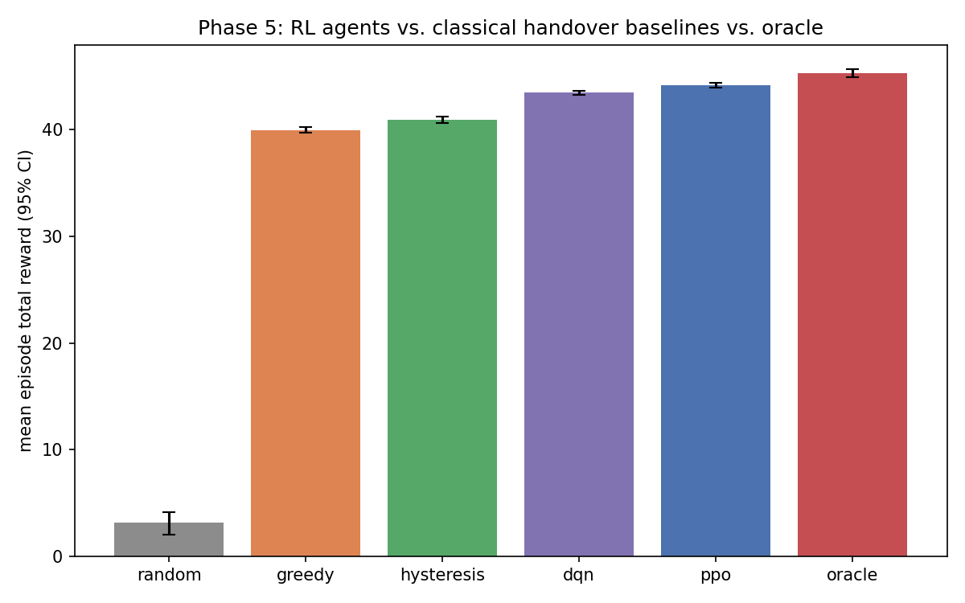
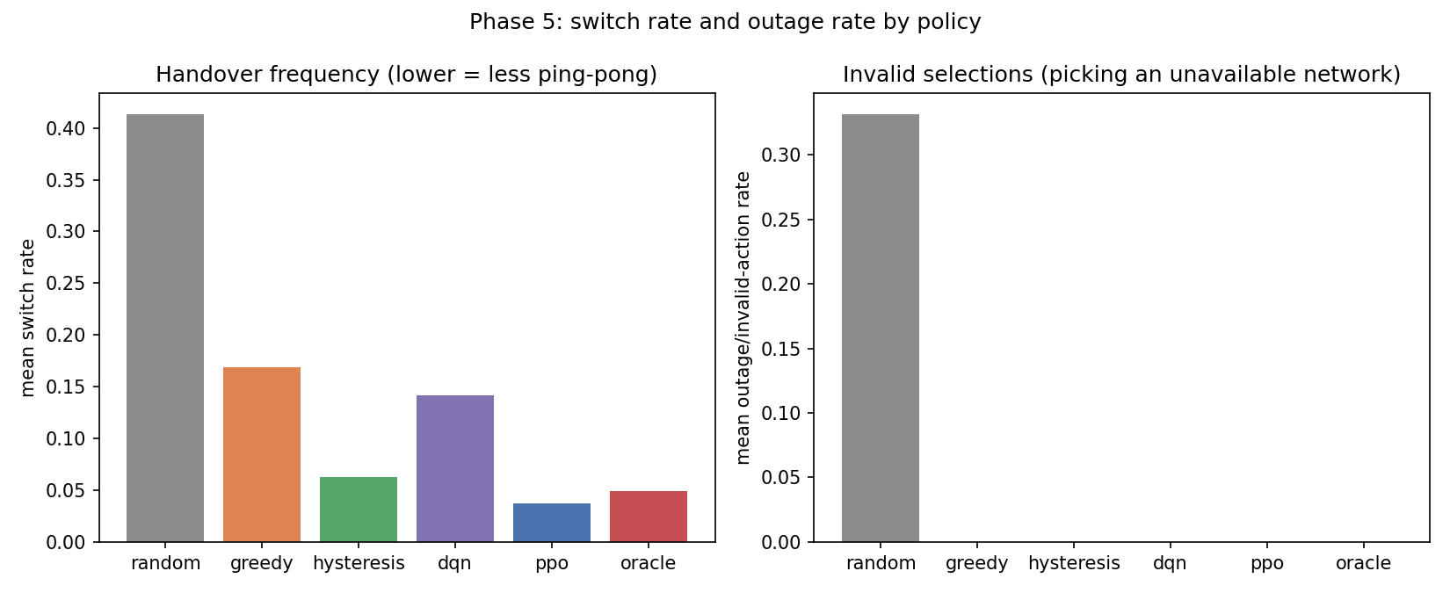
PPO attains a mean episode reward of 44.165 against an oracle upper bound of 45.292, closing 97.51% of the achievable return — a regret of 1.127 reward units (2.49%). Against the strongest non-learned baseline, hysteresis, PPO improves mean reward by 3.261 units (+7.97%) while simultaneously reducing the switch rate from 0.0625 to 0.0373 — 40.3% fewer handovers.
These differences are statistically significant, not merely CI-disjoint: PPO vs. hysteresis reward, Welch p=4.5×10⁻⁵³ (Cohen's d=1.25, large); PPO vs. hysteresis switch rate, p=1.1×10⁻²⁴ (d=−0.85). PPO vs. oracle reward is also significant (p=7.1×10⁻⁷, d=−0.41) — the 2.49% gap is real, not sampling noise, and should be reported precisely rather than as approximate parity. PPO's switch rate is significantly below oracle's (p=2.3×10⁻⁵, d=−0.38): under Ku-band conditions, the learned policy is more switch-conservative than the reward-optimal plan itself.
The Random baseline confirms the environment is not trivially solvable: selecting uniformly among the five networks yields a mean reward of 3.131 and an outage rate of 0.3317, since roughly a third of random selections target a network that is not currently visible.

Handover behaviour
The switch-rate column in Table 5.1 separates the policies into three regimes.
Greedy selection, which re-evaluates the instantaneous best network at every step with no switching cost, incurs a switch rate of 0.1688 — the ping-pong behaviour that hysteresis margins were introduced to suppress. Hysteresis with an A3 margin and time-to-trigger reduces this to 0.0625, at a modest reward gain.
PPO reaches a switch rate of 0.0373, below both hysteresis and the oracle's 0.0496, without any explicit hysteresis mechanism, margin parameter, or timer. The only pressure toward switch avoidance in its objective is the flat handover penalty subtracted from the reward. The agent recovers anti-ping-pong behaviour as a learned consequence of the cost structure rather than as an engineered rule — and does so more effectively than the hand-tuned rule (p=1.1×10⁻²⁴, §5.3).
DQN does not share this property: despite a mean reward of 43.461, comfortably above both classical baselines (p=8.8×10⁻⁷¹ vs. hysteresis, d=1.37), its switch rate of 0.1421 is close to Greedy's 0.1688, and significantly higher than PPO's (p=3.0×10⁻¹⁶⁵, d=−2.01 — a very large effect). The two RL algorithms thus reach superior reward by different routes: PPO by learning a stable, switch-averse policy, and DQN by accepting frequent switching in exchange for instantaneous link quality. Figure 5.1 (`phase5_training_curves.png`) shows this divergence has a training-dynamics counterpart: DQN's off-policy replay buffer lets it reach a good policy far faster (~10,000 environment steps) than PPO (~50,000 steps), but PPO's on-policy trust-region updates ultimately converge to a marginally higher and much more switch-disciplined final policy. This asymmetry is discussed further in Section 6.2.
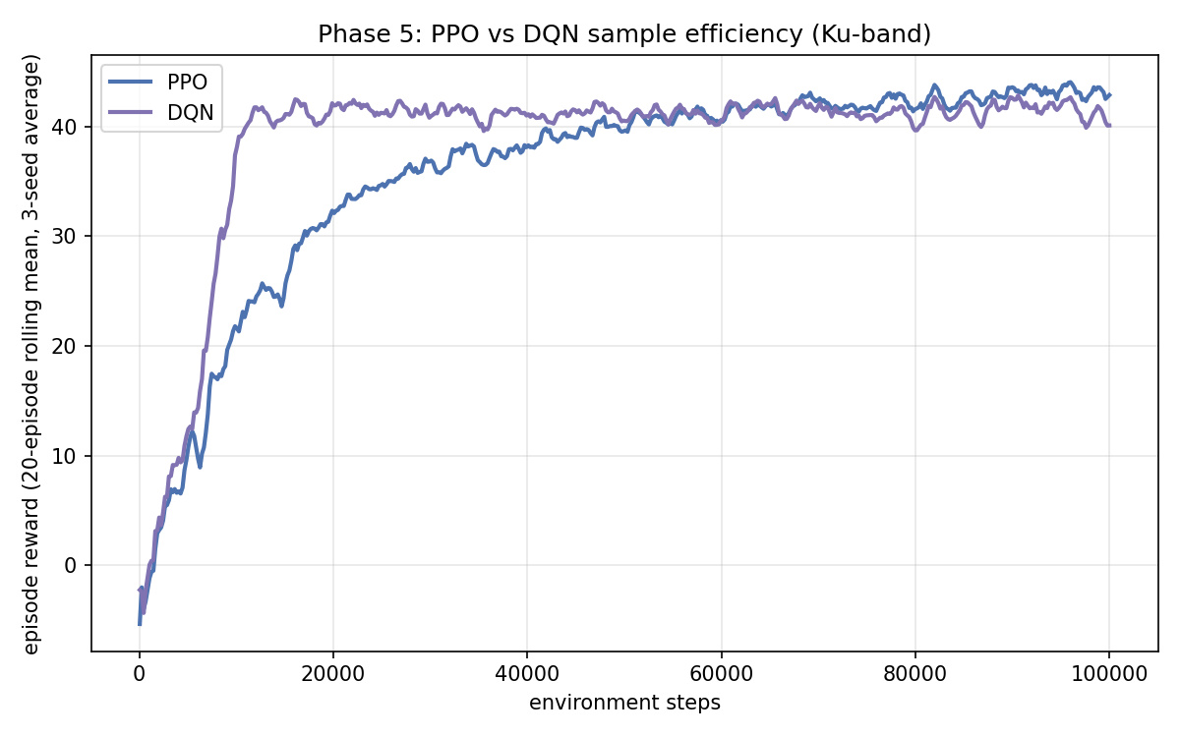

Sensitivity to handover penalty
To test whether the handover penalty is the operative mechanism behind PPO's switching behaviour, a fresh PPO agent was trained at each of five penalty values — including a true zero-penalty ablation — holding reward weights at the balanced profile. Each point is an independent training run (50,000 steps).
Table 5.2 — Effect of handover penalty on learned behaviour (Ku-band).
Handover penalty | Reward | Switch rate
0.00 (ablation) | 44.303 | 0.0690
0.05 | 44.251 | 0.0662
0.15 (default) | 43.849 | 0.0548
0.30 | 43.460 | 0.0452
0.50 | 43.006 | 0.0375
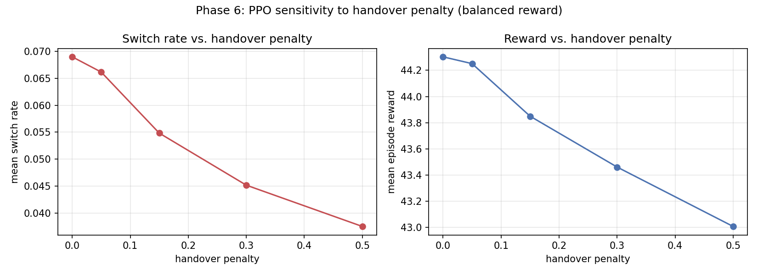
Switch rate decreases monotonically across all five points, including the zero-penalty ablation — falling 45.7% from 0.0690 to 0.0375 as the penalty rises from 0 to 0.50. This directly demonstrates the handover penalty is the causal mechanism behind the switch-avoidance behaviour reported in Section 5.4, not merely correlated with it: with the penalty entirely removed, PPO's switch rate rises to nearly twice its default-penalty value. Mean reward decreases modestly and monotonically over the same range, from 44.303 to 43.006. The penalty is thus a directly interpretable control knob: an operator can trade approximately 1.30 reward units for a 46% cut in signalling load, positioning that trade-off anywhere along the curve via a single scalar.

Sensitivity to reward weighting
The same protocol was applied to four reward-weight profiles at the default penalty of 0.15.
Table 5.3 — Effect of reward-weight profile (Ku-band).
Reward profile | Reward | Switch rate
Balanced | 43.849 | 0.0548
Throughput-leaning | 43.454 | 0.0527
Latency-leaning | 44.905 | 0.0542
Reliability-leaning | 43.264 | 0.0495
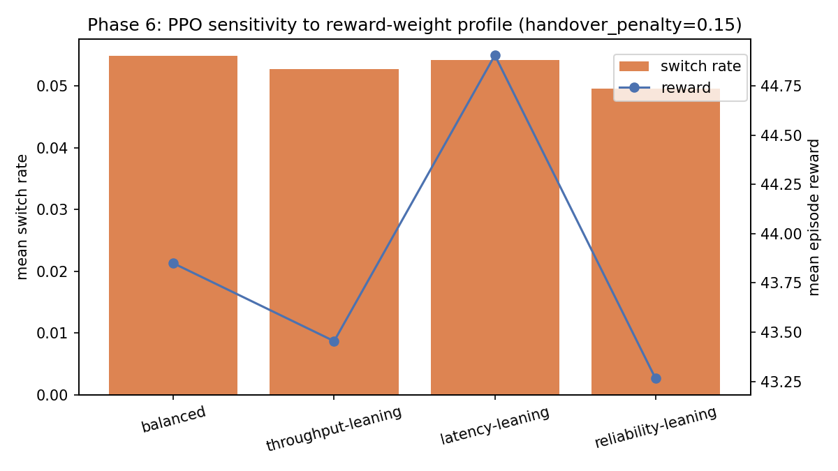
The latency-leaning profile yields the highest reward, exceeding balanced by 1.056 units. Propagation delay is the KPI that most sharply separates the terrestrial from the non-terrestrial tiers under Ku-band conditions, so weighting it more heavily gives the agent a correspondingly sharper learning signal. Section 5.9 shows this finding is band-dependent rather than universal.
As a consistency check, the balanced configuration in Table 5.3 matches the 0.15-penalty row of Table 5.2 exactly (43.849, 0.0548) — the same configuration, evaluated independently, twice.

Held-out geometry generalization
The strongest available test of whether PPO learned a transferable policy, or merely memorized the one analytic LEO/HAPS pass-geometry profile used in training: each saved PPO model, plus the hysteresis baseline, was re-evaluated under a deliberately harder, previously unseen geometry regime — lower peak elevations, shorter passes, more frequent and longer out-of-view gaps (a stand-in for a different orbital shell).
Table 5.4 — Nominal vs. held-out geometry (Ku-band).
Policy | Nominal reward | Shifted reward | Δ
Hysteresis | 40.904 | 41.312 | +0.408
PPO seed 0 | 43.897 | 43.916 | +0.019
PPO seed 1 | 44.961 | 45.045 | +0.084
PPO seed 2 | 43.998 | 44.051 | +0.053
Reward does not degrade under the shifted regime for any seed — if anything, all four policies show a small, consistent improvement, plausibly because the shifted regime's shorter LEO/HAPS passes reduce net exposure to their higher-variance links. PPO did not memorize the fixed training profile: its policy transfers to markedly different orbital geometry without loss.

Training stability
Because RL results are sensitive to seed variation, per-seed means are reported in Table 5.5.
Table 5.5 — Across-seed variability (3 training seeds, 200 episodes each, Ku-band).
Algorithm | Seed 0 | Seed 1 | Seed 2 | Across-seed SD | Within-seed episode SD
PPO (reward) | 43.748 | 45.154 | 43.593 | 0.860 | 2.771
PPO (switch rate) | 0.041 | 0.023 | 0.047 | 0.0127 | —
DQN (reward) | 43.333 | 43.954 | 43.097 | 0.443 | 2.580
DQN (switch rate) | 0.139 | 0.124 | 0.163 | 0.0194 | —
Across-seed reward variability is smaller than within-seed episode variability for both algorithms (PPO: 0.860 vs 2.771; DQN: 0.443 vs 2.580), indicating the reported ranking is driven by policy quality rather than training-run luck. A caveat: the worst PPO seed (43.593) sits close to DQN's best seed (43.954), so with 3 seeds the reward ordering is directionally consistent but not overwhelming — this is exactly what the Welch/Mann-Whitney tests in Section 5.3 (computed on all 600 pooled episodes per algorithm, not just seed means) are for, and they do show significance (p=5.9×10⁻⁶). The switch-rate separation is unambiguous regardless of this caveat: every PPO seed lies below every DQN seed.

Band sensitivity: Ku, Ka, and S
The same generator, seeds, Area assignment, and reward design were run under two additional LEO carrier bands — Ka (20 GHz) and S (2.2 GHz, the ITU space-operation/space-research downlink allocation used operationally for LEO TT&C and narrowband constellations, not the high-throughput broadband links this dataset's `Throughput_Mbps` values model — a caveat that must accompany any S-band conclusion). Only the LEO `TechConfig`'s carrier frequency and its physically-derived, fixed-aperture antenna gain differ between the three runs; bandwidth, noise figure, and all other link-budget parameters are held constant, isolating band-dependent physics as the sole variable.
Table 5.6 — Three-band comparison.
Policy | Ku reward | Ka reward | S reward | Ku switch | Ka switch | S switch
Hysteresis | 40.904 | 44.334 | 40.001 | 0.0625 | 0.0591 | 0.0823
DQN | 43.461 | 47.169 | 43.620 | 0.1421 | 0.0895 | 0.1322
PPO | 44.165 | 47.683 | 44.210 | 0.0373 | 0.0473 | 0.0550
Oracle | 45.292 | 48.167 | 45.274 | 0.0496 | 0.0414 | 0.0476
PPO / Oracle | 97.51% | 98.98% | 97.66% | — | — | —
(Each band fits its own reward normalization scale; compare ratios and orderings, not raw reward magnitudes, across bands.)
Three findings, each with a physical explanation rather than an assumed one:
PPO's gap to the oracle narrows at Ka, not at S. PPO reaches 98.98% of oracle under Ka, versus 97.51–97.66% under Ku and S. Ka's much larger rain-driven signal variance appears to compress the achievable range between a reward-optimal plan and a learned policy — there is simply less headroom for the oracle to exploit that a fast-reacting learned policy cannot also capture.
S-band's numbers land close to Ku's, and this has a specific physical cause, not coincidence. S-band's fixed-aperture antenna gain (21.26 dB) is 14.7 dB below Ku's (36.00 dB) — a real, physically-derived penalty. But S-band's rain and gaseous attenuation are close to zero at the rain rates and elevations in this dataset (verified: ≈0.04 dB vs. Ku's ≈11 dB rain attenuation at 10 mm/hr, 30° elevation), whereas Ku already carries substantial atmospheric loss. These two effects roughly cancel, so overall link quality — and the resulting policy behaviour — converges across the two bands despite operating almost two orders of magnitude apart in frequency.
The switch-rate advantage PPO holds over the oracle is Ku-specific, not a general property of learned selection. Under Ku, PPO switches significantly less than the oracle (§5.3). Under both Ka and S, PPO switches significantly more than the oracle (Ka: p=0.043; S: p=0.0095). The correct general statement is that PPO's switch discipline is competitive with, and sometimes exceeds, the oracle's — not that it systematically out-disciplines it. Tables 5.7 and 5.8 show the mechanism-level pattern behind this.
Table 5.7 — Best reward-weight profile by band.
Band | Best profile | Reward | vs. balanced
Ku | Latency-leaning | 44.905 | +1.056
Ka | Throughput-leaning | 47.654 | +1.086
S | Latency-leaning | 44.788 | +1.007
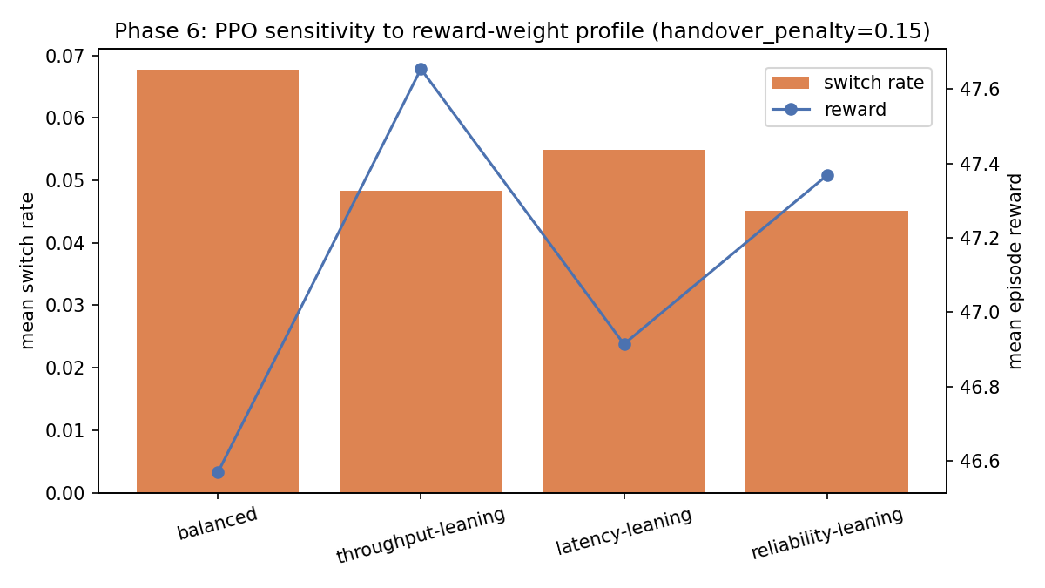
The best profile is band-dependent: latency-leaning wins under both low-rain-variance bands (Ku, S), while throughput-leaning wins under the high-rain-variance band (Ka) — plausibly because Ka-band rain fade manifests primarily as throughput degradation, so weighting throughput more heavily lets the agent more directly avoid the periods and networks where that degradation is worst. This is offered as an interpretation consistent with the data, not a demonstrated causal mechanism.
Table 5.8 — Handover-penalty sweep monotonicity by band.
Band | Switch rate monotonic across all 5 penalty points?
Ku | Yes
Ka | No — reward and switch rate both non-monotonic at the 0.15 point
S | Yes
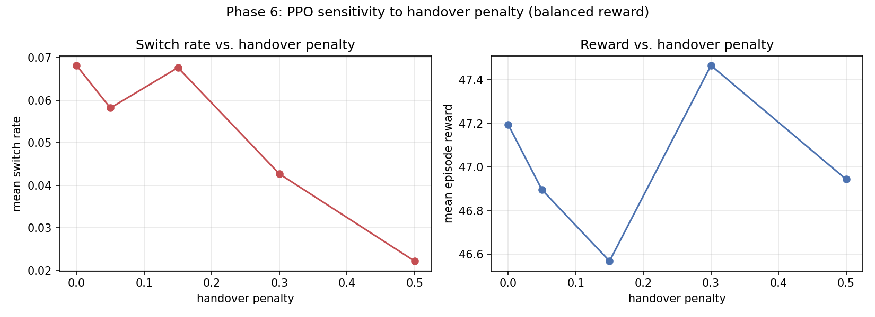
Ka's Phase 6 sweep is not monotonic (§5.5's protocol trains one seed per point, unlike Section 5.3's three). This is very likely a single-seed training-variance artifact rather than a sign the underlying mechanism differs: Ka's substantially higher rain-driven reward variance (visible in its wider spread of per-policy outcomes throughout this section) would be expected to make single-seed noise more visible precisely where Ku and S — both low-variance bands — remain clean. We report this plainly rather than smoothing it over; a multi-seed Phase 6 sweep is the direct way to confirm this interpretation and is noted as future work (§6.3).

DISCUSSION

Learned versus engineered switching discipline
The central empirical finding is that a policy optimising a composite QoE reward with a flat handover cost outperforms an explicitly engineered hysteresis rule on both axes that rule was designed to balance, under Ku-band conditions: PPO achieves higher reward and fewer handovers than the A3-margin baseline (§5.3), approaching the oracle to within 2.49%.
This matters because hysteresis parameters — margin and time-to-trigger — must be tuned per deployment, and their optimal values depend on cell geometry, mobility, and traffic. In a hybrid TN–NTN setting those conditions vary not merely between deployments but within a single episode, as a LEO platform rises and sets. A fixed margin cannot adapt to that; a learned policy conditioned on live radio measurements can. Section 5.5 shows the resulting behaviour remains controllable through one interpretable scalar — a practical requirement for any mechanism an operator would consider deploying — and Section 5.9 shows the underlying advantage is not an artifact of one carrier band, though its magnitude (and the specific oracle-relative switch-rate comparison) is.

Why the two RL algorithms diverge
PPO and DQN reach comparable reward through materially different policies (§5.4) and materially different training dynamics (Figure 5.1): DQN's off-policy replay buffer reaches a strong policy in roughly a fifth of the environment steps PPO requires, but converges to a policy that switches networks far more often for a similar final reward. A plausible explanation lies in the algorithms' treatment of action stability. PPO's clipped surrogate objective constrains each update to a trust region around the current policy, favouring convergence to a temporally consistent action distribution. DQN selects greedily with respect to a learned Q-function with no comparable smoothness constraint, so small fluctuations in estimated action values translate directly into switching. We offer this as an interpretation rather than a demonstrated mechanism; isolating it would require an ablation over policy-update constraints not conducted here.

Threats to validity
Fixed evaluation geometry, tested and found not to be an issue. Section 5.7 evaluated trained PPO policies under deliberately shifted orbital pass geometry (lower elevations, shorter passes, more frequent gaps) never seen in training; reward did not degrade for any seed. This directly addresses the concern that near-oracle performance reflects memorization of one fixed geometry profile rather than a transferable policy.
Single-seed Phase 6 sweep noise (Ka-band). Section 5.9 found Ka's handover-penalty sweep non-monotonic, plausibly because that protocol trains one seed per point while Ka's rain-driven variance is substantially higher than Ku's or S's. A multi-seed Phase 6 sweep would confirm this directly and is the most concrete methodological improvement identified by this work.
Single-source synthetic data. All five technology datasets originate from one simulation pipeline. While the channel model is grounded in ITU-R recommendations (P.838-3 rain, P.676-13 gaseous absorption, verified against the recommendations before use), it has not been validated against measured field data, and systematic modelling error would be shared across all five tiers rather than averaging out.
Modelling simplifications. Doppler shift is held at each technology's median value in the mobility model rather than derived from instantaneous relative velocity. The area context evolves according to a hand-specified Markov chain rather than a measured mobility trace. S-band results (§5.9) describe a narrowband/TT&C-representative configuration, not a broadband S-band service — this dataset's throughput values were not designed to represent that regime.
Value-function fit. PPO's explained variance remained low throughout training (approximately 0.01–0.15), indicating the learned value function accounts for little of the observed return variance. The policy performs well regardless, but this suggests the advantage estimates are noisy and a better-fitted critic might yield further improvement.
Scale. Training runs of 100,000 steps across 3 seeds, across three bands, are appropriate for establishing the comparisons presented here, but are modest relative to the broader claim of a pathway toward AI-native radio protocols. The results support the narrower, evidenced conclusion that learned selection outperforms classical handover heuristics in this environment, robustly across three carrier bands.

Deployment considerations
An operator considering a learned selection controller for live infrastructure requires more than a favourable simulation benchmark. First, explainability: the policy is a neural network whose decisions cannot be audited in the way an A3 margin can, and regulatory or operational review may require a rule-based approximation or post-hoc justification of its behaviour. Second, fallback guarantees: a deployed controller needs a well-defined degraded mode when observations are missing or the policy produces an invalid selection — Section 5.9's finding that the best reward weighting is band-dependent (latency-leaning for Ku/S, throughput-leaning for Ka) also implies a deployed system should either detect its operating band or be trained per-band rather than assume one universal reward configuration transfers across deployments.

CONCLUSION
This paper presented a physically grounded dataset and reinforcement learning environment for network selection across five heterogeneous access technologies — 5G NR, Wi-Fi 6, LEO satellite, HAPS, and UAV relay — and evaluated learned selection policies against classical handover algorithms, under a channel model whose atmospheric impairments are implemented directly from ITU-R P.838-3 (rain) and P.676-13 (gaseous absorption), verified against the recommendations before use.
The principal findings are as follows. A PPO agent conditioned on live per-candidate radio measurements attains 97.51% of an oracle upper bound under Ku-band (12 GHz) LEO, improving mean episode reward by 7.97% over a 3GPP A3-style hysteresis baseline while performing 40.3% fewer handovers — differences confirmed statistically significant (Welch's t-test, Mann-Whitney U, Cohen's d), not merely CI-disjoint. This switch-avoiding behaviour is demonstrated, not merely correlated, to emerge from the handover-cost term in the reward: a true zero-penalty ablation shows switch rate rising monotonically as the penalty is removed, and the mechanism remains controllable through that single scalar. The policy generalizes to orbital pass geometry never seen in training, with no reward degradation, addressing the most significant a priori concern about the result.
Running the identical experiment under two additional LEO bands — Ka (20 GHz) and S (2.2 GHz) — shows the headline finding is robust, while revealing that several of its specifics are band- dependent rather than universal: the optimal reward-weighting profile shifts from latency-leaning (Ku, S) to throughput-leaning (Ka) as rain-driven variance becomes the dominant impairment, and the specific claim that PPO out-disciplines the oracle on switch rate holds only under Ku, reversing under both Ka and S. S-band's results converge with Ku's for an identifiable physical reason — a lower antenna-gain penalty offsetting negligible atmospheric loss — rather than by coincidence.
The two RL algorithms tested do not behave alike: DQN matches PPO's reward advantage over the classical baselines and reaches it in roughly a fifth of the training steps, but not PPO's switching discipline. The most important remaining limitation is that the Phase 6 sensitivity sweep trains a single seed per configuration, and Ka's higher-variance conditions expose that as non-monotonic behaviour that a multi-seed sweep would most directly resolve. The dataset and environment are released to support this and further work.
This paper has been typeset from a TEX / LATEX file prepared by the author.

