**PROJECT DOCUMENTATION**

**Project Name:** Automated Employee Management System  
**Project Manager:** S Mohamad Thamimul Ansari  
**Project Start Date:** 06/01/2025

**Abstract:**

The **Automated Employee Management** **System (AEMS)** aims to streamline and automate core HR processes, such as employee onboarding, attendance tracking, performance evaluation, leave management, and Salary bonus. The purpose of this system is to reduce manual HR tasks, improve efficiency, ensure accurate data management, and provide a seamless experience for both HR staff and employees. This system will allow HR teams to focus on strategic decision-making rather than spending time on administrative tasks, while also providing employees with a self-service portal for accessing their personal information, managing leave requests, and receiving performance feedback.

1. **Project Overview:**

The **Automated Employee Management System (AEMS)** is designed to revolutionize the way organizations handle employee-related processes by automating key HR functions. This system aims to streamline and improve the efficiency of human resource management by automating tasks such as employee onboarding, attendance tracking, leave management, payroll processing, and performance evaluations. By transitioning from manual HR operations to a fully automated system, AEMS will significantly reduce the time and effort spent on administrative tasks, minimize human errors, and improve the overall employee experience.

The purpose of AEMS is to provide a seamless and integrated platform for both HR personnel and employees. For HR teams, AEMS simplifies the management of employee records, streamlines payroll and benefits administration, and enhances reporting capabilities. For employees, the system offers a self-service portal where they can easily access their personal information, request leave, view performance reviews, leading to higher engagement and transparency.

Ultimately, the AEMS is designed to increase productivity, ensure compliance with regulatory requirements, and provide real-time insights into key HR metrics, helping organizations make data-driven decisions and improve overall workforce management.

1. **Project Goals and Objectives:**
2. **Automate HR Processes:** Replace manual HR workflows (e.g., attendance, leave approvals, payroll calculations) with automated processes to enhance operational efficiency and accuracy.
3. **Centralized Data Management:** Create a single, secure database for employee information, attendance data, payroll records, performance assessments, and more, ensuring easy accessibility and management.
4. **Employee Self-Service Portal:** Enable employees to manage personal details, request time off, track attendance, access and performance reviews, empowering them with more control over their HR information.
5. **Data-Driven Decision Making:** Provide HR teams and management with comprehensive reports and analytics on employee performance, attendance patterns, and payroll, supporting strategic decision-making.
6. **Streamline HR Operations**: Automate repetitive and time-consuming tasks such as manual data entry, attendance tracking, and payroll calculation to free up HR staff for more strategic work.
7. **Improve Data Accuracy and Accessibility**: Implement a centralized, secure database that consolidates all employee-related data, ensuring easy access and real-time updates for HR teams, managers, and employees.
8. **Enable Self-Service Functionality for Employees**: Develop an intuitive self-service portal where employees can access and manage their personal information, request leave, track attendance, and view performance reviews.
9. **Track and Evaluate Employee Performance**: Implement a performance management module that allows managers to set goals, track performance progress, and conduct evaluations, promoting continuous employee development.
10. **Generate Real-Time Reports and Analytics**: Provide HR and management teams with customizable dashboards and reports on key metrics such as employee attendance, leave usage, payroll, and performance trends.
11. **Ensure Data Security and Compliance**: Integrate robust security measures to protect sensitive employee data and ensure compliance with data protection regulations such as GDPR and labor laws.
12. **Project Scope:**

**In-Scope:**

* **Employee Onboarding:** Automating the process of adding new employees to the system, capturing essential data, and uploading necessary documents.
* **Attendance and Time Tracking:** Real-time tracking of employee attendance, including clock-in/clock-out data, shift management, and overtime calculations.
* **Leave Management:** Enabling employees to request leave, track leave balances, and allow HR managers to approve or reject leave requests based on predefined policies.
* **Payroll Management:** Automating salary calculations, tax deductions, and benefits management. Integration with accounting software for seamless payroll processing.
* **Performance Management:** Enabling performance tracking, goal-setting, and employee evaluations by managers, as well as providing feedback to employees.
* **Self-Service Portal:** Providing employees with a personal dashboard to access, update, and manage their HR-related information, such as personal details, attendance.
* **Reporting and Analytics:** Generating real-time reports on attendance, leave, payroll, and employee performance for HR and management teams.

**Out-of-Scope:**

* Integration with external recruitment platforms in the initial phase.
* Mobile app development for AEMS (system will be web-based).
* Advanced AI features like predictive employee performance or attrition analysis in the first version.

1. **Target Audience:**

* **HR Managers:** Responsible for overseeing employee records, attendance, payroll processing, and performance evaluations.
* **Employees:** End users who will utilize the self-service portal to access personal information, request leave, and view performance feedback.
* **Managers:** Supervisors who will use the system to monitor team attendance, approve or reject leave requests, and evaluate employee performance.
* **IT Support Teams:** Responsible for system maintenance, security, and technical support for end-users.

1. **Key Features:**

* **Increased Efficiency:** Automates time-consuming HR tasks and processes, freeing up HR staff for more strategic responsibilities.
* **Reduced Errors:** Minimizes human errors in payroll calculations, attendance tracking, and leave management.
* **Data Accuracy:** Centralizes all employee-related data, ensuring consistent and accurate records.
* **Improved Employee Engagement:** Empowers employees with self-service access to manage their HR-related tasks independently.
* **Real-Time Reporting:** Provides up-to-date insights and analytics for HR teams and management to make informed decisions.

1. **Use Cases and Requirements:**

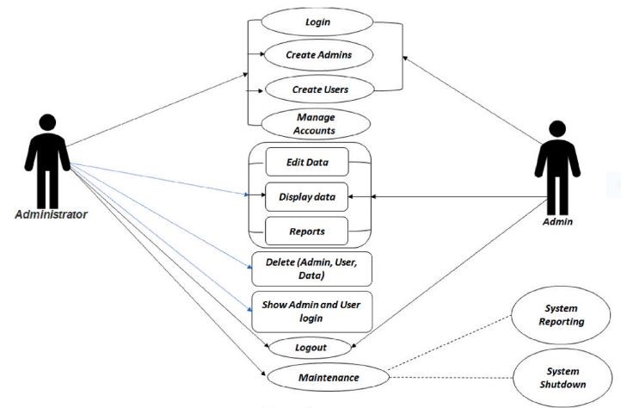

|  |  |  |  |
| --- | --- | --- | --- |
| **S.no** | **Features** | **Description** | **Requirements** |
| 1 | **User registration** | Getting the details from the employees and to store it in the database and apply accordingly to the requirements. | User name, Employee Id, email id, **Personal details** (name, date of birth, etc.) |
| 2 | **User Login and display details** | Facial images are used to ensure that the person registering is who they claim to be and Scanning **a** QR code or barcoded ID to authenticate or verify the user’s identity. Also, marking their day attendance. | Barcode ID, Facial image capture, image quality checks, profile association(personal details), Attendance management tools (Clock-in/Clock-out) |
| 3 | **Work Tracking** | Employees should be able to log their working hours or time spent on specific tasks. This can be done through automated tracking systems. | Clear Task Assignment, Time spent on tasks, Real-Time Monitoring |
| 4 | **Salary Bonus** | The salary has been given to the employee based on the work tracking by the manager or the company (Performance based). | Time spent on tasks, Quality of work |
| 5 | **Month-end Employee report** | It shows the entire details, performance, project status of the employee at the end of each month will be checked by the company and return feedback accordingly. | Employee Information, Work and Task Summary, Time Tracking and Attendance, **Key Performance Indicators,** Feedback and Communication |