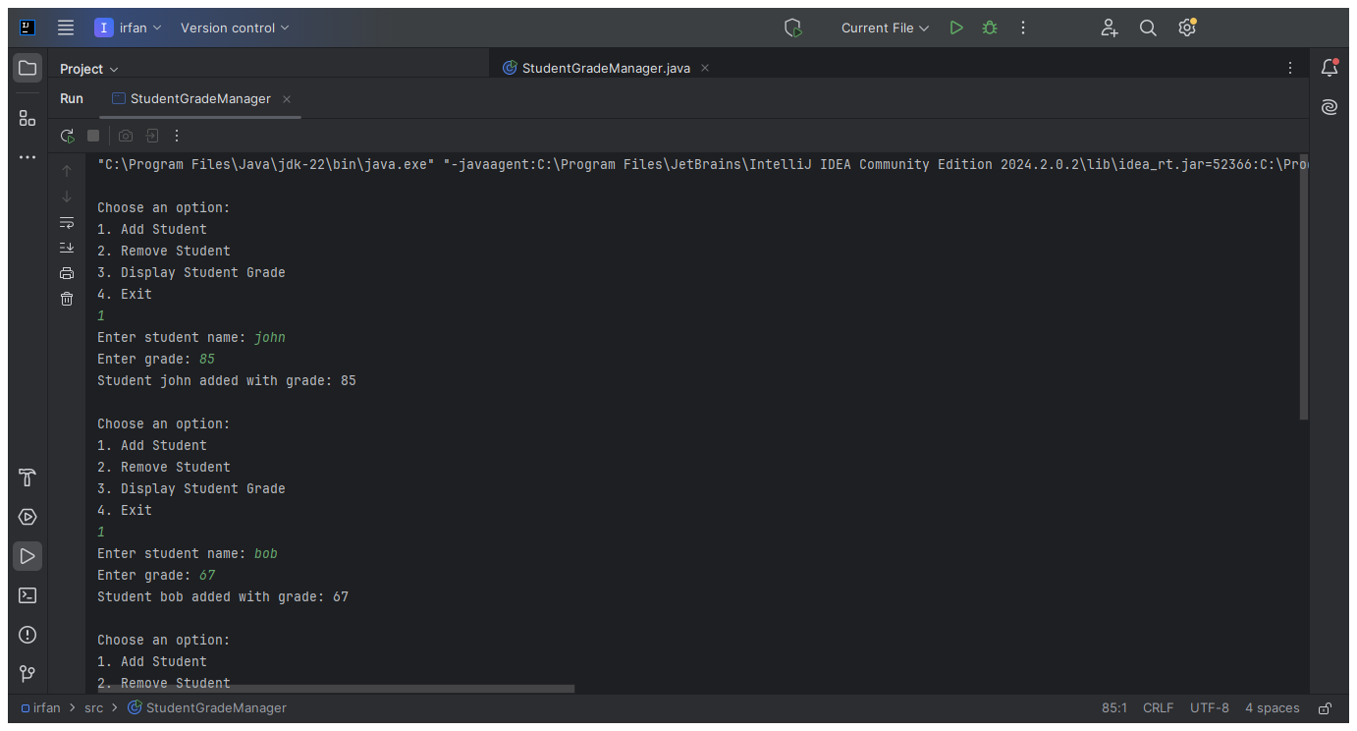

// ADD STUDENT NAME AND GRADE

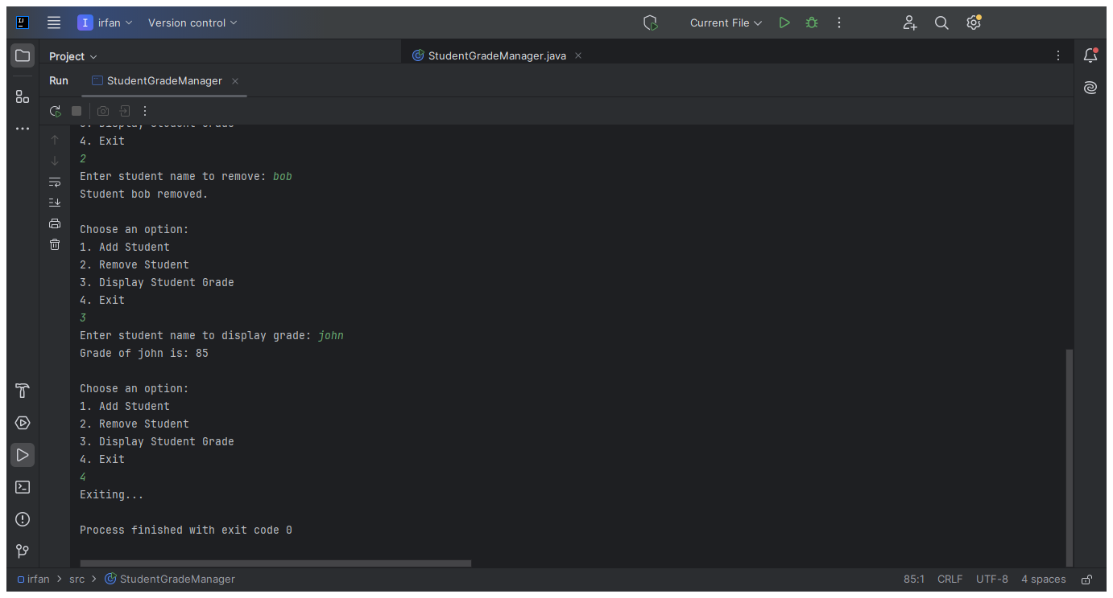

// REMOVE , DISPLAY GRADE , EXIT