Step1: create EC2 instance (Linux):
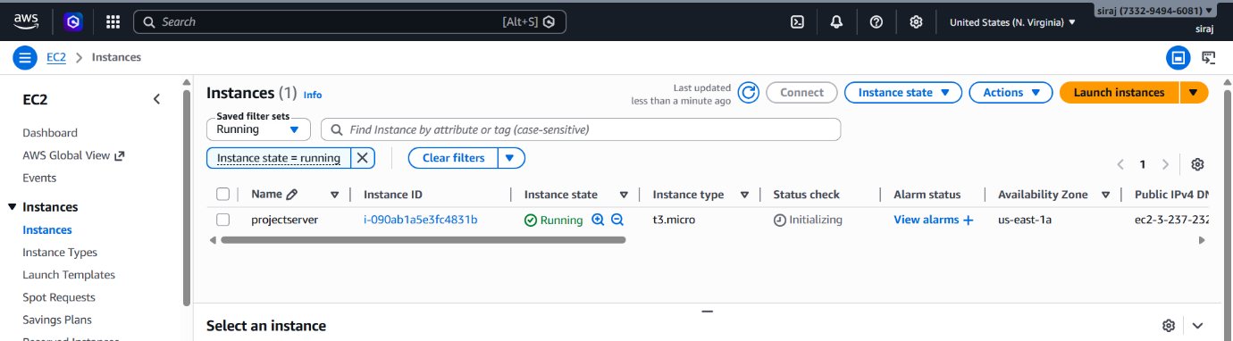

Step2 : Install Kubectl and Install AWScli:

Kubectl
curl -O https://s3.us-west-2.amazonaws.com/amazon-eks/1.24.11/2023-03-17/bin/linux/amd64/kubectl
chmod +x ./kubectl
sudo cp ./kubectl /usr/local/bin
export PATH=/usr/local/bin:$PATH

Install AWScli:
curl "https://awscli.amazonaws.com/awscli-exe-linux-x86_64.zip" -o "awscliv2.zip"
unzip awscliv2.zip
sudo ./aws/install

Install git:
$ yum install git -y

Step 3: create 3 IAM roles
- Choose Eks cluster -> next ->next and create
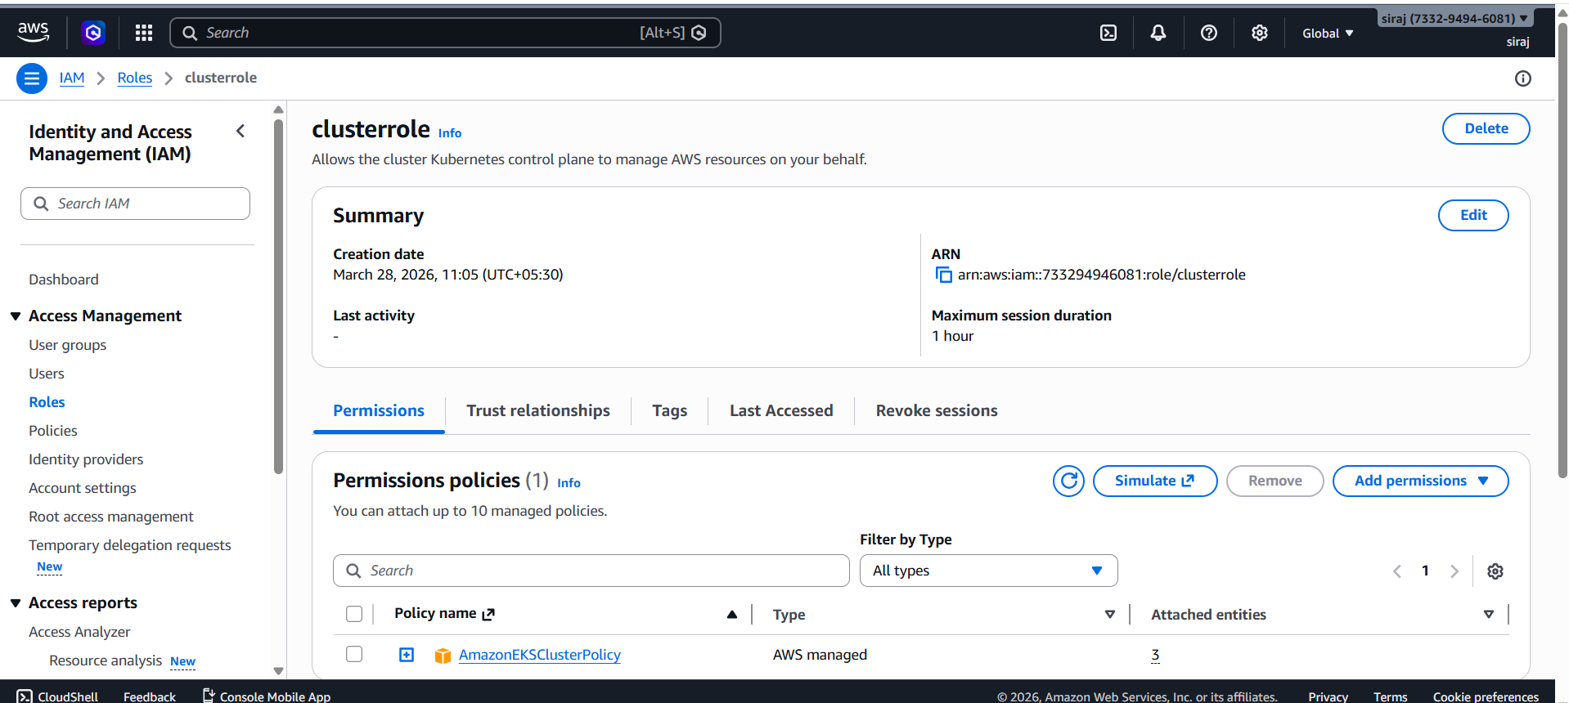
- Choose EC2 –> add policies Amazon EC2 full access

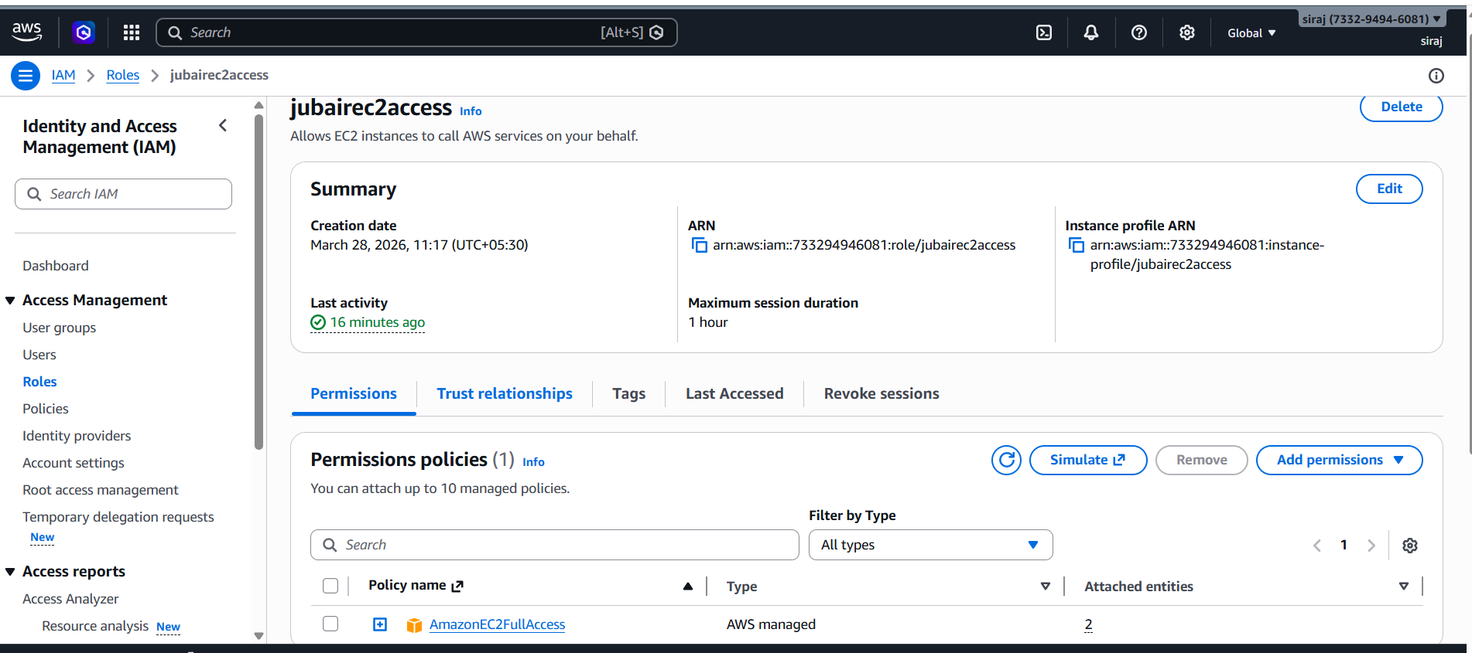
- Choose EC2 ->add policies
1.amazon eks worker node
2.amazon eks cni policy
3.amazon eks worker node policy

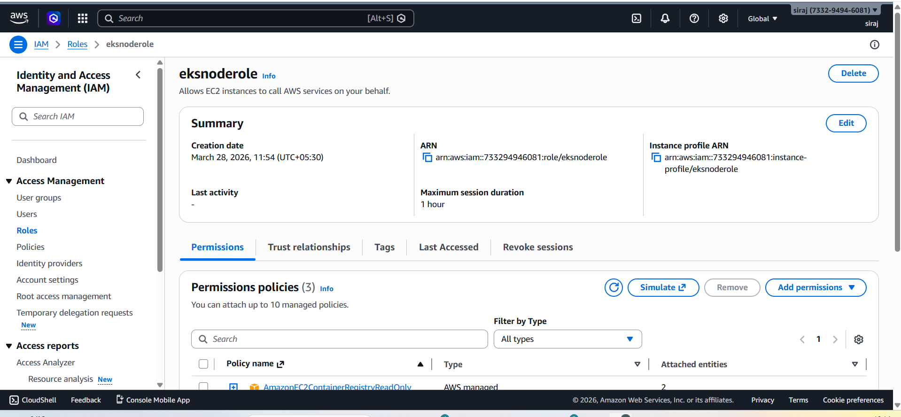
Step 4: Go to Eks and create cluster
- Add EBS CSI DRIVER
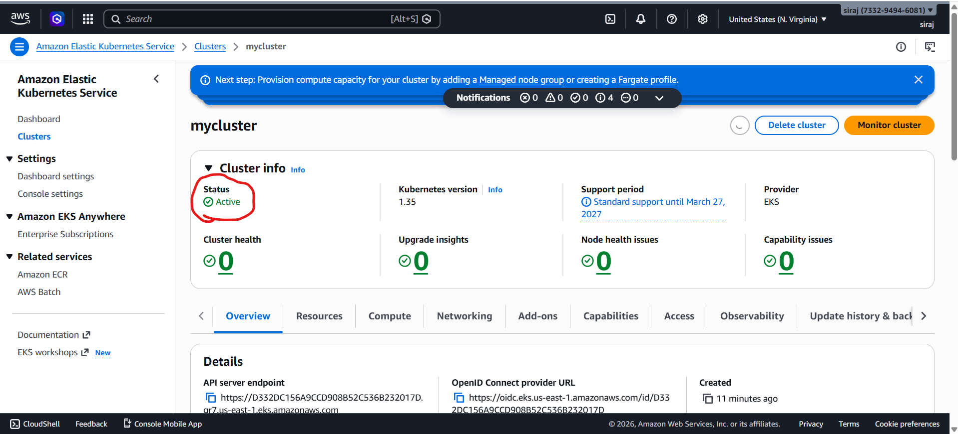

- It will take few minutes to create
- Finally cluster created

After creating cluster go to compute->add nodegroup
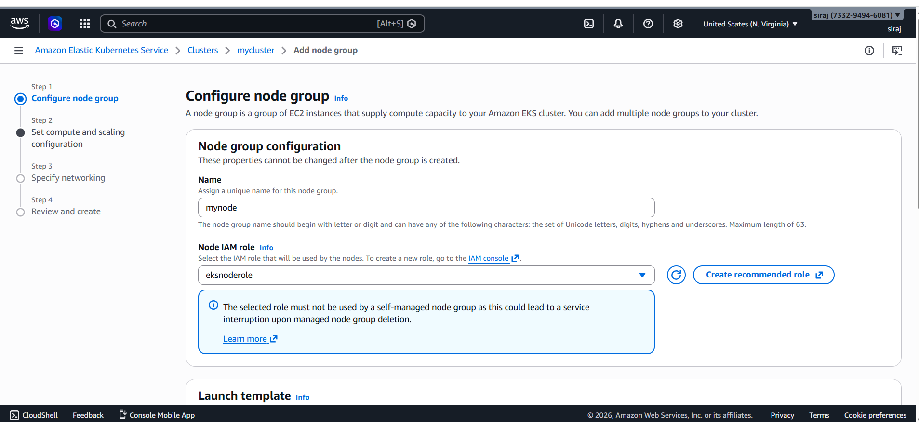

Add instance type

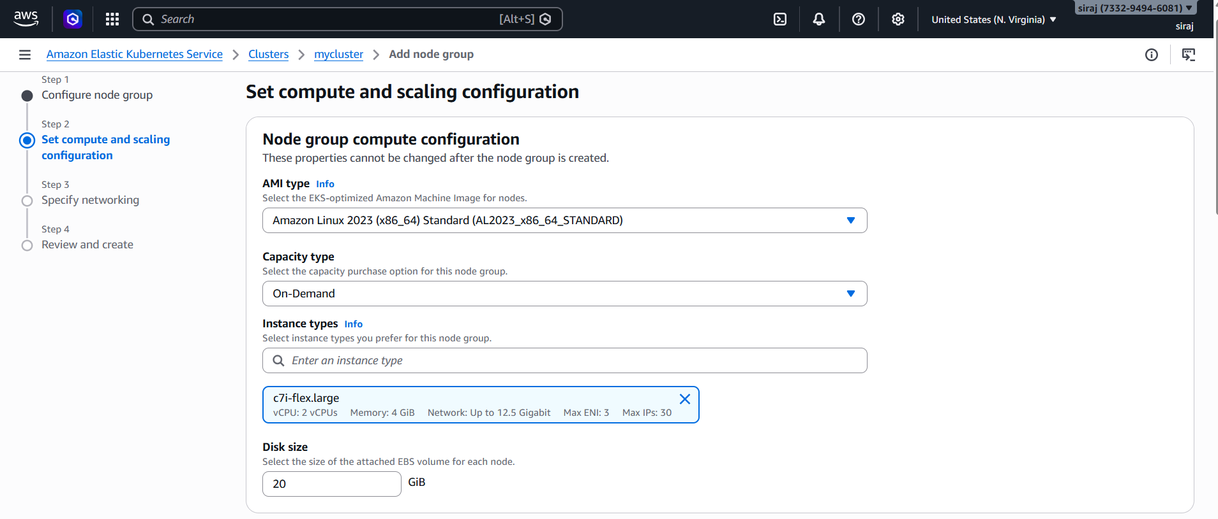

Creating….
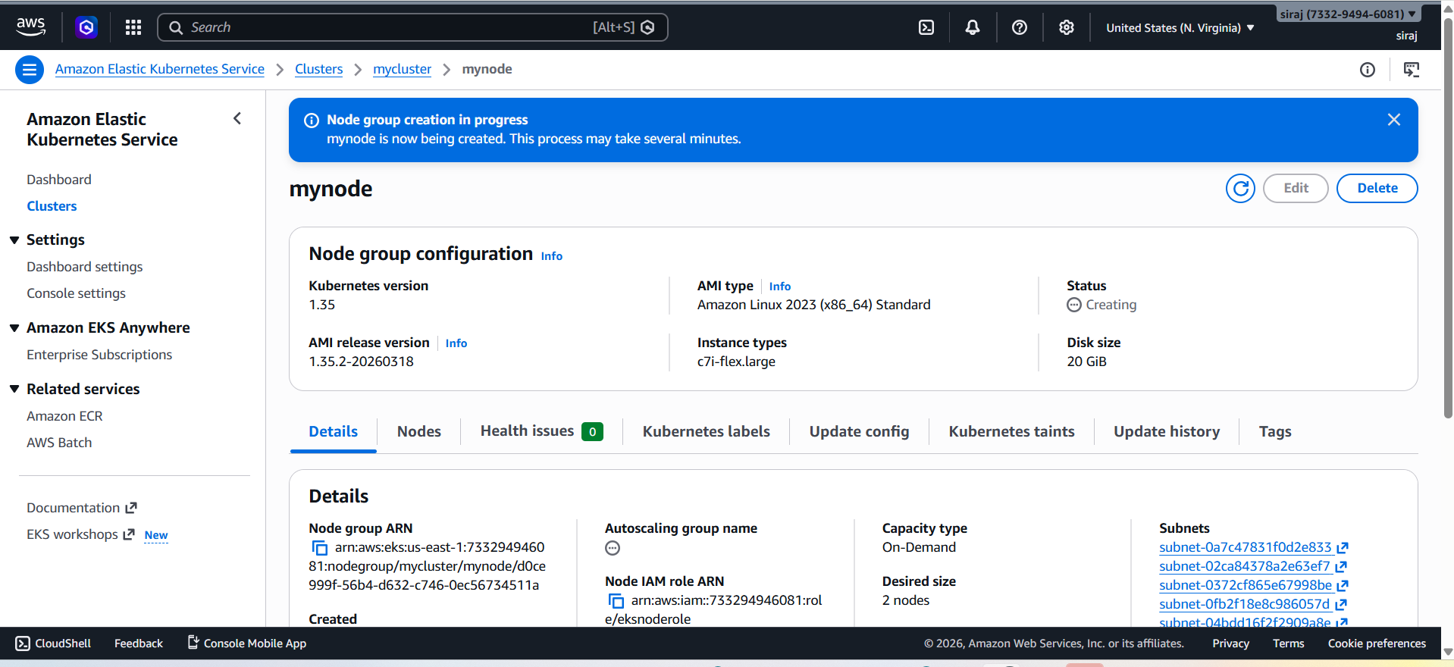
created
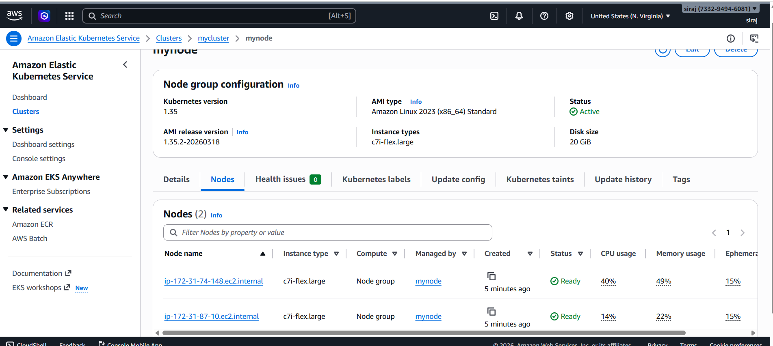

Goto mycluster-> access

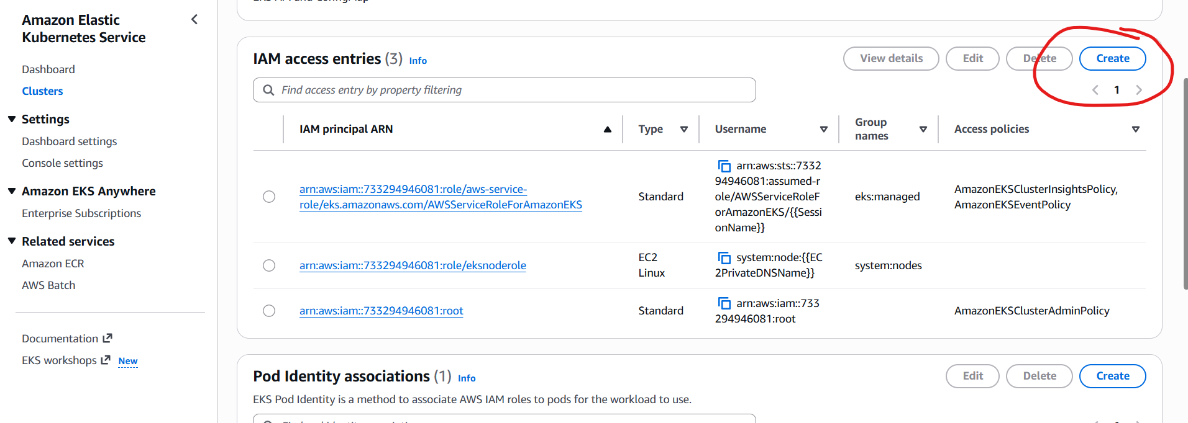

Select thr role you created for management role mine here is(clusterrole)

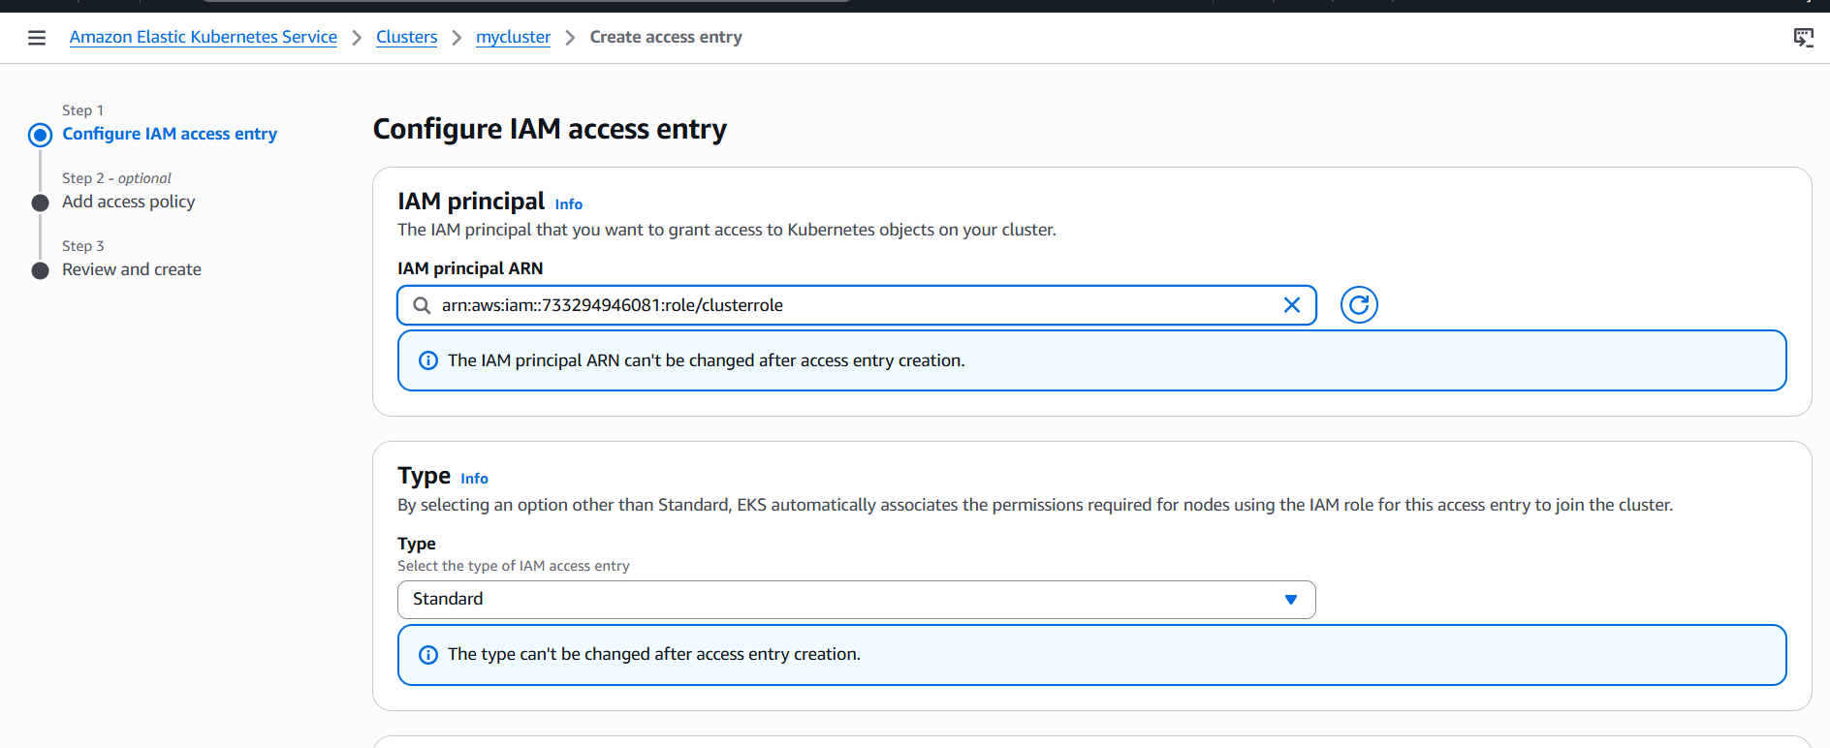

Add policy -> Amazoneksclusteradminpolicy

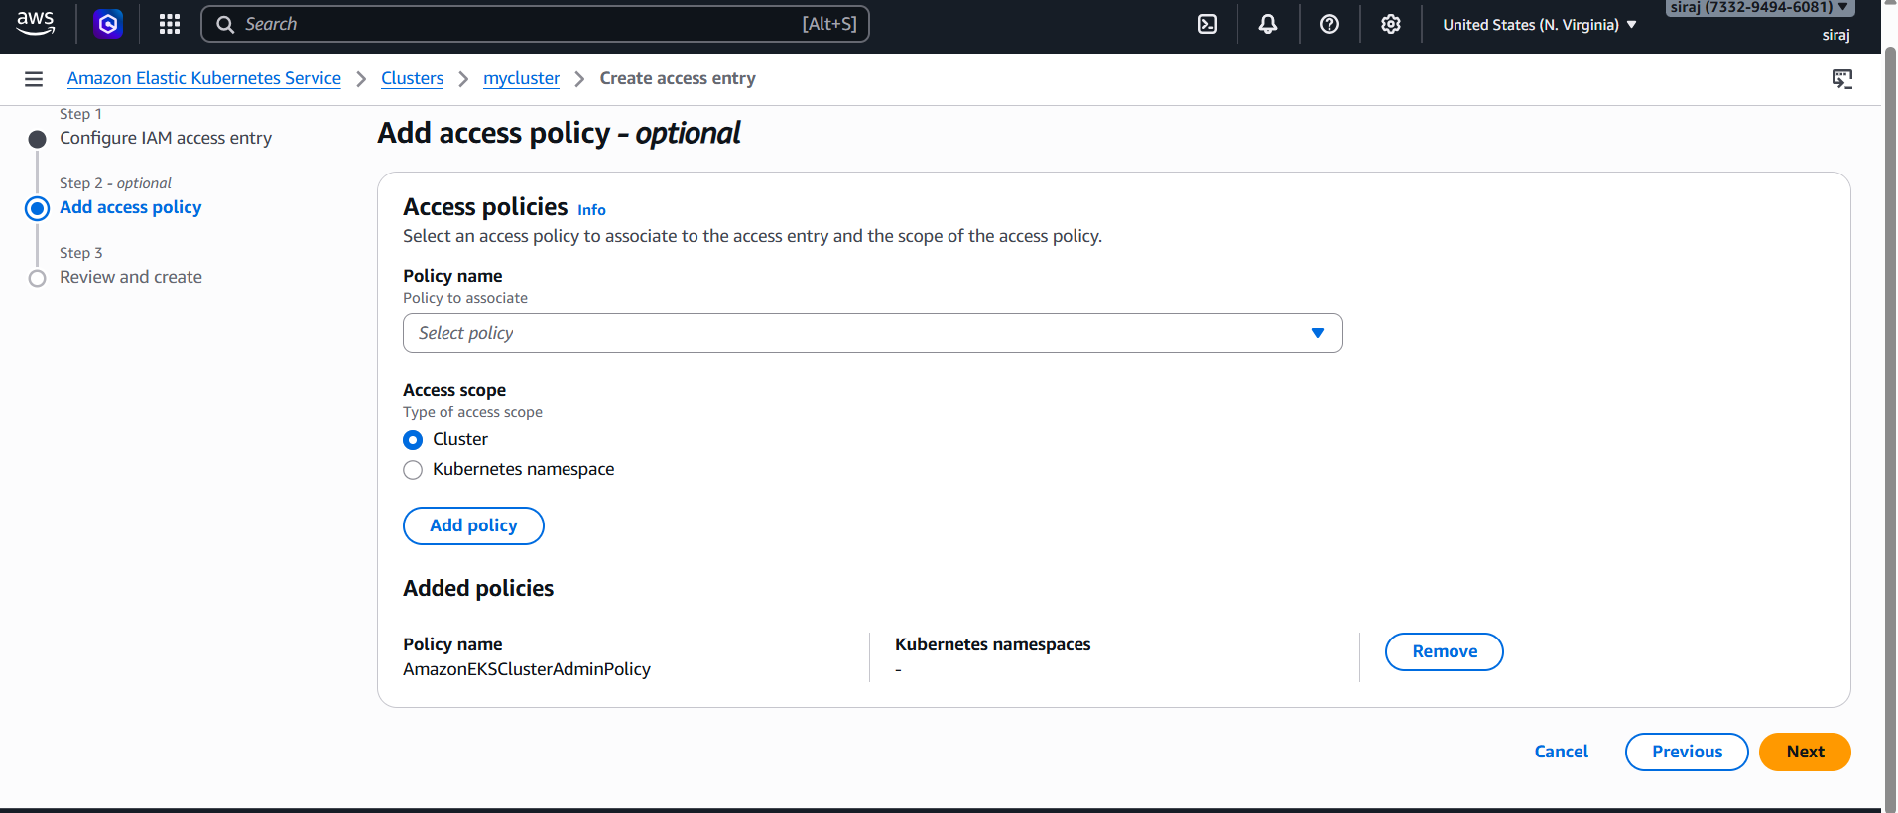

Ckeck the instance now ,2 nodes are created
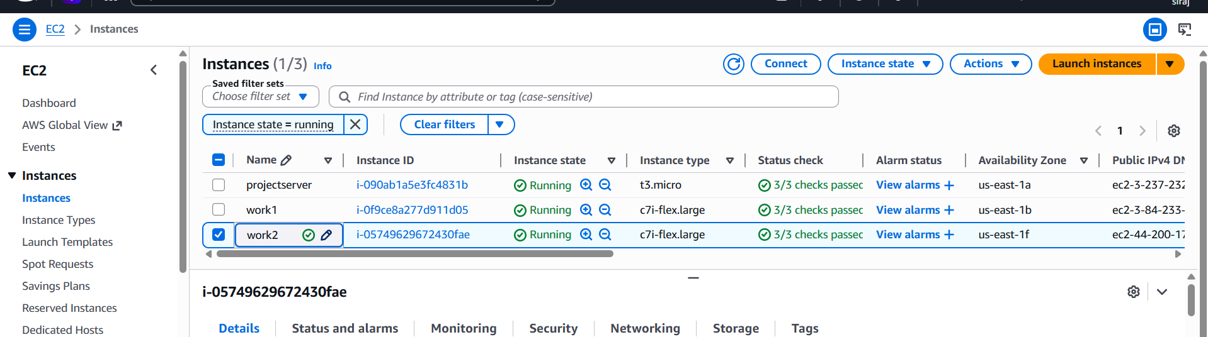

$ aws eks update-kubeconfig --name EKS_CLUSTER_NAME --region us-west-2
$ kubectl get nodes

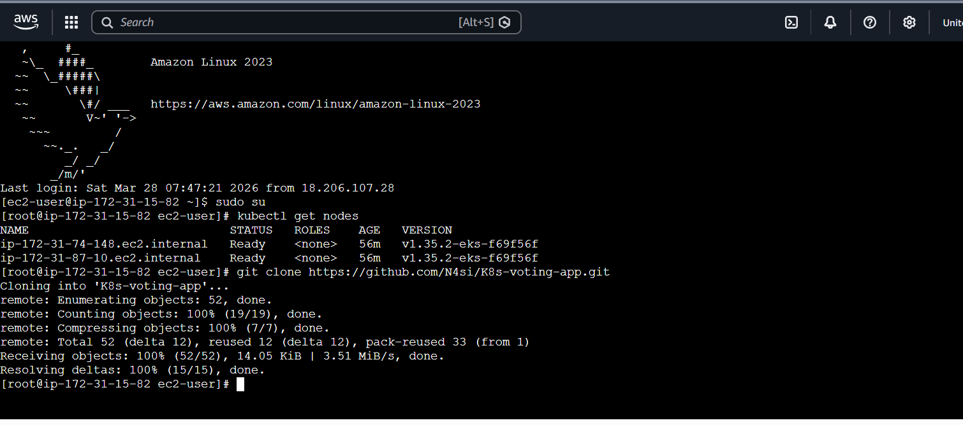
Clone git repo

git clone https://github.com/N4si/K8s-voting-app.git

Create CloudChamp Namespace

$kubectl create ns cloudchamp

$kubectl config set-context --current --namespace cloudchamp

Follow these commands in the picture

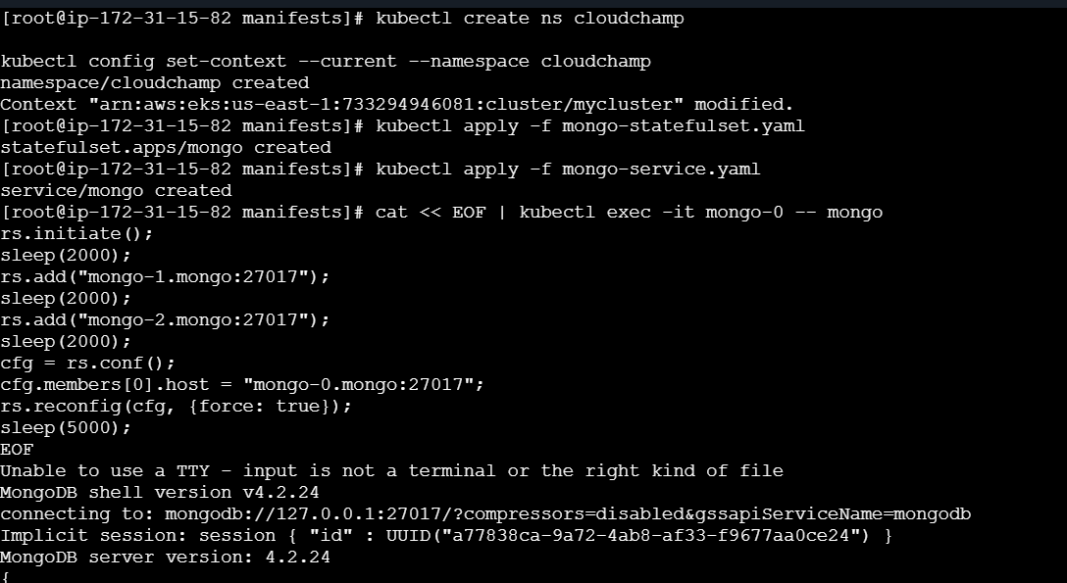

cat << EOF | kubectl exec -it mongo-0 -- mongo
rs.initiate();
sleep(2000);
rs.add("mongo-1.mongo:27017");
sleep(2000);
rs.add("mongo-2.mongo:27017");
sleep(2000);
cfg = rs.conf();
cfg.members[0].host = "mongo-0.mongo:27017";
rs.reconfig(cfg, {force: true});
sleep(5000);
EOF

cat << EOF | kubectl exec -it mongo-0 -- mongo
use langdb;
db.languages.insert({"name" : "csharp", "codedetail" : { "usecase" : "system, web, server-side", "rank" : 5, "compiled" : false, "homepage" : "https://dotnet.microsoft.com/learn/csharp", "download" : "https://dotnet.microsoft.com/download/", "votes" : 0}});
db.languages.insert({"name" : "python", "codedetail" : { "usecase" : "system, web, server-side", "rank" : 3, "script" : false, "homepage" : "https://www.python.org/", "download" : "https://www.python.org/downloads/", "votes" : 0}});
db.languages.insert({"name" : "javascript", "codedetail" : { "usecase" : "web, client-side", "rank" : 7, "script" : false, "homepage" : "https://en.wikipedia.org/wiki/JavaScript", "download" : "n/a", "votes" : 0}});
db.languages.insert({"name" : "go", "codedetail" : { "usecase" : "system, web, server-side", "rank" : 12, "compiled" : true, "homepage" : "https://golang.org", "download" : "https://golang.org/dl/", "votes" : 0}});
db.languages.insert({"name" : "java", "codedetail" : { "usecase" : "system, web, server-side", "rank" : 1, "compiled" : true, "homepage" : "https://www.java.com/en/", "download" : "https://www.java.com/en/download/", "votes" : 0}});
db.languages.insert({"name" : "nodejs", "codedetail" : { "usecase" : "system, web, server-side", "rank" : 20, "script" : false, "homepage" : "https://nodejs.org/en/", "download" : "https://nodejs.org/en/download/", "votes" : 0}});

db.languages.find().pretty();
EOF

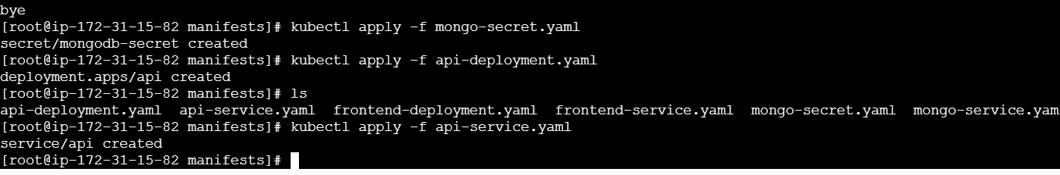

Change like this
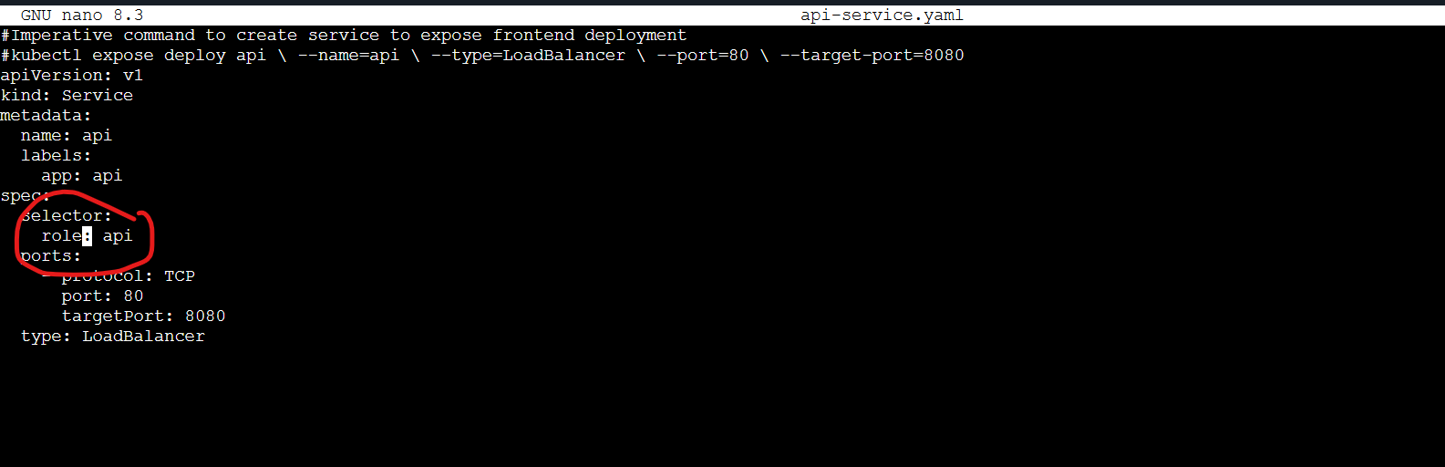

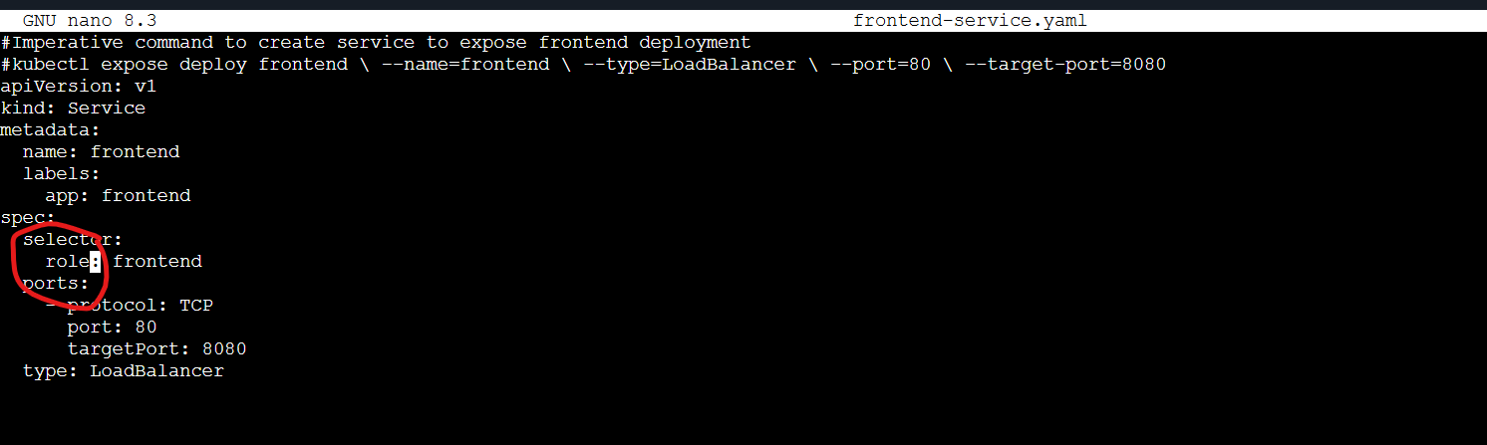

Copy that api external ip and paste it in frontend deployment

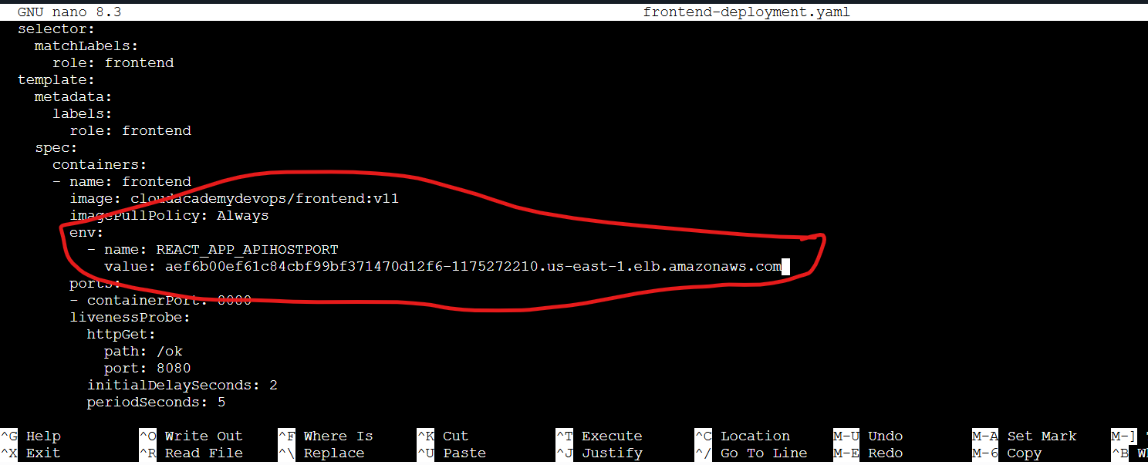

kubectl rollout restart deployment frontend -n cloudchamp
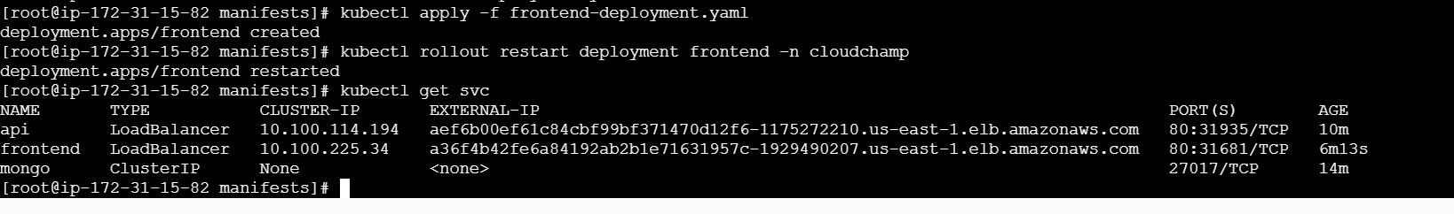

Now copy the frontend External ip and paste it in the browser

