**💡 Real-Life Analogy: Water Flow in Pipes**

Imagine **resistors** are like **narrow water pipes**, and **electricity** is like **water** flowing through them. The **narrower the pipe**, the harder it is for water to flow — just like a **higher resistance**.

**✅ Scene: Parallel Pipes Filling a Pool**

* You have a swimming pool to fill with water.
* You have **two hoses** (pipes) that can be connected to the pool.
* **Each hose has a different flow rate** (depending on how narrow it is).

**🚿 Example:**

* **Hose A (R₁ = 6 ohms)** → water flows slowly.
* **Hose B (R₂ = 3 ohms)** → water flows faster.

You connect **both hoses to the pool at the same time** — this is a **parallel connection**.

**🧠 What Happens?**

* Water flows **from both hoses together**.
* The pool fills **faster** than using just one hose.
* The total time to fill the pool is **less than the time using either hose alone**.

This represents:

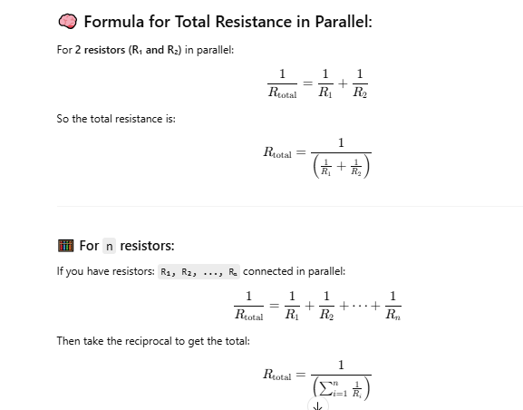

**🔍 Key Takeaway:**

* More **parallel hoses** = more water flow = **less resistance**
* Just like in electricity: more **parallel resistors** = more current flow = **less total resistance**

