**18) Considering White-Box Testing, generate a Unit-Testing Test Report for at least 7 main functions in your system. For each function consider path testing by determining a set of test cases (value of the function’s parameters) such that each path through the function is executed at least once.**

Function login user used to be able to shopping and buy prodect or rent function used variable result to check username and password may be return error If user not enter right password If do this will return to enter right password so you will retrn to first path

The (CCM) =1 for the function add and 1 for all if, else, and 1 for all operators || that mean the function =5.

Function registration used to be able to shopping if user not visit website before ,function may be display some error if you not enter any pramater of function you cant be complete registration And display acumen error If enter username already registration before or enter availd email.

The (CCM) =1 for the function add and 1 for all if, else, and 1 for all operators || that mean the function =2.

Function use to add product user would to buy it added in cart may be have some error like if not get full data you will return to first path to get full data and may be display error if user enter wrong cart number or empty cart item.

The (CCM) =1 for the function add and 1 for all if, else, and 1 for all operators || that mean the function =4.

function to add bike first bath check on the bike table, or the filed is empty return function to enter full data if the image empty this is all error the user can face it when use the add function.

The (CCM) =1 for the function add and 1 for all if, else, and 1 for all operators || that mean the function =3.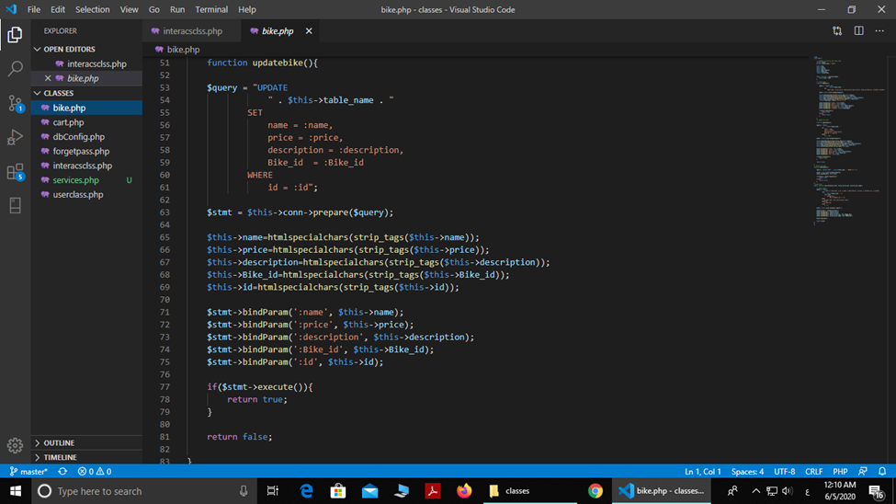

The function to update bike first bath check on the bike table, or the filed is empty return function to enter full data and check connection of database and set new data ad return false if you have any error back to right path .

The (CCM) =1 for the function add and 1 for all if, else, and 1 for all operators || that mean the function =3.

The function to delete bike first bath check on the bike table and check number of bike have or not so you will check database connection to know if you have error will return to first path to enter id again .

The (CCM) =1 for the function add and 1 for all if, else, and 1 for all operators || that mean the function =4.

The function to delete item from cart first bath check on the cart item table ,cart is empty or not and check code of item you unset item will return to first path to enter code again .

The (CCM) =1 for the function add and 1 for all if, else, and 1 for all operators || that mean the function =.