الغلاف الخارجى للبحث

|  |  |  |  |  |  |  |  |  |  |
| --- | --- | --- | --- | --- | --- | --- | --- | --- | --- |
| أولاً: البيانات الخاصة بالطالب | | | | | | | | | |
| **الفرقة الدراسية** |  | | | **التخصص** | | |  | | |
| **اسم القسم** |  | | | | | | | | |
| **اسم المقرر** |  | | | | | | | | |
| **استاذ المقرر** |  | | | | | | | | |
| ثانياً: البيانات الخاصة بالبحث | | | | | | | | | |
| **عنوان البحث** |  | | | | | | | | |
| **طبيعة المشاركة** | **بحث فردى** | | | | | **بحث جماعى** | | | |
| **ارسال البحث** | **بواسطة البريد الالكتروني** | | | | | | | | |
| **اسماء الطلاب المشاركين فى البحث**  **(يكتب الاسم رباعيا)** | **م** | **الاسم رباعى** | | | | **رقم الجلوس** | | | **الرقم القومى** |
| **1** |  | | | |  | | |  |
| **2** |  | | | |  | | |  |
| **3** |  | | | |  | | |  |
| **4** |  | | | |  | | |  |
| **5** |  | | | |  | | |  |
| **تاريخ الإرسال** | **/ 6 / 2020** | | | | | | | | |
| ثالثاً: البيانات الخاصة بالكونترول | | | | | | | | | |
| **النتيجة** | | | **ناجح** | | **راسب** | | | | |
| **أعضاء لجنة تقييم البحث** | **الاسماء** | | | | | | | **التوقيع** | |
| **1** |  | | | | | |  | |
| **2** |  | | | | | |  | |
| **3** |  | | | | | |  | |

|  |  |
| --- | --- |
| **فى حالة عدم قبول البحث يرجى ذكر الأسباب** | * **..............................................................................................................................................** * **..............................................................................................................................................** * **..............................................................................................................................................** * **.............................................................................................................................................** |

**Part 2, 10-d)**

* What is a Software Analysis Pattern?

It is a step in the overall software lifecycle. This step comes after the requirements step. It establishes an ideal solution to the problem that defined by the Use Case Models. They are patterns which capture conceptual models in an application domain in order to allow reuse across applications. There are over 50 Analysis patterns. They:

1-Speeds up the process of moving from a concrete problem to

an abstract model.

2- facilitates the transformation of the analysis model into the

design model.

-There are many types of Software Analysis Patterns like Party, Accountability, Organization Hierarchies, Quantity and etc.

So we will choose one of the patterns, define it and apply it according to our website.

|  |  |
| --- | --- |
| Pattern Name | Party |
| Intent | The intent of the Party pattern applies when a person is responsible to another. By applying the party pattern, it can ease up the complexity of an organization structure model. |
| Motivation | When a newly website getting more and more users, the website will have internal Admin information, external like user information etc. Each of those has addresses, phone numbers, email address or other contact information. |
| Solution | we will Define a party as the super type of all entities. Party is used to define countless models. |

Username

Telephone Number

Person

(Admins and Users)

Address

Party

Website System

Password

E-mail Address

**part 1-6)**

**Design and Implement Constraints:**

* They are development guidelines within which the designer must work.
* These constraints can seriously limit design and implementation options

-From the reasons of putting these constraints:

1-It may be coming from the domain requirements.

2-It may be resulting from organization requirements.

So in our Website there are many constraints which are:

1-The Frontend is designed by using these languages according to the company restrictions:

1-HTML5.

2-CSS3

3-Bootstrap 4

4-Javascript

2-The Backend is implemented by using these languages according to the company restrictions:

1-PHP

2-MySQL 🡪 for database

-The site shall be developed using open source tools and can run on both Windows OS and Linux OS.

**-The site** shall be developed using many language such as JQuery and some frameworks such as Laravel for PHP and Mongo instead of MySQL.

-Each user has an unique username with unique ID in database so the user cannot sign up twice using the same username.

**Part 2-K)**

**Deployment Diagram:**

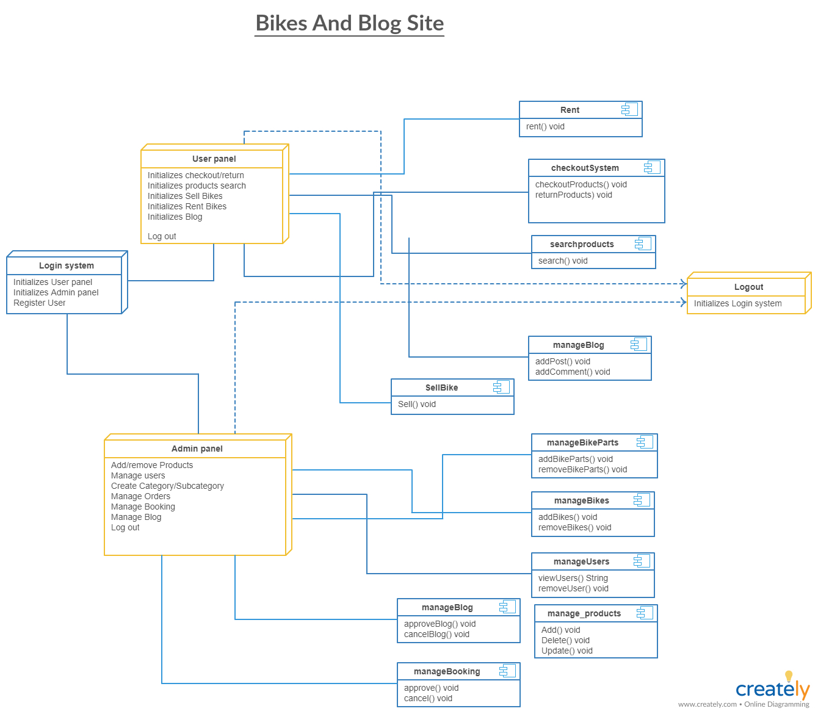

**Part 3:**