الغلاف الخارجى للبحث

|  |  |  |  |  |  |  |  |  |  |
| --- | --- | --- | --- | --- | --- | --- | --- | --- | --- |
| أولاً: البيانات الخاصة بالطالب | | | | | | | | | |
| **الفرقة الدراسية** | **الثانية** | | | **التخصص** | | | **عام** | | |
| **اسم القسم** | **عام** | | | | | | | | |
| **اسم المقرر** | **هندسة البرمجيات-1** | | | | | | | | |
| **استاذ المقرر** | **دكتور/ عمرو غنيم** | | | | | | | | |
| ثانياً: البيانات الخاصة بالبحث | | | | | | | | | |
| **عنوان البحث** | **Bike Store and Blog project** | | | | | | | | |
| **طبيعة المشاركة** | **بحث فردى** | | | | | **بحث جماعى**  صح | | | |
| **ارسال البحث** | **بواسطة البريد الالكتروني** | | | | | | | | |
| **اسماء الطلاب المشاركين فى البحث**  **(يكتب الاسم رباعيا)** | **م** | **الاسم رباعى** | | | | **رقم الجلوس** | | | **الرقم القومى** |
| **1** | **مصطفى محمود عبد العزيز محمد** | | | | **2670** | | | **30003130102593** |
| **2** |  | | | |  | | |  |
| **3** |  | | | |  | | |  |
| **4** |  | | | |  | | |  |
| **5** |  | | | |  | | |  |
| **تاريخ الإرسال** | **/ 6 / 2020** | | | | | | | | |
| ثالثاً: البيانات الخاصة بالكونترول | | | | | | | | | |
| **النتيجة** | | | **ناجح** | | **راسب** | | | | |
| **أعضاء لجنة تقييم البحث** | **الاسماء** | | | | | | | **التوقيع** | |
| **1** |  | | | | | |  | |
| **2** |  | | | | | |  | |
| **3** |  | | | | | |  | |

|  |  |
| --- | --- |
| **فى حالة عدم قبول البحث يرجى ذكر الأسباب** | * **..............................................................................................................................................** * **..............................................................................................................................................** * **..............................................................................................................................................** * **.............................................................................................................................................** |

**Project Name: Bike Store and blog**

**Team Information: Team 24**

***(typed not handwritten, except for the attendance signature)*:**

|  |  |  |  |
| --- | --- | --- | --- |
|  | **ID [Ordered by ID]** | **Full Name [In Arabic]** | **What he had done .**  **Include Pasrts 1,2 “until 11-L”,3** |
| **1** | 20180607 | مصطفي محمود سعيد | 1,2,8,9,11-e,11-j,11-l |
| **2** | 20180608 | مصطفي محمود عبد العزيز | 10-c,11-b,11-c,11-p,17,19 |
| **3** | 2018494 | محمد رمزي فرج | 6,11-d,11-k, Part3 |
| **4** | 20180525 | محمد فتحي يوسف | 3,4,5,11-h,15,16 |
| **5** | 20180527 | محمد ماهر فؤاد | 11-g,11-m,11-o,11-r,Part3 |
| **6** | 20180705 | يوسف خالد الجيوشي | 10-a,10-b,11-f,11-i, Part3 |
| **7** | 20180721 | يوسف مدحت جلال | 7,11-a,11-n,11-s,20 |

Bike Store and Blog Project

**Part 1: Overview & Software Requirements Specification**

**1)Introduction**

**a) Purpose.**

•online Bike and bike parts store that has listings of various bike along with their advantage and also consists of Bike service Registration.

•Online Bike Store and Blog Project is a combination of both sales and inventory management of the bike and bike parts.

• User can easily purchase bike or bike parts by using this system user does not have to come manually to shop to purchase the product.

•This system allows user to buy bike, bike parts and inventory online.

• System allow user to check various articles submitted by user and even comment on them. Credit card payment facility is available.

**b) Project Scope.**

•The visitor who visits the system must register himself by filling up personal details.

•After registration user can login to the system with his username and password in order to access the system

• User can check various bike listing and can view each bike feature and check features of the bike as well as inventory parts, and accessories.

•User may select the product and can add the product to shopping cart and can make payment through credit cards by clicking on credit card payment option

• User must register himself for posting an article.

c) Glossary and Abbreviations (for any technical or non-technical terms.)

### **OO SOFTWARE**

### **Object-oriented software means that we organize software as a collection of discrete objects that incorporate both data structure and behavior. The fundamental unit is the Object.**

### **CSS**

“Cascading Style Sheet.” Code that tells [browsers](https://www.wholewhale.com/tips/developer-terms-glossary/#browser) how to display a webpage for the end user. This programming formats fonts, colors, and other visual elements. When redeveloping a website, editing these elements in the mockup/[GUI](https://www.wholewhale.com/tips/developer-terms-glossary/#gui) phase is much easier than changing in CSS.

**database:**  
A collection of information organized so that a computer application can quickly access selected information; it can be thought of as an electronic filing system. Traditional databases are organized by fields, records (a complete set of fields), and files (a collection of records). Alternatively, in a Hypertext database, any object (e.g., text, a picture, or a film) can be linked to any other object

CCM (Cyclomatic Complexity Metric)

Loc (line of code)

WMC (Weighted Methods per Class)

DIT (Depth of Inheritance Tree)

NOC (Number of Children)

CBO (Coupling Between Objects)

RFC (Response for Class)

LCOM (Lack of Cohesion of Methods)

d) List of the System Stakeholders.

User admin

Admin can add user and delete user

Admin can create category or delete category, category like add bike or part bike and can delete bike or part bike and can add article.

User

user can buy bike, bike parts and inventory online

and you can service bike or sell bike to another user

but you should be login or registration.

e) References.

1.IanSommerville,"SoftwareEngineering(9thEdition)",AddisonWesley,ISBN:978-0137035151,2010

2.BerndBruegge,AllenH.Dutoit,ObjectOrientedSoftwareEngineering:UsingUML,PatternsandJava,3rdEdition,PrenticeHall2009

3. Vlissides,J.,Helm,R.,Johnson,R.andGamma,E.,1995.

Designpattns:Elementsofreusableobject-orientedsoftware.

Reading:Addison-Wesley

**2) What is a Software Requirement Pattern (SRP)? Demonstrate that concept by applying it while specifying the requirements of your system**

Software requirement patterns (SRP)

•Fundamental principle: when specifying a system, a high proportion of requirements are recurrent and belong to a relatively small number of types Specially in the case of non-functional requirements.

•Requirement pattern: an approximation to the specification of a particular type of requirement SRP

Generates one or more

Applying:

• The system should be ease - to use

• And should be user - friendly - Easy to understand.

•This means that the user can understand the system during a specific time.

•The specific time are specified by the user

• All this requirement belong to the main requirement and the system should be easy.

**3) Functional Requirements:**

The System has 2 types of users roles which {Admin , User } and every type has different basic function

* **Registration** :Every parson can view the store but only the members can checkout it become control by administrator. For being member of website, the customer need to register for membership.
* **login** : After registration user will get user ID and password through which user can login to access the system.
* User Profile:The User Profile page is area that given user maintains his her own information. The user can only change his/her password required. The user can browse and search the item and add to shopping cart and can checkout and also the user can edit profile that include change shipping address and details. For other information to be changed, the super admin and admin privilege is required.
* **Search bike & bike parts** : Customer must be able to view his/her orders history. Each customer must be able to view placed order status. Customer should be able to validate and confirm their invoice**.**
* **View** : the user can view the bike and the color and parts .
* **Add to Cart** : User can select the product and add to the shopping cart which he wants to purchase.
* **Add product** : Admin could add products to his stock on the website
* **Remove product**: Admin could remove products from his stock on the website before being consumed by the customers
* **Rent Bike :** in this module user must register himself for renting bike he will be charged according to rent per day basic.  
  **Add article** : Bikers can post article and registered user can comment over it .
* **Sell Bike** :in this module user can sell their bikes and get response from other user where admin will get to know about the item user will sell it .
* **Check servicing** : in this module user can register for bike service, where admin will get to know about date and time user wants to come for service .
* **Rate**: users could rate the product after purchasing it and post a

comment on it.

* **Reset Password** :If user forgets his password he can just click forget password, and he will be asked to enter user id and email id and new password can be sent on user’s email Id, From which he can login into the system

|  |  |
| --- | --- |
| Function name | Login |
| Actors | Admin ,User |
| Pre – Condition | Data is found |
| Basic flow | Enter id && password |
| Post condition | Actor will access his / her account successfully |
| Alternative flow | If data not found in database error message will appear |

|  |  |
| --- | --- |
| Function name | Registration |
| Actors | User |
| Pre – Condition | Valid password and id |
| Basic flow | Enter all data  Press register button |
| Post condition | Actor registered his / her account successfully |
| Alternative flow | If un valid data found an error message will appear |

|  |  |
| --- | --- |
| Function name | **Search** |
| Actors | User |
| Pre – Condition | Valid search words |
| Basic flow | Enter the keyword to search |
| Post condition | Actor will found his / her search successfully |
| Alternative flow | If data not found in database return to search box else view the item |

|  |  |
| --- | --- |
| Function name | **View** |
| Actors | User , admin |
| Pre – Condition | The user has account registered |
| Basic flow | View the bike color and price |
| Post condition | Display the search results |
| Alternative flow | If item not found in database display an error |

|  |  |
| --- | --- |
| Function name | **Add to Cart** |
| Actors | User |
| Pre – Condition | The user has account registered |
| Basic flow | Add item to cart and quantity  calculate price |
| Post condition | Display the result |
| Alternative flow | If data not found in database display an error |

|  |  |
| --- | --- |
| Function name | **Rent** |
| Actors | User |
| Pre – Condition | The user is registered |
| Basic flow | Fill data |
| Post condition | Add data to the data base  Make payment |
| Alternative flow | If data unvalid display an error |

|  |  |
| --- | --- |
| Function name | **Rent** |
| Actors | User |
| Pre – Condition | The user is registered |
| Basic flow | Fill data |
| Post condition | Add data to the data base  Make payment |
| Alternative flow | If data unvalid display an error |

|  |  |
| --- | --- |
| Function name | **Add bike** |
| Actors | admin |
| Pre – Condition | Admin loged in successfully |
| Basic flow | Fill data addition form |
| Post condition | Add data to the data base |
| Alternative flow | If data unvalid display an error |

|  |  |
| --- | --- |
| Function name | **Remove bike** |
| Actors | admin |
| Pre – Condition | Admin log in successfully  Data found |
| Basic flow | Fill data |
| Post condition | Remove data from the data base  Make payment |
| Alternative flow | If data unvalid display an error |

|  |  |
| --- | --- |
| Function name | **payment** |
| Actors | User |
| Pre – Condition | The user is registered  The user has valid credit |
| Basic flow | Choose available bike  Choose payment cash or online  Fill cc data |
| Post condition | Add data to the data base  o |
| Alternative flow | If data unvalid display an error |

|  |  |
| --- | --- |
| Function name | **Add blog** |
| Actors | User |
| Pre – Condition | The user is registered |
| Basic flow | Add article  Add comment |
| Post condition | Add data to the data base |
| Alternative flow | If user not registered display an error |

|  |  |
| --- | --- |
| Function name | **Check servising** |
| Actors | User |
| Pre – Condition | The user is registered |
| Basic flow | If the service available  Make payment  Select available data |
| Post condition | Add data to the data base |
| Alternative flow | If user not registered display an error |

|  |  |
| --- | --- |
| Function name | **Rate** |
| Actors | User |
| Pre – Condition | The user is registered |
| Basic flow | Add feedback |
| Post condition | Add data to the data base |
| Alternative flow | If user not registered display an error |

|  |  |
| --- | --- |
| Function name | **Add blog** |
| Actors | User |
| Pre – Condition | The user is registered |
| Basic flow | Add article  Add comment |
| Post condition | Add data to the database |
| Alternative flow | If user not registered display an error |

|  |  |
| --- | --- |
| Function name | **Forget password** |
| Actors | User |
| Pre – Condition | The user is registered  Valid password |
| Basic flow | Add new password |
| Post condition | Add data to the database |
| Alternative flow | If user not registered or password not valid display an error |

**High Priority:**

-The system shall reflect a new and changed product description within x minutes of the database being updated by the product owner.

-The system shall display information that is customized based on the user.

The system shall provide accounting with accurate purchase transaction data.

-The system shall provide shipping with accurate order data. This will allow the order to be processed in x days and inventory to be updated within y hours.

-The system shall allow a customer to upload their products to sale.

**Medium Priority**

The system shall provide a search facility that will allow full-text searching of all web pages that the user is permitted to access. The system must support the following searches:

* find all words specified
* find any word specified
* find the exact phrase

## **Low Priority**

The system shall allow the user's status to be stored for the next time he returns to the web site.

The system shall provide marketing with customer navigation information.

The system shall translate web pages into the languages of the countries where the company's products are available.

**4)NON-Functional Requirements:**

**Usability:**

Usability is crucial in website development. Because whether you are doing online store or online application, the page for users to make him easy and fun to use is a key; efficient to use, easy to use and consistent interface can help enhance usability.  
- Efficient to use.  
- Easy to use.  
- Consistent interfaces

**performance**:

 Fast Response Time for User Login  
The average response time for user login after entering user name and password should be  
no more than 3 sec and the maximum response time should be 10 seconds.  
- Fast Average Time for Rendering a Page  
After clicking on any link the result should be rendered within no more than 1 second in  
 - Minimum number of concurrent users  
The application should be able to address at least 600 users concurrently

**Network security :**is a complicated subject, however, it is becoming more and more important as people spend more and more time connected. n a Web shop system, network security starts from authenticating the user with a user name and password, for authentication, users have to use password with strongly of security, and also need to change it usually.

**Data security** :

The damage of the hard drive is one of threat factors for data security. A hard drive physical damage means loss of data. Loss of equipment operation, storage media failure, in order to ensure data security, redundant arrays of inexpensive disks(RAID), hierarchical storage management can solve it, and it use in modern system.

***System Requirements:***

▪ Safety .

▪ Security .

▪ Works on an online host.

▪ SEO (Search Engine Optimization).

**5)Domain Requirements:**

* User can't sell bike without admin approve .
* Bike or scooter will be deleted form system if it has any problem.
* User can’t make order without register in the system .

**6) Design & Implementation Constraints:**

* They are development guidelines within which the designer must work.
* These constraints can seriously limit design and implementation options

-From the reasons of putting these constraints:

1-It may be coming from the domain requirements.

2-It may be resulting from organization requirements.

So in our Website there are many constraints which are:

1-The Frontend is designed by using these languages according to the company restrictions:

1-HTML5.

2-CSS3

3-Bootstrap 4

4-Javascript

2-The Backend is implemented by using these languages according to the company restrictions:

1-PHP

2-MySQL 🡪 for database

-The site shall be developed using open source tools and can run on both Windows OS and Linux OS.

**-The site** shall be developed using many language such as JQuery and some frameworks such as Laravel for PHP and Mongo instead of MySQL.

-Each user has an unique username with unique ID in database so the user cannot sign up twice using the same username.

**7) System Evolution:**

1. **Anticipated Changes**

As the system grows and the need to evolve rises there might be some functions to be added such as applying for driving lessons provided by the website or adding weekly reviews about the newest bikes out there and maybe even creating an event for a marathon for the users of this website and applying would be online to make sure you can take part in it all these might be useful if the system grows enough for them to be needed and actually implemented.

1. The System design would probably change a lot due to the continuous technology evolution and the evolution team should gain the maximum profit from these evolutions as websites are now usually two sides the client side and the server side a new technology might arise causing the merging of both of them and a better performance this would change the whole system design so we should always be ready to adapt to the new technologies and implement anything new into our system even if it’s a new scripting language also there might be the need to make an mobile application and that would require change to the system design to adapt to android and iOS interfaces.

**8) What are the requirements discovery approaches that you’ll rely on? (give detailed examples.)**

▪ The process of gathering information about the required and

existing systems and distilling the user and system requirements

from this information.

▪ Interaction is with system stakeholders from managers to

external regulators.

**Example:**

There are scenarios of how the system should be used:

• A description of the starting situation

• A description of the normal follow of event

• A description of what can go wrong

• Information about other concurrent activities.

• A description of the state when the scenario finishes

• Use-cases are scenarios based technique in UML

• A set of use cases should describe all possible interactions with the system.

**9) What are the requirements validation techniques that you’ll employ/use? (give detailed examples.)**

**1-Requirements reviews**

•Systematic manual analysis of the requirements.

**2-Prototyping**

•Using an executable model of the system to check requirements.

**3-Test-case generation**

•Developing tests for requirements to check testability.

For example, in a Bike Store and Blog project, when a user sends to repair bike to the customer in order to fix it, you must verify the validity of report before fixing it.

Requirements error costs are high so validation is

very important

• Fixing a requirements error after delivery may cost up

to 100 times the cost of fixing an implementation error

PART 2: System Design & Models

11)Structural & Behavioral Diagrams:

L) Class Diagram version 3.

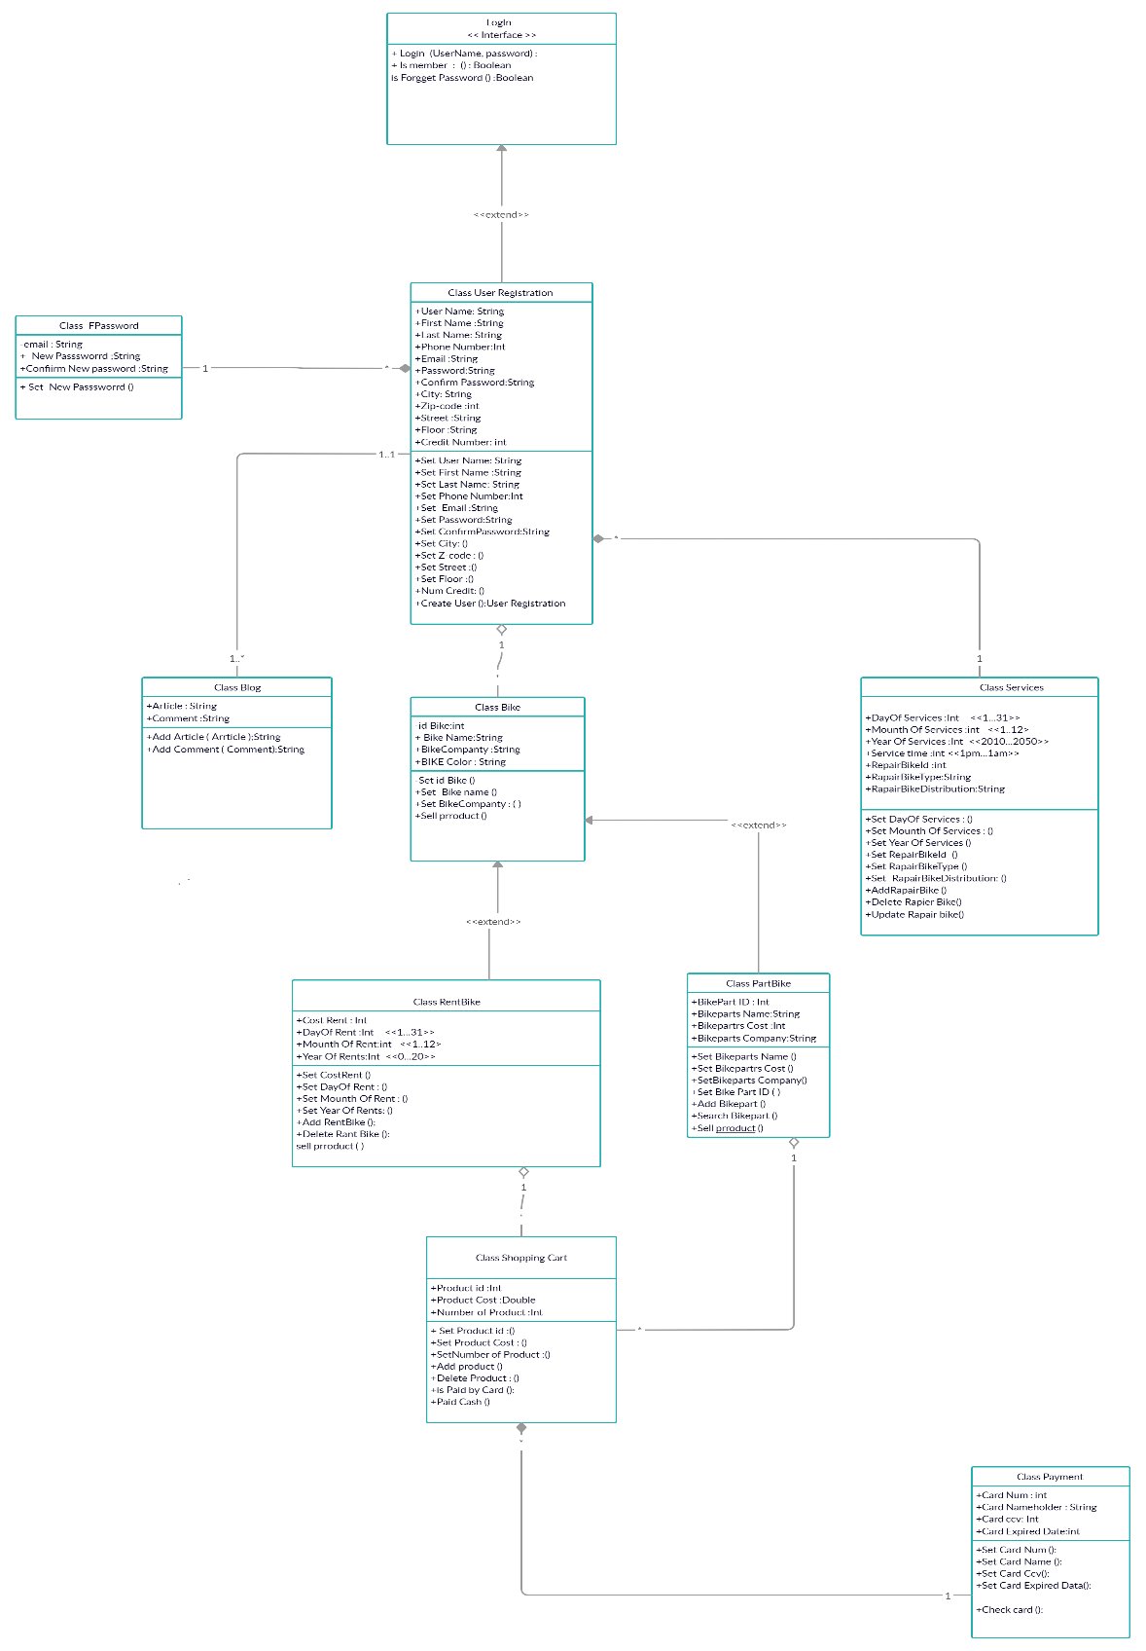

m)

n) Class Categories.

|  |  |
| --- | --- |
| **Boundary Class** | **Entity Class** |
| Login | User Registration |
| FPassword | Blog |
|  | Bike |
|  | PartBike |
|  | Services |
|  | RentBike |
|  | Shopping Cart |
|  | Payment |

o)

p) Classes Package diagram.

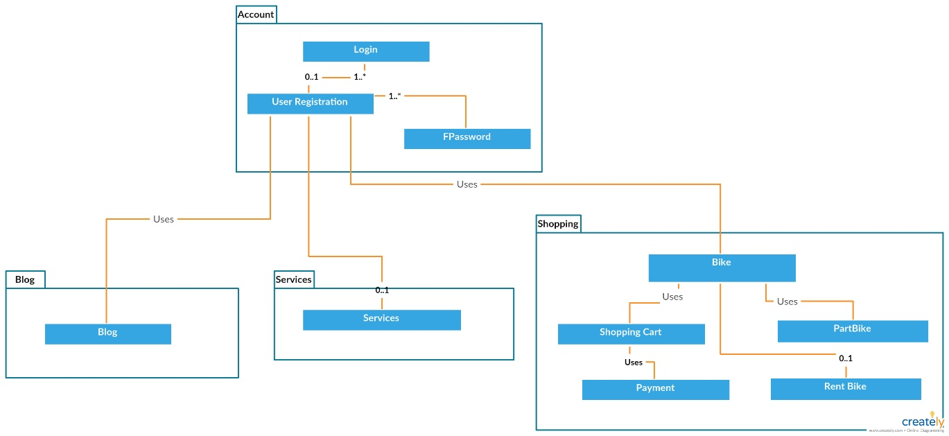

q) Object Diagram.

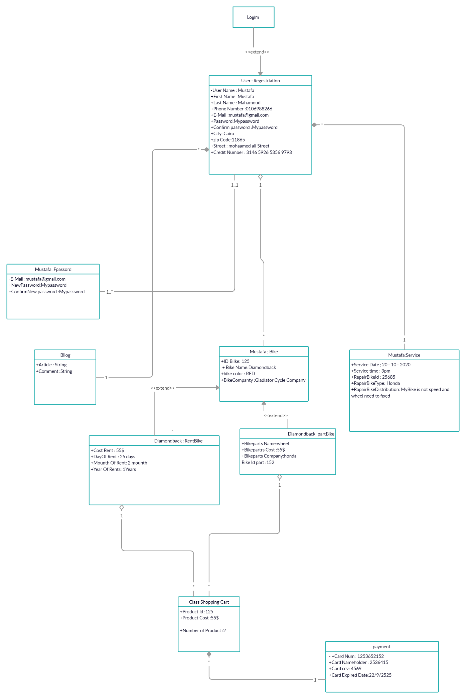

r) Database Specification.

ERD.

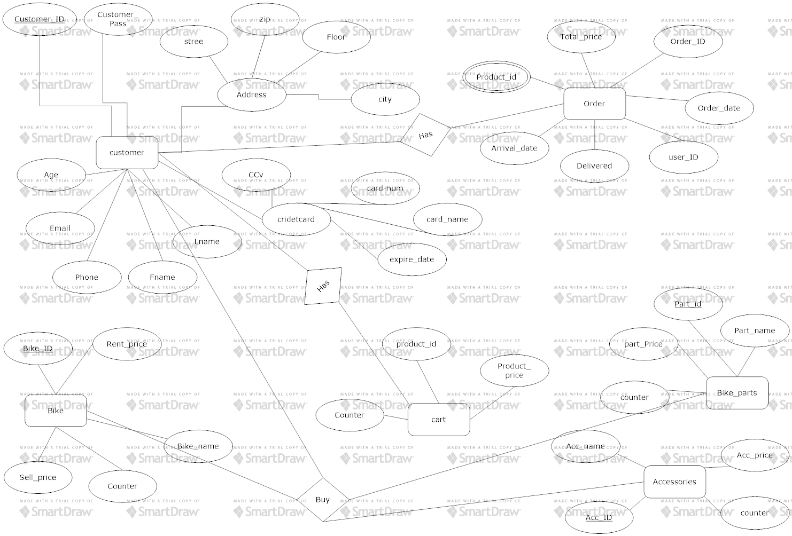

Tables

s) State Machine Diagram: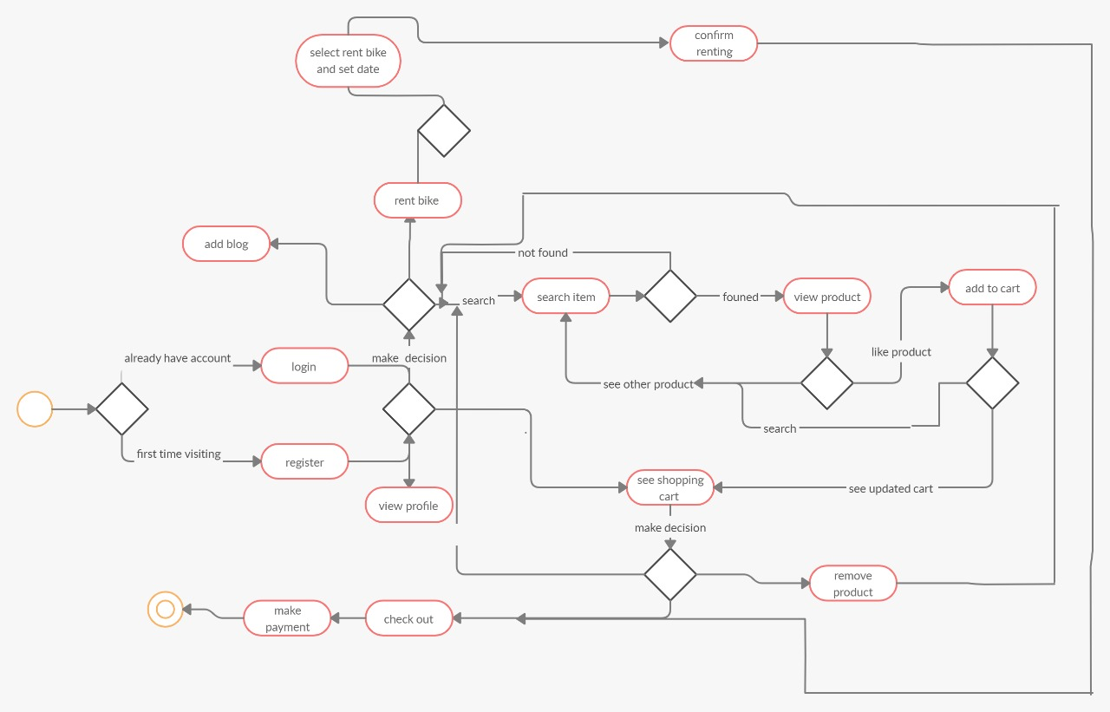

t) Deployment Diagram.

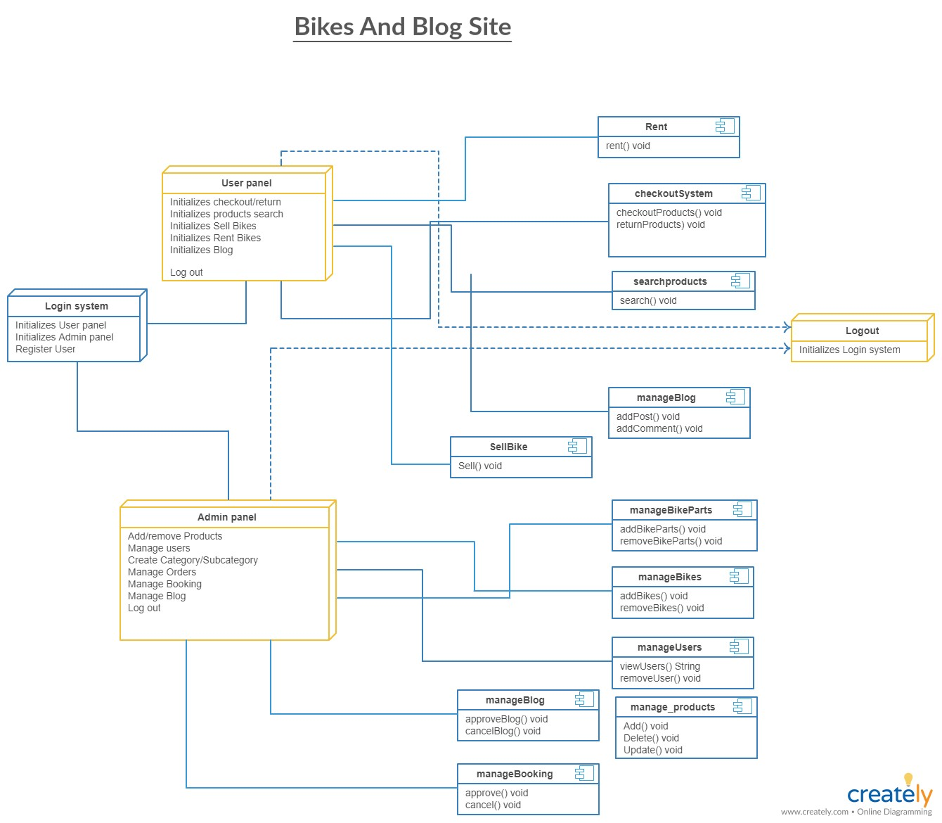

**PART 4: Complexity & Testing**

**15) Integrity && Efficiency:**

When the integrity increases, the system will affect efficiency. As making the system more secure, as it can not limit any entry to the private data on the site except the administrator to amend or accept the addition of an item for sale and not to allow this to anyone, Check passwords where only non-subscribers are allowed to enter and upload the product to the site, and this is done by confirming the password and making sure it is secure which makes the use of a specific al gorithm or authentication server and this affects efficiency.

**16)**

The (CCM) =1 for the function add and 1 for all if, else, and 1 for all operators || that mean the function =5.

LOC → 19

LOC → 16

The (CCM) =1 for the function add and 1 for all if, else, and 1 for all operators || that mean the function =2.

LOC → 19

The (CCM) =1 for the function add and 1 for all if, else, and 1 for all operators || that mean the function =4.

LOC → 22

The (CCM) =1 for the function add and 1 for all if, else, and 1 for all operators || that mean the function =3.

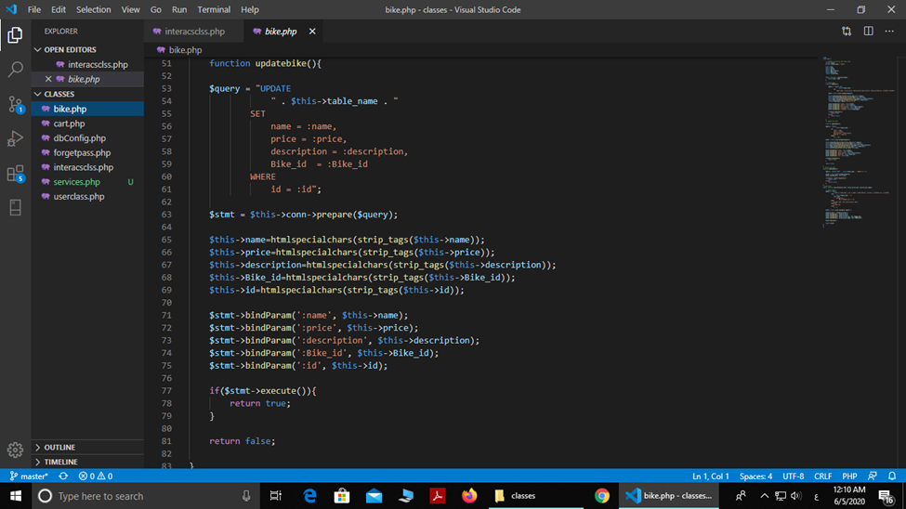

LOC → 27

The (CCM) =1 for the function add and 1 for all if, else, and 1 for all operators || that mean the function =3.

LOC → 10

The (CCM) =2 for the IF AND ELSE

**17)** **For the classes in your system, calculate all the following OO Complexity Metrics:**

**a)** WMC = The sum of Cyclomatic Complexity Metrics (CCM).

The CCM for:

Bike = 8.

Cart = 17.

dbConfig = 1.

Userclass = 9.

Forgetpass = 2.

Interactclass = 2.

WMC = 8 + 17 + 1 + 9 + 2 + 2 = 39.

**b)** The Depth of the Inheritance Tree (DIT) = 6.

**c)** The Number of Children (NOC) = the number of children for a class.

Login (NOC) = 3.

User Registration (NOC) = 1.

Bike (NOC) = 2.

RentBike (NOC) = 0.

PartBike (NOC) = 0.

Shopping Cart (NOC) = 0.

Payment (NOC) = 0.

Services (NOC) = 0.

Blog (NOC) = 0.

d) Coupling Between Objects (CBO) is the count of classes that are coupled to a particular class where the methods of one class call a method or access variables of the other class

e) Response for class (RFC) = the number of methods and the number of called methods in a class.

Login (RFC) = 3.

User Registration (RFC) = 13.

FPassword (RFC) = 1.

Blog (RFC) = 2.

Bike (RFC) = 4.

Services (RFC) = 9.

RentBike (RFC) = 7.

PartBike (RFC) = 7.

Shopping cart (RFC) = 7.

Payment (RFC) = 5.

f) LCOM is the Lack of Cohesion Of Methods it can be calculated by using this equation: LCOM = 1- which **(a)** is the number of instance variables and **(m)** is the number of the functions and constructors.

LCOM in Registration:

a = 12, m = 12, = 12.

LCOM = 1 – 12 / |12| |12| = 0,91.

LCOM Bike:

a = 3, m = 4, = 6.

LCOM = 1 – 6 / |4| |3| = 0,5.

LCOM Services:

a = 7, m = 8, = 14.

LCOM = 1- 14 / |8| |7| = 0,75.

LCOM RentBike:

a = 4, m = 5, = 8.

LCOM = 1 – 8 / |5| |4| = 0,6.

LCOM PartBike:

a = 4, m = 6, = 12.

LCOM = 1 – 12 / |6| |4| = 0,5.

LCOM ShoppingCart:

a = 3, m = 7, = 12.

LCOM = 1 – 12 / |7| |3| = 0,42.

LCOM Payment:

a = 3, m = 4, = 6.

LCOM = 1 – 6 / |4| |3| = 0,5.

LCOM Blog:

a = 2, m = 2, = 2.

LCOM = 1-2 / |2| |2| = 0,5.

**18)White Box Testing:**

**Considering White-Box Testing, generate a Unit-Testing Test Report for at least 7 main functions in your system. For each function consider path testing by determining a set of test cases (value of the function’s parameters) such that each path through the function is executed at least once.**

Function login user used to be able to shopping and buy prodect or rent function used variable result to check username and password may be return error If user not enter right password If do this will return to enter right password so you will retrn to first path

The (CCM) =1 for the function add and 1 for all if, else, and 1 for all operators || that mean the function =5.

Function registration used to be able to shopping if user not visit website before ,function may be display some error if you not enter any pramater of function you cant be complete registration And display acumen error If enter username already registration before or enter availd email.

The (CCM) =1 for the function add and 1 for all if, else, and 1 for all operators || that mean the function =2.

Function use to add product user would to buy it added in cart may be have some error like if not get full data you will return to first path to get full data and may be display error if user enter wrong cart number or empty cart item.

The (CCM) =1 for the function add and 1 for all if, else, and 1 for all operators || that mean the function =4.

function to add bike first bath check on the bike table, or the filed is empty return function to enter full data if the image empty this is all error the user can face it when use the add function.

The (CCM) =1 for the function add and 1 for all if, else, and 1 for all operators || that mean the function =3.

The function to update bike first bath check on the bike table, or the filed is empty return function to enter full data and check connection of database and set new data ad return false if you have any error back to right path .

The (CCM) =1 for the function add and 1 for all if, else, and 1 for all operators || that mean the function =3.

The function to delete bike first bath check on the bike table and check number of bike have or not so you will check database connection to know if you have error will return to first path to enter id again .

The (CCM) =1 for the function add and 1 for all if, else, and 1 for all operators || that mean the function =4.

The function to delete item from cart first bath check on the cart item table ,cart is empty or not and check code of item you unset item will return to first path to enter code again .

The (CCM) =1 for the function add and 1 for all if, else, and 1 for all operators || that mean the function =.

**19)Black Box Testing:**

1-The Registration Function Testing:

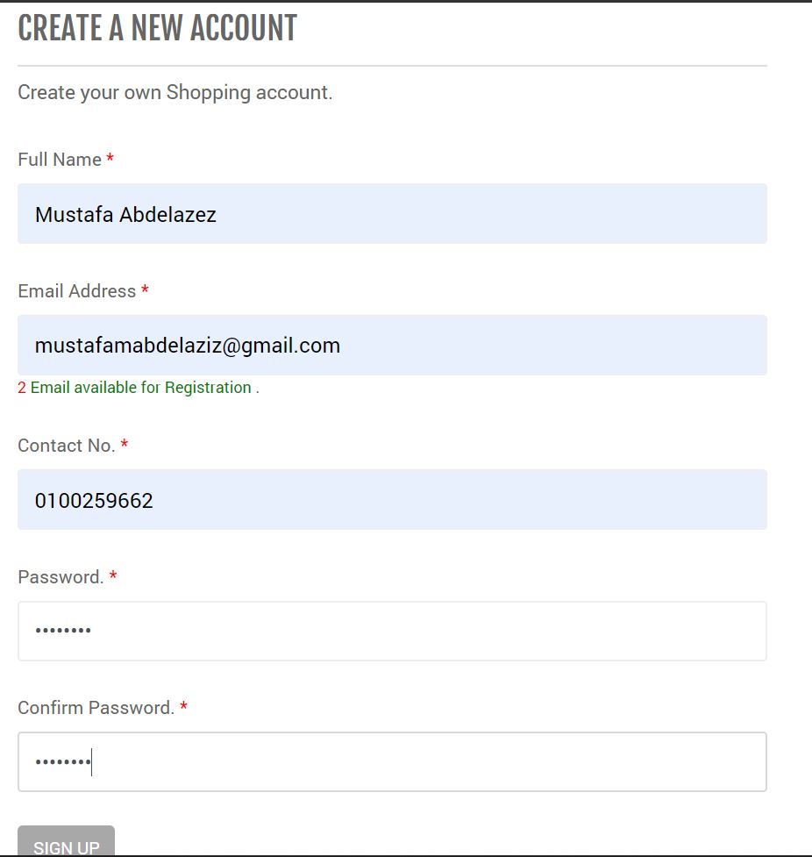

Here we have entered the fields required for the registration then we pressed Sign up button.

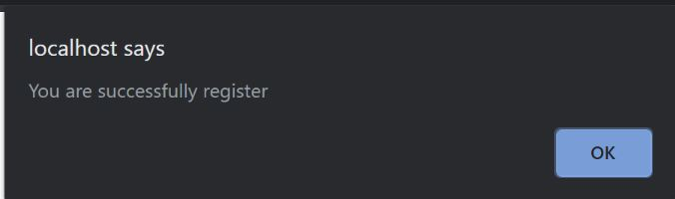

Then had this massage that confirms registering.

2- Login Function:

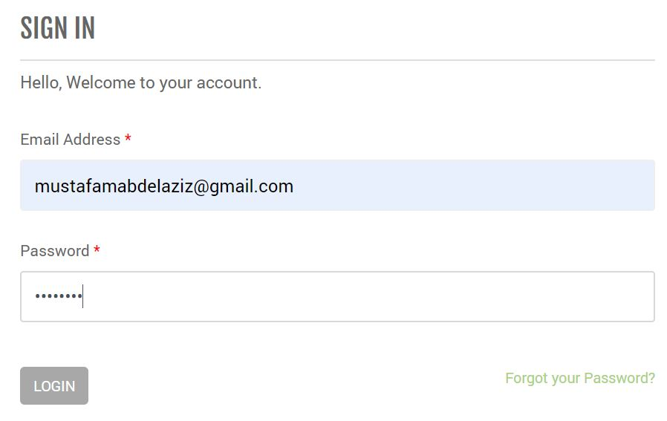

First, we Enter our login information then click login button.

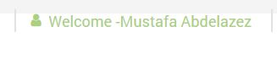

Logging in will appear to be successful as shown

3- Admin Logging in:

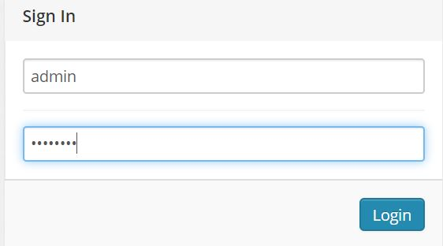

Enter the admin information.

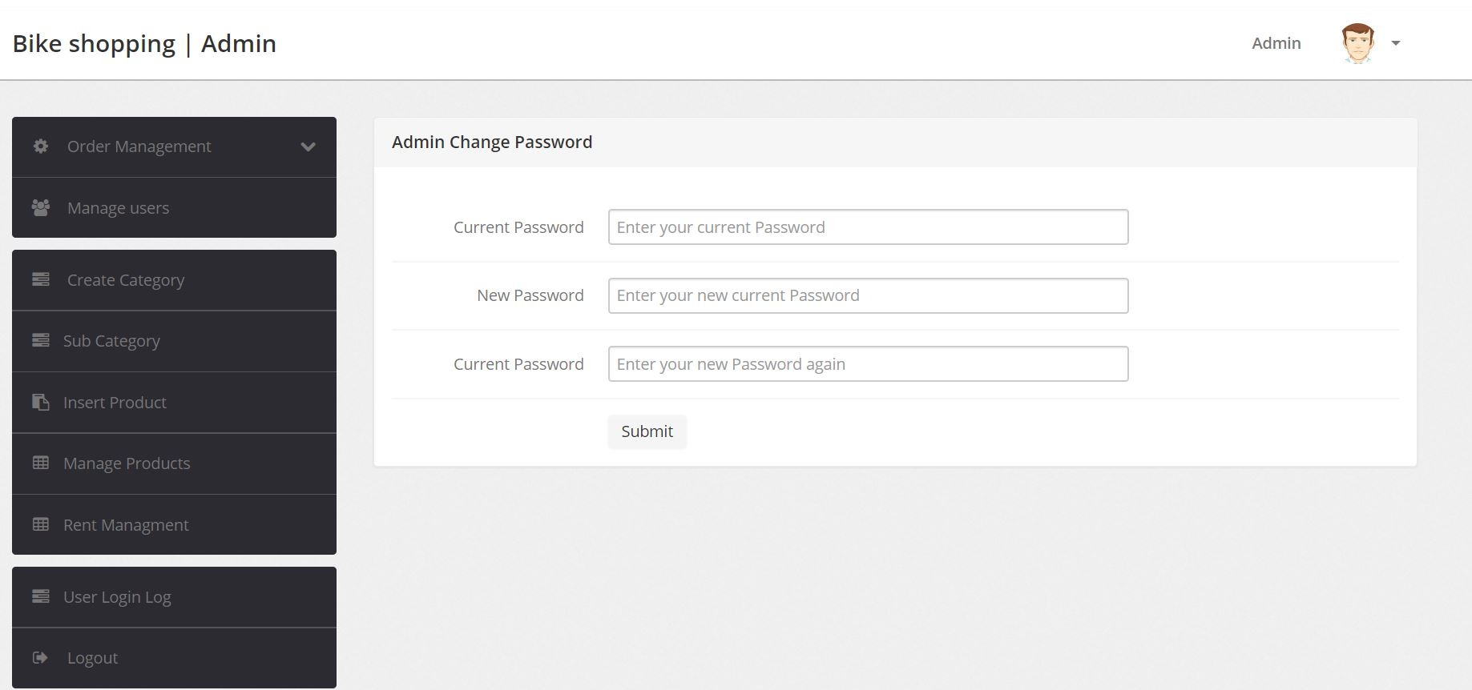

The admin profile was opened successfully.

4- Admin Manage users’ info:

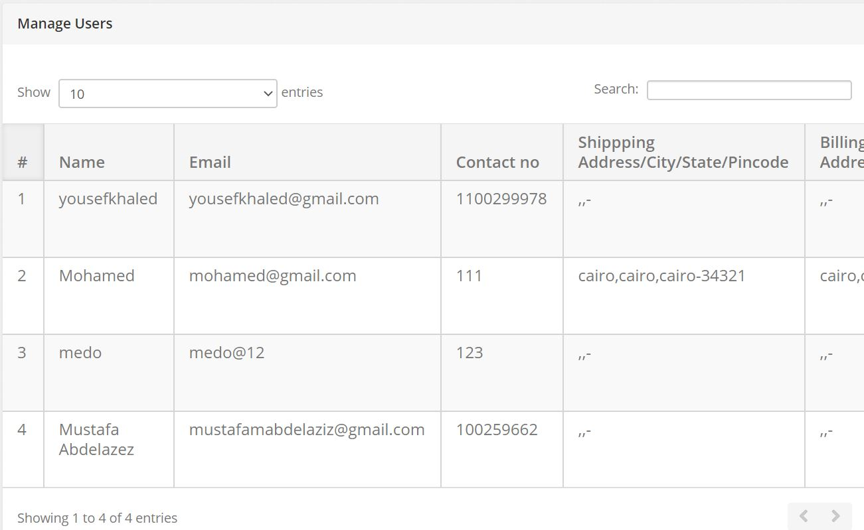

All user’s information is displayed.

5- Entering new category:

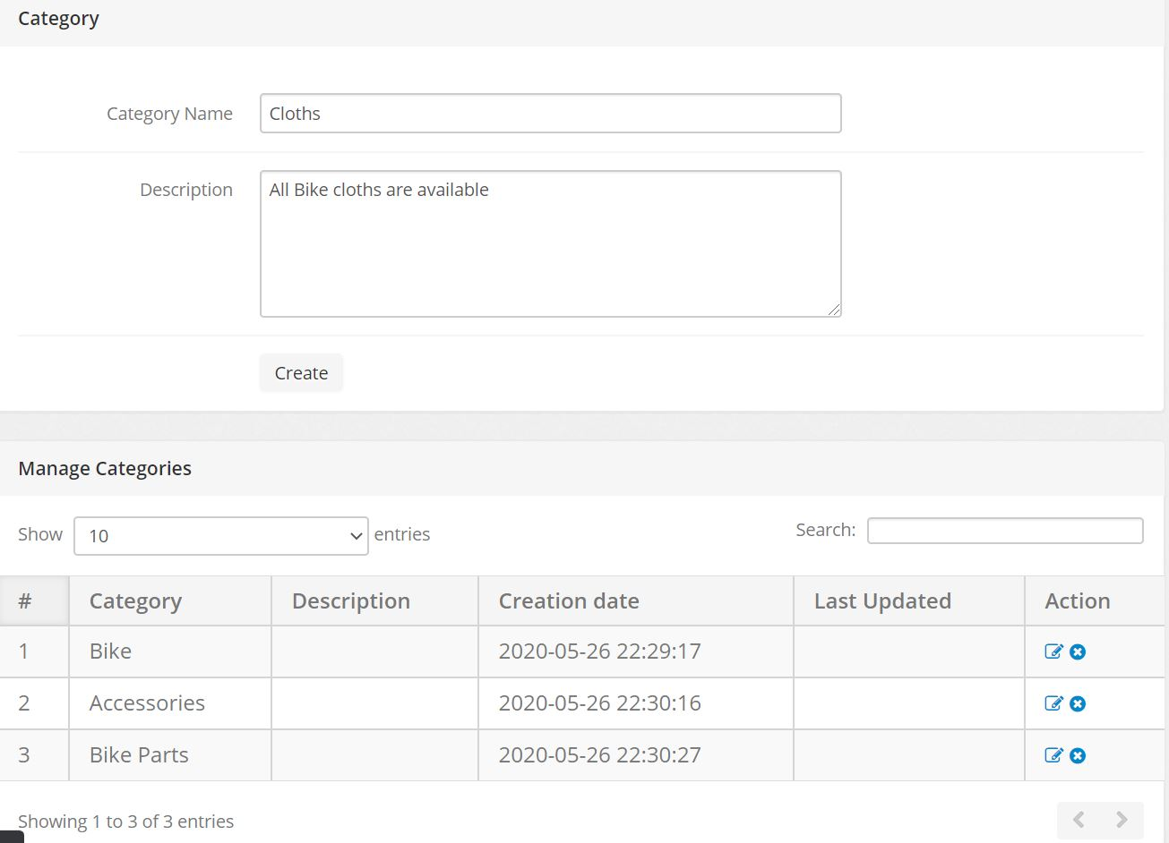

We Enter the category information then we press Create.

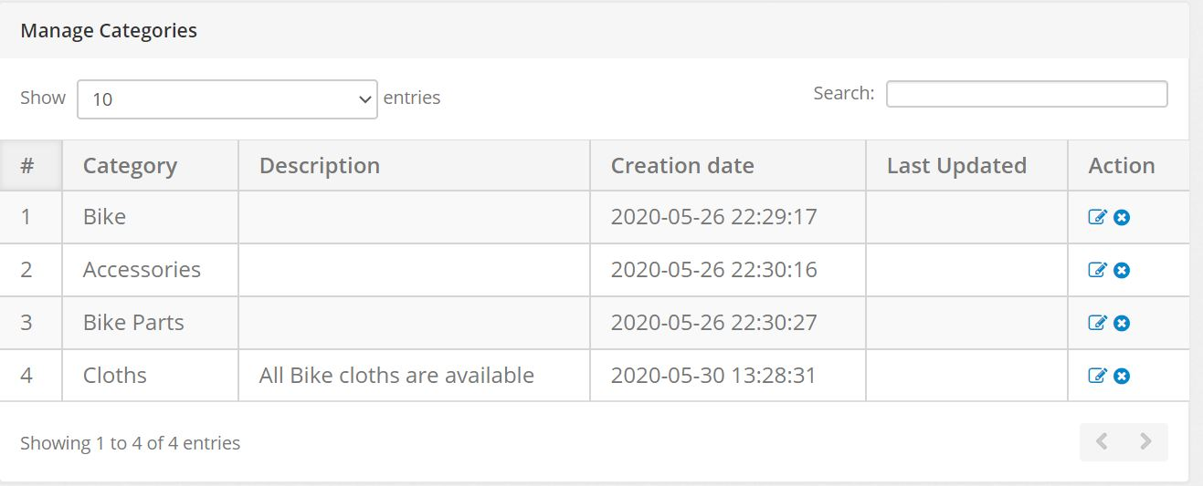

The category will be added successfully.

6- Adding Product:

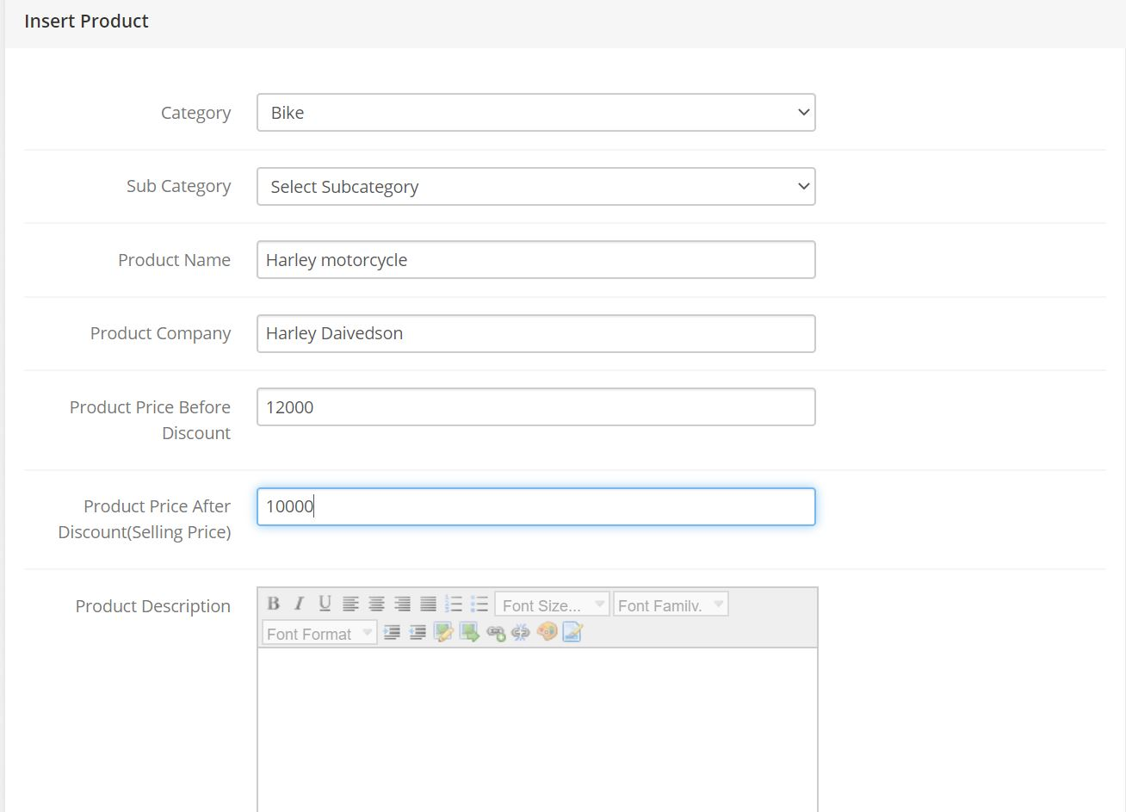Af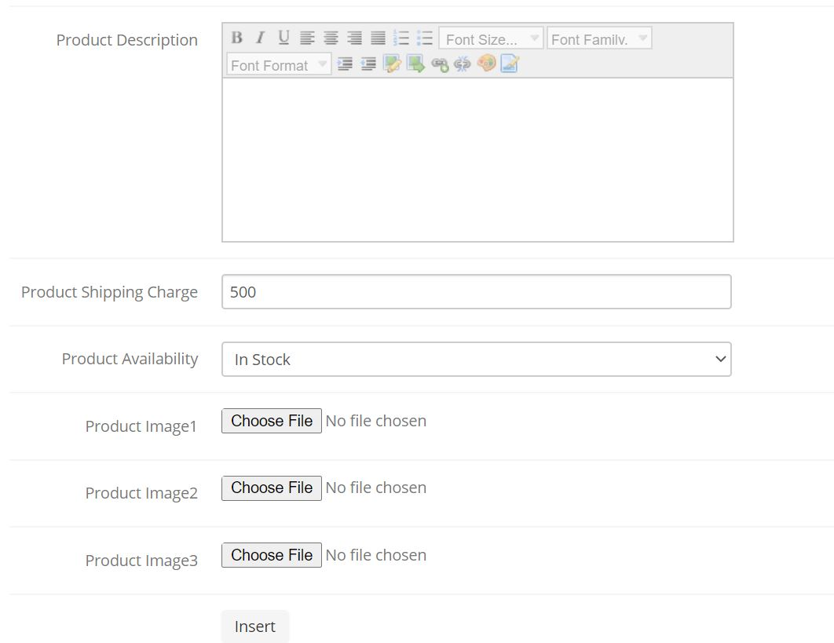

We should add All required information but, if we didn’t Enter all of them we will have an error massage.

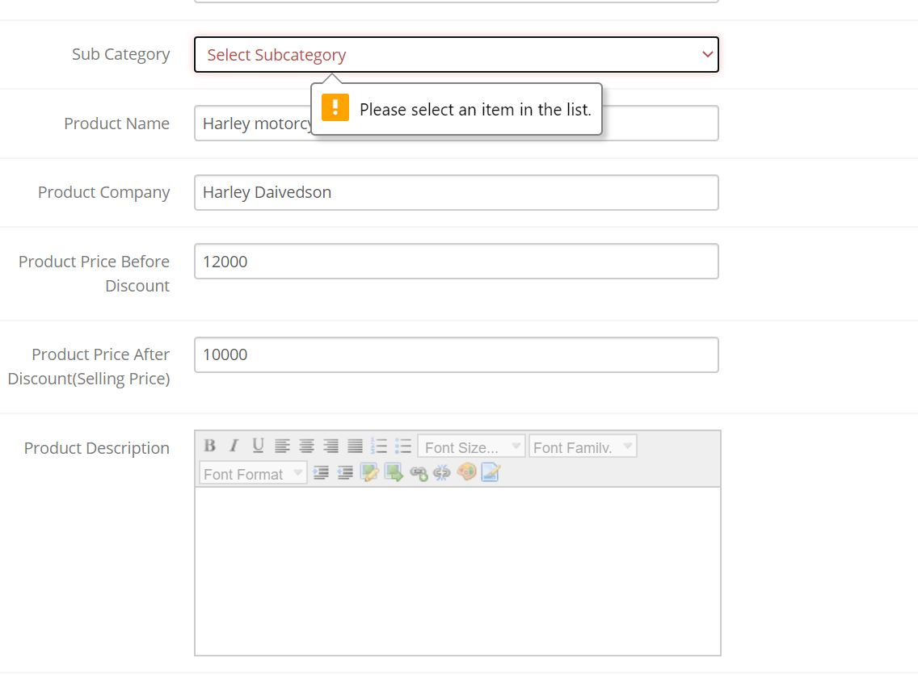

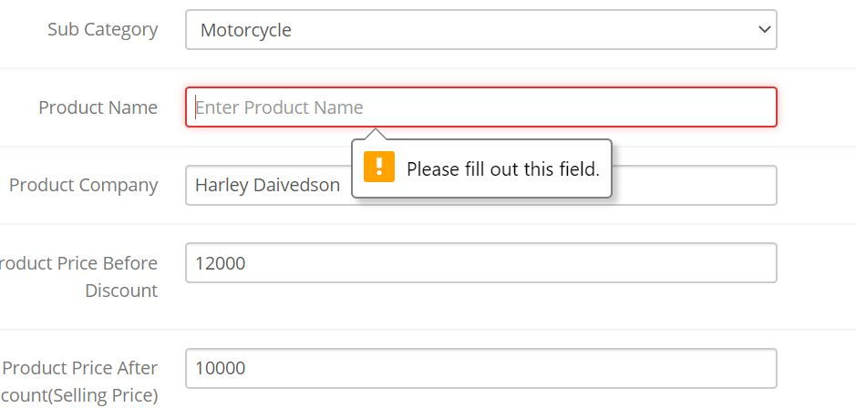

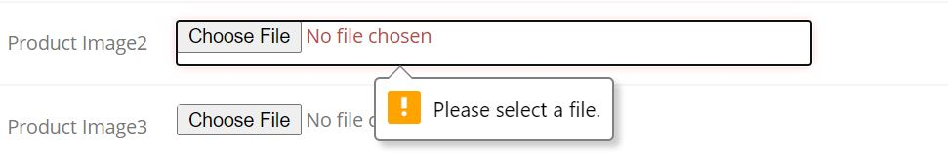

After we add all the required information, we can add our product successfully.





7- Sending Emails:

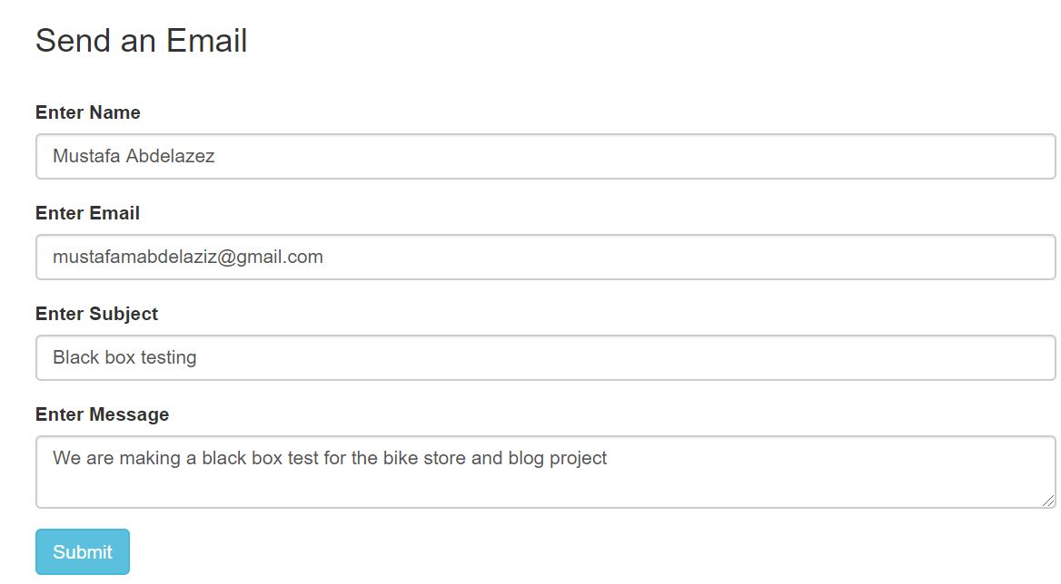

At first, we write our massage then we click submit.



Then we will see this to confirm that our mail was sent.

**20) Heuristic Review.**

## This report is based on Jakob Nielsen’s 10 general principles for interaction design.

**1)Visibility of System Status:**

The system provides visibility whenever a button is clicked on and also whenever an item is added to the cart a notification pops up confirming that the item has been added also whenever increasing the quantity on the item it’s shown.

## **2)Match between system and the real world:**

The system provides match between it and the real world as the terms is simplified for the user such as add to cart and when choosing quantity also proceed to checkout all those are simplified terms to the user to understand easily.

# 3)User Control & Freedom:

The system provides user control and freedom such as if the user mistakenly browses a category he doesn’t want due to a miss click he can easily choose again from the side also he can always update his info and shipping details also he can easily remove items from the cart which he doesn’t want any more and control the quantity of the item he wants to order.

**4)Consistency and Standards:**

The System maintained consistency both internal and external in the case of internal consistency for examples of maintaining it whenever you hover your mouse over a button its color turns green indicating that you’re about to press that button and in case of external consistency the system almost have the standard shopping form as the shopping cart is at the top right corner while there’s the menu bar in the top of the page and the categories and sub categories are on the left side vertically and that is considered to be the standard in many other websites so that confirms that the system maintained consistency both internal and external and standards.

**5)Error Prevention:**

The system contains error prevention in many ways starting from the login if you write in the email field a false format it will tell you that it requires the email to contain “@” also in the shopping cart you cannot proceed to checkout until you’ve provided your shopping and billing details also you can check the quantity of the item you’re about to order in case you’ve double clicked by mistake and that would prevent the user from ordering a quantity which he does not desire and that affirms that error prevention exists in the system.

**6)Recognition rather than recall:**

The system promotes recognition over recall for example in the menu bar it’s not vague such as a shop button or to type what category does he wants to buy instead it’s divided into three sections (Bike, Accessories, Bike parts) and whenever you choose a category sub-categories appear on the right side which allows the user more cues to use recognition of what he was searching for rather than to recall what exactly he wants and search manually for it and thus the system uses recognition over recall.

## **7)Flexibility and efficiency of use:**

The system provides flexibility and efficiency although it doesn’t provide them as much as the other heuristics but it exists within the system the shopping cart on the top right corner you can view how many items it contains and if you click on it the items in the cart will appear without having the need to go to the cart page and to continue shopping while knowing what is on your cart.

# 8)Aesthetic and Minimalist Design:

# The system uses Aesthetic and Minimalist design as the menu bar is extremely simple showing what is the categories that are available for shopping and there aren’t any unnecessary photos added randomly on the site.

## **9)Help users recognize, diagnose, and recover from errors:**

The system helps users recognize and diagnose the errors and not repeating them again such as when you forget a field while registering or filling in shipping and billing details and continue to proceed you will find that there’s an error and the field you forgot is labeled by red to help the user to recover from such an error also while logging in if the user doesn’t write a proper email format and tries to login he will not proceed and a message will appear telling him to write a proper email in the field to continue and that’s how the system helps users from recognized their errors and not falling into them once more.

## **10)Help and documentation:**

The system unfortunately doesn’t provide any documentation and the nearest thing to request help would be through the contact info at the bottom of the website but although that it doesn’t provide any of that the system is extremely simple and standard and familiar for almost every user out there that is shopping online so it doesn’t require much help or documentation at least at the current stage of the system maybe in time with system evolutions it might require due to the future functionalities.