The preparation of a computer program to estimate the relative weights of subjects in the general education stages in the member states represents one of the most important components or dimensions of the proposed concept of the relative weights of subjects and the construction of study plans in these countries. It comes to achieve one of the special objectives of the present reference guide, which is to provide an appropriate computer tool that contributes to guiding its users in estimating those weights.

**The need for the program:**

The need to design the computer program was formed as a result of a set of justifications, the most prominent of which are the multiple functions that it can perform and the data that it can provide to decision-makers related to planning and developing curricula and building and reviewing study plans. On the other hand - and considering this program as a recent version, or an update of the computer tool prepared by the Arab Center for Educational Research for the Gulf States in 2006 - the current reality of the educational materials in the various stages of general education in the member states, and the changes that have occurred as a result of the influence of many of the factors mentioned above; requires the development of this tool and the production of a new computer program that is not based on the data of this reality only, but also seeks to improve it and upgrade its response to the rapid changes in all fields, especially in the amount of human knowledge and the development of its organization.

**The aim and importance of the programme:**

The computer programme targets those concerned with the relative weights of subjects and the construction of curricula in the member states, including: education policy makers, school curriculum planning, evaluation and development specialists, teachers, as well as educational supervisors with their various specialisations and experiences. The programme aims to help these targeted people estimate and re-estimate the appropriate time to teach each subject, and compare the amounts of time allocated to it. The programme also aims to provide assistance and guidance in reviewing, evaluating and developing curricula based on the results of increasing/decreasing the time to teach some subjects or adding/deleting one or more of them.

Specifically, it can be said that the importance of the computer programme in the present reference guide is due to its assistance to those targeted by it in:

- Knowing the reality of the relative weights of subjects and curricula in grades (1-6) and grades (7-9) in the member states, which reflects the awareness-raising and educational role of the programme.

- Comparing the time allocated to teaching subjects from different perspectives; Such as: subject matter, education stage, and country.

- Developing skills in estimating the relative weights of subjects by offering an opportunity for self-training, which reflects the educational developmental role of the program.

- Monitoring the results of interventions or potential changes in the teaching time of subjects; such as: increasing or decreasing the number of teaching hours, introducing a new subject/s or free activities, or deleting one or more subjects from the subjects.

- In connection with the above, the program helps in reviewing the study plans and proposing alternatives for them; as a result of the change in the relative weights of the subjects, which reflects the practical or procedural role of the program.

- Developing the necessary plans to address the repercussions or consequences of the change in the relative weights of the subjects, including those related to developing curricula, preparing textbooks, preparing teachers, and developing them professionally, which reflects the role of the program in preparing and getting ready.

The diversity of roles that the computer program can play in awareness, education, application and preparation is noted.

**Data and information required to prepare the program:**

Preparing to design the computer program required - as a starting point - studying and analyzing the tool for estimating the relative weights of educational materials, and a guide for its use, which is the tool that was prepared within the framework of the Relative Weight of Educational Materials Program carried out by the Arab Center for Educational Research for the Gulf States in 2006 AD. This came to identify the capabilities provided by this tool, and the functions it performs, and then determine the objectives and framework of the new computer program to update this tool.

Determining the objectives and framework of the computer program entailed determining the functions that it can perform, which required providing a variety of data and information as inputs for its design, including the following:

- Curricula in general education, in grades (1-9) in the member states in the academic year 2023/2024 AD.

- The number of annual teaching hours, and their relative weight for each subject in each grade (1-9) in the member states in the academic year 2023/2024 AD.

- The criterion for evaluating the reality of the relative weights of subjects and study plans in the member states.

It is worth noting that all the data and information referred to above are available in the evaluation study.

**How to design the program:**

The computer program was created using Excel and Visual Basic, then converted to a web platform. The program helps in managing and distributing class hours across different subjects and academic years. Users can modify current study plans, and add or delete study materials in order of educational needs.

The program's dashboard includes three different tables that the user interacts with. These tables are:

* Main table: Displays the number of teaching hours for each subject.
* Under Planning table: Allows users to modify or add/remove study materials.
* Changes table: Shows the modifications made to the table compared to the main table, and also displays deviations or discrepancies in the distribution of hours.

**Skills required to use the program:**

* Effective use of the program requires mastery of the following concepts and skills:
* Concepts related to using the program: Understanding the functions of tables and buttons.
* Concepts related to preparing study plans and schedules: Understanding the distribution of time across subjects and academic years.
* Basic computer skills: Ability to deal with Internet browsing programs, websites and web forms.
* Problem solving skills: Ability to manage deviations before saving modified tables.

**Program functions:**

The program performs the following functions:

- Increase / decrease the number of hours of teaching the subjects: The user can increase or decrease the hours specified for teaching the subjects.

- Add / remove subjects: The user can add new subjects to a schedule under planning, or remove scheduled subjects.

- Manage deviations: Here the user can adjust all deviations resulting from increasing or decreasing the number of hours or adding or removing subjects, in light of the criteria for estimating the relative weights of the subjects.

- Comparison between subjects by class and by country.

- Publishing: The user can publish the tables after adjusting the deviations.

- Printing: The user can print the modified tables for reference when needed.

**How to use the program:**

- Log in:

* Go to the login page.
* Enter your email and password provided to you, to log in to the platform.
* Click on the "Login" button.

- Selecting the country:

After logging in, select the country you are targeting from the map or drop-down list.

The user can move to select one of the member countries either by clicking on its location on the map, or selecting it from the list of available countries below the map as shown in the figure:

Select the country from the map or from the list of countries

Then the user clicks “Next” to enter the data of the country he chose according to the following form:

Click here to continue

- Select the educational stage:

* Select the educational stage you are targeting.
* Select the subject for which you want to modify the number of teaching hours, or remove it (or add a new subject).

The user then selects the educational level (either primary education or middle/preparatory education):

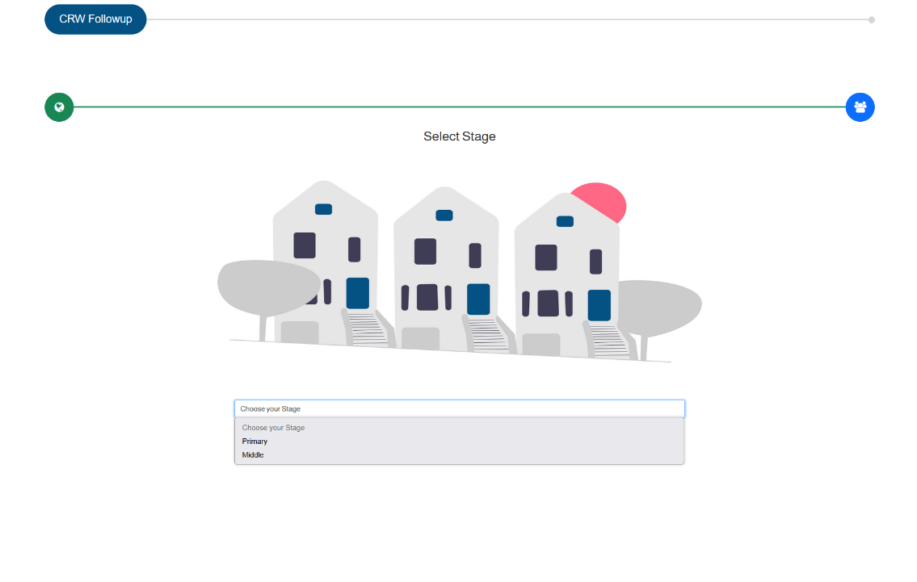

Choose the appropriate educational stage

Then click the “Calc” button to start working with the dashboard.

Click here to go to the dashboard

* Editing Subject hours:
* Select the class and Subject you want to modify the number of teaching hours for.
* Use the + button to increase the number of teaching hours for the course, or the - button to decrease it.
* Observe the cell for any deviations in light of the relative weighting criteria.
* Adding a new course:
* Click the "Add Course" button on the control panel.
* Type the name of the course you want to add in the space provided for it, and allocate its initial teaching hours.
* Adjust the hours using the + and - buttons as needed.
* Ensure that the schedule is balanced by checking the change table.
* Removing a course:
  + Select the course you want to remove from the schedule under Planning.
  + Click the "Remove Course" button to delete it from the schedule.
  + Ensure that the deletion does not result in any deviations or adjust the hours of the remaining courses to resolve discrepancies.
* Compensation for deviations:
* Deviations appear in the change table when hours are allocated incorrectly.
* Observe the graphs and tables to see and analyze the visual changes.
* Choose other materials to balance the clocks by increasing or decreasing them until the deviations become zero.

Go to the table under Planning to start editing and see the effect of the changes.

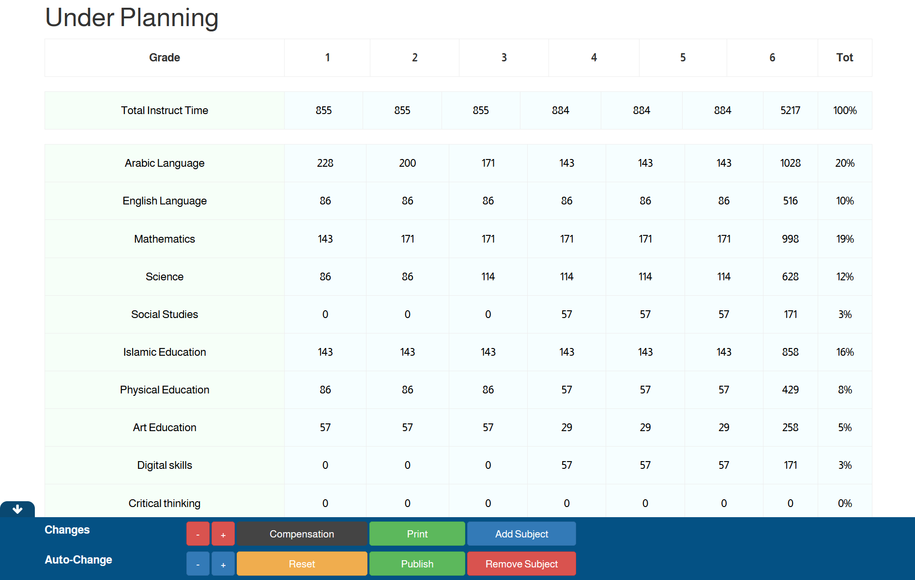

Choose the class and subject for which you want to modify the number of hours.

You can select the course you want to delete by clicking on the course name only.

This message will appear to confirm the deletion of the item.

This form appears when you click on Add Item to enter the new item data.

The user will see a control interface consisting of three tables: the main table, which is the approved table, the table under planning, where you can modify it to obtain a future table that can be approved, and the changes table, which shows the changes made by the user in the table under planning, as well as deviations.

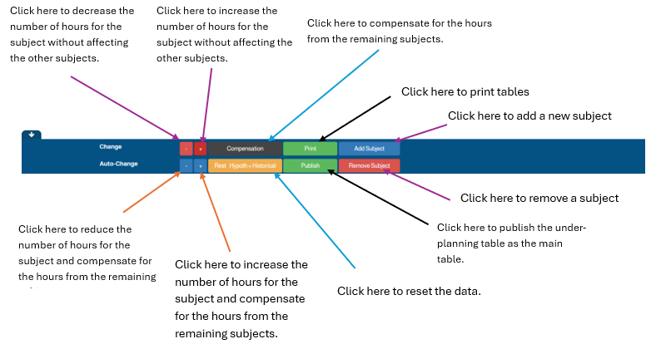

You can see the changes in the changes table.

There are alerts and alerts that appear when approaching and reaching the subject boundaries.

An initial warning appears as a light color on the material when it approaches the threshold (red when reaching the maximum threshold, yellow when reaching the minimum threshold). When the threshold is reached, a red warning message appears at the top of the page.

* Graphical representation of changes and comparison between subjects:

The user can compare the number of teaching hours for subjects in each grade by clicking on its number below the graph. He can also observe the changes in each subject, whether they are increasing or decreasing, as in the following figure. He can also see a comparison between the number of hours for all subjects shared between countries by selecting the desired subject by clicking on its name below the graph.

* Finish preparing the schedule and publishing it:
* Once all deviations are resolved, click the "Publish" button to save the new schedule.
* You can print the final schedule using the "Print" button.
* You can also return to the follow-up form to select a new stage or country.
* When you are finished, you can log out.