Milestone 1 — Analytical Report
Formula 1 Podium Prediction Companion
Data auditing, data-engineering questions, leakage-safe features, podium models, ablation and explainability
Dataset: Formula 1 World Championship 1950–2024 (Kaggle / Ergast), 14 relational tables.
Unit of analysis: one driver entering one race. Target: podium = positionOrder ≤ 3. Prediction cutoff: after qualifying, before the race starts.
Team / authors: ____________________ Submission: 18 October 2026

Contents
1. Executive Summary
2. Data Cleaning and Auditing
3. Data-Engineering Questions
4. Feature Selection, Engineering and Pre-Race Validity
5. Preprocessing and Feature-Engineering Experiments
6. Predictive Modelling
7. Feature-Group Ablation
8. Model Explainability (XAI)
9. Known Limitations
10. Conclusion
Appendix A. Requirements Coverage

1. Executive Summary
This project turns the 14 raw relational F1 tables into a validated, one-row-per-driver-per-race analytical table, answers three data-engineering questions, builds 22 leakage-safe pre-race features, and compares three podium classifiers (logistic regression, gradient boosting and a shallow neural network). Main findings:
- Cleaning. All primary keys are unique and non-null and all 20 foreign-key relationships reconcile with zero orphans. 122,887 \N sentinels in the results table were converted to real missing values, and 91 duplicated driver-race rows (shared drives) were removed. The Indianapolis 500 rounds of 1950–1960 (381 rows, 11 races) were excluded, leaving 26,287 rows.
- Q1 – front row to podium. In the 2014+ era Suzuka (88.9%), Monaco (85.0%) and Spa / Barcelona / Yas Marina (81.8%) convert qualifying front-row starts to podiums most often. Conversion rose at most circuits after 2014, but the circuit ranking is not stable across eras (Spearman 0.34 for qualifying, −0.11 for grid).
- Q2 – home advantage. Home drivers podium slightly less often in raw terms (11.9% vs 13.8%), mostly because they start further back. After controlling for grid position the odds ratio is 0.92–0.97 with 95% intervals that include 1, so there is no evidence of a home advantage.
- Q3 – mechanical retirements. League-wide strict mechanical-retirement rate fell from 9.2% (2014–2021) to 5.7% (2022–2024). Toro Rosso / AlphaTauri / RB (14.7%) led 2014–2021 and the Lotus / Renault / Alpine lineage (11.0%) led 2022–2024.
- Modelling. On the unseen 2022–2024 test set, logistic regression (PR-AUC 0.717, ROC-AUC 0.939) and gradient boosting (PR-AUC 0.717, ROC-AUC 0.938) are statistically indistinguishable and far above the 0.15 random baseline. The shallow neural network was weaker and unstable across seeds (test PR-AUC 0.555). Logistic regression was selected on validation PR-AUC.
- Explanations. Grid position (especially relative grid) is the dominant signal for all models, followed by driver career podium rate and constructor form. These are statements about what the models rely on, not causal effects.

2. Data Cleaning and Auditing

2.1 Approach
The 14 CSV files are loaded once into an immutable dictionary RAW. All cleaning happens on a separate copy CL, so every before/after comparison can always be traced back to the original data.

2.2 Sentinel values and semantic typing
The literal string \N marks missing data. The audit counted it per column across every table. Several columns are almost entirely missing by design: constructor_results.status (99.9%), race session times for practice and sprint (92–99%), driver number (93.1%) and code (87.9%). In the results table the sentinel is common for time/milliseconds (71.3%, because only lead-lap finishers have a race time), the fastest-lap fields (about 69%) and position (40.9%, unclassified finishers). In qualifying, Q2 is missing for 44.1% and Q3 for 65.0% of rows because slower drivers are eliminated.
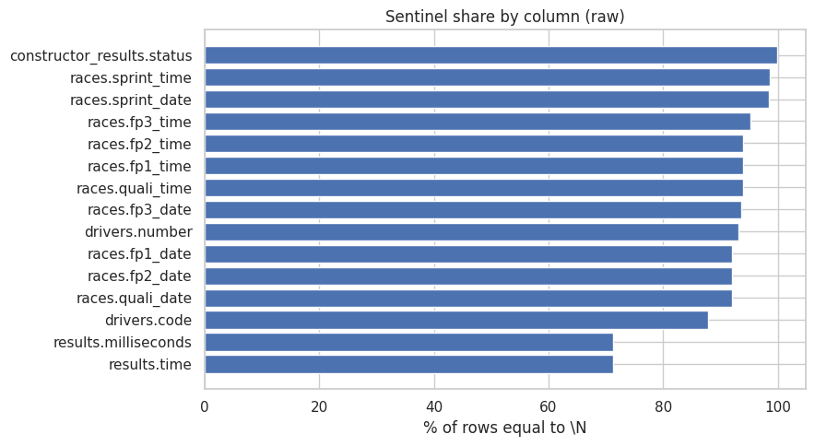
Figure 1. Share of rows equal to \N by column (raw data, top 15).
The cleaned copy is read with na_values=["\\N"], so these become genuine NaN. Race and birth dates were converted to datetime, and qualifying (Q1–Q3) and fastest-lap strings such as "1:27.452" were converted to seconds (87.452) with a regular-expression parser. All qualifying lap strings parsed (0 failures).

2.3 Primary and foreign keys
Primary keys were tested on every table, including the composite keys (raceId, driverId, stop) for pit stops and (raceId, driverId, lap) for lap times. Every table has 0 duplicate keys and 0 null keys. Twenty foreign-key relationships (for example results.raceId → races.raceId, results.constructorId → constructors.constructorId, lap_times.driverId → drivers.driverId) were tested by counting orphan values; all 20 have 0 orphan rows. The relational structure is therefore safe to join.

2.4 Grain: one row per driver per race
The modelling table needs a unique (raceId, driverId). Before fixing it, the raw results table contained 85 duplicated groups involving 176 rows, in 14 seasons (1950–1958, 1960–1962, 1964 and 1978). In the 1950s–60s these are shared drives, where two drivers swapped cars; the 1978 cases are prequalification and non-qualification entries.
Rule chosen. Within each duplicated group, rows are sorted so that a row with a real starting grid slot (grid ≠ 0) comes first, then by the better finishing order (positionOrder), and only the first row is kept. Why: the prediction question is "from this start, will the driver podium?", so the row that actually describes a grid start is the meaningful one; a grid = 0 row in these cases is a non-start or a car swap with no grid slot. Ties are broken by finishing order so the choice is deterministic. An assertion verifies that no (raceId, driverId) duplicate remains. 91 rows were removed, leaving 26,668.
The Indianapolis 500 was part of the world championship from 1950 to 1960 but was run to different rules with mostly non-F1 participants. It contributes 381 rows (11 races) and was removed (leaving 26,287 rows). The meaning of grid == 0 was checked rather than assumed: 1,635 rows have it, and 1,505 of them are "Did not qualify", "Did not prequalify" or "Withdrew", with the rest being genuine pit-lane starts.

2.5 Exploratory data analysis before and after cleaning
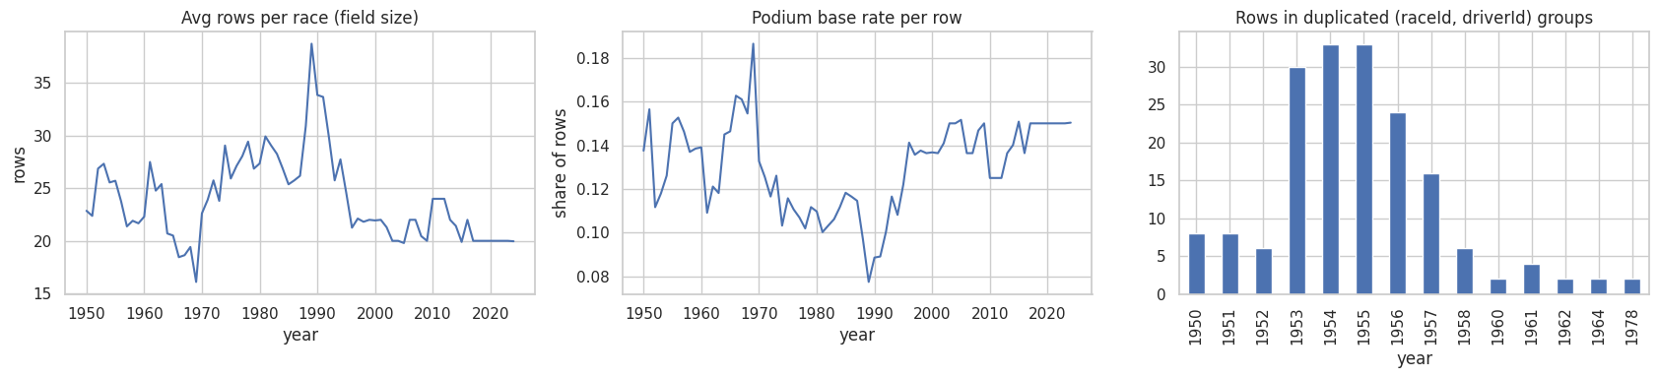
Figure 2. Raw data: average rows per race (field size), podium base rate, and rows in duplicated (raceId, driverId) groups by year.
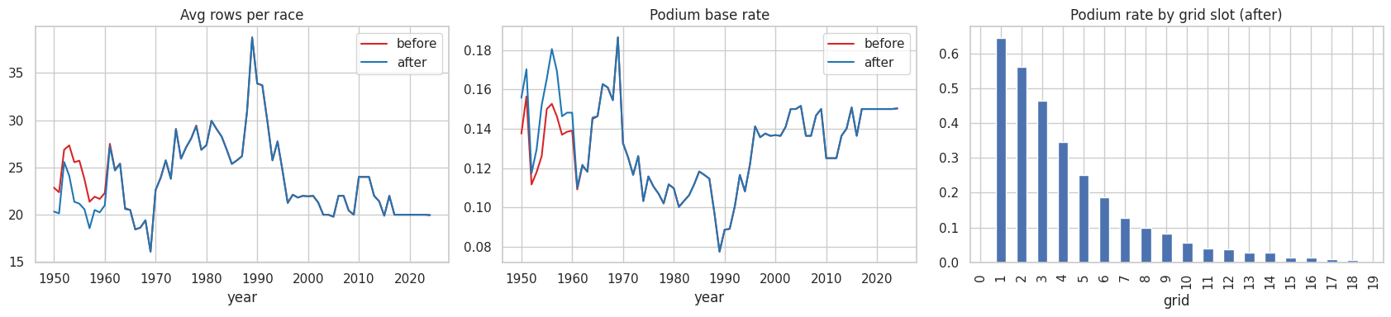
Figure 3. Before vs after cleaning: rows per race, podium rate by year, and podium rate by grid slot (after cleaning).
Table 1. Effect of cleaning on the results data
Metric | Before | After
Result rows | 26,759 | 26,287
Duplicate (raceId, driverId) rows | 176 | 0
Unique races | 1,125 | 1,114
Unique drivers | 861 | 758
\N sentinels in results | 122,887 | 0 (now NaN)
Podium rate | 0.1269 | 0.1278

Cleaning changed the podium base rate only marginally (12.69% → 12.78%), confirming that deduplication removed noise rather than distorting the target. The podium rate by grid slot falls steeply with starting position (Figure 3, right panel), which is the first evidence that grid is the dominant predictor.
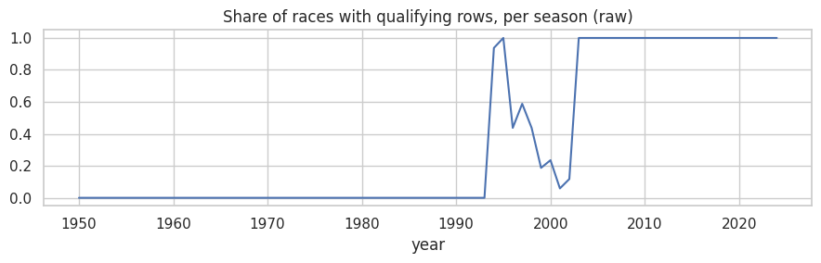
Figure 4. Qualifying coverage per season in the raw data. Qualifying data first appears in 1994.

3. Data-Engineering Questions
All three questions use multi-hop joins on the cleaned tables. The base table joins results → races (year, round, circuit, date) → status → circuits (name, country) → drivers (nationality) → constructors (name) → qualifying (position, one row per driver-race). Joins use validate="m:1" with assertions that the row count and (raceId, driverId) uniqueness are unchanged.

3.1 Question 1 — Which circuits convert a front-row start into a podium, and did that change after 2014?
Grain and missingness. One row per driver-race. Qualifying position exists for only 39.9% of all rows, but coverage is at least 90% from 1995 onward (the cut-off Q_START), so the analysis uses 1995–2024 and splits it into two eras: 1995–2013 and 2014+ (hybrid era). Qualifying position and grid are treated separately because grid can differ through penalties: of drivers with a qualifying position, 920 were front-row on both, 38 qualified front row but did not start there, 36 started front row without qualifying there, and 2 qualified top two but started from the pit lane. Pre-race cutoff: both qualifying position and grid are known before the start. Circuits need at least 10 front-row starts in each era to be compared, with Wilson 95% confidence intervals.
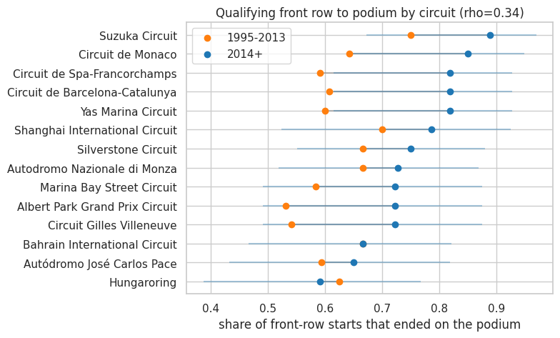
Figure 5. Podium conversion of qualifying front-row starts by circuit, 1995–2013 vs 2014+ (blue bars: 95% CI for 2014+).
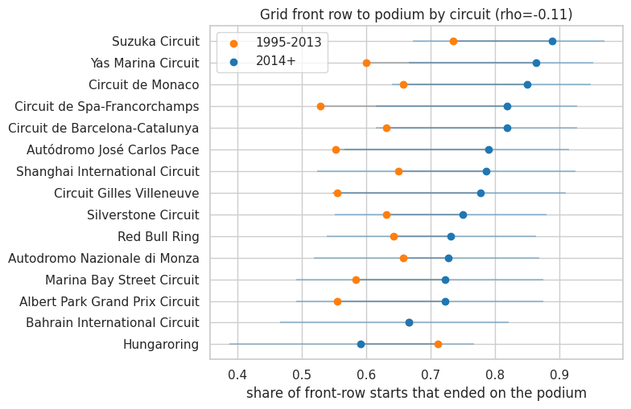
Figure 6. Same analysis using actual grid front row (positions 1–2).
Table 2. Top circuits in the 2014+ era (qualifying front row)
Circuit | 1995–2013 | 2014+ | Starts old / new | Rank change
Suzuka | 0.750 | 0.889 | 24 / 18 | 0
Monaco | 0.643 | 0.850 | 28 / 20 | +4
Spa-Francorchamps | 0.591 | 0.818 | 22 / 22 | +8
Yas Marina | 0.600 | 0.818 | 10 / 22 | +6
Barcelona-Catalunya | 0.607 | 0.818 | 28 / 22 | +5
Shanghai | 0.700 | 0.786 | 20 / 14 | −4
Silverstone | 0.667 | 0.750 | 30 / 24 | −4
Monza | 0.667 | 0.727 | 24 / 22 | −5
Bahrain | 0.667 | 0.667 | 18 / 24 | −9

Answer. In the hybrid era the front-row start is converted most reliably at Suzuka (88.9%), Monaco (85.0%) and Spa, Barcelona and Yas Marina (81.8% each). Conversion rose at most circuits after 2014; Bahrain is the clearest exception (unchanged at 66.7%, dropping nine places). The ranking does change: the Spearman rank correlation between eras is only 0.34 (p = 0.24) using qualifying and −0.11 (p = 0.68) using grid, i.e. there is no reliable carry-over. Only 14 (qualifying) and 15 (grid) of 42–43 circuits met the minimum sample, and each estimate rests on 10–38 starts, so many differences lie within the confidence intervals. For 2014+, the qualifying-based and grid-based circuit rankings are very similar (Spearman 0.84), so penalties alter individual races far more than the circuit-level ranking.

3.2 Question 2 — Do drivers podium more often at their home circuit after controlling for starting position?
Grain and definition. One row per driver-race with grid ≥ 1 (1,635 pit-lane or no-slot rows excluded because they have no starting position to control for). Driver nationality is mapped to a country (for example British → UK) and compared with the circuit country (United States → USA for consistency). Two dual-nationality labels (Argentine-Italian, American-Italian) could not be mapped and were excluded. This gives 1,937 home rows out of 24,649. Pre-race cutoff: nationality and circuit country are known from the entry list and the calendar.
Naively, home drivers podium less often (11.9% vs 13.8%) and start further back (mean grid 12.7 vs 11.7), so the raw comparison is confounded by starting position. Grid slots were therefore grouped into 1–3, 4–6, 7–10, 11–15 and 16+ and compared within each group.
Table 3. Podium rate by grid bucket, home vs away
Grid bucket | Away rate (n) | Home rate (n) | Home 95% CI
1–3 | 0.555 (3,106) | 0.572 (229) | 0.507–0.634
4–6 | 0.261 (3,108) | 0.271 (225) | 0.217–0.333
7–10 | 0.093 (4,123) | 0.074 (337) | 0.051–0.107
11–15 | 0.030 (5,134) | 0.027 (414) | 0.015–0.047
16+ | 0.007 (7,241) | 0.003 (732) | 0.001–0.010

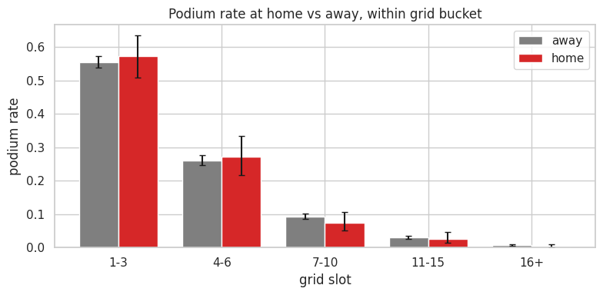
Figure 7. Podium rate at home vs away within each grid bucket, with Wilson 95% intervals.
A logistic regression with standard errors clustered by driver was fitted in four steps:
Model | Odds ratio (home) | 95% CI | p-value
M0 naive | 0.843 | 0.709–1.002 | 0.053
M1 + log(grid) | 0.937 | 0.764–1.149 | 0.532
M2 + grid buckets | 0.965 | 0.797–1.169 | 0.718
M3 + log(grid) + season effects | 0.917 | 0.742–1.132 | 0.419

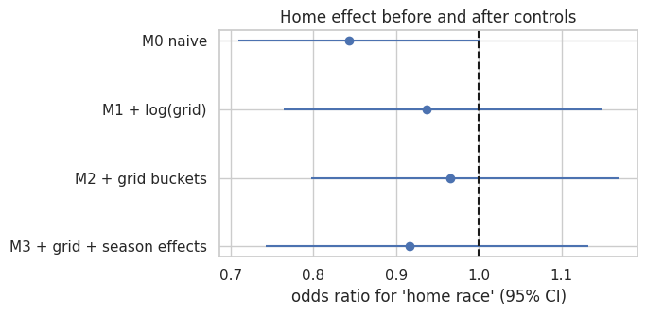
Figure 8. Home-race odds ratio before and after controls (dashed line = no association).
Answer. No. Within every grid bucket the home and away podium rates are within each other's confidence intervals (home drivers are nominally higher only in the 1–3 and 4–6 buckets). The apparent disadvantage in the naive model (odds ratio 0.84) disappears once starting position is controlled for, and every controlled model has an interval that contains 1. The data show no evidence of a home advantage after accounting for where drivers start. Home samples in the 1–3 bucket are small (229 rows), so a modest true effect cannot be ruled out.

3.3 Question 3 — Which constructors have the highest mechanical-retirement rate in 2014–2021 vs 2022–2024?
Grain and definition. The denominator is a race start (a car that actually took part), so 14 "Did not start / Withdrew" rows were excluded (4,626 rows → 4,612 starts, asserted). Every status text was classified into finished, regulation (disqualified/excluded), no_start, accident_driver (collision, accident, spun off, damage), mechanical (engine, gearbox, brakes, power unit, hydraulics, electrical and so on), ambiguous (puncture, tyre, wheel, wing, retired, illness and so on) or other. The strict definition counts only mechanical; the broad definition adds ambiguous. Team names that changed over time were merged into lineages (for example Toro Rosso / AlphaTauri / RB; Force India / Racing Point / Aston Martin; Sauber / Alfa Romeo; Lotus F1 / Renault / Alpine; Marussia / Manor). A team needs at least 40 starts in a period to be ranked. Pre-race cutoff: not applicable — this is a descriptive, after-the-fact question.
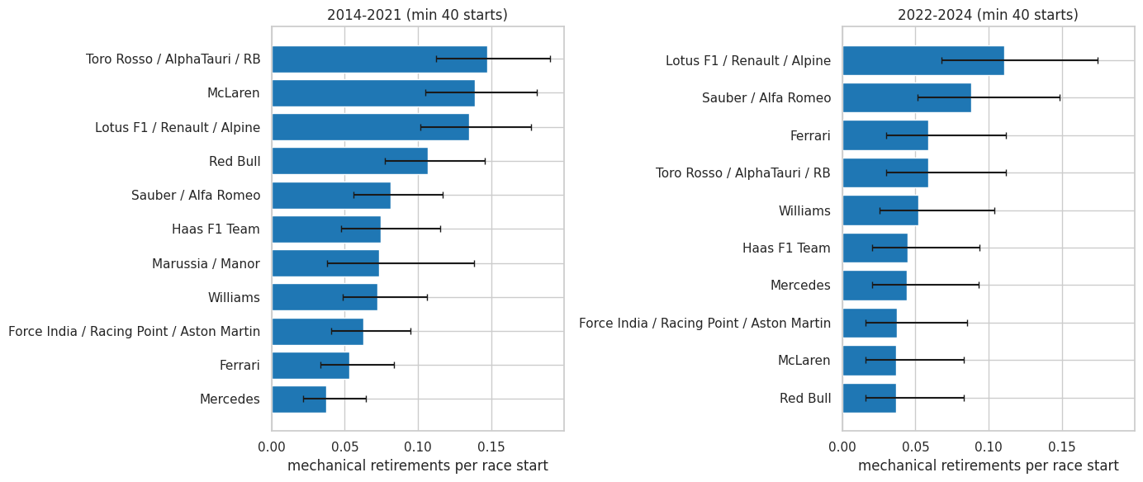
Figure 9. Strict mechanical-retirement rate per race start by team and period (min 40 starts, Wilson 95% CI).
Table 4. Five highest strict mechanical-retirement rates
Period | Team | Starts | Mech. | Rate | 95% CI
2014–2021 | Toro Rosso / AlphaTauri / RB | 320 | 47 | 14.7% | 11.2–19.0%
2014–2021 | McLaren | 318 | 44 | 13.8% | 10.5–18.1%
2014–2021 | Lotus F1 / Renault / Alpine | 319 | 43 | 13.5% | 10.2–17.7%
2014–2021 | Red Bull | 319 | 34 | 10.7% | 7.7–14.5%
2014–2021 | Sauber / Alfa Romeo | 320 | 26 | 8.1% | 5.6–11.6%
2022–2024 | Lotus F1 / Renault / Alpine | 136 | 15 | 11.0% | 6.8–17.4%
2022–2024 | Sauber / Alfa Romeo | 136 | 12 | 8.8% | 5.1–14.8%
2022–2024 | Toro Rosso / AlphaTauri / RB | 136 | 8 | 5.9% | 3.0–11.2%
2022–2024 | Ferrari | 136 | 8 | 5.9% | 3.0–11.2%
2022–2024 | Williams | 134 | 7 | 5.2% | 2.6–10.4%

Answer. In 2014–2021 the least reliable teams were the Toro Rosso / AlphaTauri / RB lineage (14.7%), McLaren (13.8%) and the Lotus / Renault / Alpine lineage (13.5%). In 2022–2024 the Lotus / Renault / Alpine lineage (11.0%) and Sauber / Alfa Romeo (8.8%) lead. Reliability improved league-wide: 9.21% → 5.69%. The largest improvements were McLaren (−10.2 percentage points), Toro Rosso / AlphaTauri / RB (−8.8) and Red Bull (−7.0); Ferrari, Mercedes and Sauber / Alfa Romeo were essentially unchanged (about +0.6 to +0.7 points). Each team has only 134–136 starts in 2022–2024, so the intervals are wide and the ranking among the top five is not statistically clear-cut.
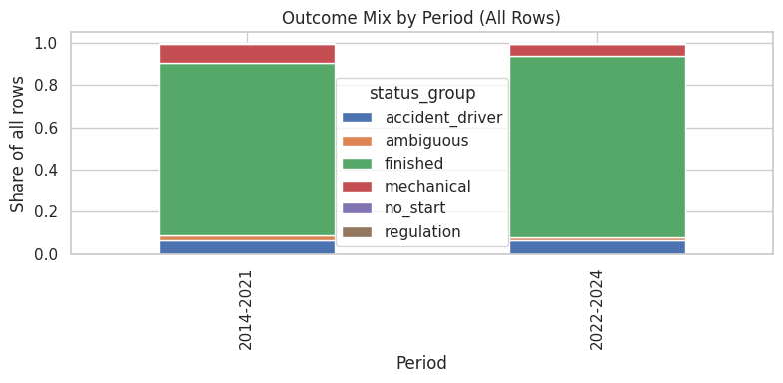
Figure 10. Outcome mix by period (all rows, including no-start entries).
Sensitivity. Team rates under the strict and broad definitions are highly correlated (Spearman 0.94 for 2014–2021 and 0.91 for 2022–2024), so conclusions are not driven by how the ambiguous statuses are treated.

4. Feature Selection, Engineering and Pre-Race Validity

4.1 Leakage audit
Every field was classified by whether it is known at the cutoff (after qualifying, before the start). Results columns such as positionOrder, position, points, laps, time, milliseconds and fastestLap*, plus the current-race status, are race outcomes and are forbidden (FORBIDDEN list, enforced with an assertion). Pit stops and lap times are recorded during the race. The stored driver and constructor standings are values after each race, so they were rebuilt as "before the race" totals from earlier races' points. Sprint results were excluded as a judgement call because their effect on the Sunday grid is already contained in grid.

4.2 Final feature set (22 features, 6 groups)
Group | Features | Why valid at the pre-race cutoff
Grid | grid_eff, is_pitlane, rel_grid, front_row | Grid is fixed after qualifying and penalties, before the start. Pit-lane starters get the slot behind the last car.
Qualifying | quali_pos, quali_missing, grid_minus_quali, q1_gap_pct | The qualifying session finishes before the race. grid_minus_quali captures penalties; q1_gap_pct is the % gap to the fastest Q1 time (clipped at the 99th percentile and log-transformed for LR/NN).
Driver form | drv_podium_rate, drv_avg_finish, drv_dnf_rate (previous 5 races), drv_races_before, drv_career_podium_rate | Computed only from the driver's earlier races using shift(1), so the current race is never included.
Constructor form | con_podium_rate, con_avg_finish (previous 5), con_mech_dnf_rate (previous 10) | Team results are aggregated per race first, then rolled over past races only (shift(1)).
Standings | drv_pts_rel, drv_rank_before, con_pts_rel | Rebuilt from points of earlier races in the same season; expressed relative to the leader.
Context | field_size, round, home | Entry list, calendar and nationality are known in advance.

4.3 Evidence for the features
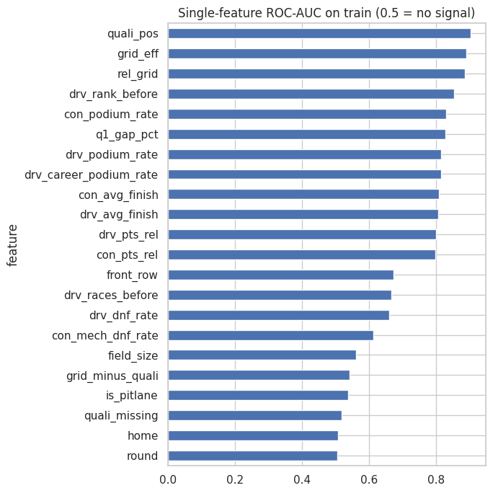
Figure 11. Single-feature ROC-AUC on the training set (0.5 = no signal).
Starting-position features are the strongest individual predictors: quali_pos 0.903 (but only 32% coverage on the training set), grid_eff 0.891, rel_grid 0.885, drv_rank_before 0.853 and con_podium_rate 0.831. Context features (round, home, field_size) are close to 0.5 individually. They were kept as cheap, valid controls and tested through ablation. Decile plots show monotonic relationships for the main features.
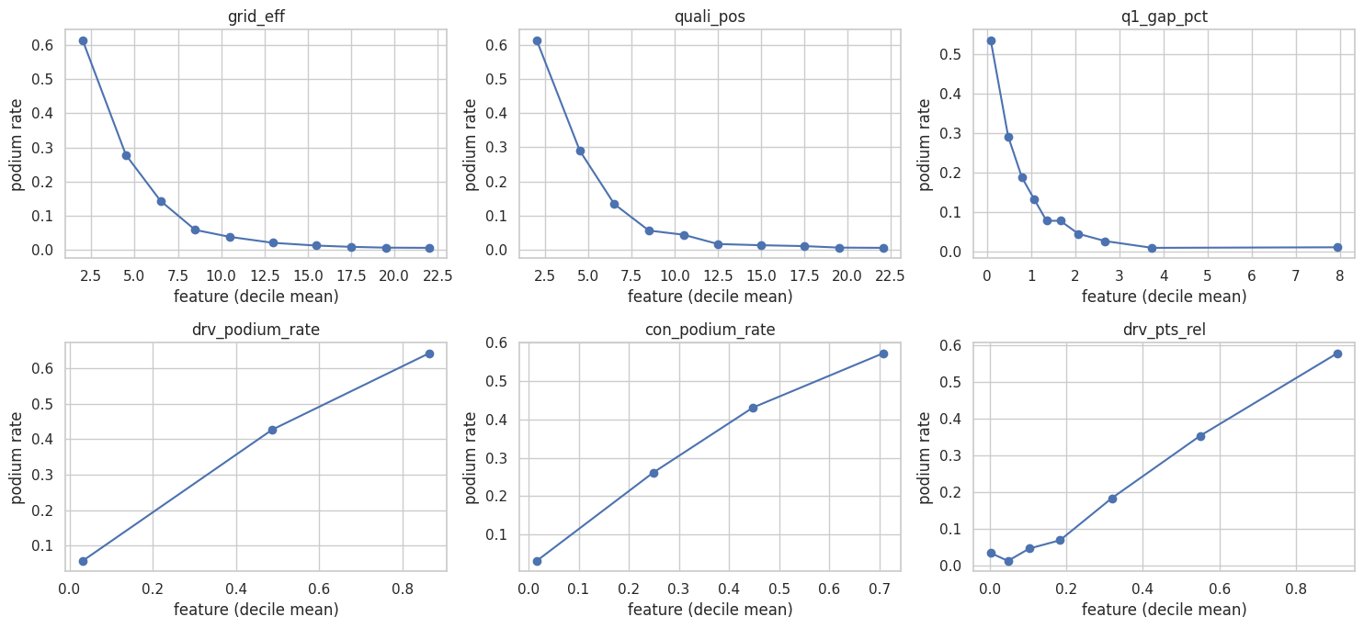
Figure 12. Podium rate by decile of key features (training set, qualifying era).
A Spearman redundancy check found seven pairs above |ρ| = 0.85, notably grid_eff / rel_grid (0.99), grid_eff / quali_pos (0.97) and drv_pts_rel / con_pts_rel (0.91). The correlated features were retained because trees are insensitive to redundancy and logistic regression is L2-regularised; the consequences for importance are discussed in Section 7.
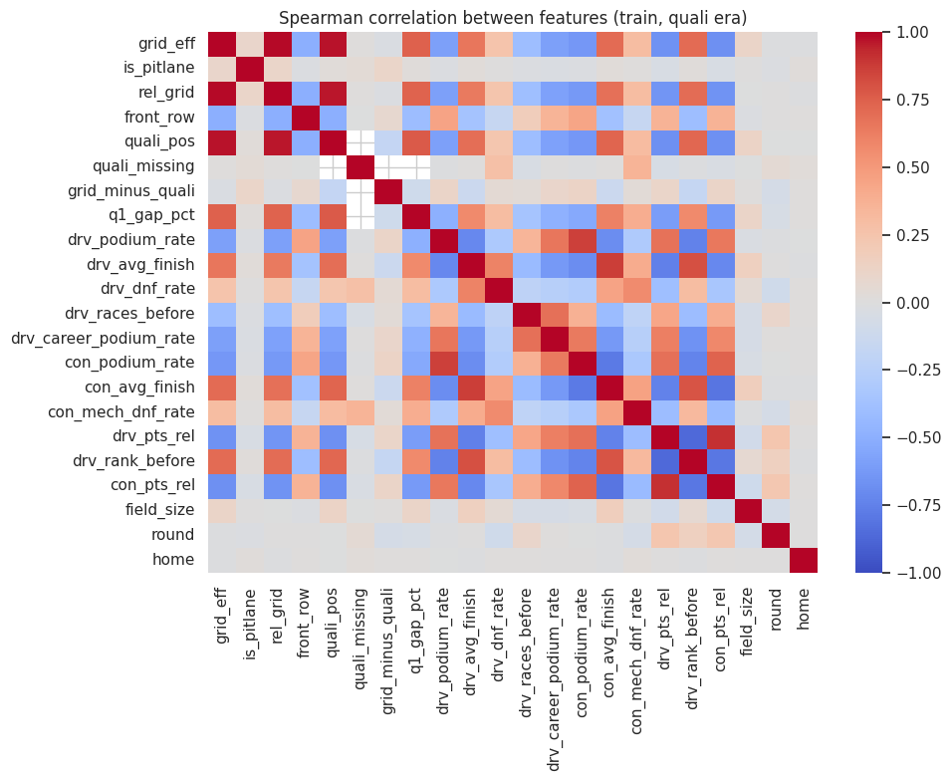
Figure 13. Spearman correlation between features (training set, qualifying era).

4.4 Train / validation / test split
Table 5. Chronological split
Split | Seasons | Rows | Races | Podium rate
Train | 1950–2017 | 23,308 | 965 | 0.125
Validation | 2018–2021 | 1,620 | 81 | 0.150
Test | 2022–2024 | 1,359 | 68 | 0.150

Justification. The task is to predict future races, so the split is chronological and a random split would let the model learn from seasons after the ones it is tested on. Validation (2018–2021) is used for hyperparameters, feature experiments, model selection and the F1 threshold. The test set (2022–2024, covering the new ground-effect regulations) is scored in a single final cell. Podium rate rises from 12.5% to 15% in the later splits (modern fields are smaller while there are always three podium places), which is why PR-AUC is compared against the 0.15 random baseline. Final models are trained on seasons from 1980 onward (15,853 rows, see E4).
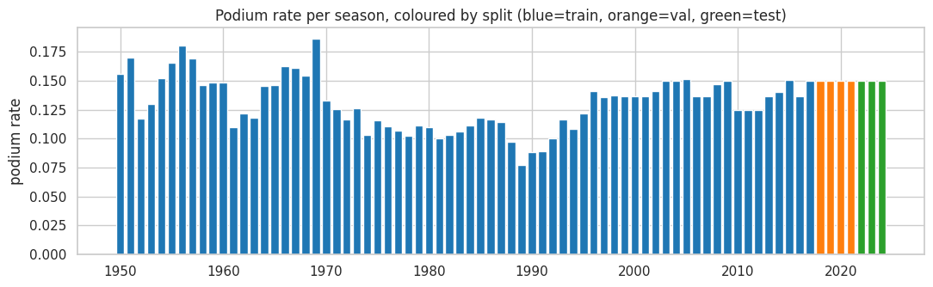
Figure 14. Podium rate per season coloured by split (blue = train, orange = validation, green = test).

4.5 Leakage tests
Three tests all pass ("ALL LEAKAGE TESTS PASSED"): (1) every driver's first race has no history (NaN form); (2) driver and constructor podium rates recomputed by brute force for 300 random rows (seed 42) match the vectorised features; (3) the strongest test rewrites one race's positions, points and statuses and confirms that that race's own features do not change.

5. Preprocessing and Feature-Engineering Experiments
Experiments use fixed, deliberately simple models (gradient boosting with 200 iterations, depth 3, and logistic regression) so that differences reflect the feature or preprocessing choice, not tuning. All numbers are validation PR-AUC (ROC-AUC in the notebook).
Table 6. Summary of experiments E1–E5
Experiment | Variants | Result (validation PR-AUC, HGB / LR) | Decision
E1 Feature-group build-up | grid → +qualifying → +driver form → +constructor form → +standings → +context | Grid only 0.668 / 0.668; +qualifying 0.688 / 0.706; +driver form 0.702 / 0.717; later groups ≈ flat (0.695 / 0.716 at 22 features) | Keep all groups; qualifying and driver form give the biggest gains
E2 Form window | 3, 5, 10, 20 races | 0.702/0.715, 0.696/0.716, 0.706/0.723, 0.705/0.723 | 10 and 20 best; 10 preferred
E3 Missing qualifying | A: keep NaN + flag; B: fill quali_pos with grid; C: drop qualifying features | A 0.6955/0.7163; B 0.6933/0.7166; C 0.6910/0.7162 | Keep NaN + missing flag (best for HGB)
E4 Training start year | 1950, 1980, 1996, 2003 | 0.704/0.716 (23,308 rows); 0.700/0.718 (15,853); 0.696/0.716 (8,517); 0.709/0.721 (5,991) | 2003 scores best but with 4× less data; 1980 chosen as a compromise
E5 Grid transform | raw, log, both (LR only) | All 0.6684 | No difference; kept raw grid_eff and rel_grid

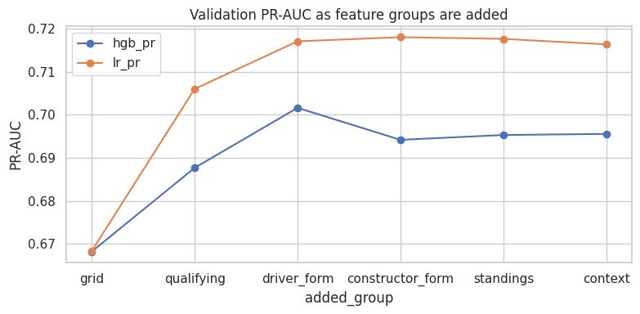
Figure 15. E1: validation PR-AUC as feature groups are added.
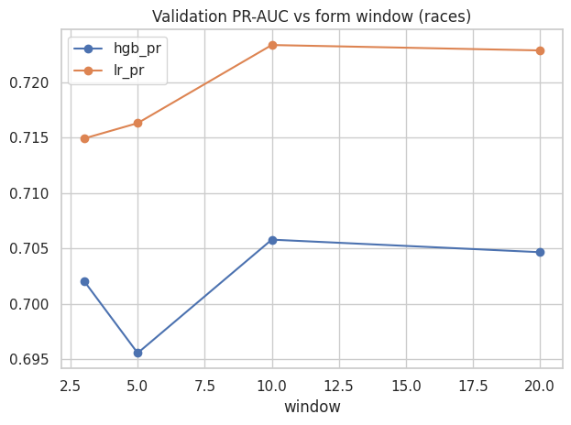
Figure 16. E2: validation PR-AUC against form window length.
All differences between variants are small (usually below 0.01 PR-AUC), so the conclusions are modest: qualifying and driver form add measurable information on top of grid, and nothing in E2–E5 materially changes performance. The 1980 training start was used for the final models to keep a broad historical base rather than optimising for a 0.003–0.01 validation gain.

6. Predictive Modelling

6.1 Models and how they work
- Logistic regression (baseline). Median imputation, standardisation and (for q1_gap_pct) clip-and-log, then a linear model of the log-odds of a podium. L2 regularisation C was chosen on validation PR-AUC from {0.01, 0.1, 1, 10}; C = 1 was selected (0.7175; the values 1 and 10 tied). Its coefficients are interpretable and it is the simplest reasonable reference.
- Histogram gradient boosting. An ensemble of shallow trees fitted sequentially; it handles missing values natively and learns non-linear interactions. A 12-configuration grid over depth {2,3,5}, learning rate {0.03, 0.1} and iterations {150, 400} was searched on validation PR-AUC; the best was depth 5, learning rate 0.03, 150 iterations (min_samples_leaf 50, L2 = 1).
- Shallow neural network (MLP). Same preprocessing as logistic regression, one or two hidden layers. Nine configurations (hidden layers (16), (32), (32,16) × alpha {0.001, 0.01, 0.1}) were each trained with three seeds and chosen by mean validation PR-AUC; (32,) with alpha 0.001 was best.
All models use the same rows (1980–2017 training, 2018–2021 validation, 2022–2024 test) and the same 22 features. The F1 threshold is the probability cut-off that maximises F1 on validation only and is then frozen for the test set.

6.2 Results
Table 7. Model comparison (ROC-AUC, PR-AUC, F1) on training, validation and unseen test data
Model | Split | ROC-AUC | PR-AUC | F1
Logistic regression (baseline) | Train | 0.9200 | 0.6097 | 0.6006
 | Validation | 0.9338 | 0.7175 | 0.7243
 | Test | 0.9386 | 0.7172 | 0.6972
Gradient boosting | Train | 0.9437 | 0.6888 | 0.6441
 | Validation | 0.9368 | 0.7131 | 0.7229
 | Test | 0.9380 | 0.7171 | 0.6598
Neural network | Train | 0.8887 | 0.5207 | 0.5447
 | Validation | 0.8999 | 0.6093 | 0.6492
 | Test | 0.8740 | 0.5550 | 0.5702

Table 8. Bootstrap 95% interval for test PR-AUC (random-guess PR-AUC = 0.15)
Model | Test PR-AUC | 95% CI
Logistic regression | 0.7172 | 0.6575–0.7862
Gradient boosting | 0.7171 | 0.6559–0.7774
Neural network | 0.5550 | 0.4969–0.6318

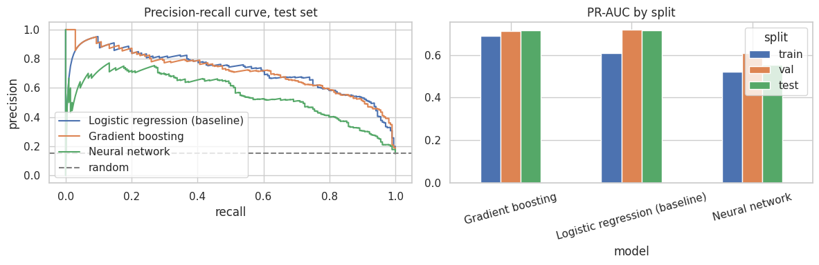
Figure 17. Test-set precision-recall curves (left) and PR-AUC by split (right).

6.3 Primary and secondary metric
Primary metric: PR-AUC. Only 12.5–15% of rows are podiums, and the real question is how well the model ranks the few podium finishers above the many non-finishers. ROC-AUC is inflated by the large negative class: all models exceed 0.87 while PR-AUC separates them clearly. Secondary metrics: ROC-AUC for overall separation and F1 at the validation-selected threshold for a concrete decision rule. F1 is the most threshold-sensitive of the three, so it is not used to select models.

6.4 Interpretation and model choice
Logistic regression and gradient boosting are essentially tied: validation PR-AUC 0.7175 vs 0.7131 and test PR-AUC 0.7172 vs 0.7171, with heavily overlapping bootstrap intervals. Logistic regression is chosen because it has the highest validation PR-AUC (selection never used the test set), is the simplest, and shows the smallest gap between validation and test. Gradient boosting fits the training data more closely (train PR-AUC 0.689 vs 0.610) without gaining on unseen data, so its extra complexity is not earning its keep. All models beat the 0.15 random baseline by a wide margin (≈0.72 vs 0.15).
The neural network underperformed. Its test PR-AUC (0.555) is below both statistical models, and training scores are lower than validation, which suggests under-fitting or optimisation instability rather than over-fitting. Validation PR-AUC over five different seeds was 0.689 ± 0.029, so network results depend strongly on the random initialisation; one seed (42) was used for the reported run.

6.5 Limitations of the models
- Logistic regression is linear in its (standardised) features and cannot capture interactions such as "grid 1 with a weak car".
- Gradient boosting needs tuning and can overfit small data; its probabilities are not guaranteed calibrated.
- The shallow MLP is sensitive to initialisation and scaling and is the least interpretable.
- All models see only pre-race tabular features: no weather, tyre strategy, car pace, safety cars or in-race incidents. Validation and test sets are small (81 and 68 races), so differences of ≈0.01 PR-AUC are not meaningful.

7. Feature-Group Ablation
Each of the six feature groups was removed in turn and the model retrained (and, separately, trained on that group alone), measuring validation PR-AUC. The neural network was averaged over three seeds. With all features, validation PR-AUC was 0.7155 (LR), 0.7131 (GB) and 0.7018 (NN).
Table 9. Change in validation PR-AUC when a group is dropped (negative = the group helped)
Group dropped | Logistic reg. | Gradient boosting | Neural network
Grid | −0.0144 | −0.0013 | −0.0133
Driver form | −0.0158 | +0.0043 | +0.0028
Constructor form | −0.0019 | +0.0019 | +0.0100
Qualifying | +0.0017 | −0.0005 | +0.0065
Standings | +0.0011 | +0.0041 | −0.0071
Context | +0.0003 | +0.0035 | +0.0186

Table 10. Validation PR-AUC using only one group
Group only | Logistic reg. | Gradient boosting | Neural network
Qualifying | 0.7048 | 0.6797 | 0.6823
Grid | 0.6683 | 0.6680 | 0.6683
Driver form | 0.6385 | 0.6041 | 0.6319
Standings | 0.6200 | 0.6241 | 0.6259
Constructor form | 0.5725 | 0.5795 | 0.5620
Context | 0.1495 | 0.1441 | 0.1500

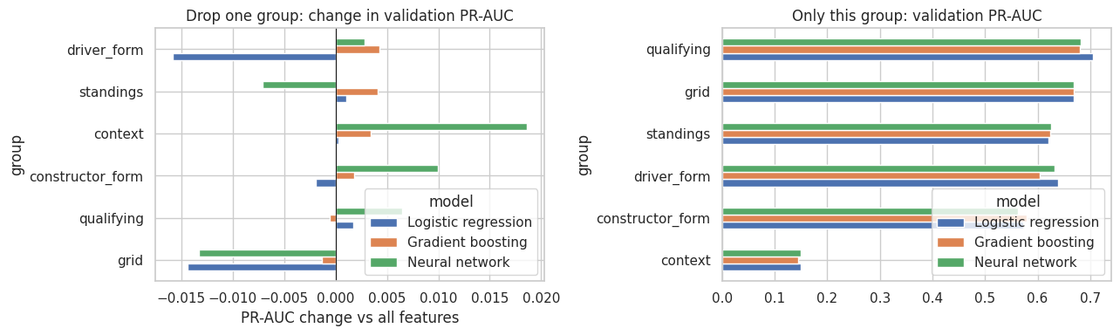
Figure 18. Feature-group ablation: change in validation PR-AUC when dropping a group (left) and PR-AUC with only that group (right).
Reading. Used alone, qualifying (0.68–0.70) and grid (≈0.668) are the strongest groups and context is almost useless (≈0.15, about the random baseline). Dropping grid hurts all three models (−0.0013 to −0.0144) and dropping driver form hurts logistic regression (−0.0158). Many other changes are tiny or slightly positive (removing a group sometimes *improves* a model by up to 0.019), meaning the groups are largely redundant with one another: grid, qualifying and standings all encode "how fast is this car and driver". Because no single group removal gave a consistent gain across models, all groups were retained. These results measure predictive usefulness on validation data, not causal contribution.

8. Model Explainability (XAI)
Important: explanations show what the models rely on, not what causes podium finishes. A feature being important means the model uses it to predict, nothing more. For example, grid position is important partly because it summarises car speed and driver skill; moving a driver's grid slot would not by itself change their chance of a podium in the real world. Correlated features (grid_eff, rel_grid and quali_pos at ρ ≈ 0.96–0.99) also share importance among themselves, so the ranking between them is unstable.

8.1 Global: permutation importance
Each feature was shuffled 20 times on the validation set and the drop in PR-AUC measured on the fixed trained models.
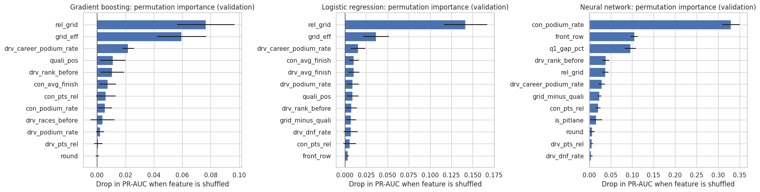
Figure 19. Permutation importance on the validation set (top 12 features per model).
Model | Most important features (mean PR-AUC drop)
Gradient boosting | rel_grid 0.077, grid_eff 0.059, drv_career_podium_rate 0.022, quali_pos 0.011, drv_rank_before 0.011
Logistic regression | rel_grid 0.142, grid_eff 0.036, drv_career_podium_rate 0.015, con_avg_finish 0.010, drv_avg_finish 0.010
Neural network | con_podium_rate 0.330, front_row 0.105, q1_gap_pct 0.096, drv_rank_before 0.039, rel_grid 0.037

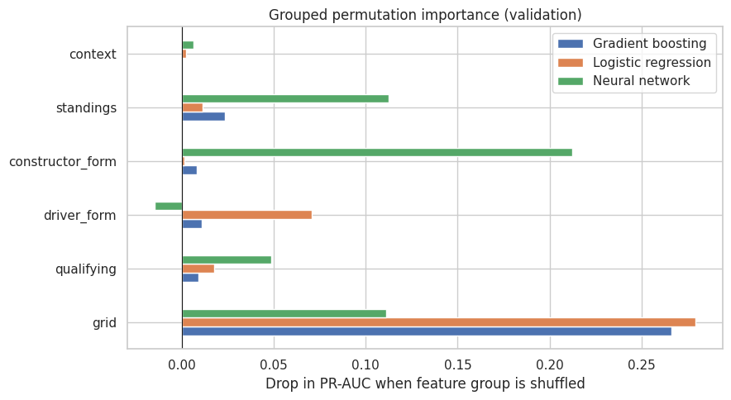
Figure 20. Grouped permutation importance (whole feature groups shuffled together).
Gradient boosting and logistic regression agree: grid is by far the dominant group (0.266 and 0.279 drop), followed by much smaller contributions from standings (GB 0.024) and driver form (LR 0.071). The neural network relies on a different set of features (constructor form 0.212, standings 0.113, grid 0.111), another sign that it found a different, less stable solution.

8.2 Global: SHAP
SHAP (permutation explainer) used 100 background training rows and 800 validation rows; the additivity check (base value + SHAP values = prediction) passed with a maximum gap of 0.0001 or less.
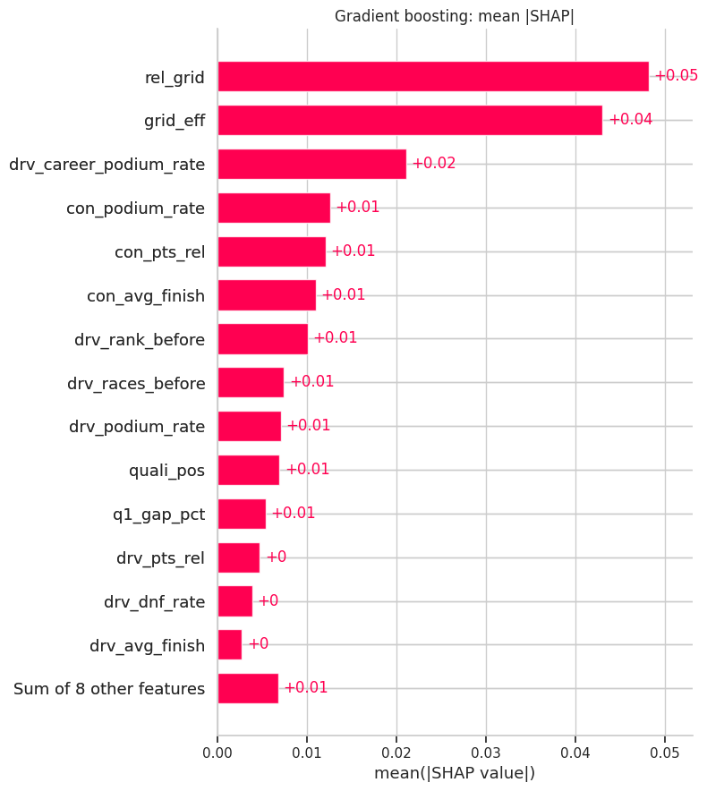
Figure 21. Gradient boosting: mean |SHAP| by feature.
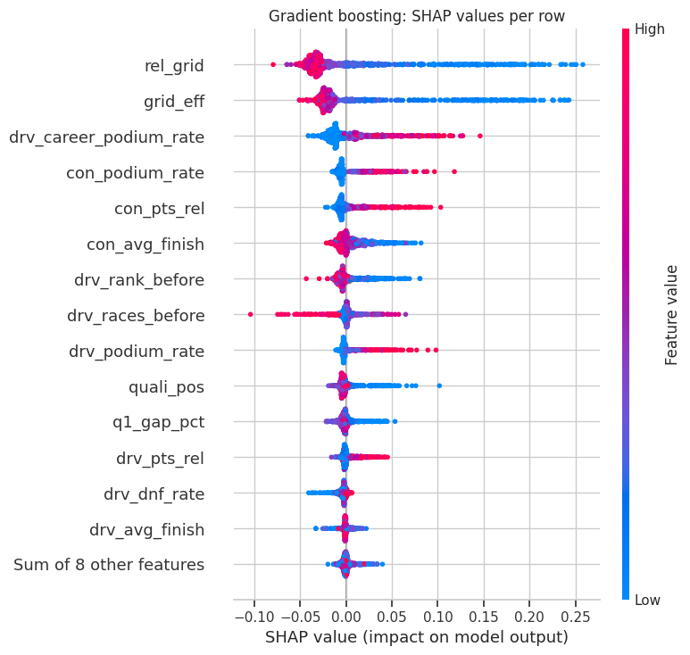
Figure 22. Gradient boosting: SHAP beeswarm. Low relative-grid values (front of the field) push predictions up.
For gradient boosting the top features by mean |SHAP| are rel_grid (0.048), grid_eff (0.043), drv_career_podium_rate (0.021), con_podium_rate (0.013) and con_pts_rel (0.012); by group, grid is first (0.092), then driver form (0.042), standings (0.027) and constructor form (0.026). Logistic regression gives a similar picture (rel_grid 0.057, grid_eff 0.032, drv_dnf_rate 0.022), and the neural network again differs (con_podium_rate 0.056, q1_gap_pct 0.052, front_row 0.028). The beeswarm shows the expected direction: starting near the front and having a strong career podium rate raise predicted probability.

8.3 Local explanations: SHAP waterfall and LIME
Three validation rows were selected using the gradient-boosting model: A, a confident hit; B, a surprise podium; C, a false alarm.
Case | Race | Driver | Grid | Finish | P(podium)
A: confident hit | 2018 Abu Dhabi GP | Lewis Hamilton | 1 | 1 | 0.896
B: surprise podium | 2019 Brazilian GP | Carlos Sainz | 20 | 3 | 0.004
C: false alarm | 2019 German GP | Lewis Hamilton | 1 | 9 | 0.880

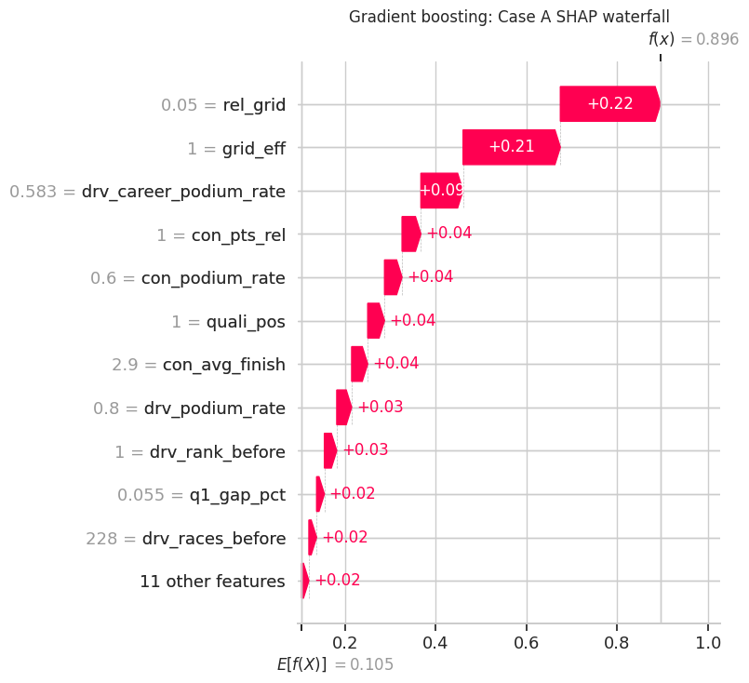
Figure 23. SHAP waterfall, Case A (baseline 0.105 → prediction 0.896).
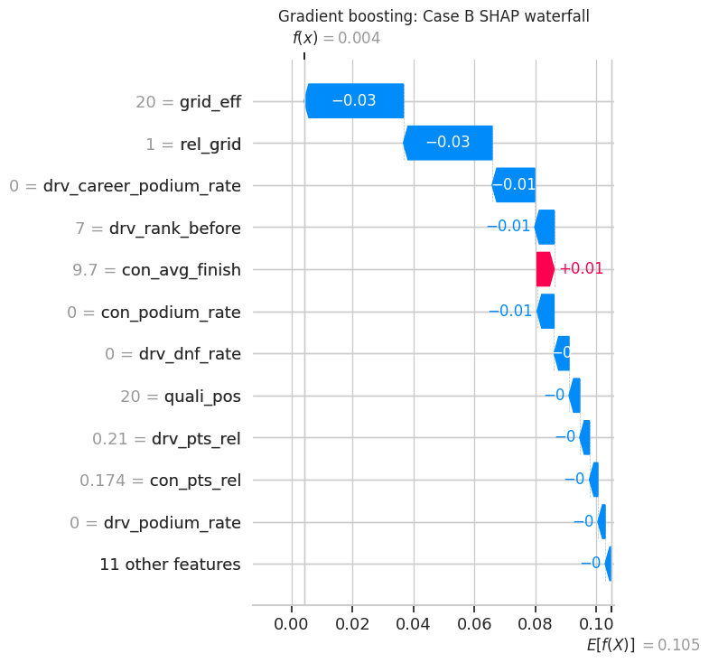
Figure 24. SHAP waterfall, Case B (baseline 0.105 → prediction 0.004).
In Case A the model is confident because the driver starts on pole and has a strong podium history, so the features together lift the prediction by about +0.79 from the baseline of 0.105. In Case B the driver started 20th with no previous career podiums (the LIME rules below), pushing the probability down to 0.4%, yet he finished third. A result like this most likely reflects in-race events (retirements and incidents ahead of him, strategy) that pre-race features cannot see. Case C shows the opposite: the model strongly backs a pole-sitter who finished ninth. Both misses most likely come from in-race events, which are by definition unavailable at the cutoff.
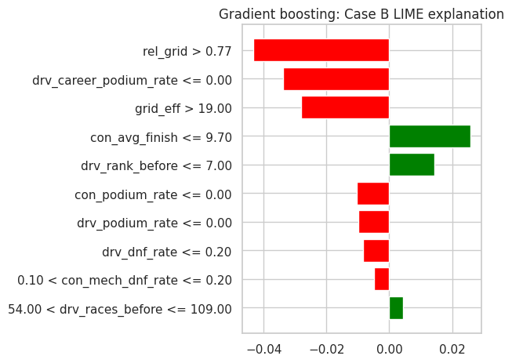
Figure 25. LIME explanation of Case B for gradient boosting.
LIME was run on Case B for all three models. For gradient boosting the strongest rules are rel_grid > 0.77, drv_career_podium_rate ≤ 0 and grid_eff > 19, all lowering the podium probability. Logistic regression gives similar rules (rel_grid > 0.77, grid_eff > 19, drv_podium_rate ≤ 0). The neural network assigns a higher probability (0.177 vs 0.004 and 0.0015) and attributes it to q1_gap_pct ≤ 1.55 (+0.197) offset by front_row = 0 (−0.184), again relying on different features. LIME local R² is 0.23 (GB), 0.28 (LR) and 0.56 (NN), so the local linear approximations are rough for the tree and linear models and should be read as indicative only.

9. Known Limitations
- Qualifying-coverage drift. Qualifying data exists for only 39.9% of rows and appears from 1994; coverage reaches 90% in 1995. Q1–Q3 times are only defined for modern sessions, so qualifying features are missing for 60% of the data (handled with a missing flag and imputation).
- Era sensitivity. Regulations changed in 2014 (hybrid) and 2022 (ground effect). The podium base rate drifted from 12.5% (train) to 15% (validation and test), and mechanical retirements fell sharply. Circuit-level rankings (Q1) did not survive the 2014 break, and models trained on 1980+ may mis-fit new regulations.
- Small samples. Q1 circuit rates rest on 10–38 front-row starts; Q3 team rates on about 136 starts in 2022–2024; validation and test sets contain 81 and 68 races. Confidence intervals are wide and many ranking differences are not significant.
- Definitions. The nationality-to-country mapping is manual (dual nationalities excluded; countries without a circuit never yield home races); the mechanical-retirement classification is keyword-based and ambiguous statuses (for example "Retired") are unresolved, though strict and broad rankings agree (ρ ≥ 0.91). Constructor lineages are merged by hand.
- Deduplication choice. Keeping the row with a real grid slot means shared drives are represented by one of the two drivers' entries; the discarded row is lost information.
- Information not in the data. No weather, tyre, strategy, penalty cause, car-pace or safety-car information, so "surprise" podiums and false alarms are partly unpredictable. Cold-start drivers and teams (no history) rely on imputed values.
- Model scope. Binary podium prediction only; probabilities were not calibrated; the neural network is seed-sensitive; ablation and explanations are correlational.

10. Conclusion
A leakage-tested pipeline over 26,287 driver-race rows predicts podium finishes with test PR-AUC ≈ 0.72 and ROC-AUC ≈ 0.94 using a simple regularised logistic regression, with gradient boosting matching but not exceeding it. Starting position carries most of the signal, qualifying and driver form add smaller increments, and home advantage is not supported by the data once grid is controlled for. The data-engineering questions show that circuit conversion rankings shifted after 2014 and that mechanical reliability improved markedly after 2021.

