Tutorial: build a booking engine with Amadeus flight booking APIs
Wednesday, March 11, 2020 | By
Anthony Roux & Gael Imperial

Tutorials

3-minute read
Take a deep dive into the structure and flow of the new Amadeus flight booking APIs then discover how to build a flight booking engine with a complete video tutorial.
In this article, we’ll take a detailed look at the booking flow with Amadeus flight booking APIs. We'll begin by looking at the role of the three APIs involved before digging deeper into the structure of each API. Then, we'll look at the most common errors developers face and provide a step-by-step video tutorial on using the flight booking APIs in Postman.
For the most courageous readers, we’ll finish with a link to the complete UML structure of the 3 APIs that form the flight booking flow.
Ready? Let's go!

Overview of the API flow



Step 1: search for flights with Flight Offers Search
The Flight Offers Search API retrieves a list of all possible flights to a selected destination. The API comes in two flavors:
- Simple version: GET operation with few parameters but which is quicker to integrate.
- On steroids: POST operation offering the full functionalities of the API.

Step 2: confirm the availability and price with Flight Offers Price
The price of airfare fluctuates constantly, and prices may change between the time you search and the time you book. Flight Offers Price allows you to confirm that the selected flight is still available at the originally listed price. If the price or availability is no longer valid at the time of booking, the reservation will be rejected and you’ll receive an error code (see below in Common Errors).

Step 3: create the reservation with Flight Create Orders
Flight Create Orders is the final API in the process and allows you to complete the booking. You must enter the passenger and flight information and a PNR (Passenger Name Record) will be created.

Now that you have an overview of the booking flow, let's look at the structure of each API.

Detailed API flow
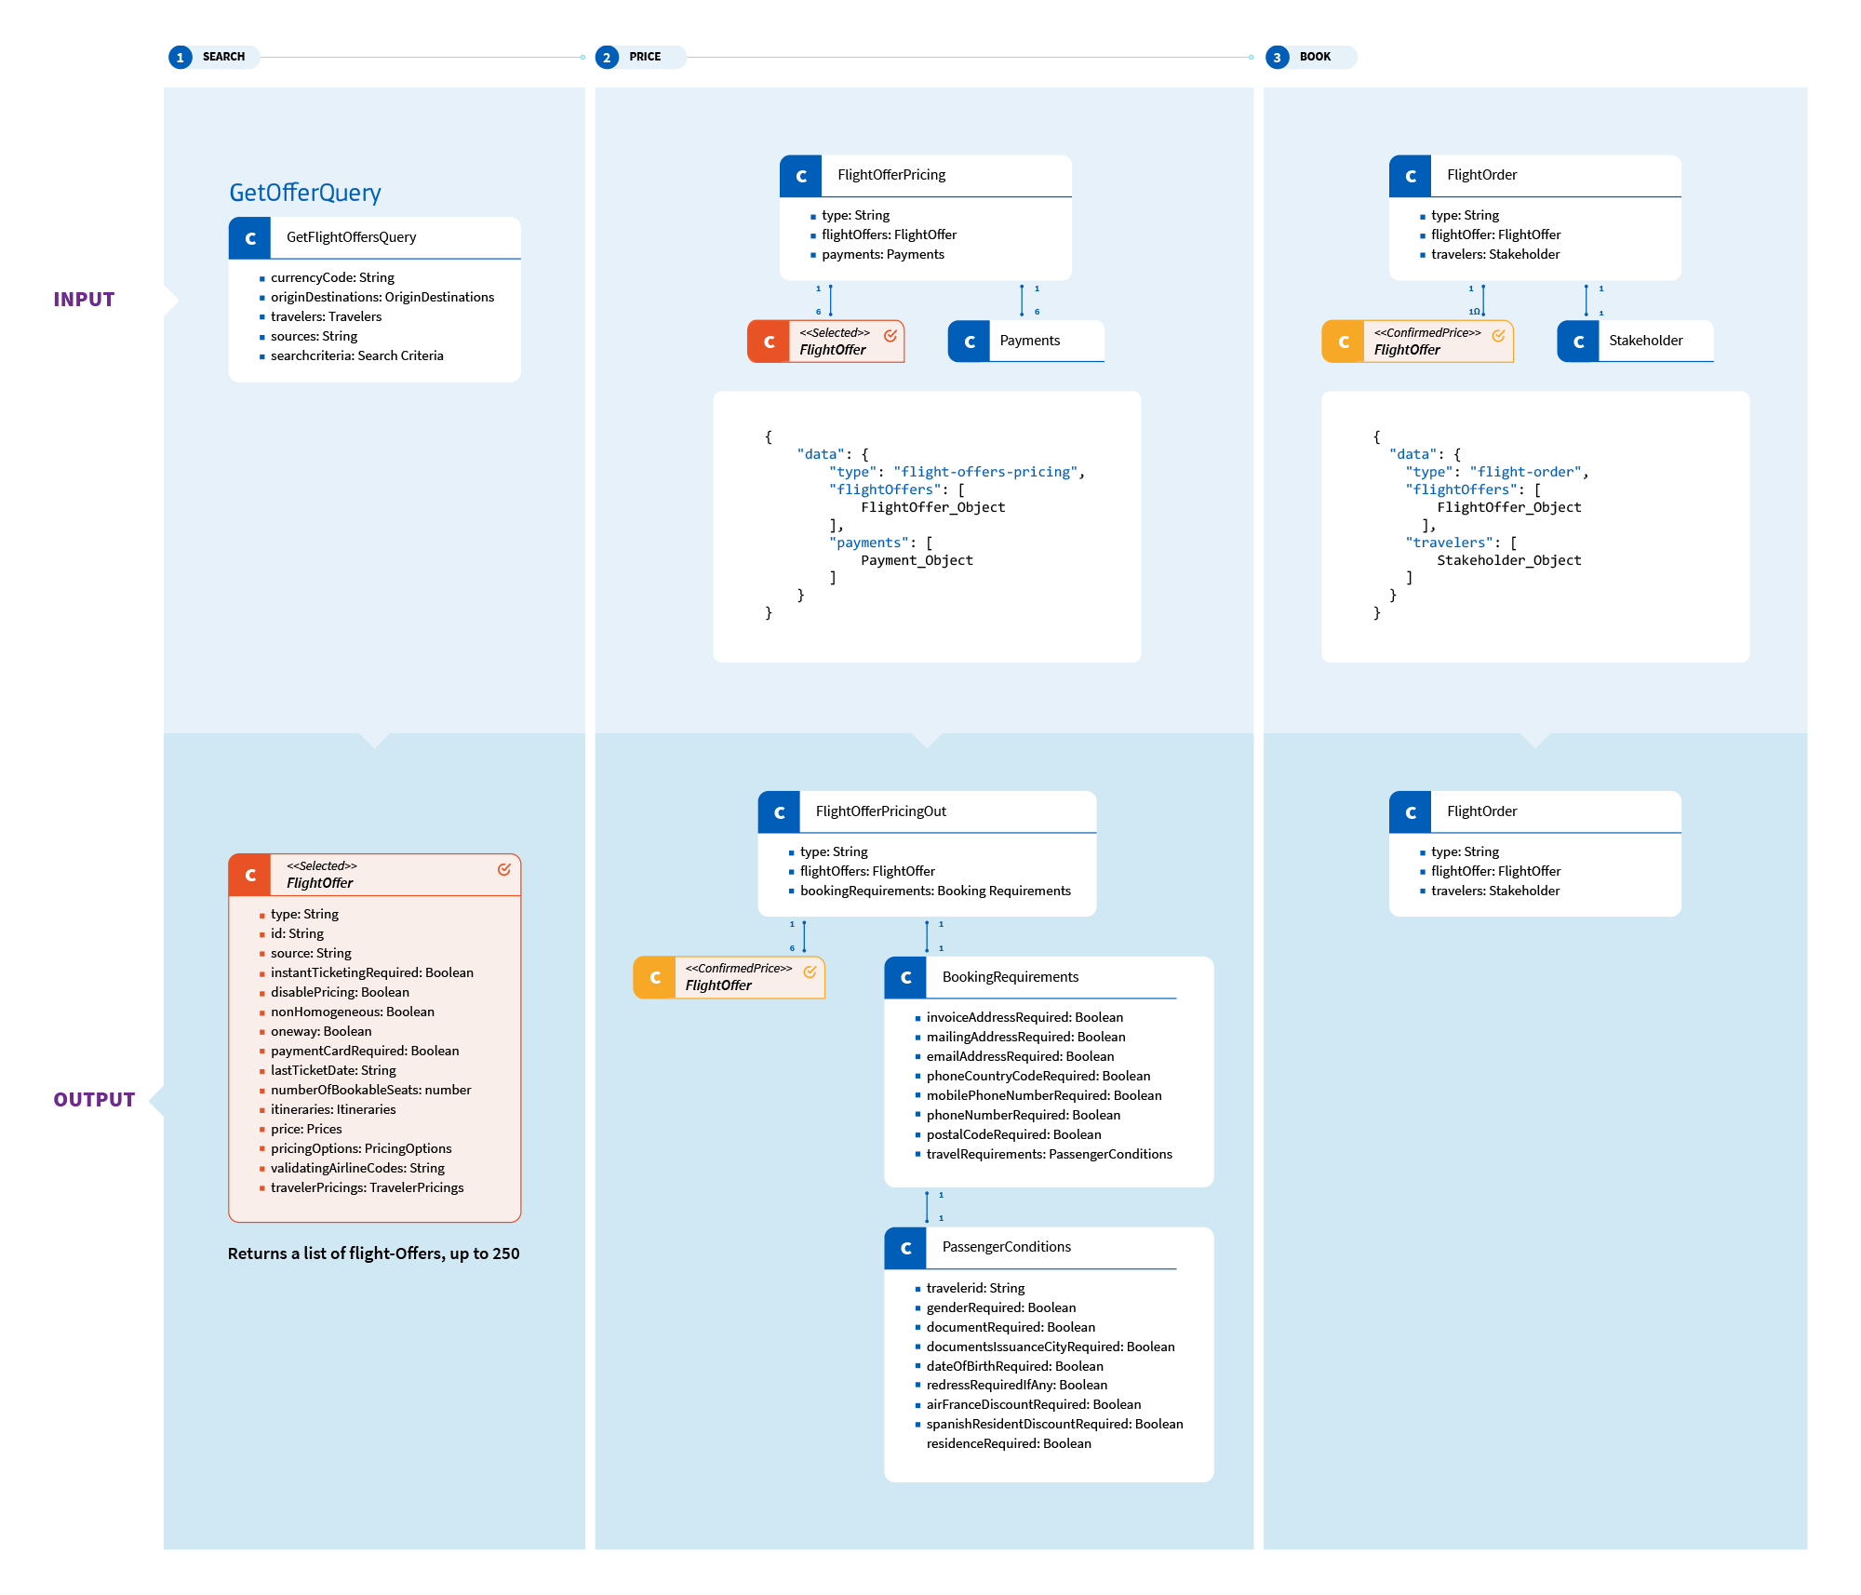
For a full-size image, visit our Flickr gallery.

Complete UML Structure
If you're still looking to go deeper, we've uploaded the full UML diagrams of our models (requests and responses):
- Flight Offers Search request
- Flight Offers Search response
- Flight Offers Price request & response
- Flight Create Orders request

Video tutorial

Common errors

Issuance not allowed in Self Service
Self-Service users must work with an airline consolidator that can issue tickets on your behalf. In that case, the payment is not processed by the API but directly between you and the consolidator. Adding a form of payment into the Flight Create Orders API will be rejected by error INVALID FORMAT.

Price discrepancy
The price of airfare fluctuates constantly. Creating an order for a flight whose price is no longer valid at the time of booking will trigger the following error:
{
"errors": [
{
"status": 400,
"code": 37200,
"title": "PRICE DISCREPANCY",
"detail": "Current grandTotal price (2780.28) is different from request one (2779.58)"
}
]
}

If you receive this error, reconfirm the fare price with the Flight Offers Price API before booking.

Getting started
For detailed documentation, visit the API reference for each API in the booking flow: Flight Offers Search, Flight Offers Price, Flight Create Orders.
To start building your app, create an account and follow the steps in our Authorization guide to get your access token. On GitHub, you can find SDKs to help simplify your workflow and an open source flight booking prototype in Django.
For any questions or feedback, or suggestions for new APIs you’d like to see in our catalog, please contact us or say hello on our Discord community channel.
Happy coding!

Performing multi-city flight search with Flight Offers Search
Tuesday, March 24, 2020 | By
Gael Imperial

Tutorials

22-minute read
Help your users get the most out of their holidays by adding a multi-city flight search functionality to your solution. In this article, we'll show you how to unlock this powerful feature of our Flight Offers Search API.

Introduction
Recently, we announced the release of Amadeus flight booking APIs to help you build a flight booking engine in three simple steps. The first step is performing a flight search with the Flight Offers Search API, our new and improved flight search API which will soon replace Flight Low-fare Search (if you haven’t started the migration, check out our guide). Today, we’ll show you how to implement one of the more advanced functionalities of the new flight search API: multi-city search.

What is multi-city search?
Many travelers take advantage of their international trips to visit several destinations. Multi-city search is a functionality that lets you search for consecutive one-way flights between multiple destinations in a single request. The returned flights are packaged as a complete, bookable itinerary. If you want to help your users plan a trip along the West Coast of the USA, a tour of Southeast Asia or an epic round-the-world (RTW) trip, then multi-city search is essential.
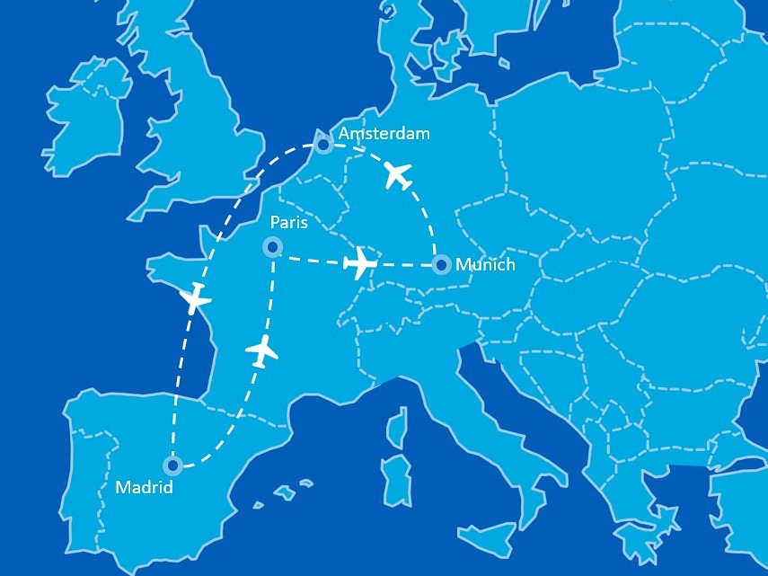Example of a multi-city flight search itinerary.

Performing multi-city searches with Flight Offers Search
The Flight Offers Search API comes in two different flavors:
- GET – quick flight search using a few basic parameters.
- POST – advanced search using the API’s full capabilities.
To perform multi-city searches, you must use the POST method. The API lets you search for up to six origin and destination city pairs, but for this example we’ll be using four. For simplicity, we’ll also limit the number of flight offers returned to one. Now, let's plan a trip!
For this example, we’ll fly from Madrid to Paris, where we’ll spend a couple days, then fly to Munich for three days. Next, we’ll visit Amsterdam for two days before finishing our journey with a return to Madrid. We'll use the following IATA city codes:
MAD > PAR > MUC > AMS > MAD
To search this itinerary, make the following request:
POST https://test.api.amadeus.com/v2/shopping/flight-offers

Then add the following to the body:
{
"originDestinations": [
{
"id": "1",
"originLocationCode": "MAD",
"destinationLocationCode": "PAR",
"departureDateTimeRange": {
"date": "2022-10-03"
}
},
{
"id": "2",
"originLocationCode": "PAR",
"destinationLocationCode": "MUC",
"departureDateTimeRange": {
"date": "2022-10-05"
}
},
{
"id": "3",
"originLocationCode": "MUC",
"destinationLocationCode": "AMS",
"departureDateTimeRange": {
"date": "2022-10-08"
}
},
{
"id": "4",
"originLocationCode": "AMS",
"destinationLocationCode": "MAD",
"departureDateTimeRange": {
"date": "2022-10-11"
}
}
],
"travelers": [
{
"id": "1",
"travelerType": "ADULT",
"fareOptions": [
"STANDARD"
]
}
],
"sources": [
"GDS"
],
"searchCriteria": {
"maxFlightOffers": 1
}
}

The API will then return the cheapest flight offers matching the itinerary. These flight offers can then be priced and booked following the flight booking flow provided by Flight Offers Price and Flight Create Orders.
Here is an example of the response:
{
"meta": {
"count": 1
},
"data": [
{
"type": "flight-offer",
"id": "1",
"source": "GDS",
"instantTicketingRequired": false,
"nonHomogeneous": false,
"oneWay": false,
"lastTicketingDate": "2022-09-28",
"numberOfBookableSeats": 9,
"itineraries": [
{
"duration": "PT2H5M",
"segments": [
{
"departure": {
"iataCode": "MAD",
"terminal": "2",
"at": "2022-10-03T06:00:00"
},
"arrival": {
"iataCode": "CDG",
"terminal": "2F",
"at": "2022-10-03T08:05:00"
},
"carrierCode": "AF",
"number": "1401",
"aircraft": {
"code": "321"
},
"operating": {
"carrierCode": "AF"
},
"duration": "PT2H5M",
"id": "1",
"numberOfStops": 0,
"blacklistedInEU": false
}
]
},
{
"duration": "PT1H30M",
"segments": [
{
"departure": {
"iataCode": "CDG",
"terminal": "2F",
"at": "2022-10-05T07:55:00"
},
"arrival": {
"iataCode": "MUC",
"terminal": "1",
"at": "2022-10-05T09:25:00"
},
"carrierCode": "AF",
"number": "1422",
"aircraft": {
"code": "319"
},
"operating": {
"carrierCode": "AF"
},
"duration": "PT1H30M",
"id": "2",
"numberOfStops": 0,
"blacklistedInEU": false
}
]
},
{
"duration": "PT1H35M",
"segments": [
{
"departure": {
"iataCode": "MUC",
"terminal": "1",
"at": "2022-10-08T17:50:00"
},
"arrival": {
"iataCode": "AMS",
"at": "2022-10-08T19:25:00"
},
"carrierCode": "KL",
"number": "1798",
"aircraft": {
"code": "73W"
},
"operating": {
"carrierCode": "KL"
},
"duration": "PT1H35M",
"id": "3",
"numberOfStops": 0,
"blacklistedInEU": false
}
]
},
{
"duration": "PT2H35M",
"segments": [
{
"departure": {
"iataCode": "AMS",
"at": "2022-10-11T17:00:00"
},
"arrival": {
"iataCode": "MAD",
"terminal": "2",
"at": "2022-10-11T19:35:00"
},
"carrierCode": "KL",
"number": "148",
"aircraft": {
"code": "E90"
},
"duration": "PT2H35M",
"id": "4",
"numberOfStops": 0,
"blacklistedInEU": false
}
]
}
],
"price": {...},
"pricingOptions": {...},
"validatingAirlineCodes": [...],
"travelerPricings": [... ]
}
],
"dictionaries": {...}
}
}

Conclusion
In this article, you've learned to implement a multi-city flight search functionality using the Flight Offers Search API. The ability to help your users book multi-destination itineraries is one of many advantages of migrating from Flight Low-fare Search to the new API.
If you're implementing multi-city search in your solution or have any questions about Flight Offers Search, please contact us - we'd love to hear from you!

Build a flight booking app with Angular and Node.js - Part 1
Monday, February 14, 2022 | By
Samuel Torimiro

Tutorials

12-minute read
In this 2-part tutorial, you'll build a flight booking app using Angular, Node.js, and Amadeus flight booking APIs. In part 1, you'll start by building the Node backend and implementing the flight booking logic.
Using a flight booking application is simple - as a user, you search and compare flights from one destination to another and then book the one you like. Developing one is not so straightforward. You not only need to access flight inventory from the airlines, but you also need to follow the process they’ve established for finding, confirming, and booking fares.
Amadeus Self-Service flight booking APIs solve this problem. They let you quickly search flights on over 400 global airlines and complete all the steps needed to book.
In this two-part tutorial, you’ll use Amadeus Self-Service flight booking APIs to build a complete flight booking application. You will use Node.js in the backend and Angular for the front end.
In part 1, you’ll start by using the Amadeus Node SDK to build the backend service using Node.js and Express. To jump straight into the frontend, to Build a flight booking app with Angular and Node.js - Part 2.
Follow along using this GitHub repo.

Prerequisites
Before you start coding, you’ll need the following:
- A basic understanding of JavaScript.
- Node.js installed. You’ll build the backend with Express, a Node.js framework.
- An Amadeus developer account. To create one, click on the register button located on the top right of this page. Then, go to My Self-ServiceWorkspace and create a new project. This will automatically generate a test API key and API secret, which will be displayed once you create your project.
You’ll need an access token to authorize your requests to the Amadeus APIs. To get one, follow the instructions in the Authentication Guide.

Step 1 - Setting up your environment
Start by bootstrapping a new Node.js application. In your terminal, create a new folder called flight_booking_app_backend and navigate into it using the following command:
$ mkdir flight_booking_app_backend && cd flight_booking_app_backend
Initialize a new Node.js project:
$ npm init -y
Install the project dependencies: express, amadeus, and cors:
$ npm install express amadeus cors
- Express is a Node.js framework. It simplifies the process of creating basic routes in Node.js and offers lots of additional features.
- Amadeus Node SDK. This will make it quick and easy to connect to Amadeus flight data.
- The cors library will enables the frontend to communicate with the backend.
Open the flight_booking_app_backend folder in your favorite code editor. In the folder, create a new file app.js. This is where your API endpoints will reside.
$ touch app.js

Step 2 - Implementing the backend logic
Next, you will create the app’s endpoints to search and book flights using Amadeus APIs.
The endpoints will look like so:
- City and airport search using the Amadeus Airport & City Search API. This will allow your user to select their origin and destination.
- Flight search using the Amadeus Flight Offers Search API. This will fetch a list of the cheapest flights between the origin and destination.
- Confirm a flight using Amadeus Flight Offers Price API. This will confirm the validity of the fare with the airline before booking.
- Flight booking using the Amadeus Flight Create Orders API. This will book the confirmed flight and generate a booking reference number.
Start by initializing a new Express application. Inside the app.js file, paste the following code:
mport express from 'express';
Import bodyParser from 'body-parser'
import cors from "cors"
const app = express();
const PORT = 5000;
app.use(bodyParser.json())
app.use(cors({
origin: 'http://localhost:4200'
}));
app.listen(PORT, () =>
console.log(`Server is running on port: http://localhost:${PORT}`)
);
This will create a new Express application listening at port 5000. In order to use import in Node.js, open the package.json file and add this code just after the main key:
...
"type": "module",
Here, you are allowing this URL (http://localhost:4200) to make requests to your backend by setting it as part of the origin in cors.
Also, you are importing the body-parser module and calling the json() function. You need this for the server to be able to successfully parse JSON data from the body of a POST request.

City and airport search
The first API endpoint will let your application retrieve airports or cities from the Amadeus Airport & City Search API so that your users can select their origin and destination.
...
import Amadeus from 'amadeus';
const amadeus = new Amadeus({
clientId: 'YOUR-API-KEY',
clientSecret: 'YOUR-API-SECRET',
});
app.get(`/city-and-airport-search/:parameter`, (req, res) => {
const parameter = req.params.parameter;
// Which cities or airports start with the parameter variable
amadeus.referenceData.locations
.get({
keyword: parameter,
subType: Amadeus.location.any,
})
.then(function (response) {
res.send(response.result);
})
.catch(function (response) {
res.send(response);
});
});
......
import Amadeus from 'amadeus';
const amadeus = new Amadeus({
clientId: 'YOUR-API-KEY',
clientSecret: 'YOUR-API-SECRET',
});
app.get(`/city-and-airport-search/:parameter`, (req, res) => {
const parameter = req.params.parameter;
// Which cities or airports start with the parameter variable
amadeus.referenceData.locations
.get({
keyword: parameter,
subType: Amadeus.location.any,
})
.then(function (response) {
res.send(response.result);
})
.catch(function (response) {
res.send(response);
});
});
...
In the above code, you imported the Amadeus package to communicate with the Amadeus API. You initialized a new instance of Amadeus and passed your API KEY and API SECRET into it.
Next, you added a basic GET request route: city-and-airport-search/:parameter. Here, parameter serves as a placeholder for any city or airport the user types. This parameter is passed as the keyword to the Amadeus API.
Since it is a GET request, you can test the API in the browser. But, you need to start the server first.
To do this, install nodemon like so:
$ npm install nodemon
This will prevent you from having to restart the server whenever you make changes to the code. Then, replace the start script with nodemon app.js in your package.json file.
"scripts": {
"start": "nodemon app.js"
},
Run npm start to start the server.
The following screenshot shows the search results of http://localhost:5000/city-and-airport-search/london.
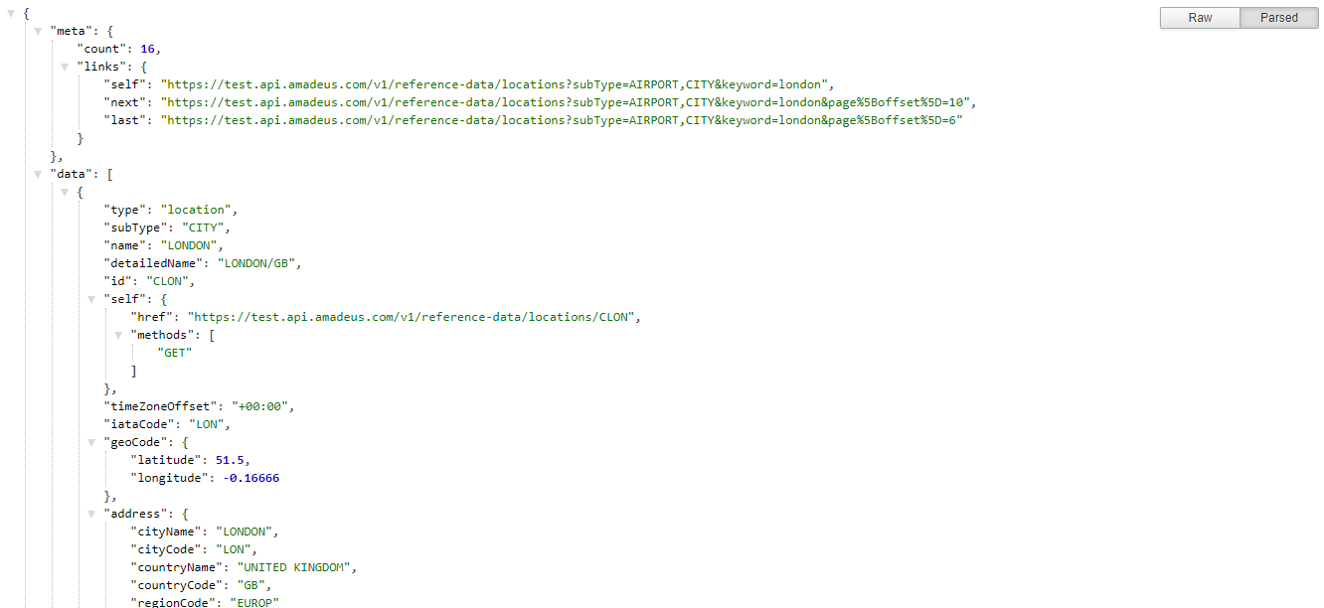

Flight search
After your user selects their origin and destination, you need to allow them to search flights between those cities on their desired travel dates. To do this, your app will need to call the Amadeus Flight Offers Search API.
...
app.get(`/flight-search`, (req, res) => {
const originCode = req.query.originCode;
const destinationCode = req.query.destinationCode;
const dateOfDeparture = req.query.dateOfDeparture
// Find the cheapest flights
amadeus.shopping.flightOffersSearch.get({
originLocationCode: originCode,
destinationLocationCode: destinationCode,
departureDate: dateOfDeparture,
adults: '1',
max: '7'
}).then(function (response) {
res.send(response.result);
}).catch(function (response) {
res.send(response);
});
});
Here, the GET request route flight-search fetches available flights from the Amadeus API. For this to work, you need to pass the following data from the user:
- origin location code
- destination location code
- departure date
- number of adult travelers
You can offer a more robust search by including more data like return date or travel class. For this tutorial, you will keep things simple.
You can get the location and destination code from the previous endpoint, which returns a three-letter IATA airport code for the selected cities. This information is passed as a query string by the client. Note that you’ve hard-coded the value of adults to 1 and set max to 7 to limit the number of flights returned.
You pass these details to the Amadeus API to fetch matching flight offers. The API will return a list of matching flights ordered by ascending price.
You can now test it in the browser.
The following screenshot shows the search results of http://localhost:5000/flight-search?originCode=LON&destinationCode=SFO&dateOfDeparture=2022-02-02.
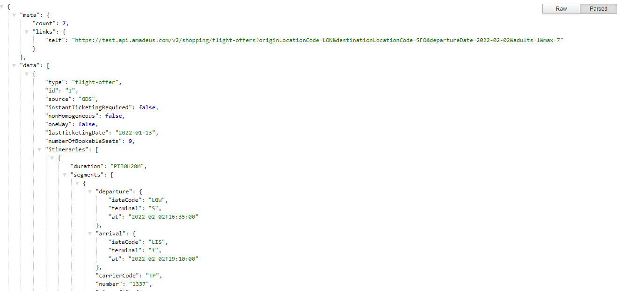

Confirming a flight
Airlines require that the price and availability of a flight is confirmed before it can be booked. This is because the price and availability of airfare can change in real time. Once your user picks a flight, you will confirm it with the airline by calling the Amadeus Flight Offers Price API.
...
app.post(`/flight-confirmation`, (req, res) => {
const flight = req.body.flight
// Confirm availability and price
amadeus.shopping.flightOffers.pricing.post(
JSON.stringify({
'data': {
'type': 'flight-offers-pricing',
'flightOffers': [flight],
}
})
).then(function (response) {
res.send(response.result);
}).catch(function (response) {
res.send(response)
})
})
Here, you have a POST request route that will accept a given flight-offerreturned by the previous endpoint. This request will confirm the flight-offerso that your user can proceed to book.
As this is a POST request, you can no longer test it in your browser. Instead, you’ll test it using Postman.
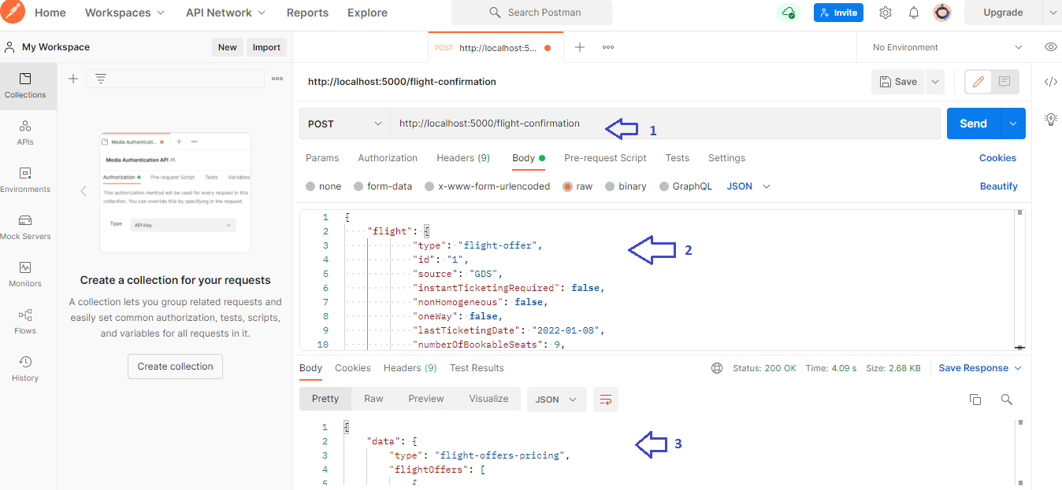
In the screenshot above, you are passing in a flight-offer object obtained from the Amadeus Flight Offers Search API in the previous step. If the fare is no longer available or has changed price, the response will contain a warning.

Flight booking
Once the flight is confirmed, your user can book the flight. To allow this, you will call the Amadeus Flight Create Orders API.
...
app.post(`/flight-booking`, (req, res) => {
// Book a flight
const flight = req.body.flight;
const name = req.body.name
amadeus.booking.flightOrders.post(
JSON.stringify({
'data':
'type': 'flight-order',
'flightOffers': [flight],
'travelers': [{
"id": "1",
"dateOfBirth": "1982-01-16",
"name": {
"firstName": name.first,
"lastName": name.last
},
"gender": "MALE",
"contact": {
"emailAddress": "jorge.gonzales833@telefonica.es",
"phones": [{
"deviceType": "MOBILE",
"countryCallingCode": "34",
"number": "480080076"
}]
},
"documents": [{
"documentType": "PASSPORT",
"birthPlace": "Madrid",
"issuanceLocation": "Madrid",
"issuanceDate": "2015-04-14",
"number": "00000000",
"expiryDate": "2025-04-14",
"issuanceCountry": "ES",
"validityCountry": "ES",
"nationality": "ES",
"holder": true
}]
}]
}
})
).then(function (response) {
res.send(response.result);
}).catch(function (response) {
res.send(response);
});
});
Above, a POST request route will book a flight for the user. It takes, as part of the request body, the confirmed flight-offer object obtained in the previous step.
To book the flight, you will also have to add your users personal details as a travelers object, as shown above.
When the flight is successfully booked, the Amadeus Flight Create Orders API will return a summary of the booking along with a booking ID and a booking reference number (PNR).
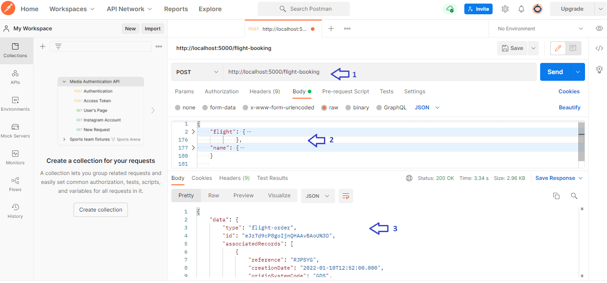

Intermission
This concludes the first part of this series. So far, you’ve successfully created the API URL endpoints for your flight booking application using Node.js, Express, and the Amadeus Node SDK.
Continue to Build a flight booking app with Angular and Node.js - Part 2 to build a user interface in Angular that interacts with your backend via HTTP requests.
For now, feel free to play around with the backend code in this GitHub repo, explore some of the more advanced search and filtering options provided by the Amadeus Flight Offers Search API, and join our community of developers on Discord.

How to build a flight booking app in Java and React - Part 1
Tuesday, October 5, 2021 | By
John Gramila

Tutorials

12-minute read
Amadeus Self-Service APIs make it easy to build a booking app and start selling flights without an IATA license. To see how it works, you’ll build a complete flight booking application using Java Spring and React. In part 1, you’ll set up the backend using Java Spring Boot.
Flight booking is a core functionality of any full-service travel app, but it's not always simple to implement - accessing airline inventory, integrating complex technology, and acquiring agency accreditation from IATA can all pose major hurdles for new companies.
Amadeus Self-Service flight booking APIs help developers avoid these barriers by offering an easy way to search and book flights on over 400 global airlines. Using three simple REST APIs, you can build complete booking app and start selling flights without IATA licensing.
To get familiar with Amadeus flight booking APIs work, you'll build a flight booking application using Java Spring and React. In part 1, you’ll set up the backend with Spring. In part two, you’ll build a React frontend so users can search and book flights.
Follow along with the application source code on GitHub.

Pre-requisites
- JDK 1.8 or later.
- Maven 3.2 or newer, or Gradle 4+ to handle your dependencies.
- Amadeus API key - you will need this to search and book flights with Amadeus. Sign-up here for a free account and create an app in your My Self-Service Workspace to generate an API key.
- Amadeus Java SDK - this will make it fast and easy to connect to Amadeus. To install the Amadeus Java SDK with Maven, add these lines to the pom.xml file:
<dependency>
<groupId>com.amadeus</groupId>
<artifactId>amadeus-java</artifactId>
<version>5.7.2</version>
</dependency>

Step 1 - Setting up Spring Boot
For this tutorial, you'll use Java Spring Boot to get your HTTP routes set up quickly.
First, use the Spring Initializr. Your IDE of choice should run Spring easily; otherwise, generate a .zip file from the above link and import it. After installation, your pom.xml file should look like this:
<?xml version="1.0" encoding="UTF-8"?>
<project xmlns="http://maven.apache.org/POM/4.0.0" xmlns:xsi="http://www.w3.org/2001/XMLSchema-instance"
xsi:schemaLocation="http://maven.apache.org/POM/4.0.0 https://maven.apache.org/xsd/maven-4.0.0.xsd">
<modelVersion>4.0.0</modelVersion>
<parent>
<groupId>org.springframework.boot</groupId>
<artifactId>spring-boot-starter-parent</artifactId>
<version>2.5.3</version>
<relativePath/> <!-- lookup parent from repository -->
</parent>
<groupId>com.Amadeus</groupId>
<artifactId>app</artifactId>
<version>0.0.1-SNAPSHOT</version>
<name>app</name>
<description>Demo project for the Amadeus Flight and Travel API</description>
<properties>
<java.version>11</java.version>
</properties>
<dependencies>
<dependency>
<groupId>org.springframework.boot</groupId>
<artifactId>spring-boot-starter-web</artifactId>
</dependency>
<dependency>
<groupId>org.springframework.boot</groupId>
<artifactId>spring-boot-starter-test</artifactId>
<scope>test</scope>
</dependency>
<dependency>
<groupId>com.amadeus</groupId>
<artifactId>amadeus-java</artifactId>
<version>5.7.2</version>
</dependency>
<dependency>
<groupId>com.google.code.gson</groupId>
<artifactId>gson</artifactId>
<version>2.8.7</version>
</dependency>
</dependencies>
<build>
<plugins>
<plugin>
<groupId>org.springframework.boot</groupId>
<artifactId>spring-boot-maven-plugin</artifactId>
</plugin>
</plugins>
</build>
</project>
Note that you include the Gson library for handling JSON. Open the src\\main\\resources\\application.properties and add this line: spring.http.converters.preferred-json-mapper=gson.

Step 2 - Creating a web application
Next, set up a simple controller. Create an ApiController.java file in the same directory as the autogenerated Spring Application class, using src\\main\\java\\com\\app\\flight. Preface these controller routes with api using Spring’s @RequestMapping decorator.
package com.amadeus.flight;
import org.springframework.web.bind.annotation.GetMapping;
import org.springframework.web.bind.annotation.RestController;
import org.springframework.web.bind.annotation.RequestMapping;
@RestController
@RequestMapping(value="/api")
public class ApiController {
@GetMapping("/")
public String hello() {
return "Hello World Travel!"
}
Test your installation by checking if the page exists. I was able to see it at localhost:8080/api/, which is the default, but your Spring installation might be using a different port.

Step 3 - Connecting to Amadeus
Next, you'll begin to set up your endpoints.
First, you'll need to request data from the Airport & City Search API to allow your user to select their origin and destination. The API turns common names of places into IATA location codes needed to search flights.
Create an AmadeusConnect.java class to hold your previously-generated Amadeus API keys and make connections:
package com.app.flight;
import com.amadeus.Amadeus;
import com.amadeus.Params;
import com.amadeus.referenceData.Locations;
import com.amadeus.resources.Location;
import com.amadeus.exceptions.ResponseException;
enum AmadeusConnect {
INSTANCE;
private Amadeus amadeus;
private AmadeusConnect() {
this.amadeus = Amadeus
.builder("YOUR_API_KEY", "YOUR_API_SECRET")
.build();
}
public Location[] location(String keyword) throws ResponseException {
return amadeus.referenceData.locations.get(Params
.with("keyword", keyword)
.and("subType", Locations.AIRPORT));
}
}
To retrieve your list of location codes, make a locations endpoint that accepts GET requests in the ApiController class. You’ll have to enter a required keyword (the city name typed by the user). This API also requires a subType, but this tutorial defaults that value to airports in the location function. Test this new route at localhost:8080/api/locations?keyword=LON.
For this sample application, you’re printing out error messages to aid debugging, but these errors should be hidden and handled before production.
@GetMapping("/locations")
public Location[] locations(@RequestParam(required=true) String keyword) throws ResponseException {
return AmadeusConnect.INSTANCE.location(keyword);
}

Step 4 - Understanding the flight booking flow
Now that you have your location, it's time to guide the user through booking a flight. You can accomplish this using the following 3 APIs:

Flight Offers Search

Fetch flight offers matching your user's search criteria.
VIEW DOCUMENTATION

Flight Offers Price

Confirm the final price of a selected flight offer.
VIEW DOCUMENTATION

Flight Create Orders

Book the flight offer and generate a booking number.
VIEW DOCUMENTATION

You’ll want a controller action and route to interact with each of these services.

Step 5 - Searching flight offers
Once you have a destination, you must search for flights using the Flight Offers Search API. The API offers both GET and POST options, but for this tutorial you'll use the GET method for simplicity. Looking at the API reference, notice that there are four required fields:
Parameter | Description
originLocationCode | IATA code of the city/airport of departure
destinationLocationCode | IATA code of the city/airport of arrival
departureDate | Date of departure in ISO 8601 format
adults | Number of adult passengers

Note that the returnDate field isn’t required. However, leaving this field blank will search for one-way flights only, so add it.
Make a new function to handle the request in AmadeusConnect.java:
public FlightOfferSearch[] flights(String origin, String destination, String departDate, String adults, String returnDate) throws ResponseException {
return amadeus.shopping.flightOffersSearch.get(
Params.with("originLocationCode", origin)
.and("destinationLocationCode", destination)
.and("departureDate", departDate)
.and("returnDate", returnDate)
.and("adults", adults)
.and("max", 3));
}
Adding the parameter max lets you limit the flight offers returned by the API.
Next, add a route to FlightController.java. You can test this route with a URL request: flights?origin=LON&destination=NYC&departDate=2022-11-15&returnDate=2022-11-17&adults=3. Note that dates must be formatted using ISO 8601 or YYYY-MM-DD.
@GetMapping("/flights")
public FlightOfferSearch[] flights(@RequestParam(required=true) String origin,
@RequestParam(required=true) String destination,
@RequestParam(required=true) String departDate,
@RequestParam(required=true) String adults,
@RequestParam(required = false) String returnDate)
throws ResponseException {
return AmadeusConnect.INSTANCE.flights(origin, destination, departDate, adults, returnDate);
}

Step 6 - Confirming the price a flight offer
As airlines continuously update information in real time, the next step is to re-confirm the final price and availability of the selected flight and generate an offer summary for the user to book.
There are multiple requirements for the Flight Offers Price API, but you can save and reuse the data structure returned from Flight Offers Search to keep the request simple. Again, formulate the request in AmadeusConnect.java.
public FlightPrice confirm(FlightOfferSearch offer) throws ResponseException {
return amadeus.shopping.flightOffersSearch.pricing.post(offer);
}
As always, you must add an endpoint to the ApiController class:
@PostMapping("/confirm")
public FlightPrice confirm(@RequestBody(required=true) FlightOfferSearch search) throws ResponseException {
return AmadeusConnect.INSTANCE.confirm(search);
}

Step 7 - Collecting traveler information
To enable a user to book a flight, you must collect user information. This tutorial is primarily designed to show you how to interact with Amadeus flight booking APIs, so the user implementation will be simple and implement no database. To make it easy to hook up whatever data store your application uses, make a new Java class called DatabaseConnect.java.
package com.app.flight;
import com.amadeus.resources.Traveler;
import com.amadeus.resources.Traveler.Document;
import com.amadeus.resources.Traveler.Name;
import com.amadeus.resources.Traveler.Phone;
import com.google.gson.JsonObject;
import com.amadeus.resources.Traveler.Contact;
public class DatabaseConnect {
public static Traveler traveler(JsonObject travelerInfo) {
String fname = travelerInfo.get("fname").getAsString();
String lname = travelerInfo.get("lname").getAsString();
String dateOfBirth = travelerInfo.get("dob").getAsString();
Traveler traveler = new Traveler();
Phone phone = traveler.new Phone();
phone.setCountryCallingCode("1");
phone.setNumber("1231231234");
phone.setDeviceType("MOBILE");
Contact contact = traveler.new Contact();
Phone[] phones = {phone};
contact.setPhones(phones);
traveler.setContact(contact);
Name name = traveler.new Name(fname, lname);
traveler.setName(name);
traveler.setDateOfBirth(dateOfBirth);
traveler.setId("1");
Document document = traveler.new Document();
document.setDocumentType("PASSPORT");
document.setNumber("00000000");
document.setExpiryDate("2025-04-14");
document.setNationality("ES");
document.setHolder(true);
document.setIssuanceCountry("ES");
Document[] documents = {document};
traveler.setDocuments(documents);
return traveler;
}
}
Note that some information is hard coded. When planning your application, consider the information you need to collect from users. You’ll also want to implement data validation, and will include both GETand POST methods to set and retrieve data. This sample application will only store one traveler at a time, so it will only have a POST method. To make this function accessible, add a route in the ApiContoller.
@PostMapping("/traveler")
public Traveler traveler(@RequestBody(required=true) JsonObject travelerInfo) {
return DatabaseConnect.traveler(travelerInfo.get("data").getAsJsonObject());
}

Step 8 - Booking the flight offer
The final step is to book the validated flight offer using the Flight Create Orders API. The Amadeus Java SDK simplifies the requirements for the API request by allowing you to use the existing FlightPrice object.
Add a function to the AmadeusConnector class:
public FlightOrder order(JsonObject order) throws ResponseException {
return amadeus.booking.flightOrders.post(order);
}
Then finish by adding a route to the ApiController class:
@PostMapping("/order")
public FlightOrder order(@RequestBody(required=true) JsonObject order) throws ResponseException{
return AmadeusConnect.INSTANCE.order(order);
}
You’ll build the necessary traveler information when you create your frontend. When turning this demo into a real-world application, make sure to add additional validation for any data fields and respect airline concerns about user identity by offering robust authentication, authorization, and input validation.

Conclusion and next steps
In this tutorial, you built the backend of a flight booking application using Java Spring Boot and Amadeus flight booking APIs. Continue with How to build a flight booking app in Java and React - Part 2 to build the frontend interface using React to enable your users to search and book their flights.
To delve deeper into the flight booking flow, check out how to build a flight booking engine and these tutorials on enhancing your booking app by building seat maps, booking seats, or adding paid baggage.
For information and questions about this tutorial or Amadeus APIs, join the Amadeus for Developers community on Discor

How to build a flight search form using Bootstrap 5 - Part 1
Friday, October 29, 2021 | By
Arek Nawo

Tutorials

11-minute read
In this two-part series, you'll build a simple yet powerful flight search form using Bootstrap 5, Express, and Amadeus Self-Service APIs. In part one, you'll create the form frontend to enable users to enter their flight search criteria.
Bootstrap 5 is the latest version of the most popular CSS framework for developing responsive and mobile-first websites. In this two-part series, you'll use Bootstrap 5 and Amadeus Self-Service APIs to create a simple but professional-looking flight search form to enable users to search for flights and view results.
You will use the Amadeus Airport & City Search API to create a rich origin/destination autocomplete system for your search and the Amadeus Flight Offers Search API to retrieve the cheapest flight deals matching your user's criteria.
In part one, you’ll build the form’s frontend with Bootstrap and Vanilla JS, while in part 2 you’ll build an Express backend powered by Amadeus APIs and connect it with the frontend to display the search results.
Here’s what the process will look like:
- Set up your development environment
- Build origin and destination inputs
- Build departure and return date inputs
- Build travel class and passenger inputs
- Initiate form’s reactivity with basic JS
You can follow along with this GitHub repo.

Step 1 - Setting up your development environment
Start by creating a new directory and initializing an npm project inside it:
mkdir flight-search && cd flight-search && npm init -y
Then create a public folder with index.html, script.js, and style.css files inside it. This is where the frontend will be located.
In index.html, set up the basic structure:
<!DOCTYPE html>
<html lang="en">
<head>
<meta charset="UTF-8" />
<meta http-equiv="X-UA-Compatible" content="IE=edge" />
<meta name="viewport" content="width=device-width, initial-scale=1.0" />
<title>Flight Search</title>
<link
href="https://cdn.jsdelivr.net/npm/bootstrap@5.1.0/dist/css/bootstrap.min.css"
rel="stylesheet"
integrity="sha384-KyZXEAg3QhqLMpG8r+8fhAXLRk2vvoC2f3B09zVXn8CA5QIVfZOJ3BCsw2P0p/We"
crossorigin="anonymous"
/>
<link
rel="stylesheet"
href="https://cdn.jsdelivr.net/npm/bootstrap-icons@1.5.0/font/bootstrap-icons.css"
/>
<link rel="stylesheet" href="./style.css" />
</head>
<body>
<script src="./script.js"></script>
</body>
</html>
Load the Bootstrap CSS bundle (JS won’t be required), together with Bootstrap Icons from CDN. Also, remember to include external script.js and style.css files.
In style.css, include all the helper classes for later use:
.flex-1 {
flex: 1;
}
With this in place, ensure you’re running a fairly recent version of npm (with npx command available) and use the serve package to run a simple development server:
npx serve public

Step 2 - Building the origin and destination inputs
Start by creating a container for the UI and setting up a locations input (origin and destination) card inside it:
<!-- ... -->
<div class="container-sm">
<div class="my-2 card">
<div class="card-body">
<h5 class="card-title">Locations</h5>
<div class="row"></div>
</div>
</div>
</div>
<!-- ... -->
The card will be placed at the top of the website and have a vertical layout with side-by-side locations input. For that, you can use Bootstrap’s flexbox grid system.
<!-- ... -->
<div class="row">
<div class="col-sm">
<div class="mb-2">
<label id="origin-label" for="origin-input" class="form-label"
>Origin</label
>
<div class="input-group"></div>
</div>
</div>
<div class="col-sm">
<div class="mb-2">
<label id="destination-label" for="destination-input" class="form-label"
>Destination</label
>
<div class="input-group"></div>
</div>
</div>
</div>
<!-- ... -->
Using col-sm ensures the layout will switch to horizontal on smaller devices.
Inputs for both the origin and destination locations will be labeled and wrapped into input-group containers so that you can decorate them with different icons.
Giving elements proper ids is also important—it helps with labeling and accessibility while simplifying access to the elements from JS.
<!-- ... -->
<div class="mb-2">
<label id="origin-label" for="origin-input" class="form-label">Origin</label>
<div class="input-group">
<span class="input-group-text"><i class="bi-pin-map"></i> </span>
<input
type="text"
class="form-control"
list="origin-options"
id="origin-input"
placeholder="Location"
aria-describedby="origin-label"
/>
<datalist id="origin-options"></datalist>
</div>
</div>
<!-- ... -->
Notice the <datalist> element. You’ll use it to provide location autocomplete suggestions using the browser’s built-in mechanisms. This is accessible by default and easy to use from the programming perspective. You’ll populate it with <option> elements using JS and results from the Amadeus Airport & City Search API.
Next, set up the destination input accordingly:
stination-label" for="destination-input" class="form-label"
>Destination</label
>
<div class="input-group">
<span class="input-group-text"><i class="bi-pin-map-fill"></i> </span>
<input
type="text"
class="form-control"
list="destination-options"
id="destination-input"
placeholder="Location"
aria-describedby="destination-label"
/>
<datalist id="destination-options"></datalist>
</div>
</div>
<!-- ... -->
With this setup, your form should now look like this:
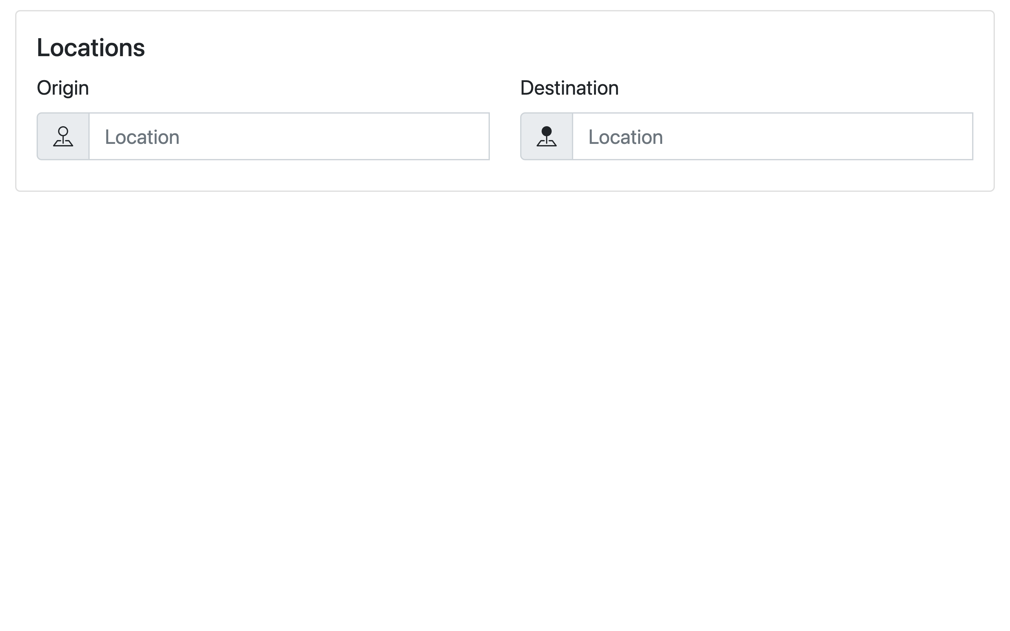

Step 3 - Building the departure and return date inputs
The space below the locations input card will be split in the middle to accommodate two cards with a horizontal layout—one for flight dates and the other for passenger details.
<!-- ... -->
<div class="row">
<div class="mb-2 col">
<div class="h-100 card">
<div class="card-body">
<h5 class="card-title">Dates</h5>
</div>
</div>
</div>
<div class="mb-2 col">
<div class="h-100 card"></div>
</div>
</div>
<!-- ... -->
The date inputs will depend on whether the user chooses a one-way or round-trip flight. If it’s one-way, only the departure date picker will be shown. Otherwise, the return date picker will appear right beneath it.
<!-- ... -->
<div class="card-body">
<h5 class="card-title">Dates</h5>
<div class="mb-2">
<label id="flight-type-label" for="flight-type-select" class="form-label"
>Flight</label
>
<select
id="flight-type-select"
class="form-select"
aria-describedby="flight-type-label"
>
<option value="one-way">One-way</option>
<option value="round-trip">Round-trip</option>
</select>
</div>
<div id="departure-date" class="mb-2"></div>
<div id="return-date" class="mb-2"></div>
</div>
<!-- ... -->
To choose a one-way or return flight, the user will be presented with a labeled select dropdown. Depending on the user’s choice, JS code will show or hide the return-date container housing the date picker.
The date pickers themselves, like location inputs, will be decorated with additional icons. Apart from that, setting the type=”date” attribute on the <input> element will ensure proper date formatting and access to the browser’s built-in date picker to improve the user experience.
<!-- ... -->
<div id="departure-date" class="mb-2">
<label id="departure-date-label" for="departure-date-input" class="form-label"
>Departure date</label
>
<div class="input-group">
<span class="input-group-text"><i class="bi-calendar"></i></span>
<input
type="date"
class="form-control"
id="departure-date-input"
aria-describedby="departure-date-label"
/>
</div>
</div>
<!-- ... -->
Set up the return date picker accordingly:
<!-- ... -->
<div id="return-date" class="mb-2">
<label id="return-date-label" for="return-date-input" class="form-label"
>Return date</label
>
<div class="input-group">
<span class="input-group-text"><i class="bi-calendar-fill"></i> </span>
<input
type="date"
class="form-control"
id="return-date-input"
aria-describedby="return-date-label"
/>
</div>
</div>
<!-- ... -->
With dates input in place, here’s how the UI should look:
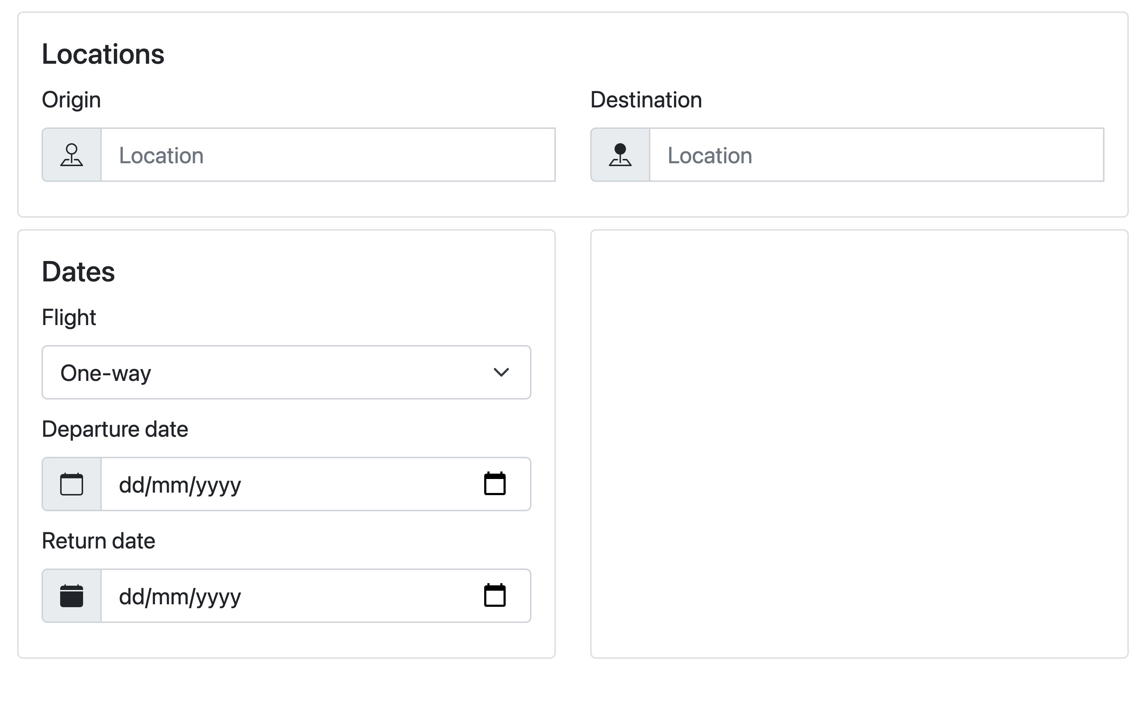

Step 4 - Building passenger and travel class inputs
The card to the right of the dates input will be dedicated to selecting the number of passengers and the desired cabin class.
Start by creating a select dropdown similar to the one from the previous card. Provide options for all travel class values allowed by the Amadeus Flight Offers Search API, with matching value attributes with meaningful descriptions.
<!-- ... -->
<div class="card-body">
<h5 class="card-title">Details</h5>
<div class="mb-2">
<label id="travel-class-label" for="travel-class-select" class="form-label"
>Travel class</label
>
<select
class="form-select"
id="travel-class-select"
aria-describedby="travel-class-label"
>
<option value="ECONOMY">Economy</option>
<option value="PREMIUM_ECONOMY">Premium Economy</option>
<option value="BUSINESS">Business</option>
<option value="FIRST">First</option>
</select>
</div>
<label class="form-label">Passengers</label>
<div class="mb-2"></div>
<div class="mb-2"></div>
<div class="mb-2"></div>
</div>
<!-- ... -->
As airlines offer different fares for different passenger age groups, the Amadeus Flight Offers Search API requires you to pass adults, children, and infants separately, so it’s important to present them as such in the UI.
<!-- ... -->
<div class="mb-2">
<div class="input-group">
<label for="adults-input" class="input-group-text">Adults</label>
<input
type="number"
min="0"
class="form-control"
id="adults-input"
aria-describedby="adults-label"
/>
</div>
<span id="adults-label" class="form-text">12 years old and older</span>
</div>
<!-- ... -->
The <input> element should have type=”number” and min=”0” attributes, be properly labeled, and come with a note about the accepted age range.
Create the inputs for children and infants accordingly:
<!-- ... -->
<div class="mb-2">
<div class="input-group">
<label for="children-input" class="input-group-text">Children</label>
<input
type="number"
min="0"
class="form-control"
id="children-input"
aria-describedby="children-label"
/>
</div>
<span id="children-label" class="form-text">2 to 12 years old</span>
</div>
<div class="mb-2">
<div class="input-group">
<label for="infants-input" class="input-group-text">Infants</label>
<input
type="number"
min="0"
class="form-control"
id="infants-input"
aria-describedby="infants-label"
/>
</div>
<span id="infants-label" class="form-text">Up to 2 years old</span>
</div>
<!-- ... -->
With this ready, you just need to add a search button beneath all the input cards and the form structure will be complete!
<!-- ... -->
<button id="search-button" class="w-100 btn btn-primary" disabled>
Search
</button>
<!-- ... -->
The resulting form should have a single-column layout on mobile and look like the following on desktop:
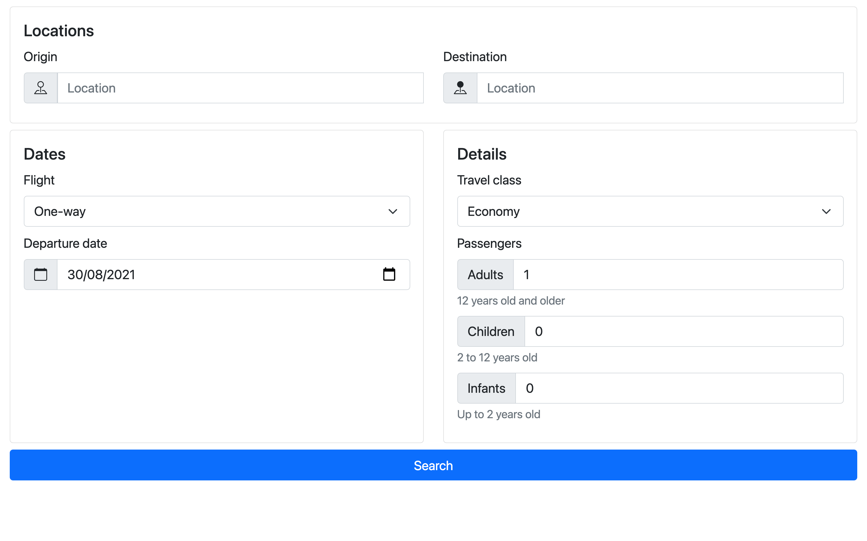

Step 5 - Making the form interactive
You’ll connect your form with the Amadeus APIs in part two of this series, but you can start laying the groundwork for that now.
Start by accessing all relevant form elements by their ids.
const originInput = document.getElementById("origin-input");
const originOptions = document.getElementById("origin-options");
const destinationInput = document.getElementById("destination-input");
const destinationOptions = document.getElementById("destination-options");
const flightTypeSelect = document.getElementById("flight-type-select");
const departureDateInput = document.getElementById("departure-date-input");
const returnDate = document.getElementById("return-date");
const returnDateInput = document.getElementById("return-date-input");
const travelClassSelect = document.getElementById("travel-class-select");
const adultsInput = document.getElementById("adults-input");
const childrenInput = document.getElementById("children-input");
const infantsInput = document.getElementById("infants-input");
const searchButton = document.getElementById("search-button");
Then define a reset function for setting all inputs to their default values.
// ...
const reset = () => {
originInput.value = "";
destinationInput.value = "";
flightTypeSelect.value = "one-way";
departureDateInput.valueAsDate = new Date();
returnDateInput.valueAsDate = new Date();
returnDate.classList.add("d-none");
travelClassSelect.value = "ECONOMY";
adultsInput.value = 1;
childrenInput.value = 0;
infantsInput.value = 0;
searchButton.disabled = true;
};
While you can do most of this with HTML, JS provides a convenient way to reuse the reset function capabilities down the line. It also allows you to initiate the date inputs with the current date through the valueAsDate property.
To finalize the setup, add event handlers to all relevant inputs for handling the following cases:
- disabling/enabling the search button depending on form completion
- autocompleting the location inputs from the Amadeus Airport & City Search API
- showing/hiding the return date input depending on whether or not the flight is round trip
- searching for flight offers with the Amadeus Flight Offers Search API
// ...
document.body.addEventListener("input", () => {
searchButton.disabled = !originInput.value || !destinationInput.value;
});
originInput.addEventListener("input", () => {
// autocomplete
});
destinationInput.addEventListener("input", () => {
// autocomplete
});
flightTypeSelect.addEventListener("change", () => {
if (flightTypeSelect.value === "one-way") {
returnDate.classList.add("d-none");
} else {
returnDate.classList.remove("d-none");
}
});
searchButton.addEventListener("click", async () => {
// search
});
You will integrate the APIs in part two of this series.
Finally, call the reset function to ensure the form is in its default state.
// ...
reset();

Conclusion
In part one of the series, you’ve created a responsive flight search form using Bootstrap 5 that enables your user to input their destination, travel dates, and passenger details. In part two, you’ll connect your form with Amadeus APIs to leverage their rich data set and querying potential to autocomplete the location inputs and search for the cheapest flight offers available.
To get started, feel free to clone the repo on GitHub and join the Amadeus for Developers community on Discord to get answers and advice straight from our developer relations team.
See you in part two !

Related articles

Tutorials
Getting started with the Amadeus Node SDK.
READ MORE

Tutorials
Flight booking app using Node and Vue.

