|  |
| --- |
| **Computer Engineering Department**  **Course Name: Microprocessor Lab Number: 10636392**  **Lab Report Grading Sheet** |

|  |  |
| --- | --- |
| Instructor: Dr. Alaa-Aldin Al-Masri | Experiment 5 |
| Academic Year:2023 | Experiment Name: DAC0832 digital-to-analog conversion |

|  |  |  |  |  |  |  |  |  |
| --- | --- | --- | --- | --- | --- | --- | --- | --- |
| **Students** | | | | | | | | |
| 1- Ahmad Ashayer | | | 2- Mohammad Aker | | | | | |
| **Report’s Outcomes** | | | | | | | | |
| ILO __ =( ) % | ILO __ =( ) % | ILO __ =( ) % | | ILO __ =( ) % | | ILO __ =( ) % | | |
| **Evaluation Criterion** | | | | | **Grade** | | **Points** |
| Abstractanswers of the questions: “What did you do? How did you do it? What did you find?” | | | | | 0.5 | |  |
| **Introduction and Theory**  Sufficient, clear and complete statement of objectives. In addition to Presents sufficiently the theoretical basis. | | | | | 1.5 | |  |
| **Apparatus**/ **Procedure** Apparatus sufficiently described to enable another experimenter to identify the equipment needed to conduct the experiment.Procedure sufficiently described. | | | | | 2 | |  |
| Experimental Results and Discussion (In-Lab Worksheet)Crisp explanation of experimental results. Comparison of theoretical predictions to experimental results, including discussion of accuracy and error analysis in some cases. | | | | | 4 | |  |
| Conclusions and RecommendationsConclusions summarize the major findings from the experimental results with adequate specificity. Recommendations appropriate in light of conclusions. Correct grammar. | | | | | 1 | |  |
| **Appearance**  Title page is complete, page numbers applied, content is well organized, correct spelling, fonts are consistent, good visual appeal. | | | | | 1 | |  |
| Total | | | | | 10 | |  |

**Experiment 5:DAC0832 Digital-to-Analog conversion**

**Objectives:-**

• Understanding of the basic principles of digital/analog conversion, and master the use of DAC0832 chips

• To know the application of DAC0832

**Introduction:-**

In electronics, digital-to-analog converter (DAC) is a system that converts a digital signal into an analog signal, They are also used in televisions and mobile phones to convert digital video data into analog video signals which connect to the screen drivers to display monochrome or color images.

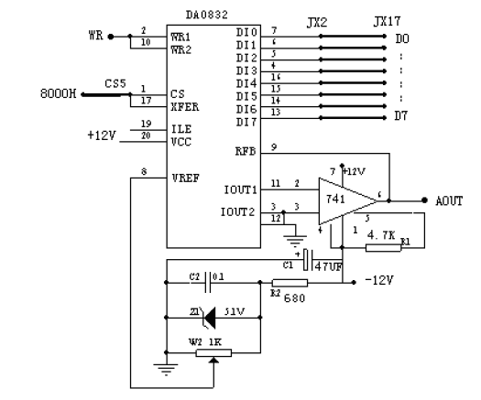

|  |  |  |
| --- | --- | --- |
| **DAC0832（C3 area）** | **System signal area**  **（D2 area）** | **Oscilloscope** |
| CS5 | 8000H |  |
| WR | IOWR |  |
| JX2 | JX17（data bus） |  |
| AOUT |  | Oscilloscope CH1 channel |

**-Procedure-**

**First part:-**

In the first part we were generated a square wave and show it on the oscilloscope, so the square wave has only two levels, 0 which is low voltage and 1 which is high voltage, After we knew this information we could give the DAC a low pulse and a high pulse, and sure we apply some delay to do that.

So we wrote a simple assembly code to do that and the code is:-

############

# Second part:-

In the second part we asked to generate another wave on the oscilloscope ,which is sin wave , and The sin wave has many levels , in each level we have a different value, so we calculated them by using this formula:- 127+127*sin(radians(Angle))

And then we stored the values in an array, and also we took angles from 0° to 360°, and adding 10° each time , so the code will be:-

###########

# The results of this experiment:-

# ##########

# Conclusion:-

In this experiment, we learned how to use the DAC. And how to generate the sine wave and also the square wave.