STRINGS

IN

JAVA

Program 1:

class StrTest1

{

public static void main(String[] args)

{

String s1 = "abcd";

String s2 = "xyz";

String s3 = "abcd";

String s4 = "xyz";

System.out.println("String - 1 : " + s1);

System.out.println("Hash Code of String - 1: " + s1.hashCode() );

System.out.println("String - 2 : " + s2);

System.out.println("Hash Code of String - 2: " + s2.hashCode() );

System.out.println("String - 3 : " + s3);

System.out.println("Hash Code of String - 3: " + s3.hashCode() );

System.out.println("String - 4 : " + s4);

System.out.println("Hash Code of String - 4: " + s4.hashCode() );

}

}

Output:-

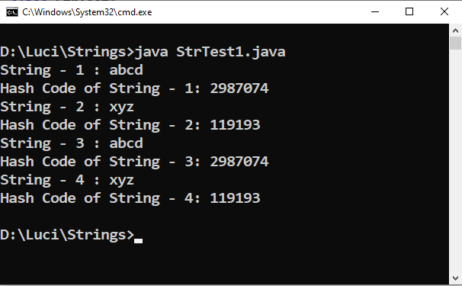

Program 2:

class StrTest2

{

public static void main(String[] args)

{

String s = "abcd";

System.out.println("String : " + s);

System.out.println("Hash Code of String - 1: " + s.hashCode() );

}

}

Output:-

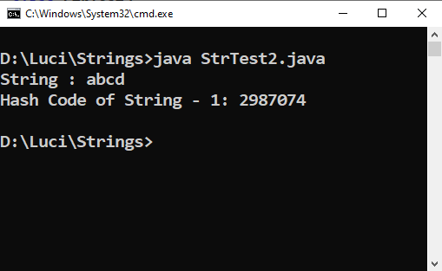

Program 3:

class StrTest3

{

public static void main(String[] args)

{

String s = "abcd"; //String Object is Immutable (Non - Changeable)

System.out.println("String : " + s);

System.out.println("Hash Code of String : " + s.hashCode() );

s = s + "xyz";

System.out.println("After Concatentation .......");

System.out.println("Hash Code of String : " + s.hashCode() );

System.out.println("String : " + s);

String s1 = "abcd";

System.out.println("Hash Code of String : " + s1.hashCode() );

System.out.println("String : " + s1);

}

}

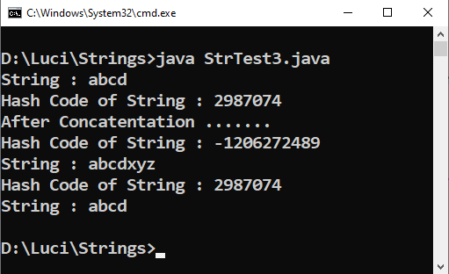Output:-

Program 4:

class StrTest4

{

public static void main(String[] args)

{

String s1 = "abcd";

String s2 = new String("abcd");

char[ ] A = { 'a' , 'b' , 'c' ,'d' , 'e' , 'f' };

String s3 = new String(A,0,4); //Character array to String Conversion ........

System.out.println("String - 1 : " + s1);

System.out.println("String - 2 : " + s2);

System.out.println("String - 3 : " + s3);

System.out.println("Hash Code of String - 1: " + s1.hashCode() );

System.out.println("Hash Code of String - 2: " + s2.hashCode() );

System.out.println("Hash Code of String - 3: " + s3.hashCode() );

}

}

Output:-

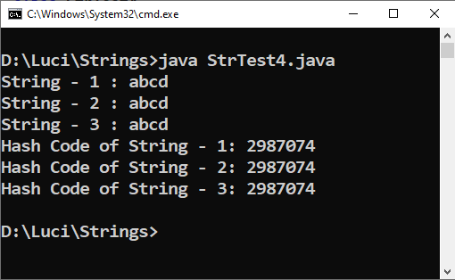

Program 5:

class StrTest5

{

public static void main(String[] args)

{

String s1 = "Hello"; //Immutable Object

StringBuffer s2 = new StringBuffer("Hello");

String s3 = "abcd";

String s4 = "xyz";

System.out.println("String - 1 : " + s1);

System.out.println("Hash Code of String - 1: " + s1.hashCode() );

System.out.println("String - 2 : " + s2);

System.out.println("Hash Code of String - 2: " + s2.hashCode() );

s1 = s1 + "xyz";

s2 = s2.append("xyz"); //append concat ,+ not works

System.out.println("String - 1 : " + s1);

System.out.println("Hash Code of String - 1: " + s1.hashCode() );

System.out.println("String - 2 : " + s2);

System.out.println("Hash Code of String - 2: " + s2.hashCode() );

}

}

Output:-

