Wire-Frames for Quiz Portal

**Login Page/ Landing Page of Quiz Portal.**

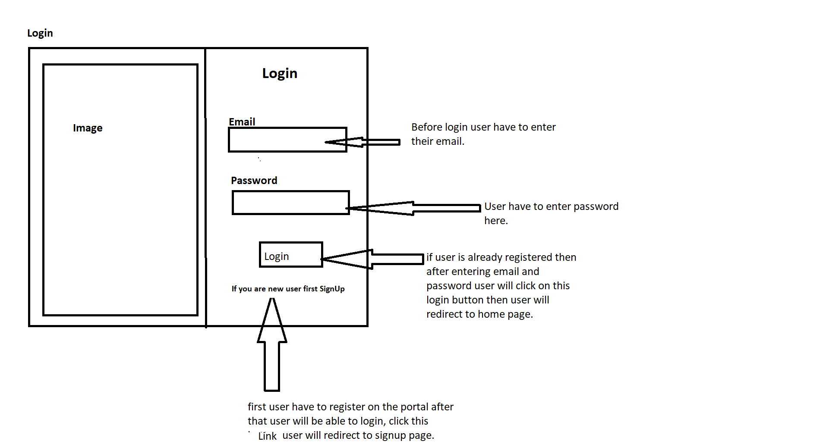

**SignUp Page for new Users-**

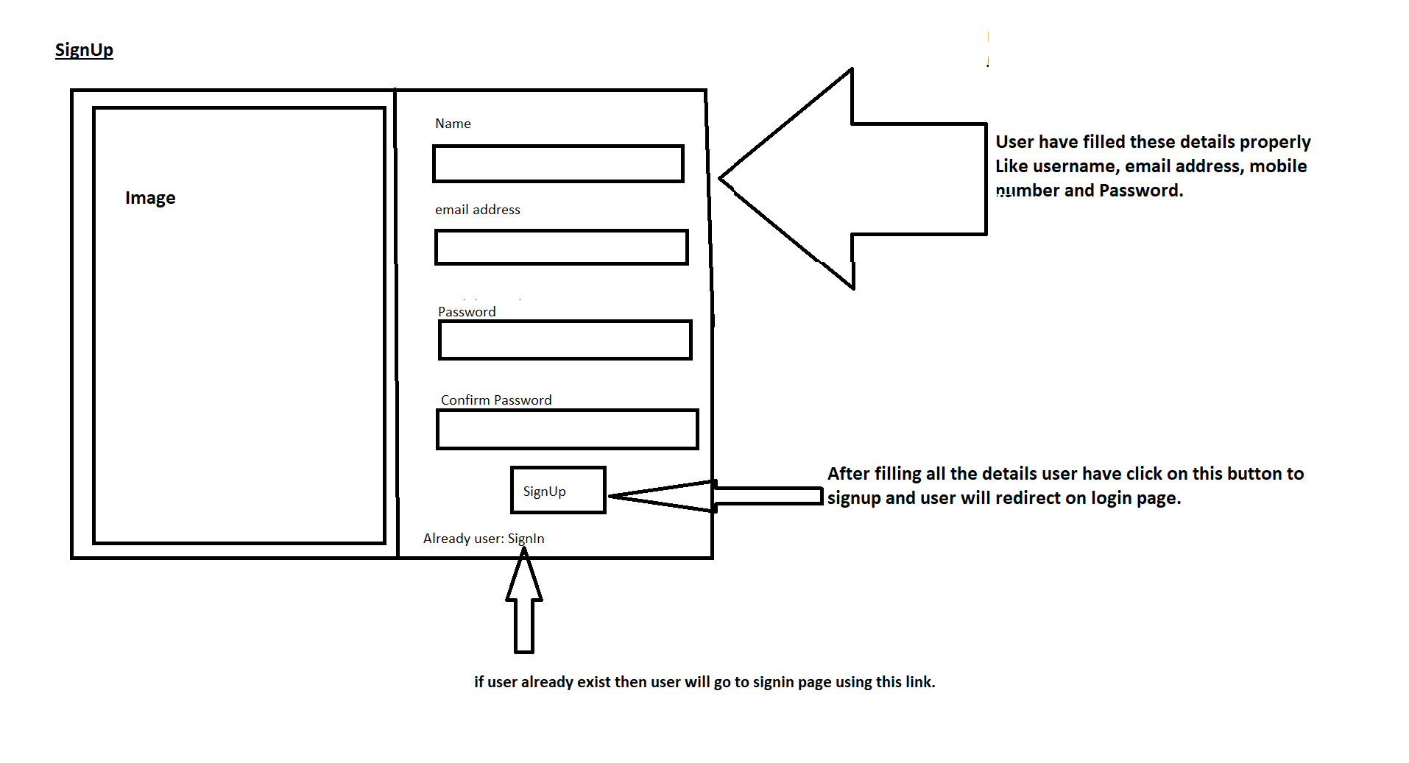

**Home Page of Quiz Portal-**

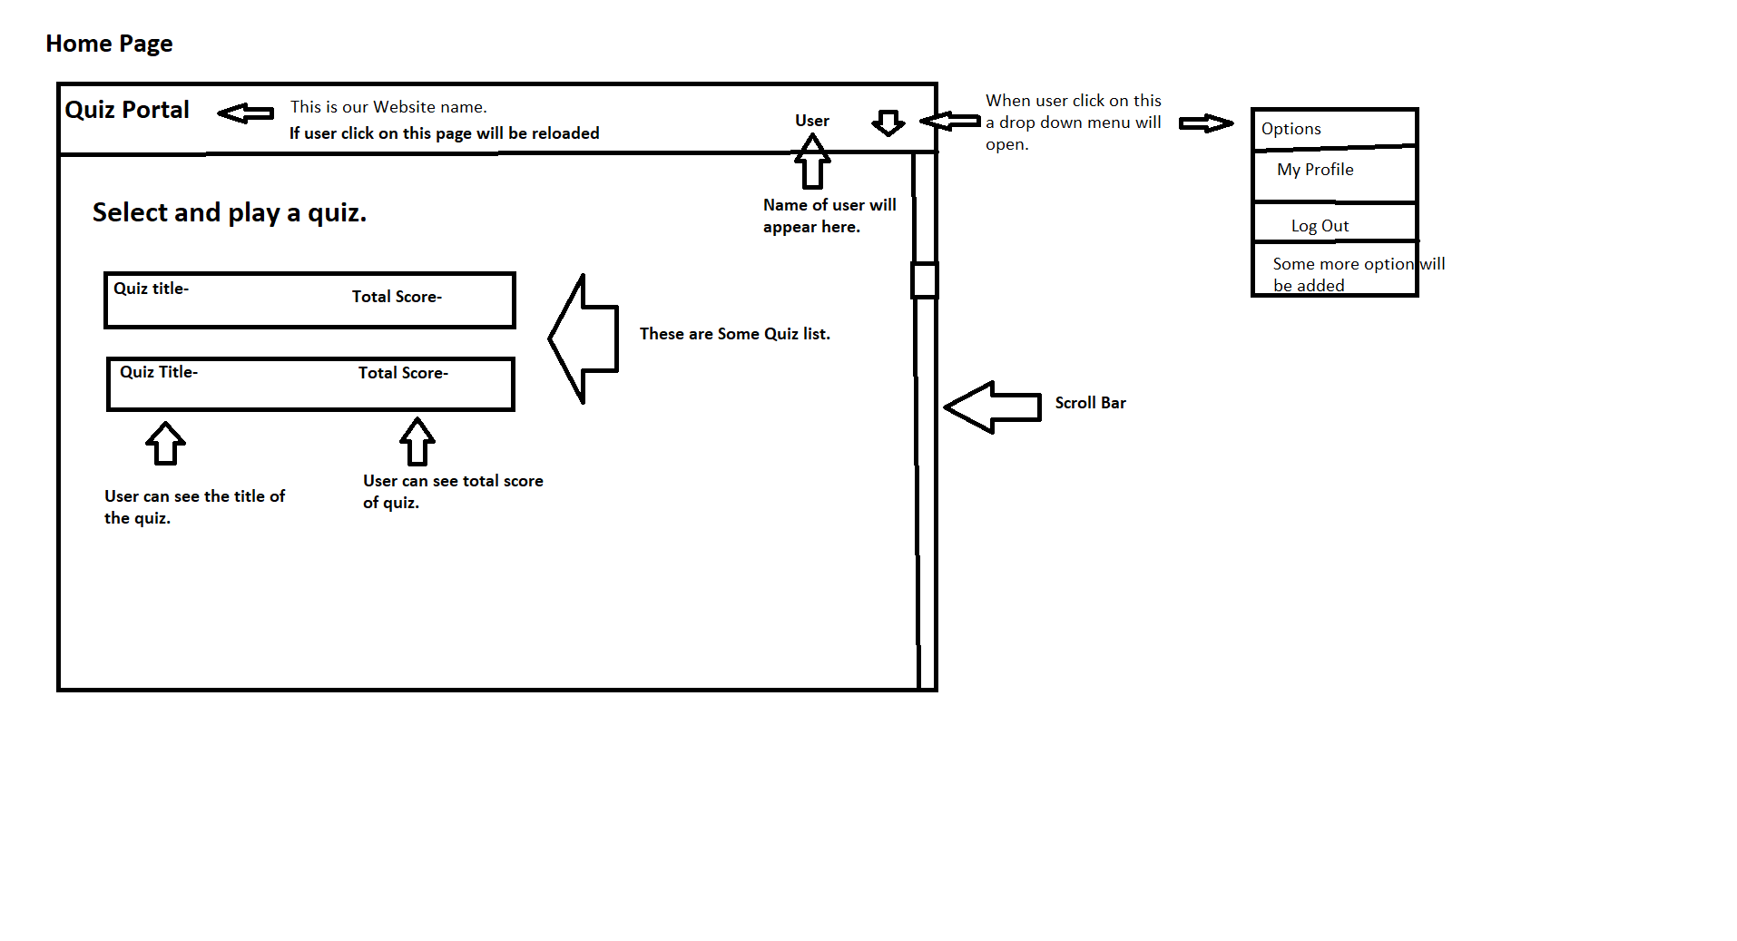

**After Selecting a Quiz User will landed on quiz page-**

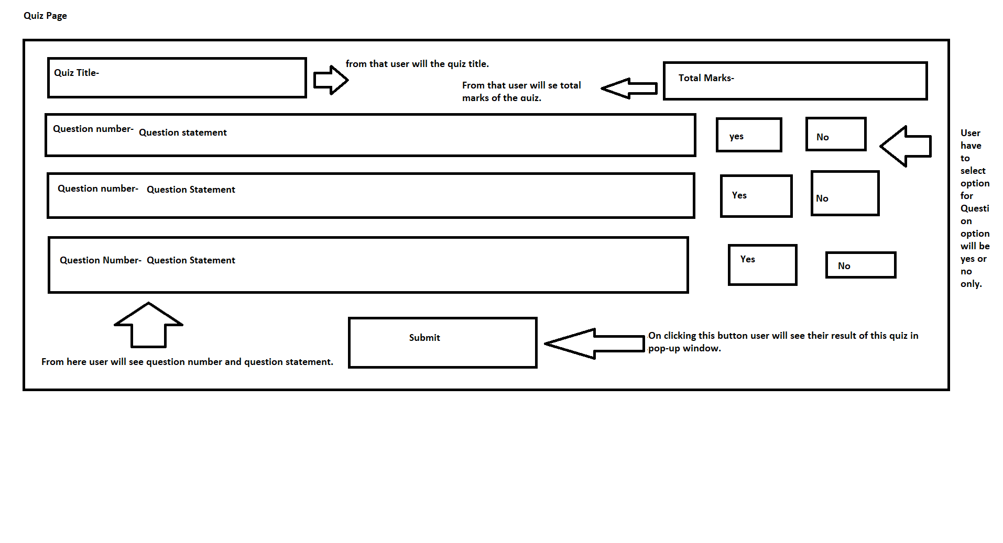

**Score Pop-up Window-**

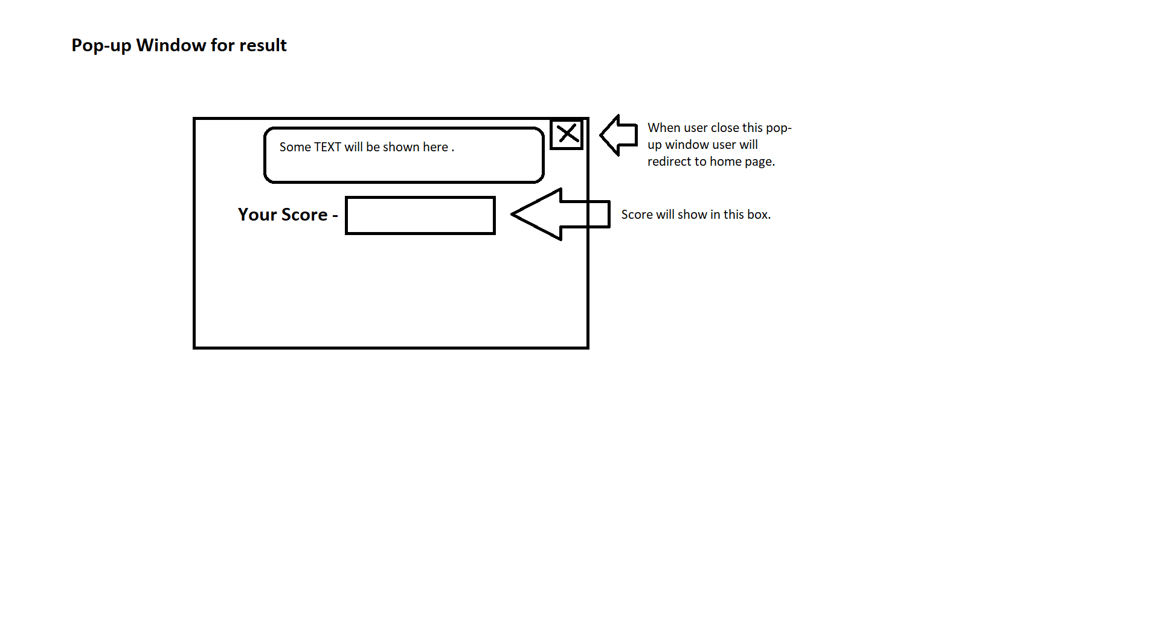

**Edit Profile Section-**

