|  |  |
| --- | --- |
| Name: Mohammad Basheer Al-Sayed, CBAP  Email: [mo_basheer@hotmail.com](mailto:mo_basheer@hotmail.com)  Mobile: +966569761973  [LinkedIn- Profile](https://www.linkedin.com/in/mohammed-basheer-cbap®-8a472a5b) |  |

# PRofessional summary

|  |
| --- |
| * Business Analysis Consultant with more than 25 years’ experience in providing solution with high business value for many branded clients in MEA and Far East regions, during my achievement journeys with international organization like ITS, Huawei, NTG Clarity, AEC, and others. * Played several roles as: Business Consultant, Senior Business Analyst, Product Owner, Service Delivery Manager, Senior System Analyst, and Pre-sales Analyst. * Prepare and present product visions and proposals to management team. * Lead business/technical teams to build new creative digital products and digital transformation for traditional existing products. * Work closely with business teams to identify pains/new opportunities, asees existing solutions, identify valuable solutions, lead technical teams to design and implement solutions * Collaboratively work with stakeholders to define product backlog, identify MVP, plan for product releases. * CBAP *(Certified Business Analysis Professional)* since 2014, * Member of IIBA *(International Institute of Business Analysis* *www.iiba.org**)* since 2009, * More than 11 years in telecoms business area, developing and enhancing business telecoms applications, through my different positions and roles at NTG, Huawei, and ITS, participate in build famous OSS/BSS products like TABS and NTS which used by more than 30 Telecom operators like: Mobily, AirTel, Zain, OTA, Etisalat. * More than 8 years in researching and developing Arabic speech technology and speech applications like Arabic TTS, blind support solution IBSAR, and other applications during my early previous job for Sakhr software. * More than 3 years in Banking industry. * Have transferable KSA Residency. |
| Skills  * Have extensive experience in all of the following:   + Product development and management   + Best practices of business analysis, and data analysis   + Define business needs, select valuable solutions, designing solutions, lead implementation.   + Solutions assessment and validations.   + Communicate and handle customers   + Work through Agile mindset culture.   + Requirement management and issues tracking tools like: enterprise architect, ClearQuest , Rational ClearCase, and JIRA   + Leadership and Influencing   + Business analysis planning.   + Requirements Elicitation, management, and communication   + Enterprise Analysis   + Negotiation and effective communication.   + EDA (Exploratory Data Analysis)   + Regression models, and statistical inference.   + Machine learning. |
| Objective:  * To seek a challenging career in a leading company that provides real growth opportunities. * Looking forward to:   + Practice business analysis and requirements engineering   + Own business processes for customer service deliveries.   + Practice Data Analysis   + Support business analysis teams to master the business analysis skills   + Enhance my skills.   + Share my knowledge with others.   + Keep in track with new technologies. |

# work experience

|  |
| --- |
| Al-Rajhi Bank- since April 2019 Senior Business Analyst/Delivery Manager |
| * Al-Rajhi Digital Dept KSA. <https://www.alrajhibank.com.sa/> * Achievement:   + Lead cross-functional teams to transfer existing retail services to digital era aligned with AlRajhi bank vision of digital transformation for the bank services.   + Lead cross-functional teams to build new from scratch creative digital products. |
| AEC/KSA 2017-2018 Senior Business Analyst/Project Lead |
| * Client: TAQAT portal for HRDF (Human Resource Development Fund) KSA. <https://www.taqat.sa/> * Achievement:   + Effective, trusted communication with the client to define their real business needs.   + Leading business analysis activities to add new and enhance existing human development programs to TAQAT like: Tamheer(On-Job-Training), Professional Certificates, Customer support, Job posting management, employers evaluations,…etc. |
| ISOFT 2016-2016 Senior Business Analyst/Project Lead (http://www.idealsoftemirates.com) |
| * Client: RTA (Road and Transportation Authority) Dubai * Achievement:   + Effective, trusted communication with client to define their real business needs.   + Fully automating management of “driving license field test”. |
| NTG clarity 2013-2016 Consultant/Senior Business Analyst |
| * Clients: Mobily, Orange, RCJY (*Royal Commission for Jubail & Yanbu*) KSA. * Responsible of customer engagement, business analysis, and BA team coaching to develop enhanced and highly business value solutions, and products for NTG customers. represent the customer side during implementation phases to ensure delivering real needed business value for the customer. * Achievement examples:   + Yanbu Smart Compound solution of CRM, network inventory, and asset management.   + “Shariki” wholesale management system, it was great success story for client Mobily *(telecom operator in Saudi Arabia)*.   + Provided training on business analysis skills for more than 10 members of my business analysis team. |
| ITS/Huawei 2007-2013 Senior System Analyst |
| * Senior System/Business Analysis at SDG (Service Development Group), SDG cares about maintaining customer's services provided by TABS platform and applying changes to the product required by customer. * Had two role hates, one related to business engagement with the customer and the other related to system architect and design for TABS. * Achievement: increasing more than 30% of telecom clients to reach 30+ operator using TABS in Middle East, Africa, and Asia. |
| Sakhr software 1998-2007 – IBSAR Product Owner |
| * Speech Researches Department: Programmer, Senior Programmer, and Product Owner. * Achievement:   + Product Owner for “IBSAR” *(complete solution for visually impaired and blind users)* the solution was the approved official solution for ministry of education in Egypt and Saudi Arabia. * Participated in:   + Sakhr TTS (Text To Speech) engine.   + Telephony Applications |
| PACC 1996-1998 |
| * Instructor and Developer for Macintosh platform |

# education and certifications

|  |
| --- |
| Cairo University 1996 |
| * B.Sc. Electronic and communication Engineering, Faculty of Engineering * Grade: Very Good with honor degree * Graduation Project: Paper Rom (2D bar code) (Grade: Distinct) |
| International Institute of Business Analysis 2014 |
| * Certified Business Analysis Professional CBAP® |
| Coursera (Johns Hopkins University) 2017-2018 Certificates: |
| * Practical Machine Learning * R Programing  * Developing Data Products * Regression Models  * Statistical Inference * Reproducible Research  * Exploratory Data Analysis * Data Scientist’s Toolbox  * Getting and Cleaning Data |
| LinkedIn 2016-2018 Certificates: |
| *Agile Product Owner Role: Foundations * Learning Digital Business Analysis, Agile *Requirements Foundations * Data Science and Analytics Career Paths *Cybersecurity Awareness: Backing Up Your Data  *Negotiation, Introduction to Data Governance  *Introduction to Data Science |

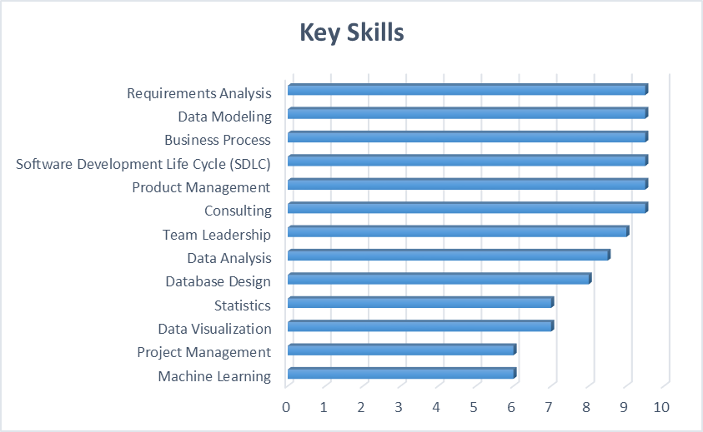

Last Updated: Jun-2022