TELECOM SECTOR DATA ANALYTICS ENGINEER

WEEK 3 REPORT
Feature Engineering & Customer Churn Prediction
Submitted by: Farukh Qureshi
Programme: Telecom Sector Data Analytics Engineer Internship
Dataset: Telco Customer Churn (7,043 customer records)
Model: Logistic Regression
Report prepared from the executed Python results

1. Executive Summary
This week’s work focused on preparing telecom customer data for predictive analysis, creating additional customer-level features, training a churn classification model, and evaluating its performance on a held-out test set. The objective was to identify customers who may discontinue telecom services so that a provider can prioritize retention activities.
The dataset contained 7,043 records and 21 original columns. Eleven blank values in TotalCharges were converted to missing numeric values and handled during cleaning. Four engineered features were added. A Logistic Regression pipeline was trained using a stratified 80:20 train-test split. The model achieved 73.39% accuracy and 79.14% recall for the churn class. Its churn precision was 49.92%, showing that the model captures many churners but also flags a substantial number of customers who do not churn.

2. Objectives
- Inspect and clean the telecom customer dataset.
- Create meaningful features that may improve churn prediction.
- Prepare numerical and categorical variables for machine learning.
- Train a Logistic Regression classification model.
- Evaluate the model using accuracy, precision, recall, F1-score and a confusion matrix.
- Use permutation importance to identify influential input features.
- Translate model findings into practical telecom retention recommendations.

3. Dataset Overview
The project used the Telco Customer Churn CSV file. The observed dataset shape was (7043, 21), meaning 7,043 customer rows and 21 columns. The target variable was Churn, with No mapped to 0 and Yes mapped to 1. The customerID field was excluded from model inputs because it is an identifier rather than a meaningful behavioral predictor.
Item | Observed value | Interpretation
Original records | 7,043 | Customer-level observations
Original columns | 21 | Includes customer attributes, services, charges and churn
Training records | 5,634 | 80% of the dataset
Testing records | 1,409 | 20% held out for evaluation
Missing TotalCharges | 11 | Blank strings became NaN after numeric conversion
Missing values after cleaning | 0 | No missing values remained in the cleaned dataset

4. Data Cleaning
TotalCharges was initially stored as text. A direct missing-value check did not identify the blank strings as null values. The column was therefore stripped of surrounding whitespace and converted with pandas.to_numeric(errors='coerce'). This conversion identified 11 missing numeric values.
All 11 affected records had tenure equal to zero. Since these customers had no completed tenure period and the blank TotalCharges values represented no accumulated charge, the values were filled with 0. Any remaining missing TotalCharges values were set to the column median as a fallback. The final missing-value count was 0.
Reasoning: converting the column to numeric was essential because a machine-learning preprocessing pipeline cannot reliably scale or calculate with text-formatted charges. Filling the zero-tenure records with zero preserves their observed customer status rather than removing 11 valid rows. This assumption should be checked against the dataset's documentation if the data source changes.

5. Feature Engineering
Four additional features were created to represent customer lifecycle, service adoption and household context:
Engineered feature | Construction | Potential business value
TenureGroup | Groups tenure into New (0–12), Short (12–24), Medium (24–48), Long (48–72) months using the defined bins. | Allows comparison of churn risk across customer lifecycle stages.
TotalServices | Counts Yes responses across seven service fields. | Represents breadth of service adoption and possible product engagement.
AverageMonthlySpend | TotalCharges / tenure when tenure > 0; otherwise MonthlyCharges. | Provides a per-tenure-month spending measure; may overlap with MonthlyCharges.
HasFamily | 1 if Partner or Dependents is Yes; otherwise 0. | Represents a household-related customer attribute that may be useful for segmentation.
These engineered features were added alongside the original predictors. They are candidate predictors, not proof of causation. In particular, AverageMonthlySpend is derived from TotalCharges and tenure, so it can contain information similar to existing billing fields.

6. Preprocessing and Model Development
The target Churn was encoded as No = 0 and Yes = 1. CustomerID and the target column were removed from X. Numerical and categorical columns were detected separately.
- Numerical variables: median imputation followed by StandardScaler.
- Categorical variables: most-frequent imputation followed by OneHotEncoder(handle_unknown='ignore').
- A ColumnTransformer applied the appropriate processing to each variable group.
- The Logistic Regression classifier used max_iter=1000, class_weight='balanced' and random_state=42.
- The dataset was split with test_size=0.20, random_state=42 and stratify=y.
The balanced class-weight setting increases the penalty associated with errors on the minority churn class. This is a deliberate choice when missing a customer who is about to leave may be costly. It can, however, increase false-positive churn predictions.

7. Model Evaluation
The executed model produced the following results on 1,409 test records:
Metric | Score | Meaning
Accuracy | 73.39% | Share of all test predictions that were correct.
Precision (churn class) | 49.92% | Of customers predicted to churn, about half actually churned.
Recall (churn class) | 79.14% | The model identified about 79% of actual churners.
F1-score (churn class) | 61.22% | Balance between churn precision and churn recall.
Interpretation: accuracy alone is not sufficient for this imbalanced classification task. The churn recall of 79.14% is useful for screening because the model detects a large share of actual churners. However, precision of 49.92% means many flagged customers will not actually churn. A retention team should therefore treat the output as a prioritization signal, not as a definitive churn decision.

8. Confusion Matrix
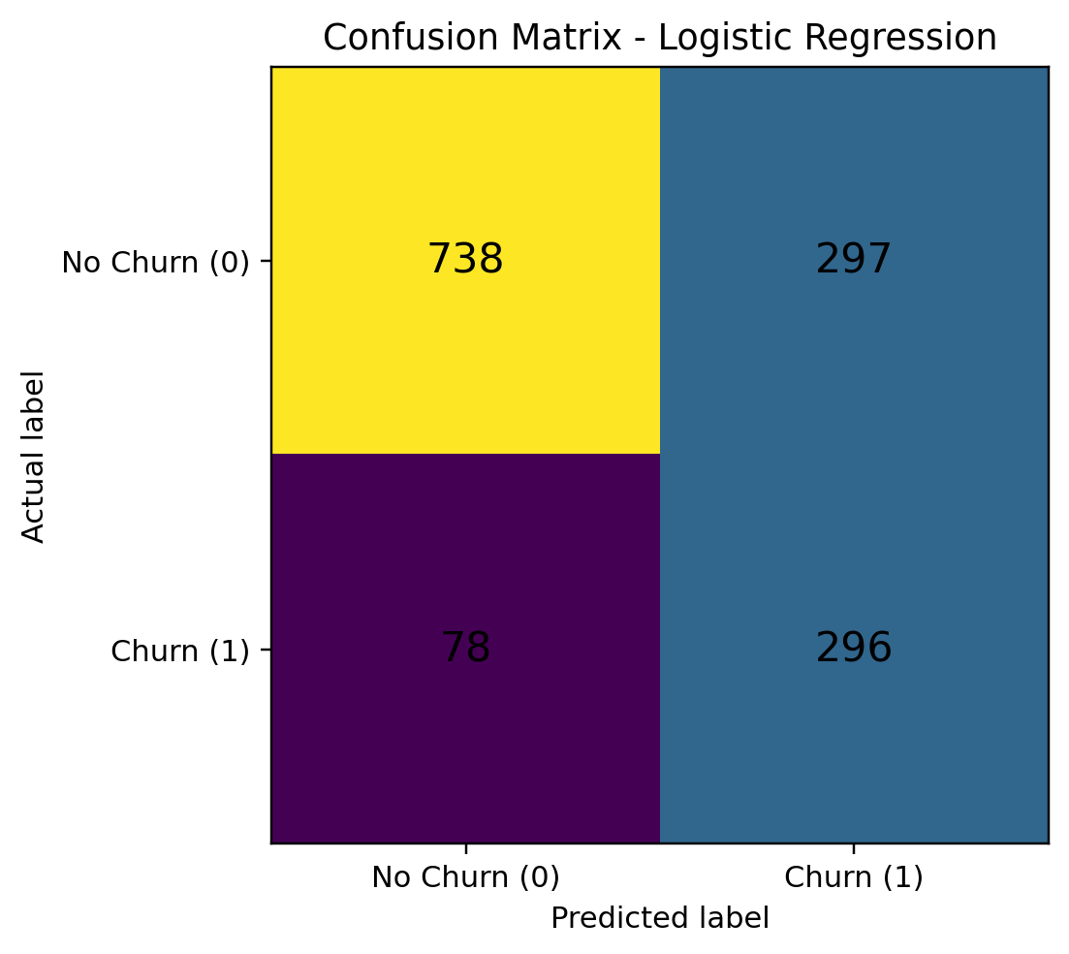
Figure 1. Confusion matrix from the held-out test set.
The matrix is [[738, 297], [78, 296]] using rows as actual classes (No Churn, Churn) and columns as predicted classes (No Churn, Churn). Therefore: 738 true negatives, 297 false positives, 78 false negatives and 296 true positives. The 78 false negatives represent customers who actually churned but were not identified by the model. The 297 false positives represent customers flagged for churn who did not churn in the test data.

9. Feature Importance
Permutation importance was calculated on the held-out test set using recall as the scoring metric and five repeats. Each feature is shuffled and the resulting change in recall is measured. A larger positive value indicates that shuffling the feature reduced recall more.
Rank | Feature | Mean importance
1 | tenure | 0.216043
2 | Contract | 0.112299
3 | InternetService | 0.062032
4 | MonthlyCharges | 0.013904
5 | AverageMonthlySpend | 0.003743
6 | OnlineSecurity | 0.003209
7 | PaymentMethod | 0.001070
8 | HasFamily | 0.000000
9 | PhoneService | 0.000000
10 | SeniorCitizen | -0.000535
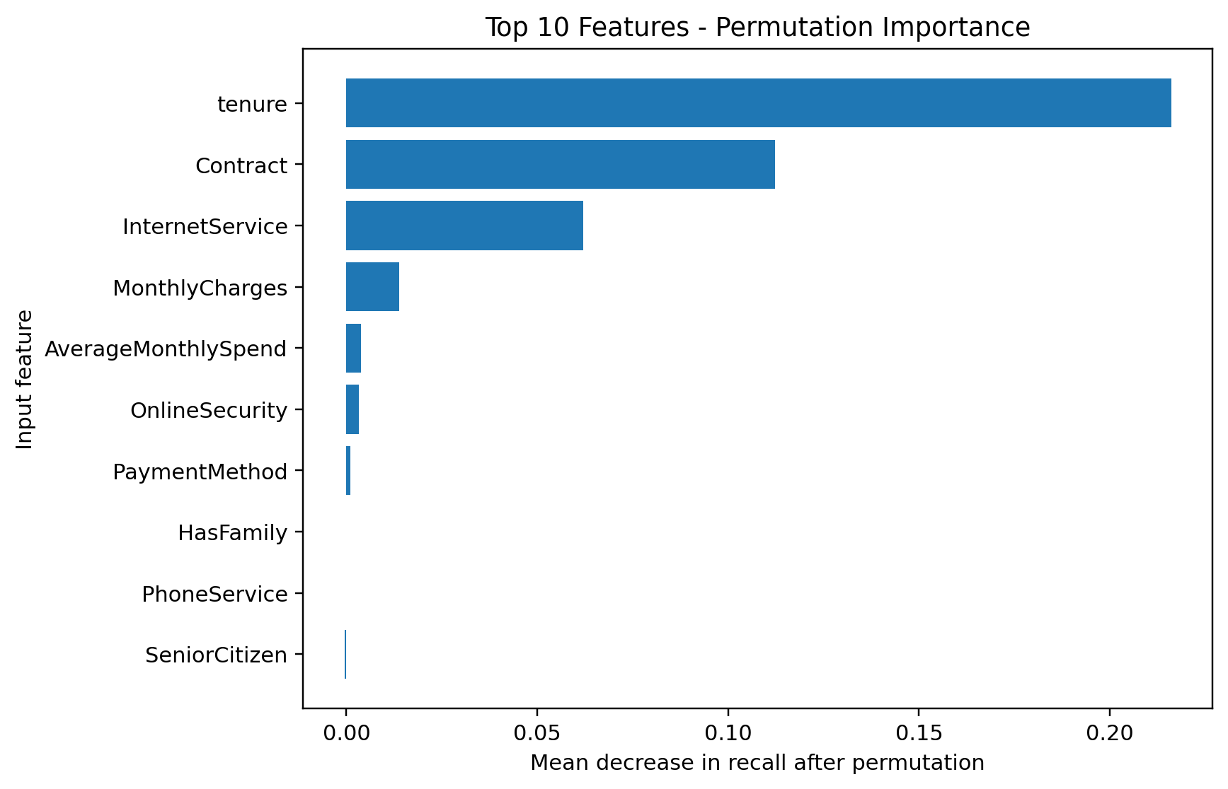
Figure 2. Top 10 features by permutation importance (recall scoring).
Tenure had the highest observed importance (0.216043), followed by Contract (0.112299) and InternetService (0.062032). MonthlyCharges was lower (0.013904). The remaining listed features had values close to zero, and SeniorCitizen had a small negative value (-0.000535). A negative or near-zero permutation score does not mean the feature is harmful; it means shuffling it did not reduce recall in this particular test run and can reflect noise, redundancy or limited incremental contribution.
Business interpretation: tenure and contract type are strong segmentation signals in this model. A telecom provider could examine onboarding and early-tenure customer experience, and compare retention outcomes across contract types. The feature-importance result is associational and does not establish that changing a feature will cause churn to fall.

10. Business Recommendations
- Prioritize early-tenure customers for onboarding support, service education and proactive issue resolution.
- Review churn rates and customer feedback by contract type before designing contract-specific retention offers.
- Investigate service-quality and support issues across internet-service categories.
- Use the model to create a review list for retention agents, then validate customer circumstances before offering discounts.
- Track false positives and false negatives after deployment so the retention team can tune the decision threshold to its budget and campaign capacity.

11. Limitations and Future Improvements
- The analysis uses one customer churn dataset and one random train-test split; performance may differ on new regions, time periods or customer populations.
- No cross-validation or external validation dataset was used. Future work should use stratified cross-validation and, where possible, a time-based holdout.
- The model has moderate precision (49.92%), so retention campaigns based only on predicted churn may contact many customers who would stay.
- The class-weight setting favors recall but may increase false positives. A probability-threshold analysis should compare recall, precision and campaign cost.
- Some engineered variables overlap with original variables. Feature redundancy and stability should be assessed before deployment.
- Permutation importance was computed on the test set for this exploratory report. For a stricter model-selection workflow, calculate feature importance on a validation set or training folds and reserve the final test set for one-time evaluation.
- Further models such as Decision Tree, Random Forest or Gradient Boosting can be compared using the same split and evaluation metrics.
- The dataset is not a live operational feed. A real deployment requires current customer data, privacy controls, monitoring and periodic retraining.

12. Conclusion
Week 3 successfully completed the end-to-end development of a baseline telecom churn classification workflow. The data was cleaned, four features were engineered, numerical and categorical preprocessing was applied, and a balanced Logistic Regression model was evaluated. The model achieved 73.39% accuracy and 79.14% churn recall. Tenure, Contract and InternetService were the most influential features in the reported permutation importance analysis. The results provide a useful starting point for customer-retention analysis, but the model should be validated and its precision/recall trade-off improved before operational use.

Appendix: Generated Project Artifacts
- week3_model.py – end-to-end data cleaning, feature engineering, training and evaluation code.
- week3_model_results.csv – model metric summary.
- week3_confusion_matrix.png – confusion matrix visualization.
- week3_feature_importance.csv – permutation importance values.
- week3_feature_importance.png – top 10 feature importance visualization.

