**Deep Learning**

**Techniques in IDS (3)**

Wednesday, June 25, 2025

Table of Contents

1 LSTM/BiLSTM/GRU 2

1.1 Structure 2

1.2 Training Validation Result 3

1.2.1 CIC_IDS_2017 3

1.2.2 CIC_TON_IOT 4

1.3 Test Result 5

1.3.1 CIC_IDS_2017 5

1.3.2 CIC_TON_IOT 6

1.3.3 CIC_IDS_2017 6

2 Auto Encoder Decoder Classifier/ CNN_LSTM 7

2.1 Structure 7

2.2 Train Validation Result 8

2.2.1 CIC_IDS_2017 8

2.2.2 CIC_TON_IOT 9

2.3 Test Result 10

2.3.1 CIC_IDS_2017 10

2.3.2 CIC_TON_IOT 11

3 FINAL RESULTS 12

3.1 CIC_IDS_2017 12

3.2 CIC_TON_IOT 13

4 NOTES 14

# LSTM/BiLSTM/GRU

## Structure

|  |  |
| --- | --- |
| Figure : LSTM Structure. | Figure : BiLSTM Structure. |
| Figure : GRU Structure. | |

## Training Validation Result

### CIC_IDS_2017

|  |  |
| --- | --- |
|  |  |
|  |  |

### CIC_TON_IOT

|  |  |
| --- | --- |
|  |  |
|  |  |

## Test Result

### CIC_IDS_2017

|  |
| --- |
|  |
|  |

### CIC_TON_IOT

|  |
| --- |
|  |
|  |

### CIC_IDS_2017

# Auto Encoder Decoder Classifier/ CNN_LSTM

## Structure

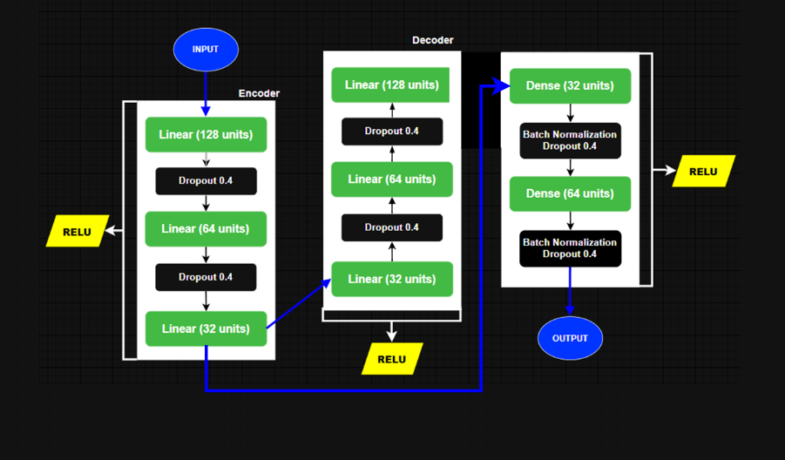

Figure : Auto Encoder Decoder Structure.

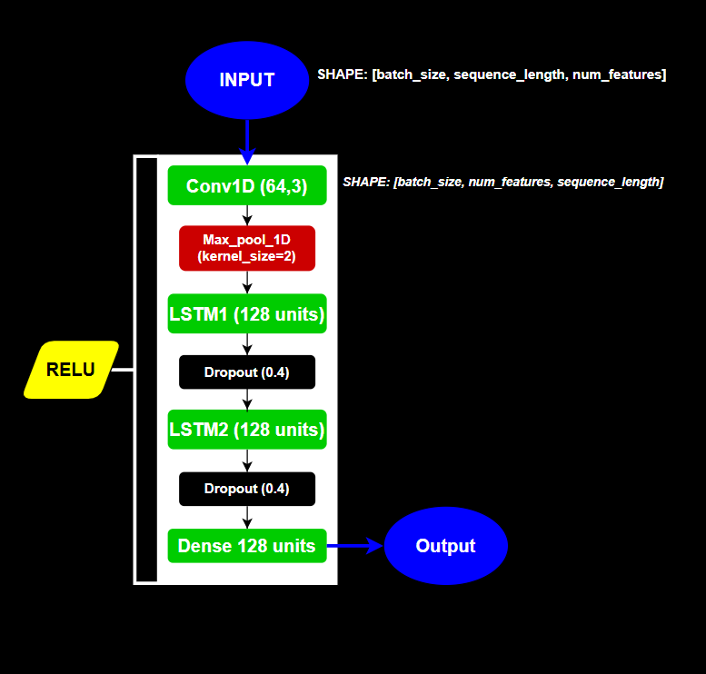

Figure : CNN_LSTM_UB Structure.

## Train Validation Result

### CIC_IDS_2017

|  |  |
| --- | --- |
|  |  |
|  |  |

### CIC_TON_IOT

|  |  |
| --- | --- |
|  |  |
|  |  |

## Test Result

### CIC_IDS_2017

|  |
| --- |
|  |
|  |

### CIC_TON_IOT

|  |
| --- |
|  |
|  |

# FINAL RESULTS

## CIC_IDS_2017

|  |
| --- |
|  |
|  |

## CIC_TON_IOT

|  |
| --- |
|  |
|  |

# NOTES

While searching for an AutoEncoderDecoder-based IDS model in recent research papers, I was unable to find one that directly fits our use case. Most models were either limited to encoders without a decoding component, or were developed for entirely different domains, making them unsuitable for adaptation to network intrusion detection. However, I did find an interesting CNN-LSTM architecture, which I evaluated under the name CNN_LSTM_UB.

The CNN_LSTM_2 is a model that we simulate from the research paper:

* IOT-BASED INTRUSION DETECTION SYSTEM USING NEW HYBRID DEEP LEARNING ALGORITHM

Similarly, the CNN_LSTM_UB is a model simulated from an existing one in the research paper:

* DDOS ATTACK DETECTION USING HYBRID (CCN AND LSTM) ML MODEL

Additionally, visualizations and performance graphs are available on **Weights & Biases** at the following links:

* [CIC-IDS-2017 Results](•%09https:/wandb.ai/mohammad-fleity-lebanese-university/DL-NIDS-2--cic-ids-2017?nw=nwusermohammadfleity)
* [CIC-TON-IoT Results](https://wandb.ai/mohammad-fleity-lebanese-university/DL-NIDS-2--cic-ton-iot/workspace?nw=nwusermohammadfleity)

All notebooks (excluding the one shared by Mr. Thermos) are available on [**GitHub**](https://github.com/Mohammad-Fleity2002/DL_IDS.git), which contains:

* Reports DL_1, DL_2 and the DL_3.
* Notebook used.
* An excel that include the final results.

**Thank you for your Time.**