

Movie Store

DR. Charbel Gemayel



July 14, 2023

LEBANESE UNIVERSITY FACULTY OF SCIENCE



Table of Contents

Subject**: Movie Store** 2

**Implementation** 3

1. Identity and Login Functionality: 3

2. Authentication and Authorization: 4

3. Multiuser Application: 6

4. Functionality: 6

5. MVC: 11

6. Database (***MovieStore2***): 12

# Subject**: Movie Store**

The subject is to create a simple Movie store website that

1. Allow an admin to
   1. add/remove/edit a movie definition (Title, Cast, Director, Poster and Release Year)
   2. add/remove/edit a genre of movie (Horror, Action, Adventure ...)
   3. see all the genres and movies that are available in the database and manage them
   4. assign to each movie the corresponding genres
2. Allow a normal User to:
   1. create a user account
   2. Login as a user
   3. examine all provided movies
   4. search for a certain movie by providing the least similar title.
   5. Logout

System should

1. Prevent a normal user to access Admin functionality (***Authorization***)
2. Prevent any unauthorized access (***Authentication***)
3. Prevent user from creating week passwords

# **Implementation**

The Code will be available on [GitHub](https://github.com/Mohammad-Fleity2002/MovieStore.git)

## Identity and Login Functionality:

* 1. Login page:

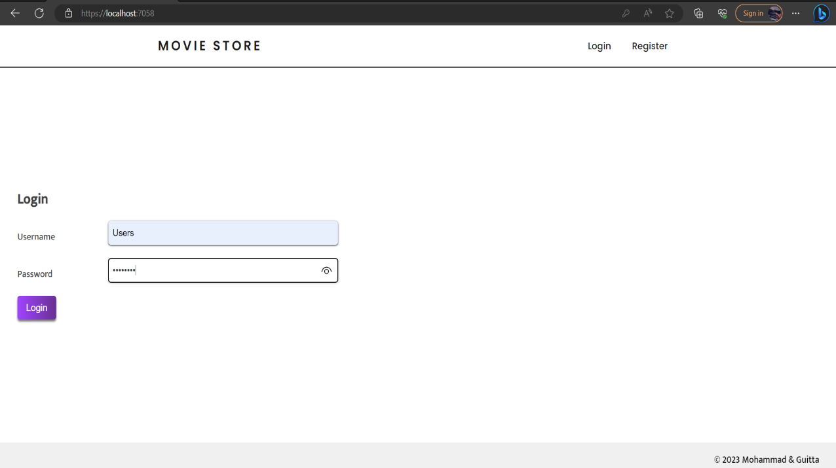

Login handler:

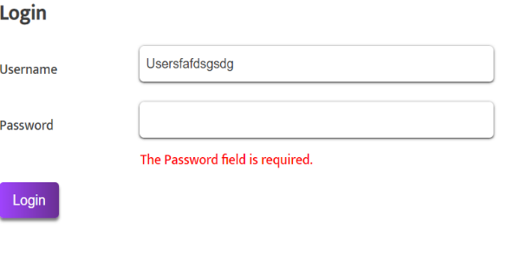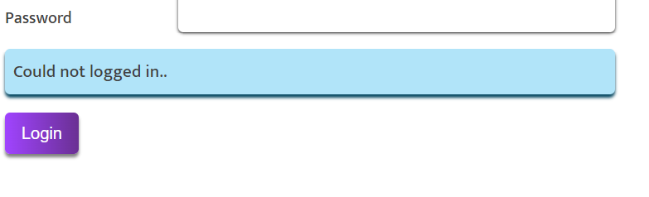

* 1. Register Page:

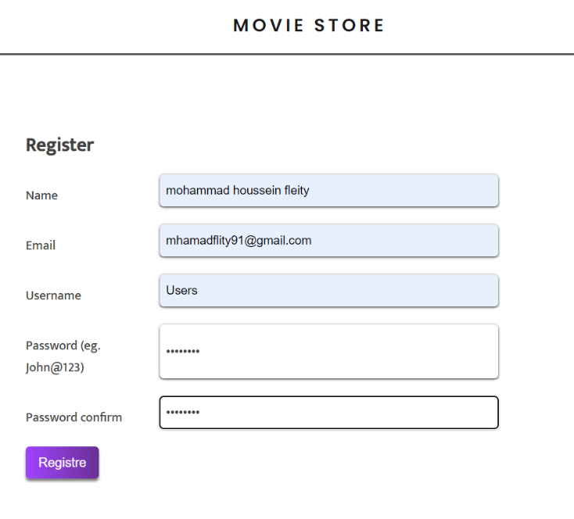 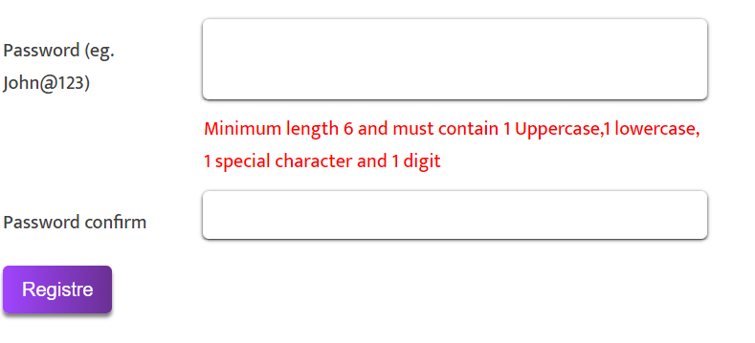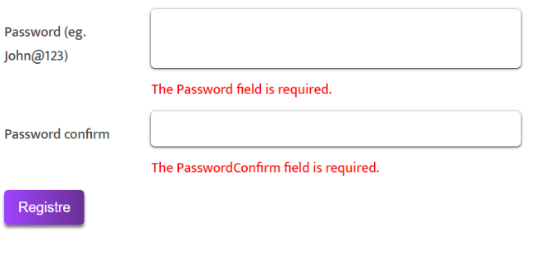

User Added successfully:

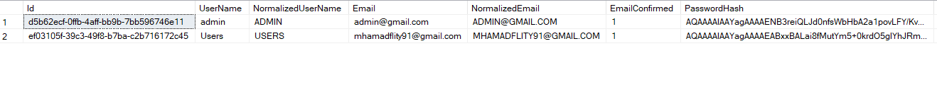

* 1. Logout:

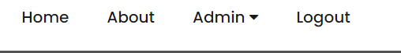

## Authentication and Authorization:

* 1. Prevent Unauthorized access:

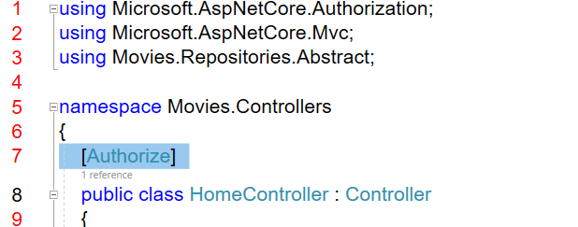

Redirecting them to our custom login age:



* 1. Preventing Normal User to access Admin Functionality:

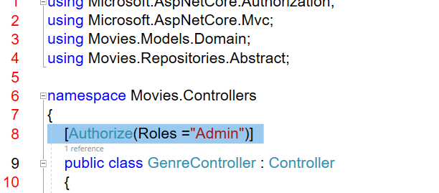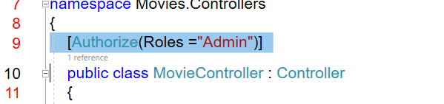

Navigation bar:

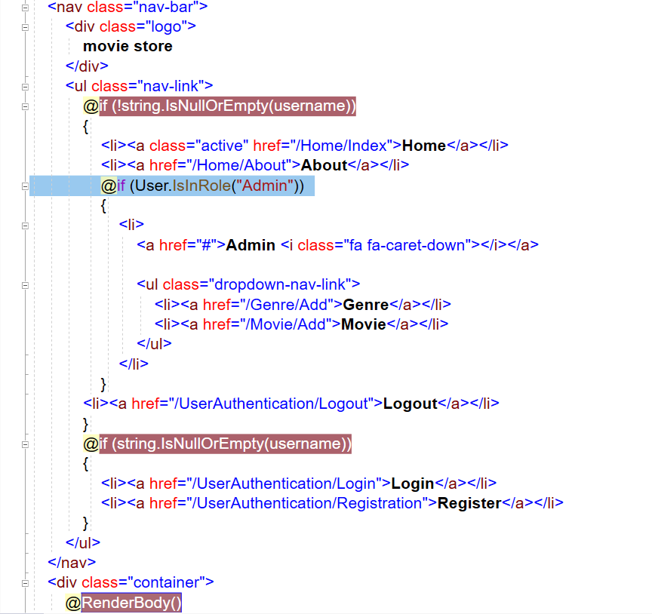

## Multiuser Application:

* 1. User Home Page:

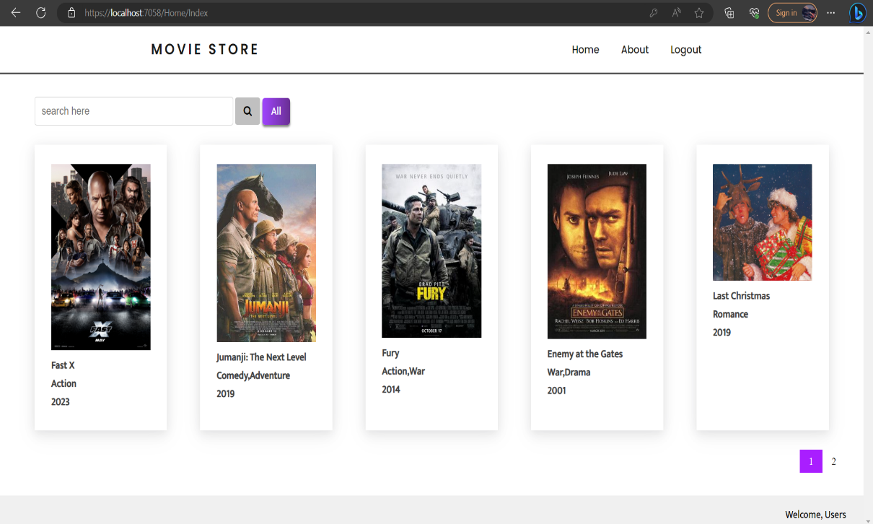

* 1. Admin Page:

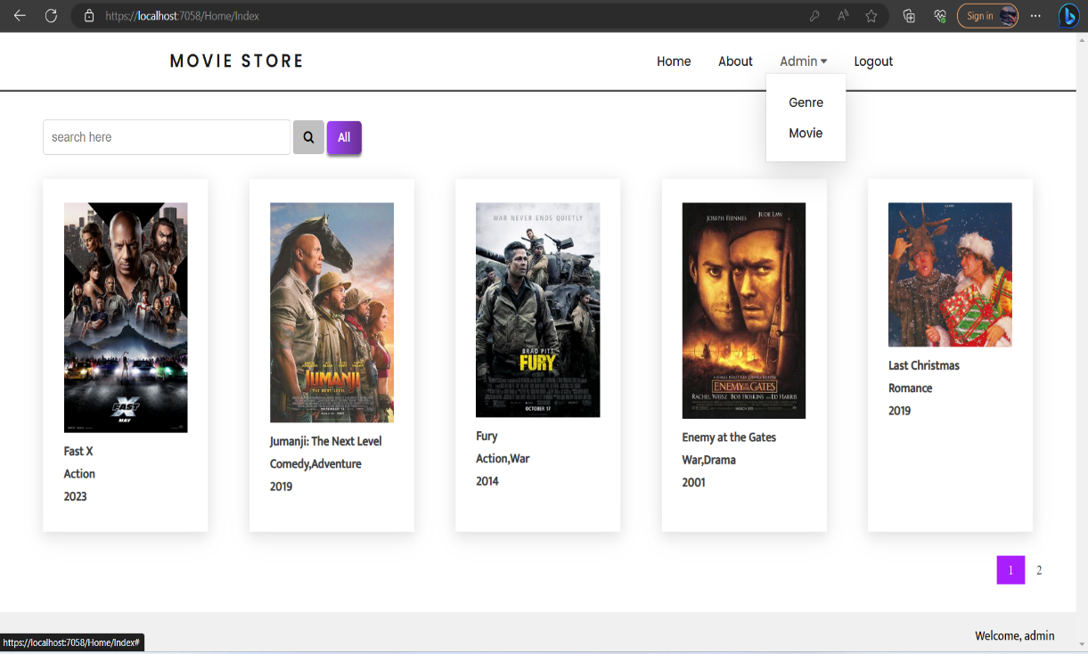

## Functionality:

* 1. Movie Managing (admin):

Add Movie: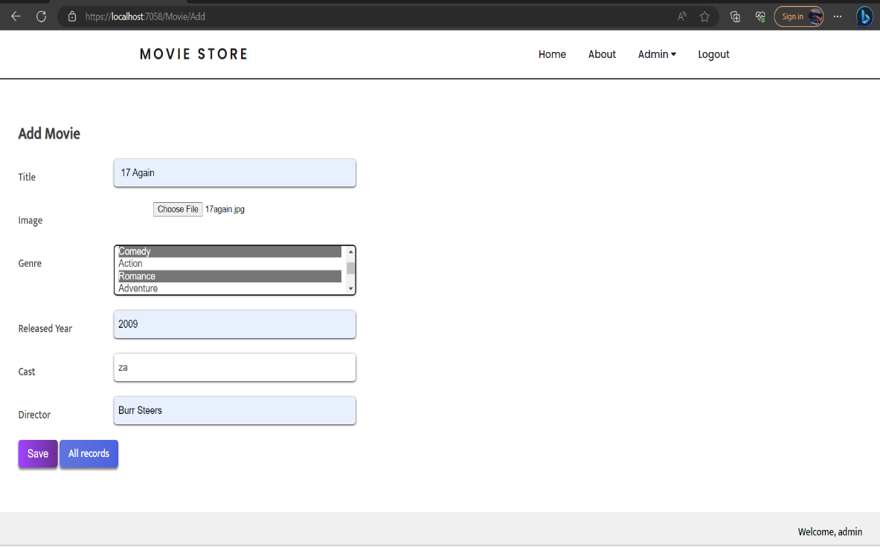

All Movie:

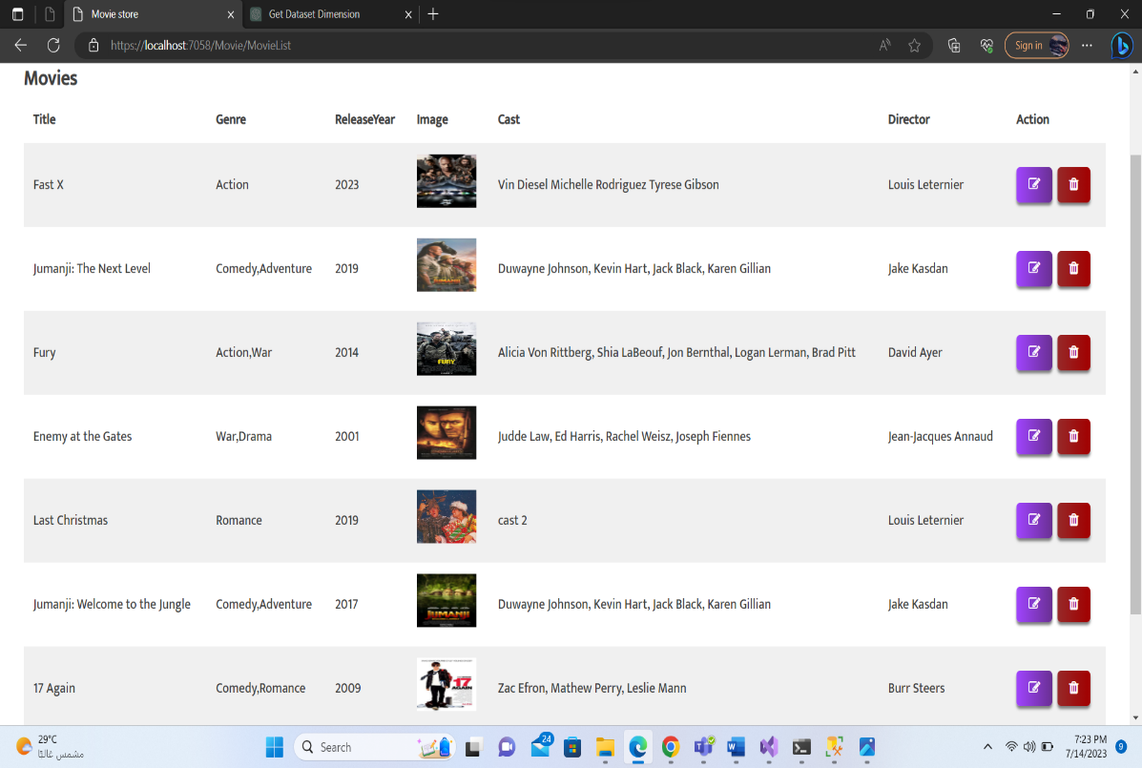

Update Movie:

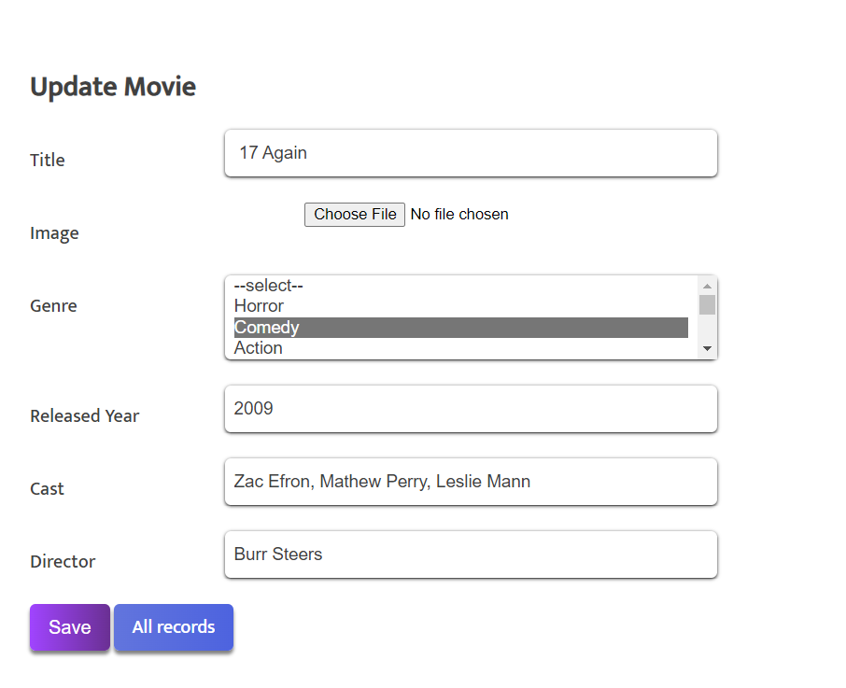

Movie Added Successfully:

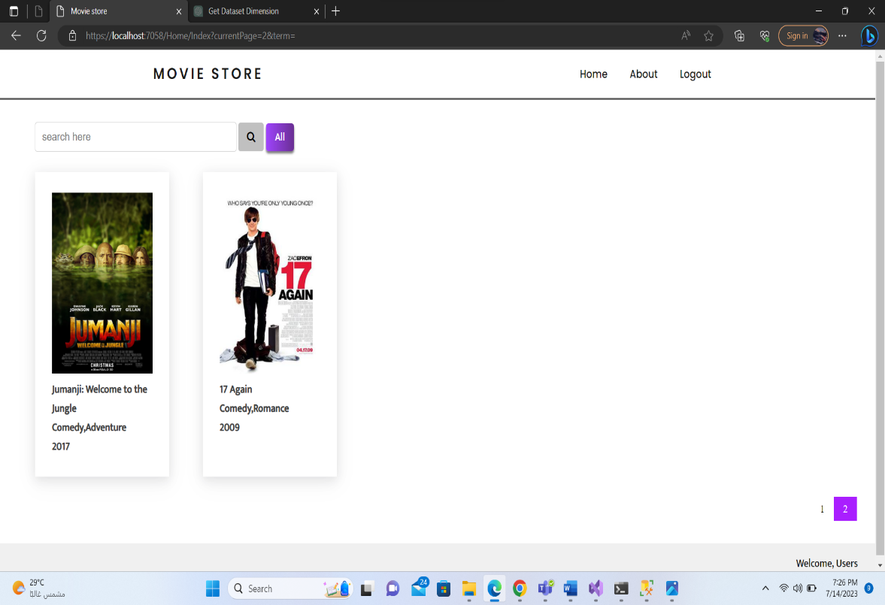

* 1. Genres Managing (Admin)

Add Genres:

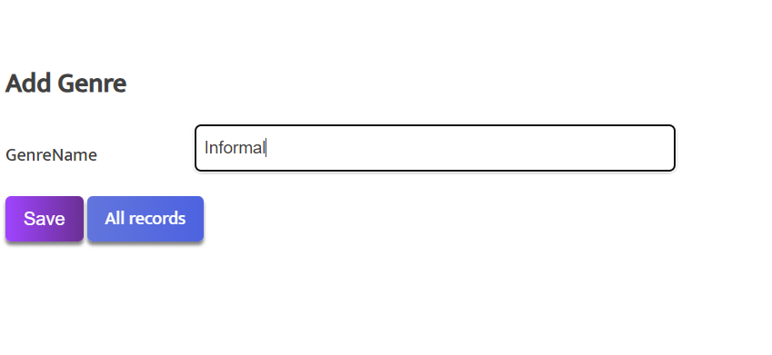

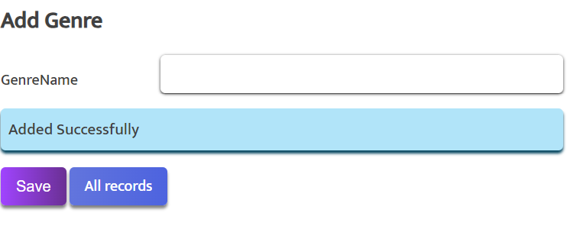

All Genres, Genre Added Successfully:

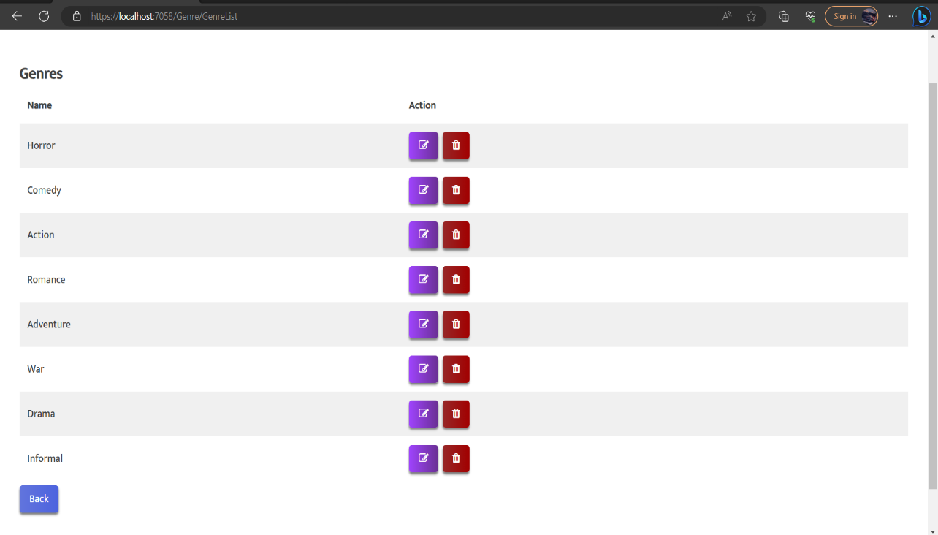

* 1. Search:

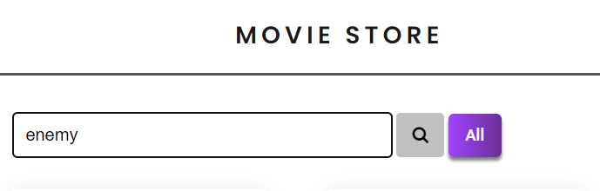

Result:

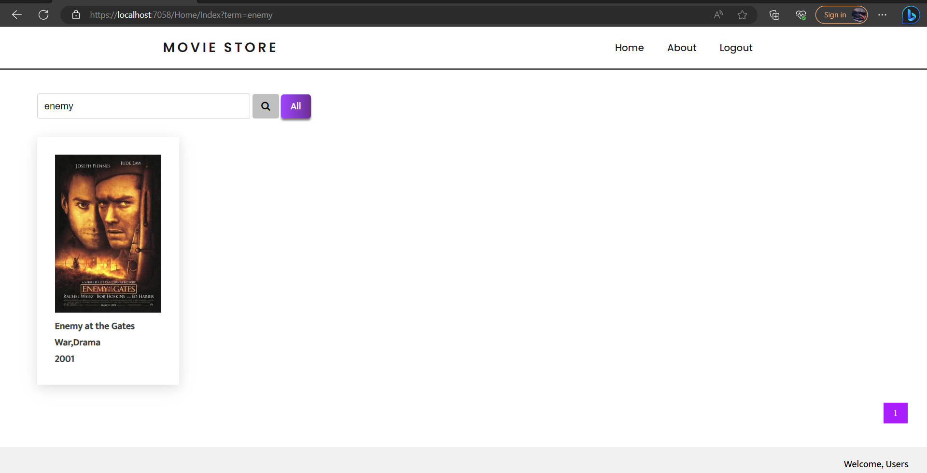

* 1. Movie Detail:

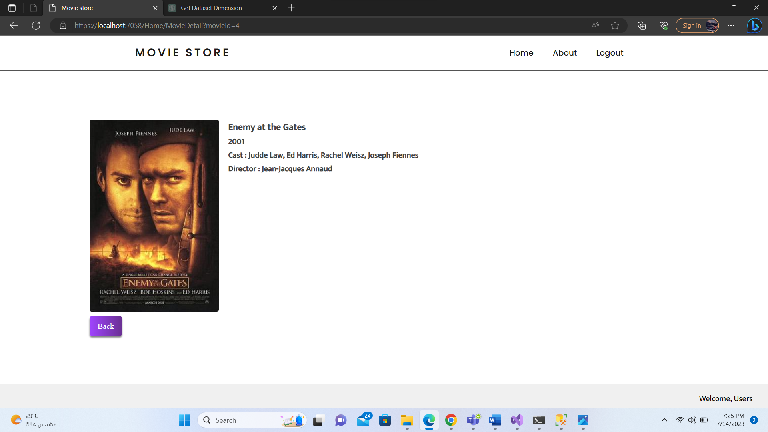

## MVC:

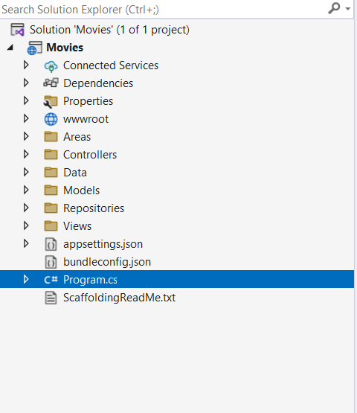 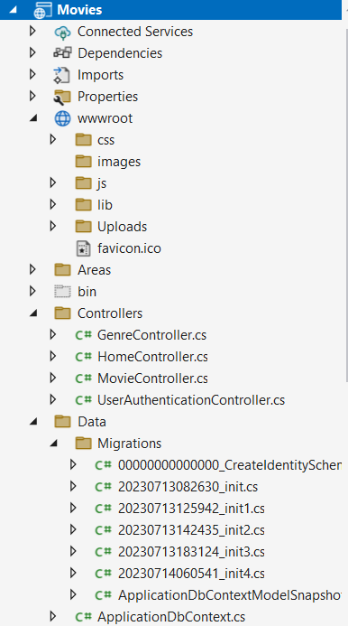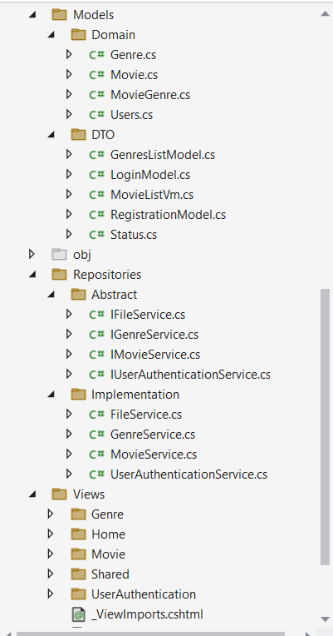

## Database (***MovieStore2***):

