

MIAI515: Advanced XAI for Computer Vision Applications.

Semantic Segmentation XAI Evaluation

Prepared for
Dr. AbdulKarim GIZZINI

Prepared by
Mohammad Fleity
Karine Melhem

May 1, 2025

Table of Contents
I. Impact Of Threshold 3
On M1 3
On M2 4
On M3 4
Conclusion: 5
II. Segmentation Score on M3: 5
III. Considering Second Decoder Block: 6
Conclusion 8
IV. Final Conclusion 8

Impact Of Threshold
On this part we’ve tried four threshold values 0.4 (the default), 0.2, 0.6 and 0.8 on all three types of evaluation M1. M2, M3. Then we calculate the percentage of the drop in the Segmentation Score (SS) for M1 and M2, as well as the percentage of increase in entropy for M3

On M1
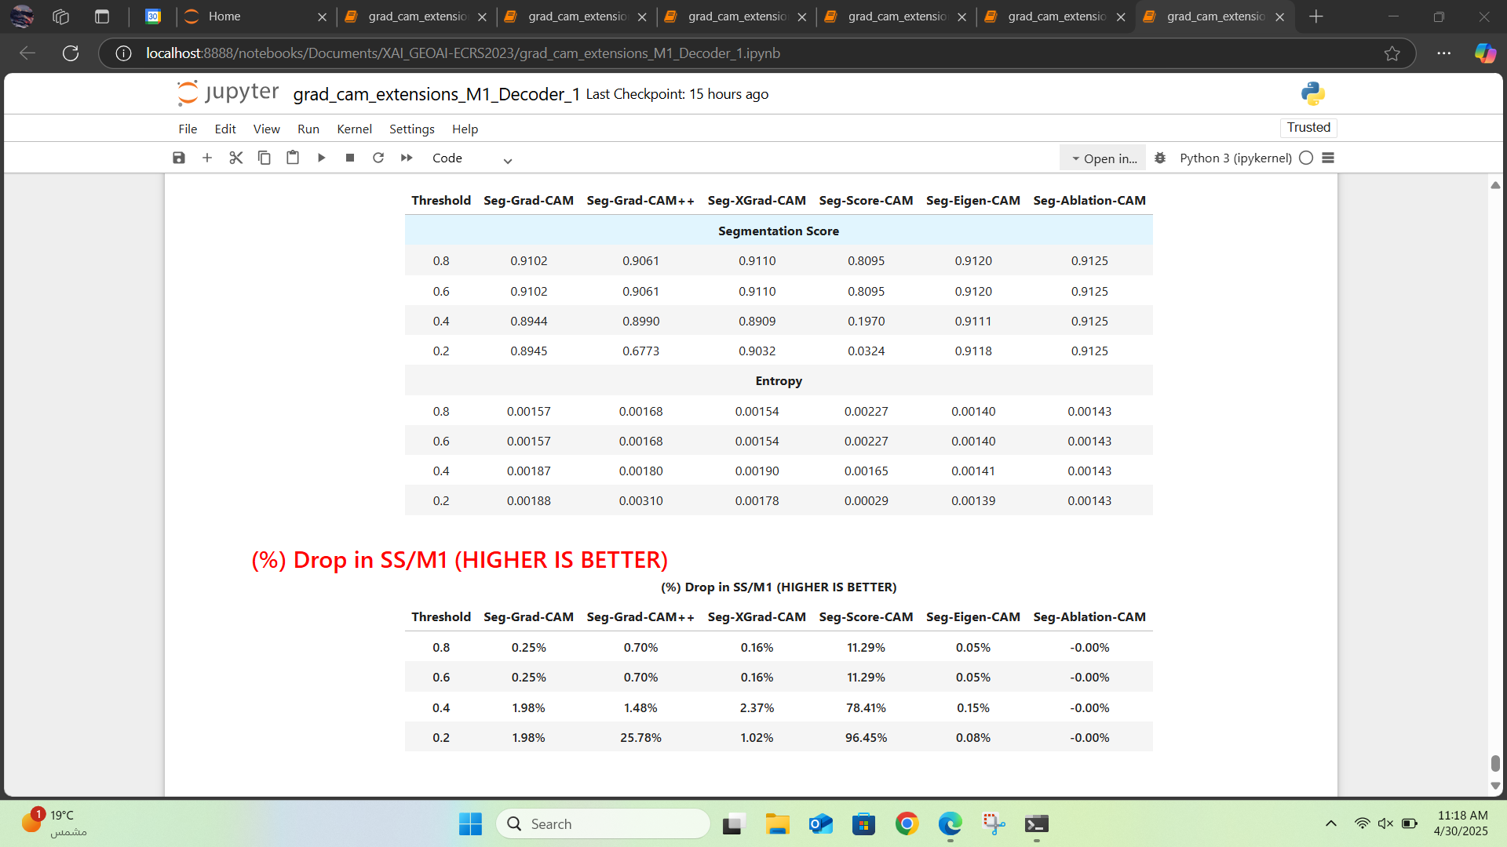
Figure 1: Evaluation of Threshold Impact on M1 (decoder_idx=1).
As we can see in the tables in Figure 1, the lower the threshold, the higher the percentage drop in Segmentation Scores (SS%) relative to M1, which indicates a negative correlation between threshold relaxation and SS preservation. This trend suggests that decreasing the threshold improves the evaluation outcome for most methods, and leads to a higher drop in segmentaion score indicating the less impact that the background have on the model detecting the buildings in the image. for e.g.: the Seg-Score-CAM had a drop of 11% at Threshold 0.8 and it picks up to nearly 96% at Threshold 0.2. The second good example is the Seg-Grad-CAMM++ which goes from 1% at Threshold 0.8 to 26% at Threshold 0.2.

On M2

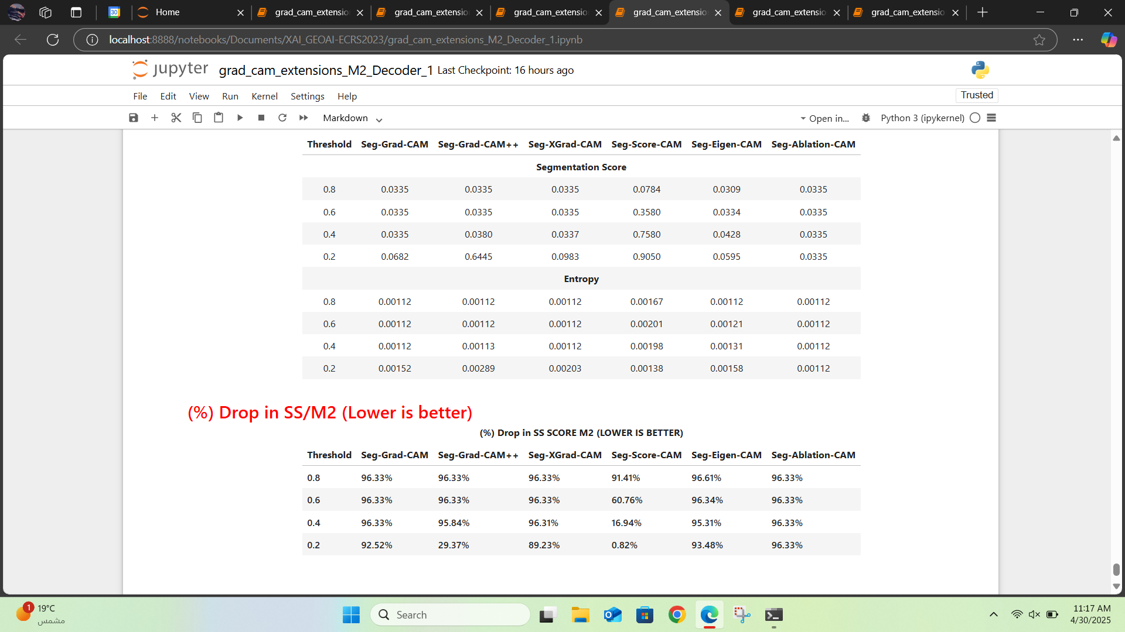
Figure 2: Evaluation of Threshold Impact on M2 (decoder_idx=1).
Figure 2, show us that the lower the threshold, the lower the percentage drop in Segmentation Scores (SS%) relative to M2, which indicates a positive correlation between threshold relaxation and SS preservation. This trend suggests that decreasing the threshold improves the evaluation outcome for most methods, for e.g.: the Seg-Score-CAM had a drop of 91% at Threshold 0.8 and it drops to nearly 1% at Threshold 0.2.

On M3

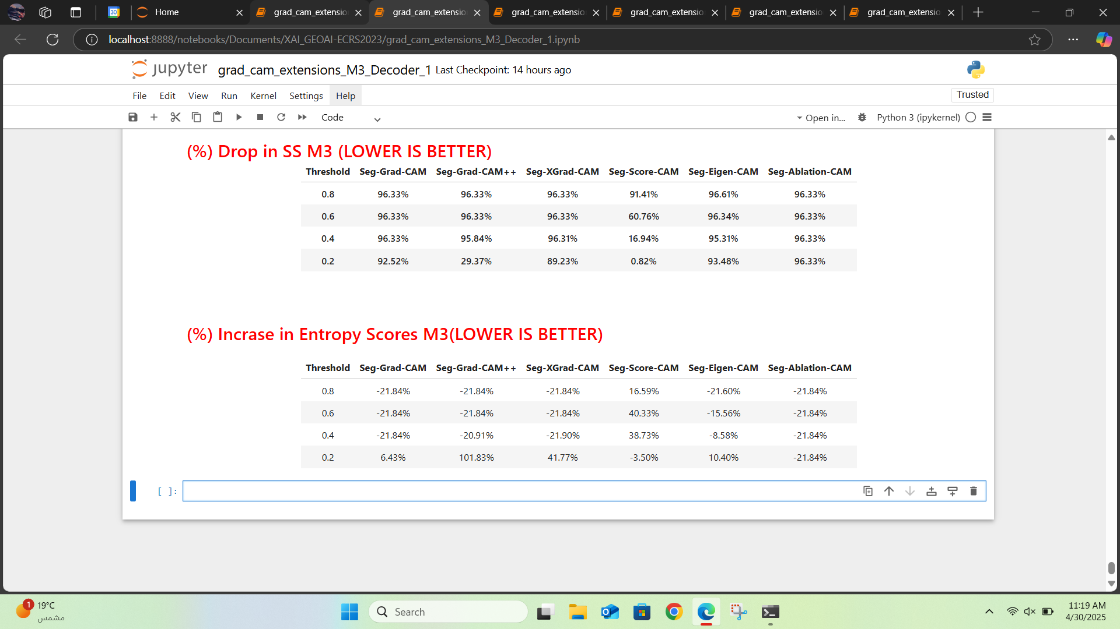
Figure 3: Evaluation of Threshold Impact on M3 (decoder_idx=1).
In Figure 3, as the threshold decreases, entropy scores generally increase, indicating higher uncertainty in model outputs. Higher thresholds (e.g., 0.8, 0.6) consistently yield negative entropy values, showing more confident predictions but not necessarily better ones.
The Seg-Ablation-CAM shows a constant value of -21.84% across all thresholds, due to malfunction, therefore, it is excluded from the analysis.
Among all, Seg-Score-CAM shows the smallest entropy increase, especially at threshold 0.2, with only -3.50%, compared to large spikes in other models (e.g., 101.83%). This suggests Seg-Score-CAM handles threshold variation better and retains stability.
Note: results may also reflect issues in the entropy measurement approach.

Conclusion:
The default Threshold 0.4 used is a moderate choice for evaluation however and if we compare the tables in the 3 previous figures, we could find out that it’s better to use a threshold of 0.2 since, in all 3 evaluation methods, performed better.

Segmentation Score on M3:
Since, in our case, the percentage increase in Entropy did not provide meaningful insight into the overall performance and the impact of threshold on evaluation, it is recommended to rely on the percentage drop in SS to support our previous conclusion.
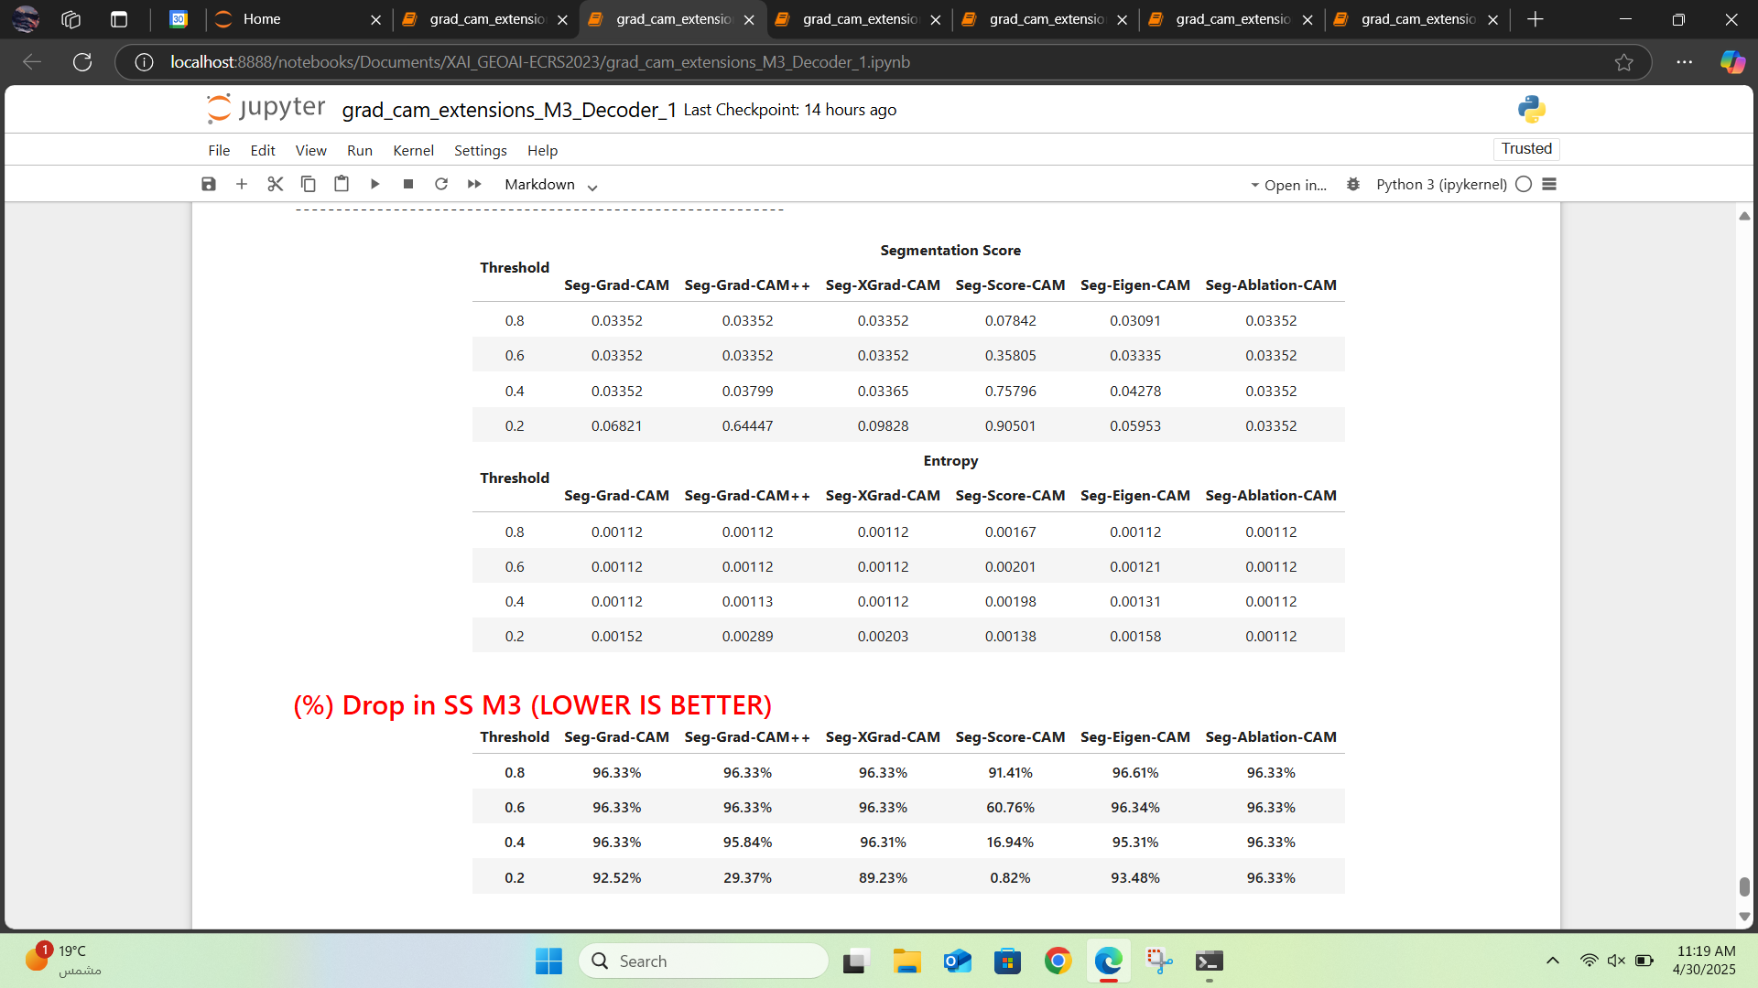
Figure 4: percentage drop in SS/M3
And as it’s expected the (%) Drop in SS relative to M3, support and verify our previous conclusion, which is that the Thresholds 0.2 is better than the default 0.4.

Considering Second Decoder Block:
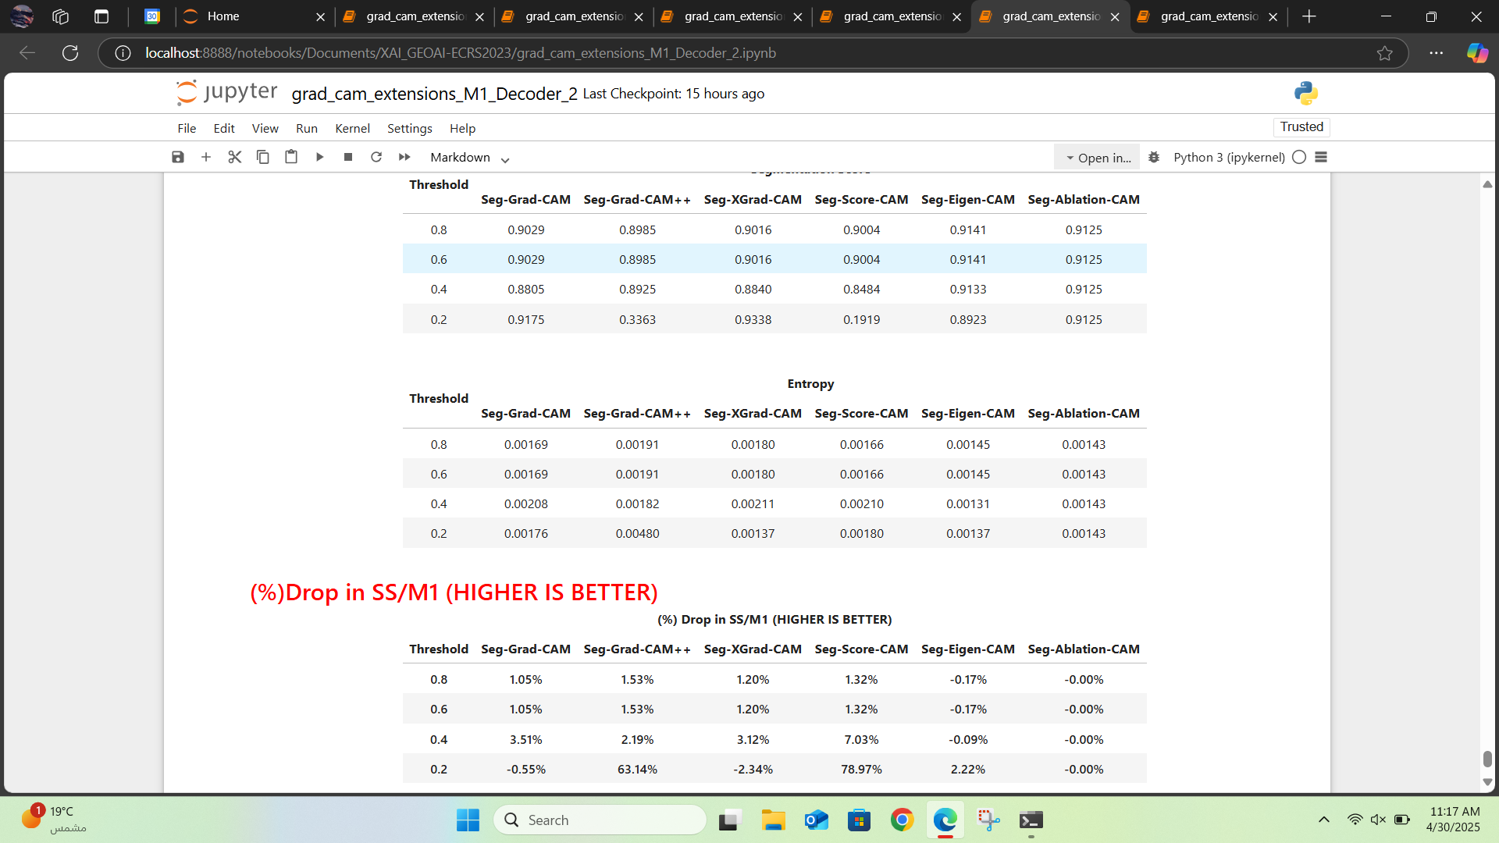
Figure 5: Evaluation of Threshold Impact on M1 (decoder_idx=2).
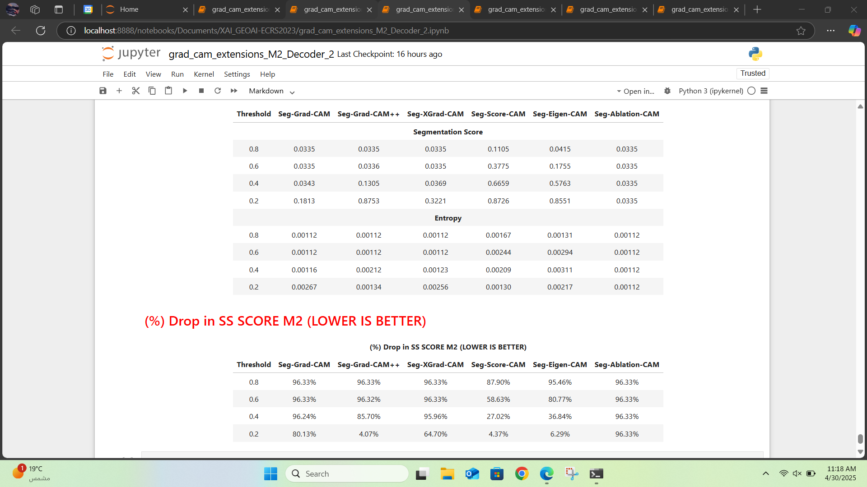
Figure 6: Evaluation of Threshold Impact on M2 (decoder_idx=2). 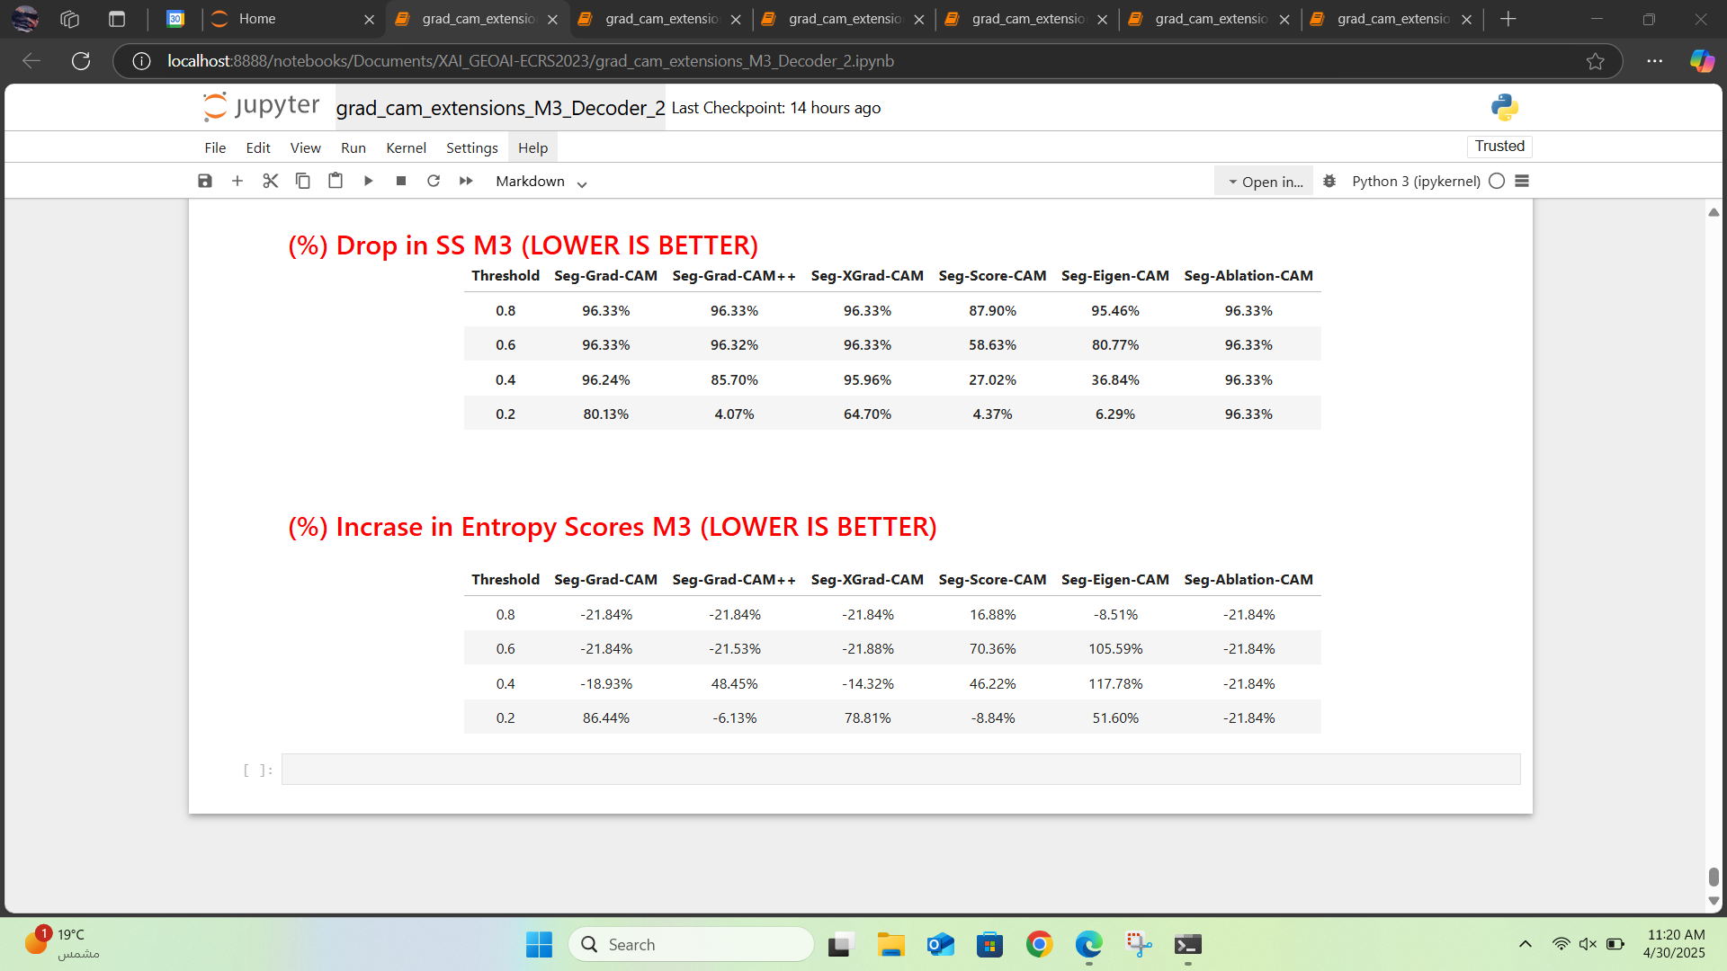
Figure 7: Evaluation of Threshold Impact on M3 (decoder_idx=2).
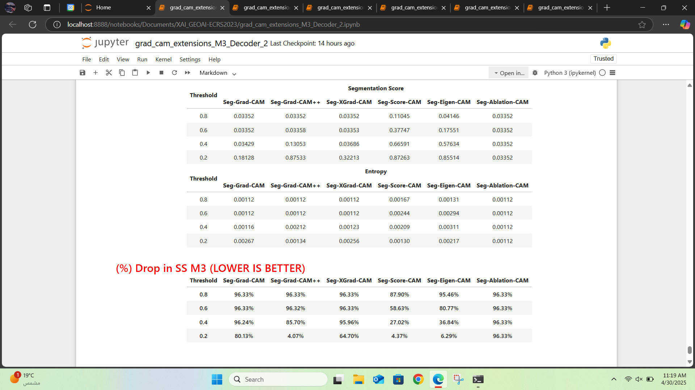
Figure 8: Evaluation of Threshold Impact on M3 (decoder_idx=2).
Across all four previous tables, we observe that Decoder Block 2 performs worse than Decoder Block 1 in terms of evaluation metrics. However, it requires less computation time, as illustrated in Figure 9 and Figure 10.
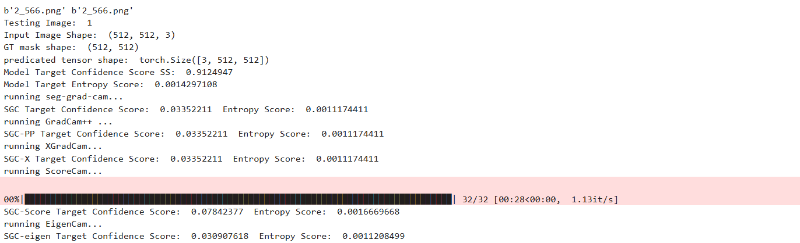
Figure 9: M3 decoder_idx = 1
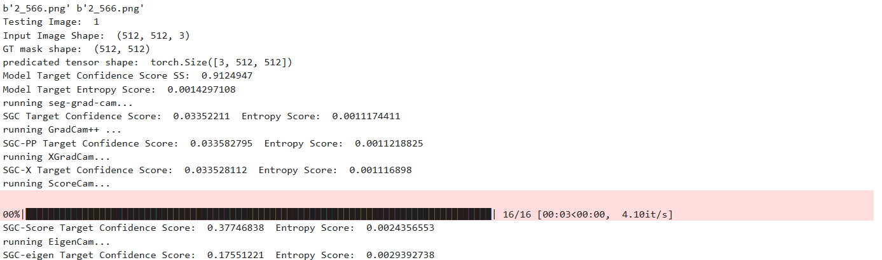
Figure 10: M3 decoder_idx = 2
Additionally, as shown in Figure 11 and Figure 12, the heatmaps generated using Decoder Block 2 exhibit lower contrast compared to those from Decoder Block 1.
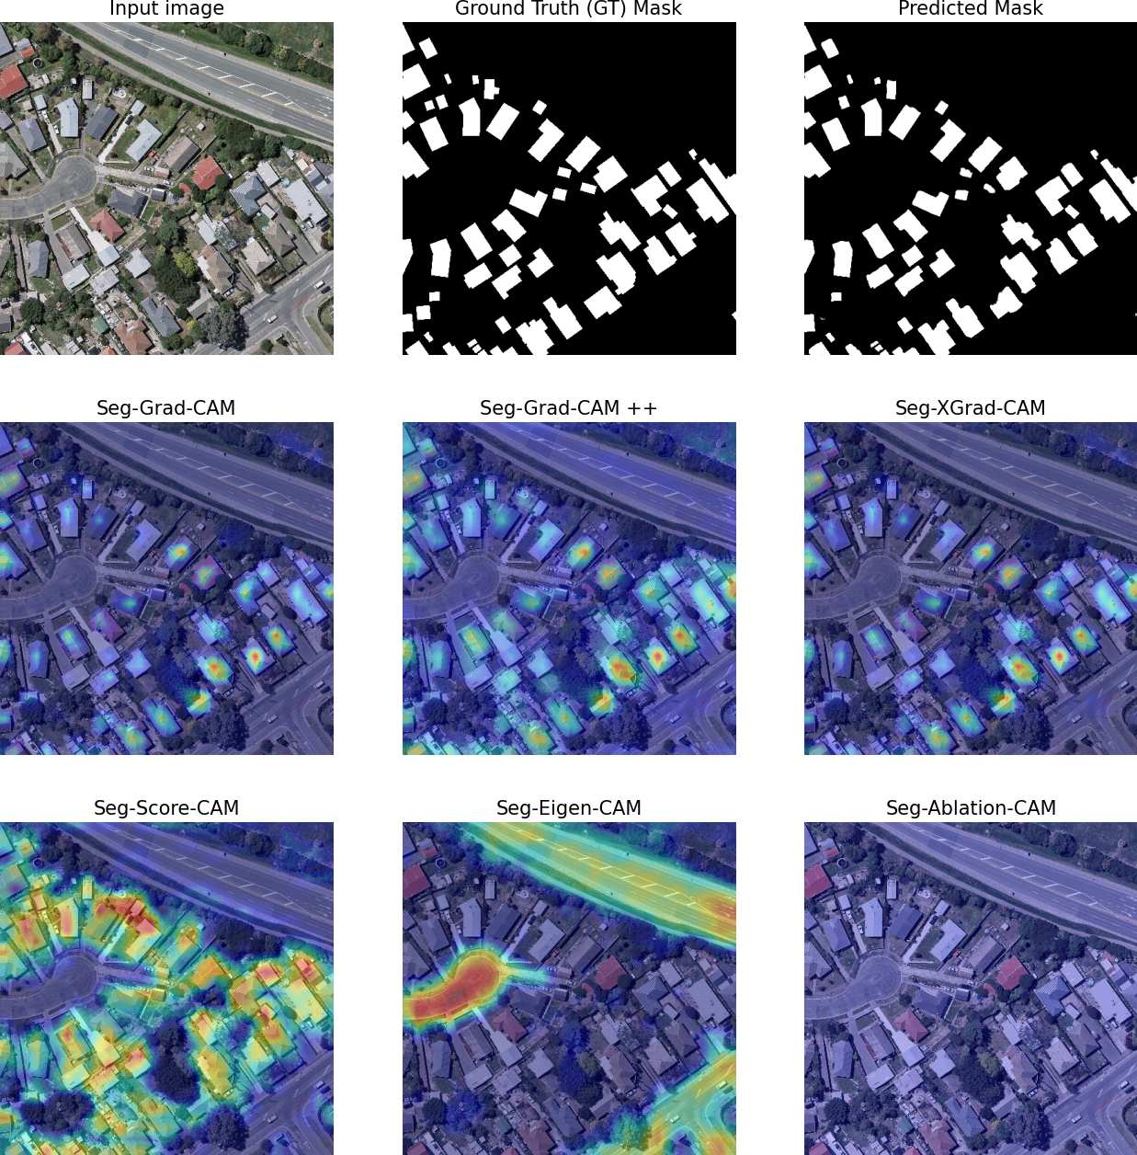
Figure 11: M3 decoder_idx = 1 heatmap.
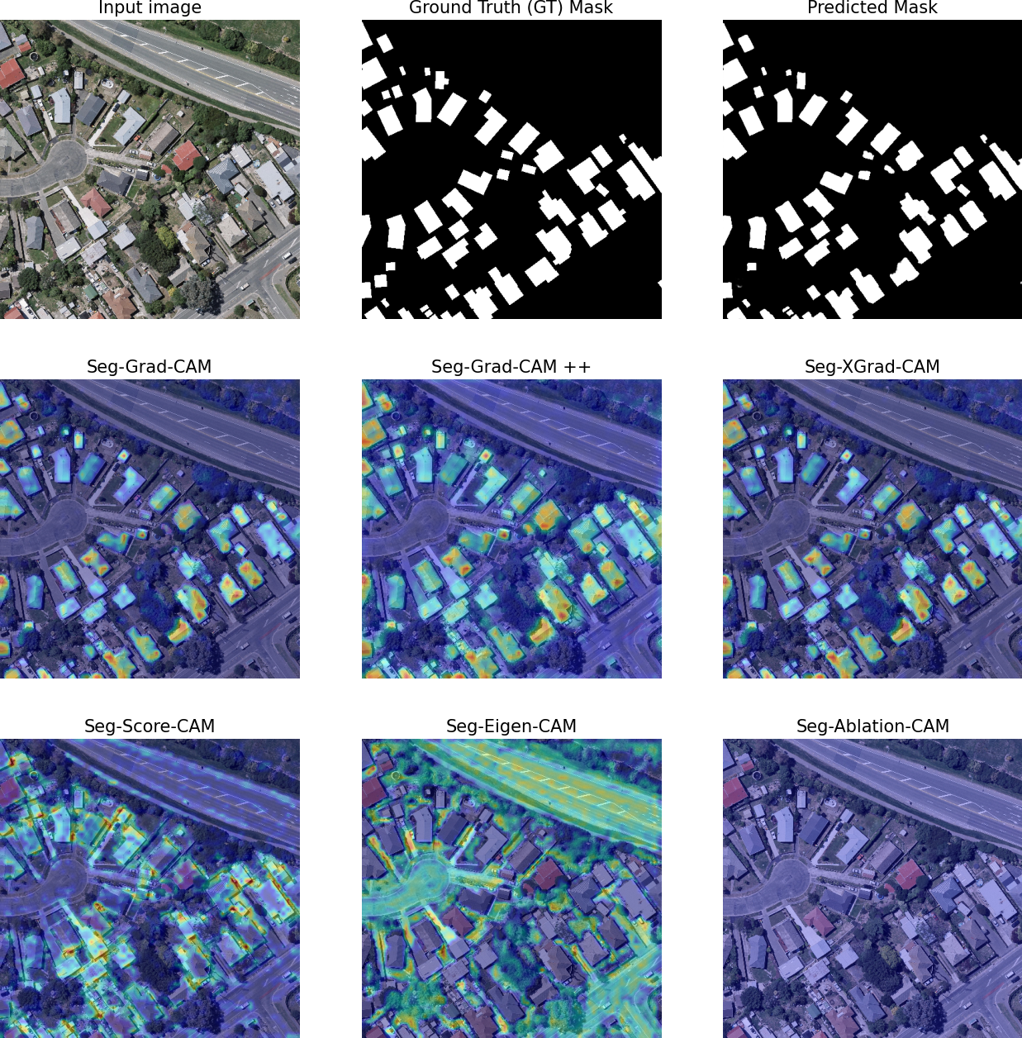
Figure 12: M3 decoder_idx = 2 heatmap.

Conclusion
The evaluation across multiple thresholds and decoder configurations highlights that while Decoder Block 2 offers reduced computational cost, it comes at the expense of performance and interpretability. The segmentation scores drop more significantly, entropy becomes less reliable as a metric, and the resulting heatmaps show lower visual contrast. In contrast, Decoder Block 1 consistently provides better evaluation results and clearer activation maps, making it the preferred choice when performance and interpretability are prioritized over efficiency.

Final Conclusion
Through a detailed evaluation of various thresholds and decoder configurations across three evaluation methods (M1, M2, and M3), we conclude that using a threshold of 0.2 yields the most consistent and reliable performance. Decoder Block 1 proves to be the better choice in terms of segmentation quality, interpretability, and stability, despite its higher computational cost compared to Decoder Block 2.
Additionally, it is important to note that the SGC-Ablation-CAM method was excluded from the analysis due to persistent malfunction in its output, likely stemming from issues in the code implementation.
All code, analysis notebooks, and related materials will be made publicly available on the following GitHub repository.
This repository will allow for full reproducibility of results, further exploration, and potential contributions from the community.

Thank you for your time!

