

Texple

Business Requirement Specifications

360 ONE: Wealth

**Document Revisions**

|  |  |  |
| --- | --- | --- |
| Date | Version | Document Changes |
| 09/02/2023 | 0.0.1 | Initial Draft |
| 27/02/2023 | 0.0.2 | Added Screen Listing |
| 01/03/2023 | 0.0.3 | Added Beneficiary details and other discussion points |
|  |  |  |
|  |  |  |
|  |  |  |
|  |  |  |
|  |  |  |
|  |  |  |

**Approvals**

|  |  |  |  |  |
| --- | --- | --- | --- | --- |
| **Role** | **Name** | **Title** | **Signature** | **Date** |
| Project Sponsor |  |  |  |  |
| Business Owner |  |  |  |  |
| Project Manager |  |  |  |  |
| System Architect |  |  |  |  |
| Development Lead |  |  |  |  |
| User Experience Lead |  |  |  |  |
| Quality Lead |  |  |  |  |
| Content Lead |  |  |  |  |

**Table of Content**

1. Introduction 3

1.1 Objective 4

1.2 Business Drivers 4

2. Project Summary 5

2.1 Description 6

2.1.1 Client (Settlor) 6

2.1.2 Will 6

2.1.3 Trust 7

2.1.4 Trusteeship 8

2.2 Current Workflow 10

3. Application Details 10

3.1 UI Screens 11

3.2 Masters 13

3.3 User Roles 14

4. Objectives 14

4.1 Functional Objective 15

4.2 Non-Functional Objectives 16

4.1.1 Performance 16

4.1.2 Compatibility 17

4.1.3 Usability 17

4.1.4 Security 18

4.1.5 Scalability 18

5. User Journey Diagram 19

5.1 Management Persona: Report generation 20

5.2 Bill generation for FRN 20

5.3 Admin Roles 21

5.4 Client Onboarding 22

6. Tech Stack 23

6.1 Application stack 24

6.2 AWS Infrastructure 24

7. Glossary 26

# 1. Introduction

## 1.1 Objective

From past few years the whole process of managing the trust, storing and documenting the client data was done manually, several files and folders were created to document each data in a decentralized manner which made the process hectic, and more error prone. In the era of digitalization, it’s possible to overcome such processes by developing an end-to-end system.

The whole idea of creating this web application is to provide a convenient and user-friendly way to perform a specific or set of tasks such as,

* To create and store every data as well as its required documents in a structured manner into a database
* Easy to access, download and process the required data and document whenever it’s required and easy to fetch.
* Transactions and billing details can be easily maintained and recorded.
* The estate planning application and the wealth software system (caliber) can be integrated and can sync or fetch data, which will give a complete overview of relevant data from both systems at one place I.e., estate planning portal.

Overall, the objective of an estate planning web portal is to provide value to its users, whether that value comes in the form of increased efficiency, improved communication, enhanced user experience, reducing human errors or better data analysis.

## 1.2 Business Drivers

When considering the development of this web application that is intended for use within a company by its employees, the business drivers may have the key factors that motivate a business to take a specific action:

* **Increasing productivity:** A well-designed application can help employees to perform their tasks more efficiently and accurately, thereby increasing productivity and reducing errors.
* **Streamlining processes:** A web application can help to automate and streamline various business processes, such as data entry, record-keeping, and communication, freeing up employees to focus on higher-level tasks. This can reduce the workload on employees and help to optimize the company's operations.
* **Enhancing data-integrity:** A web application can help to collect and record the data with details on who has entered, modified the information / data and in-a-way helping to manage data-integrity. Since actions are tracked, the system can give clear visibility on the movement of workflow as well.
* **Increasing security**: A web application can help to ensure the security of sensitive data and information within the company. By implementing appropriate security measures, such as user authentication, data encryption, and access controls, a web application can help to reduce the risk of data breaches and other security threats. Also considering that this is an internal application it further enhances security.

Overall, a well-designed estate planning portal will help to improve employee productivity, streamline business processes, and optimize the company's operations.

# 2. Project Summary

Since the organization’s main commercial business is to manage ultra-high network individuals (i.e., clients), this system will help to manage details of clients as follows:

* Client Onboarding - Settlor
* Will
* Trust
* Trust Engagement

## 2.1 Description

### 2.1.1 Client Onboarding (Settlor)

The Settlor is a person who creates trust by placing a particular asset that they own into the trust i.e., by transferring that asset to another person (trustee) along with clear instructions that the asset be held for the benefit of the beneficiaries.

The initial stage between the settlor and trustee:

* The very first discussion between the Settlor and trustee is an understanding of the requirement of the Settlor, all the points of their requirement are noted, and a solution statement is given according to the settlor's needs.
* Once the Settlor is satisfied with the solution statement given, both parties sign a mandate letter (i.e., parties have agreed to cooperate, and the Settlor wants to onboard). Mandate contains information regarding client’s requirements, it can be either will, deed or trust.
* The Term sheet is then given to the settlor and if they agree with terms and conditions, then the sheet is signed by the Settlor. This phase is called effective solution planning.

### 2.1.2 Will

A Will is a **legal document** which is prepared during the lifetime of the person (Settlor). All the required whishes can be mentioned in the will of notarized document and registered, A will can also be called as Letter of Wishes (LoW) or deeds of amendment

Wills are created to benefit the beneficiaries, so their KYC documents will be taken for the identity information to be accurate. The following documents can be- PAN, Passport, Adhaar, Driving License, SSN, OCI, Cancelled Cheque.

For any transaction transmit to the beneficiaries the will has to be checked, approved and then disbursed. If the Settlor wants to update or add more will/letter/deed then he can do it anytime. But if any changes take place in the existing will then a codicil is created and it will always be attached to the original will document, while reading the original will, the codicil is read together. Suppose if a new will is restated, then in future codicil will be attached to latest will I.e., restated will.

The will as a service is generally provided in 2 ways:

1. Will Only: In this case, if a client wishes to make a will and keep it with himself then the system will record the basic client information and service provided.

2. Will and Trust Deed: If the client wants to make a will and trust deed with us then we follow the entire process of creating the will, trust then documenting and recording each process throughout the phase.

### 2.1.3 Trust

* **Family trust**

Family trust is a most selling component in estate planning and management. You know your family best, and a family trust can help you plan and provide your assets, wealth for your family, both during your lifetime and after your death.

* **To set up family trust**

A full contract is formed and signed between the Settlor (Client) and trustee and following documents are created

* Original Registered Trust Deed(s) and will(s)
* DOA (Date of appointment)
* Letter of Appointment
* Mandate letters
* KYC documents self-attested
* Declaration from Settlor
* Initial deposit cheque

The list of documents is sent to trustee in a form of a kit to verify and create a family Trust.

* **Steps to create a Family Trust**
* Background Verification is an important aspect before onboarding the settlor.
* 360 ONE understands the requirement of the Settlor and then Hands down the term sheet to be looked on by settlor.
* Once the Settlor agrees with the terms then the trust document is created
* KYC documents of the owner and respective beneficiaries are validated so the Identity information is accurate and thereafter the trust document is signed (i.e., between Settlor and trustee)
* A Physical Trust Rubber Stamp is created for the on-boarded trust.
* PAN application for the trust is submitted to NSDL office and within a week's time PAN number is allotted.
* After receiving the physical PAN, the documents are submitted for creating a new bank account. The account can be a corpus bank account or/and a Demat account.
* After the account is activated, the initial cheque is deposited which was collected at the start of the onboarding process.

### 2.1.4 Trust Engagement

Once the trust is created and activated all the assets are transferred into the account then according to the Settlor's wish the investment or transaction can start.

IIFL trustee does not *suggest* or *advise* for any investment or transaction to be made, they only execute the settlor's instruction. Each trust is created as a portfolio and every transaction that happens in the portfolio is documented. An audit takes place every monthly / quarterly / yearly and the generated reports along with the bank statements are sent/updated to the Settlor as well as the management team.

* **The following steps are followed for any transaction to take place from the Trust**
* **Seek NetWorth Certificate from CA**: The Initial phase of the trust doesn’t have any net worth so, the certificate is made for the initial amount deposit in the bank account.
* **Demat or POA distribution bank account opening:** This is a trading account and is default opened within IIFL but if the client wants to choose another bank, then they have to apply to the preferred bank to open a Demat or POA account. Demat and POA account can be opened within IIFL wealth or outside.
* **Demat Broking account / KRA / CRF opening and activation:** Once the account is open and active the RM is then notified and allotted to the Settlor.
* **Intimate RM / SRM / client with bank and demat broking account numbers:** RM or SRM will coordinate with Settlor and understand all the assets that are required to be managed.
* **Asset Transfer into Trust & seek corpus in signed declaration from client:** RM co-ordinates with client and gets all his assets into the account along with a signed declaration from client.
* **Seek acquisition cost declaration letter and support from client / RM / SRM:** To get the acquisition cost (Total cost of the assets transferred) through the declaration letter. To calculate the capital cost, by capturing the buying date and cost of the shares or certificates.
* **Trust account funded:** Once all the setup is completed and assets are transferred, the trust account will be ready to manage the transaction.
* **Seek Settlor / TA consents on every transaction - Corpus** **In and Corpus / Income Out:** The trustee will inform the Settlor that all accounts are setup and now we can start with managing the transaction so the Settlor can start giving instruction on the investments to be made.
* **Execute Corpus** **In and Corpus / Income Out transactions**: The transaction related instructions of the Settlor are executed (Trustee doesn’t advice or suggest on any investments or transaction to be made, they simply execute the Settlor instruction)
* **Operational Due Diligence and real-time book entry:** All the investments are monitored and if any risks occur then the Settlor has been notified in near real time.
* **Execute investments in TPP, Filing & maintenance of documentation:** Each transaction made can be either to sell or buy investments are documented.
* **Prepare monthly MIS, BoA/c's & Email to Clients / RM:** The report Is made on monthly basis along with all the bank as well as demat account statement are send to the client at its registered email.
* **Update Trust MIS report and send to Management:** The generated MIS report is sent to the management.
* **Billing**

IIFL 360 One bills clients for the services they provide. The settlor can choose the frequency of the billing he wants to pay, bills can be generated monthly, quarterly, half yearly and annually. The services and rates are already settled at the initial stage of onboarding.

For wealth management, the data of each transaction is recorded on a daily basis and the reports are generated monthly. Reports from every department (Trust/Wealth) are merged and sent to the settlor on his registered email.

The bills that are generated get settled through the trust itself and in rare cases if the settlor wishes to pay the bill manually then the trustee can generate a bill and send it to settlor via email.

* **Third Party**

When settlor creates a trust with 360 One but wants a third party to handle / record it’s transactions, then each time the settlor executes an order (Buy or sell) or add assets s/he informs to the third party and since the trust is managed by 360 one, client submits the transactions summary documents from third party to 360 one to add into the trust’s portfolio.

Based on the data received from Settlor regarding a Third party, 360 One generates the bills and sends them to Settlor for the services offered.

## 2.2 Current Workflow

Currently Team handles all the data through Excel sheets and folders. The client onboarding process begins with registering the client in the master sheet and creating client folder where all the documents are saved and few of them on emails.

During the management process all the account's bookkeeping is maintained within a single sheet, these includes registering a transaction, invoice generation and recording all other bills / records.

The whole idea of managing clients on excel sheet becomes too cumbersome and error-prone while generating reports monthly, quarterly and yearly. Imagine generating yearly AUM report for a client having 100s of transaction. Whereas if the data was managed using system the data and reports would be just few clicks away.

# 3. Application Details

### 3.1 UI Screens

1. **Dashboard**
   * A dashboard is a visual representation of key performance indicators (KPIs) that provides an at-a-glance view of the status of a system.
   * This screen provides in order summarized data of the whole system.
   * The summarized data widgets will include
2. Summary Details
3. Billing Details
4. Activity Timeline
5. Trust Engagement – Asset details
6. Top families details
7. Recently updated details
8. **Clients**
   * **View Clients**
     + User friendly interface where the user can view the client’s information and filter client via search functionality.
   * **Select Client Status**
     + Client status types will include
     + Billable
     + Non-Billable
     + Dormant
     + Closed
   * **Add Client**
     + This functionality allows users to easily onboard new clients to the system and save their information making it easier to track and manage the data.
9. **Wills**
   * **View Wills**
     + User friendly interface where the user can view the will’s information and filter it via search functionality.
   * **Add Wills**
     + Users can add wills by just uploading the document into the system.
     + Users can also add codicil document (This represents minor changes in will).
     + Users can add a revised bill document (This represents major changes in will).
10. **Trusts**
    * **View Trusts**
      + User friendly interface where the user can view the trust’s information and filter trust via search functionality.
    * **Add Trust**
      + This functionality allows users to easily add new Trust to the system and save their information, making it easier to track and manage the data.
11. **Assets**
    * **View Assets**
      + User friendly interface where the user can view all the asset's information and can filter via FRN parameter.
    * **Add Asset**
      + This functionality allows users to easily add new Assests to the system and save their information, making it easier to track and manage the data.
12. **Asset Transfer**

* **Within the family Transfer**
  + Ownership of asset can be transferred within the trusts of the family
  + Transfer can take place between one trust to other trust or from multiple trust to single Trust and vice versa.
* **Outside the family Transfer**
  + Ownership of asset can be transferred from trust/s to another family (i.e,From one Family to another Family)

1. **Billing**
   * **Bill Listing**
     + It allows users to review and manage their billing information.
   * **Add Bill**
     + This functionality allows users to easily add bill details to the system, making it easier to track and manage the data.
2. **Reports**
   * **FRN wise AUM Report**
     + This functionality provides a summarized AUM report for specific FRN.
     + User can filter data by setting start date and end date.
     + These reports can be viewed as well as downloadable.
   * **FRN wise billing report**
     + This functionality provides report of bills generated within a specific period.
     + User can filter data by setting start date and end date.
     + These reports can be viewed as well as downloadable.
   * **CRN wise AUM report**
     + This functionality provides a summarized AUM report for specific CRN.
     + User can filter data by setting start date and end date.
     + These reports can be viewed as well as downloadable.
3. **Admin panel**
   * **View Users**
     + The Super admin and management team can view and keep track of all users that are authorized to access the system.
   * **Add User**
     + This functionality allows the super admins and the management team to easily add new users, so they are authorized to access the system.
   * **Profile**
     + Contains basic personal information and allows to change password.

### 3.2 Masters

1. **Rates**
   * The higher-level of services offered are Will Setup, Trust Setup, Trust AUM Management
   * This data will also consist of rack rates, notional rates and transfer rates offered as default.
   * To change these rates for the coming financial year Rate master will be provided.
2. **Third Party List**
   * This List consist of all Third parties
   * If any new Third party arises then they can be added to the list
   * If any existing Third party closes, they can be removed from the list by changing its status to Inactive
3. **Third party AUM Value**

* This master screen stores the AUM value of the families managed by third party

1. **Billing Cycle**
   * The Bill cycle of the family can be Monthly, Quarterly, Half yearly, Yearly
   * This master screen manages the date and time to Bill a family according to the selected Bill cycle
2. **GST Master**
   * GST charges are applied to every bill
   * If there is any rise or fall on the GST percent, then the admin can update it on the GST master screen, and these percentage will be taken to calculate the GST amount for the upcoming Bills.

### 3.3 User Roles

1. **Sales**
   * This type of user is considered as a maker, they have access to create entities.
   * They can only create and view
     1. Client
     2. Will
     3. Trust
2. **Operation**
   * This type of user is considered as maker and approver, they have access to view, create, modify and approve.
   * They can perform operations on
     1. Client
     2. Will
     3. Trust
     4. Bills
   * They can also generate reports for management and communication purposes.
3. **Admin / Super Admin**
   * These are the users who have major interactions with billing and reports, and generally do not create or modify entities.
   * So they have viewers access, where they can generate reports, view bills and view each entity.
   * As a higher-level user, they do have access to add / delete / modify lower-level system users.

# 4. Objectives

### 4.1 Functional Objective

The following are the functional objectives

* **User Management**

According to the role and varying levels of access, the employees are allowed to create, update, delete, upload and download the data.

Few roles:

* **Maker:** This role can update all the information / data in the system.
* **Approver:** The approver has the authority to view the data and then approve or modify the data made by the maker.
* **Entity management**

Identifying and describing the various entities that are involved in the system.

* **Client / Settlor:** Client is a person who will directly interact with the Relationship Manager (RM), with all his requirements and opt for the service they want to pursue with.
* **Will:** A will is a legal document that sets forth your wishes regarding the distribution of your property and the care of any blood relations / family members. Our system will store versioned documents of a client’s will and relevant modifications.
* **Trust:** For our system trust is a product with KYC documents and beneficiary details.
* **Trusteeship:** In trusteeship we manage the trusts and record all the assets like real estate, private equities, LLP firms, stocks, etc and raise the bill against the number of assets managed to the settlor.
* **Documents:** Every entity will be required to upload various documents. There will be many cases where new versions of documents will be added so maintaining documents will be a huge aspect.
* **Trusteeship**

Every transaction (Buy or Sell) and billing of the trust account are recorded and documented in a structured format.

Bookkeeping contains records of every transaction and bills, such as:

* Buying or selling of Financial & Moveable or Non-financial & Immoveable Assets.
* Bills generated for the services provided. This can be setup / one time service fee or management fee.
* **Reporting**

When the user wants to generate reports based on specific data points or filters (Daily or Monthly Basis), so the user can fetch the data from the centralized database accordingly. Each report that is generated will be downloadable for any further use.

* **Integration**

The Estate Planning application and the software system (caliber) are synced so that the required data are fetched when needed. The syncing of data will take place one a pre-decided scheduled time.

Required fields that will be fetched from Caliber are:

* Family Name
* Trust Name
* Family Relationship Number (FRN No)
* Customer Relationship Number (CRN No)
* Region
* Wealth RM
* IIFL Wealth AUM Value
* IIFL One AUM Value

## 4.2 Non-Functional Objectives

### 4.1.1 Performance

The web application should be responsive and load quickly, with a minimum amount of downtime or errors. Some key factors that can impact the performance of a web application:

* Page load time: The time it takes for a page to load can have a significant impact on user experience. Factors that can impact page load time include server response time, file size, and the number of requests required to load the page.
* Database performance: The performance of the database used by the web application can impact overall application performance. This can include factors such as database design, indexing, and query optimization.
* Code optimization: Poorly optimized code can result in slow application performance. Effective use of caching, reducing database queries, and minimizing the use of expensive operations can improve application performance.

To ensure that our web application is performing optimally, we will take the necessary steps to test the application before releasing it to the client.

### 4.1.2 Compatibility

The web application should be compatible with various modern web browsers, ensuring that all employees can access the application. Some Key factors that should be considered are,

* Web Browser Compatibility: Different web browsers may render web pages differently, resulting in variations in appearance and behavior of the web application. It is important to ensure that the web application is compatible with modern web browsers such as Google Chrome, Mozilla Firefox and Safari.
* Responsiveness: Generally, the admin portals are developed to view them on the Desktop equivalent resolutions, keeping same thought process in mind, this web portal will be developed to load and render properly on a standard desktop resolution. Although the application will be responsive in nature but many screens like reports, etc. are not recommended to be viewed on the smaller device resolutions.

### 4.1.3 Usability

The web application should be intuitive and easy to use, with clear instructions and minimal training required

* Learnability: A user should be able to learn how to use the web application quickly and easily. This can be achieved through clear and concise instructions, intuitive design, and well-organized information architecture.
* Navigation: The web application should have clear and consistent navigation, allowing users to easily move around the application to find what they need.
* Error prevention and handling: The web application should be designed to prevent errors and provide clear error messages when they occur. This can help users to recover quickly from mistakes and avoid frustration.

### 4.1.4 Security

The web application should be secure, with strong user authentication, data encryption, and access controls.

Here are some key factors to consider when addressing the security of a web application:

* Authentication and Authorization: The application should have a strong authentication mechanism to verify the identity of users and allow only authorized users to access the application. This can include password policies, multi-factor authentication, and session management.
* Input Validation: The application should validate all user input to prevent injection attacks, cross-site scripting (XSS). This can include validating user input on the client side and server side.
* Access Control: The application should enforce access controls to ensure that users have appropriate levels of access to different parts of the application. This can include role-based access control, least privilege access, and other security mechanisms.
* Encryption: The application should use encryption to protect sensitive data in transit and at rest. This can include using SSL/TLS to encrypt data in transit and encrypting data in the database.
* Security Testing: This project does not include VAPT as part of the scope, but Texple will help in solving the VAPT bugs if they are reported.

### 4.1.5 Scalability

The portal should be designed to accommodate the growth of the company, with the ability to handle increased user traffic and data storage. Some key factors to consider when addressing the scalability of a web application:

* Horizontal Scaling: One way to scale a web application is to add more servers (i.e., containers) to the system to distribute the workload.
* Asynchronous Processing: Using asynchronous processing can help to reduce the workload on the server and improve application responsiveness performance. This can include using message queues, background processing, and other techniques to handle long-running tasks.
* Microservices Architecture: Breaking the application into smaller, more manageable services can help to improve scalability by allowing each service to scale independently. This can include using containers and other techniques to deploy and manage the services.

# 5. User Journey Diagram

## 5.1 Management Persona: Report generation

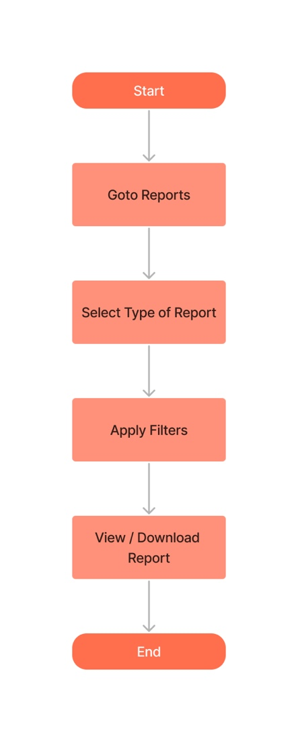

**Description:** The management team can generate reports monthly/quarterly/half yearly/annually basis by applying a filter that is to and from date and can view or download report whenever required.

## 5.2 Bill generation for FRN

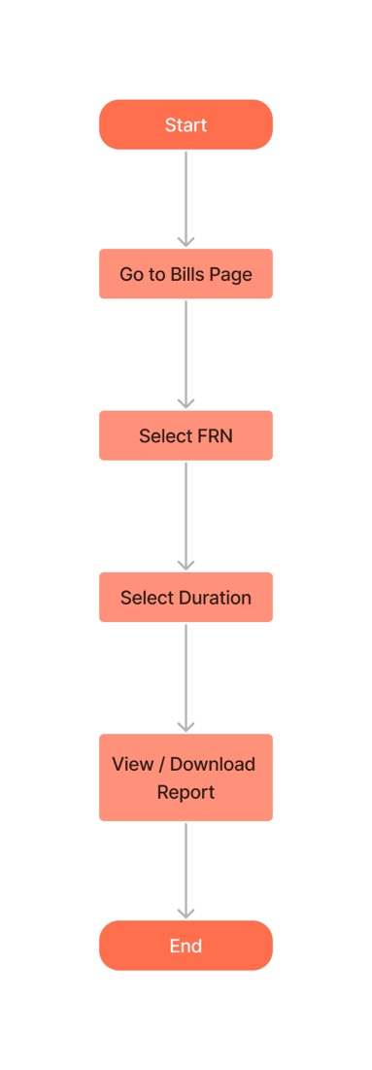

**Description:** The Bills are reviewed for specific FRN. We can apply a date filter to view bills generated for a specific period.

## 5.3 Admin Roles

**Editing Roles and permissions Editing Product**

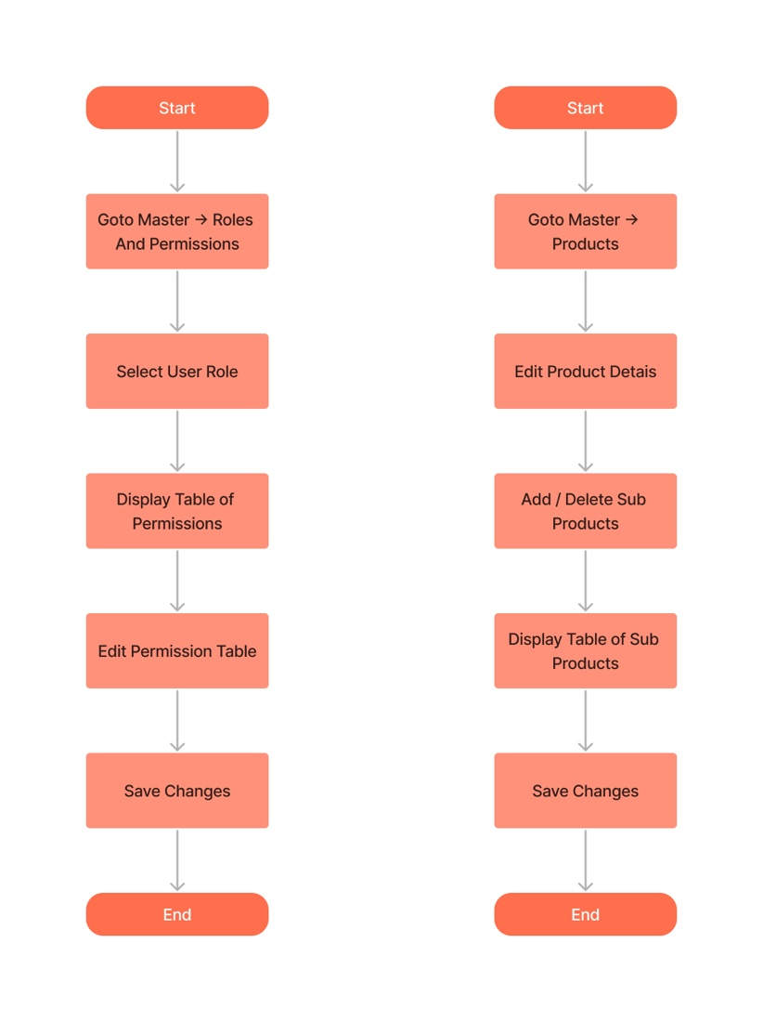

* **Description:**
* A Super Admin is responsible for managing the roles and access levels permission of the users within an application. They must ensure that roles and permissions are assigned appropriately based on the user's job function and level of authority.
* An admin is also responsible for managing the products that are available within application. They must make sure sub-products are mapped accurately as described in the system.

## 5.4 Client Onboarding

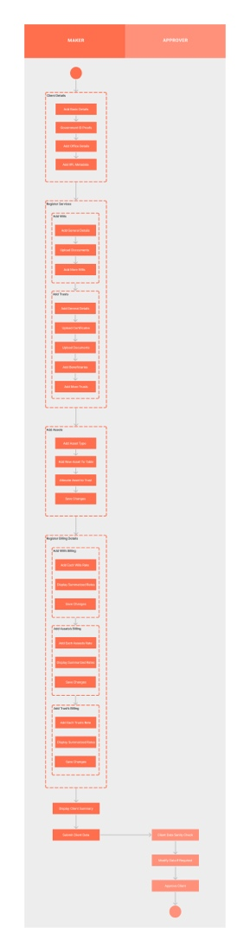

[For better visibility follow this link](https://texple1-my.sharepoint.com/:i:/g/personal/hiten_chothani_texple_com/EecJD3pAKtpLs2VI29sRuxUBxfR1agbrcwoLRtZ5n6M1YQ?e=AWGT2g)

# 6. Tech Stack

## 6.1 Application stack

* **PERN Stack**

The PERN stack consists of;

* **PostgreSQL:** a powerful open-source relational database management system that provides high reliability, scalability, and data integrity for web applications. For this application we will be using Managed Postgres Relational Database Service (RDS).
* **Express JS:** a flexible and lightweight web application framework for Node.js that provides a variety of features for building robust web applications.
* **React JS:** a popular JavaScript library for building user interfaces. It provides a declarative and efficient approach to building UI components that can be easily reused across different parts of a web application.
* **Node JS:** a server-side JavaScript runtime environment that allows developers to build high-performance and scalable web applications.

Together, these four components make up the PERN stack, which is commonly used for building modern web applications that require a powerful backend, fast frontend rendering, and real-time updates. The PERN stack provides developers with a flexible and modular architecture that allows them to build complex web applications in a structured and efficient manner.

## 6.2 AWS Infrastructure

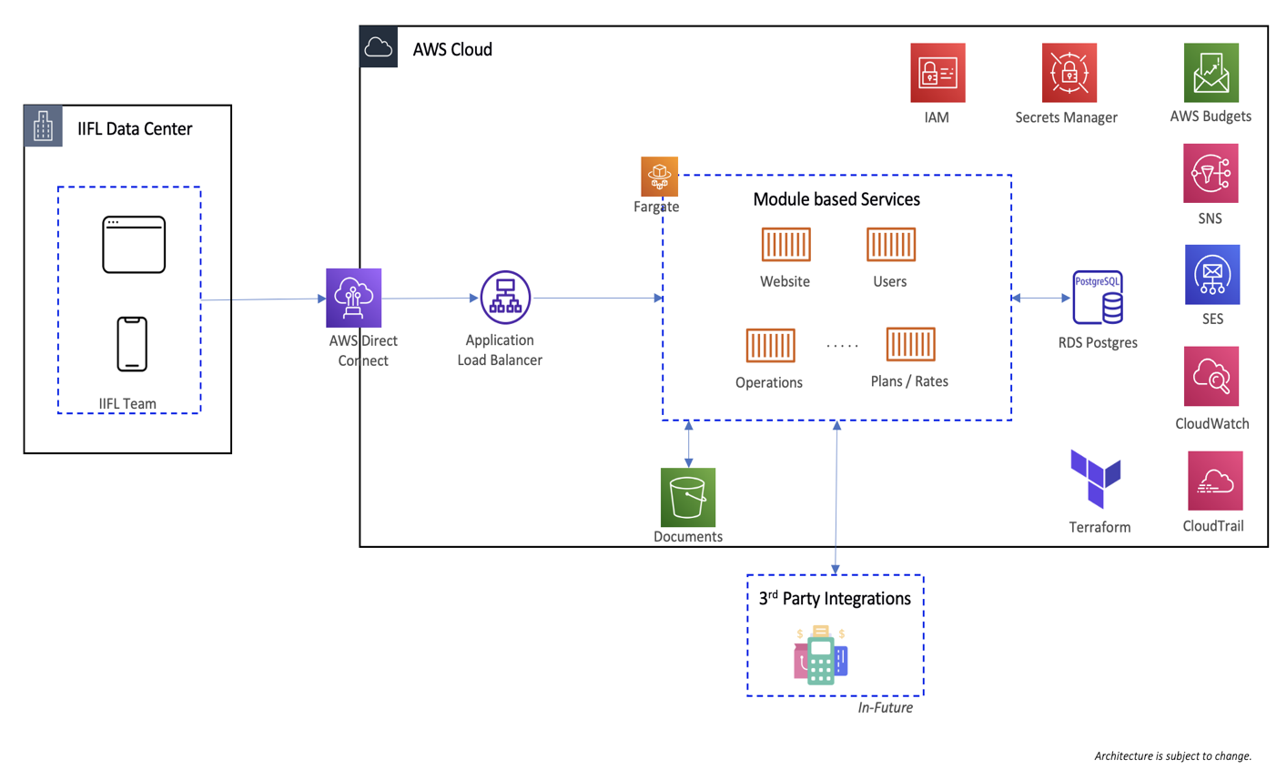

**Key Requirements for AWS Infrastructure:**

**Load Balancer**

* Create listeners with micro services path. We will need 4 paths. We will require a target group for each listener. ALB will have only private subnet. There should be a common health path. Security groups will have access to fargate. Logs will be enabled.

**ECS**

* ECS contains task definition, ECR and ECS with fargate configuration.
* At initial we will have 4 micro services. ECS common security group will have access to load balancer and RDS Aurora Postgres. We will attach the created application load balancer to ECS with auto scaling enabled. The open port for now will be 3001. Desired state will be 1. ECS will have SES, SNS, RDS, System manager, S3 permissions. Logs will be enabled.

**S3 Bucket**

* The bucket will be private. Micro services will have permission to upload documents in S3 bucket.
* Website will be hosted in the S3 bucket using AWS Services

**RDS**

* We will have private Postgres Aurora. It will connect to ECS micro service. For the time being we can keep a test password.

**IAM**

* IAM role with suitable permissions.
* SNS, SES, SSM parameters will be created.

# 7. Glossary

Definitions of key terms and concepts used:

* Settlor/Client/Owner: The Settlor is the person who creates the trust by placing a particular asset that he/she owns into the trust, i.e., by transferring that asset to other person (trustee) along with clear instructions that the asset be held for the benefit of the beneficiaries.
* Corporate Trustee means a corporation, a bank, a trust company or any other entity that is authorized to serve as a professional Trustee
* Initial Cheque/ Settlement mean assets settled by the Settlor in the Trust at the time of setting up the Trust including but not limited to cash, financial assets, real estate and shareholding in entities
* Initial Trustee shall mean the Trustee appointed by the Settlor at the time of settling the Trust
* Letter of Wishes: A letter issued by the Settlor to the Trustee at the time of settlement of the Trust/Trust Property, clarifying the intentions of the Settlor behind the settlement of the Trust/Trust Property, laying down broad policy and parameters for operation of the Trust and utilization of the Trust Property, to provide a direction to the Trustee. Any Letter of Wishes of the Settlor, shall be valid only if such Letter of Wishes has been acknowledged by the Trustee
* Nature of the Trust: This Trust is IRREVOCABLE by the Settlor and is a DISCRETIONARY and INDETERMINATE Trust in nature
* Property: Property includes both movable and immovable assets and all other rights, title and interests as may be includable within the ambit of the term property under the Transfer of Property Act 1882.