**ASSIGNMENT**

**Assignment no - 01**

CSE 476

Data Mining Lab

23.03.2023

:

:

:

Course NO

Course Name

Submission Date

|  |
| --- |
| Submitted To |
| Name: Khan Md. Hasib  Assistant Professor  Department of Computer Science & Engineering |
| Submitted By |
| Name: Hashibur Rahman Redoy  ID:18192103276 INATKE: 41 SECTION: 03 |

**CO1. Apply data preprocessing steps (such as: Viewing your data, Handling duplicates, Column cleanup, DataFrame slicing, selecting, and extracting) in the following dataset -** [**https://www.kaggle.com/datasets/selinraja/irish-**](http://www.kaggle.com/datasets/selinraja/irish-)

**data.**

1. Import Library
2. 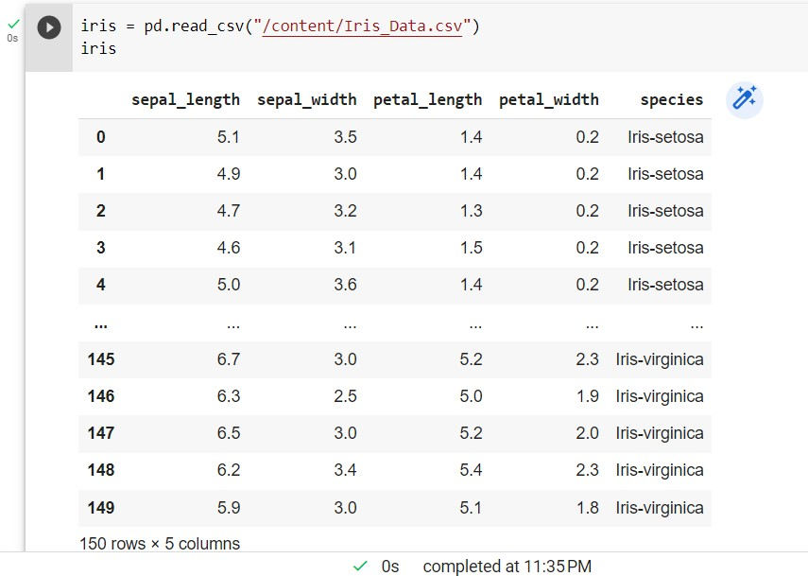Upload the dataset & Viewing the data
3. 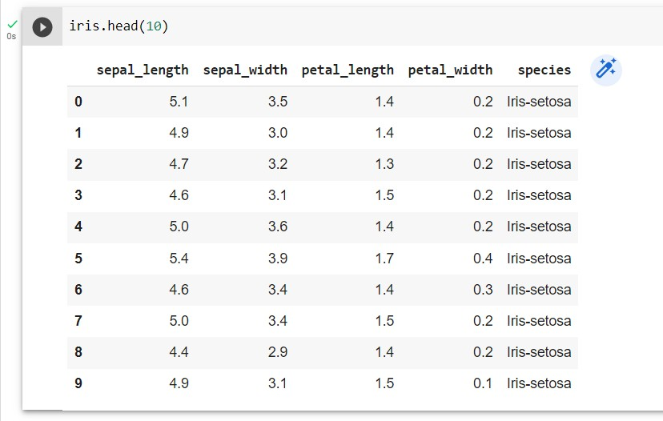View the top 10 rows of the dataset.
4. 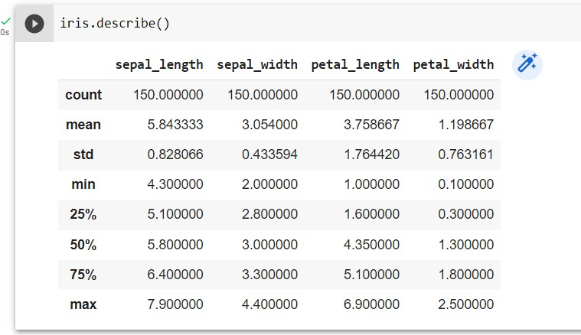Showing the description of the whole dataset.
5. Showing the info of the dataset.

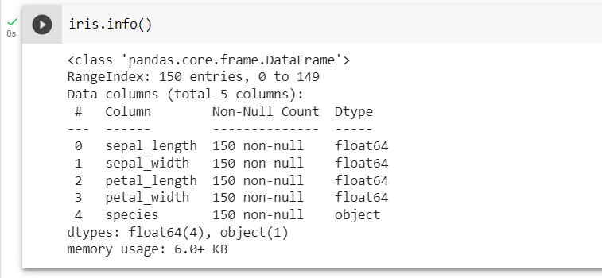

1. 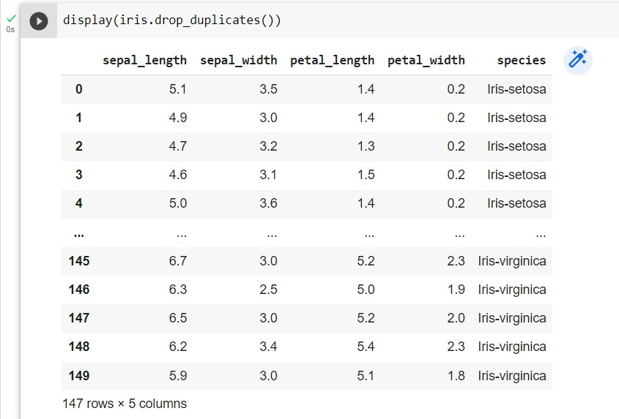Dropping the duplicate data
2. Column cleanup

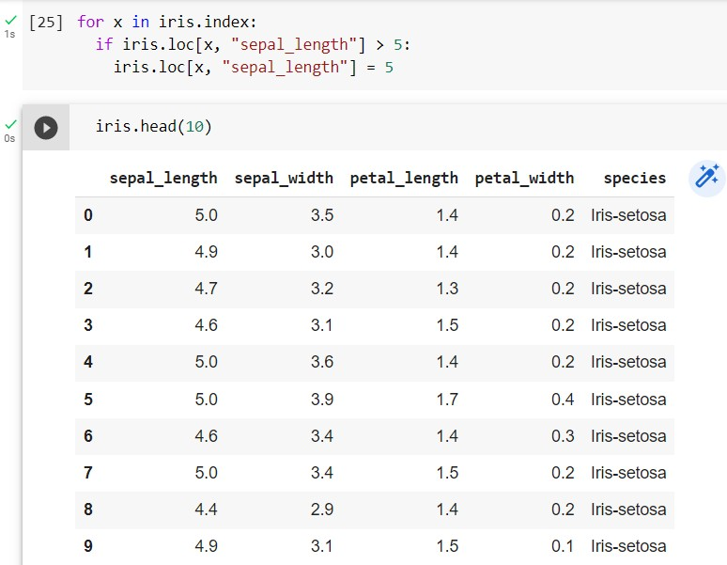

1. Showing the unique data of a specific column.

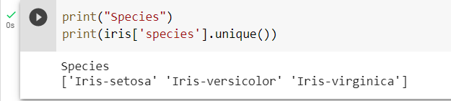

1. 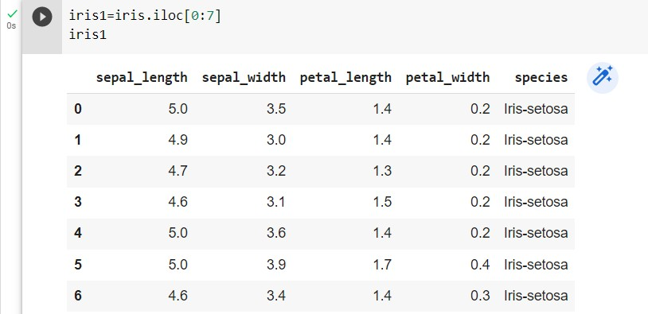Showing the data frame slicing.
2. 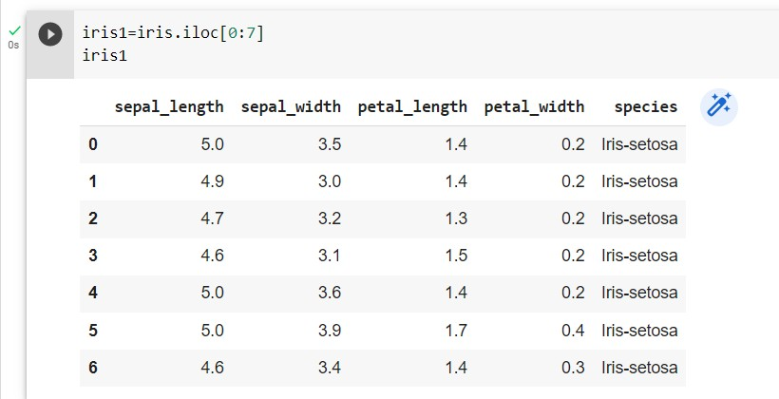Showing the data frame selection.
3. 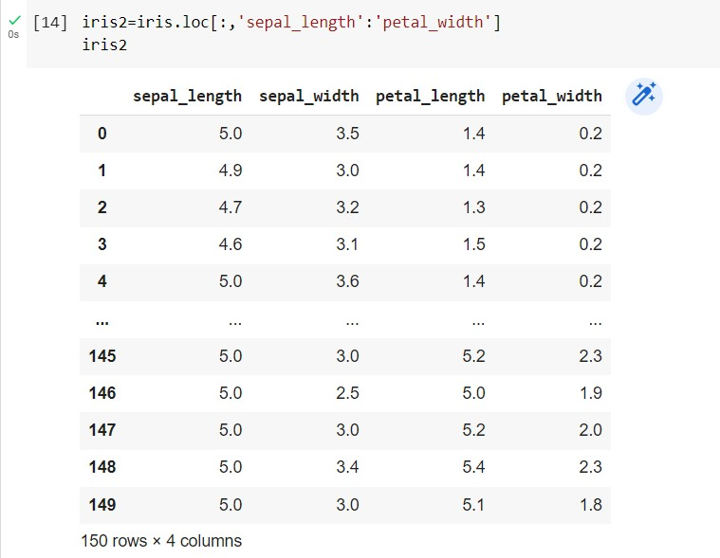Showing the data frame slicing.

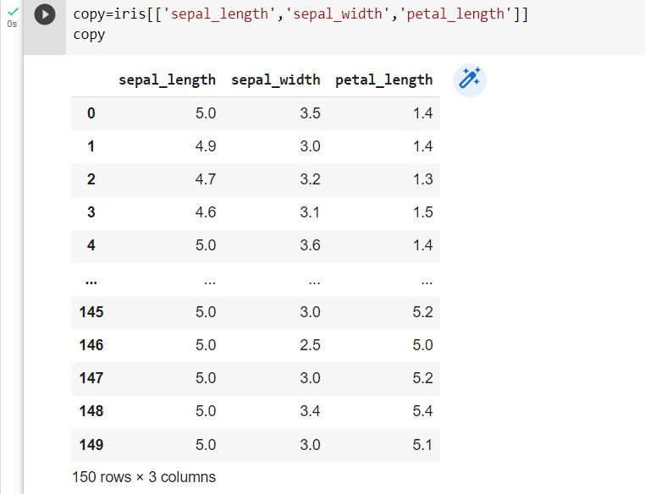

1. 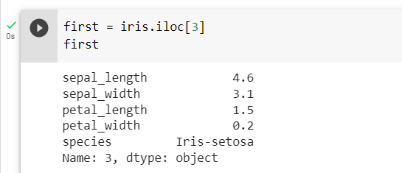Showing the data frame extracting.

