**ASSIGNMENT**

**Assignment no - 02**

CSE 476

Data Mining Lab

23.03.2023

:

:

:

Course NO

Course Name

Submission Date

|  |
| --- |
| Submitted To |
| Name: Khan Md. Hasib  Assistant Professor  Department of Computer Science & Engineering |
| Submitted By |
| Name: Hashibur Rahman Redoy  ID:18192103276 INATKE: 41 SECTION: 03 |

**CO2 Apply calculating mathematical statistics techniques (such as: mean - average value, median - middle value, median - middle value, median - middle value) in the following dataset -**

[**https://www.kaggle.com/datasets/muthuj7/weather-dataset**](https://www.kaggle.com/datasets/muthuj7/weather-dataset)

1. 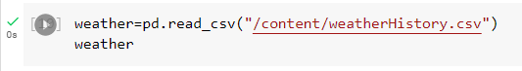**Upload the dataset & Viewing the data**

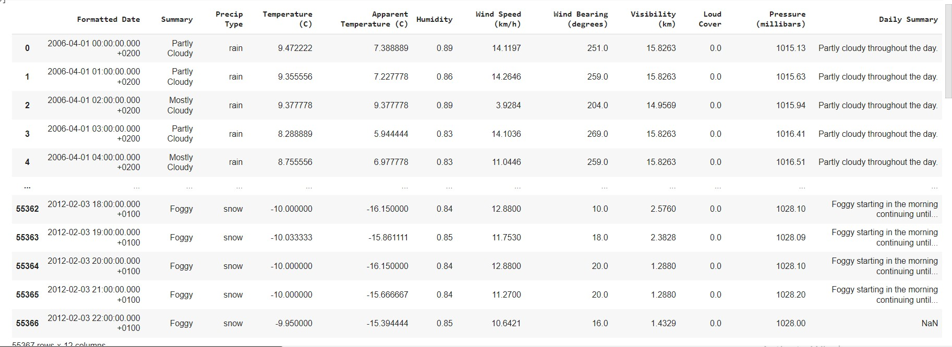

1. 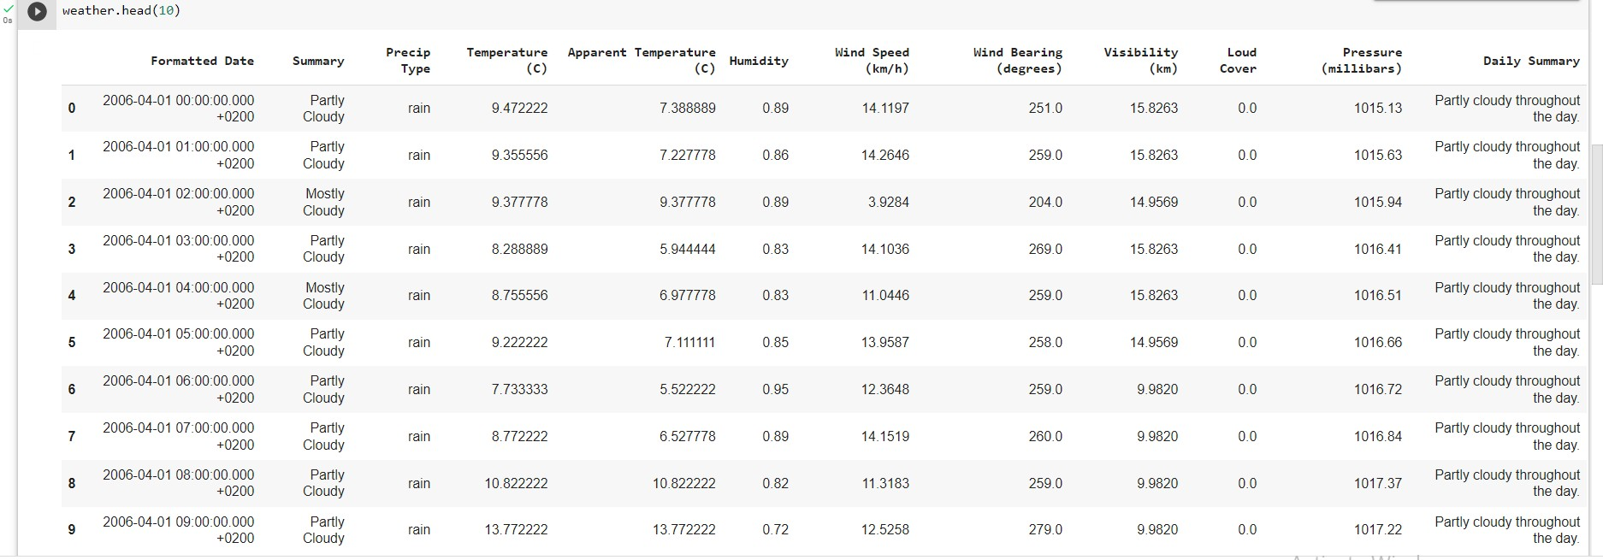View the top 10 rows of the dataset.

4. Showing the mean value of the Humidity Column,

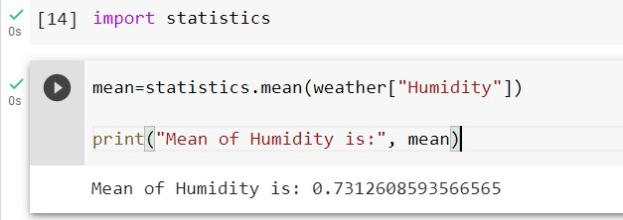

1. 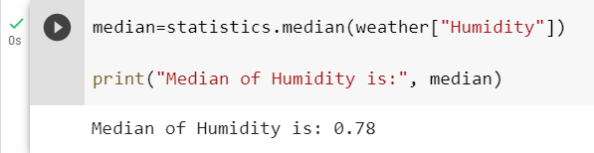Showing the median value
2. Showing the mode value

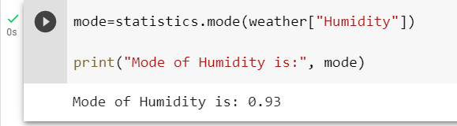

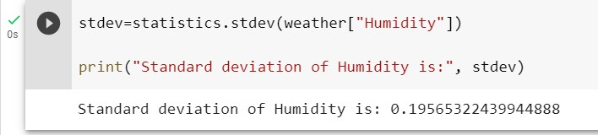6 . Showing the Standard deviation value