**ASSIGNMENT**

**Assignment no - 03**

CSE 476

Data Mining Lab

23.03.2023

:

:

:

Course NO

Course Name

Submission Date

|  |
| --- |
| Submitted To |
| Name: Khan Md. Hasib  Assistant Professor  Department of Computer Science & Engineering |
| Submitted By |
| Name: Hashibur Rahman Redoy  ID:18192103276 INATKE: 41 SECTION: 03 |

# CO3 What are the differences between the following data sets?

1. **Contact Lens data:** [**http://archive.ics.uci.edu/ml/datasets/Lenses**](http://archive.ics.uci.edu/ml/datasets/Lenses)
2. **Iris data:** [**http://archive.ics.uci.edu/ml/datasets/Iris**](http://archive.ics.uci.edu/ml/datasets/Iris)

# The main differences between the Lenses and Iris datasets are:

Purpose: The Lenses dataset is a diagnostic dataset used for classifying patients based on certain medical features, while the Iris dataset is a classification dataset used for identifying different species of iris flowers based on their petal and sepal dimensions.

Size and attributes: The Lenses dataset contains 24 instances and 5 attributes, while the Iris dataset contains 150 instances and 4 attributes.

Attribute types: The attributes in the Lenses dataset are a mixture of categorical and continuous variables, while the attributes in the Iris dataset are all continuous variables.

Class labels: The Lenses dataset has 3 class labels, while the Iris dataset has 3 class labels as well.

Complexity: The Iris dataset is a relatively simple dataset with well-separated classes, while the Lenses dataset is more complex and may require more sophisticated models to achieve good accuracy.

# From the following algorithms which one is expected to perform best on the Contact Lens data?

Ans: It is difficult to determine which model will perform the best without testing them on the dataset and evaluating their performance. Each of the algorithms you mentioned has its own strengths and weaknesses and is suitable for different types of problems.

For the Lenses dataset, which contains categorical features and a small number of instances, decision trees may perform well because they are good at handling categorical data and can produce interpretable models.

Neural networks can also be effective on this dataset as they can handle non-linear relationships between the input features and output labels. However, for small datasets like this, overfitting can be a problem if the model is too complex or the number of training examples is too small.

K-Nearest Neighbors (KNN) is also a simple algorithm that can perform well on this dataset. However, its performance may be impacted by the choice of k and the distance metric used.

In general, the best approach would be to try all three algorithms and evaluate their performance using appropriate metrics such as accuracy, precision, recall, and F1-score. Cross-validation can also be used to estimate the performance of each model and reduce the risk of overfitting.

Implement those on the Contact Lens data. K-Nearest Neighbors

Decision Tree Neural Networks

1. Upload the dataset and assign column names and showing the top 5 values

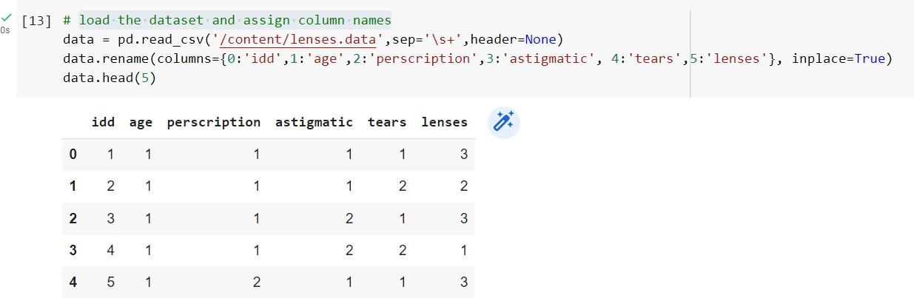

1. Splitting the data into train & test data

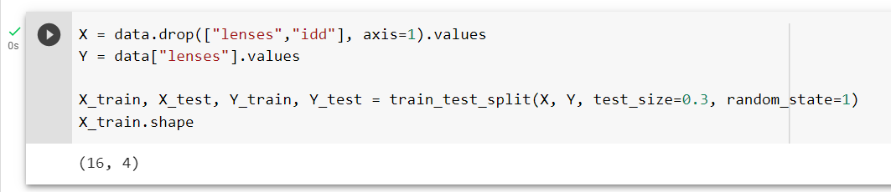

1. Applying the Decision Tree to the lens dataset

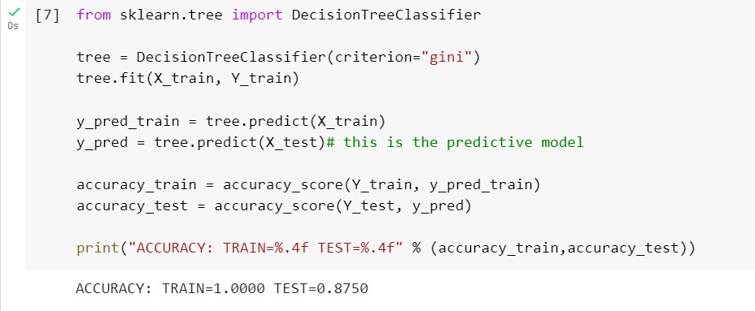

1. After the training, we got the training Accuracy = **100%** & testing accuracy= **87%**

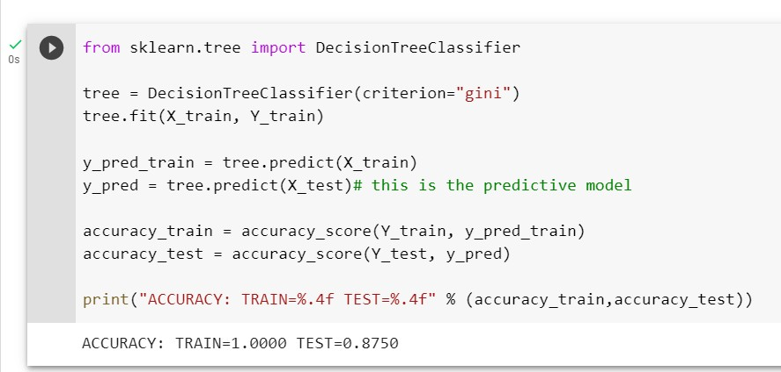

# Applying K-Nearest Neighbors

1. Importing the KNeighborsClassifier library & also defining the k-neighbors model.

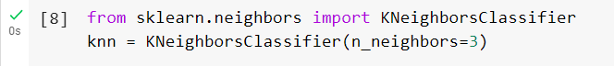

1. Fitting the dataset in the KNN Model.

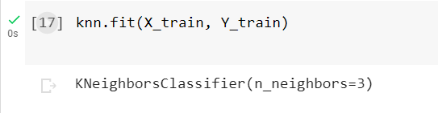

1. Storing the predicted values and here we got an accuracy of **87%**

