PMA Technical Assessment
PM Accelerator Mission
By making industry-leading tools and education available to individuals from all backgrounds, we level the playing field for future PM leaders. This is the PM Accelerator motto, as we grant aspiring and experienced PMs what they need most – Access. We introduce you to industry leaders, surround you with the right PM ecosystem, and discover the new world of AI product management skills.
Project Overview
- Objective: Analyze the Global Weather Repository dataset to forecast future weather trends using data science techniques.
- Assessment Track: Advanced
- Name: Mohammad Ibtesam Khan
- Submission Date: April 22nd, 2026
Dataset
- Source: Kaggle — "nelgiriyewithana/global-weather-repository"
- File: GlobalWeatherRepository.csv
- Download size: ~10.8 MB
- Shape: 136,828 rows × 41 columns
Unique Analysis
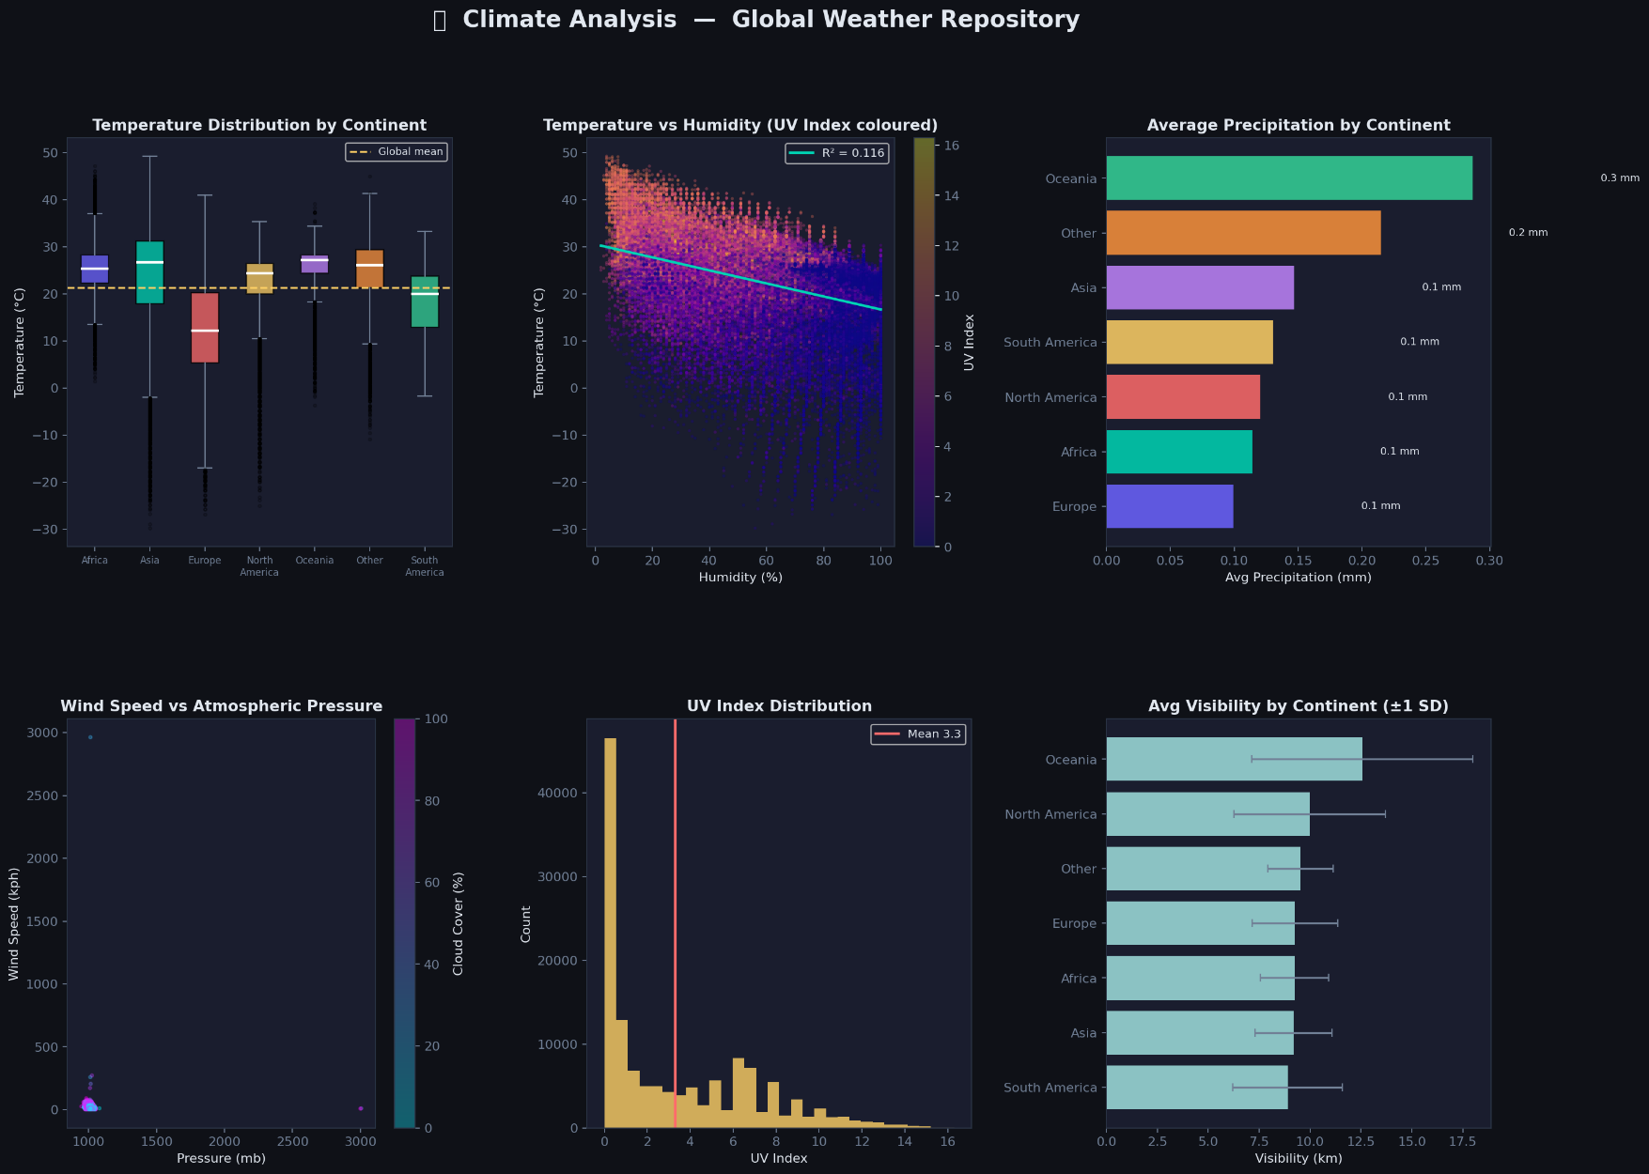
FIGURE 1 — CLIMATE ANALYSIS

FIGURE 1 — CLIMATE ANALYSIS
Subplot (a): Temperature Distribution by Continent [Box Plot]
• Grouped box plots for each continent showing temperature spread in °C.
• Median lines in white; outliers shown as small semi-transparent dots.
• A global mean reference line (dashed amber) is overlaid.
• Insight: Tropical continents (Africa, Asia, North America) show higher median temperatures; Europe
and Oceania have wider spread and cooler values; North America shows diverse distributions.
Subplot (b): Temperature vs Humidity [Scatter Plot]
• X-axis: Humidity (%); Y-axis: Temperature (°C)
• Points coloured by UV Index.
• Insight: Moderate negative correlation between humidity and temperature;
higher UV index concentrates in drier, hotter regions.
Subplot (c): Average Precipitation by Continent [Horizontal Bar Chart]
• Mean precipitation (mm) per continent, sorted ascending.
• Values annotated at bar ends.
• Insight: Europe and Africa typically have the highest mean precipitation.

Subplot (d): Wind Speed vs Atmospheric Pressure [Scatter Plot]
• X-axis: Pressure (mb); Y-axis: Wind Speed (kph)
• Insight: Higher cloud cover tends to appear at moderate pressure ranges. Also, wind speed tends to
increase as Atmospheric pressure decreases.
Subplot (e): UV Index Distribution [Histogram]
• 30-bin histogram of UV index values.
• Mean UV value overlaid as vertical dashed line.
• Insight: Most of the records have UV-index within [0 – 1] range.
Subplot (f): Average Visibility by Continent [Horizontal Bar Chart]
• Mean visibility (km) per continent with ± 1 standard deviation error bars shown in muted grey.
• Insight: Oceania tends to have the highest average visibility.

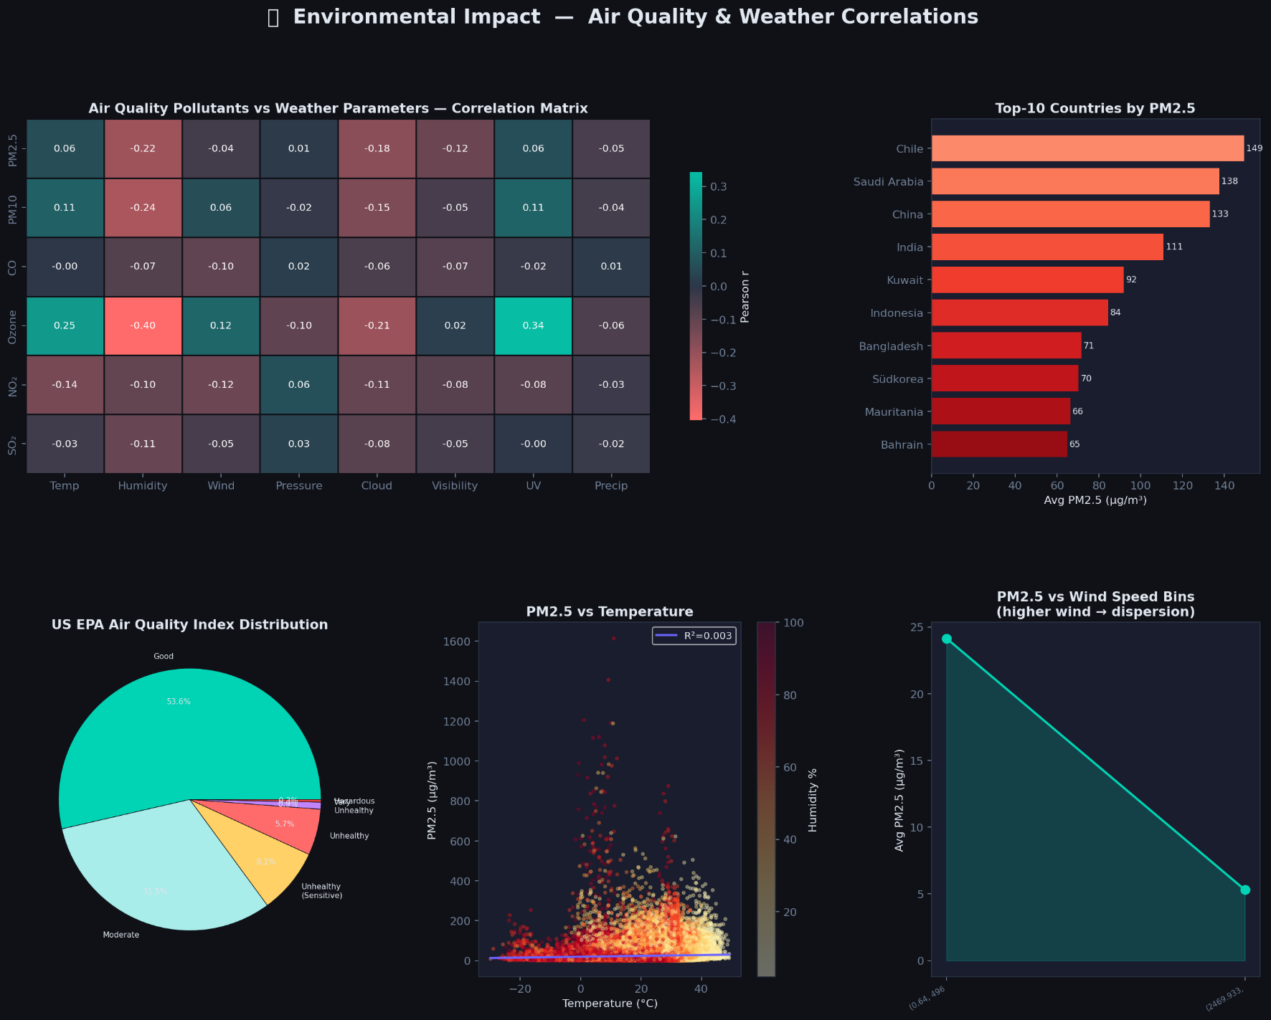
FIGURE 2 — ENVIRONMENTAL IMPACT: AIR QUALITY & WEATHER CORRELATIONS

Subplot (a): Air Quality Pollutants vs Weather Parameters [Correlation Matrix]
• Rows: PM2.5, PM10, CO, Ozone, NO₂, SO₂
• Columns: Temperature, Humidity, Wind, Pressure, Cloud, Visibility, UV, Precipitation
• Coloured with a custom diverging red–navy–teal colormap centred at 0.
• Pearson correlation values annotated on each cell.
• Insights:
- Temperature shows positive correlation with pollutants.
- Ozone has highest correlations with temperature and UV-index.
Subplot (b): Top-10 Countries by Average PM2.5 [Horizontal Bar Chart]
• Red gradient bars listing the 10 most polluted countries by mean PM2.5.
• Values annotated at bar ends in μg/m³.
• Insight: Mostly Asian countries top the list.

Subplot (c): US EPA Air Quality Index Distribution [Pie Chart]
• Categories: Good, Moderate, Unhealthy (Sensitive), Unhealthy, Very Unhealthy, Hazardous
• Insight: The majority of global observations fall in the "Good" (53.6%) or "Moderate" (31.5%)
categories.

Subplot (d): PM2.5 vs Temperature [Scatter Plot]
• X: Temperature (°C); Y: PM2.5 (μg/m³)
• Points coloured by humidity (Yellow or Red colormap).
• Linear regression line with R² annotated.
• Insight: Positive but noisy relationship; extreme PM2.5 outliers appear at moderate temperatures with
higher humidity.
Subplot (e): PM2.5 vs Wind Speed Bins [Line + Fill Chart]
• Wind speed divided into 6 equal-frequency bins; mean PM2.5 per bin.
• Insight: Clear downward trend — as wind speed increases, average PM2.5 decreases substantially,
confirming atmospheric dispersion.

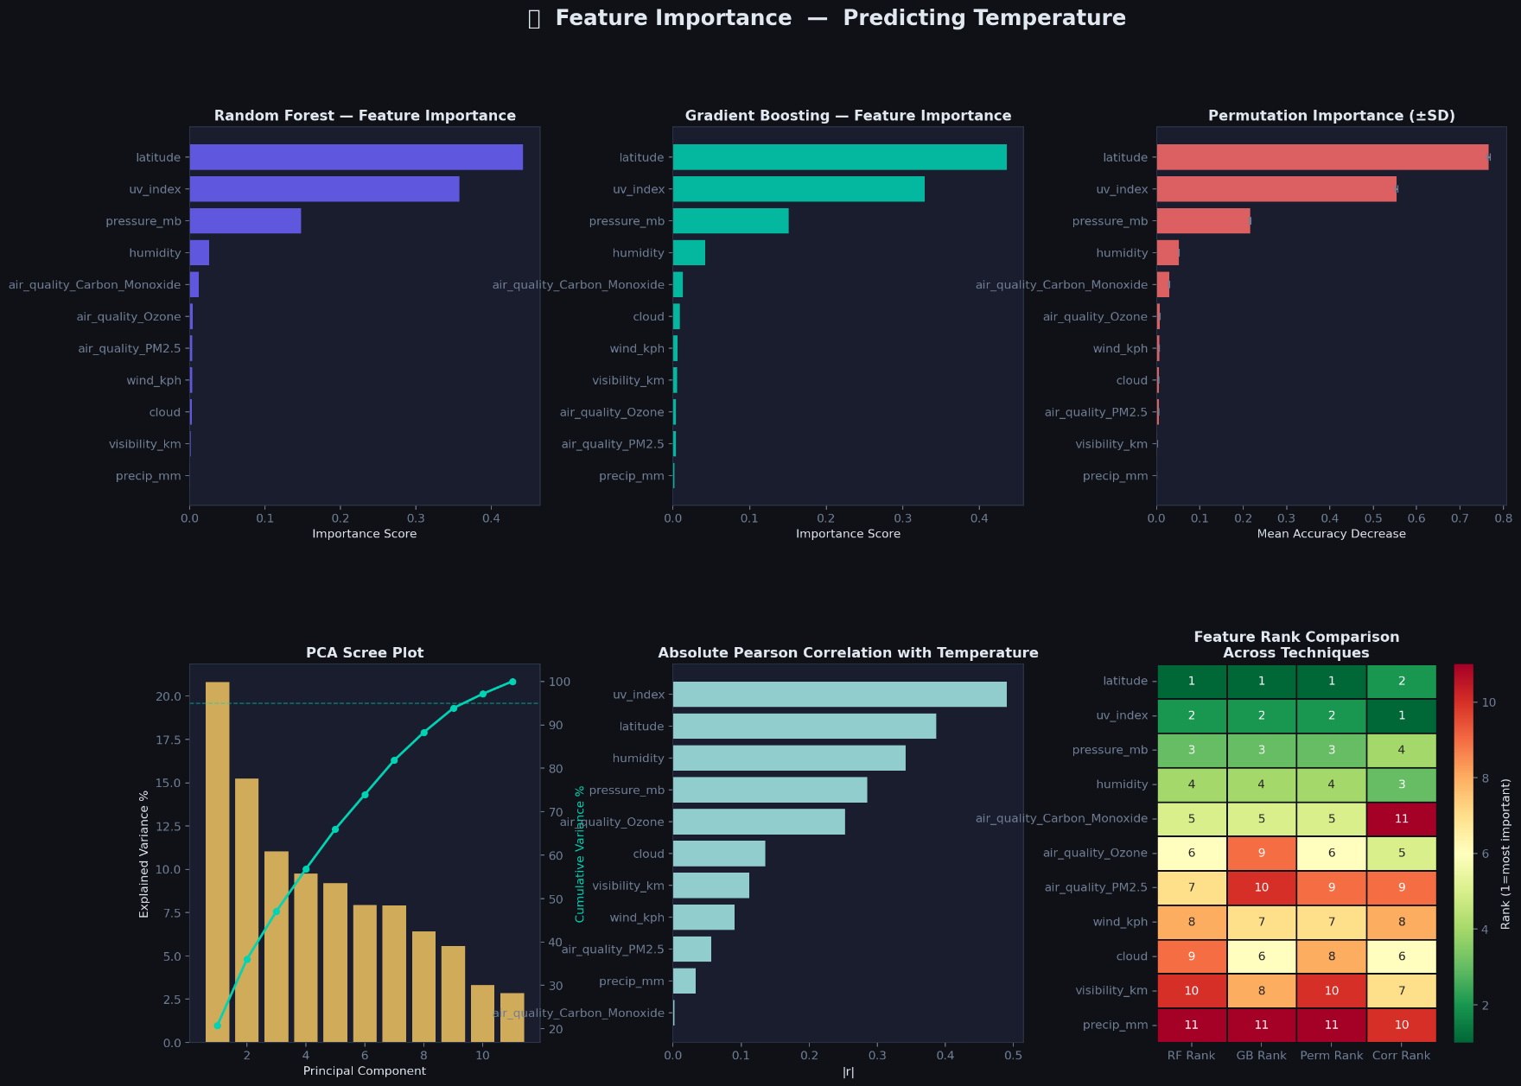
FIGURE 3 — FEATURE IMPORTANCE IN PREDICTING TEMPERATURE
Subplot (a): Random Forest Feature Importance [Horizontal Bar]
• RandomForestRegressor: 200 estimators, max_depth=8, random_state=42
• Top features: latitude, humidity, uv_index, pressure_mb

Subplot (b): Gradient Boosting Feature Importance [Horizontal Bar]
• GradientBoostingRegressor: 150 estimators, max_depth=4, random_state=42
• Generally agrees with Random Forest; slight re-ordering in mid-tier features.

Subplot (c): Permutation Importance (±SD) [Horizontal Bar with Error Bars]
• 15 repeats of permutation importance using the Random Forest model.
• Error bars (±1 SD) indicate stability of each feature's importance.
• Top features: latitude and humidity most impactful; small error bars indicate reliable estimates.
Subplot (d): PCA Scree Plot [Bar + Line]
• Data standardised with StandardScaler; PCA fitted on 11 features.
• Bar chart shows % of variance explained per principal component.
• 95% cumulative variance reference line (dashed teal) overlaid.
Subplot (e): Absolute Pearson Correlation with Temperature [Horizontal Bar]
• Direct linear correlation of each feature with temperature_celsius.
• latitude shows the strongest linear relationship, while humidity also shows notable correlation.
Subplot (f): Feature Rank Comparison Across Techniques [Annotated Heatmap]
• Columns: RF Rank, GB Rank, Permutation Rank, Correlation Rank.
• Rows sorted by RF Rank.
• Coloured by Red, Yellow, and Green (low = most important i.e. green).
• Insight: latitude consistently ranks #1 across all four methods.

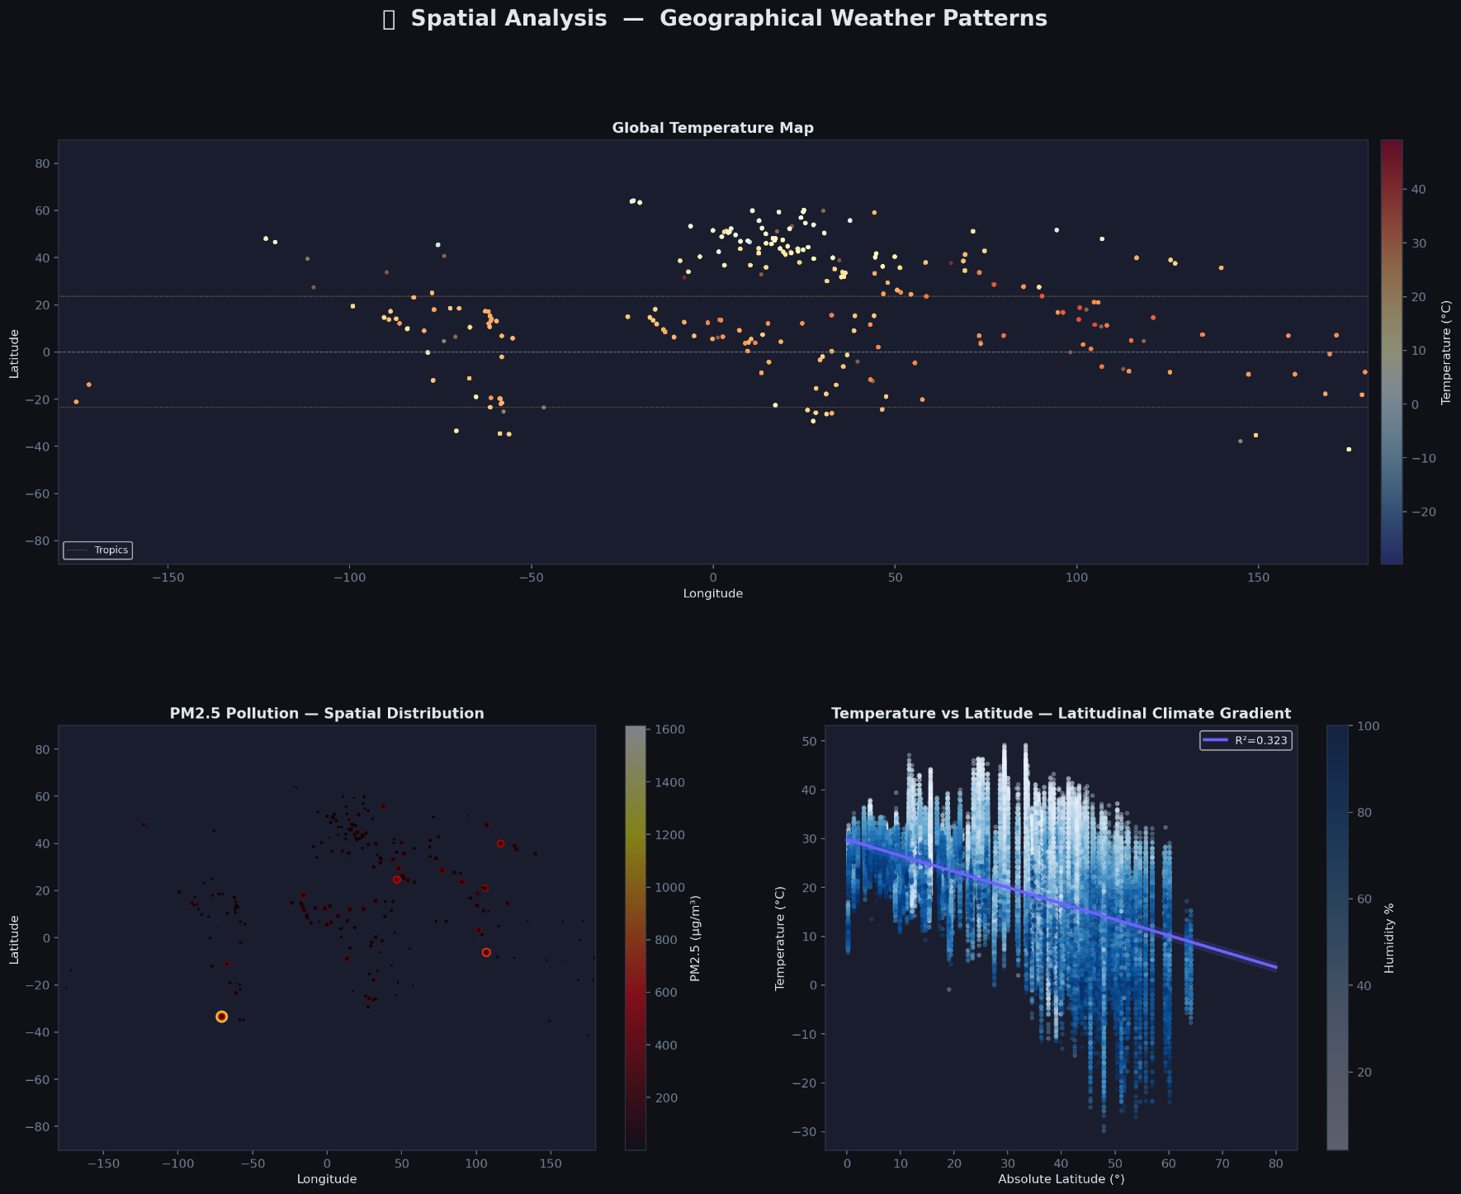
FIGURE 4 — SPATIAL ANALYSIS: GEOGRAPHICAL WEATHER PATTERNS

Subplot (a): Global Temperature Map [Full-Width Scatter Map]
• Longitude on X-axis, Latitude on Y-axis.
• Points coloured by temperature_celsius (blue=cold, red=hot).
• Reference lines for equator (dashed grey), Tropics of Cancer/Capricorn
• Insight: Clear band of high temperatures between ±23.5°; polar regions appear in blue; desert regions
in orange-red.

Subplot (b): PM2.5 Pollution — Spatial Distribution [Bubble Map]
• Longitude on X-axis, Latitude on Y-axis, and bubble size = PM2.5 value / 15
• Insight: High PM2.5 clusters in South Asia, East Asia, and Middle East.

Subplot (c): Temperature vs Absolute Latitude [Scatter + Regression Band]
• X-axis: |Latitude| (0–80°); Y-axis: temperature_celsius.
• Points coloured by humidity (Blues colormap).
• Linear regression line with R² and ±2 SE confidence band overlaid.
• Insight: Strong negative relationship — temperature decreases significantly as absolute latitude
increases.

3. Data Cleaning & Preprocessing

4. Exploratory Data Analysis (EDA)
🔍 Trends & Correlations
• [Brief summary of key trends discovered]
• [Mention strongest correlations found]
📊 Temperature & Precipitation Visualizations
• [Embed images or link to/plots/directory]
• Key Observation 1: ...
• Key Observation 2: ...
⚠️ Advanced EDA (If Advanced Track)
• Anomaly Detection: [Algorithm/method used, e.g., Isolation Forest, Local Outlier Factor]
• Outlier Analysis Insights: [Brief summary]
________________________________________
5. Forecasting Models
📈 Model(s) Built
Model Type Key Parameters
[e.g., ARIMA] [Baseline/Advanced] [e.g., p=2, d=1, q=1]
[e.g., Prophet] [Advanced] [e.g., seasonality_mode='multiplicative']
[e.g., XGBoost/LSTM] [Advanced] [Brief config]
📊 Evaluation Metrics
Model MAE RMSE MAPE R²
[Model 1] ... ... ... ...
[Model 2] ... ... ... ...
• Best Performing Model: [Name]
• Ensemble Approach (If Advanced): [Briefly explain stacking/voting/blending & accuracy improvement]
• Time Series Analysis Note: [Explain how the "last updated feature" was utilized as instructed]
________________________________________
6. Advanced/Unique Analyses (Required for Advanced Track, Optional for Basic)
• 🌡️ Climate Analysis: [Long-term patterns & regional variations]
• 🌬️ Environmental Impact: [Air quality correlation with weather parameters]
• 🔑 Feature Importance: [Technique used: e.g., SHAP, Permutation, Tree-based importance]
• 🌍 Spatial & Geographical Patterns: [How conditions differ across continents/countries + visualization link]
________________________________________
7. Key Insights & Implications
1. [Insight 1 with business/environmental relevance]
2. [Insight 2]
3. [Insight 3]
4. [Conclusion on forecasting reliability & limitations]
________________________________________
8. How to Run This Project
📦 Requirements
• requirements.txt or environment.yml is included in the repository.
• Install dependencies: pip install -r requirements.txt
▶️ Execution Steps
1. Clone repository: git clone [repo-link]
2. Navigate to project folder: cd weather-forecast-pma
3. Run main script/notebook: [Specify command, e.g., jupyter notebook main.ipynb]
4. Outputs & plots will be saved in /outputs/ and /plots/
🎥 Demo Video
• Watch Demo (1-2 min screen recording explaining code & results)
________________________________________
9. Conclusion & Future Work
• [Brief wrap-up]
• [Suggested improvements: e.g., more granular spatial models, real-time data ingestion, deployment as API]
________________________________________
📁 Repository Structure

1
2
3
4
5
6
7
├── data/ # Raw & cleaned datasets
├── notebooks/ # EDA & Modeling code
├── src/ # Modular scripts (if applicable)
├── outputs/ # Model results, metrics
├── plots/ # EDA & forecasting visualizations
├── requirements.txt # Dependencies
└── README.md # This file

