# Documentation

## Login/Signup

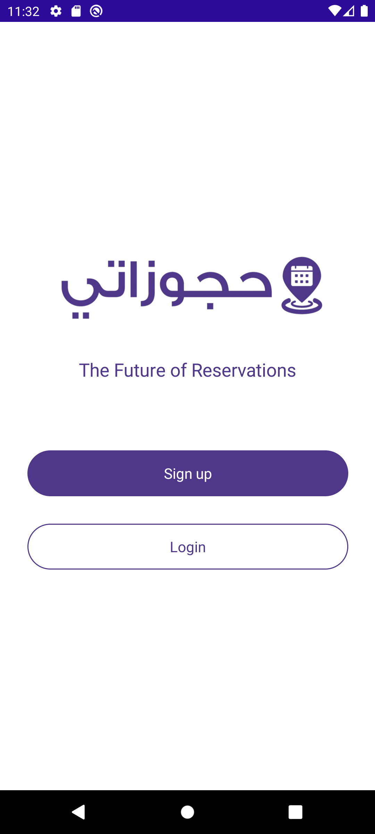

The app’s entry screen offers three straightforward pathways for users to begin their experience:

1. **Sign Up**

* + **Purpose**: For new users to create an account.
  + **Benefits**:
    - Save reservation history.
    - Enable quick bookings in the future.
    - Access exclusive features (e.g., loyalty rewards, personalized recommendations).
  + **Process**: Users will be prompted to enter basic details (e.g., email, password) or sign up via social media accounts.

1. **Login**

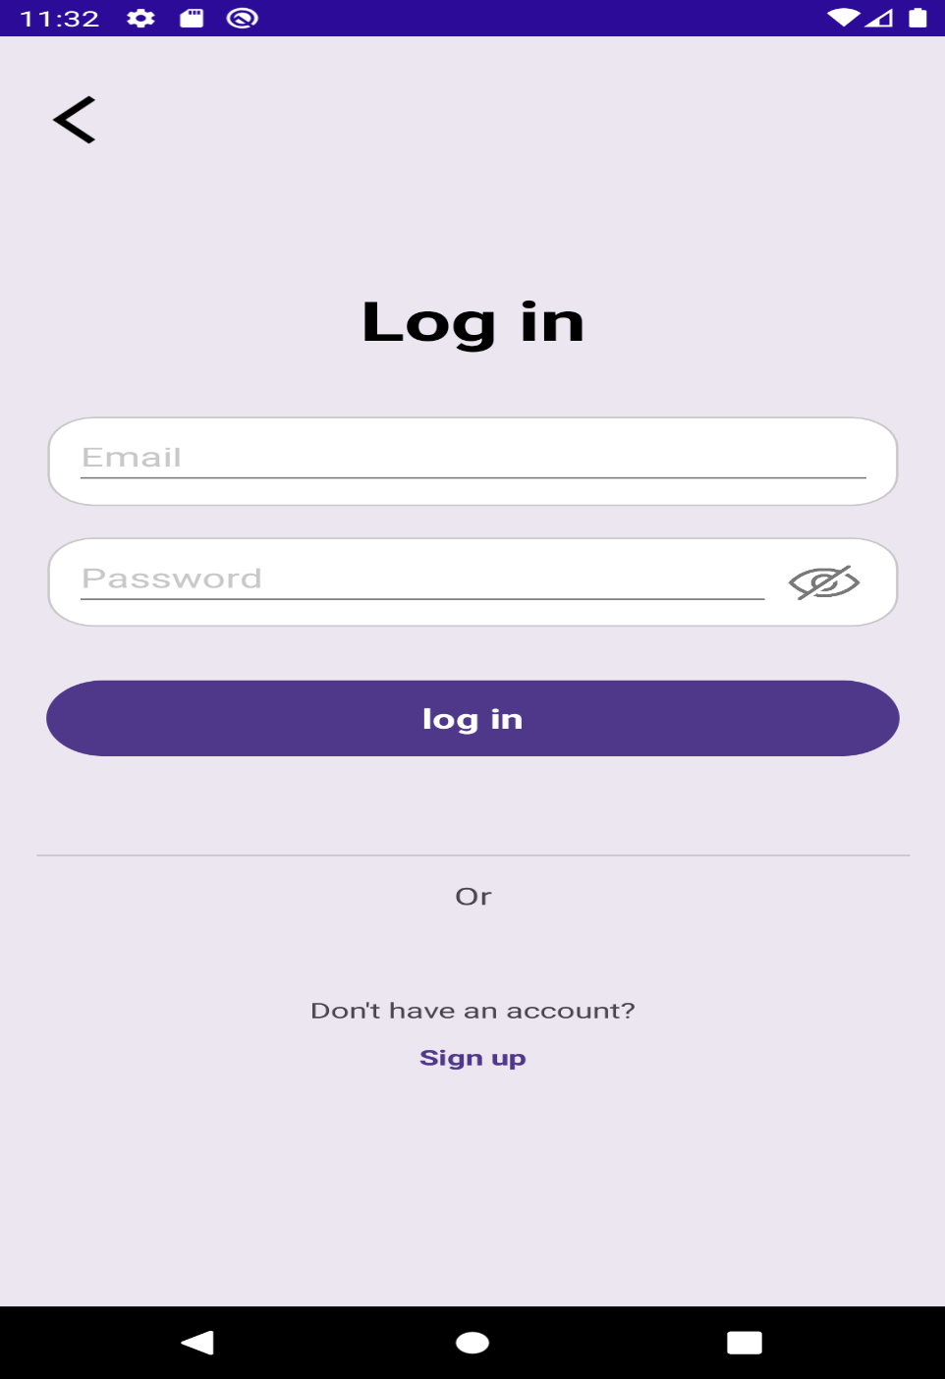

* + **Purpose**: For returning users to access their existing accounts.
  + **Benefits**:
    - Retrieve saved preferences and past reservations.
    - Continue using personalized features.
  + **Process**: Users enter their credentials (email/password)

In addition the user can change their information after login or sign up from the profile info screen.

* **Profile Info**

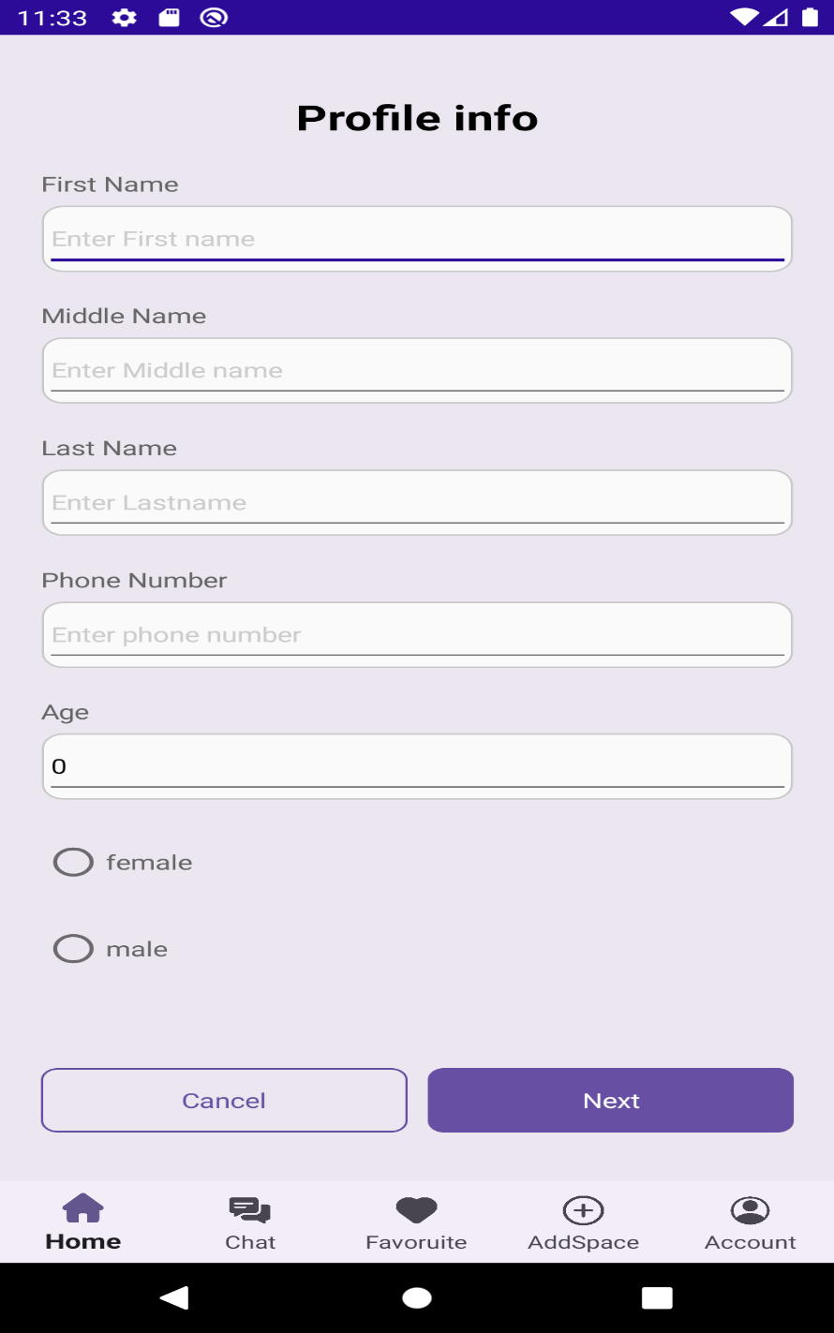

* + **Purpose**: Users can view, edit, and update details like name , phone number, Gender, and Age.
  + **Benefits**:
  + User Control & Security: Manage personal data
  + Personalization & Branding: Customize profiles to reflect identity, preferences, or professional expertise.

**Process**: **access your profile** by logging into your account and navigating to the settings or profile section to review existing details (e.g., contact information, bio, preferences).

# HomePage:

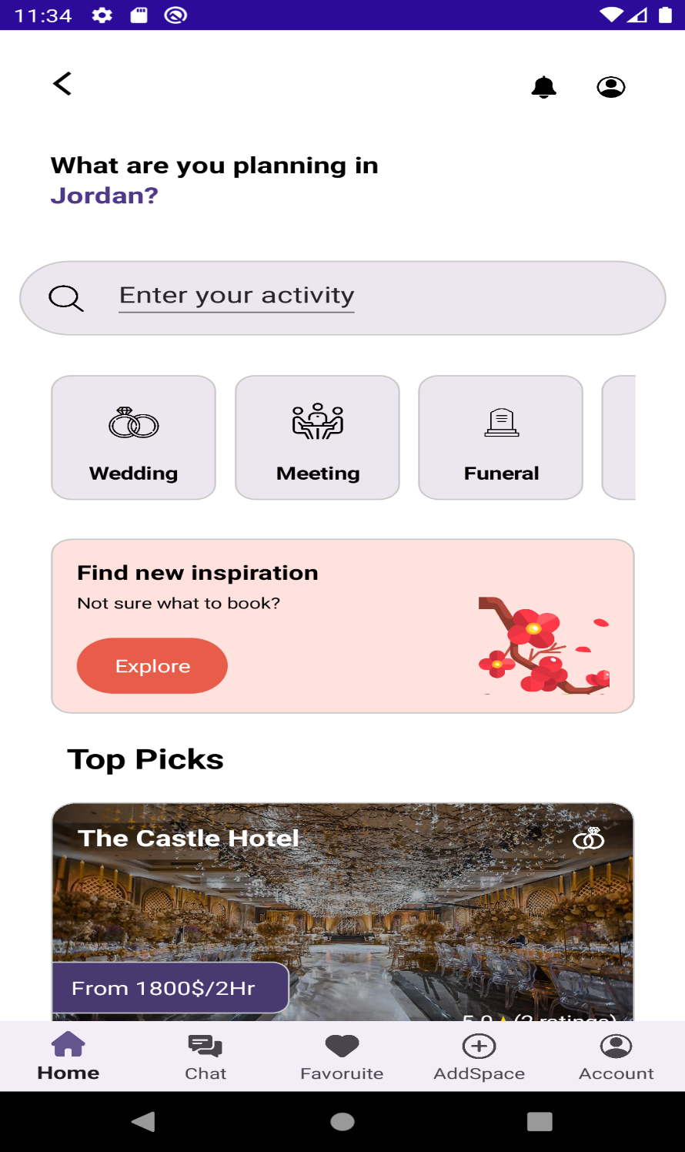

Overview

The Hojozaty website welcomes users to a friendly platform for finding and booking unique venues. Whether you’re planning a wedding, a meeting, or even something as somber as a funeral, the site offers a straightforward way to search for the perfect space that fits your needs.

Navigation & Layout

* Top Navigation Bar:
  + Home: This is the default landing page.
  + Chat: For connecting with Venue Owners.
  + Favourite: Quickly access your saved venues.
  + AddSpace: A dedicated section for venue owners who want to list their spaces.
  + Account: Manage your profile and settings.
  + There’s also a hamburger menu in the center for additional navigation options, plus a notification icon on the right to keep you updated.
* Main Content Area:
  + Search Bar:  
    Right at the top, you’ll find a search bar with the placeholder text “Enter your activity.” This helps direct you to venues tailored to your event type.
  + Activity Categories:  
    Four easily identifiable categories help jump-start your search:
    - Wedding : For your special day.
    - Meeting : Ideal for professional or casual get-togethers.
    - Funeral : Respectful options for end-of-life arrangements.
    - More : Explore additional categories if your event doesn’t fit the first three.
  + Inspiration Banner:  
    Not sure what you’re looking for? A prominent banner invites you to “Find new inspiration. Not sure what to book?” with a clear call-to-action button labeled Explore. This is designed to spark ideas and guide you toward popular choices.
  + Highly Rated Spaces Section:  
    Below the main search and category options, you’ll find a selection of highly recommended venues:
    - The Castle Hotel: Offers a distinctive experience at $1800/2Hr with a perfect 5.0 rating (based on 2 reviews).
    - Zain Bent Al Husain: Another intriguing option priced at $25/1Hr.
    - Each listing typically includes high-quality images, pricing information, and customer ratings, making it easy to compare your options.

Design & Aesthetic

* Theme & Colors:  
  The page embraces a dark theme with a sleek, modern look. Buttons and highlights use soft pastel colors, adding warmth to the overall design.
* Icons & Imagery:  
  Carefully chosen icons help visually differentiate between categories, and vibrant venue images capture attention while giving you a preview of what to expect.
* User Experience:  
  The design emphasizes clarity and ease-of-use. With intuitive navigation, prominent search functionality, and clear call-to-action elements, the page feels welcoming and easy to explore.

# Chat Pages:

**1. Chat List View**

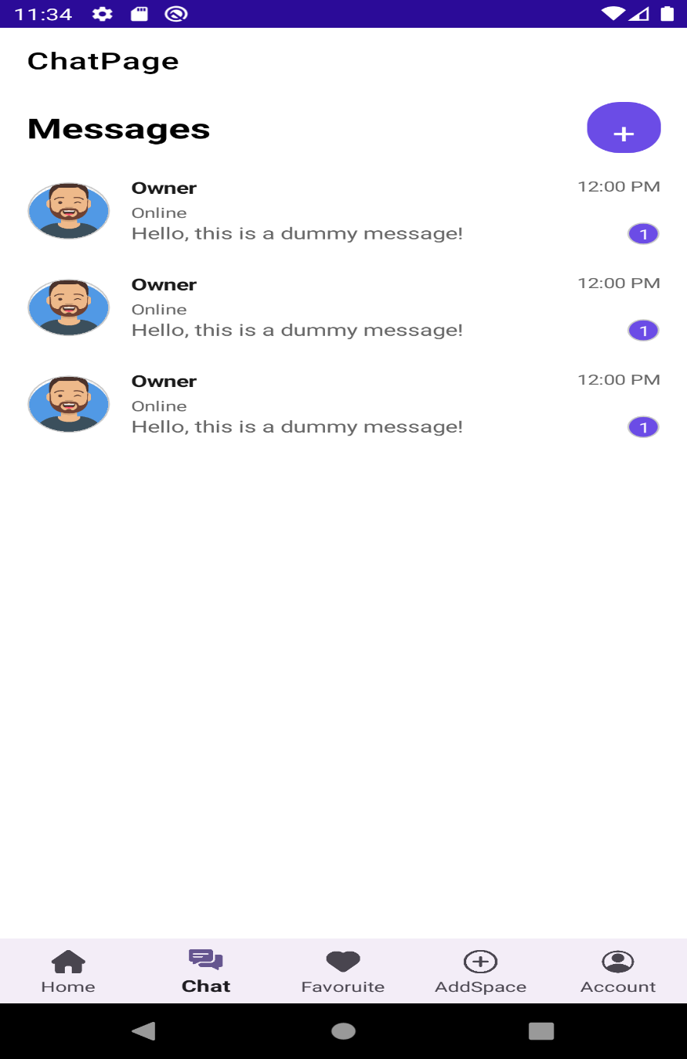

**What You See:**

* **Navigation Bar:**
  + Just like on the home page, the bar includes **Home**, **Chat** , **Favorite**, **Add Space**, and **Account**.
* **Conversation Cards:**
  + Each recent conversation is shown as a friendly card that includes:
    - **User Avatar:** A circular image representing the contact (e.g., "Owner").
    - **Username:** Clearly displayed so you know who you're talking to.
    - **Online Status:** A visual indicator to show if the contact is currently online.
    - **Message Preview:** A snippet of the most recent message so you can quickly catch up.
    - **Timestamp:** Tells you when the last message was sent.
    - **Unread Count:** A small bubble showing how many new messages you have.
* **New Chat Button:**
  + In the Upper right corner, a bright purple floating action button makes it easy to start a new conversation.

**User Experience:**

This view is all about getting you quickly back into your chats. The design is clean and straightforward, letting you focus on your conversations without distractions.

1. Individual Chat View

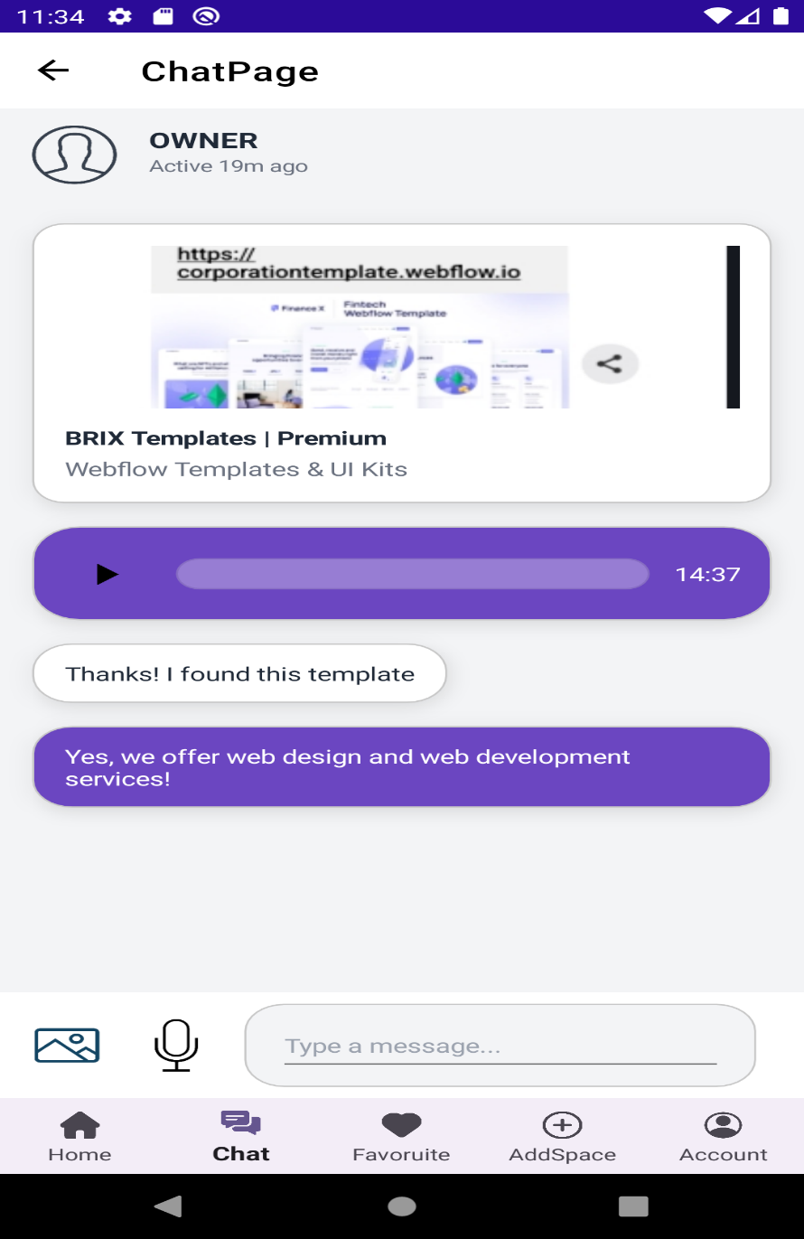

**What You See:**

* **Header Information:**
  + At the top of your chat, you'll see the contact’s name, profile picture, and their last active status—so you always know who you're chatting with and if they're around.
* **Messaging Area:**
  + **Text Messages:** The conversation flows naturally with text messages.
  + **Rich Link Previews:** Sometimes, you'll see a nice preview when a link is shared (for example, a template link preview), making it easier to understand the context.
  + **Voice Messages:** There’s a dedicated area that shows voice messages with a clear timestamp (like 14:37), indicating that sending audio is just as simple as text.
* **Message Input Area:**
  + At the bottom, there's a text box with a friendly placeholder text like “Type a message…”.
  + **Attachment Icons:**
    - A camera icon for images.
    - A microphone icon to record and send voice messages.

**User Experience:**

The individual chat view is designed to be clear and inviting. With a mix of light and dark themes (depending on the context), the layout focuses on readability and ease-of-use. It’s intuitive enough for you to switch between text, images, and voice messages without missing a beat.

**Design & Interaction**

* **Theme Options:**
  + The chat list often uses a dark theme, which is easy on the eyes, while the conversation view may switch to a lighter theme for better readability—giving you the best of both worlds.
* **Simple & Clear Layout:**
  + The card-based design in the chat list and the clean individual chat view ensure that everything is organized and accessible.
* **Interactive & Responsive:**
  + Whether you’re sending a quick text, sharing a photo, or leaving a voice message, every element is designed to respond smoothly, making your communication feel natural and effortless.