**Faculty of Science**

**Physics Department**

**General Physics Lab 2**

**(PHYS112)**

**Instructor: Dr. Naser sami**

**{Report_2 --> Experiment_2}**

**<Source Internal resistance, Loading Problems & Circuit Impedance Matching>**

**Student Name: Mohammad Raddad**

**Student ID: 1180812**

# **Abstract**

1. **The aim of this experiment:** isto measure the internal resistance of a voltage source, the potential difference, and see when does the power reach its maximum value. to find the emf given by a voltage source and its internal resistance, and to find the value of R L when the maximum power is consumed in the load by recording the value of the current (I) at different values of R L and using the graphs of (1/I) vs. R L and P(R L ) to calculate or estimate the values mentioned above.
2. **The method used**: The direct calculation of the electrical current passing through a simple circuit at different values of the resistance.
3. **The main result:** was that the maximum amount of power is consumed R L was when RL = ΣRin.

* Є = 9.51 volt
* ΣRin = 498 Ω
* Maximum power consumed in Load ≈ 30.342 mWatt (when RL ≈ 502 Ω)

# **Theory**

One of the main characteristics of a voltage source is the electro motive force (emf), which is the open circuit voltage difference between its terminals, as shown in fig.1, and the maximum value of the current deliver to a short circuit. And according to Ohm’s law; an ideal voltage source connected to a short circuit (rin = 0) should be able to provide an almost infinite current.

However, in real circuits a voltage source connected to a short circuit can neither maintain its (emf) as a voltage difference across its terminals nor can it provide the circuit with unlimited current. It should be obvious that voltage sources with small internal resistances can maintain most of their (emf) as voltage differences between their terminals and provide circuits with higher current values than would the ones with high internal resistances.

Voltage sources are used to provide useful electrical power to certain circuit components, such as electric motors and light bulbs. Any component which consumes electrical power to produce useful work is called a load and the resistance of such a component is called the load resistance, and is referred to by (RL).

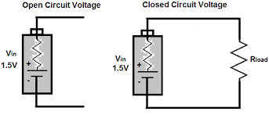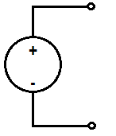

Figure 1:Real

Figure 2:ideal

## Loading Problem

The current passing through the simple series circuit, like the one shown in

(fig.3) is:



Figure 3:Closed circuit voltage

So, the voltage difference between the source terminals is:

If (RL >>rin)then (VRL >> €) and the source delivers most of its emf as a voltage difference across its terminals.

On the other hand, if RL is comparable to rin then VRL is smaller than (). Hence, a considerable amount of power is consumed inside the source and converted to unuseful heat energy. In this case the source is said to be loaded. In practical circuits we usually want to avoid loading the source, therefore, choosing (RL $≥$ 10Rin) is recommended.

But as we know the internal resistance in the voltage source is usually small, namely a few ohms. Therefore, we face the problem of a limited load. In order to solve this problem, we usually add another external resistance. However, this resistance, to which I refer by (R) here, is

considered as an internal resistance by the load, whereas it is considered an external one by the voltage source. The only disadvantage in this method is the fact that we lose a fraction of the electrical energy through this resistance.

## Impedance Matching (Maximum Power Transfer)

In real circuits, power consumed in the load produces useful work. Therefore, we seek to consume the maximum available power there. In (Fig.3) the power consumed in the load resistor is:

Therefore

The previous equation represents the power consumed in the load as a function of the load resistance itself. The function P(RL) has a maximum value which can be obtained by setting  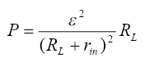 see Fig.4. And this gives RL = Rin

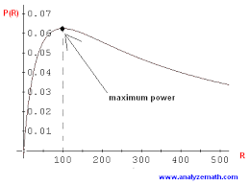

Figure 4:maximum value of P(RL)

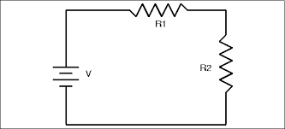As the condition for transferring maximum power to the load resistance. This choice of load resistance is called impedance matching.

Figure 5:Resistance in series

As the internal resistance of voltage sources is usually small (a few Ohms), in practical circuits an additional resistor is connected in series with the source as shown in fig.5 in order to produce the maximum power transfer condition for large values of RL.

While this additional resistance appears to RL as an additional internal resistance, it is seen by the source as an additional load resistance. Consequently, this resistance helps in avoiding loading problems and fulfilling the condition of impedance matching for large load values. The only disadvantage is that this additional

resistance consumes part of the power delivered to the circuit by the source. And by applying the law of energy conservation to the circuit in (figure 4), we get:



And by rearranging the equation we get:





When we plot this relation, we get a straight line with a slope

and a Y-intercept of

If we apply the condition of maximum power transfer to the load resistance of the same circuit we get: RL = R + rin

## Efficiency

A useful concept to use with power is that of efficiency (). The efficiency

of a component with impedance (resistance) RL operated from source with internal resistance (Rin) is the power dissipated in RL divided by the power dissipated in the circuit. Therefore:

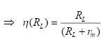



# **Procedure & Data Discussion**

1. We connected the circuit in Fig.6.
2. Changed the value of the Load resistance (0-1 MΩ) and recorded the value of the current each time as in the table below:

Table 1: Value of current

|  |  |  |  |  |
| --- | --- | --- | --- | --- |
| **RL (KΩ)** | **I(mA)** | **I-1 (mA)-1** | **I2 (mA)2** | **PL =I2 RL (mWatt)** |
| **0.1** | 8.54 | 0.117 | 72.93 | 7.293 |
| **0.3** | 7.23 | 0.14 | 52.3 | 15.69 |
| **0.5** | 6.26 | 0.16 | 39.2 | 19.6 |
| **0.7** | 5.54 | 0.183 | 30.7 | 21.49 |
| **0.75** | 5.38 | 0.185 | 28.94 | 21.7 |
| **0.8** | 5.09 | 0.19 | 27.35 | 21.9 |
| **0.85** | 5.23 | 0.196 | 25.9 | 22.01 |
| **0.9** | 4.95 | 0.2 | 24.5 | 22.05 |
| **0.95** | 4.85 | 0.2 | 23.5 | 22.325 |
| **1.0** | 4.69 | 0.21 | 21.99 | 21.99 |
| **1.05** | 4.58 | 0.22 | 20.97 | 22.01 |
| **1.1** | 4.47 | 0.22 | 19.98 | 21.97 |
| **1.2** | 4.27 | 0.23 | 18.23 | 21.87 |
| **2** | 3.13 |  | 9.8 | 19.6 |
| **5** | 1.57 |  | 2.5 | 12.5 |
| **8** | 1.01 |  | 1.02 | 8.16 |
| **10** | 0.85 |  | 0.73 | 7.3 |
| **15** | 0.58 |  | 0.34 | 5.1 |
| **20** | 0.44 |  | 0.19 | 3.8 |
| **25** | 0.36 |  | 0.13 | 3.25 |
|  |  |  |  |  |

1. We plotted a graph of (1/I) vs. (R L) to get Є and r in.
2. We plotted a graph of P (R L) for impedance matching.

## Calculations:

* From the graph of (1/I) vs. R L:
* (1/Є) = slope of line = 0.1273 volt -1 → Є = (1/ 0.1273volt -1) = 7.855 volt.
* (ΣRin / Є) = Y-intercept = 0.0634 mA -1 → ΣRin = (Y-intercept * Є) =

(7.855 volt * 0.0634 mA-1) = 498 Ω.

* From the graph of P vs. R L:
* Pmax when dP/dRL = 0 then RL= Rin
* Pmax = 30.342 mWatt so, Rin = 0.502 KΩ.
* We put graphs in Appendix :D

# **Results and Conclusions**

* Є = 7.855 volt
* ΣRin = 498 Ω
* Maximum power consumed in Load ≈ 30.342 mWatt (when RL ≈ 502 Ω)

We can conclude that impedance matching occurs when the total internal

resistance is equal to the load’s resistance.

The Result we got for Є matched what we expected: we knew that if the value we

got for Є using the multimeter is 9.51 volt, then the real value should a little more

then that because of the source’s internal resistance.

We also confirmed our observation about the loading problem practically.

Factors which might have contributed to the presence of errors in our experiment

include: not taking into account the resistance of other elements of the circuit such

as the wiring. Also, the results we got using the graphs have limited our accuracy

due to the limitation imposed by the divisions on the graphs; this is especially clear

when we tried to estimate the value of R L at which the maximum power is

consumed, from the graph the best estimate we could give was at 1000Ω but

theoretically it should be about 498 Ω. Measurements which we took from the

graph of (1/I) vs. R L are much more precise because we used the values which the

computer calculated for the slope and Y-intercept using the least square fit method.

# **Appendix**

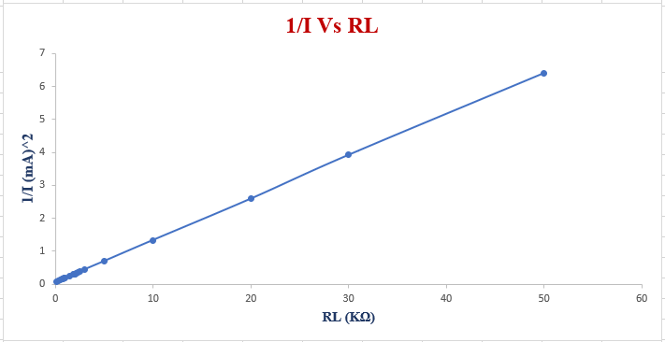

Figure 6: Graph of 1/I vs. V

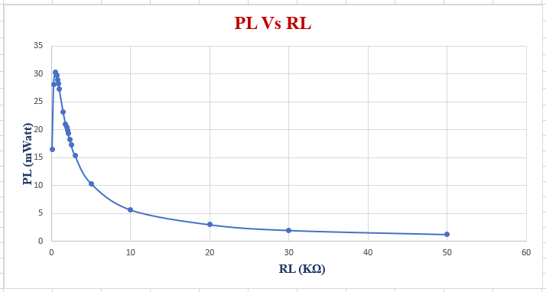

Figure 7: Graph of P vs. RL