**Faculty of Engineering and Technology**

**Electrical and Computer Engineering Department**

**Computer Networks Laboratory ENCS413**

**EXP 3 report**

**Dynamic Routing 1 (Distance Vector Routing Protocols)**

**RIP & IGRP**

**Name : Aya shalabi**

**ID : 1171091**

**Instructor : Dr.Amr slimi**

**Assistant : Eng. Shahd muhareb**

**Section: 2**

**Table Of Contents**

**Theory** 5

1.Introduction 5

2.Types of Dynamic Routing 5

3.Routing Information Protocol(RIP) Definition 6

4.RIP Configuration 6

5.Enhanced Interior Gateway Routing Protocol 6

6.EIGRP Configuration 6

**Procedure & Discussion** 7

1.Topology 7

2.Networks IPs 7

3.Configuring RIP Routing 8

4.Verifying the RIP routing tables 8

5.Configuring EIGRP Routing 9

6.Verifying the EIGRP routing tables 9

**Results** 10

1.Verifying the RIP routing tables 10

2.Verifying the EIGRP routing tables 11

**Conclusion** 13

**References** 14

**Abstract**

The aim of this experiment is to understand how to configure and verify IP routing with Cisco routers , and to learn about Routing Information Protocol (RIP) and the Interior Gateway Routing Protocol (IGRP),also to understand the diffrence between them and which is better to deal with it.

# **Theory**

**Introduction**

In this experiment we going to talk about dynamic routing,which is one way of configuring routing .

There are two main routing classes used in data communication networks. The first class is called distance vector routing protocol and the second one is called link state routing protocol.

Routing Information Protocol (RIP) and Interior Gateway Routing Protocol (IGRP), which will be used in this experiment, are distance vector routing protocols. An example of the other category is Open Shortest Path First (OSPF). In distance vector routing Protocols at the beginning each node (router) has only routing information about its direct neighbors. Each router broadcast periodically its routing information to its neighbors. This way, eventually, each node will get information about the entire network. When a node goes down, the direct neighbors will update their routing information and then update their neighbors using the periodic broadcasts and so on, until all nodes in the network knows about this change.

**Dynamic Routing**

Dynamic routing is when protocols are used to find networks and update routing tables onrouters. True—this is easier than using static or default routing, but it’ll cost you in terms of router CPU processes and bandwidth on the network links. A routing protocol defines the set of rulesused by a router when it communicates routing information between neighbor routers. The two routing protocols we will talk about in this Lab are Routing Information Protocol (RIP) and Interior Gateway Routing Protocol (IGRP).

**Administrative Distances**

The administrative distance (AD) is used to rate the trustworthiness of routing information received on a router from a neighbor router. An administrative distance is an integer from 0 to 255,where 0 is the most trusted and 255 means no traffic will be passed via this route. If a router receives two updates listing the same remote network, the first thing the router checks is the AD.If one of the advertised routes has a lower AD than the other, then the route with the lowest AD will be placed in the routing table.If both advertised routes to the same network have the same AD, then routing protocol metrics (such as hop count or bandwidth of the lines) will be used to find the best path to the remote network.

**Routing Information Protocol (RIP)**

It uses only hop count to determine the best path to a network. If RIP finds more than one link to the same remote network with the same hop count, it will automatically perform a round-robin load balancing. RIP can perform load balancing for up to six equal-cost links (four by default) and it uses classful subnetting.

**RIP Configuration**

**To configure RIP routing, just turn on the protocol with the:**

**Router(config)#router rip**

**Router(config-router)#**

That tell the RIP routing protocol which networks to advertise. Now to configure our router internet work with RIP.

**Router(config-router)#network <ID-OF-CONNECTED-NETWORKS>**

**Interior Gateway Routing Protocol (IGRP)**

is a Cisco-proprietary distance-vector routing protocol. This means that all your routers must be Cisco routers to use IGRP in your network. Cisco created this routing protocol to overcome the problems associated with RIP.

IGRP has a maximum hop count of 255 with a default of 100. This is helpful in larger networks and solves the problem of 15 hops being the maximum possible in a RIP network. IGRP also uses a different metric than RIP. IGRP uses bandwidth and delay of the line by default as a metric for determining the best route to an internetwork. This is called a composite metric. Reliability, load, and maximum transmission unit (MTU) can also be used, although they are not used by default.

The main difference between RIP and IGRP configuration is that when you configure

IGRP, you supply the autonomous system number. All routers must use the same number in order to share routing table information. Here is a list of IGRP characteristics that you won’t find in RIP:

• IGRP can be used in large Internetworks

• IGRP uses an Autonomous System number for activation

• IGRP gives a full route table update every 90 seconds

• IGRP uses bandwidth and delay of the line as metric (lowest composite metric)

**IGRP Configuration**

**Here is how to turn on IGRP routing:**

**Router(config)#router IGRP <AS>**

**Router(config-router)#network <ID-OF-CONNECTED-NETWORKS>**

**Networks IPs**

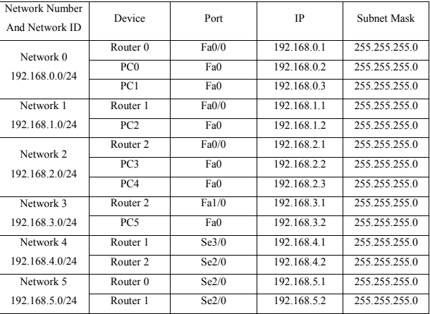

**Configuring RIP Routing**

From Table 1, each PC has been configured its IP address, subnet mask and gateway.Also, the routers have been turned on for each interface that we used in the network and each interface has been given a certain IP address.

After that, RIP has been configured by writing commands in the routers that specify process ID of the routing, and select network IDS connected with that router .

# **Procedure & Discussion**

# 1.Topology

The topology in the figure below was built in Cisco packet tracer.

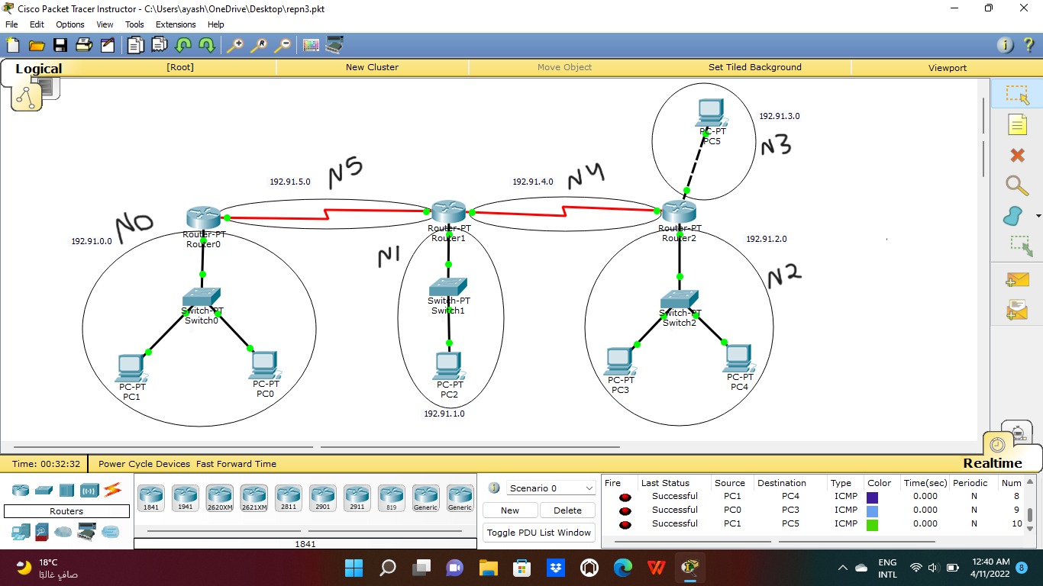

1.Topology

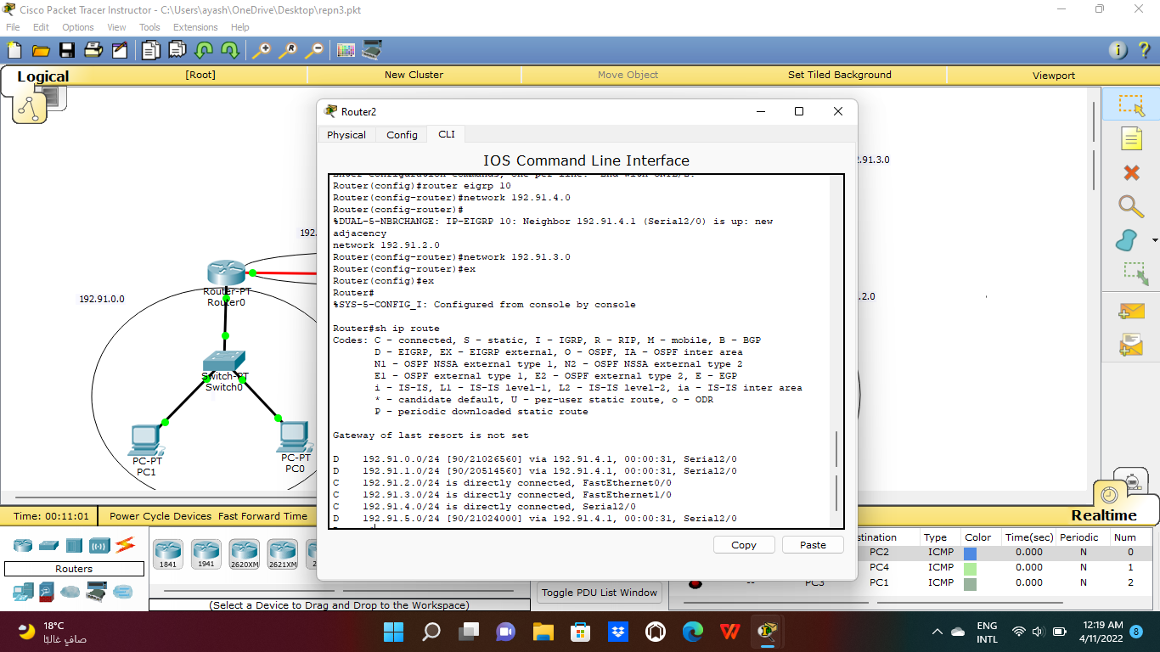

2. Configuring EIGRP for Router 2

# **Results**

# 1.Verifying the RIP routing tables

The figure below shows the routing table we got after running the command “sh ip route” for router 1

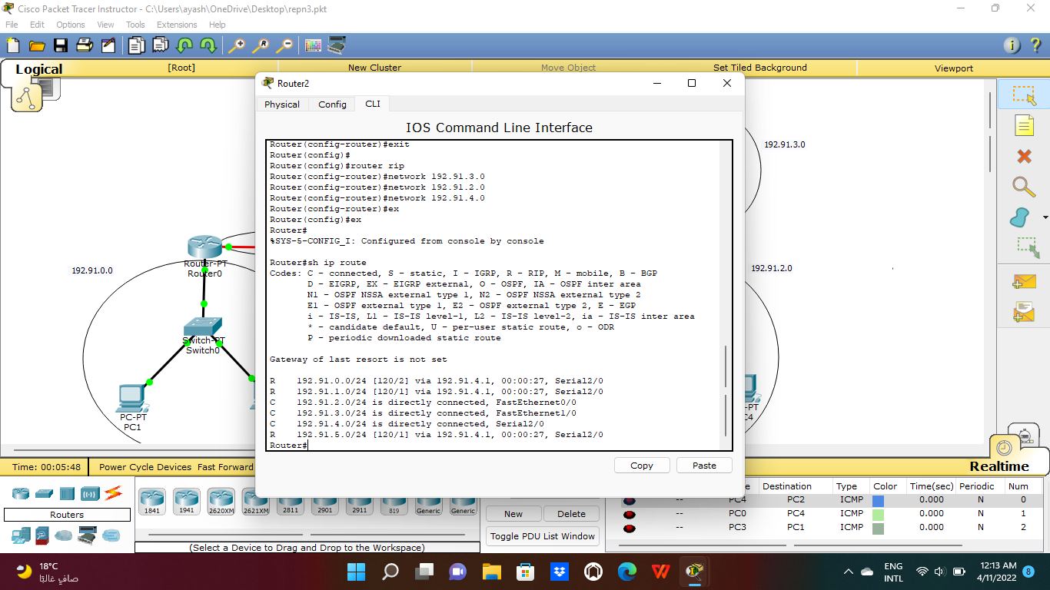

3. routing of router 2 in RIP

We notice that router 1 knows about all networks in the system from network 0 to network 5 even though we only added the directly connected networks to router 1 which are network 1, network 4 and network 5 and that’s because the RIP routing configuration job is to let routers know about every network in the system using rumor routing by sending the entire routing table to directly connected neighbors and then combining routing tables to complete the router’s routing table.

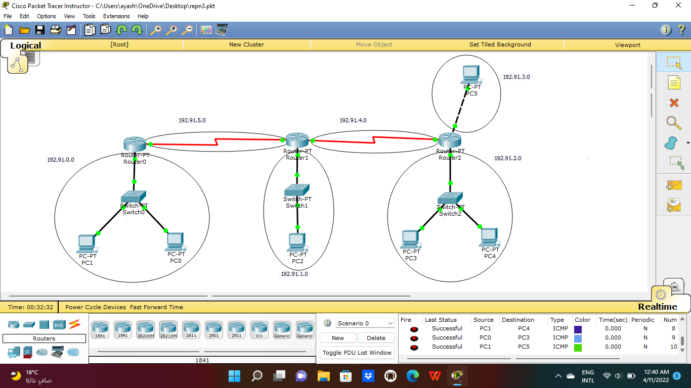

4.successful message of RIP

# 2.Verifying the EIGRP routing tables

The figure below shows the routing table we got after running the command “sh ip route” for router 0

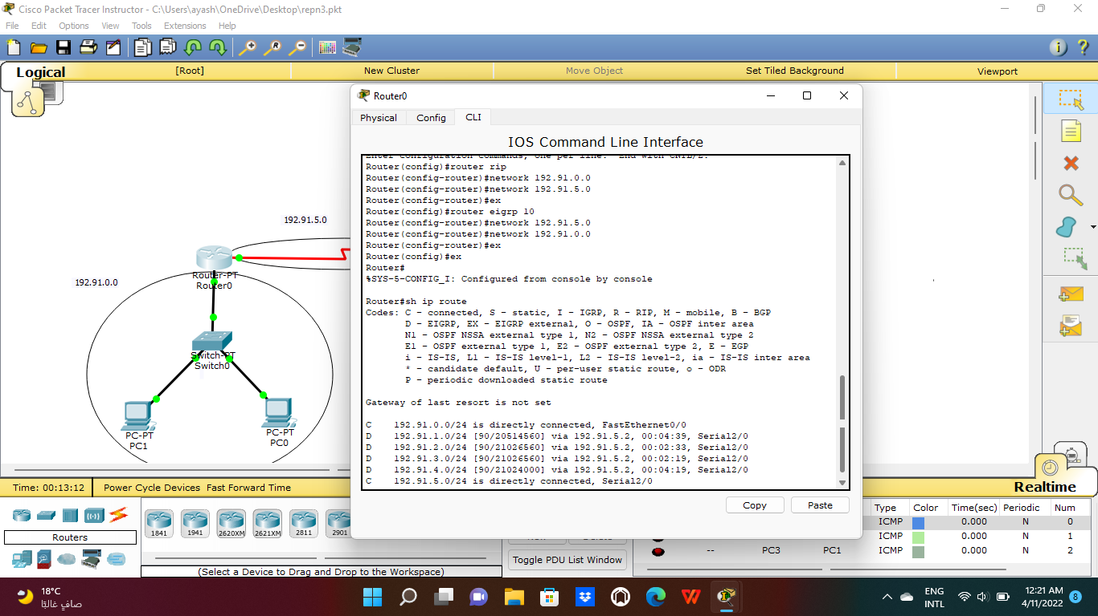

5. routing of router 0 in EIGRP

We notice that router 0 knows about all networks in the system from network 0 to network 5 even though we only added the directly connected networks to router 1 which are network 1, network 4 and network 5 and this’s the advantage of using the EIGRP routing protocol.

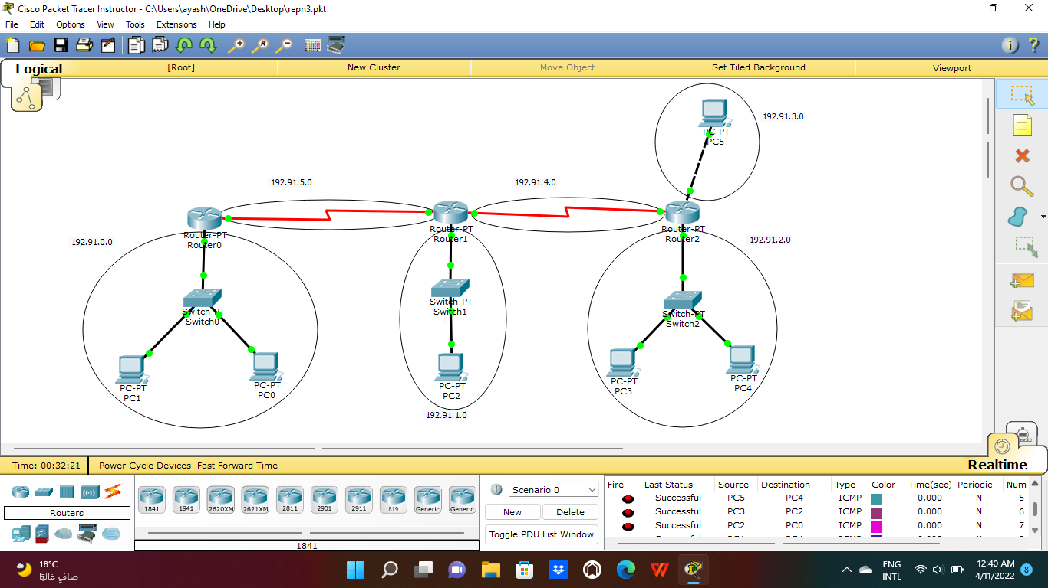

6. message of EIGRP

# **Conclusion**

In this experiment we learned an important class of data communication networks( distance vector routing protocols ) with its two types of routing (Routing Information Protocol (RIP) and Interior Gateway Routing Protocol (IGRP).

We understand how to configure and verify IP routing with Cisco routers and how to configure the (RIP & IGRP) by executing their commands , the difference between these two protocols and the Administrative Distances for each one.We learned how to execute configuration commands to verify the routed and routing protocols configured on Cisco routers like (show ip route , show protocols, show ip protocols ………)

The results that were obtained from the previous procedures are successful .

# **References**

<https://www.geeksforgeeks.org/eigrp-fundamentals/>

<https://ritaj.birzeit.edu/bzu-msgs/attach/2054870/ENCS413Manual.pdf>