**Faculty of Engineering and Technology**

**Electrical and Computer Engineering Department**

**Computer Networks Laboratory ENCS413**

**EXP 5 report**

**EXP. No. 5. Dynamic Routing 3 (Path Vector) BGP**

**Name : Mohammad Alhassasn**

**ID : 115**

**Instructor : Dr.Mohammad helal**

**Teacher assistant : Ayham Hashesh**

**Abstract:**

**The aim of this experiment is to know how the BGP works and the why we use it .**

**Introduction:**

Border Gateway Protocol (BGP) advertises, learn, and choose the best paths inside the wide internet. When two ISPs connected, they typically use BGP to exchange routing information. The ISPs of the world wide exchange routing information with one or more than one ISPs **.**

**Procedure**

* **Step 1.** Create the BGP Routing Process. Initialize the BGP process with the global command **router bgp** as-number.
* **Step 2.** Identify the BGP Neighbor’s IP address and Autonomous System Number. Identify the BGP neighbor’s IP address and autonomous system number with the BGP router configuration command **neighbor** ip-address **remote-as** as-number.

**NOTE**

IOS activates the IPv4 address-family by default. This can simplify the configuration in an IPv4 environment because Steps 3 and 4 are optional, but may cause confusion when working with other address families. The BGP router configuration command **no bgp default ip4-unicast** disables the automatic activation of the IPv4 AFI so that Steps 3 and 4 are required.

* **Step 3.** Initialize the address-family with the BGP router configuration command **address-family** afi safi.
* **Step 4.** Activate the address-family for the BGP neighbor with the BGP address-family configuration command **neighbor** ip-address **activate**.

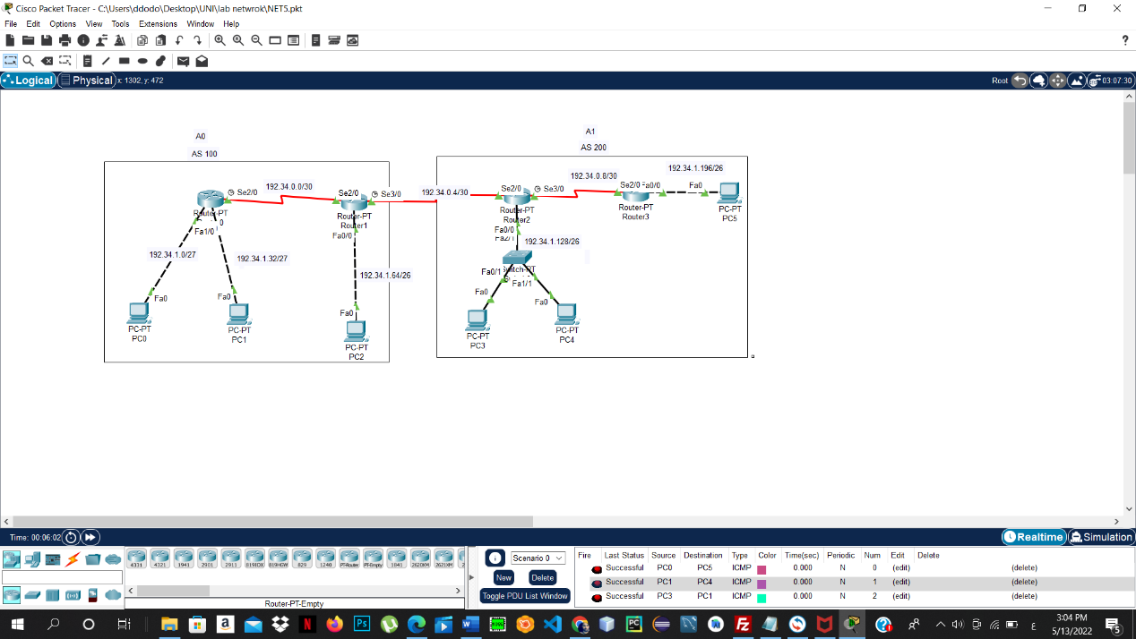

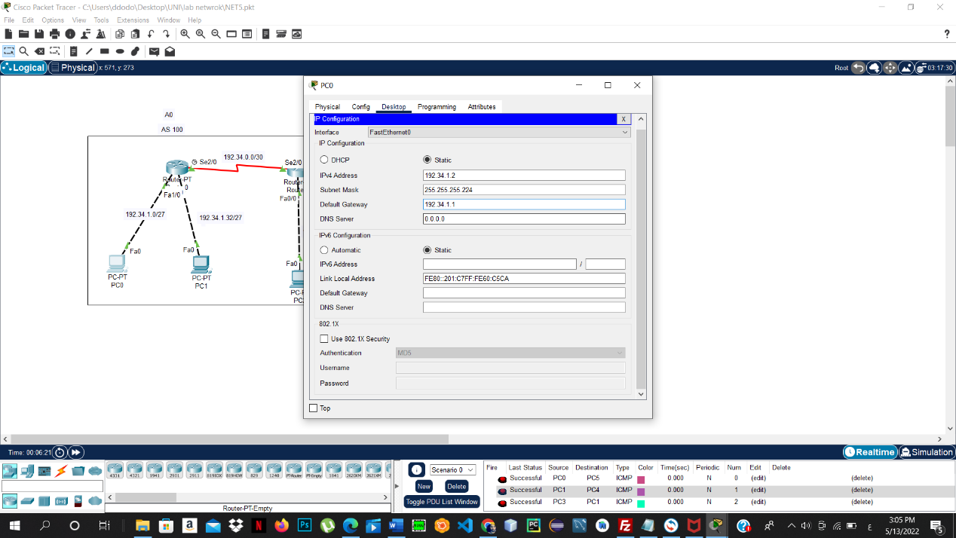

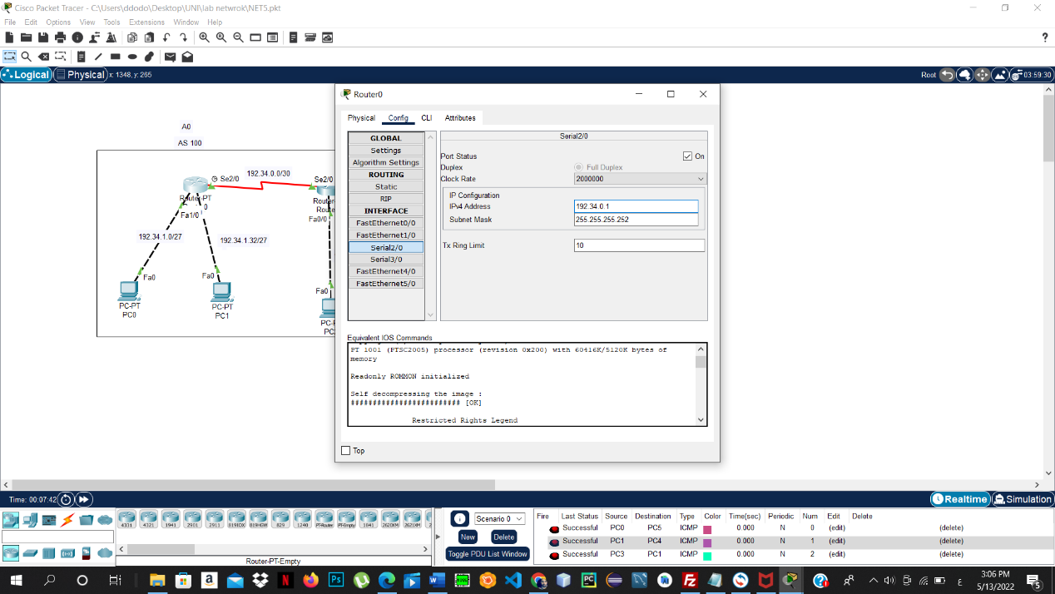

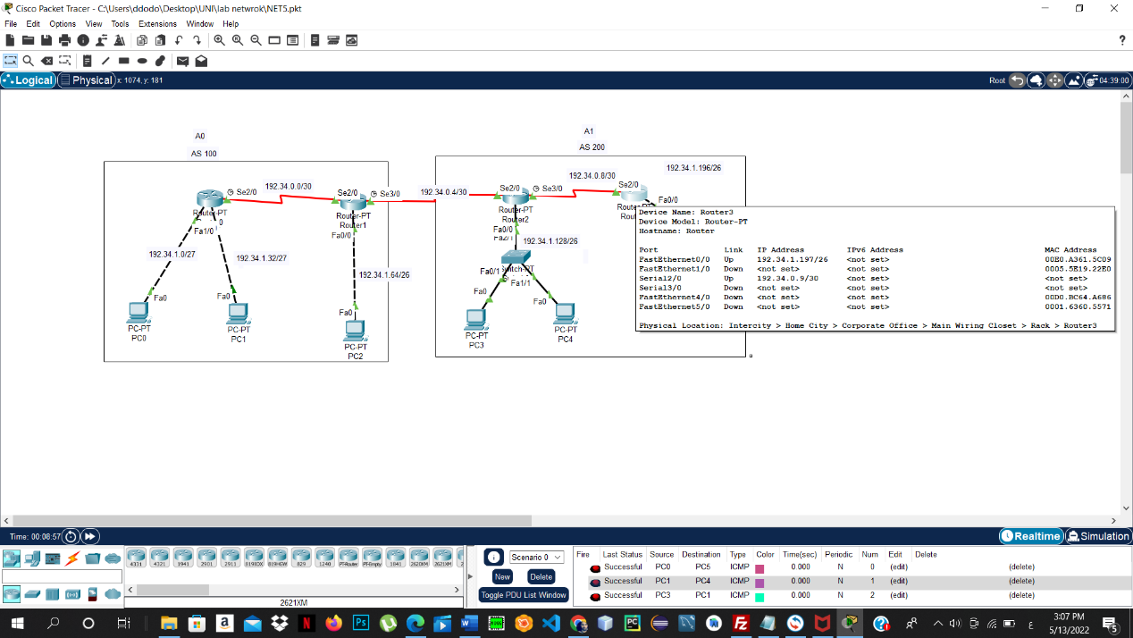

**References :**

<https://ritaj.birzeit.edu/bzu-msgs/attach/2054870/ENCS413Manual.pdf>