**Faculty of Engineering and Technology**

**Electrical and Computer Engineering Department**

**Computer Networks Laboratory ENCS413**

**EXP 3 report**

**Dynamic Routing 1 (Distance Vector Routing Protocols)**

**RIP & IGRP**

**Name : Mohammad Alhassan**

**ID : 1150734**

**Instructor : Dr.Mohammad helal**

**Table Of Contents**

**Theory** 5

1.Introduction 5

2.Types of Dynamic Routing 5

3.Routing Information Protocol(RIP) Definition 6

4.RIP Configuration 6

5.Enhanced Interior Gateway Routing Protocol 6

6.EIGRP Configuration 6

**Procedure & Discussion** 7

1.Topology 7

2.Networks IPs 7

3.Configuring RIP Routing 8

4.Verifying the RIP routing tables 8

5.Configuring EIGRP Routing 9

6.Verifying the EIGRP routing tables 9

**Results** 10

1.Verifying the RIP routing tables 10

2.Verifying the EIGRP routing tables 11

**Conclusion** 13

**References** 14

**Abstract:**

the aim of this experiment is to solve static problem in a dynamic way and helps to learn about routing information protocol (RIP) and the Interior Gateway Routing Protocol (IGRP), and to know the difference between them .

# **Theory**

**Introduction**

There are primary routing lessons utilized in statistics communique networks. The first magnificence is referred to as the gap vector routing protocol and the second one magnificence is referred to as the link-country routing protocol. There are primary routing lessons utilized in statistics communique networks. The first magnificence is referred to as the Distance Vector Routing Protocol, the second one magnificence is referred to as the Link State Routing Protocol, and the Routing Information Protocol (RIP) and Extended Internal Gateway Routing Protocol (EIGRP) used on this test are distance vector routing. The protocol. An instance of some other class is Open Shortest Path First (OSPF). In the gap vector routing protocol, every node (router) first of all has handiest routing statistics approximately its neighbors. Each router periodically pronounces routing statistics to neighboring routers. In this way, every node in the end gets statistics approximately the whole community. If a node is going down, the neighbor at once updates the routing statistics after which updates the neighbor, consisting of via way of means of normal pronounces, till all nodes withinside the community are aware about this change.

**Dynamic routing**

Dynamic routing uses a protocol to search the network and update the router's routing table. that's right. It is easier than using static routing or default routing, but at a cost in terms of router CPU processes and network link bandwidth. A routing protocol defines a set of rules that routers use when communicating routing information between neighboring routers. The two routing protocols described in this lab are the Routing Information Protocol (RIP) and the Interior Gateway Routing Protocol (IGRP).

**Management distance**

Management distance (AD) is used to assess the reliability of routing information received by a router from its neighbors. The management distance is an integer from 0 to 255. Where 0 is the most trusted and 255 means no traffic is routed through that route. If the router receives two updates listing the same remote network, the first thing the router does is check AD. If one of the advertised routes has a lower AD than the other, the route with the lowest AD is included in the routing table. If both advertised routes to the same network have the same AD, to find the best path to the remote network (of the routing protocol metric (hop count, bandwidth, etc.) line). Routing Information Protocol (RIP)

Uses only hops to determine the best path to your network. RIP automatically performs round-robin load balancing when it detects multiple links to the same remote network with the same hop count. RIP allows load balancing for up to 6 Equalcost links (4 by default) and uses classful subnetting.

IGRP, you supply the autonomous system number. All routers must use the same number in order to share routing table information. Here is a list of IGRP characteristics that you won’t find in RIP:

IGRP can be used in large Internetworks

IGRP uses an Autonomous System number for activation

IGRP gives a full route table update every 90 seconds

IGRP uses bandwidth and delay of the line as metric (lowest composite metric)

# **Procedure & Discussion**

1. Topology

First of all we distribute the ips on the routers and pcs

Then we give each router all neighbor networks by the command

Network then the ip of the net work for example

Network 192.168.1.0

Network 192.168.2.0

This will connect network one with network 2 dynamically

And so on to the all routers

**Conclusion**

In this experiment, we learned about an important class of data communication networks (distance vector routing protocols) with two types of routing (Routing Information Protocol (RIP) and Interior Gateway Routing Protocol (IGRP)). Understand how to use Cisco routers to configure and validate IP routing, how to execute and configure commands (RIP and IGRP), the differences between these two protocols, and the management distances for each. You learned how to run configuration commands to display the routing protocols and routing protocols configured on your Cisco router As a result, the previous step was successful.

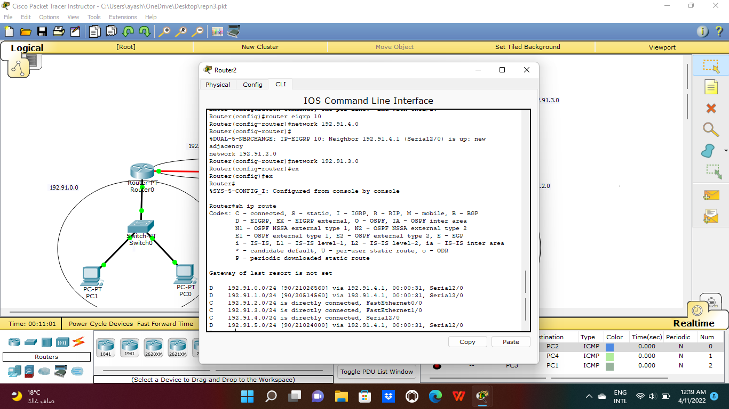

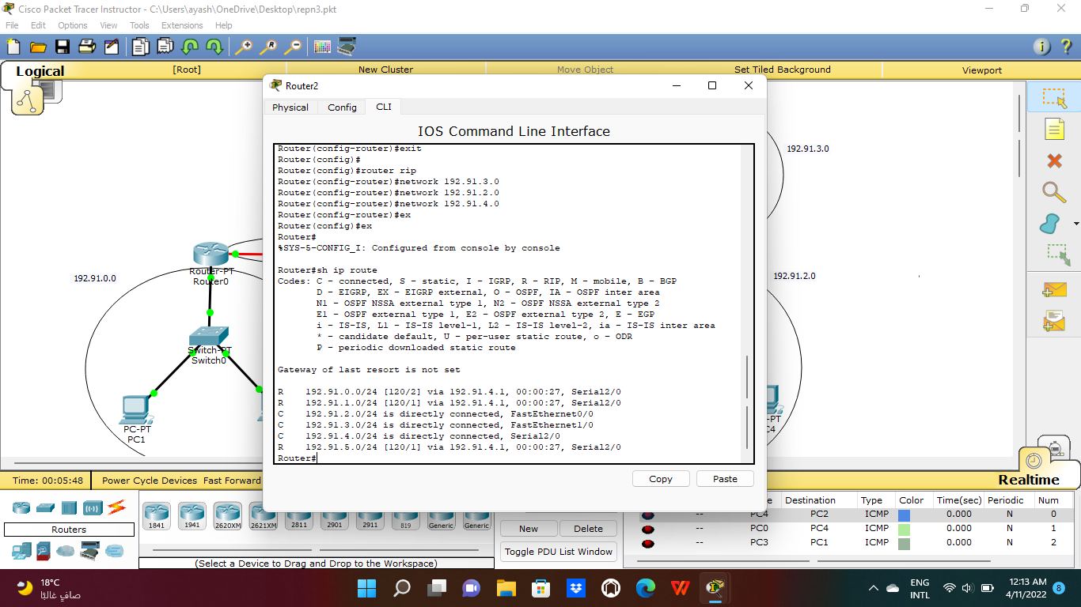

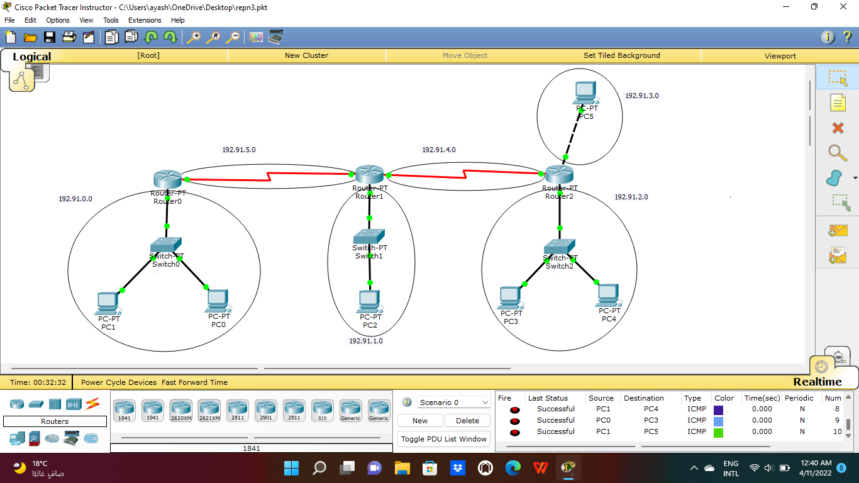

# **References**

<https://www.geeksforgeeks.org/eigrp-fundamentals/>

<https://ritaj.birzeit.edu/bzu-msgs/attach/2054870/ENCS413Manual.pdf>