1. Make an ER Diagram of this Schema

Answer to the question no: 1

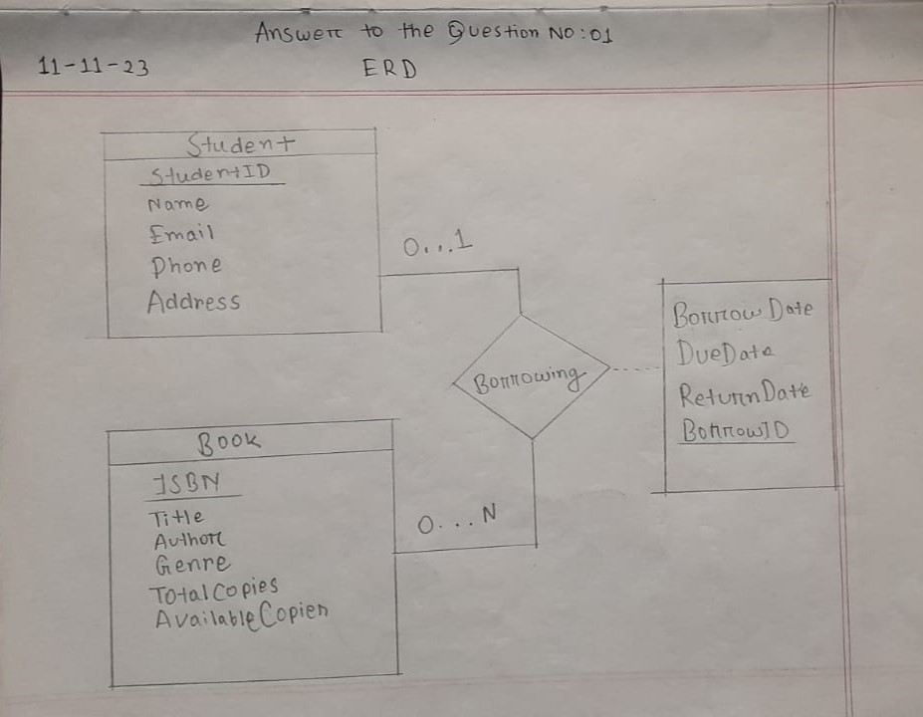

**Question 2**: Insert a new borrowing record for a student (e.g., StudentID 3) for a book with the most available copies.

Answer to the question no: 2

INSERT INTO Borrowing (StudentID, ISBN, BorrowDate, DueDate)

SELECT 3, ISBN, CURDATE() AS BorrowDate, DATE_ADD(CURDATE(), INTERVAL 7 DAY) AS DueDate

FROM Book

ORDER BY AvailableCopies DESC

LIMIT 1;

**Question 3**: Using Update Query, decrease the available copies of a book (e.g., ISBN '9781234567890') by 1 when a student borrows it.

Answer to the question no: 3

UPDATE Book

SET AvailableCopies = AvailableCopies - 1

WHERE ISBN = ‘9781234567890’;

**Question 4**: Retrieve the names of students who have borrowed the most books.

Answer to the question no: 4

SELECT S.Name, COUNT(B.BorrowID) AS BooksBorrowed

FROM Student S

JOIN Borrowing B ON S.StudentID = B.StudentID

GROUP BY S.StudentID

ORDER BY BooksBorrowed DESC

LIMIT 1;

**Question 5**: Retrieve the books that are overdue (i.e., the return date is before the current date).

Answer to the question no: 5

SELECT B.Author, B.Title, B.ISBN

FROM Book B

JOIN Borrowing brow ON B.ISBN = brow.ISBN

WHERE Brow.ReturnDate < CURDATE();

**Question 7**: Explain UNION and UNION ALL set operations in MySQL

Answer to the question no: 7

UNION and UNION ALL are basically set operations where-

i) UNION is the collection of common values from 2 set. Here we do not allow duplication values for each set. For example if we have set A = {1, 2, 5, 6} and B = {2, 5, 1, 5}. Here our Union is A U B or A UNION B = {1, 2, 5}. 

ii) On the other hand in UNION ALL set there we accept the common value as UNION but here we allow all the duplication values also. Such as if we have the same set like we used in UNION so our UNION ALL would be:   
A UNION ALL = {1, 2, 5, 2, 5, 1, 5}.

**Question 8**: There is a table named Employee. In that table there is a field named Salary. Determine the second lowest salary.

Answer to the question no: 8

SELECT DISTINCT Salary

FROM Employee

ORDER BY Salary

LIMIT 1 OFFSET 1;

**Question 9**: There are tables named Employee, Job History, Department.

1. Use ON DELETE CASCADE on Job History for deleting Employee
2. Use ON DELETE SET NULL on Employee for deleting Department

Answer to the question no: 9

CREATE TABLE Department (

DeptID INT PRIMARY KEY,

DeptName VARCHAR(100) NOT NULL

);

a) CREATE TABLE JobHistory(

JobHisID INT PRIMARY KEY,

EmpID INT,

JobDesc VARCHAR(100) NOT NULL,

FOREIGN KEY (EmpID) REFERENCES Employee(EmpID) ON DELETE CASCADE

)

b) CREATE TABLE Employee (

EmpID INT PRIMARY KEY,

FirstName VARCHAR(100) NOT NULL,

LastName VARCHAR(100) NOT NULL,

DeptID INT,

FOREIGN KEY (DeptID) REFERENCES Department(DeptID) ON DELETE SET NULL

);

**Question 10**: In this course, which topic you found most interesting. Explain the topic in short and why you found it most interesting?

Answer to the question no: 10

First of all I am so much thankful for joining as a part of a student of this course. Actually I have learnt every basic things clearly and very effectively to start my database journey. Our tutor draw the repetitive table over and over again and he tried his best effort to learn us so that I also understand every concept properly. And I love the course when it comes to our hands on problem solving in Module no. 09 from the leetcode. Also I feel pretty much interested when it comes week 3 Python and MYSQL (Module 11). Frankly, I was kind of bored for the theory and i slow down and had a break from database. Suddenly when Week 3 come and I observe that there is a topic like these such as problem solving and leetcode also with Python my interest getting more and more. Then I sit down with mysql journey and finally I have contributed on this final exam. This all happen for Phitron team and their special organization. I am pretty much grateful for this database course and hope best of luck to our mentor who taught us from the first to last.