# 2D GAME DEVELOPMENT FULL NOTE

**April 6, 2025**

# Introduction setup

Essential note:

1. In introduction to unity there I have made a pretend platformer using “Sprites all elements”

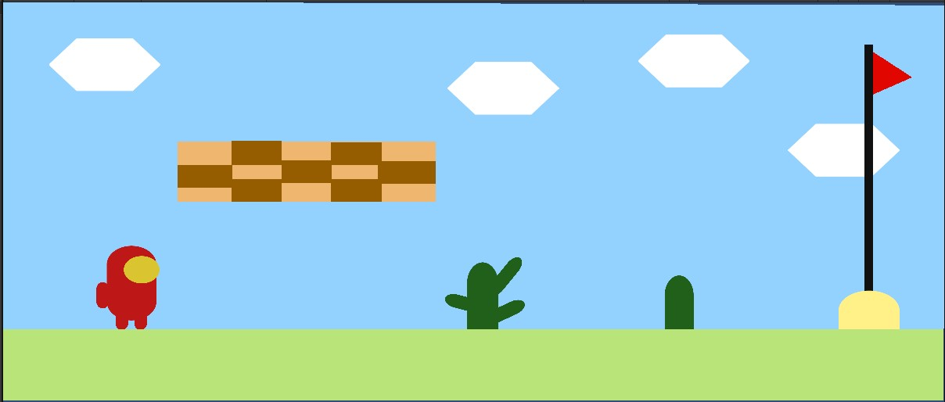

Added it in Gamedev.tv website:

<https://community.gamedev.tv/t/show-your-pretend-platformer-screenshot/168220?u=md_rakib>

1. Setup VS code: install vs code and check which compiler is active

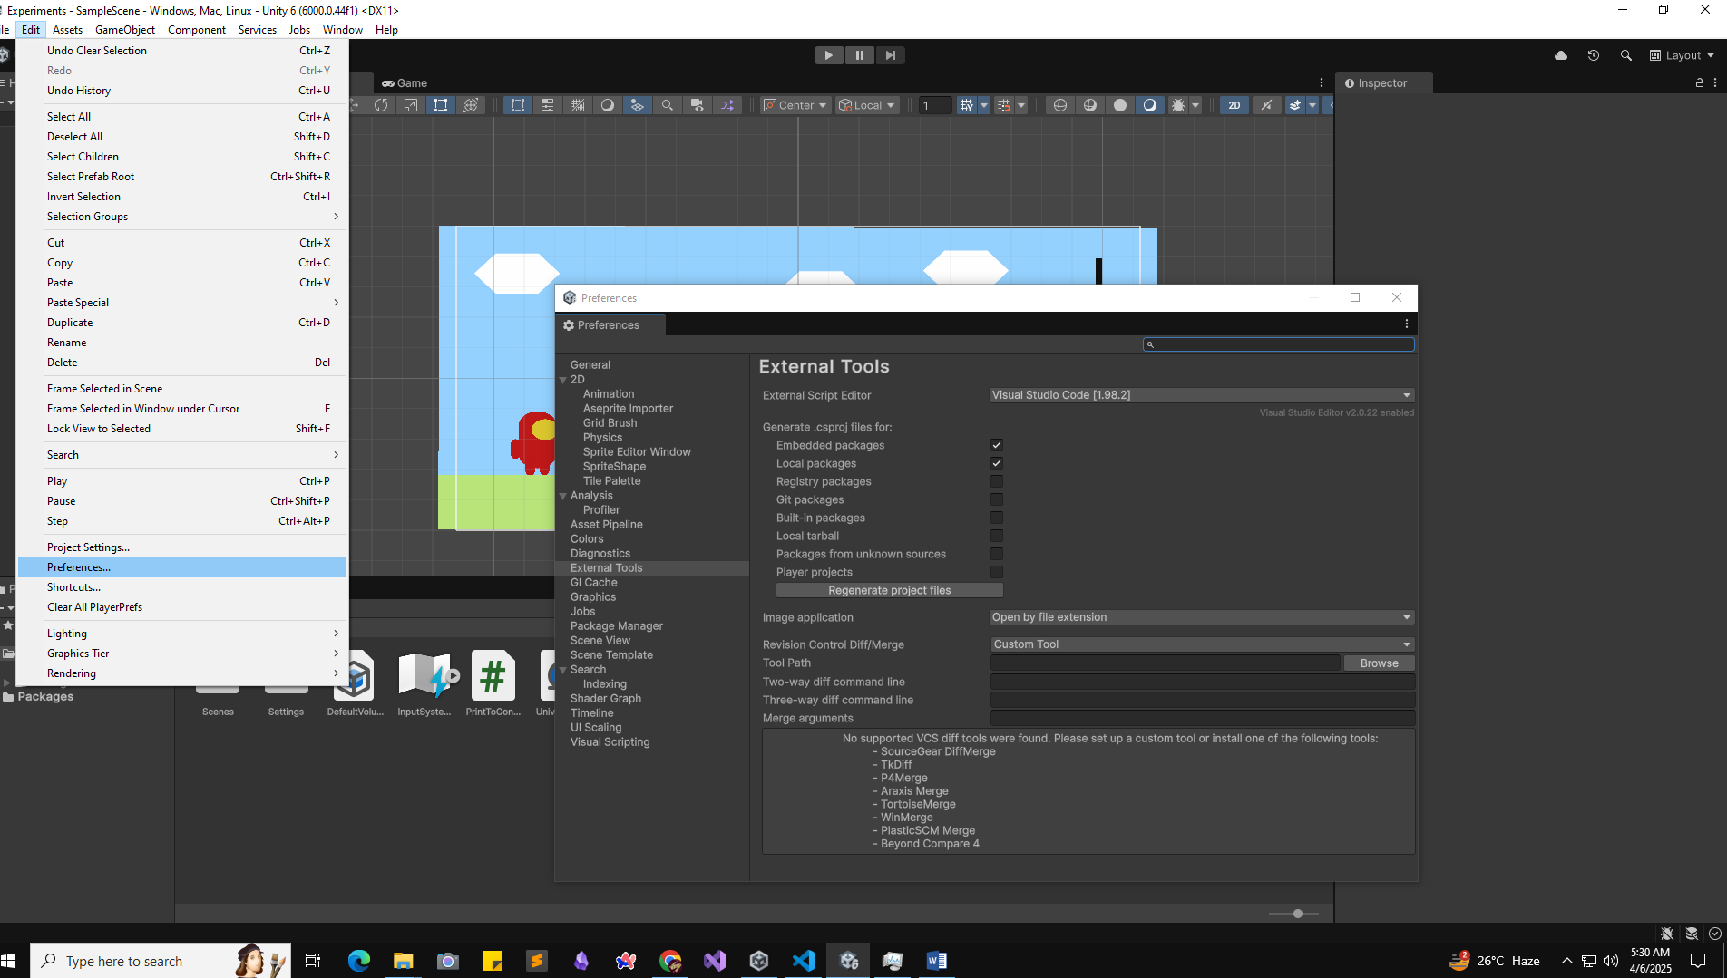

Just check and then add a empty script of C# and double click in file it will open in vscode.

Ensure 2 extension is important:

1. C# by Microsoft and

2. Unity Code Snippets by Kleber Silva

Update code in vs code:

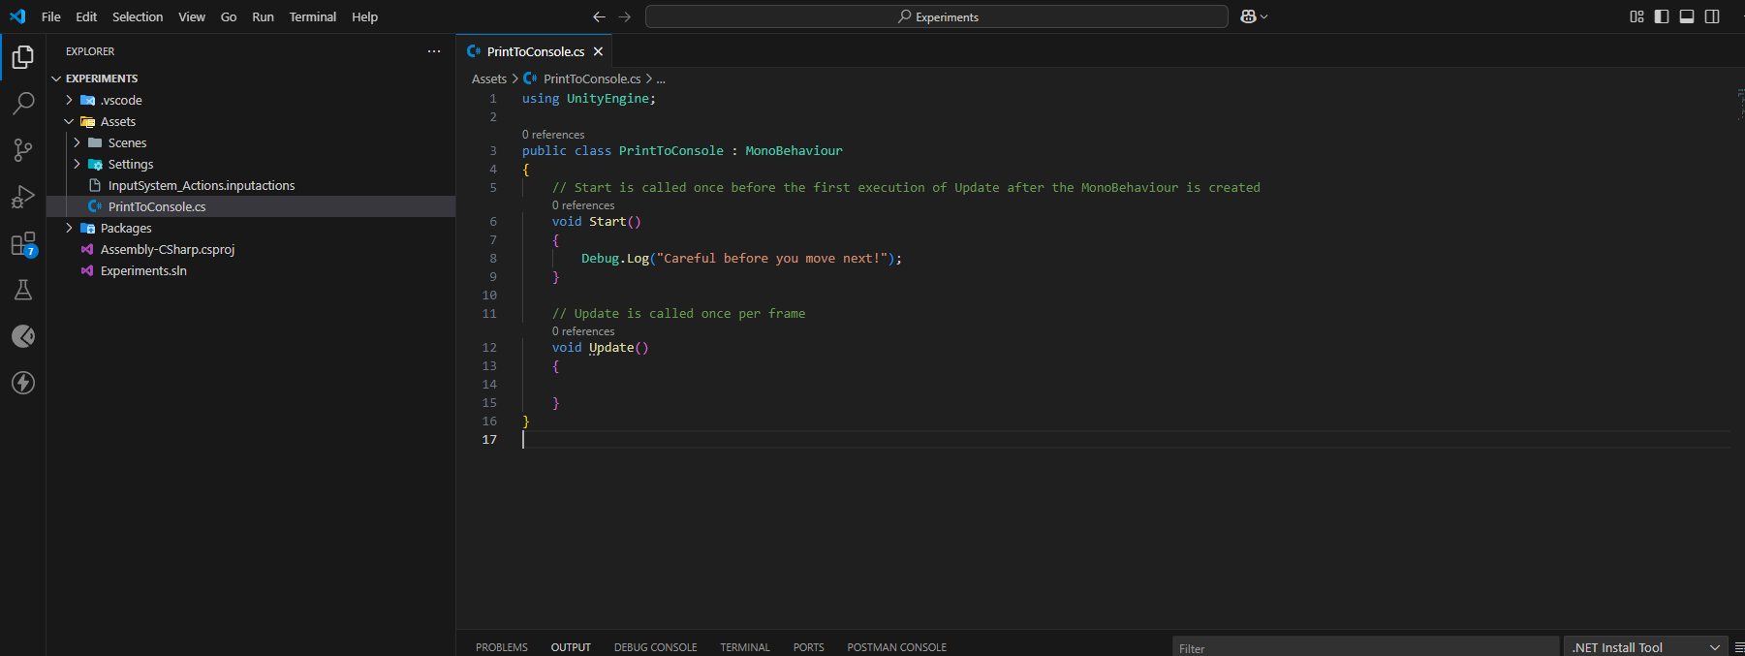

**Community support:**

* Community.Gamedev.tv
* GameDev.tv discord

# 