**Diagrams**

***Process User Process***

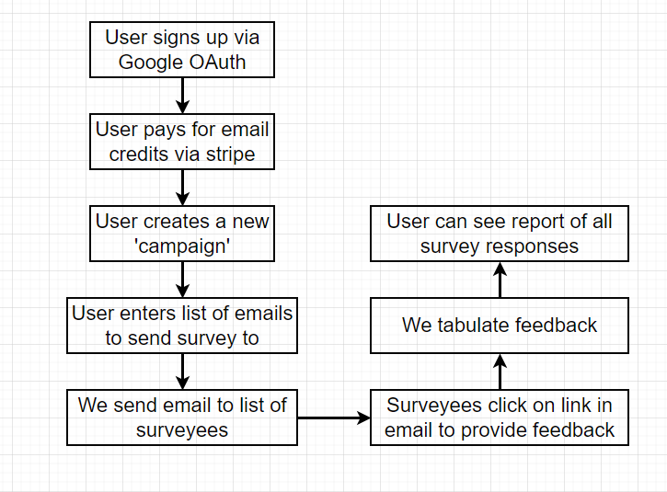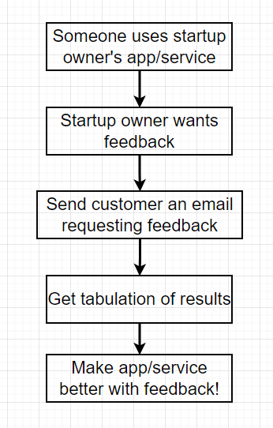

***Tech Used***

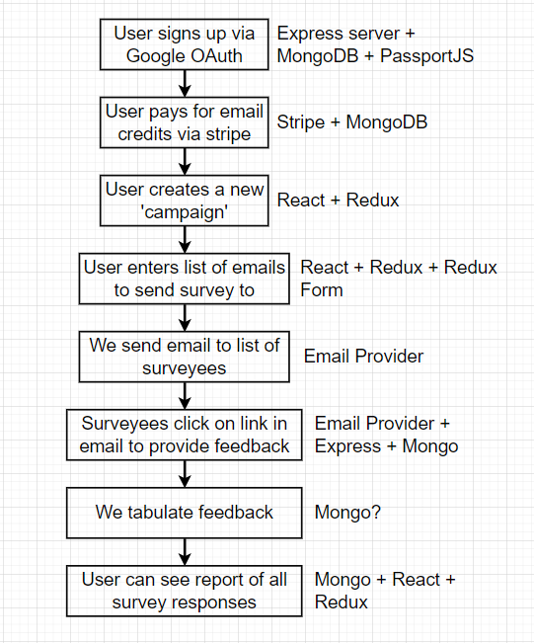

**App Mockup**

***Landing Page Dashboard***

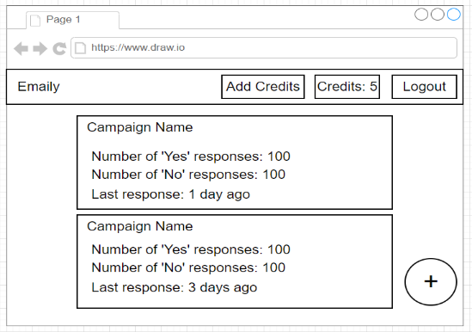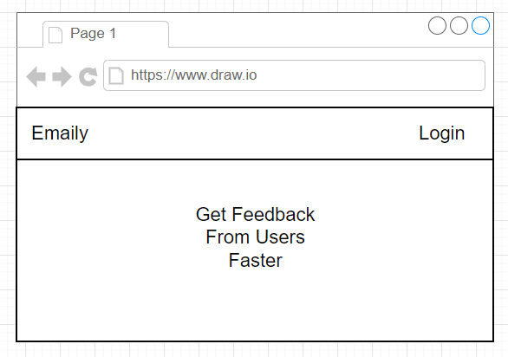

***Create Campaign***

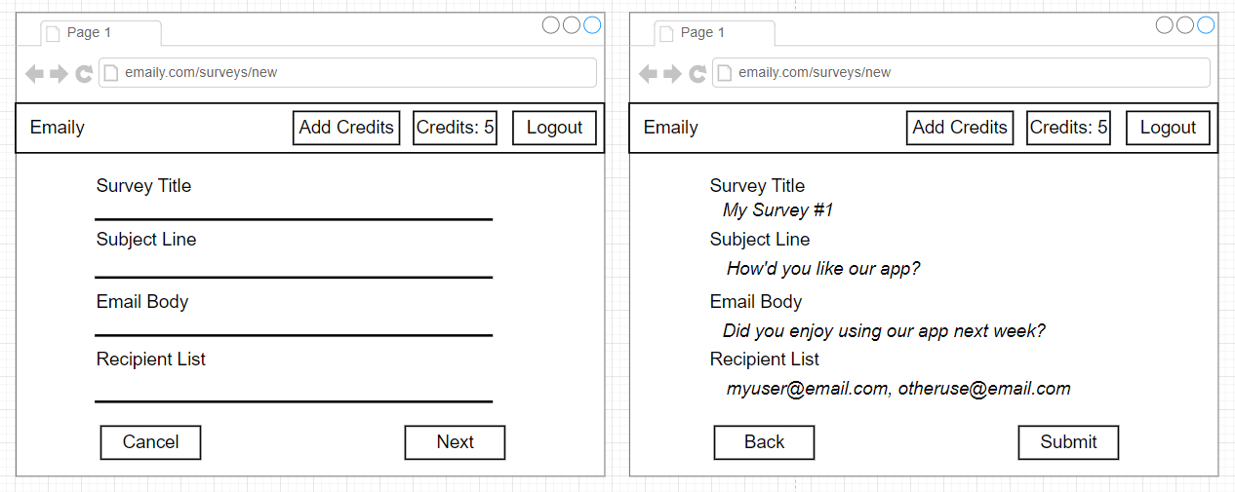

***Billing***

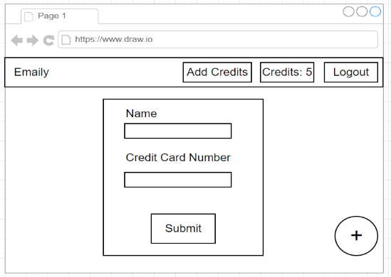

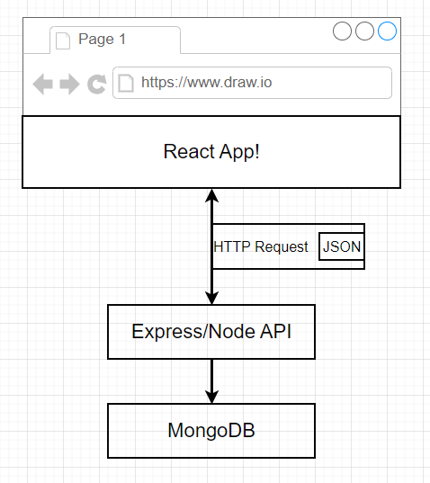**Request Process**

Here the we will provide the customer with a React App, which will send a request to the Express/Node API which will fetch data from the Mongo DB. Mongo DB will give the results to the API which will return the results to the React app and customer will get the results.

**Step: 1**

***Getting the package.json file and installing express.js file***

* Open the terminal of VS Code and type **npm init** (Keep pressing enter until it says ‘Is this, OK?’)
* Type **npm install –save express**

**Step: 2**

Create an index.js file and in this file, we are going to import the express library by writing the command **[ const express = require (‘express’); ]**

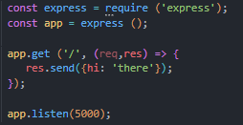

After the express library is imported, the express app is initialized in the variable app. The chunk of code of app.get is a route handler. The forward slash (/) is trying to access some of the routes. Req is representing the incoming request and Res is representing the outgoing response and the res.send is sending some output in the form of JSON. The app.listen is looking for the port 5000.