

NATIONAL UNIVERSITY OF SCIENCES AND TECHNOLOGY
School of Electrical Engineering and Computer Sciences

Software Construction (SE-314)
Lab # 8
Title of the assignment: Recursion

Name: | Mohammad Subhan Khalid (455680)
Class: | BESE 14 A
Date: | 20/10/2025
Submitted to: | Dr. Sidra Sultana  Mr. Aftab Farooq

Task 1
Code:
package filesearch;

import java.io.File;
import java.util.ArrayList;
import java.util.List;

public class RecursiveFileSearch {

public static void main(String[] args) {

// Ensure sufficient arguments are provided
if (args.length < 3) {
System.out.println(
"Usage: java RecursiveFileSearch <directory_path> <case_sensitive:true|false> <file1> <file2> ...");
return;
}

String directoryPath = args[0];
boolean caseSensitive = Boolean.parseBoolean(args[1]);

// Extract the file names to search for
List<String> fileNames = new ArrayList<>();
for (int i = 2; i < args.length; i++) {
fileNames.add(args[i]);
}

// Validate directory
File directory = new File(directoryPath);
if (!directory.exists() || !directory.isDirectory()) {
System.out.println("Error: The specified directory does not exist or is not a directory.");
return;
}

// Search each file
for (String fileName : fileNames) {
System.out.println("\nSearching for file: " + fileName);
List<String> foundPaths = new ArrayList<>();
searchFileRecursive(directory, fileName, foundPaths, caseSensitive);

if (foundPaths.isEmpty()) {
System.out.println("File not found: " + fileName);
} else {
System.out.println("Found " + foundPaths.size() + " instance(s) of '" + fileName + "':");
for (String path : foundPaths) {
System.out.println(" - " + path);
}
}
}
}

/**
* Recursively searches for a file within a directory and its subdirectories.
*
* @param directory The directory to search
* @param targetName The name of the file to find
* @param foundPaths A list to store paths of found files
* @param caseSensitive Whether the search is case-sensitive
*/
public static void searchFileRecursive(File directory, String targetName, List<String> foundPaths,
boolean caseSensitive) {
File[] files = directory.listFiles();

for (File file : files) {
if (file.isDirectory()) {
// Recursively search in subdirectory
searchFileRecursive(file, targetName, foundPaths, caseSensitive);
} else {
String fileNameToCompare = caseSensitive ? file.getName() : file.getName().toLowerCase();
String targetNameToCompare = caseSensitive ? targetName : targetName.toLowerCase();

if (fileNameToCompare.equals(targetNameToCompare)) {
foundPaths.add(file.getAbsolutePath());
}
}
}
}
}

Output:
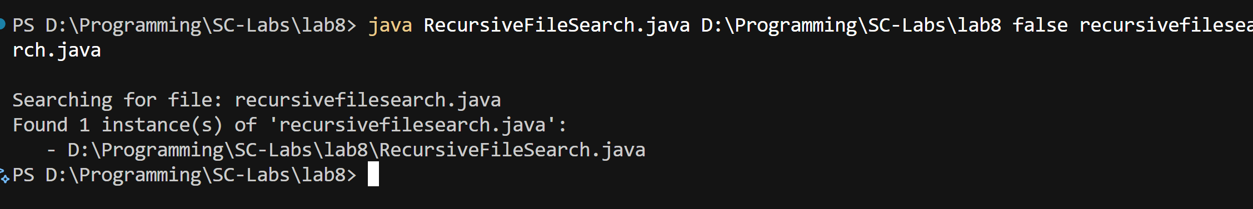

Task 2
Code:
package filesearch;

import java.util.*;

public class StringPermutations {

public static void main(String[] args) {
Scanner scanner = new Scanner(System.in);

try {
// Input string
System.out.print("Enter a string: ");
String input = scanner.nextLine();

if (input == null || input.trim().isEmpty()) {
System.out.println("Error: Input string cannot be empty.");
return;
}

// Option for duplicates
System.out.print("Include duplicate permutations? (true/false): ");
boolean includeDuplicates = scanner.nextBoolean();

// --- Recursive approach ---
long startRecursive = System.nanoTime();
Set<String> recursivePermutations = generatePermutationsRecursive(input, includeDuplicates);
long endRecursive = System.nanoTime();

System.out.println("\nRecursive Permutations (" + recursivePermutations.size() + "):");
for (String perm : recursivePermutations) {
System.out.println(perm);
}

System.out.println("Time (Recursive): " + (endRecursive - startRecursive) / 1_000_000.0 + " ms");

// --- Non-recursive approach ---
long startIterative = System.nanoTime();
Set<String> iterativePermutations = generatePermutationsIterative(input, includeDuplicates);
long endIterative = System.nanoTime();

System.out.println("\nNon-Recursive Permutations (" + iterativePermutations.size() + "):");
for (String perm : iterativePermutations) {
System.out.println(perm);
}

System.out.println("Time (Non-Recursive): " + (endIterative - startIterative) / 1_000_000.0 + " ms");

// Time comparison
System.out.println("\nPerformance Comparison:");
System.out.printf("Recursive: %.3f ms | Iterative: %.3f ms\n",
(endRecursive - startRecursive) / 1_000_000.0, (endIterative - startIterative) / 1_000_000.0);

} catch (InputMismatchException e) {
System.out.println("Invalid input. Please enter 'true' or 'false' for the duplicate option.");
} catch (Exception e) {
System.out.println("An unexpected error occurred: " + e.getMessage());
} finally {
scanner.close();
}
}

/**
* Generates all permutations of a string recursively.
*
* @param str The input string
* @param includeDuplicates Whether to include duplicate permutations
* @return A set of all permutations
*
* Time Complexity: O(n!) where n = length of the string. Space
* Complexity: O(n) for recursion stack.
*/
public static Set<String> generatePermutationsRecursive(String str, boolean includeDuplicates) {
Set<String> result = includeDuplicates ? new LinkedHashSet<>() : new TreeSet<>();
permute(str.toCharArray(), 0, result, includeDuplicates);
return result;
}

private static void permute(char[] chars, int index, Set<String> result, boolean includeDuplicates) {
if (index == chars.length - 1) {
result.add(new String(chars));
return;
}

Set<Character> used = new HashSet<>(); // to avoid duplicate branches
for (int i = index; i < chars.length; i++) {
if (!includeDuplicates && used.contains(chars[i]))
continue;
used.add(chars[i]);

swap(chars, index, i);
permute(chars, index + 1, result, includeDuplicates);
swap(chars, index, i); // backtrack
}
}

private static void swap(char[] arr, int i, int j) {
char temp = arr[i];
arr[i] = arr[j];
arr[j] = temp;
}

/**
* Generates all permutations of a string using an iterative algorithm. Based on
* Heap's algorithm for permutation generation.
*
* @param str The input string
* @param includeDuplicates Whether to include duplicate permutations
* @return A set of all permutations
*
* Time Complexity: O(n!) similar to recursive approach. Space
* Complexity: O(n)
*/
public static Set<String> generatePermutationsIterative(String str, boolean includeDuplicates) {
Set<String> result = includeDuplicates ? new LinkedHashSet<>() : new TreeSet<>();

char[] chars = str.toCharArray();
int n = chars.length;
int[] c = new int[n];

result.add(new String(chars));

int i = 0;
while (i < n) {
if (c[i] < i) {
if (i % 2 == 0)
swap(chars, 0, i);
else
swap(chars, c[i], i);

result.add(new String(chars));
c[i]++;
i = 0;
} else {
c[i] = 0;
i++;
}
}

// Remove duplicates if requested
if (!includeDuplicates) {
return new TreeSet<>(result);
}
return result;
}
}

Output:
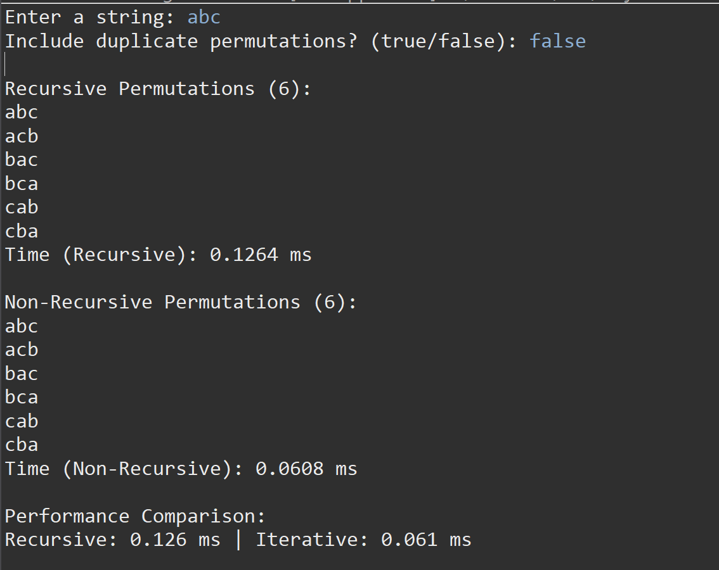
Task 3
Code:
RecursiveFileSearchTest.java
package test;

import org.junit.jupiter.api.*;

import filesearch.RecursiveFileSearch;

import java.io.*;
import java.util.*;

import static org.junit.jupiter.api.Assertions.*;

/**
* Unit tests for RecursiveFileSearch.
* Tests base, recursive, and edge cases for file search functionality.
*/
public class RecursiveFileSearchTest {

private static File testRootDir;

@BeforeAll
public static void setup() throws IOException {
// Create temporary directory structure for testing
testRootDir = new File("test_data");
testRootDir.mkdir();

// Create subdirectories and files
File subDir = new File(testRootDir, "sub");
subDir.mkdir();

new File(testRootDir, "report.txt").createNewFile();
new File(subDir, "report.txt").createNewFile();
new File(subDir, "notes.txt").createNewFile();
}

@AfterAll
public static void cleanup() {
deleteDirectory(testRootDir);
}

private static void deleteDirectory(File dir) {
if (dir == null || !dir.exists()) return;
File[] files = dir.listFiles();
if (files != null) {
for (File f : files) {
if (f.isDirectory()) deleteDirectory(f);
else f.delete();
}
}
dir.delete();
}

@Test
public void testFileFoundInRootDirectory() {
List<String> foundPaths = new ArrayList<>();
RecursiveFileSearch.searchFileRecursive(testRootDir, "report.txt", foundPaths, true);
assertFalse(foundPaths.isEmpty(), "File should be found in root directory");
}

@Test
public void testFileFoundInSubdirectory() {
List<String> foundPaths = new ArrayList<>();
RecursiveFileSearch.searchFileRecursive(testRootDir, "notes.txt", foundPaths, true);
assertEquals(1, foundPaths.size(), "File should be found in subdirectory");
}

@Test
public void testFileNotFound() {
List<String> foundPaths = new ArrayList<>();
RecursiveFileSearch.searchFileRecursive(testRootDir, "missing.txt", foundPaths, true);
assertTrue(foundPaths.isEmpty(), "Missing file should not be found");
}

@Test
public void testCaseInsensitiveSearch() {
List<String> foundPaths = new ArrayList<>();
RecursiveFileSearch.searchFileRecursive(testRootDir, "REPORT.TXT", foundPaths, false);
assertEquals(2, foundPaths.size(), "Case-insensitive search should find all instances");
}

@Test
public void testInvalidDirectory() {
File invalidDir = new File("nonexistent_dir");
List<String> foundPaths = new ArrayList<>();
assertDoesNotThrow(() ->
RecursiveFileSearch.searchFileRecursive(invalidDir, "file.txt", foundPaths, true),
"Function should handle invalid directories gracefully"
);
}
}

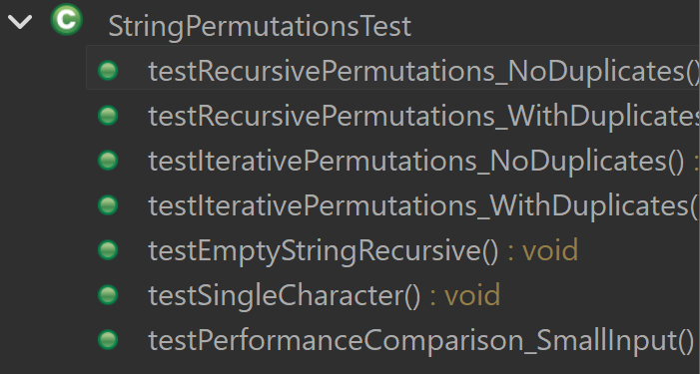
StringPermutationsTest.java
package test;

import org.junit.jupiter.api.*;

import filesearch.StringPermutations;

import java.util.*;

import static org.junit.jupiter.api.Assertions.*;

/**
* Unit tests for StringPermutations. Covers recursive and iterative
* implementations, including duplicates and edge cases.
*/
public class StringPermutationsTest {

@Test
public void testRecursivePermutations_NoDuplicates() {
Set<String> result = StringPermutations.generatePermutationsRecursive("ABA", false);
assertEquals(3, result.size(), "Duplicate permutations should be removed");
assertTrue(result.contains("AAB"));
assertTrue(result.contains("ABA"));
assertTrue(result.contains("BAA"));
}

@Test
public void testRecursivePermutations_WithDuplicates() {
Set<String> result = StringPermutations.generatePermutationsRecursive("ABA", true);
assertEquals(6, result.size(), "All permutations including duplicates should be present");
}

@Test
public void testIterativePermutations_NoDuplicates() {
Set<String> result = StringPermutations.generatePermutationsIterative("ABC", false);
assertEquals(6, result.size(), "Should generate 3! = 6 permutations");
}

@Test
public void testIterativePermutations_WithDuplicates() {
Set<String> result = StringPermutations.generatePermutationsIterative("ABA", true);
assertEquals(6, result.size(), "Should include duplicate permutations");
}

@Test
public void testEmptyStringRecursive() {
Set<String> result = StringPermutations.generatePermutationsRecursive("", false);
assertTrue(result.isEmpty(), "Empty string should produce no permutations");
}

@Test
public void testSingleCharacter() {
Set<String> result = StringPermutations.generatePermutationsRecursive("A", false);
assertEquals(Set.of("A"), result, "Single character should have one permutation");
}

@Test
public void testPerformanceComparison_SmallInput() {
// Not strict assertion — ensures both methods return same set for small input
String input = "AB";
Set<String> recursive = StringPermutations.generatePermutationsRecursive(input, false);
Set<String> iterative = StringPermutations.generatePermutationsIterative(input, false);
assertEquals(recursive, iterative, "Recursive and iterative results should match");
}
}

