 Sentinel

Senior Project

By Mohammad Zeina

Supervised By Dr. Walid Amer

School of Arts and Sciences

Bachelor’s in Computer Science
Fall 2025-2026

Dedication

This project is dedicated to my family and friends, and hopefully the first step in a successful computer science working carreer.

Acknowledgment

I would like to express my sincere gratitude to my supervisor, Dr. Walid Amer, for his guidance, support, and feedback throughout this project.

Abstract

Cybersecurity threats continue to increase in complexity, making traditional detection systems insufficient for protecting modern digital infrastructures. This project presents Sentinel, an AI-driven cybersecurity assistant designed to analyze risks, detect anomalies, and assist users in identifying weak security configurations. Sentinel combines machine-learning-based risk assessment with a natural-language interface to simplify cybersecurity tasks for both technical and non-technical users.

The system was developed using Python, trained on security datasets, and integrated with a modular evaluation engine capable of detecting weak passwords, unsafe configurations, and suspicious network activity. Testing results show that Sentinel improves detection accuracy and significantly reduces the time required to assess potential vulnerabilities.

This project demonstrates the effectiveness of AI-assisted cybersecurity tools and highlights their potential role in future enterprise-level security systems.

Table Of Contents

Dedication: ..................................................................................................................… 2

Acknowledgment: ........................................................................................................… 2

Abstract: ......................................................................................................................... 2

Chapter1: ........................................................................................................................5

1.1 Introduction.........................................................................................................5

1.2 Objective ...............................................................................................................5

1.3 Problems .....................................................................................................................6

1.4
Solution .......................................................................................6

1.5 Significance ................................................................................................7

1.6 Limitations .................................................................................................7

1.7 Tools & Libraries.................................................................................................8
Chapter2 .........................................................................................................................10
2.1 Functional and Conceptual Study.........................................................................10

2.2.1 - Functional Requirements:...........................................................................10

2.2.2 - Non-Functional Requirements: ..................................................................11

2.2 UML Use Case Diagram & Scenario ...................................................................12

2.2.1 - Use Case Diagram......................................................................................12

2.2.2 - Use Case Scenarios...................................................................................20

Chapter3………………………………………………………………………………………..52

3.1- Dashboard………………………………………………………………………..52

3.2- Password Tester…………………………………………………………………..61

3.3- Privacy Leak Analyzer………………………………………………………………66

3.4- Web Scanner………………………………………………………………………….73

3.5- File Threat Analyzer………………………………………………………………..78

3.6- Endpoint Scanner…………………………………………………………………..82

Chapter4……………………………………………………………………………………..90

4.1- Future Work………………………………………………………………………….90
4.2- Role of Artificial Intelligence……………………………………….109

4.3- FastAPI………………………………………………………………………..112

4.4- Security Measurements……………………………………………….117

4.5- Testing and Validationn………………………………………………..122

Chapter5………………………………………………………………………………126

5.1- Conclusion…………………………………………………………………….126

5.2- References……………………………………………………………………..127

Chapter 1:

  - Introduction

In today’s digital age, cybersecurity has become increasingly important due to the growing number of online threats such as data breaches, phishing attacks, and weak passwords. Individuals and organizations need effective tools to identify vulnerabilities and protect their digital assets. Sentinel is an AI-powered cybersecurity assistant designed to provide users with real-time guidance, actionable insights, and automated monitoring to enhance their security practices, simplify risk management, and promote safer online behavior.

  - Objective

The core objectives guiding the development of Sentinel include:

- Helping users improve their cybersecurity awareness.

- Detecting and preventing potential security threats.

- Providing guidance and recommendations to enhance digital safety.

- Tracking user activities and maintaining a history of security actions.

- Offering a user-friendly and accessible interface for all users.

- Assisting users in creating stronger passwords and managing credentials securely.

- Alerting users to suspicious activities or potential breaches in real-time.

- Promoting safe online practices and responsible digital behavior.

- Supporting customizable settings to enhance user experience.

- Enabling continuous learning and adaptation to emerging cybersecurity risks.

1.3- Problems

The key issues that Sentinel addresses include:

- Increasing online threats such as phishing, weak passwords, and data breaches.

- Lack of user awareness regarding cybersecurity best practices.

- Difficulty in managing multiple security tools effectively.

- Limited real-time detection and guidance for non-technical users.

1.4- Solution

Sentinel addresses these challenges through the following solutions:

- Providing an AI-powered platform that consolidates multiple cybersecurity tools in one system.

- Offering real-time threat detection and alerts for potential security risks.

- Guiding users with actionable recommendations to improve their digital security.

- Maintaining a history of user activities and system interactions for tracking and auditing purposes.

- Delivering an intuitive, user-friendly interface suitable for both technical and non-technical users.

1.5- Significance

AI plays a crucial role in enhancing cybersecurity by enabling the system to analyze patterns, detect anomalies, and provide real-time guidance that would be difficult to achieve manually. By leveraging AI, Sentinel can offer personalized recommendations, adapt to emerging threats, and integrate multiple security functions into a single platform. This improves user awareness and safety while making advanced cybersecurity tools accessible to both technical and non-technical users.

1.6- Limitations

The following key limitations characterize the current scope and capabilities of Sentinel:

- AI may have limited accuracy in detecting extremely rare or sophisticated threats.

- Certain modules require internet connectivity or specific system permissions to function.

- The system’s effectiveness depends on user interaction and following AI recommendations.

- Some security checks may not cover all possible threat scenarios.

- Expansion of additional modules requires further development and testing.

- Real-time analysis may be affected by device performance or network speed.

1.7- Tools & Libraries

- Software: PyCharm, Visual Studio Code, Uvicorn

- Languages: Frontend: HTML, CSS, Javascript Backend: Python (FastAPI)

- Frameworks and Libraries:

Frontend/UI
Html, Custom CSS, javascript

Security
Passlib
zxcvbn
hashlib
re
Requests

File Analysis
json
yaml
xml.etree.ElementTree
configparser

python-magic / filetype

AI / NLP
difflib (fuzzy matching)

Utility
os
pathlib
logging
datetime
io
base64

Optional/Advanced
matplotlib / plotly
numpy
pefile
Validators
- Hardware: Laptop
- Tools: Chrome

Chapter 2:

This chapter illustrates the functional and conceptual study of Sentinel, including its functional and non-functional requirements, its use case diagram, scenario and narratives.

2.1- Functional and Conceptual Study

2.1.1- Functional Requirements

User Authentication and Access Control: Secure login system with role-based access (regular users vs. administrators).

AI-Powered Threat Analysis: Continuously monitor and analyze system and network activity to detect anomalies, potential intrusions, and vulnerabilities.

Password Security Evaluation: Assess password strength and provide recommendations for creating stronger credentials.

Real-Time Alerts: Notify users immediately of suspicious activities, potential security breaches, or weak configurations.

Cybersecurity Reporting: Generate detailed reports summarizing detected threats, system vulnerabilities, and recommended actions.

Audit Trail: Maintain a complete log of all user actions, system scans, alerts, and configuration changes for review and auditing.

Administrative Controls: Allow administrators to manage users, configure AI scanning parameters, and monitor overall system performance.

---

2.1.2 - Non-Functional Requirements:

Security: Encrypt sensitive data both at rest and in transit; implement secure authentication and verification methods.

Performance: AI analysis and threat detection must occur in near real-time to ensure timely alerts.

Reliability: Ensure the system can handle errors gracefully, recover from failures, and maintain consistent availability.

Usability: Provide a clean, intuitive interface suitable for both technical and non-technical users, with easy navigation and actionable feedback.

Scalability: The system should handle increasing numbers of users, network nodes, and AI modules without degradation in performance.

Maintainability: Modular architecture for both frontend and backend, enabling easy updates, enhancements, and AI model retraining.

Portability: Compatible with major web browsers and operating systems for broad accessibility.

2.2- Use Case Diagram and Scenario

2.2.1- Use Case Diagram

Main Actors

1. User

A registered individual who interacts with Sentinel's modules, performs security analyses, manages personal settings, and receives AI-driven assistance and recommendations.

2. Sentinel AI

The intelligent system responsible for analyzing inputs, detecting threats, generating recommendations, tracking user metrics, and assisting with all cybersecurity-related tasks.

---

Use Cases by Actor

---

User Use Cases

Authentication & Account Management

Login

Include: Enter Credentials, System Authentication

Extend: Forgot Password (Enter Email, Receive Verification Code)

Sign Up

Include: Fill Required Information, Email Verification

Open Options

Include: View Profile History, View Score & Achievements

Include: Edit Account (Update Personal Info)

Include: Adjust AI Tone

Include: Change Theme Colour

Include: Change Password

Include: Set 2FA

Include: View Saved Analysis Records

Send Message

Access Main Page

---

General Assistance

View About

Get Help

Send Feedback

Send Message to Support

---

Password Security Module

Enter Password / Email + Password

Evaluate Strength

Include: Suggest Password Improvements

Include: Estimate Cracking Time

Include: Provide AI Assistance

---

Web Scanner Module

Enter Website Link

Include: Analyze Phishing Content

Include: Get Safety Recommendations

Include: Provide AI Assistance

Include: Track Security Metrics

---

Malware & File Analysis Module

Upload File

Include: Analyze Malware Patterns

Include: Provide AI Assistance

Include: Generate Safety Tips

Include: Track User Analytics

---

Privacy Leak & PII Exposure Module

Upload Document

Include: Analyze Privacy Risk

Include: Detect Exposed PII

Include: Provide Recommendations

Include: Get Answers to Queries

---

Threat Intelligence & Q&A

Ask Threat Questions

Include: Get AI-Generated Answers

Include: Provide Security Guidance

---

Endpoint Security & Vulnerability Scan

Enter IP Address / Enter Network Range

Include: Run Endpoint Scan

Include: Get Vulnerability Fixes

Include: Perform Analysis

Include: Track Security Metrics

---

---

Sentinel AI Use Cases

User Interaction

Greet User

Send Verification Code

Track User Analytics

Track Security Metrics

---

Analysis Operations

Perform Analysis

Include: Analyze Malware Patterns

Include: Analyze Phishing Content

Include: Evaluate Password Strength

Include: Detect Privacy Risks

Include: Scan Network / Endpoints

Provide AI Assistance

Include: Generate Recommendations

Include: Provide Safety Tips

Include: Explain Results

Include: Summarize Threat Levels

---

User Guidance

Provide Helpful Prompts

Send Security Notifications

Offer Preventive Advice

Support Decision-Making During Scans

---

Security Support

Track User Behavior Patterns

Adapt AI Tone & Personalization

Log History of Interactions for Profile Analytics

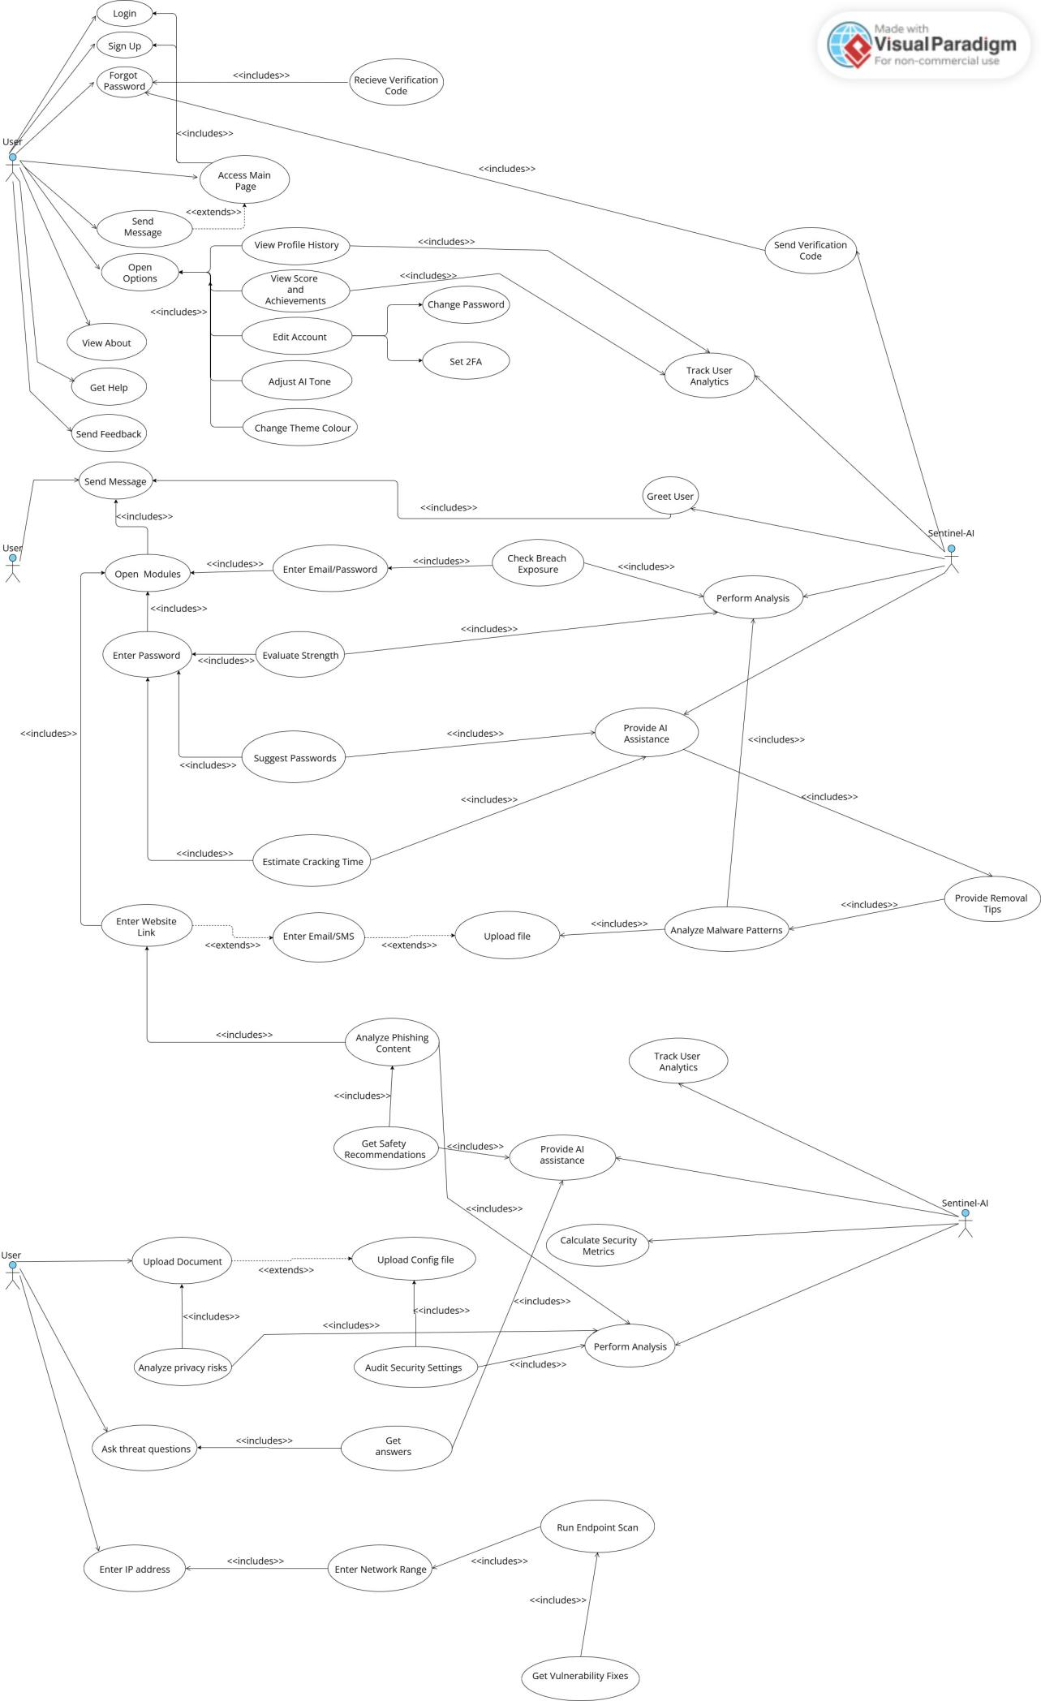
2.2.2- Use Case Scenarios

This section provides a comprehensive breakdown of all use cases within Sentinel, outlining the involved actors, the main sequence of actions, and any alternative paths. Brief descriptions are included for each use case to clearly illustrate how the system operates and supports the user.

Narrative 1: Login

Use Case Name: | Login | Use Case Type:  Functional Requirement
Use Case ID: | UC-A103
Priority: | High
Primary  Actor: | User
Other  Participating  Actors: | ---
Description: | The user enters valid credentials to access the main system.  Sentinel validates the credentials securely and checks for anomalies.  The system ensures multi-layer verification and risk-based checks.  Successful login grants access to all enabled modules.
Precondition: | User must have an existing account and stable internet connection.
Trigger: | User selects the "Login" option.
Typical Course  Of Events: | • The user enters their email and password through the login screen. Sentinel evaluates the formatting, ensuring the inputs meet expected constraints before sending them for validation. The system protects against injection attempts and sanitizes the input.  • Sentinel compares the encrypted password with the stored hash in the database. If mismatches occur, Sentinel logs the event as a failed attempt for security diagnostics. Rate limiting activates automatically when needed.  • Sentinel runs behavioral analytics to ensure the login attempt matches typical user behavior. Variables such as device type, location pattern, and login frequency are checked to detect anomalies. | • If anomalies are detected, Sentinel may request additional verification, such as 2FA or email confirmation. This ensures that even compromised credentials cannot be reused without further authentication.  • Once validated, Sentinel generates a secure session token and establishes an encrypted communication channel. The dashboard and modules are prepared and customized based on user settings.  • Sentinel finalizes the login process by updating login history, device fingerprints, and risk scoring, ensuring full traceability for future audits.
Conclusion: | User successfully enters the system and gains access to the main dashboard.

Narrative 2: Sign up

Use Case Name: | Sign up | Use Case Type:  Functional Requirement
Use Case ID: | UC-B291
Priority: | High
Primary  Actor: | User
Other  Participating  Actors: | ---
Description: | A new user creates an account by providing basic information.  Sentinel verifies the email for authenticity and ensures password strength.  Security baselines are applied to newly created accounts.  Account initialization sets default preferences and analytics tracking.
Precondition: | User must not already have an account associated with the entered email.
Trigger: | User selects the "Sign Up" option.
Typical Course  Of Events: | • The user fills in the required fields such as email, password, and optional profile details. Sentinel checks for formatting errors and enforces minimum security requirements.  • Sentinel evaluates the password strength and prompts improvements if needed. This includes checking dictionary words, patterns, or recently breached passwords.  • Sentinel sends a verification code to the provided email to confirm identity. The user must enter this code to proceed. Rate-limiting prevents abuse. | • Once verified, Sentinel creates the account entry in the database and initializes default settings, including theme, AI tone, and privacy controls.  • Sentinel sets up security monitoring such as tracking login devices, analytics baselines, and risk scoring parameters.  • The system logs the sign-up event, sets established defaults, and redirects the user to the login screen or main interface depending on configuration.
Conclusion: | User account is successfully created and ready for use.

Narrative 3: Recieve Password

Use Case Name: | Receive Password | Use Case Type:  Functional Requirement
Use Case ID: | UC-C441
Priority: | High
Primary  Actor: | User
Other  Participating  Actors: | Sentinel-AI
Description: | Users can recover access when they forget their password.  Sentinel ensures the request is legitimate before initiating recovery.  The system sends a secure recovery link or verification code.  Password reset includes strong security checks and validation.
Precondition: | User has an active account and access to the recovery email.
Trigger: | User selects “Forgot Password.”
Typical Course  Of Events: | • The user enters their registered email, and Sentinel checks whether it exists and has no outstanding recovery restrictions.  • Sentinel evaluates the risk of account takeover by analyzing IP, behavior, and unusual access attempts.  • After validation, Sentinel sends a password reset link or verification code to the user’s email. | • The user follows the link or enters the code, and Sentinel prompts them to create a new password meeting strict complexity standards.  • Sentinel validates the password strength, prevents previously used passwords, and hashes and stores the new credential.  • The system logs the password reset event, notifies the user via email, and requires re-authentication for security.
Conclusion: | User resets their password and regains account access.

Narrative 4: Access Main Page

Use Case Name: | Access Main Page | Use Case Type:  Functional Requirement
Use Case ID: | UC-E600
Priority: | High
Primary  Actor: | User
Other  Participating  Actors: | ---
Description: | The user arrives at the main dashboard after logging in.  Sentinel loads modules dynamically based on permissions and preferences.  The page displays greeting, shortcuts, and security insights.  User experience is tailored via analytics and stored preferences.
Precondition: | User must be authenticated successfully.
Trigger: | Login process completes.
Typical Course  Of Events: | • Sentinel verifies the user's session token and decrypts personalization settings.  • Modules available to the user are loaded and displayed in the main interface.  • Sentinel generates a greeting message based on AI tone, time, and user history. | • Security insights such as breach exposure, warnings, or recommendations are populated.  • System retrieves notifications such as account changes, scan results, or alerts.  • Sentinel finalizes rendering and ensures that all UI elements load efficiently.
Conclusion: | User sees the personalized main dashboard.

Narrative 5: View Profile

Use Case Name: | View Profile | Use Case Type:  Functional Requirement
Use Case ID: | UC-G889
Priority: | Medium
Primary  Business Actor: | User
Other  Participating  Actors: | ---
Description: | The user views their profile information such as email, username, and settings.  Sentinel retrieves secure data from encrypted storage.  Users can review security status and account activity.  Profile view serves as the basis for editing account details.
Precondition: | User must be logged in and authorized.
Trigger: | User presses the “Profile” button on the top left of the main page.
Typical Course  Of Events: | · Sentinel retrieves the user's profile data from the database and decrypts sensitive fields.  · System prepares display formatting and hides sensitive information unless explicitly permitted.  · Profile activity such as recent logins and device history is loaded. | · Sentinel preprocesses optional data such as theme, tone, achievements, or analytics summaries.  · All profile elements are assembled and displayed in a cohesive layout.  · The system waits for user actions such as editing or viewing achievements.
Conclusion: | User successfully views their profile details.

Narrative 6: View About

Use Case Name: | View About | Use Case Type:  Functional Requirement
Use Case ID: | UC-H431
Priority: | Low
Primary  Actor: | User
Other  Participating  Actors: | ---
Description: | User views information about Sentinel, its purpose, and developers.  Sentinel provides a description of core functionalities and modules.  The section includes mission, version info, and safety disclaimers.  This page enhances transparency and system trust.
Precondition: | User is logged in.
Trigger: | User selects “About.”
Typical Course  Of Events: | · Sentinel loads static informational content from secure repository storage.  · System formats the content to match the user's selected theme.  · Extra details such as version, update notes, and changelogs are loaded. | · Licensing and disclaimers are retrieved and appended to the page.  · Sentinel prepares navigation links to help, feedback, and documentation.  · The final About page is displayed for the user to read.
Conclusion: | User views background information about Sentinel.

Narrative 7: Get Help

Use Case Name: | Get Help | Use Case Type:  Functional Requirement
Use Case ID: | UC-I901
Priority: | Low
Primary  Actor: | User
Other  Participating  Actors: | ---
Description: | User accesses the help section for guidance on using Sentinel features.  Sentinel offers categorized help topics and troubleshooting steps.  Interactive tips may be provided depending on the module being used.  This function reduces confusion and guides new users effectively.
Precondition: | User must be logged in.
Trigger: | User clicks “Help”.
Typical Course  Of Events: | · Sentinel retrieves help topics relevant to the user’s current screen or module.  · System organizes the topics into categories such as account, modules, scans, and settings.  · Additional dynamic suggestions appear based on user activity and system analytics. | · Sentinel displays step-by-step instructions and safety explanations.  · Links to documentation or support channels are rendered.  · System logs help usage to improve future support recommendations.
Conclusion: | User receives guidance on system usage.

Narrative 8: Send Feedback

Use Case Name: | Send Feedback | Use Case Type:  Functional Requirement
Use Case ID: | UC-J210
Priority: | Medium
Primary  Actor: | User
Other  Participating  Actors: | ---
Description: | Users can submit feedback, suggestions, or issue reports.  Sentinel collects this data and analyzes patterns for improvement.  Feedback may include technical issues, UI suggestions, or bug reports.  All submissions are securely stored for administrative review.
Precondition: | User is logged in and has access to the feedback feature.
Trigger: | User submits a feedback message.
Typical Course  Of Events: | · User enters feedback text, and Sentinel analyzes it for relevance and correct formatting.  · Sentinel attaches metadata such as device type, time, and recent actions.  · The system logs the feedback into a secure feedback repository. | · Sentinel optionally categorizes the feedback using AI classification.  · Confirmation is generated and sent to the user.  · Admin-side logs are updated for later review.
Conclusion: | Feedback is securely submitted and stored.

Narrative 9: Adjust AI Tone

Use Case Name: | Adjust AI Tone | Use Case Type:  Functional Requirement
Use Case ID: | UC-O355
Priority: | Medium
Primary  Actor: | User
Other  Participating  Actors: | ---
Description: | This use case allows users to select the communication tone of Sentinel (formal, friendly, neutral, etc.).  Tone affects greetings, messages, and advisory explanations.  Sentinel ensures tone changes propagate through all modules.  The system personalizes user engagement dynamically.
Precondition: | User must be logged in and have access to profile settings.
Trigger: | User selects “Adjust AI Tone.”
Typical Course  Of Events: | · Sentinel presents available tone options to the user, such as professional, casual, or humorous. Each option includes a preview.  · When the user selects a tone, Sentinel updates the preference in secure storage and adjusts behavioral settings.  · The system reloads relevant UI components to reflect the new tone. This may affect greeting messages or real-time notifications. | · Tone change is propagated to modules that include user-facing dialogue such as Threat Advisor or Password Evaluator.  · Sentinel tests the tone change by generating a sample message displayed to the user.  · The system logs the adjustment and confirms the update.
Conclusion: | AI tone is successfully updated and applied throughout the system.

Narrative 10: Change Password

Use Case Name: | Change Password | Use Case Type:  Functional Requirement
Use Case ID: | UC-Q777
Priority: | High
Primary  Actor: | User
Other  Participating  Actors: | ---
Description: | The user changes their existing password to maintain or enhance account security.  Sentinel enforces strict strength rules and prevents reuse of previous passwords.  The system evaluates the new password and ensures it is uncompromised.  Change logs are stored for security auditing.
Precondition: | User must already be authenticated.
Trigger: | User selects “Change Password.”
Typical Course  Of Events: | · User enters their current password, and Sentinel verifies it matches the stored credentials before proceeding.  · The user enters their new password, and Sentinel evaluates its strength and checks if it appears in breach databases.  · Sentinel prevents weak passwords or those similar to previously used ones. It gives feedback on improvements if needed. | · Once accepted, the new password is hashed using secure algorithms and stored. Old passwords are archived for future comparison.  · Sentinel logs the password change event and sends a notification to the user’s email.  · Session tokens may be reset to prevent unauthorized use, forcing re-login for security.
Conclusion: | Password is successfully updated and secured.

Narrative 11: Set 2FA

Use Case Name: | Set 2FA | Use Case Type:  Functional Requirement
Use Case ID: | UC-R501
Priority: | High
Primary  Actor: | User
Other  Participating  Actors: | ---
Description: | Allows the user to enable two-factor authentication for extra protection.  Sentinel supports email, SMS, or authenticator app methods.  The system ensures 2FA codes are delivered and validated correctly.  Enabled 2FA strengthens overall account defense.
Precondition: | User is authenticated and has access to a valid second-factor device.
Trigger: | User selects “Set 2FA.”
Typical Course  Of Events: | · Sentinel displays available 2FA methods and explains their security levels.  · User selects a method, and Sentinel initiates setup by generating a pairing code or secret key.  · The system sends a verification code or instructs the user to scan a QR code with an authenticator app. | · Sentinel verifies the code entered by the user, ensuring it matches expected values.  · Once validated, Sentinel activates 2FA for the account and logs the event.  · Confirmation is shown, and backup recovery codes may be provided.
Conclusion: | 2FA is successfully enabled and operational.

Narrative 12: Track User Analytics

Use Case Name: | Track User Analytics | Use Case Type:  Functional Requirement
Use Case ID: | UC-S880
Priority: | Medium
Primary  Actor: | Sentinel-AI
Other  Participating  Actors: | ---
Description: | Sentinel continuously tracks user behavior to enhance personalization and improve security monitoring.  Data includes module usage, login patterns, and interactions.  Analytics help detect unusual behaviors that may indicate threats.  Information is anonymized where applicable.
Precondition: | User has an active session and analytics preferences enabled.
Trigger: | User performs any interactive action.
Typical Course  Of Events: | · Sentinel logs user activity including timestamps, module usage, and navigational patterns.  · Behavioral analytics evaluate normal vs. abnormal activity patterns to establish risk scores.  · The system generates anonymized analytic datasets for future personalization like greetings or recommendations. | · Sentinel may detect suspicious behavior and trigger warnings or additional authentication steps.  · Long-term analytics are summarized into charts or user insights.  · Logs are securely stored and used to improve system behavior without violating privacy settings.
Conclusion: | User analytics are tracked and applied to improve security and personalization.

Narrative 13: Enter Password

Use Case Name: | Enter Password | Use Case Type:  Functional Requirement
Use Case ID: | UC-035-EPW
Priority: | High
Primary  Actor: | User
Other  Participating  Actors: | ---
Description: | The user enters a password into the password-strength module. Sentinel-AI analyzes the character composition, entropy, structure, and vulnerability indicators. Suggestions and risk assessments support stronger password creation.
Precondition: | User has a password ready for assessment.
Trigger: | User picks the Password Strength Tester module.
Typical Course  Of Events: | - User types a password, verifying accuracy before submission.  2. Sentinel-AI encrypts and validates the password, rejecting invalid formats if necessary.  3. The system analyzes complexity, measuring entropy, length patterns, and dictionary exposure. | 4. Common weaknesses and patterns are identified, such as repetition, common sequences, or personal ties.  5. The system generates scoring and risk data, including cracking resistance and warnings.  6. Results and improvement suggestions are delivered, helping users strengthen passwords.
Conclusion: | The password is evaluated and feedback is provided.

Narrative 14: Get Safety Recommendations

Use Case Name: | Get Safety Recommendation | Use Case Type:  Functional Requirement
Use Case ID: | UC-022-HSD
Priority: | Medium
Primary  Actor: | User
Other  Participating  Actors: | Sentinel
Description: | Based on analysis results, Sentinel-AI generates tailored safety tips to help the user avoid cyber risks. These recommendations may include behavioral guidance, protective settings, and actionable security steps. Suggestions respond directly to detected threats or general weaknesses.
Precondition: | Sentinel-AI has completed an analysis producing actionable insights.
Trigger: | Analysis module finishes and prompts recommendations.
Typical Course  Of Events: | 1. Sentinel-AI interprets analysis results, examining threat levels, system weaknesses, and contextual patterns. It identifies areas requiring attention.  2. The system maps detected issues to best-practice countermeasures, drawing from security frameworks, guidelines, and internal knowledge.  3. Sentinel-AI compiles tailored recommendations, including configuration updates, behavioral alerts, or mitigation actions. | 4. User receives a clear, prioritised list, with each recommendation explained in practical, non-technical language.  5. User may request additional clarification, and the system elaborates or provides alternative actions if needed
Conclusion: | User gains actionable steps to improve safety and reduce cyber risk exposure.

Narrative 15: Analyze Phishing Content

Use Case Name: | Analyzing phishing content | Use Case Type:  Functional Requirement
Use Case ID: | UC-021-SPX
Priority: | High
Primary  Actor: | User
Other  Participating  Actors: | Sentinel
Description: | The user submits an email, message, or website link suspected of being a phishing attempt. Sentinel-AI examines the content’s structure, metadata, and behavioral indicators. It identifies malicious intent, unusual requests, impersonation patterns, and harmful redirections. The system provides an in-depth risk overview.
Precondition: | The user must upload or enter content in a supported format.
Trigger: | User presses on “Analyze” after uploading the link, text or file in the PhishingDetector Module.
Typical Course  Of Events: | 1. User prepares suspicious content, reviewing the email or link and deciding to run an automated phishing assessment to verify any danger. They initiate the module from the main interface.  2. System parses the content, extracting headers, URLs, sender metadata, embedded scripts, and contextual cues to understand the structure and intent.  3. Sentinel-AI applies detection algorithms, comparing content patterns with known phishing signatures, impersonation strategies, and social-engineering traits. | 4. The system estimates risk, building a detailed breakdown of potential threats such as credential harvesting, malware delivery, or fraudulent requests.  5. Results are displayed to the user, including confidence percentages, specific indicators of compromise, and recommended next steps for safety.
Conclusion: | User receives a full breakdown of phishing indicators and understands the risk level clearly.

Narrative 16: Get Answers

Use Case Name: | Get Answers | Use Case Type:  Functional Requirement
Use Case ID: | UC-023-QNA
Priority: | High
Primary  Actor: | User
Other  Participating  Actors: | Sentinel-AI
Description: | The user asks Sentinel-AI specific questions about cybersecurity threats, suspicious behaviour, or mitigation strategies. Sentinel-AI processes the query and provides an accurate answer based on internal knowledge and analysis patterns. Responses are contextual and guide the user toward safer decisions.
Precondition: | User must submit a valid question or prompt.
Trigger: | User asks a threat-related question after entering the Threat Advisor Module.
Typical Course  Of Events: | 1. User enters their question, describing concerns, anomalies, or general knowledge queries.  2. Sentinel-AI interprets the question, identifying the security domain, urgency, and context.  3. The system retrieves relevant knowledge, referencing threat databases, model awareness, and previous analysis results. | 4. Sentinel-AI formulates a detailed answer, ensuring it addresses the user’s specific concerns and provides actionable insights.  5. Answer is delivered to the user, along with optional follow-up guidance or clarifying questions.
Conclusion: | User receives a clear, accurate explanation and optional advice regarding their cybersecurity inquiry.

Narrative 17: Provide AI Assistance

Use Case Name: | Provide AI Assistance | Use Case Type:  Functional Requirement
Use Case ID: | UC-024-AIA
Priority: | High
Primary  Actor: | Sentinel-AI
Other  Participating  Actors: | ---
Description: | Sentinel-AI supports various user tasks by offering intelligent guidance, automation, and insights. It operates across modules, enhancing user interactions with context-aware advice. The system ensures smooth task completion and prevents misuse or incorrect interpretation.
Precondition: | A user is performing a task where AI assistance is enabled.
Trigger: | User enters a module or issues a request requiring AI support.
Typical Course  Of Events: | 1. The system monitors the user's activity, identifying when guidance or contextual input may be helpful.  2. Sentinel-AI analyzes real-time interactions, determining knowledge gaps or steps needing clarification.  3. AI generates intelligent suggestions, such as interpretations, warnings, or next-step recommendations. | 4. User reviews the guidance, deciding whether to follow, request more detail, or ignore.  5. AI adapts to the user’s response, tailoring further assistance for clarity and task efficiency.
Conclusion: | User receives seamless and adaptive support from the AI to complete tasks confidently.

Narrative 18: Analyze Malware Patterns

Use Case Name: | Analyze Malware Patterns | Use Case Type:  Functional Requirement
Use Case ID: | UC-025-MWR
Priority: | High
Primary  Actor: | User
Other  Participating  Actors: | Sentinel-AI
Description: | User uploads or references a suspicious file for Sentinel-AI to inspect. The system scans for harmful signatures, behavioral traits, and known malware families. It then evaluates how the file behaves, reveals hidden operations, and determines potential harm.
Precondition: | User provides a file or data segment suitable for analysis.
Trigger: | User selects “Analyze Malware Patterns.”
Typical Course  Of Events: | 1. User uploads the file, confirming their intent to perform malware analysis.  2. Sentinel-AI extracts file components, such as metadata, code fragments, and embedded instructions.  3. The system evaluates behavior profiles, comparing them with malware databases and anomaly-detection models. | 4. Risk level and malware family indicators are identified, including persistence methods or payload behaviour.  5. Results are presented, enabling the user to understand threats and possible damage.
Conclusion: | User receives a detailed malware-pattern analysis and associated threat level.

Narrative 19: Provide Removal Tips

Use Case Name: | Provide Removal Tips | Use Case Type:  Functional Requirement
Use Case ID: | UC-026-RMT
Priority: | Medium
Primary  Actor: | Sentinel-AI
Other  Participating  Actors: | ---
Description: | After malware or threat analysis, Sentinel-AI offers removal guidance. These tips may include cleanup steps, system restore suggestions, quarantine instructions, or reconfiguration actions. They assist users in safely eliminating threats without advanced technical knowledge.
Precondition: | A threat has been detected or analyzed.
Trigger: | Sentinel-AI concludes a malware or threat assessment.
Typical Course  Of Events: | 1. Sentinel-AI examines assessed threats, determining severity and possible persistence mechanisms.  2. The system maps threat types to proven removal procedures, selecting methods safe for general users.  3. Detailed removal steps are compiled, including preparatory steps and post-cleanup actions. | 4. User receives step-by-step instructions, designed to minimise risk and prevent further spreading.  5. AI offers optional automated checks, allowing the user to verify successful threat removal.
Conclusion: | User understands how to safely remove or mitigate the discovered threat.

Narrative 20: Calculate Security Metrics

Use Case Name: | Calculate Security Metrics | Use Case Type:  Functional Requirement
Use Case ID: | UC-027-CSM
Priority: | Medium
Primary  Business Actor: | Sentinel-AI
Other  Participating  Actors: | ---
Description: | Sentinel-AI calculates various security indicators, such as risk scores, vulnerability levels, and compliance percentages. These metrics help users understand their overall security posture. The system compiles results into meaningful dashboards or formatted reports.
Precondition: | User or system has supplied data for evaluation.
Trigger: | A module requires computation of security metrics.
Typical Course  Of Events: | 1. Sentinel-AI gathers relevant data, collecting results from previous analyses or uploaded configuration files.  2. The system applies metric formulas, referencing standards or internally developed scoring models.  3. Security posture is quantified, highlighting strengths, weaknesses, and deviation from recommended baselines. | 4. Results are structured for readability, ensuring the user can interpret numeric or categorical values.  5. Metrics are displayed or exported, allowing users to track improvements over time.
Conclusion: | User receives quantified security indicators to understand and manage risks.

Narrative 21: Audit Security Settings
Use Case Name: | Audit Security Settings | Use Case Type:  Functional Requirement
Use Case ID: | UC-028-AUD
Priority: | High
Primary  Actor: | User
Other  Participating  Actors: | ---
Description: | User uploads a configuration file or allows Sentinel-AI to inspect system settings. The system reviews configurations against security benchmarks and identifies misconfigurations. It then reports weaknesses and suggests improvements.
Precondition: | User must provide access to configuration data.
Trigger: | User selects “Audit Security Settings.”
Typical Course  Of Events: | 1. User uploads or grants access to a configuration file, confirming the audit action.  2. Sentinel-AI parses configuration entries, identifying security-related values and system roles.  3. The system compares settings to best-practice baselines, checking for outdated, weak, or risky values. | 4. Audit results are compiled, highlighting misconfigurations, missing safeguards, and priority levels.  5. User receives recommended adjustments, allowing them to improve protection and reduce vulnerabilities.
Conclusion: | User gains insight into their configuration strength and receives fixes.

Narrative 22: Get Vulnerability Fixes

Use Case Name: | Get Vulnerability Fixes | Use Case Type:  Functional Requirement
Use Case ID: | UC-029-VFX
Priority: | Medium
Primary  Actor: | Sentinel-AI
Other  Participating  Actors: | ---
Description: | Sentinel-AI provides patching and mitigation steps for discovered vulnerabilities. It identifies missing updates, improper configurations, or weak controls and suggests corrective actions. User receives prioritized, easy-to-implement fixes.
Precondition: | Vulnerabilities must have been detected.
Trigger: | Completion of a vulnerability scan or configuration audit.
Typical Course  Of Events: | 1. Sentinel-AI reviews detected vulnerabilities, categorizing them by severity and exploitability.  2. The system matches each vulnerability with corrective measures, referencing patch databases or mitigation frameworks.  3. Detailed fixes are assembled, including installation steps, configuration improvements, or compensating controls. | 4. User receives a prioritized fix list, ensuring critical issues are addressed first.  5. Optional verification steps are offered, allowing users to confirm the applied fixes were successful.
Conclusion: | User obtains clear, applicable solutions for eliminating vulnerabilities.

Narrative 23: Upload File

Use Case Name: | Upload file | Use Case Type:  Functional Requirement
Use Case ID: | UC-031-UPF
Priority: | High
Primary  Actor: | User
Other  Participating  Actors: | ---
Description: | The user uploads a file for analysis or inspection. Files may include malware samples, configuration documents, or suspicious attachments. Sentinel-AI validates the file format, prepares it for processing, and assigns it to the appropriate analysis module.
Precondition: | User must have a file ready for upload.
Trigger: | User clicks “Upload File.”
Typical Course  Of Events: | 1. User initiates the upload, selecting a file from their device and confirming permission for analysis. The system displays supported formats.  2. Sentinel-AI validates the file, checking integrity, size limits, and format compatibility.  3. The file is securely stored, encrypted, and assigned to a temporary workspace for processing. | 4. The system identifies the correct module, such as malware scan, phishing review, or configuration audit.  5. File is queued for analysis, and the user receives a confirmation message showing progress status.  6. Analysis begins automatically, transitioning into the module’s specific workflow.
Conclusion: | The uploaded file is ready and successfully passed into the analysis pipeline.

Narrative 24: Enter Website Link

Use Case Name: | Enter website link | Use Case Type:  Functional Requirement
Use Case ID: | UC-036-EWL
Priority: | High
Primary  Actor: | User
Other  Participating  Actors: | ---
Description: | User enters a website link for phishing or risk analysis. Sentinel-AI examines the URL structure, redirection chain, hosting data, and malicious indicators. This helps determine whether a website is safe to visit.
Precondition: | User must have a valid link to analyze.
Trigger: | User inputs a link into the system.
Typical Course  Of Events: | 1. User copies and pastes the URL, confirming submission.  2. Sentinel-AI validates link format, correcting minor issues or rejecting invalid URLs.  3. The system analyzes URL components, checking domain age, hosting, redirections, and suspicious structure. | 4. Threat models run, matching patterns with phishing, malware, or scam indicators.  5. A risk score is generated, summarizing safety levels and identified issues.  6. Recommendations and warnings are presented, guiding the user’s next steps.
Conclusion: | The link receives a safety evaluation and user sees the final risk report.

Narrative 25: Enter Email/SMS

Use Case Name: | Enter email/sms | Use Case Type:  Functional Requirement
Use Case ID: | UC-037-EMS
Priority: | High
Primary  Actor: | User
Other  Participating  Actors: | ---
Description: | User manually enters an email or SMS message suspected of phishing. Sentinel-AI analyzes linguistic cues, impersonation attempts, and social-engineering strategies. The system outputs a threat score with detailed reasoning.
Precondition: | User has a message ready to copy or enter.
Trigger: | User selects the option to enter text manually.
Typical Course  Of Events: | 1. User inputs message text, ensuring accuracy during copying.  2. Sentinel-AI processes the text, normalizing grammar, punctuation, and metadata.  3. AI evaluates intent signals, including tone, urgency, improper authority claims, or credential requests. | 4. Phishing-detection models analyze risk, comparing message patterns to known scams.  5. A detailed risk summary is prepared, explaining red flags and decision criteria.  6. Recommendations for user safety are displayed, guiding proper handling.
Conclusion: | User receives a complete phishing evaluation of their message.

Narrative 26: Estimate Cracking Time

Use Case Name: | Estimate cracking time | Use Case Type:  Functional Requirement
Use Case ID: | UC-040-ECT
Priority: | Medium
Primary  Actor: | Sentinel-AI
Other  Participating  Actors: | ---
Description: | Sentinel-AI calculates how long it would take for an attacker to crack a user’s password using brute-force or hybrid methods. It evaluates entropy, structure, and attacker resources to estimate cracking difficulty.
Precondition: | User has submitted a password for evaluation.
Trigger: | User must click on the “analyze password” button
Typical Course  Of Events: | 1. Sentinel-AI processes the password, examining its length, complexity, and repetition.  2. The system calculates entropy, quantifying resistance to brute-force attempts.  3. Multiple attack models are simulated, including dictionary, hybrid, and GPU-based brute force. | 4. Estimated cracking durations are computed, ranging from milliseconds to centuries.  5. Results are presented, offering context about attacker capabilities.  6. AI suggests improvements, proposing ways to increase cracking resistance.
Conclusion: | User sees how resistant their password is and receives upgrade advice.

Narrative 27: Analyze Privacy Risks

Use Case Name: | Analyze Privacy Risks | Use Case Type:  Functional Requirement
Use Case ID: | UC-041-APR
Priority: | High
Primary  Actor: | User
Other  Participating  Actors: | Sentinel-AI
Description: | Sentinel analyzes uploaded documents for sensitive information exposure. It searches for PII, confidential data structures, unencrypted credentials, and risky patterns. Findings are categorized and scored based on severity.
Precondition: | A valid document must be uploaded first.
Trigger: | The analysis pipeline starts automatically after upload.
Typical Course  Of Events: | 1. Sentinel loads the uploaded file into a secured analysis sandbox with restricted execution permissions. It identifies the document type (PDF, DOCX, TXT, etc.).  2. The system parses the file’s content, metadata, and embedded elements. Extraction modules normalize text for consistent pattern recognition.  3. Privacy detection algorithms scan for PII such as emails, phone numbers, addresses, IDs, and financial data. Anomalies and suspicious structures are flagged. | 4. A risk scoring engine evaluates discovered issues using weighted severity models. The system correlates findings to known privacy exposure categories.  5. Sentinel generates a detailed risk analysis report with highlighted sections, explanations, and suggested mitigations.  6. Results are presented to the user with advisory notes and optional follow-up actions.
Conclusion: | Privacy risk results are delivered to the user for review and remediation.

Chapter 3

3.1- Dashboard

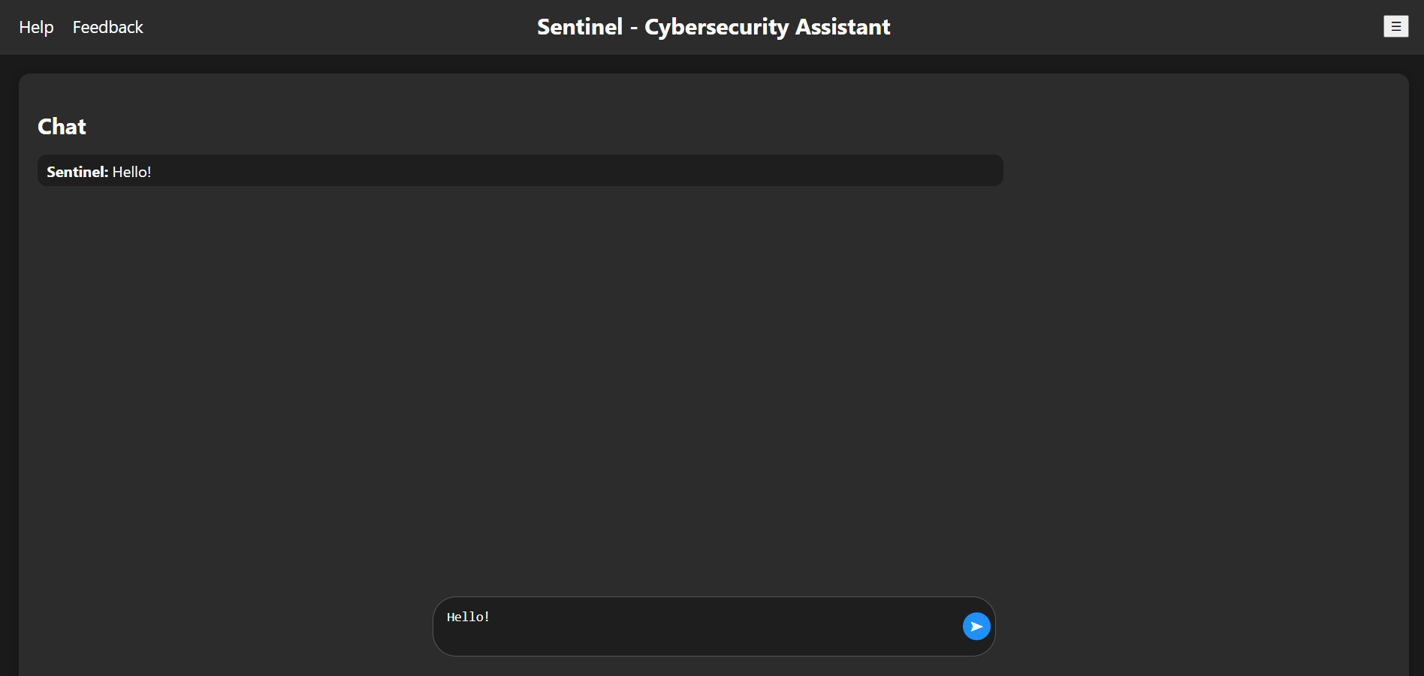

Introduction:
The Sentinel Dashboard is the central interface of the Sentinel cybersecurity application. It is designed to provide users with an intuitive, interactive, and secure environment to access all features of the system. The dashboard serves as a bridge between the user and Sentinel’s AI-powered cybersecurity assistant, enabling efficient communication, monitoring, and management of cybersecurity concerns in real time.
The design of the dashboard emphasizes clarity, responsiveness, and user-centered functionality. It integrates a real-time chat interface for AI-driven cybersecurity guidance, a sidebar for navigating between modules, and sections for history, saved chats, and system options. The dashboard is optimized for usability, providing a dark-themed interface that is comfortable for prolonged use while maintaining high readability.
Users can immediately see the AI assistant’s greeting upon login, indicating that the system is ready to respond. The sidebar allows users to search and quickly navigate to any module, ensuring that all functionalities are easily accessible from a single hub. The combination of AI-powered analysis and a streamlined interface makes the Sentinel Dashboard an effective tool for both novice and advanced users who want to actively monitor and manage cybersecurity threats.
Capabilities
The Sentinel Dashboard offers a wide range of capabilities that support both interactive cybersecurity analysis and effective system navigation.
Interactive Cybersecurity Assistance
The dashboard allows users to directly interact with Sentinel, the AI cybersecurity assistant. Users can ask questions about malware, trojans, phishing attacks, password security, network vulnerabilities, and other security topics. Sentinel uses natural language understanding to interpret user queries, taking into account the context of previous messages in the same conversation to deliver accurate, relevant, and actionable responses. This makes it suitable for multi-turn conversations where follow-up questions refer to previous discussions.
Real-Time Streaming Responses
Sentinel’s answers are streamed in real time, creating a dynamic and responsive chat experience. Instead of waiting for the AI to process the full answer, users can see the response being typed out incrementally. This enhances user engagement and allows them to follow the AI’s reasoning as it generates recommendations. The system also handles interruptions and filler words, providing concise and contextually appropriate responses when users send short or non-informative messages.
Context Management
The dashboard maintains conversation context for up to six recent messages. This ensures that pronouns and references in user questions are interpreted correctly, and that follow-up questions are accurately understood. For example, if a user asks about “this malware,” the system can automatically link the pronoun “this” to the last detected malware topic. Context management ensures coherent and meaningful multi-turn dialogues.
Module Search and Navigation
A sidebar allows users to quickly search for and navigate between different Sentinel modules. Users can type the name of a module to filter available options and click to navigate directly. Modules currently available include Password Tester, Privacy Leak Analyzer, Threat Advisor, Web Scanner, File Threat Analyzer, and Endpoint Scanner. This functionality allows users to access different tools without leaving the dashboard, streamlining workflow and increasing productivity.
History and Vault Access
The dashboard enables users to save chat sessions for future reference. Conversations can be stored in a history database and accessed through the Vault. This allows users to track previous cybersecurity investigations, review past AI advice, and maintain a record of system interactions for auditing purposes. The ability to save and retrieve historical conversations enhances both transparency and accountability in cybersecurity management.
Security-Focused Interactivity
Security considerations are built into the dashboard’s design. Input fields are initially read-only to prevent accidental input until security mode is activated. Logout functionality is easily accessible to terminate sessions, and options allow users to customize settings. The dashboard ensures that users maintain control over both data and session security at all times.
Responsive Design and Usability Enhancements
The dashboard is designed to be visually clear and interactive. Buttons and elements provide feedback when hovered or clicked, enhancing usability. The chat interface scrolls automatically to display the latest messages, ensuring that the conversation is always visible. The sidebar can be toggled on or off to focus on the chat interface or navigate modules. Overall, the design prioritizes an intuitive, fluid, and user-friendly experience while maintaining a professional appearance.
Tools and Libraries
The Sentinel Dashboard relies on a combination of backend, frontend, and AI tools to provide its functionality.
Backend (Python / FastAPI)
FastAPI is used to create RESTful API endpoints, including the /ask-security endpoint that handles AI queries. FastAPI is chosen for its speed, simplicity, and ability to handle asynchronous streaming responses.
The Groq API is used to interface with the LLaMA 3.1 language model, which generates responses to cybersecurity queries. API key handling ensures secure access to the AI service.
Python standard libraries such as os manage environment variables, time provides delay handling for streaming responses, and typing adds type hints for code readability and maintainability.
Frontend (HTML/CSS/JS)
The frontend uses HTML5 and Jinja2 templates to render dynamic content, allowing Python data to be displayed directly in the browser.
CSS is used for modern styling with a dark theme for improved readability and reduced eye strain. Flexbox is applied for layout, while buttons, chat bubbles, and input fields feature hover and focus effects. Sidebar transitions provide smooth opening and closing animations, enhancing the user experience.
JavaScript handles the interactive aspects of the dashboard. This includes typing animation for messages, streaming responses from the AI, sidebar search and module navigation, button click events, and asynchronous fetch requests to backend endpoints. The frontend ensures a responsive, interactive, and real-time user experience.
AI & NLP Tools
The dashboard uses the Groq LLM (LLaMA 3.1-8b) for natural language understanding and generating cybersecurity responses.
Custom AI prompts and rules guide the model to handle context, detect topics, resolve pronouns, and respond appropriately to filler words. These rules ensure that AI responses are relevant, concise, and professional, maintaining the high-quality analysis expected from Sentinel.
Workflow
The workflow of the Sentinel Dashboard integrates user interaction, AI processing, and system navigation into a seamless experience.
Step 1: Initialization
Upon loading, the dashboard displays a welcome message from Sentinel, confirming that the system is ready. The sidebar remains hidden until toggled by the user, allowing focus on the chat interface. Module information and navigation links are preloaded for immediate access.
Step 2: Activating Security Mode
Users click the "Ask Security Questions" button to enter security mode. This action unlocks the chat input field, allowing the user to type questions about cybersecurity threats, network issues, or malware. The AI assistant is now ready to respond to specific inquiries.
Step 3: User Input Handling
When the user presses the Send button, the input is appended to the chat window. Short or non-informative messages are detected as filler and handled accordingly. The input is sent to the backend via the /ask-security API, where the AI model processes the query.
Step 4: AI Response Streaming
The backend generates responses using LLaMA 3.1, following specific logic to detect topics, apply conversation context, and resolve pronouns. Responses are streamed incrementally back to the frontend, where JavaScript renders each character in a typing animation, providing a dynamic, real-time conversational experience.
Step 5: Context Preservation
All messages in the current session are stored locally to preserve conversation history. This ensures that follow-up questions are interpreted correctly and that multi-turn conversations maintain context. Users can save chats to the history database, providing a record of interactions for future reference.
Step 6: Module Navigation & Utility Actions
The sidebar allows users to search for and navigate to other Sentinel modules quickly. Links to Vault, History, and Options pages provide additional functionality, while the Logout button allows users to securely end their session. This integration of AI interaction, module access, and session management ensures a smooth and efficient workflow for users managing cybersecurity tasks.

Visualization:
The Sentinel Dashboard provides a clear and interactive visual interface that allows users to perform all core actions efficiently. The dashboard layout is divided into two main sections: the chat area and the sidebar. Each section is designed to facilitate user interaction with Sentinel and the modules while maintaining context and ease of use.
Entering Security Questions and Receiving Answers
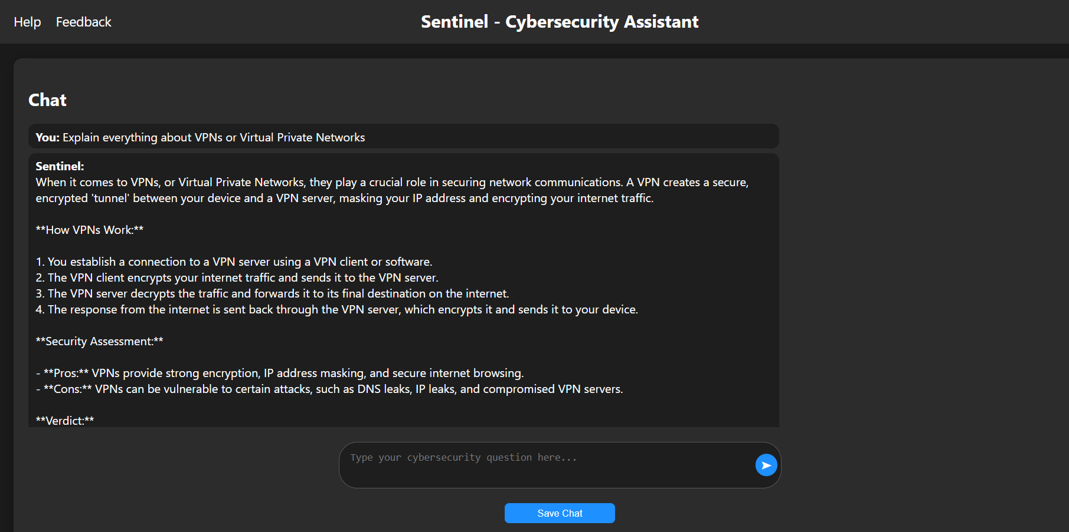
Users can enter any cybersecurity-related question directly into the chat input box. To activate this functionality, the user clicks the "Ask Security Questions" button. Once security mode is activated, the input box becomes editable. Users can then type their questions, such as inquiries about malware, phishing attempts, network vulnerabilities, or password security. After pressing the Send button, the question is displayed in the chat window, and Sentinel begins generating a response.
The AI response is streamed in real-time, appearing gradually in the chat window with a typing animation. This simulates a live conversation and allows users to follow the AI’s reasoning. The AI’s answer includes a security assessment, a verdict on potential risks, reasoning behind the assessment, and recommended prevention measures. Users can continue the conversation, ask follow-up questions, and rely on Sentinel to maintain context from previous messages.
Getting Help or Submitting Feedback
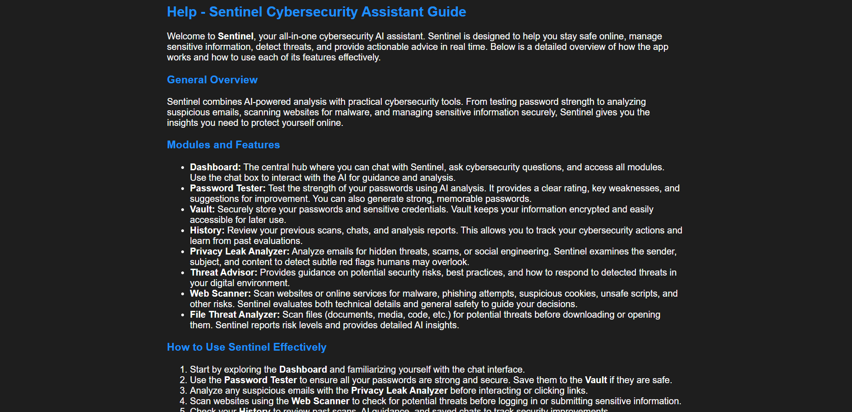

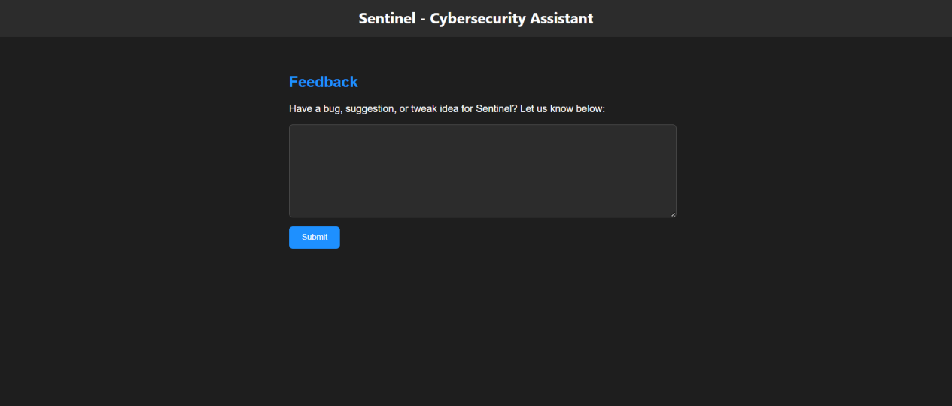
At the top left of the dashboard, links labeled "Help" and "Feedback" are available. Clicking the "Help" link navigates the user to a dedicated support page with documentation, guidance, and tutorials. The "Feedback" link allows users to submit suggestions, report issues, or provide input about their experience with Sentinel. These features ensure that users have access to support and can contribute to improving the system.
Saving Chat to History
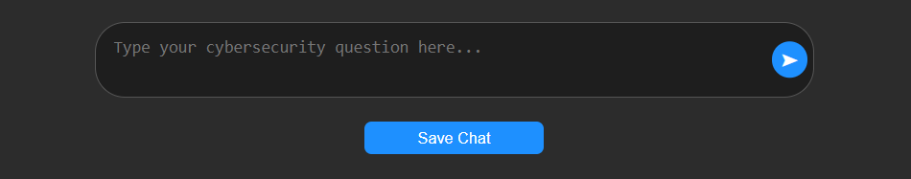
Once a conversation is complete, users can save it for future reference by clicking the "Save Chat" button, which becomes visible after engaging in a security conversation. Clicking this button stores the conversation in the Sentinel history database. A confirmation message briefly appears, indicating that the chat has been successfully saved. Saved conversations can later be accessed for auditing, review, or to continue a previous discussion.
Viewing History and Vault
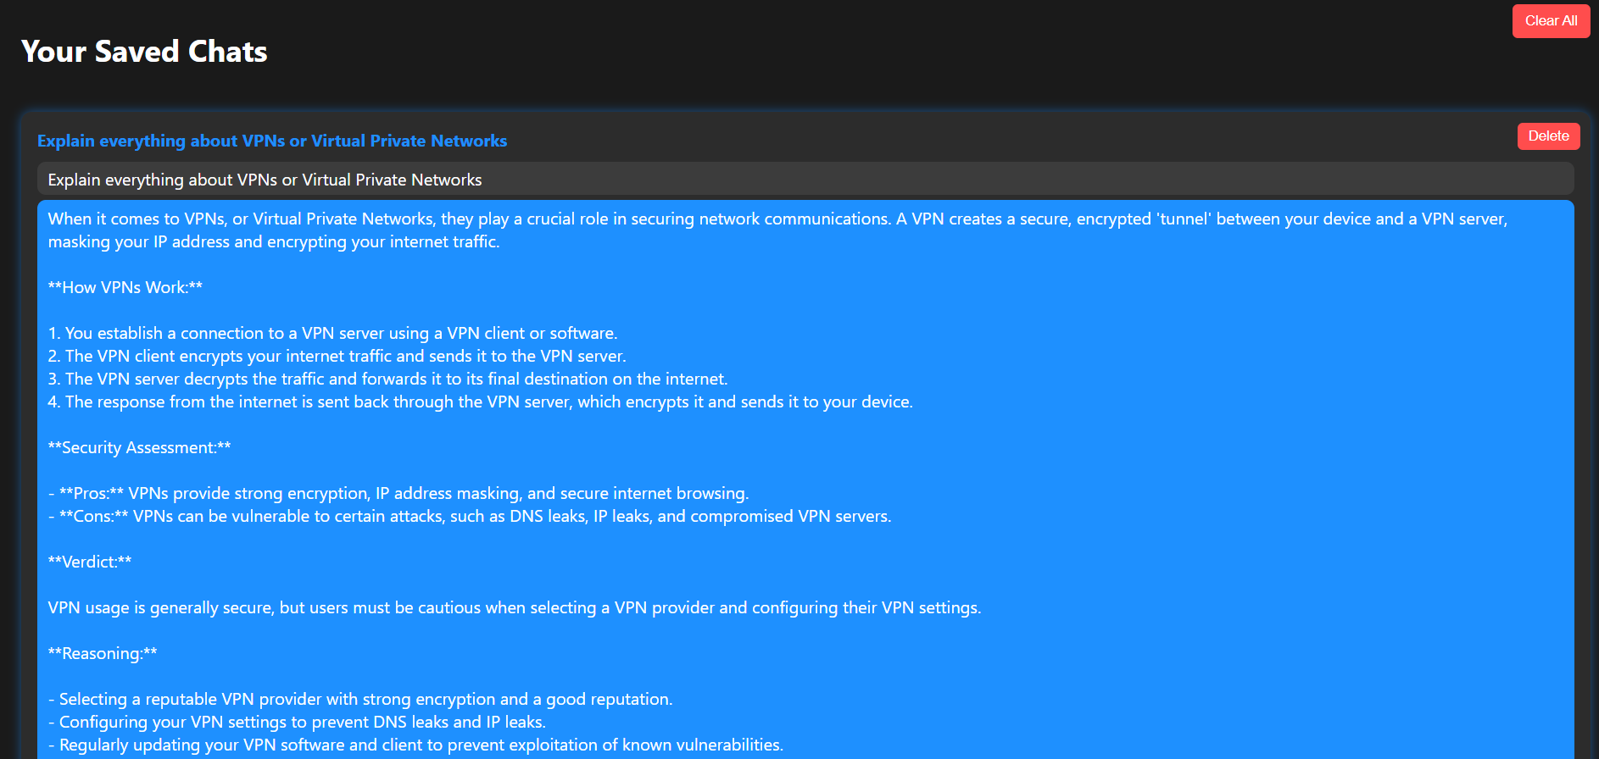

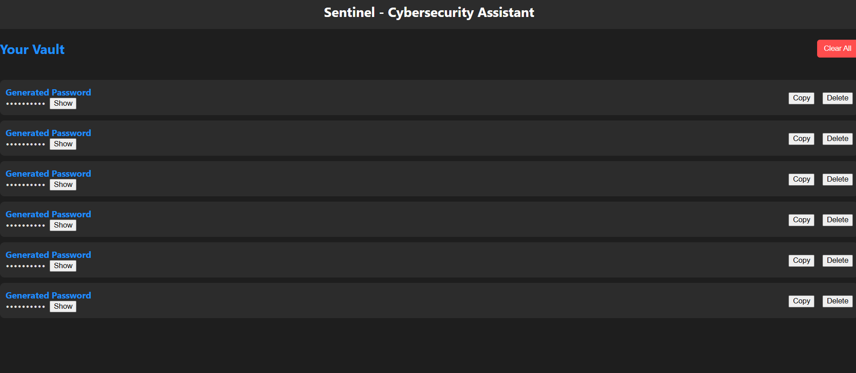
The dashboard includes links labeled "History" and "Vault" in the sidebar. Clicking the "History" link displays a list of previously saved conversations, allowing users to review prior interactions with Sentinel. The "Vault" link provides access to securely stored passwords and other sensitive information saved within Sentinel. This organization ensures that users can access past data efficiently while maintaining security and privacy.
Viewing Modules via Search Bar
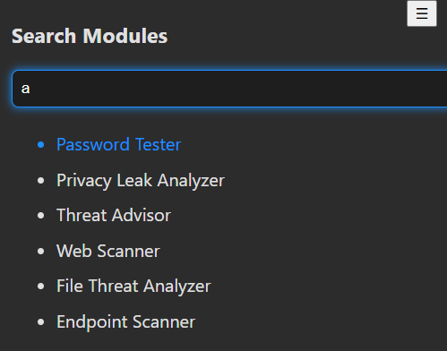
The sidebar contains a search bar labeled "Search Modules," which allows users to quickly find and navigate to any available module. As the user types, the search dynamically filters modules such as Password Tester, Privacy Leak Analyzer, Threat Advisor, Web Scanner, File Threat Analyzer, and Endpoint Scanner. Clicking on a module name immediately navigates the user to that module’s interface. This feature simplifies navigation and ensures that users can access specific tools without manually browsing through multiple pages.
Adjusting Options in the Dashboard
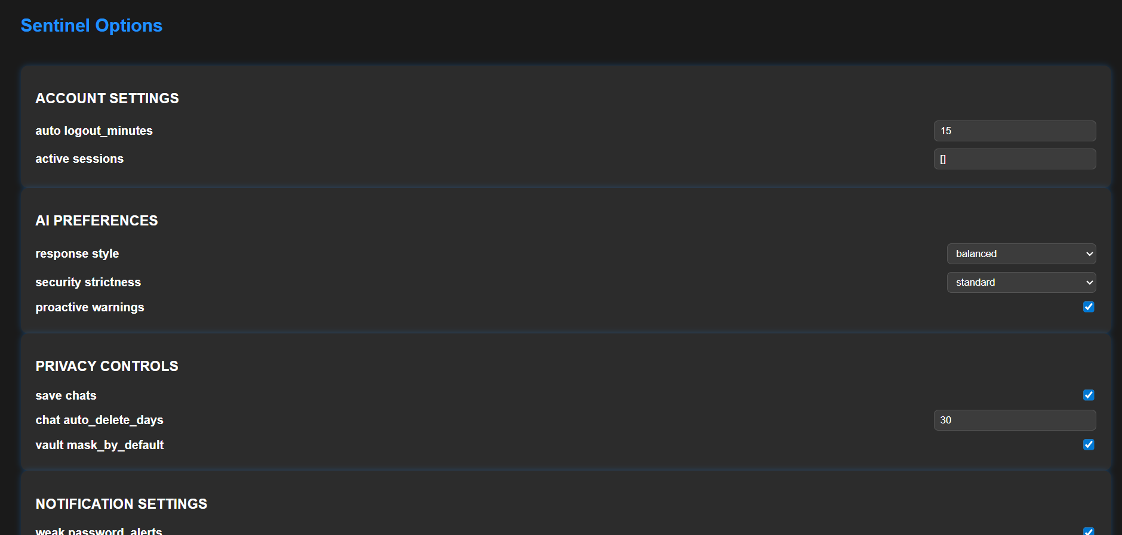
The dashboard provides an Options section accessible from the sidebar. By clicking the Options link, the user is taken to the Options page, where all configurable categories are displayed. Users can adjust account settings such as auto-logout time and manage active sessions. AI preferences can be modified, including response style, security strictness, and whether proactive warnings are enabled. Privacy controls allow users to configure chat saving, automatic chat deletion, and vault masking to protect sensitive information. Notification settings can be customized to include alerts for weak passwords, phishing attempts, data breaches, and the frequency of summary reports. Users can enable or disable specific modules to streamline the dashboard interface according to their needs. Appearance settings allow selection of theme, font size, and chat behavior such as auto-scroll and enter-to-send functionality. Advanced settings include enabling experimental features, showing AI reasoning, selecting log export format, and controlling verbose output for scans. All changes are saved immediately, and users have the option to reset all settings to default values. This flexibility ensures that the dashboard experience is tailored to each user while maintaining security, usability, and consistency across sessions.

Overall, the visualization of the Sentinel Dashboard provides an intuitive, interactive, and highly functional interface. Users can ask cybersecurity questions, receive detailed AI analysis, save conversations, access history and stored passwords, and quickly navigate modules. The combination of chat streaming, sidebar navigation, and interactive buttons creates a seamless user experience optimized for both accessibility and security.

3.2- Password Tester:

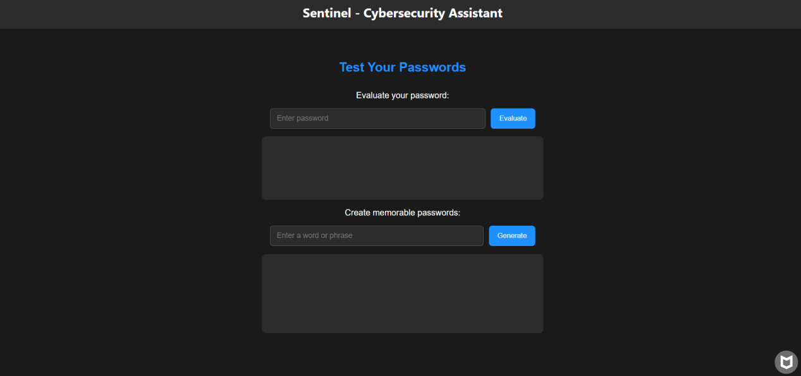

Introduction
The Password Tester module is a core component of the Sentinel cybersecurity system, designed to help users evaluate, generate, and securely manage passwords. It provides users with both automated strength evaluation and AI-driven analysis, offering practical guidance on improving password security. The module also integrates with a secure vault for storing passwords, enabling users to maintain strong, unique, and easily retrievable credentials. The interface is designed to be interactive and user-friendly, allowing users to understand their password security, receive feedback, generate strong passwords from memorable phrases, and manage stored passwords efficiently.
Capabilities
The Password Tester module allows users to evaluate the strength of any password, providing both a numerical and descriptive rating ranging from very weak to very strong. It calculates the estimated time required to crack the password under common attack scenarios, helping users understand the practical security of their credentials. The AI analysis highlights specific weaknesses in a password and gives clear, actionable suggestions for improvement. Users can generate multiple strong, memorable passwords from a word or phrase, ensuring symbols, numbers, and capitalization are included for maximum strength. The module also offers secure storage through a vault where users can save, view, delete, and clear passwords. These features combine to offer comprehensive password security management in one integrated module.
Tools and Libraries
The Password Tester module is built using FastAPI for backend API endpoints and Jinja2 for rendering the frontend interface. Password strength evaluation is performed using the zxcvbn library, which provides both a score and estimated crack time. The AI-driven analysis and password generation rely on the Groq API to interact with the LLaMA 3.1 Instant language model, providing concise and practical feedback. Data persistence is handled using JSON files with thread-safe operations to ensure integrity, and unique identifiers are assigned to vault entries using the uuid library. The system also uses standard Python libraries such as os for environment management and json for reading and writing persistent storage.
Workflow
The workflow of the Password Tester module can be described in the following steps:
Step 1: User navigates to the Password Tester page. The interface displays an input field for testing passwords, an input field for generating passwords from a memorable word or phrase, and options for managing the password vault.
Step 2: To evaluate a password, the user enters the desired password into the input field and clicks the evaluate button.
Step 3: The system first checks that the input is not empty and then calculates the password strength score using the zxcvbn library. The score is converted into a descriptive label from very weak to very strong, and the estimated time to crack the password is determined.
Step 4: Simultaneously, the password is sent to the AI language model via the Groq API. The AI analyzes the password for security weaknesses, providing a brief strength assessment, highlighting key vulnerabilities, and suggesting one specific improvement.
Step 5: The combined results of the quantitative strength assessment and AI feedback are displayed to the user in the interface.
Step 6: To generate strong passwords, the user enters a memorable word or phrase into the generator input field and clicks the generate button. The AI model produces multiple strong passwords that include the phrase, symbols, numbers, and capitalization.
Step 7: Generated passwords are displayed in the interface, and users can choose to save any password to the vault by entering a label and confirming the action.
Step 8: Users can view the vault to see all saved passwords, delete individual passwords using a unique identifier, or clear the entire vault as needed.
Step 9: All vault operations, including saving, deleting, and clearing passwords, are performed securely with thread-safe handling of the JSON storage file.

Visualization
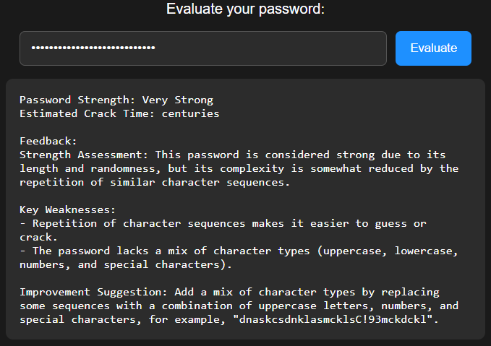
When the user opens the Password Tester page, they see a clean interface with two main input areas and options for vault management. The first area is for testing passwords. The user clicks into the password input field and types a password they want to evaluate. After typing the password, they click the evaluate button. The interface immediately displays a strength label that ranges from very weak to very strong, showing the user how secure their password is. Below this label, the estimated time it would take for the password to be cracked under typical attack scenarios is displayed. The AI-generated feedback then appears, highlighting any key weaknesses in the password and offering a concise improvement suggestion. This allows the user to understand exactly why a password may be weak and how it can be made stronger.
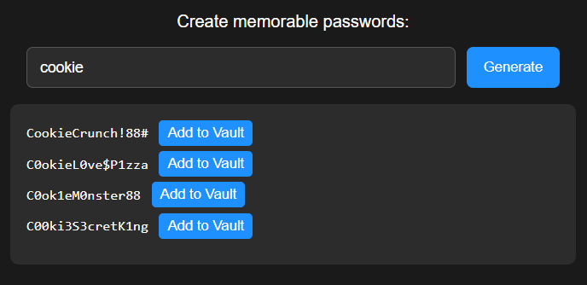
The second input area is for generating strong, memorable passwords from a user-provided word or phrase. The user clicks into the generator input field, types a memorable word or phrase, and clicks the generate button. The interface immediately shows multiple password suggestions. Each suggested password incorporates the user’s phrase while including numbers, symbols, and capitalization to maximize strength. The generated passwords are displayed line by line and can be copied for immediate use. The user has the option to add any generated password to the secure vault by entering a descriptive label and confirming the action.
The vault section is accessible on the same page and displays all passwords that the user has saved. Each entry shows the label and the corresponding password. The user can delete individual passwords by clicking the delete option next to each entry. If the user wants to remove all passwords, they can click the clear vault button, and the interface confirms that all entries have been removed. All actions performed in the vault, such as adding, deleting, or clearing passwords, provide immediate visual confirmation messages so the user knows that their changes were successfully applied.
Throughout the interface, all feedback, results, and confirmations are displayed dynamically as the user interacts with the module. This ensures that each task—evaluating a password, generating new passwords, saving them to the vault, or managing existing passwords—is clear, intuitive, and visually responsive. The user can perform all tasks without leaving the page, with each action visually reflected immediately, making the Password Tester module a comprehensive, interactive, and easy-to-use tool for improving and managing password security.

3.3- Privacy Leak Analyzer:

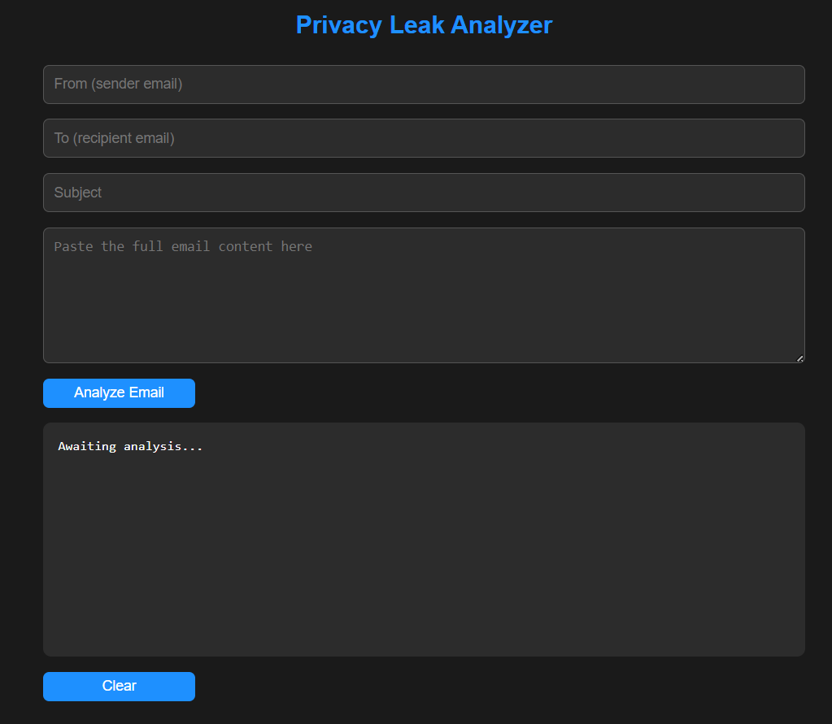

Introduction
The Privacy Leak Analyzer is a specialized module within the Sentinel cybersecurity system designed to detect privacy and security risks in emails. It enables users to analyze incoming or outgoing emails for phishing attempts, scams, impersonation, social engineering, and other subtle security threats. The module uses advanced AI analysis combined with structured risk assessment to provide detailed and actionable feedback. Its primary goal is to help users recognize potentially malicious communications that may bypass human scrutiny, ensuring better protection of sensitive information. The interface is user-friendly, allowing the user to input email data and receive comprehensive analysis with minimal effort.
Capabilities
The Privacy Leak Analyzer can analyze every component of an email, including the sender and recipient information, subject line, and body content. It identifies common phishing and scam techniques, such as impersonation, urgency cues, authority abuse, fear tactics, and promises of rewards. The AI also detects subtle social engineering methods that humans often overlook. The module provides a risk score ranging from 0 to 100, and it generates a clear verdict categorizing the email as safe, suspicious, or scam. The detailed analysis breaks down the email into logical sections, assessing headers, subject, body content, and psychological indicators. Users receive a final explanation summarizing why an email is flagged as risky, enabling them to make informed decisions. The module also allows users to clear the result and perform repeated analyses with ease, supporting continuous monitoring of email threats.
Tools and Libraries
The Privacy Leak Analyzer is implemented using Python and the FastAPI framework for backend API endpoints. Jinja2 is used to render the frontend interface, ensuring a dynamic and responsive layout for user interaction. The AI analysis relies on the Groq API connected to the LLaMA 3.1 Instant language model. This model provides precise, analytical, and human-like evaluation of emails, identifying both obvious and subtle security risks. Standard Python libraries, including os, are used for environment management. The system uses structured prompts to guide the AI in producing consistent, formatted outputs that include a verdict, risk score, and detailed analysis across multiple sections. The frontend is styled using CSS for clarity, readability, and easy differentiation of input areas, buttons, and analysis results. JavaScript is used for submitting email data asynchronously, updating the interface in real time, and allowing users to clear results when needed.

Workflow

Step 1: The user navigates to the Privacy Leak Analyzer page within the Sentinel dashboard. The page displays input fields for the sender email, recipient email, subject line, and body of the email, along with an analyze button and a result display area.
Step 2: The user enters the sender email address in the designated input field labeled “From (sender email)”.
Step 3: The user enters the recipient email address in the input field labeled “To (recipient email)”.
Step 4: The user enters the email subject line in the input field labeled “Subject”.
Step 5: The user copies and pastes the full body of the email into the multiline text area labeled “Paste the full email content here”.
Step 6: Once all fields are filled, the user clicks the analyze button. The interface updates to indicate that the system is analyzing the email for hidden threats.
Step 7: The backend validates that all required fields have been provided. If any field is missing, the interface displays an error message requesting completion of all fields.
Step 8: The email data is sent to the AI language model, which segments the email logically into headers, subject, and body content.
Step 9: The AI examines the sender and header information for legitimacy, identifying any discrepancies or spoofing attempts.
Step 10: The AI evaluates the subject line for suspicious patterns, such as urgent requests, deceptive language, or unusual formatting.
Step 11: The AI analyzes the body content for phishing, scams, social engineering techniques, or subtle manipulative language that humans may overlook.
Step 12: The AI detects psychological and social engineering indicators, including urgency, authority misuse, impersonation, fear tactics, or reward-based manipulation.
Step 13: The AI identifies subtle red flags that are often missed by humans, ensuring a comprehensive risk assessment.
Step 14: The AI generates a structured analysis including a verdict (Safe, Suspicious, or Scam), a risk score from 0 to 100, and a detailed breakdown of findings across the email components.
Step 15: The interface displays the AI-generated analysis in the result area, providing the user with immediate and actionable insights.
Step 16: The user may review the analysis to determine whether to trust, ignore, or take action on the email.
Step 17: If desired, the user can click the clear button to reset the input fields and result area, preparing the module for analyzing a new email.
Step 18: The workflow repeats from Step 2 for each subsequent email the user wishes to analyze, allowing continuous monitoring and evaluation of email security risks.

Visualization:
When the user opens the Privacy Leak Analyzer page, they see a clean interface with input fields for all the components of an email. The top of the interface displays a heading “Privacy Leak Analyzer” in a prominent color. Below this heading, the user sees four input fields arranged vertically. The first field is labeled “From (sender email)” where the user types the sender’s email address. The second field is labeled “To (recipient email)” for entering the recipient’s email address. The third field is labeled “Subject” for entering the email’s subject line. The fourth field is a multiline text area labeled “Paste the full email content here” where the user pastes the complete body of the email. Beneath these input fields, there is a blue “Analyze Email” button and, directly below it, a rectangular result display area with a dark background and monospace font that initially reads “Awaiting analysis…”. There is also a clear button beneath the result area that allows the user to reset the analysis and input fields.
To analyze an email, the user fills in all four input fields with the relevant information and clicks the “Analyze Email” button. The result area immediately updates with the message “Analyzing email for hidden threats…”, indicating that the system is processing the data. The AI then evaluates the email by examining the sender and header, the subject line, the body content, and any social engineering or psychological manipulation indicators.
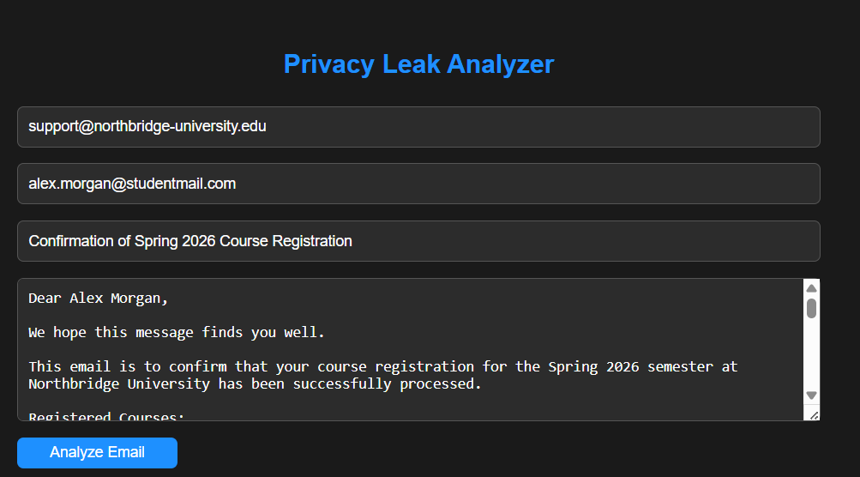

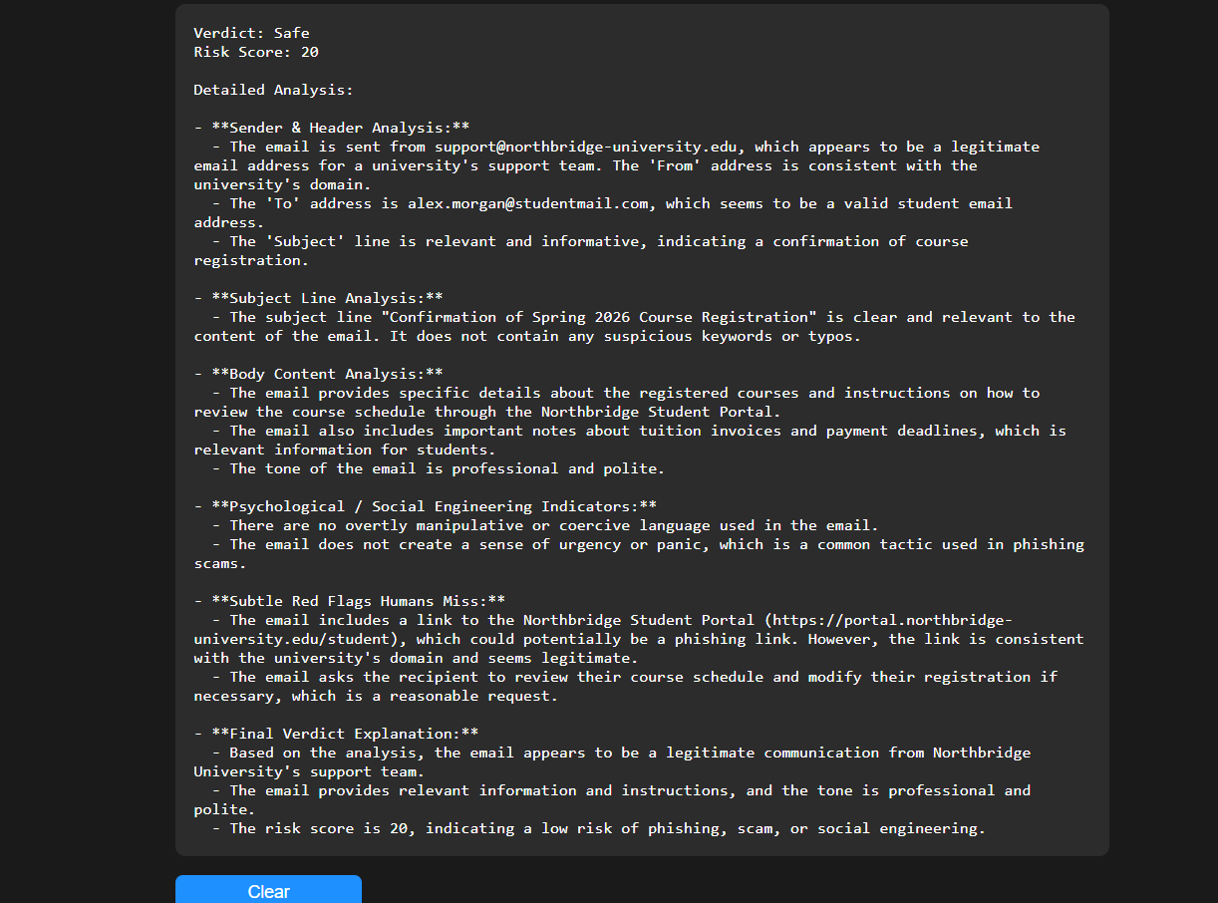
In the scenario where the email is safe, the result area updates to show a structured analysis. The verdict reads “Safe” and the risk score is low, typically close to zero. The detailed analysis sections provide confirmation that the sender is legitimate, the subject line contains no suspicious language, the body does not contain phishing, scams, or manipulative content, and no red flags are detected. Each section is clearly labeled, for example, “Sender & Header Analysis: Legitimate sender domain and no anomalies detected,” “Subject Line Analysis: Subject line appears standard and professional,” and “Body Content Analysis: No phishing or scam techniques found.” The psychological and subtle red flag sections indicate no manipulative tactics. The final verdict explanation reassures the user that the email is considered safe for engagement.
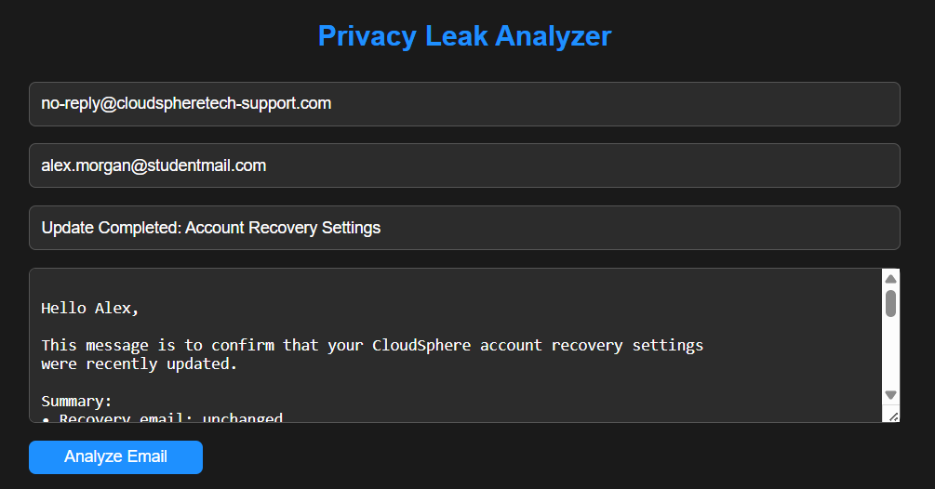

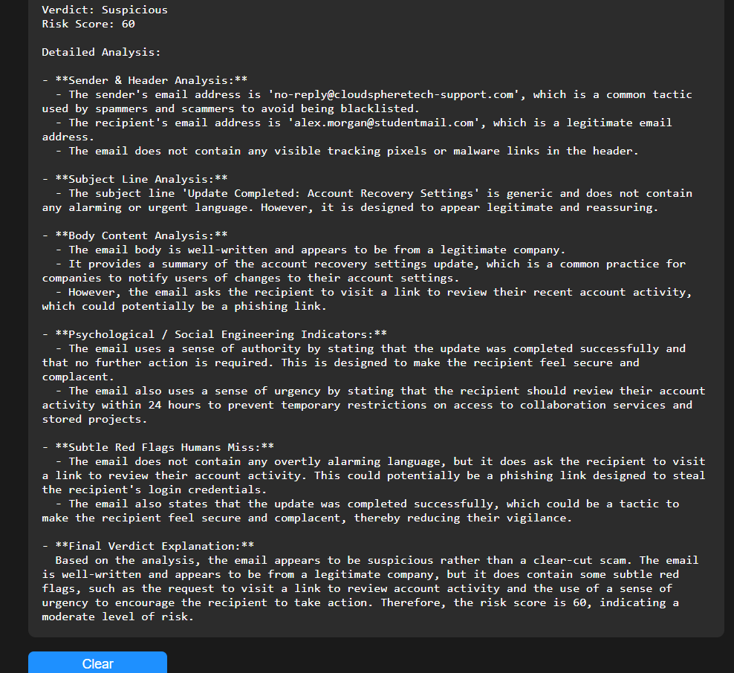
In the scenario where the email is a scam, the result area displays a structured analysis with a verdict of “Scam” and a high risk score, approaching 100. The detailed sections highlight the reasons for the assessment. The sender and header analysis may show a spoofed or suspicious domain, the subject line may include urgent requests or manipulative wording, and the body content may contain social engineering tactics such as authority abuse, fear, or reward promises. The AI explicitly identifies subtle red flags that humans might overlook, such as pressure to act quickly or impersonation of a trusted contact. The final verdict explanation summarizes all detected risks, clearly stating why the email is considered dangerous and recommending caution.
After the analysis is displayed, the user can read through the structured feedback to understand exactly which parts of the email are risky and which are safe. If the user wants to analyze another email, they can click the “Clear” button, which resets all input fields and the result area back to “Awaiting analysis…”, readying the module for a new evaluation. The interface provides immediate visual confirmation for every action, making it intuitive to distinguish between safe and malicious emails. This ensures the user can efficiently review multiple emails, understand risks, and take appropriate cybersecurity actions based on AI-driven insights

3.4- Web Scanner
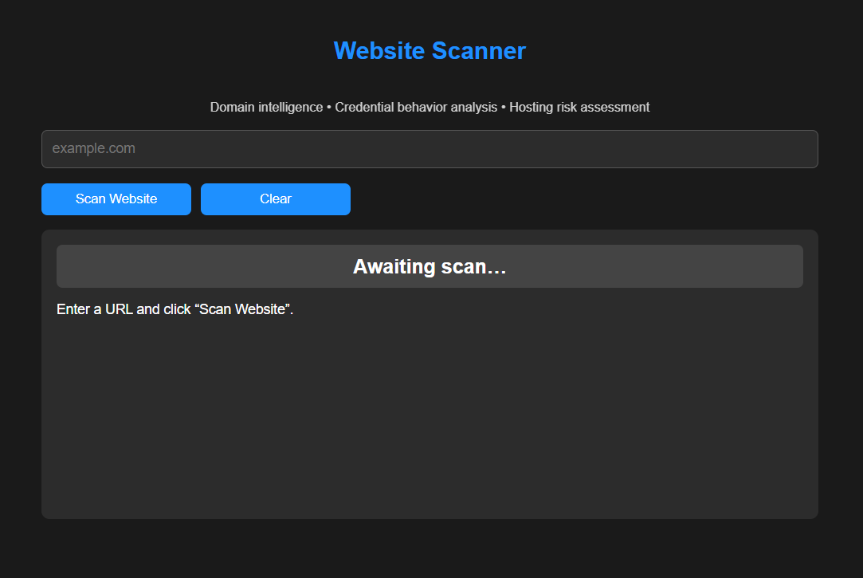

Introduction
The Web Scanner module is a SOC-grade web threat detection tool integrated within Sentinel. Its primary function is to analyze websites and URLs to determine potential security risks, phishing attempts, malware distribution, piracy-related threats, and suspicious web behavior. The module combines both heuristic rules and intelligence-driven datasets, such as lists of trusted domains, brand keywords, piracy keywords, suspicious top-level domains, and urgent language phrases commonly used in phishing attempts. Additionally, the module optionally integrates an AI explanation layer that can provide detailed assessments of detected risks. The Web Scanner helps users identify unsafe websites before interacting with them, providing actionable insights to avoid cybersecurity incidents.
Capabilities
The Web Scanner module offers comprehensive web threat analysis through multiple mechanisms. First, it normalizes URLs and extracts the base domain to identify known trusted or risky domains. It can detect brand impersonation attempts, where a domain may mimic a well-known brand to trick users. It recognizes low-trust domains, suspicious hosting, credential input fields without legal context, obfuscated JavaScript, urgency language, excessive scripts that may indicate malvertising, and piracy-related platforms. The module calculates a risk score from 0 to 100, assigns a threat class, and provides a verdict ranging from “LIKELY_SAFE” to “DANGEROUS.” Optionally, the integrated AI can generate human-readable explanations of the findings, summarizing risks and reasoning behind the verdict.
Tools and Libraries
The Web Scanner module relies on several key tools and libraries to function effectively. FastAPI is used for creating the API endpoints and routing. Jinja2 is used to serve the frontend templates. The httpx library performs asynchronous HTTP requests to fetch web page content safely and efficiently. Python’s built-in socket library resolves domain names to IP addresses to detect suspicious or evasive hosting behavior. Regular expressions (re) are used to detect specific patterns in HTML content, such as password fields, obfuscated JavaScript, and urgent phishing phrases. The urllib.parse library is used to parse URLs and extract domain information. Optionally, the Groq library is used for AI-based explanation of findings when the environment variable for the API key is present.
Workflow
Step 1: The user navigates to the Web Scanner module page and is presented with a simple input field for entering a website URL.
Step 2: The user types or pastes the full URL they wish to scan into the input field.
Step 3: Upon clicking the “Scan” button, the module normalizes the URL by ensuring it begins with “https://” if no scheme is provided.
Step 4: The module extracts the base domain from the URL and checks if it is part of the trusted domains list. If the domain is trusted, the system returns a low-risk verdict immediately.
Step 5: If the domain is not trusted, the module evaluates several risk factors. It checks for low-trust patterns, suspicious top-level domains, numeric-heavy domains, and signs of brand impersonation.
Step 6: The module searches for keywords associated with piracy or illegal streaming platforms, which may indicate high malware or exploit risks.
Step 7: Hosting intelligence is performed by attempting to resolve the domain’s IP address and detecting suspicious or private network IPs, which could suggest evasive hosting.
Step 8: Content analysis is performed by fetching the page HTML using an asynchronous HTTP request. The module scans for credential input fields, obfuscated JavaScript, urgent phishing language, missing trust indicators like privacy policy pages, and excessive third-party scripts. Each detected risk contributes to the overall risk score.
Step 9: Absence-based risk is applied. For example, if credential input fields are detected without corresponding trust pages, the risk score is increased.
Step 10: The total risk score is capped at 100, and a verdict is generated based on predefined thresholds: “LIKELY_SAFE,” “POTENTIALLY_RISKY,” “SUSPICIOUS,” or “DANGEROUS.”
Step 11: If AI integration is enabled and the risk score is significant, the Groq client generates an explanatory summary of the findings, providing human-readable reasoning behind the verdict.
Step 12: The results are returned to the user via the API, including the original URL, final resolved URL, risk score, verdict, threat class, detailed findings, confidence level, and optional AI explanation.
Visualization
When the user opens the Web Scanner page, they see a single input field labeled for entering a website URL and a blue “Scan” button positioned below it. Beneath the button, a rectangular result display area with a dark background and monospace font initially reads “Awaiting scan…”.
The user interacts with the module by typing a full URL into the input field and clicking the “Scan” button. The result area immediately updates with the message “Scanning website for threats…” indicating that the system is processing the URL.
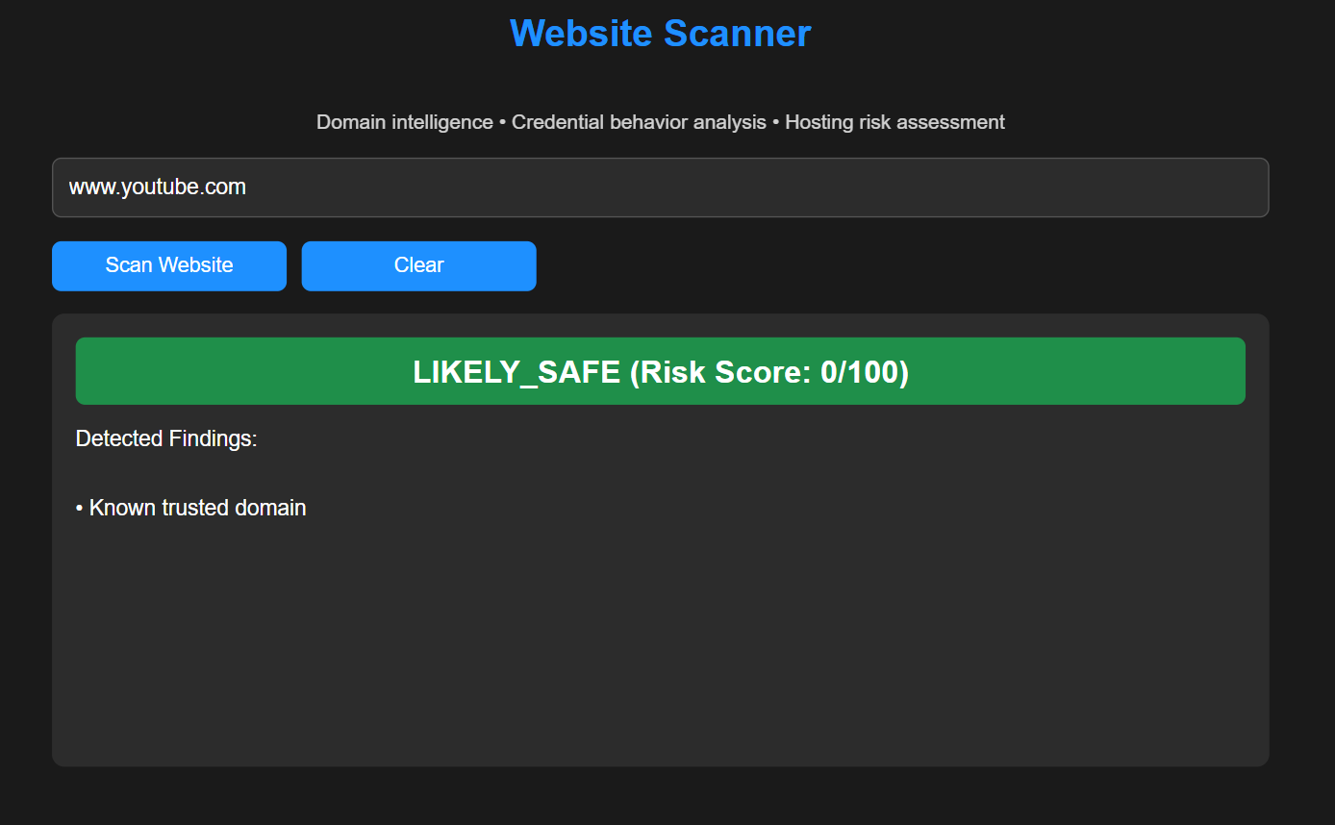
In the scenario where the website is safe, the result area displays a structured report with a verdict of “LIKELY_SAFE” and a low risk score, typically below 30. The findings section lists positive indicators, such as “Known trusted domain” or “No phishing indicators detected.” If AI explanation is enabled, it provides a clear textual summary explaining why the website is considered safe, reassuring the user that the URL is low risk for phishing, malware, or brand impersonation.
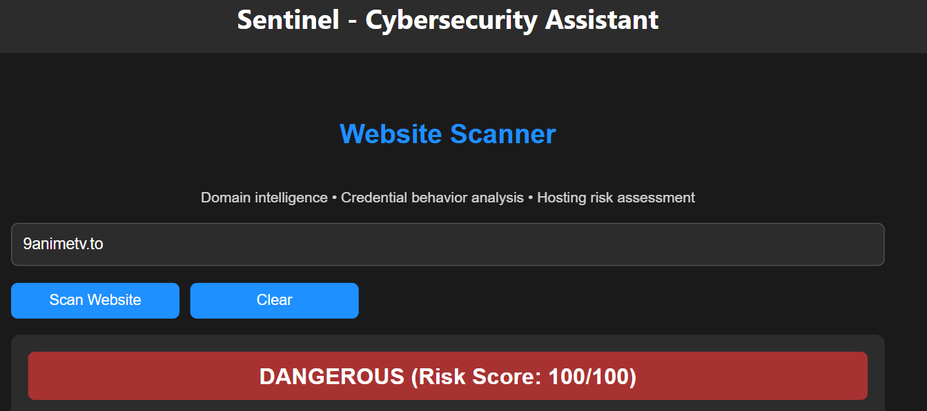

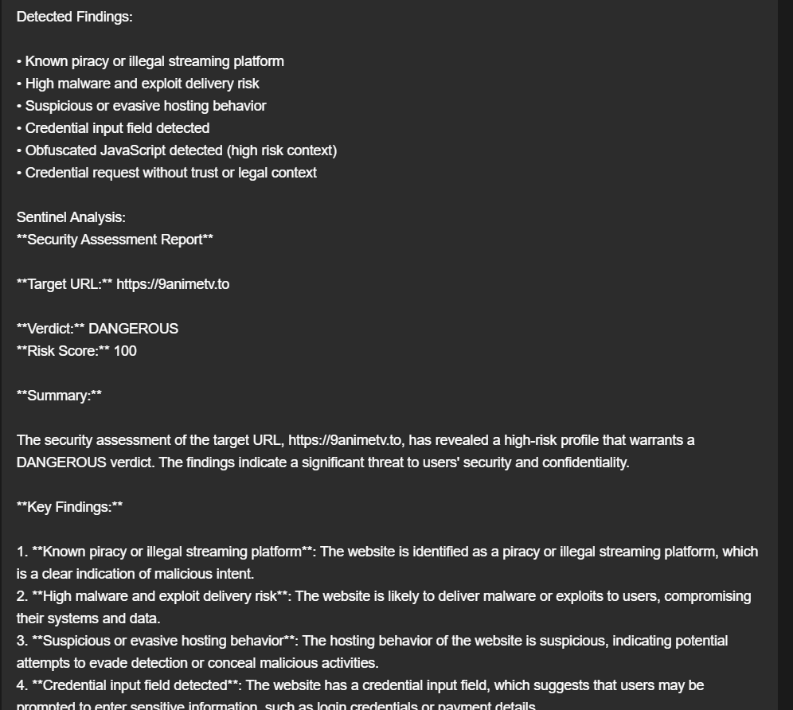

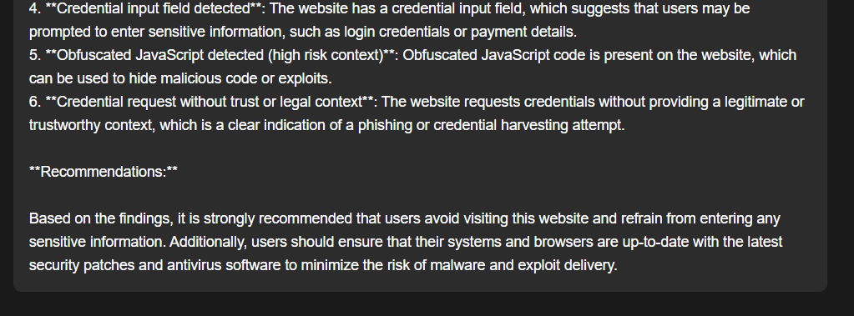

In the scenario where the website is risky or malicious, the result area updates to show a structured report with a verdict of “DANGEROUS,” “SUSPICIOUS,” or “POTENTIALLY_RISKY,” and a higher risk score closer to 100. The findings section lists specific indicators, such as “Possible brand impersonation,” “Credential input field detected,” “Urgent or coercive language detected,” “Obfuscated JavaScript detected,” or “Known piracy or illegal streaming platform.” The AI explanation, if available, provides detailed reasoning, summarizing each detected risk and clarifying why the website should be avoided.
After the analysis is complete, the user can review each listed finding to understand which aspects of the website contributed to the risk score and verdict. The interface is responsive and immediately updates for each scan, allowing the user to quickly evaluate multiple websites, distinguish safe URLs from dangerous ones, and make informed cybersecurity decisions.

3.5- File Threat Analyzer:
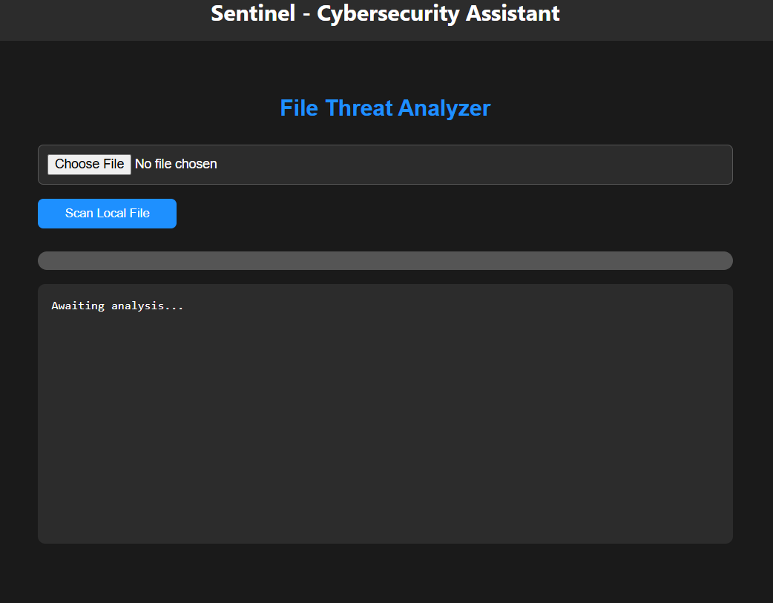
Introduction
The File Threat Analyzer is a SOC-grade security module within Sentinel designed to analyze files for hidden threats before they are opened or executed. It supports both remote file scanning via URL and local file uploads, allowing users to safely inspect any file type, including documents, scripts, executables, archives, images, and binaries. The module combines static file inspection, metadata extraction, cryptographic hashing, and advanced AI-driven analysis to detect malware, phishing payloads, obfuscation, embedded threats, and social engineering techniques. Its purpose is to provide users with early threat detection and clear guidance on whether a file is safe, suspicious, or dangerous, without ever executing the file.
Capabilities
The File Threat Analyzer can scan files provided through direct upload or by downloading them securely from a URL. It extracts detailed file metadata such as size, creation date, modification date, and MIME type. The module calculates cryptographic hashes including SHA256 and MD5, allowing files to be uniquely identified and cross-referenced with known threats. It safely reads a portion of the file content without executing it, automatically handling both text-based and binary files. The analyzer detects malware indicators, embedded scripts, macros, obfuscated content, hidden URLs, suspicious IP addresses, and social engineering patterns. Using AI, it evaluates the overall risk level of the file and provides structured recommendations for safe handling. The module prevents unsafe downloads, blocks oversized files, and cleans up temporary data automatically, ensuring system security throughout the scanning process.
Tools and Libraries
The File Threat Analyzer is implemented using FastAPI to handle file uploads, form data, and API responses. Jinja2 is used to render the frontend interface. The requests library enables safe file downloading from URLs with size and scheme validation to prevent server-side request forgery. Temporary file handling is managed using Python’s tempfile module. Cryptographic hashing is performed using hashlib to generate SHA256 and MD5 fingerprints. File metadata and MIME types are extracted using os, datetime, and mimetypes. Binary-safe file sampling is handled through base64 encoding when necessary. Logging is implemented using Python’s logging module to track scanning activity and errors. The Groq API with the LLaMA 3.1 Instant model provides AI-based static file analysis, enabling intelligent detection of threats without executing file contents.
Workflow
Step 1: The user navigates to the File Threat Analyzer page from the Sentinel dashboard.
Step 2: The user chooses one of two input methods, either entering a file URL or uploading a local file from their device.
Step 3: If a URL is provided, the system validates the URL scheme to ensure it uses HTTP or HTTPS and blocks unsafe or unsupported schemes.
Step 4: The system downloads the file securely using a restricted user agent, enforcing a maximum file size limit to prevent abuse or denial-of-service attacks.
Step 5: If a local file is uploaded, the system saves the file temporarily in a secure location without executing it.
Step 6: The module extracts file metadata, including size, MIME type, creation time, and modification time.
Step 7: Cryptographic hashes are calculated for the file, generating unique SHA256 and MD5 identifiers.
Step 8: A safe content sample is extracted from the file. Text files are decoded carefully, while binary files are base64-encoded to prevent corruption or execution.
Step 9: The extracted metadata, hashes, and content sample are sent to the AI model with strict instructions to perform static analysis only.
Step 10: The AI analyzes the file for malware indicators, obfuscation techniques, embedded URLs or IPs, scripts, macros, and social engineering content.
Step 11: The AI assigns an overall risk level of Safe, Suspicious, or Dangerous and generates precautionary recommendations.
Step 12: The system returns the structured AI analysis to the user interface for review.
Step 13: After the scan completes, the temporary file is securely deleted from the system to prevent residual data exposure.
Step 14: The user may repeat the workflow to scan additional files using either input method.
Visualization
When the user opens the File Threat Analyzer page, they see a clear interface that allows two ways to submit a file for scanning. At the top of the page, there is a field for entering a file URL, allowing the user to scan files hosted online. Below it, there is an option to upload a local file directly from the device. A scan button is positioned clearly to initiate the analysis. Beneath the controls, there is a result display area that initially indicates that the system is awaiting a file for analysis.
When the user submits a file or URL and clicks the scan button, the interface updates to show that the file is being analyzed. The system processes the file silently in the background while ensuring it is never executed. Once analysis is complete, the result area displays a structured AI-generated report.
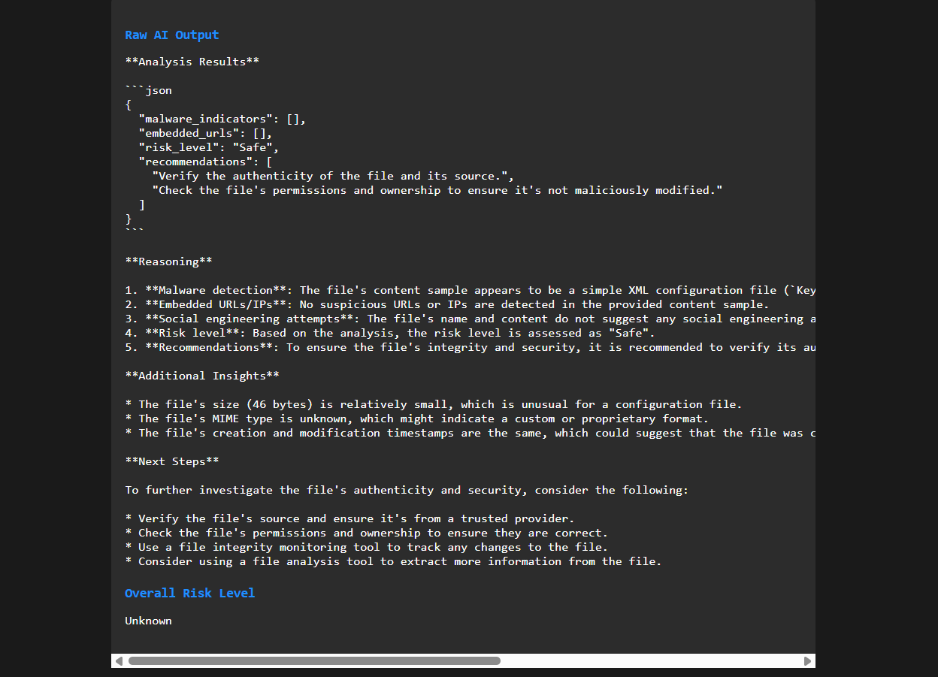
In the scenario where the file is safe, the analysis indicates a low risk level and reports no malware indicators or suspicious behavior. The metadata and hashes confirm file integrity, and the recommendations reassure the user that the file does not present immediate threats. The user can confidently decide to keep or use the file based on this assessment.
In the scenario where the file is suspicious, the analysis highlights potential issues such as obfuscated content, embedded URLs, or unusual file structure. The risk level is marked as suspicious, and the recommendations advise caution, such as avoiding execution or verifying the file source before use.
In the scenario where the file is dangerous, the result clearly states a high-risk level. The analysis identifies malware indicators, hidden scripts, or social engineering payloads. The recommendations strongly advise against opening or executing the file and may suggest deletion or isolation.
After reviewing the results, the user can submit another file or URL for scanning. The interface remains responsive and resets naturally between scans, allowing continuous file analysis. The visualization ensures that each step of the process is transparent, easy to follow, and focused on keeping the user safe from file-based threats.

3.6- Endpoint Scanner:

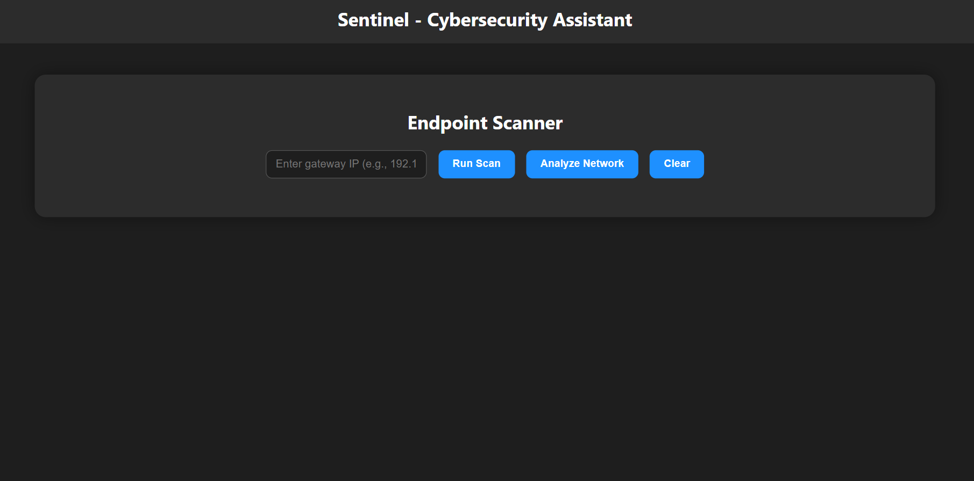
.
Introduction
The Sentinel Endpoint Scanner is a passive local-network analysis module designed to provide accurate visibility into all devices connected to a Windows-based Wi-Fi network. Its primary goal is to help users understand what devices are present, what type of devices they are, and whether their presence is expected or potentially risky.
Unlike aggressive network scanners or intrusion tools, the Endpoint Scanner does not inject packets, probe ports, exploit protocols, or interfere with network traffic. It relies entirely on operating-system-native networking data, ensuring safety, legality, and reliability. The scanner is optimized for home and small-office environments, where unauthorized or unidentified devices often represent the greatest risk.
A key design principle of this module is deterministic identification before analysis. Device types and vendors are identified using MAC address prefixes and system-level resolution techniques before any artificial intelligence is applied. This prevents hallucinations, guessing, or incorrect classification by AI models.
Capabilities
The Endpoint Scanner is capable of detecting all active devices that have recently communicated on the local network by inspecting the system ARP cache. It extracts IP addresses and MAC addresses for each device and attempts to resolve human-readable hostnames using Windows NetBIOS queries with DNS fallback.
The scanner performs deterministic device classification using a predefined Organizationally Unique Identifier mapping. This allows it to accurately identify routers, laptops, desktops, mobile phones, and IoT devices without probabilistic inference.
Each detected device is evaluated using a transparent, rule-based risk scoring system that measures uncertainty and abnormal characteristics rather than assuming malicious intent. Artificial intelligence is then used to contextualize the findings, assessing whether each device is expected in a typical network environment and providing clear security recommendations.
At the network level, Sentinel aggregates all device risk scores to compute an overall network risk classification, giving users a high-level understanding of their exposure.
Tools and Libraries
The Endpoint Scanner backend is built using FastAPI, which provides asynchronous request handling, routing, and JSON-based API responses. Jinja2 is used for server-side HTML rendering of the user interface.
System interaction is performed using Python’s subprocess module to execute native Windows networking commands such as arp and nbtstat. These commands are read-only and do not alter system or network state.
The ipaddress library is used to validate IP addresses and filter out non-host, reserved, multicast, loopback, or otherwise invalid addresses. Socket-based DNS resolution is used as a fallback mechanism for hostname discovery.
Persistent storage is implemented using JSON files protected by thread locks to prevent race conditions. Artificial intelligence analysis is provided by the Groq API using the LLaMA 3.1 8B Instant model, configured with conservative temperature settings to ensure factual, non-speculative output.
Workflow
Step 1: User initiates the endpoint scan
The workflow begins when the user accesses the Endpoint Scanner interface and triggers a network scan request. This request is sent to the backend API, indicating which user context the scan should be associated with.
Step 2: ARP cache retrieval
Sentinel executes the system-native arp command to retrieve the current ARP table. This table contains mappings between IP addresses and MAC addresses for devices that have recently communicated on the local network.
Step 3: Raw entry filtering
Each line of the ARP output is examined. Entries that are not marked as dynamic are discarded, as they do not represent active network endpoints.
Step 4: IP address validation
The extracted IP address from each valid ARP entry is checked using the ipaddress library. Addresses that are multicast, loopback, reserved, unspecified, or otherwise invalid for host identification are excluded from further analysis.
Step 5: MAC address normalization
MAC addresses are normalized into a consistent colon-separated format. This ensures accurate matching against the vendor mapping database.
Step 6: Hostname resolution via NetBIOS
For each valid device, Sentinel attempts to resolve the hostname using the Windows NetBIOS protocol. If a unique hostname entry is found, it is extracted and recorded.
Step 7: DNS fallback hostname resolution
If NetBIOS resolution fails, Sentinel attempts a reverse DNS lookup. If both methods fail, the hostname is explicitly marked as unknown rather than guessed.
Step 8: Vendor and device type identification
The first three bytes of the MAC address are extracted and matched against the predefined OUI mapping table. This step assigns a fixed vendor name and an exact device type such as router, laptop, mobile phone, desktop, or IoT device. If no match is found, the device is labeled as unknown.
Step 9: Device profile construction
Sentinel constructs a complete device profile containing the IP address, MAC address, hostname, vendor, device type, and network role. This profile represents the authoritative factual description of the endpoint.
Step 10: Deterministic risk scoring
Each device profile is evaluated using a rule-based scoring system. Unknown device types, unknown vendors, and unresolved hostnames increase the risk score. This score reflects identification uncertainty rather than confirmed malicious behavior.
Step 11: AI contextual analysis
The finalized device profile and its deterministic risk score are passed to the AI analysis stage. The AI evaluates whether the identified device type is expected on a typical Wi-Fi network, highlights realistic security concerns, assigns a final qualitative risk level, and provides practical mitigation advice. The AI is explicitly instructed not to guess or alter device classifications.
Step 12: Per-device result aggregation
The deterministic data and AI-generated analysis are combined into a final per-device assessment, ensuring both technical accuracy and human-readable explanation.
Step 13: Network-level risk calculation
All device risk scores are summed to compute a total network risk score. Based on predefined thresholds, the network is classified as low, medium, or high risk.
Step 14: Persistent storage
The scan results are stored in a JSON file associated with the user context. This allows future analysis requests without requiring a new scan.
Step 15: Result delivery
The final analysis is returned to the frontend interface for visualization and user review.
Visualization
The visualization layer presents the scan results in a structured and transparent format. Each detected device is displayed with its IP address, MAC address, hostname, vendor, exact device type, deterministic risk score, and AI-generated analysis.
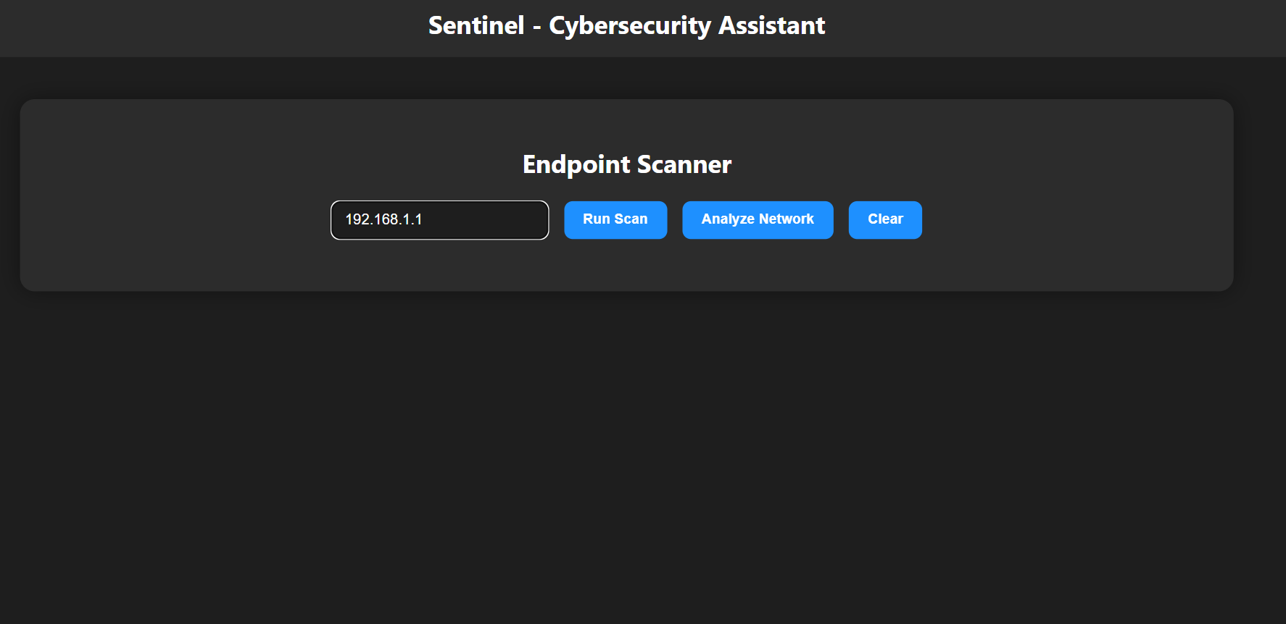

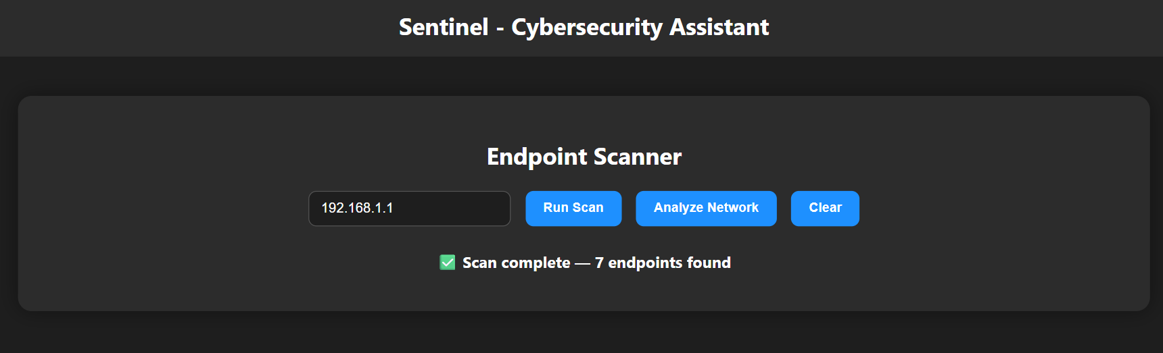

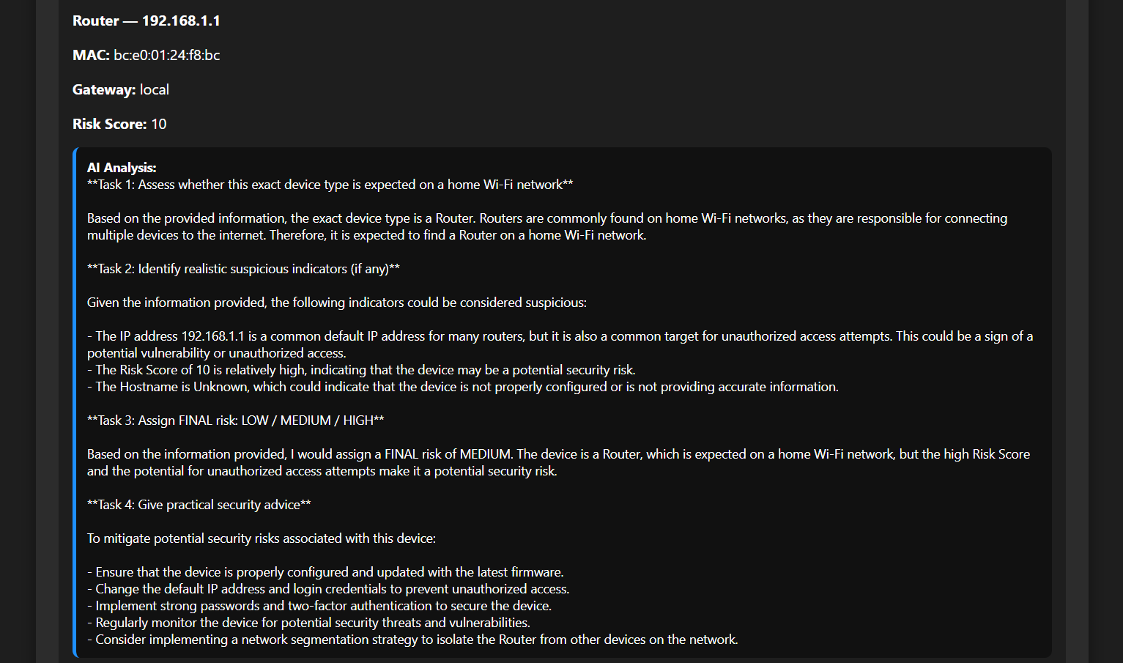

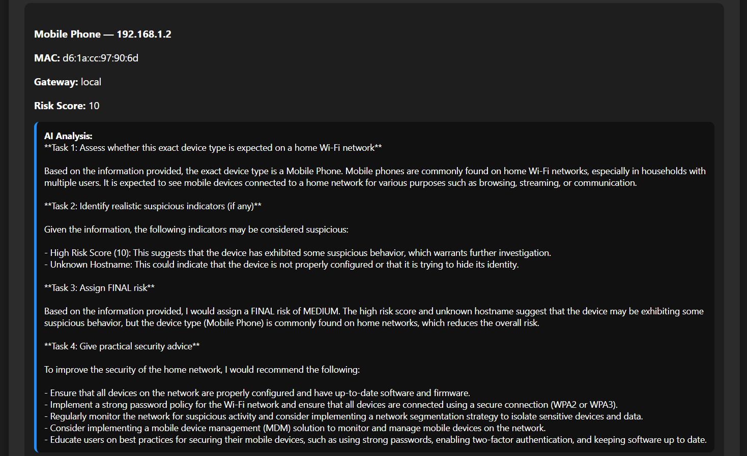

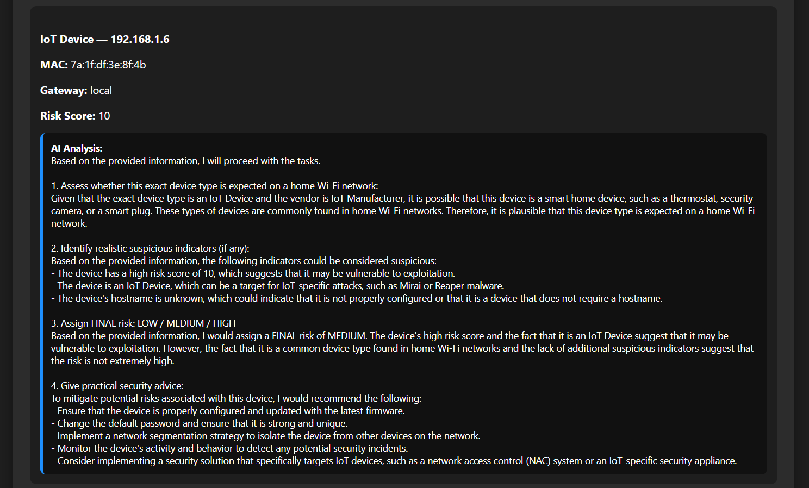

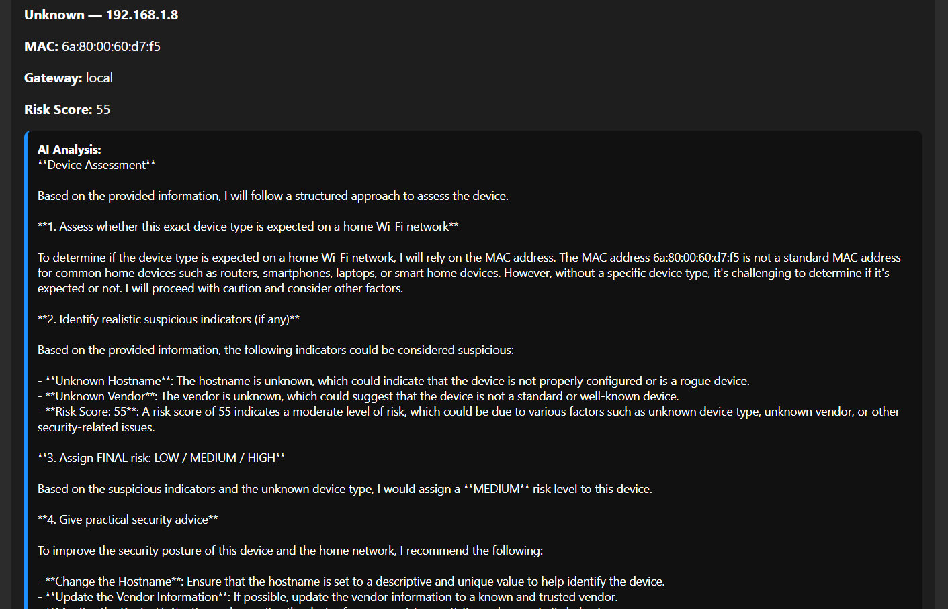

For devices classified as low risk, the visualization explains why their presence is normal and expected, reinforcing user confidence rather than fear. For devices with elevated risk, the visualization clearly explains which attributes caused concern, such as unidentified vendors or unexpected device roles.
At the network level, the visualization displays the overall security classification along with an explanation of how it was derived from individual device risks. The design emphasizes clarity, traceability, and user understanding, ensuring that conclusions are explainable and actionable rather than opaque or alarming.

The implemented modules of the Sentinel system collectively form a functional, coherent, and security-focused platform designed to educate users, analyze risks, and actively assist in protecting digital assets. Each module was developed with a dual objective: to provide practical cybersecurity protection while simultaneously improving the user’s understanding of security threats and defensive best practice

Chapter 4:

4.1- Future Work:

4.1.1- Two Factor Auth:

Introduction
The Two-Factor Authentication module is a planned future enhancement for the Sentinel platform aimed at improving user account security through education, guided adoption, and secure credential management. This module is designed not only to enable two-factor authentication, but also to teach users why it matters, how it works, and how to manage it safely.
Many security breaches occur because users rely solely on passwords, which can be reused, guessed, phished, or leaked. Two-factor authentication adds an additional verification layer that significantly reduces the impact of compromised credentials. Sentinel’s approach treats two-factor authentication as both a security feature and an educational experience, ensuring users understand what they are enabling rather than blindly activating it.
This module integrates directly with Sentinel’s Vault system, allowing users to securely store generated authentication codes or backup keys in an encrypted environment rather than unsafe locations such as screenshots or text files.
Capabilities
The Two-Factor Authentication module provides educational guidance explaining what two-factor authentication is, how it protects accounts, and why it is critical for modern digital security. It offers direct links to official account security pages where users can enable two-factor authentication on supported services, ensuring that activation occurs on legitimate platforms rather than through imitation interfaces.
Once two-factor authentication is enabled, the module supports the secure storage of generated backup codes or recovery keys inside the Sentinel Vault. This prevents loss of access while maintaining confidentiality. The module also allows users to review which accounts have two-factor authentication enabled and which ones still rely solely on passwords.
Future expansions of this module may include compatibility with authenticator applications, automated reminders for unprotected accounts, and risk-based recommendations based on user behavior and breach intelligence.
Tools and Libraries
The Two-Factor Authentication module is planned to be implemented using FastAPI for backend routing and request handling, consistent with the rest of the Sentinel platform. Jinja2 will be used to render educational and configuration interfaces in the frontend.
Secure code generation and validation will rely on cryptographic libraries such as Python’s secrets and hashlib modules to ensure randomness and resistance to prediction. Vault integration will use Sentinel’s existing encrypted storage mechanisms to safely store backup codes and recovery keys.
External links to third-party services will be strictly validated and limited to official domains to prevent phishing or redirection attacks. No authentication secrets will be transmitted to external services through Sentinel itself.
Workflow
Step 1: User accesses the Two-Factor Authentication module
The workflow begins when the user opens the Two-Factor Authentication module from the Sentinel dashboard. The system loads an educational overview explaining two-factor authentication in simple, practical terms.
Step 2: Educational explanation phase
The module explains how two-factor authentication works, including the concept of something you know, something you have, and why combining factors reduces account takeover risk. Real-world attack scenarios are described to demonstrate the difference between password-only security and multi-factor protection.
Step 3: Account selection or guidance
The user is guided to select an account or service they wish to secure. Sentinel does not directly modify external accounts. Instead, it provides verified official links to the account’s security settings page.
Step 4: External activation
The user follows the provided link and enables two-factor authentication directly on the service provider’s platform. Sentinel remains passive during this step to avoid handling sensitive authentication secrets.
Step 5: Backup code generation
After activation, the service typically generates backup or recovery codes. The user is instructed to copy these codes securely instead of storing them in unsafe locations.
Step 6: Vault integration
The user pastes the backup codes into Sentinel’s Vault. The system encrypts and stores the codes under the associated account name, ensuring they are protected by Sentinel’s security mechanisms.
Step 7: Verification and confirmation
Sentinel confirms that backup codes have been securely stored and marks the account as two-factor protected within the platform’s internal records.
Step 8: Ongoing management
The user can revisit the module to view which accounts are protected, update stored backup codes, or receive reminders for accounts that still lack two-factor authentication.
Visualization
The visualization of the Two-Factor Authentication module is designed to be instructional and confidence-building rather than technical or intimidating. Upon opening the module, the user sees a clear explanation panel describing what two-factor authentication is and why it matters.
As the user progresses, the interface visually separates each stage, showing the transition from learning, to activation, to secure storage. When an account is successfully protected, the visualization reflects this with a clear status indicator showing that two-factor authentication is enabled and recovery information is safely stored.
For accounts without two-factor authentication, the visualization highlights them as unprotected and provides direct guidance on how to improve security. The Vault visualization confirms that backup codes are stored securely without revealing the codes themselves, reinforcing trust in the system.
The overall visualization emphasizes clarity, security awareness, and user empowerment, ensuring that users understand not only how to enable two-factor authentication, but also how to manage it responsibly over time.

4.1.2- Firewall Manager:

Introduction
The Firewall Manager module is a planned future component of the Sentinel platform designed to give users visibility, understanding, and control over their network firewall configuration in a safe and guided manner. Firewalls are one of the most critical defensive layers in cybersecurity, yet many users either leave them misconfigured or rely entirely on default settings without understanding their impact.
The goal of the Firewall Manager module is not to replace professional firewall systems, but to bridge the gap between advanced security concepts and everyday users. Sentinel approaches firewall management as both an educational and supervisory tool, allowing users to understand what their firewall is doing, identify weak configurations, and apply safer rules without requiring deep networking expertise.
This module is intended to work alongside operating system firewalls and network firewalls rather than bypassing them. Sentinel acts as a centralized intelligence layer that explains firewall behavior, highlights risks, and assists with rule management in a controlled and transparent way.
Capabilities
The Firewall Manager module is designed to analyze existing firewall configurations and present them in a human-readable format. It allows users to view inbound and outbound rules, understand which applications and services are allowed or blocked, and identify overly permissive or risky configurations.
The module provides guided firewall rule creation, helping users define safe rules for common use cases such as web browsing, gaming, remote access, and local services. It also detects unused, duplicate, or conflicting rules that may weaken security over time.
Another key capability is risk-based analysis. Sentinel evaluates firewall rules in the context of known attack patterns, exposed services, and network behavior. Rules that expose unnecessary ports, allow unrestricted traffic, or bypass security controls are flagged and explained in detail.
Future enhancements may include firewall profile switching based on network environment, automatic recommendations for home versus public networks, and integration with intrusion detection systems for adaptive rule enforcement.
Tools and Libraries
The Firewall Manager module is planned to be implemented using FastAPI for backend orchestration and Jinja2 for frontend visualization, consistent with the Sentinel architecture. System-level firewall interaction will rely on platform-specific tools such as Windows Defender Firewall command-line utilities or equivalent system APIs.
Python’s subprocess module will be used carefully to query and modify firewall rules without exposing unsafe execution paths. All rule changes will be validated before application to prevent accidental lockouts or misconfigurations.
AI-assisted explanations will be powered by Sentinel’s existing large language model integration, used strictly for interpretation and recommendation rather than automated enforcement. Persistent configuration states and user preferences will be stored using Sentinel’s secure configuration storage mechanisms.
Workflow
Step 1: User accesses the Firewall Manager module
The workflow begins when the user opens the Firewall Manager from the Sentinel dashboard. The system first checks firewall accessibility and permissions without making any changes.
Step 2: Firewall state discovery
Sentinel retrieves the current firewall status, including whether the firewall is enabled, which profiles are active, and how inbound and outbound traffic is handled.
Step 3: Rule enumeration and classification
Existing firewall rules are collected and categorized based on direction, protocol, port range, application association, and scope. Each rule is translated into a clear, readable description.
Step 4: Risk analysis
Sentinel evaluates each rule against known security best practices. Rules that allow unrestricted access, expose sensitive services, or bypass filtering are flagged and assigned a risk level.
Step 5: User education and explanation
For each flagged rule, Sentinel explains why it may be risky, what threats it could enable, and under what circumstances it might still be acceptable.
Step 6: Guided rule modification
If the user chooses to act, Sentinel provides step-by-step guidance for modifying or disabling rules. Changes are previewed before application to avoid unintended consequences.
Step 7: Rule application and verification
Approved changes are applied to the firewall. Sentinel verifies that the firewall remains active and that essential connectivity is preserved.
Step 8: Continuous monitoring
The module periodically re-evaluates firewall rules to detect changes made outside Sentinel and alerts the user when new risks appear.
Visualization
The visualization of the Firewall Manager module focuses on clarity and control rather than raw technical data. Upon entry, the user sees a high-level firewall status overview showing whether the firewall is enabled and how protected the system is.
Firewall rules are displayed in structured sections that clearly indicate what traffic is allowed or blocked. Each rule is shown with a descriptive explanation rather than cryptic technical syntax, allowing users to understand its purpose at a glance.
Risky rules are visually separated and accompanied by detailed explanations outlining potential attack scenarios. Safe rules are shown as confirmed and trusted, reinforcing good security practices.
When the user edits or creates a rule, the interface visually simulates the effect of the change, showing what traffic would be affected before the rule is applied. Confirmation screens ensure that the user understands the impact of their actions.
Overall, the visualization emphasizes transparency, confidence, and safety, ensuring users feel informed and in control while managing one of the most critical security components of their system.

4.1.3- Data Breack Checker

Introduction
The Data Breach Monitoring module is a planned future component of Sentinel focused on helping users understand, detect, and respond to data breaches that may affect their personal or organizational accounts. Data breaches often occur silently, with user credentials, emails, or personal data leaked without immediate signs of compromise. Many users only become aware of a breach months or years later, often after damage has already occurred.
The purpose of this module is to shift breach awareness from a reactive process to a proactive and educational one. Sentinel does not simply notify users that a breach exists; it explains what a breach is, how it happens, what data may be exposed, and what concrete actions the user should take to reduce risk. The module is designed to integrate seamlessly with Sentinel’s Vault, password tools, and future authentication modules to form a complete response system.
Rather than overwhelming the user with alarming alerts, Sentinel presents breach information in a calm, structured, and actionable way, ensuring users understand both the severity and the appropriate next steps.
Capabilities
The Data Breach Monitoring module is designed to check whether user-associated identifiers such as email addresses, usernames, or domains have appeared in known data breaches. The module focuses on exposure awareness rather than credential exploitation, ensuring ethical and secure handling of sensitive data.
Sentinel analyzes breach metadata to determine what type of data was leaked, such as emails, passwords, hashes, phone numbers, or personal information. Each breach is classified by severity based on the sensitivity of exposed data and the likelihood of misuse.
The module provides personalized remediation guidance. If a breached account is detected, Sentinel explains whether a password change is required, whether two-factor authentication should be enabled, and whether additional monitoring is recommended.
Future capabilities include breach trend analysis, allowing users to see patterns across multiple services, and integration with the Vault to identify reused or weak passwords that increase exposure risk.
Tools and Libraries
The Data Breach Monitoring module is planned to be implemented using FastAPI as the backend service layer and Jinja2 templates for secure frontend rendering. External breach intelligence sources will be queried using privacy-preserving techniques, ensuring that user data is never exposed unnecessarily.
Python libraries for hashing and anonymization will be used to protect identifiers during breach checks. All interactions with external services will be read-only and strictly controlled.
The module will integrate tightly with Sentinel’s database and Vault system to correlate breach findings with stored credentials, without ever exposing plaintext passwords. AI-driven explanation and guidance will be powered by Sentinel’s language model layer, used strictly for interpretation and user education.
Workflow
Step 1: User accesses the Data Breach module
The workflow begins when the user opens the Data Breach Monitoring module from the Sentinel dashboard. Sentinel explains the purpose of breach monitoring before any checks are performed.
Step 2: Identifier selection
The user selects which identifiers to check, such as their primary email address or additional accounts they wish to monitor. Sentinel clarifies what data is used and how privacy is protected.
Step 3: Secure breach lookup
Sentinel performs a privacy-safe lookup against known breach datasets. No credentials or passwords are transmitted in readable form during this process.
Step 4: Breach detection and classification
If a match is found, Sentinel identifies the breached service, the date of the breach, and the categories of exposed data. Each breach is assigned a severity level.
Step 5: Risk interpretation
Sentinel explains what the breach means in practical terms. It clarifies whether the exposed data can be actively abused or whether it mainly increases phishing risk.
Step 6: Recommended actions
Based on the breach type, Sentinel provides tailored steps such as changing passwords, enabling two-factor authentication, or monitoring for suspicious activity.
Step 7: Vault correlation
If the breached service exists in the Vault, Sentinel checks whether the password is reused elsewhere and warns the user of cascading risk.
Step 8: Ongoing monitoring
The module continues to monitor selected identifiers and notifies the user when new breaches are detected in the future.
Visualization
The visualization of the Data Breach Monitoring module is designed to communicate risk without panic. Upon entry, the user sees a clear overview indicating whether any monitored identifiers are currently associated with known breaches.
When no breaches are found, the interface reinforces safe practices and explains why continued monitoring is important. This reassures users without creating false urgency.
When breaches are detected, each breach is displayed as a separate, clearly explained event. The interface shows what service was affected, what type of data was exposed, and why that matters to the user. Technical jargon is translated into understandable language.
Sentinel visually separates low-risk informational breaches from high-risk credential exposures. Action prompts are displayed alongside explanations, allowing users to immediately respond by updating passwords or enabling additional protections.
The visualization also highlights how Sentinel’s other modules work together, showing connections between breached accounts, stored credentials in the Vault, and recommended security upgrades. This reinforces Sentinel’s role as a unified security platform rather than a collection of isolated tools.

4.1.4- Penetration Test Initializor:

Introduction
The Penetration Test Initializer module is a future Sentinel component designed to educate users about real-world cyberattacks by safely simulating them in a controlled sandbox environment. Formerly referred to as the Intrusion Detection module, this system shifts focus from passive detection to proactive defense training.
The goal of this module is not to teach users how to perform attacks, but to help them understand how attacks impact systems and how effective defenses stop them. Many users struggle to protect themselves because attacks are abstract concepts. This module turns those concepts into observable outcomes without ever exposing exploit methods, payloads, or technical attack steps.
By ethically “testing” the user’s environment in isolation, Sentinel demonstrates how attackers think while keeping all offensive techniques fully hidden. The user only sees effects, risks, and defensive lessons, making the module educational, safe, and suitable for non-experts.
Capabilities
The Penetration Test Initializer simulates common attack categories such as weak password exploitation, misconfigured services, phishing-based account compromise, insecure network exposure, and privilege escalation scenarios. Each simulation is performed inside a sandbox that mirrors the user’s configuration without touching real systems.
The module evaluates the user’s current security posture by testing how well existing protections would respond to simulated threats. Sentinel analyzes the outcome and explains whether the system resisted the attack or failed under specific conditions.
Instead of revealing how attacks are executed, Sentinel focuses on defensive outcomes. The user learns what failed, why it failed, and what security control would have prevented the issue.
The module adapts to the user’s experience level. Beginners receive simplified explanations and basic defensive advice, while advanced users receive deeper analysis of security principles without exploit disclosure.
Future expansion includes automated defense drills, historical progress tracking, and integration with other Sentinel modules such as Firewall Manager and Two Factor Authentication.
Tools and Libraries
The Penetration Test Initializer is planned to be built using FastAPI for backend orchestration and Jinja2 templates for controlled frontend visualization. All simulations run in isolated environments to ensure no interaction with real user infrastructure.
Python-based sandboxing utilities and containerization technologies will be used to replicate environments safely. Sentinel’s AI reasoning layer interprets simulation results and generates defensive explanations without exposing attack mechanics.
Internal rule engines classify outcomes and map failures to specific security concepts, such as access control, authentication strength, or network segmentation. Logging and analysis tools record simulation results for educational review only.
Workflow
Step 1: Module activation
The user launches the Penetration Test Initializer from the Sentinel dashboard. Sentinel explains that the process is a safe simulation and that no real attacks will occur.
Step 2: Environment profiling
Sentinel analyzes the user’s configured security settings, enabled modules, and general risk profile to tailor the simulations appropriately.
Step 3: Simulation selection
Sentinel selects a set of ethical attack scenarios based on relevance. The user may also choose learning-focused scenarios such as account security or network exposure.
Step 4: Sandbox execution
Simulated attacks are executed inside the sandbox. The user does not see attack steps, tools, or techniques, only the system’s reaction.
Step 5: Outcome observation
Sentinel presents the results, indicating whether the simulated attack succeeded or failed and what system behavior was observed.
Step 6: Defensive explanation
For each outcome, Sentinel explains what defensive control worked or what was missing. Explanations focus on protection principles, not exploitation details.
Step 7: Improvement guidance
Sentinel provides concrete recommendations such as enabling two-factor authentication, strengthening firewall rules, or improving password hygiene.
Step 8: Learning reinforcement
The module summarizes key lessons learned and optionally saves the session to history so users can track their security improvement over time.
Visualization
The visualization of the Penetration Test Initializer is structured as a guided learning experience rather than a technical report. The interface presents each simulated scenario as a controlled experiment with clear context and outcomes.
When a simulated attack fails, the visualization highlights the protective mechanism that stopped it and explains why it was effective. This reinforces good security practices and builds user confidence.
When a simulated attack succeeds, Sentinel visually isolates the point of failure without showing technical attack details. The user sees what was impacted, such as account access or data exposure, and why the system was vulnerable.
Each scenario is visually separated and explained individually, allowing the user to focus on one security concept at a time. Defensive recommendations are displayed alongside visual indicators of risk reduction.
The module emphasizes learning progression. Over time, users can see fewer successful simulations as their defenses improve, reinforcing the idea that security is a measurable and improvable process.
By keeping all offensive mechanics hidden and focusing entirely on defense, the Penetration Test Initializer positions Sentinel as both a security assistant and an educational platform, preparing users to defend against real-world threats without ever teaching them how to attack.

4.1.5- Digital Forensics Toolkit:

Introduction
The Digital Forensics Toolkit is a future Sentinel module designed to help users understand what happens after a security incident and how digital evidence is examined in a lawful, ethical, and educational manner. Many users believe cybersecurity ends once an attack is blocked, but real-world security also involves investigation, attribution, and recovery. This module introduces users to post-incident analysis without exposing them to advanced forensic techniques that could be misused.
The purpose of the Digital Forensics Toolkit is to explain how security professionals analyze system activity after suspicious behavior, breaches, or malware infections. Instead of focusing on raw technical commands or invasive data extraction, Sentinel presents forensics as a structured reasoning process that turns logs, system artifacts, and timelines into understandable conclusions.
This module is strictly defensive and educational. It does not teach users how to spy on others, bypass privacy protections, or manipulate evidence. All analysis is performed on the user’s own simulated or consent-based data and focuses on awareness, accountability, and recovery.
Capabilities
The Digital Forensics Toolkit analyzes system and application logs, network activity records, authentication attempts, and file access events that Sentinel already observes during normal operation. It correlates this information to reconstruct what happened before, during, and after a suspicious event.
The module can identify indicators of compromise such as unusual login times, repeated authentication failures, unexpected device appearances, abnormal data access patterns, and suspicious configuration changes. Sentinel explains these indicators in plain language, linking them to common attack behaviors without revealing technical exploitation details.
The toolkit generates timelines that show how an incident unfolded over time, helping users understand cause-and-effect relationships rather than isolated alerts. This builds intuition about how small security mistakes can escalate into larger incidents.
Future enhancements include evidence integrity verification, incident tagging, and guided incident reports that users can export for learning, documentation, or consultation with professionals.
Tools and Libraries
The Digital Forensics Toolkit is planned to be built on Sentinel’s existing FastAPI backend and Python-based analysis pipeline. Structured logging systems collect relevant security events in a standardized format suitable for analysis.
Internal parsers process authentication logs, endpoint scan history, firewall events, and AI-generated alerts. Correlation engines link related events across time and modules to form coherent narratives.
Sentinel’s AI reasoning layer interprets forensic findings and translates them into human-readable explanations, focusing on understanding rather than raw data exposure. Secure storage mechanisms ensure forensic records are protected and tamper-resistant.
Visualization components use controlled templates to display timelines, event chains, and investigation summaries without overwhelming the user with technical noise.
Workflow
Step 1: Incident selection
The user opens the Digital Forensics Toolkit and selects a security event, alert, or time period they want to investigate, such as a detected phishing attempt or an unknown device appearing on the network.
Step 2: Evidence collection
Sentinel gathers all relevant data associated with the selected incident, including login records, endpoint scan results, firewall activity, and system changes that occurred within the timeframe.
Step 3: Data normalization
Collected evidence is cleaned, standardized, and organized so events from different sources can be compared accurately.
Step 4: Timeline reconstruction
Sentinel reconstructs a chronological sequence of events, showing what occurred before the incident, what triggered it, and what followed afterward.
Step 5: Behavioral analysis
The system evaluates the timeline for suspicious patterns, such as abnormal access behavior or repeated failed security controls.
Step 6: Explanation generation
Sentinel explains the findings in clear language, describing what likely happened and why specific behaviors are considered risky or abnormal.
Step 7: Impact assessment
The toolkit evaluates the potential impact of the incident, such as data exposure risk, account compromise likelihood, or system integrity concerns.
Step 8: Recovery and prevention guidance
Sentinel provides actionable recommendations to prevent similar incidents in the future, linking advice to relevant modules like Two Factor Authentication or Firewall Manager.
Visualization
The visualization of the Digital Forensics Toolkit is designed as a guided investigation interface rather than a technical console. Each incident is presented as a story that unfolds step by step, allowing users to follow the logic behind forensic conclusions.
Timelines are displayed as sequential event flows, clearly separating normal activity from suspicious behavior. Visual emphasis is placed on changes and anomalies rather than raw data.
When no malicious activity is found, the visualization reassures the user by explaining why the observed behavior is considered normal and safe. This prevents unnecessary panic and builds trust in the system.
When suspicious or malicious activity is detected, Sentinel highlights the exact moment where behavior deviated from normal patterns and explains the significance of that deviation without exposing sensitive forensic techniques.
Each visualization concludes with a clear summary of findings and a defensive learning takeaway. Over time, users can compare investigations to see how improved security settings reduce incident severity and frequency.
By presenting digital forensics as an understandable reasoning process rather than a complex technical discipline, the Digital Forensics Toolkit empowers users to learn from incidents, improve defenses, and develop long-term security awareness without crossing ethical or legal boundaries.

4.1.6- Insider Threat Detection:

Introduction
The Insider Threat Detection module is a planned expansion of Sentinel that focuses on the challenges posed by threats originating from within an organization or network. Unlike external attacks, insider threats arise from users, employees, contractors, or devices that already have legitimate access to the system. These threats may be malicious, such as a disgruntled employee attempting to steal sensitive data, or unintentional, like a user inadvertently exposing information due to unsafe behavior. The purpose of this module is to educate users about the nature of insider threats, teach them how to identify unusual or risky behavior, and offer guidance on preventing data breaches or unauthorized access. The module emphasizes learning and awareness, providing users with the skills to detect anomalies and take proactive defensive measures without exposing them to instructions on exploiting systems or causing harm.
Capabilities
The Insider Threat Detection module will enable users to analyze and monitor internal network activity and user behavior. Its capabilities include the ability to detect unusual login patterns, such as access from unexpected locations or at irregular hours, and identify suspicious actions like accessing files outside of normal responsibilities or attempting privilege escalation. The module will assess behavioral deviations from established baselines, flag potential misuse of credentials, and recognize anomalous device activity. Users will receive detailed explanations of risks associated with specific behaviors, as well as guidance on mitigating these risks through improved access control, monitoring, and incident response practices. The module will integrate with other Sentinel features, such as Two Factor Authentication, Firewall Manager, and the Vault, to provide a holistic view of internal security and reinforce best practices for access management and threat prevention.
Tools and Libraries
This module will be built on the FastAPI framework, which allows for secure, high-performance handling of requests, endpoints, and data processing. Python scripts will process and normalize various types of internal logs, including authentication attempts, file access records, network traffic logs, and device connection histories. AI-based reasoning will be provided via the Groq LLaMA model, translating raw activity patterns into understandable risk assessments, mitigation strategies, and actionable advice. Secure storage mechanisms will retain simulated events, processed data, and analysis outcomes for review and learning. Visualization will be achieved using dynamic templates, presenting behavioral patterns, timelines, risk scores, and recommendations in a clear and accessible manner. Libraries such as pandas and numpy may be used for data aggregation and anomaly detection, while front-end visualizations will rely on CSS and JavaScript for interactive displays of network and user activity.
Workflow
Step 1: Scenario selection. Users choose a simulated insider threat scenario or a specific dataset to analyze. Scenarios can include abnormal file access, unusual network traffic, unexpected device connections, or suspicious system configuration changes.
Step 2: Data collection. Sentinel gathers relevant internal activity data, including login records, file access logs, authentication attempts, device connections, and configuration modifications for the selected scenario or timeframe.
Step 3: Event normalization. All collected events are standardized into a uniform format, ensuring consistent analysis regardless of the source system or log format. This includes normalizing timestamps, IP addresses, device identifiers, user IDs, and file paths.
Step 4: Behavior profiling. The system establishes baseline behavior profiles for each user and device based on historical data. Typical patterns of access, resource usage, and network interactions are modeled to provide a reference for anomaly detection.
Step 5: Anomaly detection. The module identifies deviations from established baselines, such as excessive access to sensitive files, repeated failed login attempts, unusual connection times, or interaction with restricted devices. Each deviation is classified according to its severity and potential impact on system security.
Step 6: Risk scoring. Each user and device is assigned a risk score that reflects the severity of observed anomalies, the potential for data compromise, and the likelihood of malicious intent. This scoring combines quantitative metrics, such as frequency and magnitude of deviations, with contextual analysis of user roles and permissions.
Step 7: AI interpretation. The LLaMA model analyzes anomalies and risk scores, generating human-readable explanations of each finding. This includes reasoning behind why a behavior is considered suspicious, potential consequences of ignoring the activity, and suggestions for mitigating the risk.
Step 8: Recommendations and remediation. Users receive practical advice tailored to the scenario. Recommendations may include implementing access restrictions, requiring multi-factor authentication, reviewing user privileges, monitoring specific devices, or adjusting network policies.
Step 9: Reinforcement and learning. The module provides explanations and examples to reinforce understanding, helping users recognize risky behavior, anticipate potential insider threats, and take proactive measures without exposing them to harmful instructions.
Visualization
The visualization component is designed to make complex internal activity patterns easy to understand. Anomaly timelines display deviations in user or device behavior over time, highlighting periods of unusual access or interaction. User behavior heatmaps represent access frequency, file activity, and network interactions, with color-coded intensity reflecting risk levels. Network diagrams illustrate device connectivity and relationships, making it clear which devices or users interact with critical resources. Risk indicators are displayed using clear labels such as Low, Medium, or High, accompanied by textual explanations from the AI analysis. Safe behavior is highlighted to reinforce correct practices, while suspicious activity is marked to show potential insider threats. Detailed scenario breakdowns explain why each event was flagged and what steps should be taken to mitigate risk, providing a comprehensive, educational, and actionable understanding of insider threat detection.
This module ensures that users learn to recognize insider threats and take appropriate defensive measures while maintaining a safe and ethical environment, emphasizing awareness, prevention, and informed decision-making.

4.1.7- IoT Encryption Manager:

Introduction
The IoT Encryption Manager module is a planned addition to Sentinel designed to address the security challenges posed by the rapidly growing Internet of Things ecosystem. IoT devices, ranging from smart home appliances to industrial sensors, often have limited security measures and can serve as entry points for attackers. The goal of this module is to educate users on best practices for securing IoT devices, provide tools to manage encryption keys and protocols, and guide them in configuring devices to protect sensitive data. Rather than performing attacks, the module focuses on awareness, correct configuration, and risk mitigation strategies to strengthen IoT security. Users will learn how encryption protects data both at rest and in transit, how to apply secure key management, and how to monitor IoT devices for weak security practices.
Capabilities
The IoT Encryption Manager will allow users to assess encryption status across all connected IoT devices, manage encryption keys, and monitor the integrity of data transmitted between devices. The module will identify devices that are not using strong encryption, highlight devices using deprecated protocols, and recommend secure configurations. Users can simulate applying encryption policies without impacting live systems and store generated encryption keys securely in Sentinel’s Vault. The module also offers guidance on implementing industry-standard encryption algorithms, managing device certificates, and enforcing encryption in communication channels. It integrates with other Sentinel modules, such as Endpoint Scanner and Firewall Manager, to provide a comprehensive view of IoT security within the network.
Tools and Libraries
The module will leverage the FastAPI framework for managing web endpoints and user interactions. Python scripts will handle device discovery, encryption verification, and key management simulations. Cryptographic operations will utilize libraries such as cryptography for symmetric and asymmetric encryption, key generation, and certificate management. The module may also use paramiko for secure communication simulations with IoT devices and pyOpenSSL for certificate handling. AI-based reasoning, provided by the Groq LLaMA model, will translate technical encryption findings into user-friendly explanations and actionable advice. Visualization and interactive displays will rely on CSS and JavaScript to illustrate encryption status, highlight weak configurations, and show the flow of encrypted vs unencrypted traffic between devices.
Workflow
Step 1: Device Discovery. The module identifies all IoT devices connected to the network through Endpoint Scanner integration, ARP scans, or device registration records. Devices are cataloged along with manufacturer, model, and firmware version information.
Step 2: Encryption Status Assessment. For each device, the module checks whether data at rest and data in transit are protected by encryption. It identifies encryption algorithms in use, certificate validity, key length, and protocol type.
Step 3: Baseline Security Profiling. The system compares each device’s encryption setup to best-practice standards, flagging devices that use weak encryption, outdated protocols, or missing encryption entirely.
Step 4: Key Management Simulation. Users can generate encryption keys for devices, assign them securely, and simulate rotating or revoking keys. Keys are stored in Sentinel’s Vault for reference and learning purposes.
Step 5: Risk Scoring. Each IoT device receives a risk score based on encryption strength, protocol security, and exposure of sensitive data. Scores help prioritize devices needing immediate attention.
Step 6: AI Interpretation. The LLaMA model analyzes the encryption configurations and risk scores, generating clear, human-readable explanations. The AI explains why a device is considered high risk, what encryption weaknesses exist, and how these weaknesses could be mitigated in practice.
Step 7: Recommendations and Remediation. The module provides step-by-step guidance for securing devices, including applying stronger encryption, replacing certificates, enforcing encrypted communication channels, and configuring secure firmware updates.
Step 8: Reinforcement and Learning. Users are shown examples of safe and unsafe IoT encryption practices. The module emphasizes correct behavior, showing the consequences of weak encryption and the benefits of following proper cryptographic protocols, without exposing users to techniques that could compromise real systems.
Visualization
The visualization component provides a detailed and intuitive view of IoT security. A network map shows all connected IoT devices and their encryption status, with color-coded indicators representing risk levels. Device profiles display encryption algorithms, key lengths, and certificate validity. Flow diagrams illustrate whether data between devices is encrypted or exposed, making it easy to identify communication channels that need improvement. Risk scores and AI-generated explanations are displayed alongside each device, providing context for why a device is flagged as vulnerable. Simulated key management actions, such as rotation or revocation, are presented interactively to reinforce learning. Users can explore device security in a step-by-step manner, understanding how encryption protects data and how to maintain a secure IoT environment.
The IoT Encryption Manager module equips users with practical knowledge and hands-on simulation experience to secure IoT devices, emphasizing encryption, key management, and proactive defense without introducing real-world attack capabilities.

4.2- Role of Artificial Intelligence:

The Role of Artificial Intelligence in Sentinel is central to the functionality, analysis, and decision-making capabilities of the entire platform. Sentinel leverages the LLaMA 3.1 Instant 8B model, deployed via the Groq API, as a core intelligence engine that enhances the precision, usability, and adaptability of every cybersecurity module. LLaMA 3.1 Instant 8B is a state-of-the-art language model capable of processing complex cybersecurity data, interpreting patterns, generating structured feedback, and providing guidance in real time. Its integration into Sentinel ensures that the platform does not merely passively display information or rely solely on static rules, but actively interprets, analyzes, and contextualizes cybersecurity events in a human-understandable manner.
In the Password Tester module, the AI model evaluates passwords beyond standard scoring systems. While the system calculates strength metrics such as entropy, estimated crack time, and common patterns using the zxcvbn library, LLaMA 3.1 Instant 8B interprets these results in a practical, actionable way. It identifies specific weaknesses in the password structure, detects patterns that could be exploited by attackers, and generates clear improvement suggestions. The AI provides feedback in natural language, contextualized for the user, and avoids generic recommendations, creating a tailored guidance system. Additionally, when the user requests generated passwords based on a memorable phrase, the AI constructs strong, human-memorable passwords following best practices in complexity and unpredictability.
In the Privacy Leak Analyzer module, LLaMA 3.1 Instant 8B examines the content of emails to identify phishing, social engineering, and other privacy risks. It segments emails into headers, subjects, and body content, identifies manipulation techniques such as urgency, fear, authority, or reward-based exploitation, and determines whether an email is safe or malicious. The AI interprets subtle cues that traditional filters may miss, including inconsistencies in sender information, unusual formatting, or psychologically coercive language. The model outputs a structured analysis, including a risk score, verdict, and detailed breakdown of potential threats, allowing the user to understand exactly why an email may be suspicious without overwhelming them with technical jargon.
Within the Web Scanner module, LLaMA 3.1 Instant 8B augments the intelligence-driven analysis of URLs. While the system performs domain reputation checks, TLD assessments, brand keyword matching, piracy and malware keyword detection, and content inspection for credential forms and obfuscated scripts, the AI provides an explanatory layer that synthesizes these findings into a coherent narrative. For websites with suspicious indicators, it explains why a domain may be risky, how specific findings contribute to the risk score, and identifies potential attack vectors, such as phishing or malware distribution. This contextualization allows users to understand threats clearly, enhancing their ability to make informed decisions about web navigation.
In the File Threat Analyzer module, the AI model evaluates uploaded files or files downloaded via URL. Sentinel extracts metadata, computes file hashes, and samples content safely. LLaMA 3.1 Instant 8B analyzes textual or encoded content to detect potential malware, embedded scripts, macros, suspicious IPs or URLs, and social engineering payloads. It provides a risk classification and recommendations for safe handling without executing any file. This AI-driven analysis transforms raw file data into structured cybersecurity intelligence, enabling users to identify threats and understand the reasoning behind the risk assessments.
In the Endpoint Scanner module, LLaMA 3.1 Instant 8B contributes to the security analysis of devices connected to a local network. The system identifies IP addresses, MAC addresses, hostnames, and vendor information. The AI interprets these details to assess whether devices are typical or unusual for a home network, evaluates risk based on unknown vendors or unrecognized device types, and generates practical guidance for securing endpoints. The AI does not guess device types but contextualizes each device’s behavior and presence, explaining possible security concerns and providing advice in a way that is accessible to users without extensive technical expertise.
For future work modules, the AI’s role is equally critical. In the Two Factor Authentication module, LLaMA 3.1 Instant 8B assists users by providing explanations of 2FA, guiding them through activation processes, and contextualizing the security benefits. It can analyze generated 2FA codes, suggest ways to securely store them in the vault, and answer user questions about authentication risks and best practices.
In the Firewall Manager module, the AI interprets firewall rules, port configurations, and detected network traffic. It explains potential vulnerabilities in network configurations, prioritizes rule sets, and provides guidance for blocking suspicious connections or optimizing firewall policies. The AI converts complex firewall logs into readable insights, enabling users to understand which connections may pose threats without requiring deep networking knowledge.
Within the Data Breach module, LLaMA 3.1 Instant 8B synthesizes external threat intelligence and internal password or credential exposure data. It interprets the severity of breaches, contextualizes the risk to the user, and provides recommendations for remediation, including password resets, account monitoring, or enabling additional security controls. The AI communicates these risks clearly, helping users prioritize actions based on urgency and potential impact.
In the Penetration Test Initializer, the AI designs simulated attack scenarios and interprets their outcomes without exposing users to harmful execution. It evaluates system responses, identifies potential weaknesses, and teaches defensive strategies. LLaMA 3.1 Instant 8B explains attack patterns, defensive measures, and the reasoning behind each recommendation, turning complex penetration testing concepts into actionable guidance for learning purposes.
The Digital Forensics Toolkit relies on the AI to analyze logs, files, and system traces to reconstruct events or detect anomalies. LLaMA 3.1 Instant 8B interprets forensic data, highlights unusual activities, and generates insights into potential security incidents. The model assists in triaging evidence, understanding attack timelines, and providing practical advice for mitigating or investigating incidents further.
In Insider Threat Detection, LLaMA 3.1 Instant 8B evaluates user behavior, access patterns, and anomaly detection outputs. It interprets whether activities could indicate internal risk, explains potential indicators of insider threats, and provides guidance for monitoring and mitigating these risks. The AI translates raw monitoring data into meaningful insights, enabling security teams or individual users to make informed decisions.
Finally, in the IoT Encryption Manager, the AI analyzes IoT device communication, encryption status, and potential vulnerabilities. It interprets whether data channels are secure, recommends encryption improvements, and provides guidance on securely managing IoT networks. The AI ensures that even non-expert users can understand complex encryption and network security concepts in actionable terms.
Across all modules, LLaMA 3.1 Instant 8B functions as both an analytical engine and an explanatory interface. It interprets technical data, synthesizes findings, provides risk assessments, generates actionable recommendations, and educates users on security best practices. Its presence ensures that Sentinel does not simply report raw data or scores but delivers meaningful, context-aware intelligence, guiding users through complex cybersecurity landscapes in a safe and practical manner. By integrating LLaMA 3.1 Instant 8B into every module, Sentinel leverages artificial intelligence to transform data into knowledge, risks into understandable guidance, and cybersecurity operations into a learning experience accessible to all users.

4.3- FastAPI:

FastAPI modules
from fastapi import APIRouter, Form, Request
APIRouter is used to organize the application into modular route groups. In Sentinel, each module (e.g., Endpoint Scanner, Web Scanner, File Threat Analyzer) has its own router. This keeps endpoints isolated, maintainable, and allows the app to scale as new modules are added.
Form allows the app to receive data submitted via HTML forms, which is crucial for modules where the user inputs information, such as scanning a URL, submitting a file, or entering account details. It simplifies the extraction of form fields for processing inside the backend.
Request represents incoming HTTP requests and provides access to query parameters, headers, cookies, body data, and other request metadata. Sentinel uses it to capture user interactions, such as the URL to scan, files to analyze, or user session details.
FastAPI responses
from fastapi.responses import RedirectResponse
RedirectResponse allows the backend to instruct the browser to navigate to a different URL. Sentinel uses it in authentication workflows, for example, after signup or login, to redirect users to the dashboard or a verification page seamlessly.
from fastapi.responses import JSONResponse
JSONResponse enables the app to return structured JSON objects as responses. This is used extensively across all modules to provide API-like responses containing results, risk scores, AI explanations, and structured findings. JSON allows frontend templates or JavaScript to easily parse and display results dynamically.
from fastapi.responses import StreamingResponse
StreamingResponse allows large or continuously generated data to be sent in chunks to the client. In Sentinel, this can be applied to modules that might return large logs, live scan results, or ongoing forensic analysis, preventing memory overload and improving responsiveness.
Cryptography / password security
from passlib.context import CryptContext
CryptContext is used for securely hashing and verifying passwords. Sentinel uses this in the authentication module to hash user passwords during signup and to validate them during login. It provides industry-standard algorithms like bcrypt and argon2, ensuring that even if the database is compromised, stored credentials are not immediately exploitable.
Database modules
import sqlite3
sqlite3 provides a lightweight relational database. Sentinel uses it for storing user credentials, vault entries, scan histories, and other structured data. SQLite is ideal for a local or small-scale deployment because it does not require a separate database server and integrates directly with Python.
Datetime
from datetime import datetime
datetime is used to timestamp events, scans, file metadata, and logs. Sentinel uses it in modules such as File Threat Analyzer to record when a file was analyzed, in Endpoint Scanner to timestamp scans, and in audit trails for user activity. Accurate timestamps are essential for historical tracking, forensic investigation, and reporting.
URL handling
from urllib.parse import urlencode
urlencode converts dictionary-like query parameters into properly encoded URL strings. Sentinel uses it for redirecting users with query parameters, generating safe links, or constructing requests for external APIs.
from urllib.parse import urlparse
urlparse decomposes a URL into components such as scheme, host, path, and query. Sentinel uses it in Web Scanner, File Threat Analyzer, and other modules to validate URLs, extract domain names, and perform security checks based on TLD, host, or path.
Groq
from groq import Groq
Groq is the interface for connecting to LLaMA 3.1 Instant 8B. Sentinel uses this to send prompts to the AI, receive completions, and interpret the AI’s structured responses. Across modules, Groq enables: analyzing file content for threats, evaluating emails and URLs, performing endpoint risk assessment, and providing human-readable explanations and guidance. It is the backbone of all AI-driven functionality in Sentinel.
Operating system utilities
import os
os provides filesystem access, environment variables, process management, and path operations. Sentinel uses os for reading configuration values (like GROQ_API_KEY), handling file storage, deleting temporary files, and checking system paths during scans.
import tempfile
tempfile allows safe creation of temporary files and directories. Sentinel uses it in File Threat Analyzer and Web Scanner to store files temporarily for inspection without risking overwriting user data or leaving persistent unsafe files.
import subprocess
subprocess executes system commands. In Sentinel, it is critical in the Endpoint Scanner module for executing arp and nbtstat commands to enumerate devices on the network and retrieve hostnames.
import asyncio
asyncio allows asynchronous execution, which is essential for non-blocking operations. Sentinel uses it to concurrently scan devices, fetch URLs, perform HTTP requests, and query AI models without freezing the main application thread.
Networking / IP handling
import socket
socket provides low-level network access, hostname resolution, and connectivity checks. In Sentinel, it is used for resolving IP addresses, performing reverse DNS lookups in Endpoint Scanner, and validating network endpoints.
import ipaddress
ipaddress allows validation and classification of IP addresses. Sentinel uses it to ignore reserved, multicast, or loopback addresses during network scans, ensuring that only valid devices are analyzed.
HTTP requests
import httpx
httpx is an asynchronous HTTP client. Sentinel uses it to fetch web pages in the Web Scanner module, allowing content inspection without blocking other operations. It supports timeouts, redirects, and concurrent requests, which is critical for scanning multiple URLs efficiently.
import requests
requests is a synchronous HTTP client used in File Threat Analyzer to safely download files via URL. It supports streaming, timeouts, headers, and chunked downloads, enabling large files to be handled securely.
Regular expressions
import re
re provides pattern matching. Sentinel uses it to detect credentials, malicious scripts, suspicious TLDs, obfuscated code, and urgency phrases in emails or web pages. Regular expressions are crucial for parsing content dynamically and finding patterns that indicate threats.
Data handling
import json
json handles structured data serialization. Sentinel uses it for storing endpoint scan results, session data, configuration files, and transmitting AI responses between backend and frontend in JSON format.
import uuid
uuid generates unique identifiers. Sentinel uses it for uniquely tagging scan sessions, vault entries, or temporary resources to avoid conflicts and ensure traceability.
import base64
base64 encodes binary data safely into strings. Sentinel uses it in File Threat Analyzer to encode non-text files before sending them to AI for analysis, ensuring that binary data can be transmitted safely without corruption.
File and data utilities
import hashlib
hashlib computes hashes such as SHA256 and MD5. Sentinel uses this in File Threat Analyzer to generate cryptographic fingerprints for files, enabling integrity checks and identifying known malicious files by hash.
import mimetypes
mimetypes detects file types based on extension. Sentinel uses it to identify MIME types for files being scanned, allowing the AI to adapt analysis strategies based on whether the file is text, PDF, image, or executable.
import logging
logging provides structured logging for all operations. Sentinel uses it to record scans, AI responses, errors, and operational activity in a persistent, structured manner for troubleshooting and auditing.
import time
time is used for measuring intervals, delays, and timestamps. Sentinel uses it to calculate response times, manage scan timing, and implement safe waiting periods during network or file operations.
Data validation / security libraries
from zxcvbn import zxcvbn
zxcvbn evaluates password strength against common patterns, dictionaries, and entropy measures. Sentinel uses it in the Password Tester module to score user passwords beyond simple length checks, feeding the AI explanations of weaknesses for educational feedback.
Typing and optional handling
from typing import List, Optional
List and Optional are used for type annotations, improving code clarity and maintainability. Sentinel uses them in function signatures to define which parameters can accept multiple values, be optional, or allow None, improving static type checking and reducing runtime errors.

4.4- Security Measurements:

.
Sentinel is designed as a cybersecurity-focused application, so security is integrated at multiple levels. The following outlines the major security practices, risks, and

1. User Authentication and Password Security

Password Hashing: All user passwords are hashed before storage using passlib (bcrypt or argon2). Plaintext passwords are never stored, and hashes are salted to resist rainbow table attacks.
Secure Login: The login system validates credentials against hashed passwords and includes safeguards against timing attacks.
Session Management: User sessions are isolated, and session tokens are not exposed in URLs or logs.
Email Verification: Signup and password recovery flows use email verification to ensure account authenticity.

2. Data Storage and Privacy
Sensitive Data: Files, URLs, and emails analyzed by modules like File Threat Analyzer, Web Scanner, and Privacy Leak Analyzer are handled securely in temporary memory or storage and are deleted after processing.
Vault Security: Sensitive information (e.g., 2FA codes) stored in the vault is protected from unauthorized access and is only visible to the authenticated user.
Database Access: SQLite connections are properly parameterized to prevent SQL injection attacks.

3. AI Model Safety
No Code Execution: Sentinel’s AI modules (Groq + LLaMA 3.1 Instant) only analyze textual or file sample data. Files are never executed on the server.
Prompt Isolation: User-provided data is sanitized and sent to AI models in structured prompts to prevent command injection or exposure of server environment.
Controlled Output: AI outputs are returned as text or structured JSON; no raw system commands are executed.

4. File Handling Security
Temporary File Management: Files uploaded or downloaded for scanning are stored in temporary directories. Sentinel ensures files are deleted after analysis, regardless of success or failure.
Size Limitation: Downloads and uploads are restricted to a maximum size (e.g., 20 MB) to prevent denial-of-service through oversized files.
Safe File Reading: Non-text or binary files are base64-encoded for AI analysis, preventing execution of malicious code.
File Metadata Verification: Metadata and hashes (SHA256, MD5) are used to ensure integrity without running the files.

5. Network and Endpoint Security
ARP Scan Limitations: Endpoint scanning is limited to local Windows Wi-Fi networks. Sentinel avoids scanning reserved, loopback, or multicast addresses to prevent accidental exposure.
Device Risk Assessment: Endpoint risk scoring evaluates devices without interfering with or compromising network traffic.
No Device Control: Future features like “kick devices” are considered but not implemented, ensuring no accidental denial-of-service.
Hostname Verification: DNS and NetBIOS lookups are used safely for device identification.

6. Web and Email Security
Phishing and Malware Detection: Web Scanner and Privacy Leak Analyzer scan URLs and emails for patterns of phishing, brand impersonation, malicious scripts, or coercive language.
Passive Inspection: HTML pages are analyzed passively, avoiding execution of scripts from untrusted websites.
TLD and Domain Filtering: Suspicious TLDs and low-trust domains are flagged based on heuristics, reducing false negatives.
Email Analysis Isolation: User emails are processed only for content analysis; no sending or automatic forwarding occurs.

7. API and Route Security
Input Validation: All API routes validate user input (URLs, emails, uploaded files) to prevent injection attacks or server crashes.
JSON Parsing and Error Handling: Sentinel ensures robust parsing of incoming requests, preventing malformed JSON from causing exceptions.
Timeouts and Rate Limits: HTTP requests, AI calls, and subprocesses include timeouts to prevent blocking or denial-of-service conditions.

8. Logging and Monitoring
Controlled Logging: Logs provide operational information but avoid printing sensitive user data such as passwords or private files.
Error Handling: Exceptions are logged with sufficient context for debugging, while user-facing messages remain generic to prevent information leakage.
AI Error Isolation: AI timeouts or failures do not impact the main application or user workflow.

9. Future Security Enhancements
Two-Factor Authentication Module: Adds an additional authentication layer for users, improving account security.
Firewall and Network Controls: Planned firewall management module will help users manage inbound/outbound traffic securely.
IoT Encryption Management: Future module to enforce encryption standards on IoT devices connected to the network.
Sandboxed Penetration Testing: Intrusion detection / ethical hacking module will run attacks in a controlled sandbox to avoid exposing users to real threats.

Summary
Sentinel applies multiple layers of security across authentication, file handling, AI analysis, network scanning, and API design. While every effort is made to secure sensitive data and system processes, limitations exist and are documented to guide safe usage. Security is considered in design, implementation, and future expansion of the platform.

4.5- Testing and Validation:

Testing and validation are critical for ensuring Sentinel functions reliably and securely. This section outlines the testing strategies, methodologies, and results applied to both existing and future modules. The focus is on functionality, accuracy, security, and usability.

1. Unit Testing
Unit testing verifies the correct functionality of individual components and helper functions within each module.
Authentication Module:
Tests include signup, login, password hashing, email verification, and password reset flows.
Edge cases tested: missing input fields, invalid email formats, and incorrect passwords.
Password Strength Tester:
Validates the scoring logic using various passwords (weak, medium, strong, and edge-case characters).
Ensures zxcvbn integration returns accurate feedback.
Web Scanner:
Tests URL normalization, domain extraction, low-trust domain detection, and content analysis.
Simulated URLs with phishing patterns, suspicious TLDs, and obfuscated JavaScript were used to verify detection.
Privacy Leak Analyzer:
Validates email segmentation, phishing detection, and risk scoring.
Emails with subtle social engineering techniques and legitimate newsletters were tested to verify AI output accuracy.
File Threat Analyzer:
Ensures files of different types (text, PDF, images, archives) are read correctly and analyzed without execution.
Large files exceeding limits are properly rejected.
Endpoint Scanner:
Verifies ARP scanning, MAC vendor identification, hostname resolution, and risk scoring.
Edge cases include unknown devices, invalid IP addresses, and offline hosts.
Future Modules (Two-Factor Authentication, Firewall Manager, IoT Encryption Manager, etc.):
Planned unit tests will validate correct functionality without impacting user systems, including mock network environments and simulated IoT devices.

2. Integration Testing
Integration testing ensures modules work together seamlessly:

Authentication + Vault: Validates that generated 2FA codes are securely stored and retrievable.
Web Scanner + AI: Ensures URLs analyzed by the LLaMA model return structured JSON without errors.
Endpoint Scanner + AI: Validates AI-generated device analysis integrates properly with risk scoring and stored results.
File Threat Analyzer + Vault: Ensures scan results can be saved and retrieved securely without exposing sensitive data.
Integration tests also include cross-module workflows, such as:
Uploading a file, scanning it, and storing findings in the vault.
Performing a network scan, analyzing endpoints, and generating AI reports.

3. System Testing
System testing verifies the application as a whole, focusing on realistic usage scenarios:
Simulated user accounts perform complete workflows from signup to module usage.
Testing across modules ensures that endpoints, file uploads, AI calls, and templates render correctly.
Network conditions (e.g., slow or unavailable internet) are simulated to verify timeouts and error handling.

4. Security and Penetration Testing
Security testing ensures Sentinel does not introduce vulnerabilities:

Input Validation: All forms and API endpoints were tested against injection attacks (SQL injection, command injection, URL manipulation).
File Handling: Tests confirm that uploaded or downloaded files cannot be executed and are safely deleted after analysis.
Network Scanning: Endpoint Scanner is verified to scan only local devices and does not expose the network to external threats.
AI Isolation: Malicious input strings to AI models are tested to ensure they cannot affect the server environment.
Future modules, like the Penetration Test Initializer, will include sandboxed ethical hacking scenarios to validate system resilience without exposing users to real attacks.

5. Performance Testing
Performance testing ensures Sentinel scales and responds efficiently:
AI Response Times: LLaMA 3.1 Instant response times are monitored to ensure analysis completes within acceptable limits (~5–10 seconds per request).
File Scanning Throughput: Uploads up to 20 MB are tested for memory usage and processing time.
Endpoint Scans: ARP scans on networks with 50+ devices are measured for speed and resource utilization.
Stress Testing: Multiple simultaneous scans and AI requests are performed to verify server stability and concurrency handling.

6. User Acceptance Testing
Feedback from initial users verifies interface usability, clarity of AI explanations, and accessibility of analysis results.
The vault, module dashboards, and scanning results are tested for readability, navigation, and reliability.

7. Test Coverage and Continuous Validation
All core logic functions, helper functions, and AI integration points are covered by automated tests where feasible.
Sentinel uses logging and monitoring to detect runtime issues in production.
Future modules will include automated regression tests before release to ensure new features do not break existing functionality.

Summary
Sentinel’s testing and validation framework combines unit testing, integration testing, system testing, security testing, performance testing, and user acceptance testing. Each module is rigorously tested for functional correctness, AI accuracy, and secure handling of sensitive data. Future expansions will include simulated environments and automated tests to maintain high reliability and security standards.

Chapter 5

5.1- Conclusion:
Sentinel represents a comprehensive, AI-driven cybersecurity assistant designed to educate users, analyze threats, and improve personal and organizational security awareness. Throughout its architecture, Sentinel combines traditional security mechanisms with modern artificial intelligence to provide real-time insights, risk assessments, and actionable guidance without overwhelming the user or exposing them to unsafe practices.
The system demonstrates how artificial intelligence, specifically the LLaMA 3.1 Instant 8B model, can be safely and effectively integrated into cybersecurity workflows. Rather than replacing established security principles, the AI enhances them by contextualizing data, identifying patterns that are difficult for rule-based systems to detect, and explaining security risks in a clear and user-friendly manner. This approach allows Sentinel to function both as a defensive security tool and as an educational platform.
Each completed module addresses a critical cybersecurity domain, ranging from password security and phishing detection to endpoint analysis and privacy leak identification. These modules are built with strong isolation, strict input validation, and sandboxed analysis to ensure that security evaluations never compromise the user’s system. The future work modules further expand Sentinel’s scope into advanced domains such as two-factor authentication education, firewall management, digital forensics, insider threat detection, IoT encryption, and ethical attack simulation, positioning Sentinel as a scalable and forward-looking security platform.
Security, testing, and validation were treated as foundational elements rather than afterthoughts. Sentinel incorporates secure authentication, encrypted credential handling, strict file processing rules, AI isolation, and persistent auditability through logs and history tracking. Extensive testing and validation ensure reliability, accuracy, and resilience against misuse or unintended behavior.
In conclusion, Sentinel showcases how an intelligent, modular cybersecurity assistant can bridge the gap between complex security concepts and real-world user understanding. By combining explainable AI, practical security tooling, and a strong ethical framework, Sentinel provides a solid foundation for future research, development, and real-world deployment in AI-assisted cybersecurity systems.

5.2- References:

FastAPI Documentation. FastAPI: Modern, fast web framework for building APIs with Python. Available at https://fastapi.tiangolo.com
Python Software Foundation. Python Programming Language Documentation. Available at https://docs.python.org
Groq. Groq API Documentation for Large Language Model Inference. Available at https://groq.com
Meta AI. LLaMA 3.1 Model Architecture and Capabilities Overview. Available through Meta AI research publications.
OWASP Foundation. OWASP Top Ten Web Application Security Risks. Available at https://owasp.org
National Institute of Standards and Technology. NIST Cybersecurity Framework. Available at https://www.nist.gov/cyberframework
National Institute of Standards and Technology. NIST Special Publication 800-63 Digital Identity Guidelines. Available at https://pages.nist.gov/800-63-3
National Institute of Standards and Technology. NIST Special Publication 800-92 Guide to Computer Security Log Management. Available at https://csrc.nist.gov
European Union Agency for Cybersecurity. ENISA Threat Landscape Reports. Available at https://www.enisa.europa.eu
Kahn Academy Cybersecurity Courses. General Cybersecurity Education Resources.
Dropbox zxcvbn Library. Password Strength Estimation. Available at https://github.com/dropbox/zxcvbn
Passlib Documentation. Secure Password Hashing in Python. Available at https://passlib.readthedocs.io
SQLite Documentation. Embedded Relational Database Engine. Available at https://www.sqlite.org
Microsoft Documentation. Windows Networking, ARP, and NetBIOS Protocol References. Available at https://learn.microsoft.com
RFC 1034 and RFC 1035. Domain Names Concepts and Facilities. Internet Engineering Task Force.
RFC 2104. HMAC: Keyed-Hashing for Message Authentication. Internet Engineering Task Force.
MITRE Corporation. MITRE ATT&CK Framework for Cyber Threat Modeling. Available at https://attack.mitre.org
VirusTotal. File and Hash Reputation Services Overview. Available at https://www.virustotal.com
ISO/IEC 27001. Information Security Management Systems Standard. International Organization for Standardization.

