What does the sales data look like?
Show the first 20 orders, sorted by order date from oldest to newest
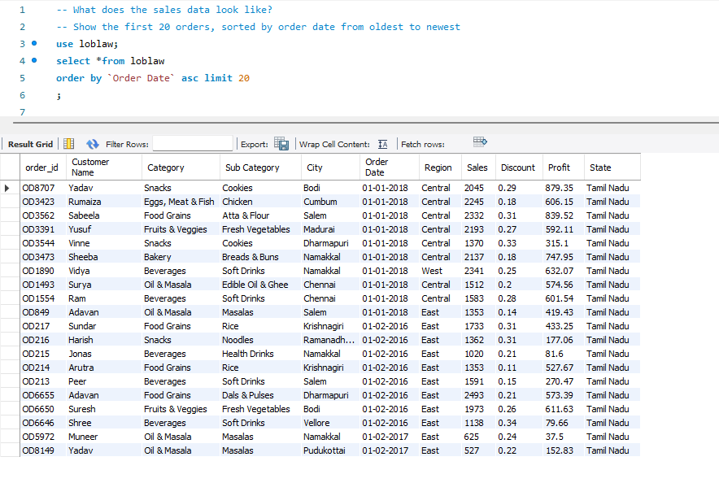
Which orders have strong sales and low discounts?
Find orders with sales above 2,000, a discount below 15%, and positive profit. Sort by sales descending.
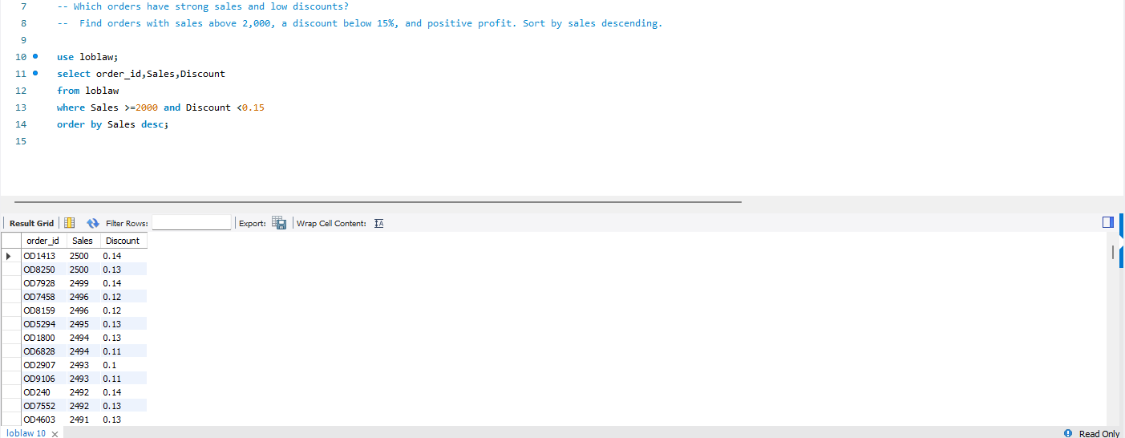
How is the business performing overall?
Calculate total sales, total profit, distinct order count, average order value, and profit margin percentage.
Display: Total sales, total profit, total orders, average order value, and profit margin %.

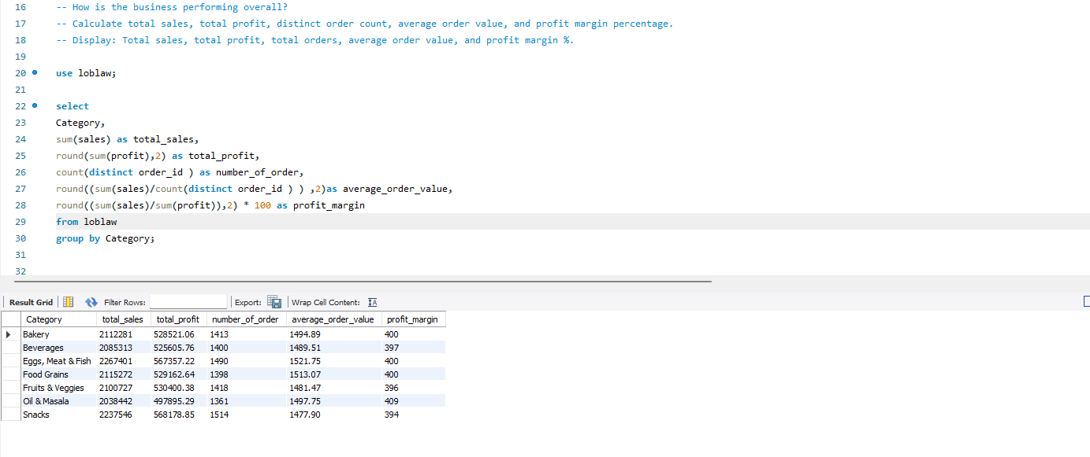

Which categories and subcategories drive business performance?
Calculate sales, profit, order count, and profit margin for each category and subcategory combination. Sort by total profit descending.

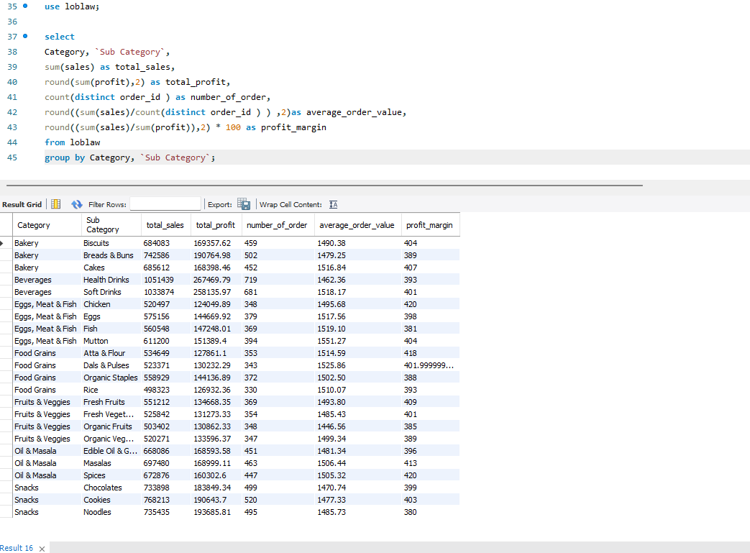

Which cities generate significant sales?
Find cities with total sales above 500,000 and at least 300 distinct orders.
Display: City, total sales, total profit, and order count.
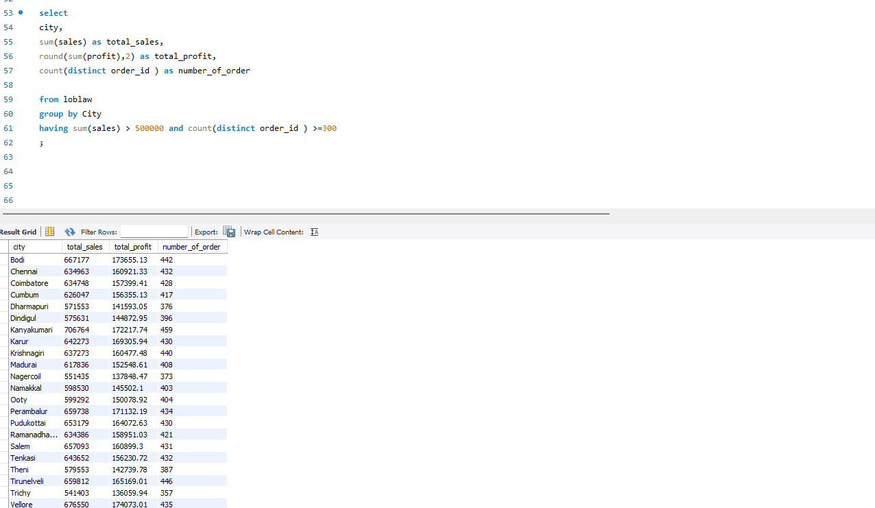

-- How does business performance change each month?
-- Calculate monthly sales, profit, and order counts for each year. Identify the year and month with the highest sales.

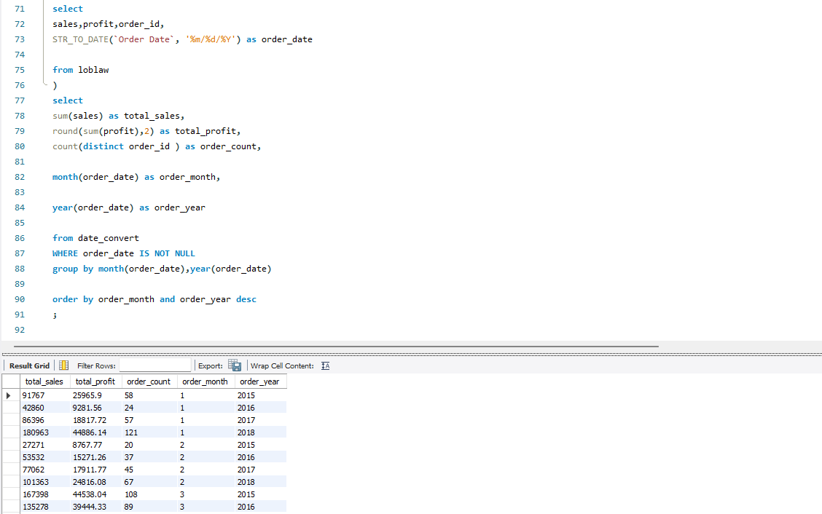
And
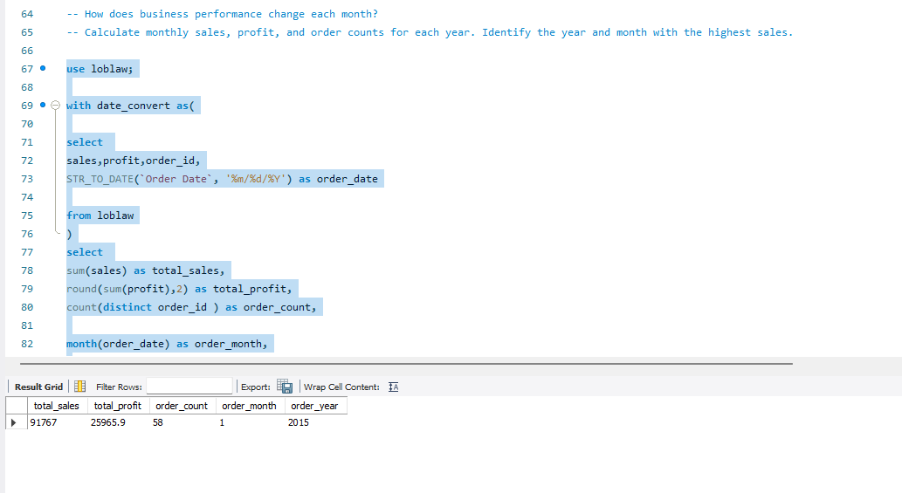

What happened during the latest 30 days in the dataset?
Using the latest order date as the reference, calculate daily sales and distinct order counts for that date and the previous 29 days. Return only days with sales.
Display: Order date, daily sales, and order count.

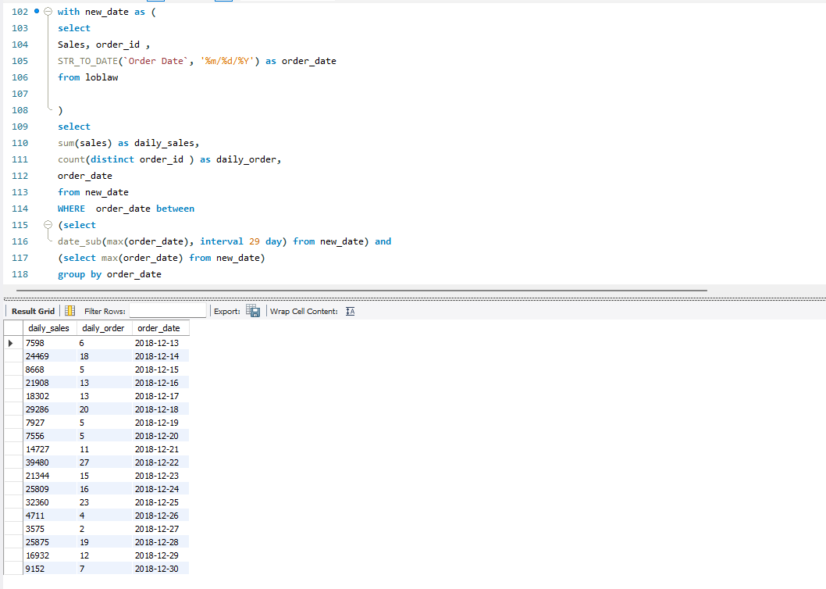

How do shipping methods compare?
Use an INNER JOIN to combine sales and shipping records. For each shipping method, calculate matched order count, total sales, recorded profit, total shipping cost, and average shipping cost.
Display: Shipping method, order count, total sales, total profit, total

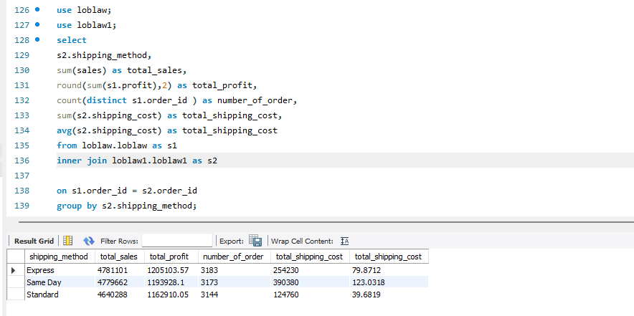

Which sales orders have no shipping records?
Use a LEFT JOIN to find orders without matching shipping details. Then summarize their order count and sales value by region.
Display: Order ID, order date, region, and sales; followed by a regional summary.

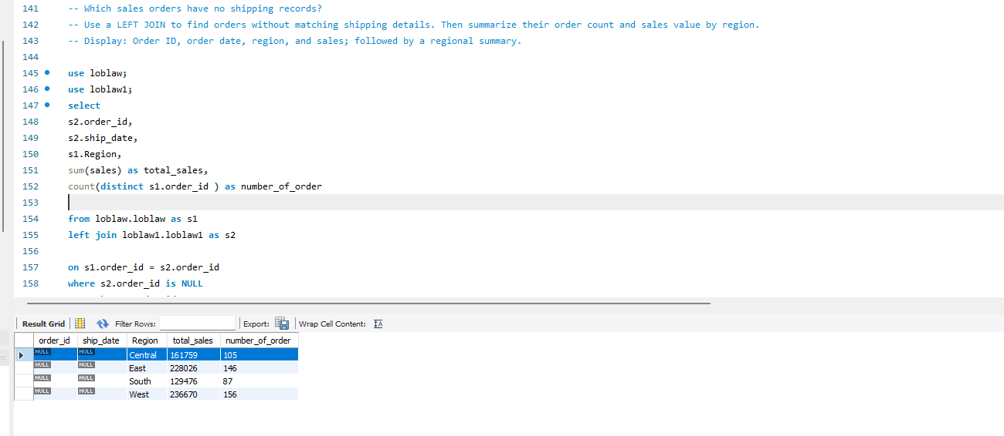

-- Are deliveries meeting their expected dates?
-- Use CASE WHEN to classify matched orders as Early, On Time, or Late, based on delivery date compared with expected delivery date. Count orders in each group.
-- Display: Delivery status and order count.

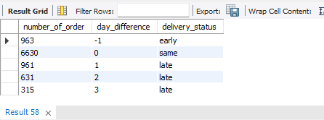

-- Which shipping methods have the most delivery problems?
-- For each shipping method, calculate matched order count, late order count, late-delivery percentage, and average days between order date and delivery date.
-- Display: Shipping method, total orders, late orders, late-delivery %, and average delivery days.

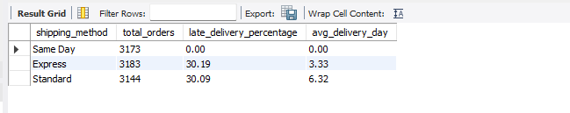

-- Which late deliveries had above-average sales?
-- Join the sales and shipping tables using order ID.
-- Find orders delivered after their expected delivery date whose sales were greater than the average sales across all orders in the sales table, calculated using a subquery.
-- Sort by sales descending.
-- Display: Order ID, customer name, sales, shipping method, expected delivery date, and actual delivery date.

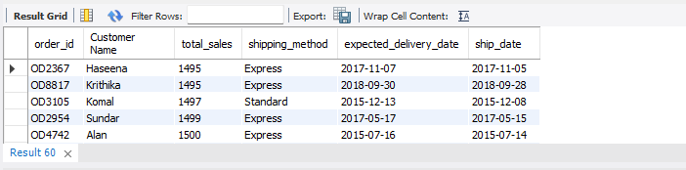
- Find each customer’s most recent order. If dates tie, choose the highest order_id. Return one order per customer.
-- Display: Customer name, order ID, order date, and sales.
