**c-sharp**

**HW #1**

In console application :

1. Write a C# program that computes ***y = sin(2x) + 5cos(x)***. The program should obtain the value of *x* from the user and prints the value of *y*.

Hint :: **use math libraries .** (math.sin) – (math.cos)

1. Write a C# program that inputs two integers from the keyboard, and prints the sum, difference, product, and division to the screen .

Hint :: **use DataType.Parse**

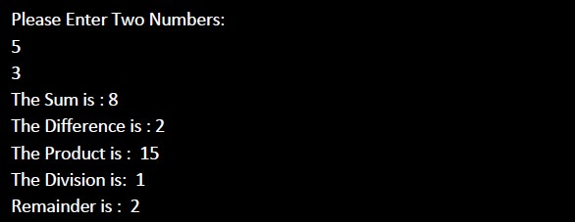

1. Write a C# program to find the maximum and minimum number among three integer values entered by the user from the keyboard.
2. Write a C# program that accepts a person age and prints to which age category he/ she belongs as described in the table below :

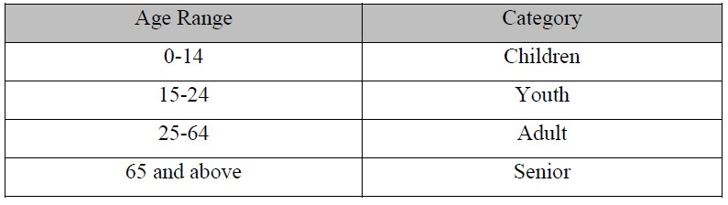

Hint : **Use nested if else structure**

1. Write a program that accepts the number of the day of the week and displays the name of the corresponding day. Assume Day 1 is Saturday, Day 2 is Monday, and so on. For example if you have entered 1 as your day number, the program should display "The day is Saturday." as the output.

Hint : **(Use switch statement to solve the problem).**