High Museum of Art

Mohammad Darkhbani

2023-04-14

Table of contents

# 1. Title:

Author: Mohammad Darkhabani

ORCID: https://orcid.org/0009-0001-0033-6060

Date: 28.04.2023

DOI: 10.5281/zenodo.7874714

Repository URL: https://orcid.org/0009-0001-0033-6060

## 1.1 Based on Baroque AI: Publication Prototype

## 1.2 Part of the series: Baroque TOC

[Programme instructions](https://nfdi4culture.github.io/class-ADA-CP-pipeline/)

2023-03-17

This work is licensed under a Creative Commons Attribution-ShareAlike 4.0 International License.

Book cover: Reworking of [Baroque pearl with enamelled gold mounts set with rubies](https://en.wikipedia.org/wiki/File:Pendant_in_the_form_of_a_siren_MET_DT7173.jpg). Creative Commons CC0 1.0 Universal Public Domain Dedication. This file was donated to Wikimedia Commons as part of a project by the Metropolitan Museum of Art.

This work is licensed under a Creative Commons Attribution-ShareAlike 4.0 International License.

# 2. Colophon

Fork title: Mohammad19921991/catalogue-003

Author: Mohammad Darkhabani

ORCID: https://orcid.org/0009-0001-0033-6060

Date: 28.04.2023

DOI: 10.5281/zenodo.7874714

Repositor: https://github.com/Mohammad19921991/catalogue-003

PUBLISHING FROM COLLECTIONS USES OF COMPUTATIONAL PUBLISHIGN AND LINKEDOPEN DATA

Open Science Lab - TIB Hannnover

First published 2023-03-30

Copyright © The Authors 2023 Licensed as https://creativecommons.org/licenses/by-sa/4.0/

DOI: https://doi.org/10.5281/zenodo.7701161

# 3. High Museum of Art

Source: https://en.wikipedia.org/wiki/High_Museum_of_Art

The High Museum of Art (colloquially the High) is the largest museum for visual art in the Southeastern United States. Located in Atlanta, Georgia (on Peachtree Street in Midtown, the city’s arts district), the High is 312,000 square feet (28,985 m2) and a division of the Woodruff Arts Center.

The High organizes and presents exhibitions of international and national significance alongside its comprehensive collection of more than 18,000 works of art, and is especially known for its 19th- and 20th-century American decorative arts, folk and self-taught art, modern and contemporary art, and photography.[3] A cultural nexus of Atlanta since 1905, it hosts festivals, live performances, public conversations, independent art films, and educational programs year-round.[4] It also features dedicated spaces for children of all ages and their caregivers, an on-site restaurant, and a museum store.[5]

In 2010, it had 509,000 visitors, 95th among world art museums.

# 4. Activity: Paintings catalogue

Wikidata link: <http://www.wikidata.org/entity/Q3842759>

Title: Madonna enthroned with child with Saints James the Greater and Jerome

Year: 1517

Creator: Moretto da Brescia

Copyright: public domain

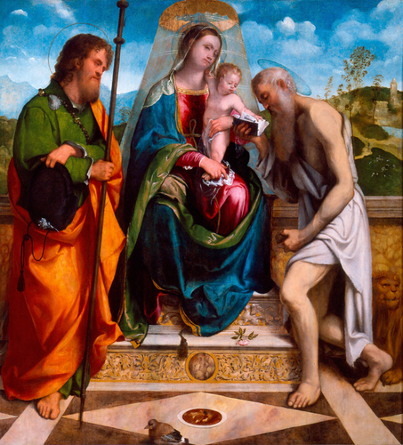

Wikidata link: <http://www.wikidata.org/entity/Q19900722>

Title: The Tempest

Year: 1826

Creator: Thomas Cole

Copyright: public domain

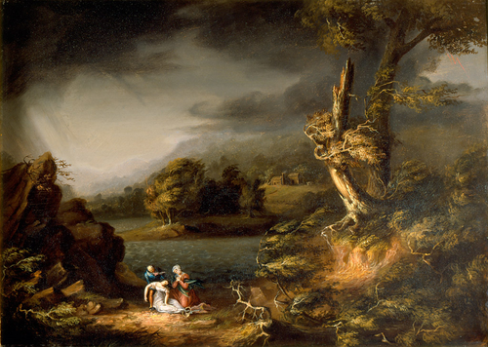

Wikidata link: <http://www.wikidata.org/entity/Q19912652>

Title: Twilight

Year: 1886

Creator: Martin Johnson Heade

Copyright: public domain

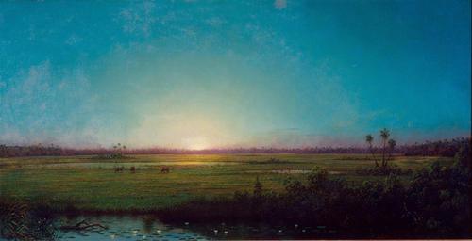

Wikidata link: <http://www.wikidata.org/entity/Q19967290>

Title: Tuileries Garden

Year: 1897

Creator: Childe Hassam

Copyright: public domain

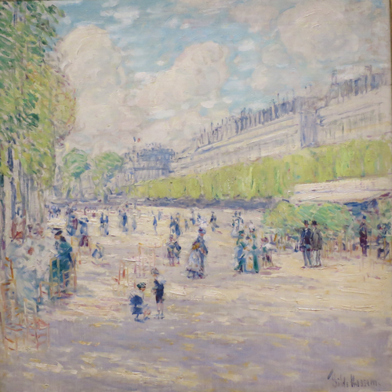

Wikidata link: <http://www.wikidata.org/entity/Q19968178>

Title: Abandoned in the Arctic Ice Fields

Year: 1876

Creator: William Bradford

Copyright: public domain

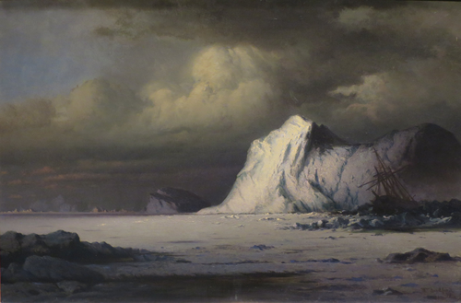

Wikidata link: <http://www.wikidata.org/entity/Q20032033>

Title: Coast of Labrador

Year: 1866

Creator: William Bradford

Copyright: public domain

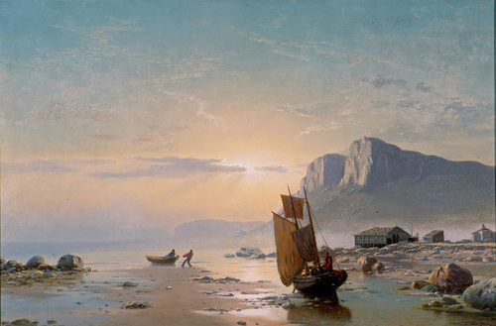

Wikidata link: <http://www.wikidata.org/entity/Q20032045>

Title: Shipwrecked off Labrador

Year: 1867

Creator: William Bradford

Copyright: public domain

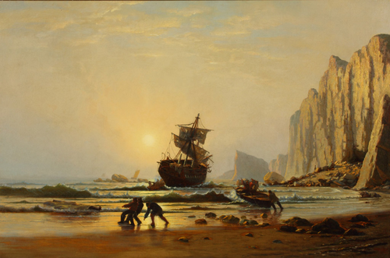

Wikidata link: <http://www.wikidata.org/entity/Q20054586>

Title: A Bit of the Roman Aqueduct

Year: 1852

Creator: George Inness

Copyright: public domain

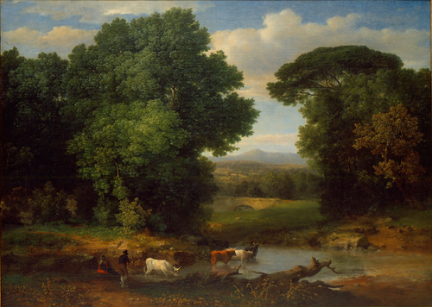

Wikidata link: <http://www.wikidata.org/entity/Q20054664>

Title: Clearing Up

Year: 1875

Creator: George Inness

Copyright: public domain

