*Table of contents*

*Introduction……………………………………………………………………………………………………………………..01*

*Install app…………………………………………………..................................................................................................02*

*Registration Login…………………………………………………………………………………………………………… 04*

*Project evolution………………………………………………………………………………………………………………05*

*Individual contribution…………………………………………………………………………………………………..…06*

*Proposal project ……………………………………………………………………………………………………………….08*

*First increment…………………………………………………………………………………………………………..……09*

*Second increment………………………………………………………………………………………………………….…10*

*Third increment……………………………………………………………………………………………………………....14*

*Fourth increment ……………………………………………………………………………………………………………..16*

*Expected effects……………………………………………………………………………………………………………….17*

*Future work……………………………………………………………………………………………………………………..18*

*1. Introduction:*

*Until now, there are very few apps developed which helps to send email while opening the door. Our app supports house owner to secure from doubtful neighborhoods. Hence, this app can be used many aspects of home privacy as a tools e.g. Wardrooms.*

*2. Install app:*

*Download the app from* [*https://play.google.com/store/apps/details?id=net.superblock.pushover*](https://play.google.com/store/apps/details?id=net.superblock.pushover) *then*

*Install on android device:*

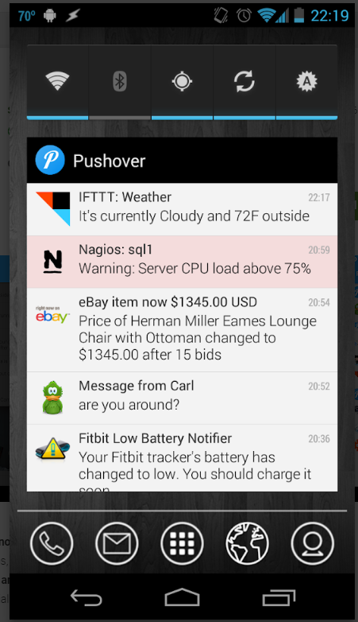

*3. Application features:*

*1. Registration: email, password, confirm password and press sign up button to register to the application.*

*2. Login: Enter correct email and password then press login button to login to the application. Once user enters correct credentials, user will be redirected to home page.*

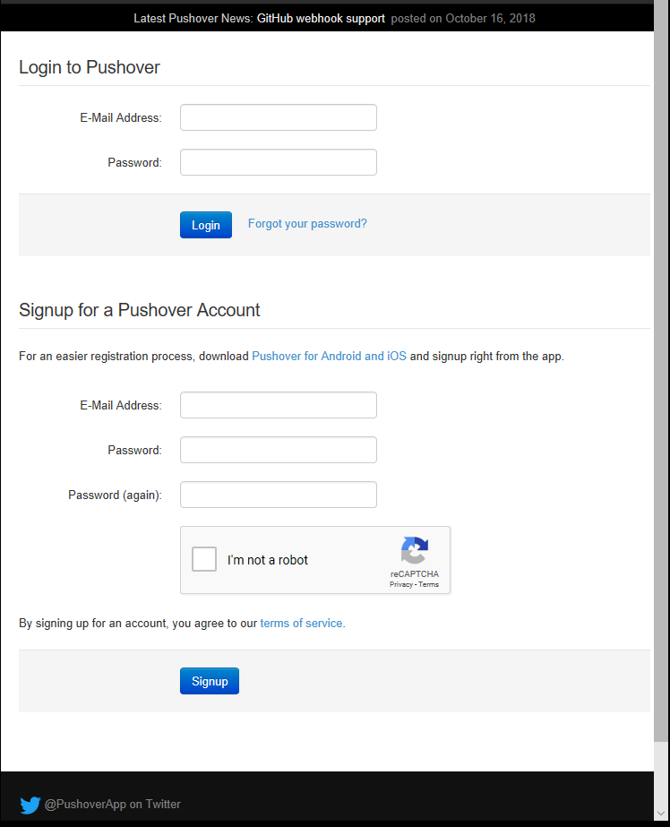

*Home page & logout*

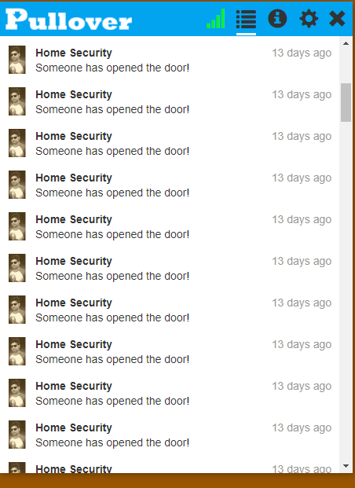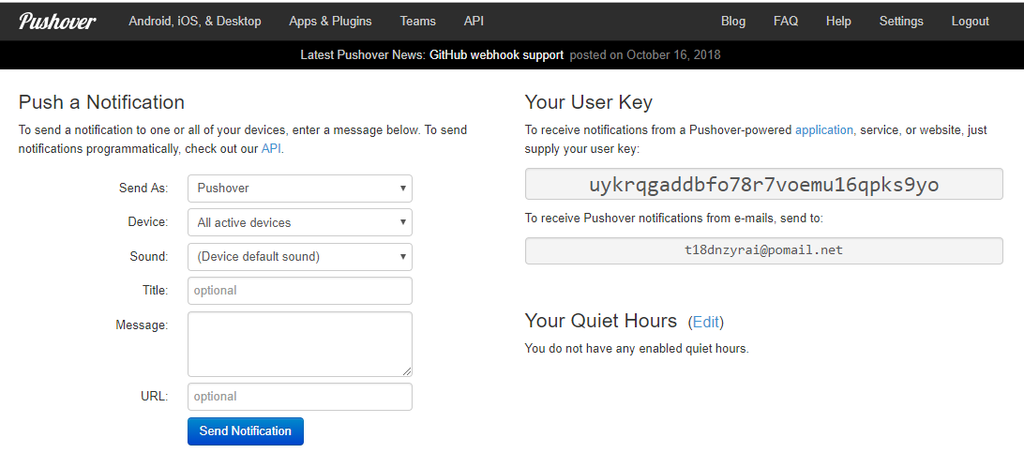

*Bottom of Form*

*Account & Security Settings:*

*E-Mail Address and Password: To change your e-mail address or create a new password, enter them below. Note that changing your password does not affect your Pushover device clients. To disable a device client, toggle it on the dashboard. For security, please verify your current password to change your e-mail address, password, or user key.*

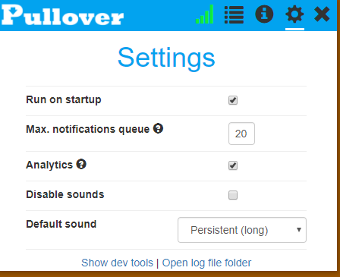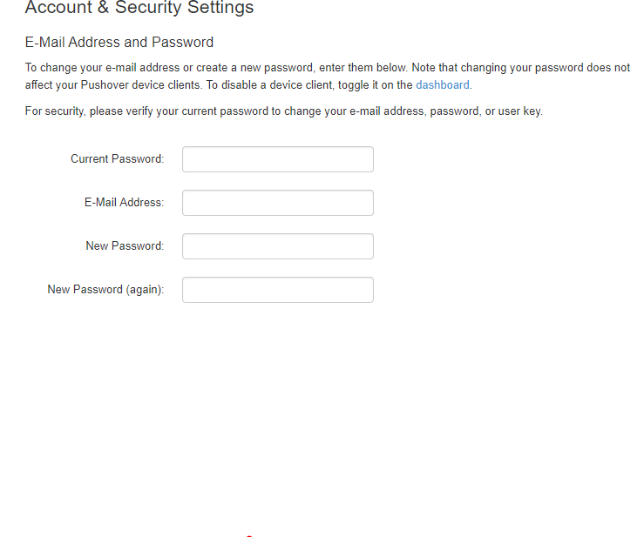

*Project Evaluation*

*I have implemented almost all the key features which we have specified in the project proposal. Although, some features are modified and additional features are implemented. As the API provided by them was not free of cost. I have implemented the push notifications for this module but this feature added to the user module could be add on to the application. I have also implemented sensor alarm is not in proposal. Apart from these our project satisfied all the specifications mentioned. Agile process was very much handy during the course of this application development. I was able to adapt to the additional features which were added in the development of various modules. I was able to update the application according to the inputs from the professor. Even though I had to implement some additional features in between, I stood by my plan and implemented all the features according to the plans. I had initially divided the modules of the application among myself and completed the respective tasks according to the deadlines.*

*Individual Contribution to Project:*

*Mohammad Abul Hossain: 100%• Login and Registration –pushover API, simulating Linux with Raspberry pi3, coding and embedding between hardware and software application.*

*Project proposal:*

*Project Title: Home security  
group member:  
 Mohammad Abul Hossaain & student id 20152785*

*Project Goal:*

*To develop an app this helps to secure house from doubtful neighborhood and which is more efficient and more convenient secure house system.*

*Objective:*

* *To aid house owner in security.*
* *Relief from suspicious neighborhood*
* *It is easier to use to users.*
* *Create a unique platform of combination between software application and hardware device.*

*Intended client:*

*This product’s target is all classes of costumers, urban and rural, office or house doors. Since, it safe from unwanted person and all control in hand on mobile by texting door notification .If you are around house then you can check it out and identifying them.*

*Form and functionality:*

*Door closed- it means pairs magnetic switch is disconnected Wi-Fi from operating system of raspberry pi3.*

*Door Open- it means pairs of magnetic switch is connected Wi-Fi from operating system of raspberry pi3.*

*Pushover API/server-users can be notified from Pushover server while Operating system of raspberry pi3 is connecting with WI-FI.*

*Challenges:*

* *There are some challenges in this project.*
* *The most challenge is embedded between software and hard ware, and setting connectivity of hardware devices.*
* *To require magnetic switch and electronics tools.*
* *To need more research on this app, API/ Server, hardware devices.*

*Backup Project:*

*An application which helps to meet with friends’ room and kitchen then I feel insure about my room privacy. After then I thought that I can make such a door privacy which I get notification while opening door and where is my house’s privacy will have in my hand .*

*Project Plan:*

*As a part of first increment we have will implement the simple modules of our application, setting raspberry pi3 with Linux operating system. Research about the available API’s to implement the modules like notifying massage.*

*As a part of the second increment we will work on the storing and retrieving of data from the application .We shall develop the pushover API form the communication with Raspberry pi3 operating system*

*• As a part of the third increment, we will work on the sign in and registration pages, module. We will also added the setting and account organizing for the house owner and make sure privacy as change account information.*

*As a part of final increment we will implement the sending text to application from operating system / raspberry pi3 as push notifications. Integrate the hyperlinks to the pesticides module. Integrate all the modules to the home security application.*

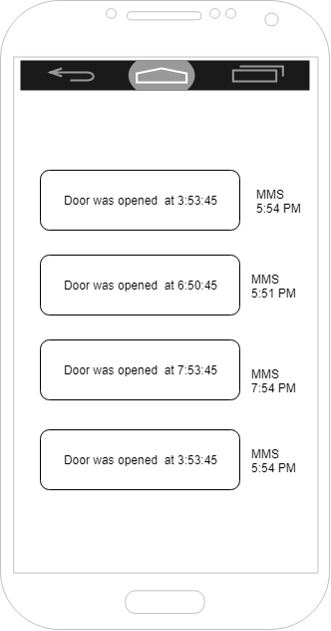

*First inclement:*

*Mockup – up loading operationg system kernel in raspberry pi and connecting wifi in raspberry pi. Up date all data in opearting system.*

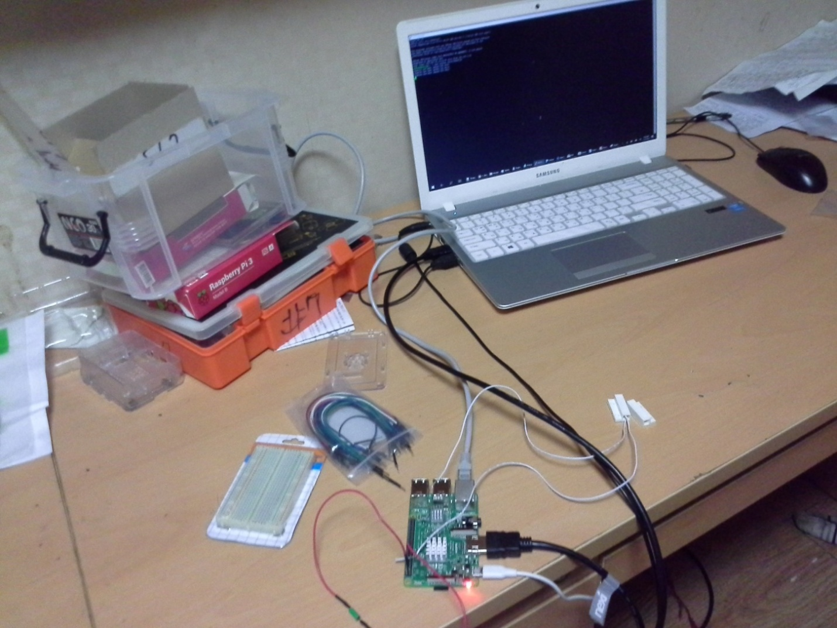

*Second increment:*

*Use case diagram-Door closed- it means pairs magnetic switch is disconnected Wi-Fi from operating system of raspberry pi.*

*Door Open- it means pairs of magnetic switch is connected Wi-Fi from operating system of raspberry pi.*

*Pushover API/server-users can be notified from Pushover server while Operating system of raspberry pi is connecting with WI-FI.*

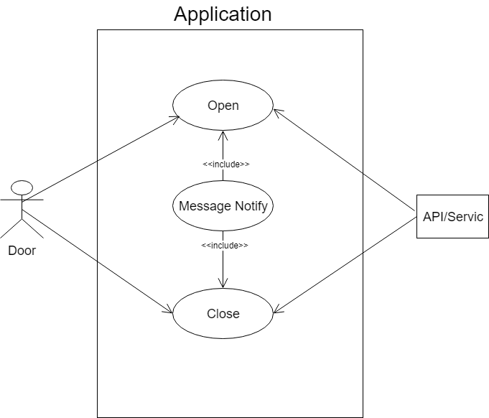

*Sequence diagram- the user open the door then operating system call service and the service return service and notifying text if the service is available. If service is not available then service is closed.*

*The user close the door then the service is not available and service is closed*

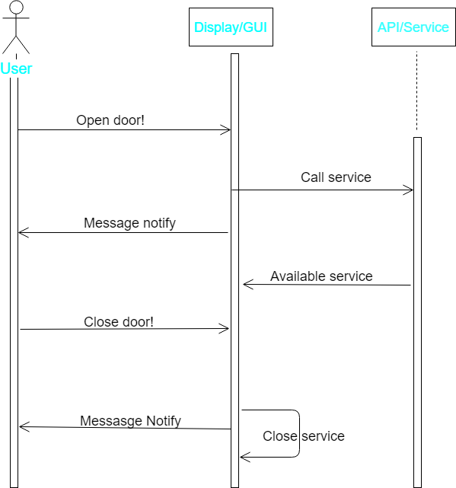

*Architecture diagram –when user open the door then operating system call the service of pushover API if service is available then return the service to user and after then notifying text to user.*

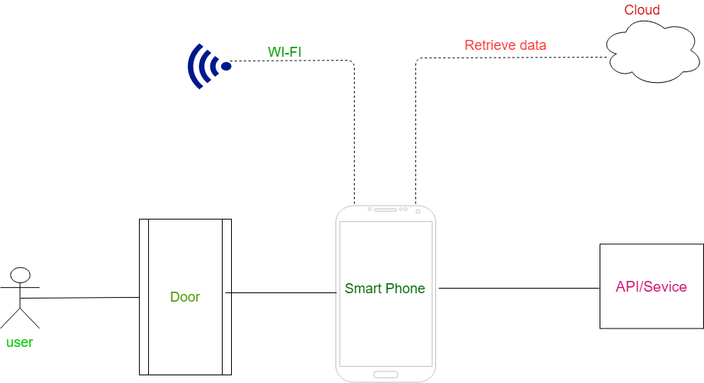

*Third increment:*

*Coding part-pushover API provides some information for connecting between raspberry pi and pushover API. After then it needs set up between hardware parts raspberry pi and magnetic pairs switch, and then it requires synchronize program.*

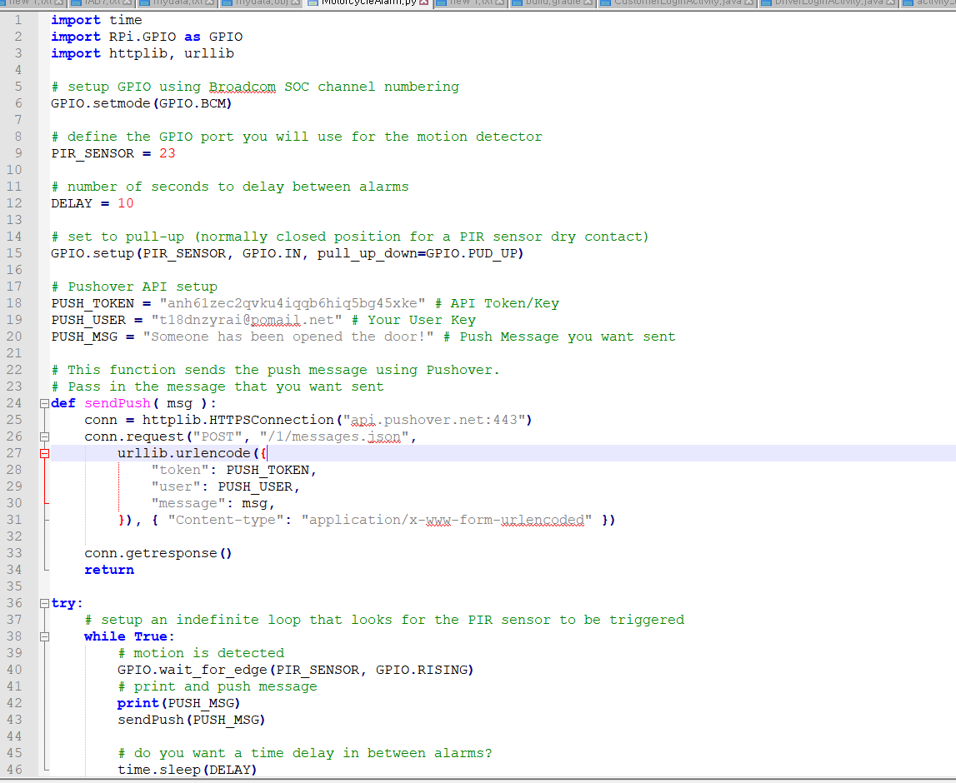

*Output - after embedding hard ware and software its expected result .if user open the door then operating system retrieves the expected output.*

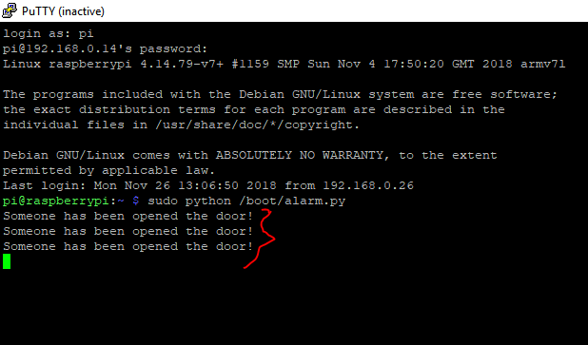

*Fourth increment:*

*Pushover application- the user open the door then operating system/raspberry pi sends to message to pushover application and it shows exact time and date .*

**

*Expected effect:*

*This app will help to the house privacy .house owner can be able to all control of house in their hand instantly. This application is very easy to use to all age’s user. Users can be notified text to smart phone while opening the door of house owner. After then house owner can be able to identify unauthorized people who enter the room without permission.*

*Future work:*

*Building a security camera with motion-control and connected to raspberry pi with MotionEyeOS. MotionEyeOS you can connect the pi to your Google drive or drop box, also make sure to connect your mail so you get notifications. Set motion trigger alarm so when there is a movement the camera start taking pictures and you will be notified in a second*

