**Prediction of the Age and Gender Based on Human Face Images Based on Deep Learning Algorithm: Literature Review 1**

**Abstract:**

Current studies on the food domain deal with a recommendation system that focuses on independent users and their health problems but lack nutritional advice to individual users. The proposed system is developed to suggest nutritional food to people based on age and gender predicted from their face image. The designed methodology preprocesses the input image before performing feature extraction using the deep convolution neural network (DCNN) strategy. Support vector machine (SVM) is used to classify a person’s age and gender. The proposed system is evaluated using classification rate, precision, and recall using Adience dataset and real-world images exhibit excellent performance by achieving good prediction results and computation time.

**Method**

* A nutrition recommendation framework is developed to provide nutritional advice based on the user’s age and gender
* DCNN is utilized for feature extraction, which learns relevant characteristics by retrieving distinctive features
* PCA is used to select the best features in the image
* Combining DCNN with PCA improves the computation time and accuracy
* SVM classifies age and gender

*Computational and Mathematical Methods in Medicine*

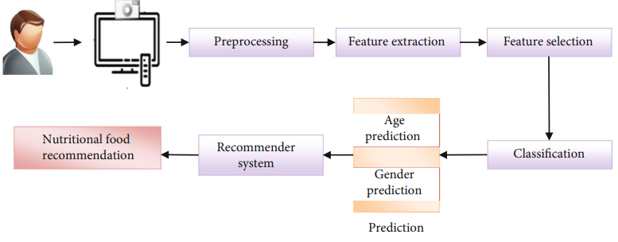

**Conclusion and Future Work**

For a wide range of applications, age and gender are critical factors. The scientific community has been more interested in estimating age and gender through facial photographs. This research offers a revolutionary nutrition recommendation system depending on age and gender detection from a facial image. Most of the existing nutrition recommendation system provides nutritional advice based on the information entered by the user manually or using the pathological reports. In this context, the current paper presents a recommender system which automatically captures the face and classifies the age and gender of an individual without any physical communication. In future, it is planned to develop group recommendation system for a group of users in public place

**Human Gender Classification: Literature Review 2**

**Introduction**

Automatic gender classification is receiving increasing attention, since gender carries rich and distinguished information concerning male and female social activities. The aim of gender classification is to recognize the gender of a person based on the characteristics Human Gender Classification: A Review 3 that differentiate between masculinity and femininity. In the area of artificial intelligence, It, gender classification is considered to be one of the most important applications of pattern recognition method The progress of gender classification research has driven many potential applications. For instance, a computer system with gender recognition functions has a wide range of applications in fundamental and applied research areas including: human-computer interaction the security and surveillance industry [4], demographic research commercial development [6], and mobile application and video games furthermore, multi-mechanisms are proposed.

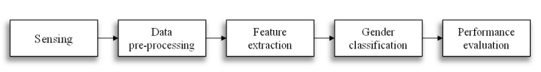

*Figure 1: The general classification framework.*

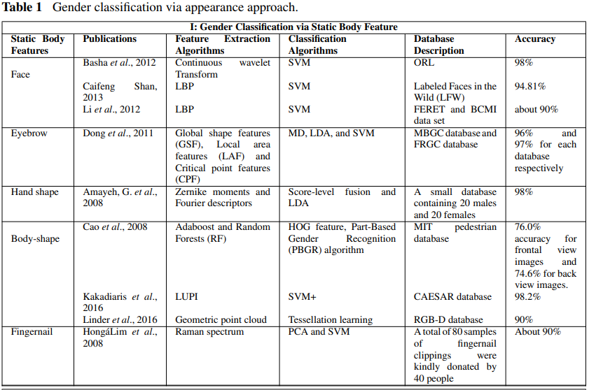

*Figure1.1: Gender Classification via Static Body Feature*

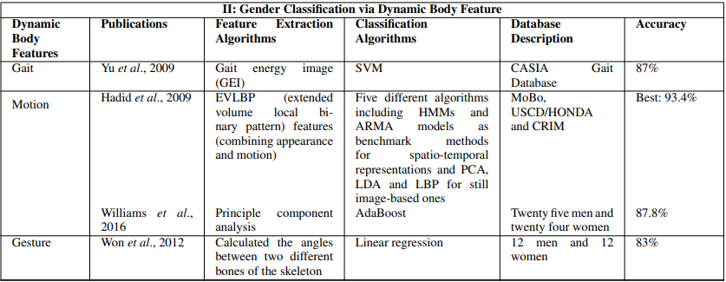

*Figure1.2: Gender Classification via Dynamic Body Feature*

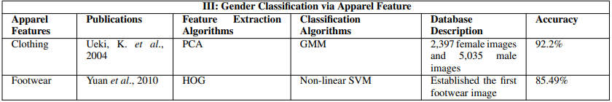

*Figure 1.3: Gender Classification via Apparel Feature*

**Conclusion and Future Research**

In this paper, we reviewed the state-of-the-art gender classification approaches, which are divided into two groups according to these metric traits: the appearance approach (i.e., static body features, dynamic body features, and apparel features) and the non-appearance approach (i.e., biometrics, bio-signals, and social network information). Moreover, a comparison among them was presented. We found that biology information using the physiological signal is not easily tricked in the classification and it has a higher accuracy

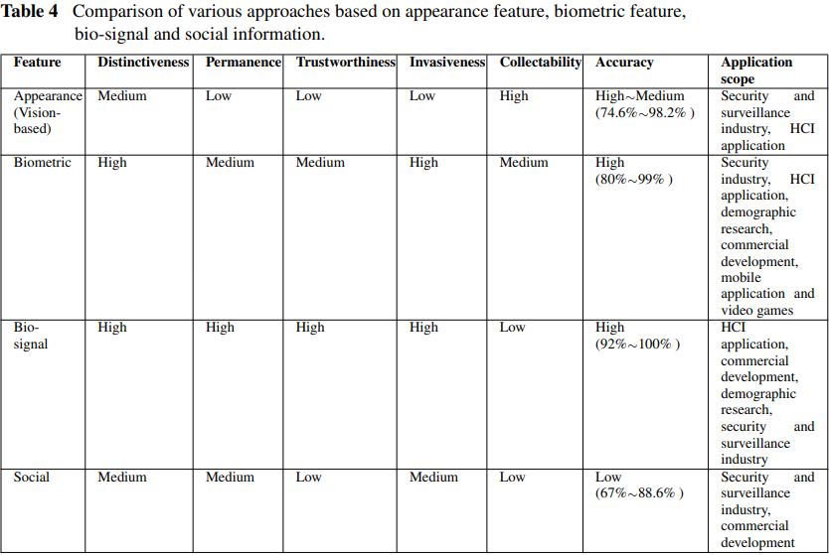

The existing approaches also have some limitations such as low accuracy, low efficiency, and restricted application domain. This review brings a new insight analysis on various gender classification methods in different contexts.